Q1 | Install Anaconda on your system and launch Jupyter Notebook from the Anaconda Navigator.
Code | Step1:  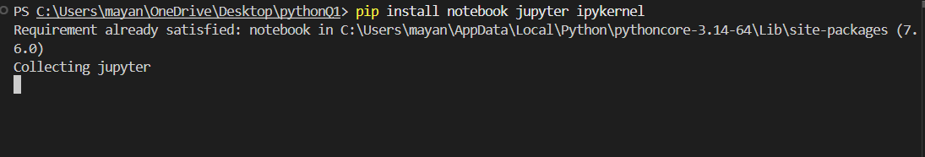  Code:  print("Name: Mayank")  print("Favorite App: Instagram")  print("Welcome to Data Science with Python!")
Output | 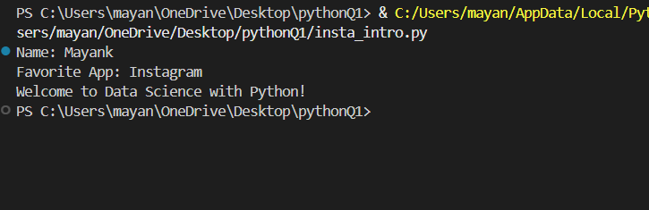

Q2 | Create a new Jupyter Notebook file named insta_intro.ipynb and write a cell that prints your name and your favorite app (like Instagram or Zomato) using the print() function.
Code | print("Name: Mayank")  print("Favorite App: Instagram")
Output | 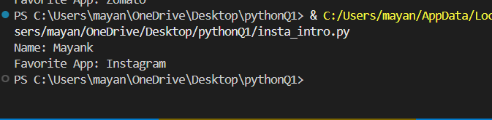

Q3 | In Jupyter Notebook, add a new cell and write Python code to print the message: 'Welcome to Data Science with Python!'.
Code | print("Name: Mayank")  print("Favorite App: Instagram")  print("Welcome to Data Science with Python!")
Output | 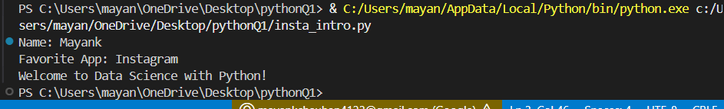

Q4 | Create a Python script file called hello_app.py (not a notebook) that prints 'Hello from .py file!' when run from the terminal.<br><br><em><strong>Hint:</strong> Use a text editor like VS Code or Notepad to create the file, then run it using the command: python hello_app.py</em>
Code | print("Hello from .py file!")
Output | 