Q1 | Write a lambda function to convert a list of song titles from Spotify to all lowercase letters and use map() to apply it to ['Shape Of You', 'Blinding Lights', 'Levitating', 'Senorita'], printing the cleaned list.
Code | songs = ['Shape Of You', 'Blinding Lights', 'Levitating', 'Senorita']  lowercase_songs = list(map(lambda song: song.lower(), songs))  print("Lowercase Songs:")  print(lowercase_songs)
Output | 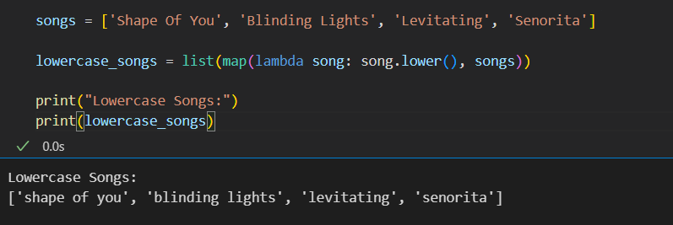

Q2 | Given a list of Zomato restaurant ratings [4.2, 3.8, 4.5, 2.9, 3.5], use filter() with a lambda to find and print only the restaurants with ratings above 4.0.
Code | ratings = [4.2, 3.8, 4.5, 2.9, 3.5]  high_ratings = list(filter(lambda rating: rating > 4.0, ratings))  print("Ratings Above 4.0:")  print(high_ratings)
Output | 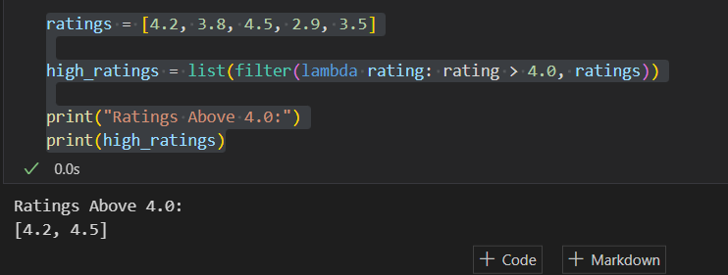

Q3 | Use reduce() from functools to calculate the total price of items in a Flipkart shopping cart: [499, 1299, 299, 799]. Print the final total.<br><br><em><strong>Hint:</strong> Import reduce from functools and use a lambda to sum two numbers.</em>
Code | from functools import reduce  cart = [499, 1299, 299, 799]  total = reduce(lambda x, y: x + y, cart)  print("Total Cart Price:")  print(total)
Output | 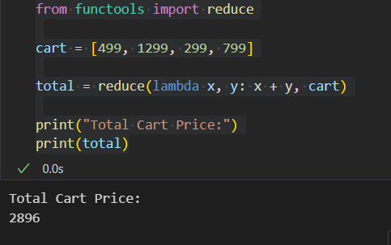

Q4 | Create a function format_followers that takes a number and returns it in 'K' or 'M' format (e.g., 1500 → '1.5K', 1200000 → '1.2M'), then use map() to apply it to a list of follower counts: [950, 1500, 25000, 1200000].
Code | def format_followers(num):  if num >= 1000000:  return f"{num / 1000000:.1f}M"  elif num >= 1000:  return f"{num / 1000:.1f}K"  else:  return str(num)  followers = [950, 1500, 25000, 1200000]  formatted = list(map(format_followers, followers))  print("Formatted Followers:")  print(formatted)
Output | 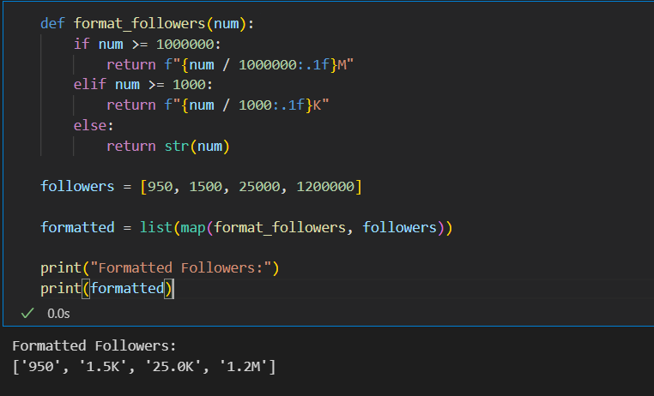

Q5 | Use an AI tool like ChatGPT or Copilot to generate a lambda function that filters out all odd numbers from a list of IPL scores [101, 98, 120, 77, 88], then test the code in your Python environment and paste the working code here.
Code | scores = [101, 98, 120, 77, 88]  even_scores = list(filter(lambda score: score % 2 == 0, scores))  print("Even IPL Scores:")  print(even_scores)
Output | 