Q1 | Create a Python script that imports the math module and uses math.sqrt() to calculate and print the square root of 225.
Code | import math  result = math.sqrt(225)  print("Square Root of 225 =", result)
Output | 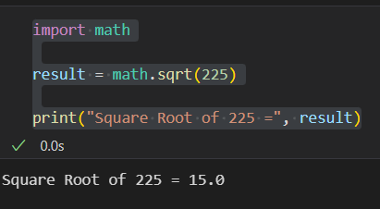

Q2 | Write a script that uses the os module to create a new folder named 'MyDownloads' in your current working directory, then print the absolute path of the new folder.
Code | import os  folder_name = "MyDownloads"  os.makedirs(folder_name, exist_ok=True)  print("Folder created at:")  print(os.path.abspath(folder_name))
Output | 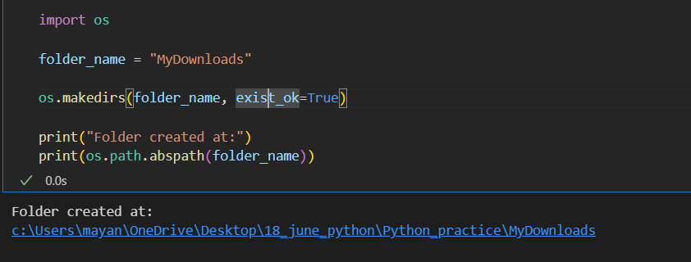

Q3 | Use the datetime module to get the current date and time, then format and print it as 'DD-MM-YYYY HH:MM:SS', similar to how WhatsApp shows message timestamps.<br><br><em><strong>Hint:</strong> Use strftime() to format the output.</em>
Code | from datetime import datetime  current_time = datetime.now()  formatted = current_time.strftime("%d-%m-%Y %H:%M:%S")  print("Current Date and Time:")  print(formatted)
Output | 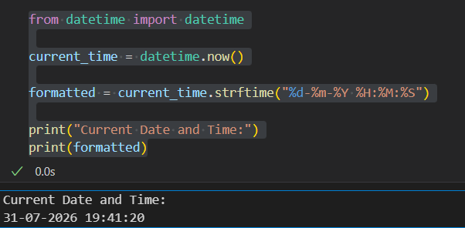

Q4 | Create a custom Python module called playlist_utils.py with a function add_song(playlist, song) that adds a song to a list. Import this module in another script and use it to add three songs to a playlist, then print the final playlist.
Code | import playlist_utils  playlist = []  playlist_utils.add_song(playlist, "Shape Of You")  playlist_utils.add_song(playlist, "Levitating")  playlist_utils.add_song(playlist, "Blinding Lights")  print("Final Playlist:")  print(playlist)
Output | 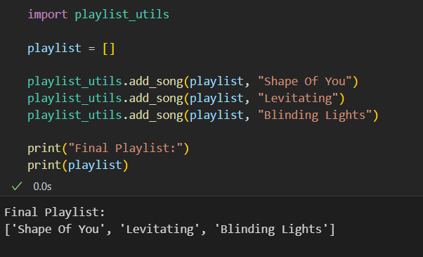

Q5 | Set up a new virtual environment using venv, activate it, and install the 'requests' package using pip. Write a short script that imports requests and prints the version installed.<br><br><em><strong>Hint:</strong> Use 'python -m venv venv_folder', then 'pip install requests'.</em>
Code | import requests  print("Requests Version:", requests.__version__)
Output | 