Q1 | Use the requests.get() function to fetch the latest posts from the JSONPlaceholder API endpoint https://jsonplaceholder.typicode.com/posts and print the status code and the first post's title.
Code | import requests  url = "https://jsonplaceholder.typicode.com/posts"  response = requests.get(url)  print("Status Code:", response.status_code)  posts = response.json()  print("First Post Title:")  print(posts[0]["title"])
Output | 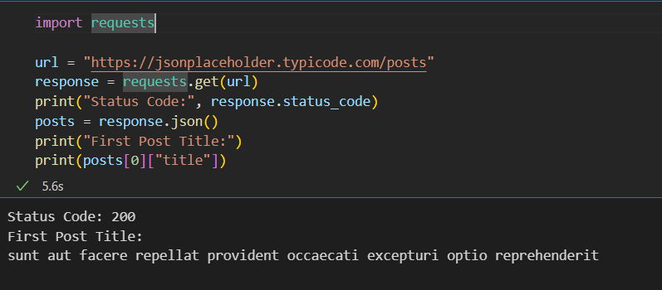

Q2 | Send a POST request to https://jsonplaceholder.typicode.com/posts using requests.post() with the data: title='My First Post', body='Hello from Python!', userId=101, and print the status code and the returned JSON response.
Code | import requests  url = "https://jsonplaceholder.typicode.com/posts"  data = {  "title": "My First Post",  "body": "Hello from Python!",  "userId": 101  }  response = requests.post(url, json=data)  print("Status Code:", response.status_code)  print("Response:")  print(response.json())
Output | 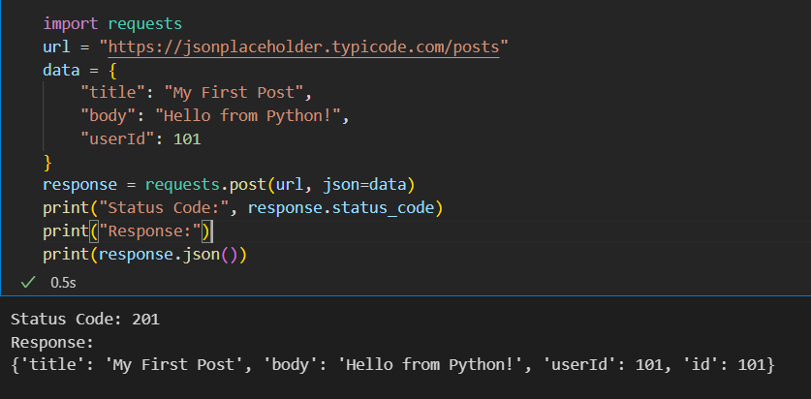

Q3 | Fetch a list of users from https://jsonplaceholder.typicode.com/users using requests.get(), then use the .json() method to extract and print the usernames of all users whose email ends with '.org'.
Code | import requests  url = "https://jsonplaceholder.typicode.com/users"  response = requests.get(url)  users = response.json()  print("Users with .org email addresses:")  for user in users:  if user["email"].endswith(".org"):  print(user["username"])
Output | 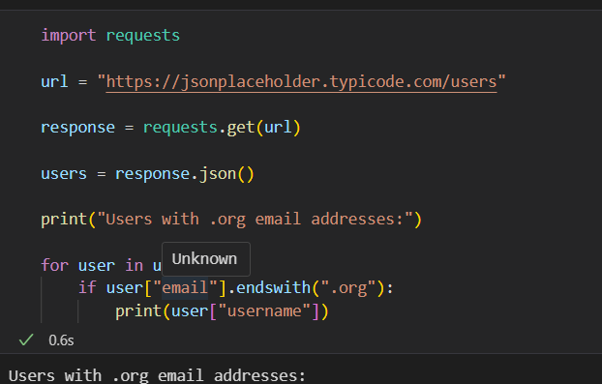
\

Q4 | Build a small script that fetches movies from the OMDB API (http://www.omdbapi.com/) by sending a GET request with query parameters: apikey='demo', s='Avengers'. Print the total number of results found.<br><br><em><strong>Hint:</strong> Pass the parameters using the params={} argument in requests.get().</em>
Code | import requests  url = "http://www.omdbapi.com/"  params = {  "apikey": "demo",  "s": "Avengers"  }  response = requests.get(url, params=params)  data = response.json()  if "totalResults" in data:  print("Total Results:", data["totalResults"])  else:  print("API Response:")  print(data)
Output | 