Q1 | Create three variables in Python named item_price, delivery_fee, and coupon_discount, and assign them values representing a Swiggy order (e.g., 250, 30, 20). Print each variable.
Code | item_price = 500  delivery_fee = 45  coupon_discount = 40  print("Item Price:", item_price)  print("Delivery Fee:", delivery_fee)  print("Coupon Discount:", coupon_discount)
Output | 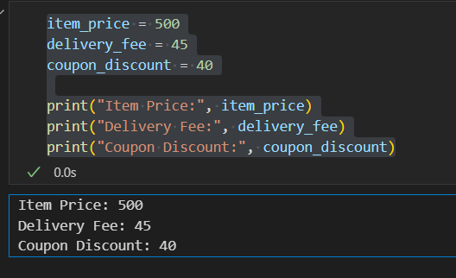

Q2 | Write a Python script that uses indentation correctly to check if a Flipkart product's price is above 1000; if yes, print 'Eligible for free delivery', else print 'Delivery charges apply'.<br><br><em><strong>Hint:</strong> Use an if-else block and make sure your indentation is consistent.</em>
Code | product_price = 500  if product_price > 1000:  print("Eligible for free delivery")  else:  print("Delivery charges apply")
Output | 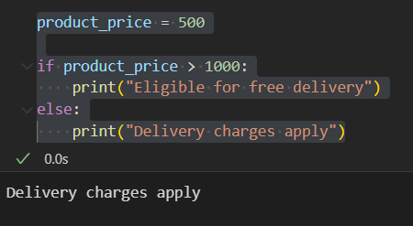

Q3 | Add both single-line and multi-line comments in your script explaining what each section does, using # for single-line and triple quotes for multi-line comments.
Code | ''' multiple line  comment '''  # SIngle line comment  product_price = 1200  if product_price > 1000:  print("Eligible for free delivery")  else:  print("Delivery charges apply")
Output | 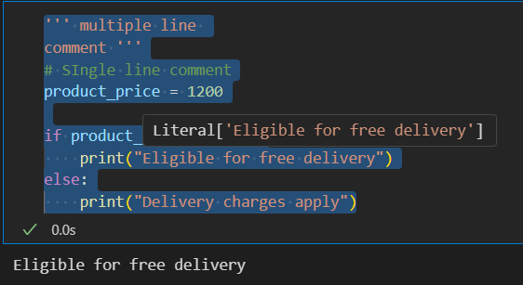

Q4 | Create variables for an IPL match: team_name, runs_scored, and overs_played. Assign appropriate values and print them using the correct naming conventions for Python variables.<br><br><em><strong>Constraint:</strong> Use snake_case for all variable names.</em>
Code | team_name = "Mumbai Indians"  runs_scored = 250  overs_played = 20.0  print("Team Name:", team_name)  print("Runs Scored:", runs_scored)  print("Overs Played:", overs_played)
Output | 