Q1 | Declare four variables in Python: your age as an int, your height in centimeters as a float, your name as a str, and whether you have a Spotify account as a bool. Print each variable and use the type() function to display its data type.
Code | age = 20  height = 170.5  name = "Mayank"  has_spotify = True  print("Age:", age)  print("Height:", height)  print("Name:", name)  print("Has Spotify Account:", has_spotify)  print("Type of age:", type(age))  print("Type of height:", type(height))  print("Type of name:", type(name))  print("Type of has_spotify:", type(has_spotify))
Output | 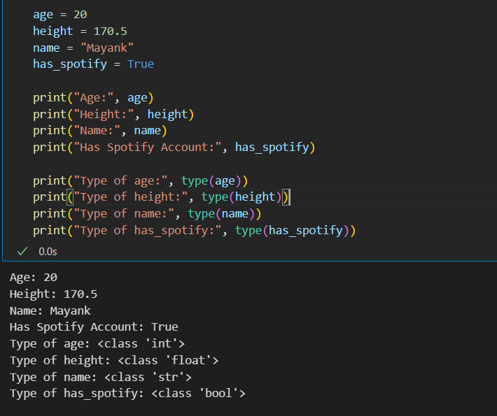

Q2 | Write a function total_cart_amount(prices) that takes a list of product prices as strings (like ['199.99', '49', '350.75']) and returns the total as a float. Print the result for a sample Flipkart-style cart.<br><br><em><strong>Hint:</strong> Use float() to convert each string before summing.</em>
Code | def total_cart_amount(prices):  total = 0.0  for price in prices:  total += float(price)  return total  cart_prices = ['200.25', '100', '221.25']  print("Cart Prices:", cart_prices)  print("Total Cart Amount:", total_cart_amount(cart_prices))
Output | 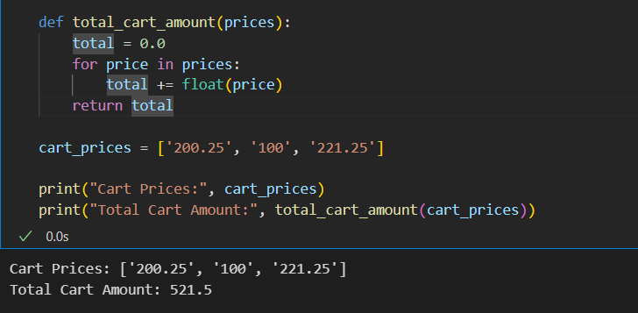

Q3 | Create a script that asks the user to input their cricket score as a string, converts it to an int, and prints 'Half-century!' if the score is 50 or more, otherwise prints 'Keep going!'.<br><br><em><strong>Constraint:</strong> Use input(), int(), and if-else.</em>
Code | score = input("Enter your cricket score: ")  score = int(score)  if score >= 50:  print("Half-century!")  else:  print("Keep going!")
Output | 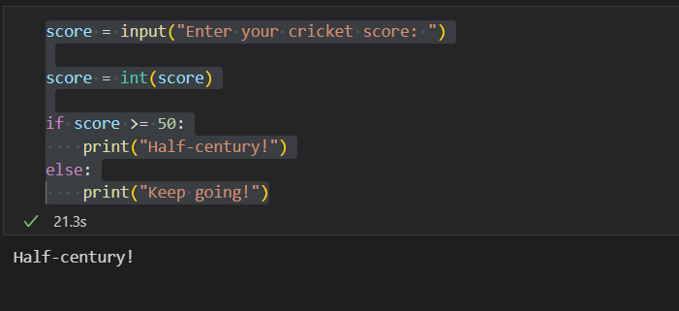

Q4 | Given the variable is_premium = 'True' (as a string), write code to correctly convert it to a boolean value and print its type.<br><br><em><strong>Hint:</strong> The bool() function alone won’t work as expected. Think about string comparison.</em>
Code | is_premium = "True"  is_premium = (is_premium == "True")  print(is_premium)  print(type(is_premium))
Output | 