Q1 | Create a Python dictionary called insta_followers that stores the number of followers for 5 Instagram influencers (use their usernames as keys and follower counts as values). Print the dictionary.
Code | insta_followers = {  "viratkohli": 2700000,  "shraddhakapoor": 950000,  "aliaabhatt": 880000,  "deepikapadukone": 810000,  "katrinakaif": 800000  }  print(insta_followers)
Output | 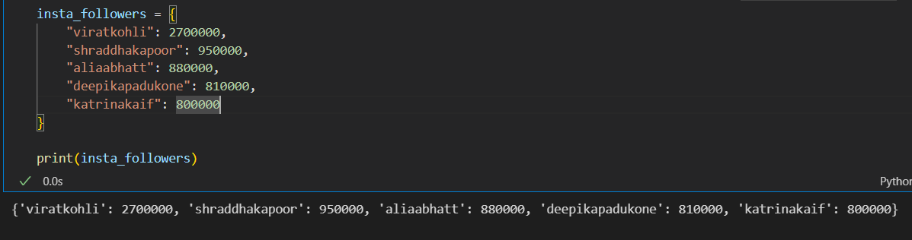

Q2 | Add a new influencer to your insta_followers dictionary and update the follower count for one existing influencer. Then, delete one influencer from the dictionary and print the updated dictionary.
Code | insta_followers = {  "viratkohli": 2700000,  "shraddhakapoor": 950000,  "aliaabhatt": 880000,  "deepikapadukone": 810000,  "katrinakaif": 800000  }  insta_followers["carryminati"] = 450000  insta_followers["viratkohli"] = 2750000  del insta_followers["katrinakaif"]  print(insta_followers)
Output | 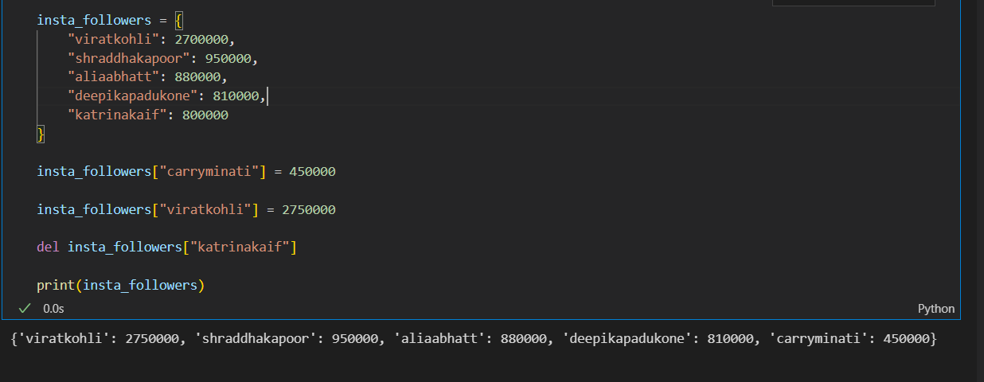

Q3 | Given a dictionary called food_prices with 5 Zomato food items as keys and their prices as values, write code to display all items that cost more than ₹200.
Code | food_prices = {  "Pizza": 250,  "Burger": 180,  "Biryani": 300,  "Pasta": 220,  "Sandwich": 150  }  print("Food items costing more than ₹200:")  for item, price in food_prices.items():  if price > 200:  print(item, ":", "₹" + str(price))
Output | 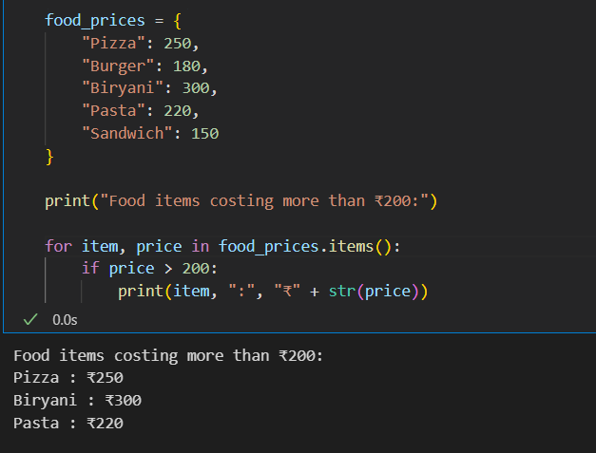

Q4 | Create two sets: flipkart_users and myntra_users, each containing 5 unique usernames. Find and print the set of users who have accounts on both platforms using set intersection.
Code | flipkart_users = {"Mayank", "Priyanshu", "Dipti", "Neha", "Sneha"}  myntra_users = {"Mayank", "amit", "Dipti", "Sneha", "Yash"}  common_users = flipkart_users.intersection(myntra_users)  print("Users with accounts on both Flipkart and Myntra:")  print(common_users)
Output | 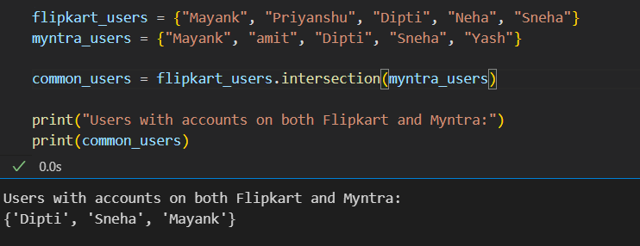

Q5 | Write a function get_unique_artists(spotify_playlist1, spotify_playlist2) that takes two sets of artist names and returns a set of all unique artists across both playlists (set union).<br><br><em><strong>Hint:</strong> Use the union() method or the | operator for sets.</em>
Code | def get_unique_artists(spotify_playlist1, spotify_playlist2):  return spotify_playlist1.union(spotify_playlist2)  spotify_playlist1 = {"Jaymes Young", "Ed Sheeran", "Wiz Khalifa"}  spotify_playlist2 = {"Divine", "Wiz Khalifa", "Jaymes Young"}  unique_artists = get_unique_artists(spotify_playlist1, spotify_playlist2)  print("Unique Artists:", unique_artists)
Output | 