Q1 | Write a Python script that takes your current Spotify listening time in minutes and checks if it is above 120 minutes; if yes, print 'You are a true music fan!', otherwise print 'Keep listening!'.
Code | listening_time = int(input("Enter your Spotify listening time (in minutes): "))  if listening_time > 120:  print("You are a true music fan!")  else:  print("Keep listening!")
Output | 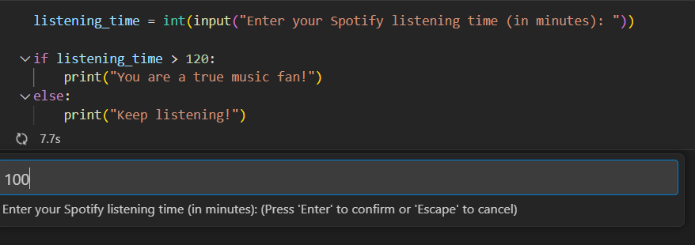  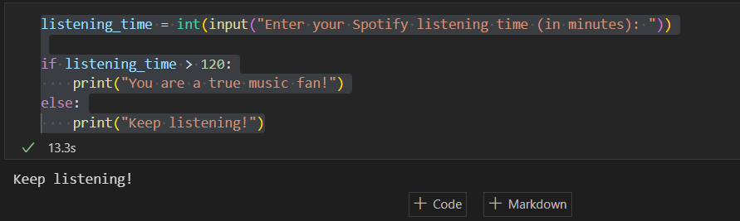

Q2 | Create a Python program that asks the user to enter their Zomato order amount and checks if it is above 300; if yes, print 'Eligible for free delivery', else print 'Delivery charges apply'.
Code | order_amount = float(input("Enter your Zomato order amount: "))  if order_amount > 300:  print("Eligible for free delivery")  else:  print("Delivery charges apply")
Output | 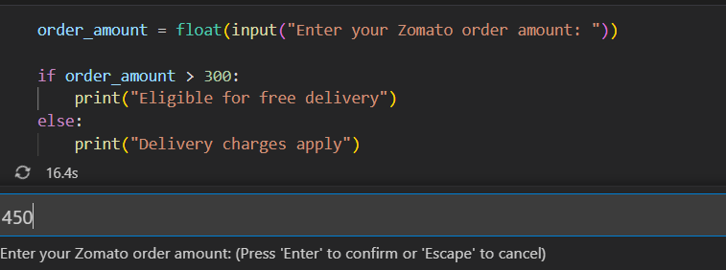  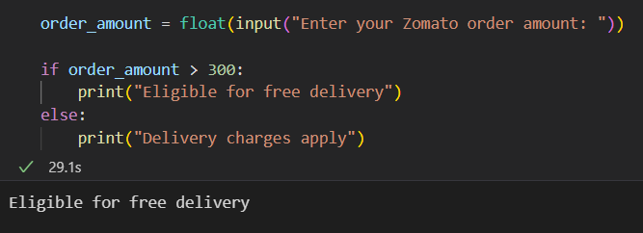

Q3 | Build a Python script that takes your Flipkart cart total and applies the following logic: if total > 2000, print 'You get a 10% discount'; elif total > 1000, print 'You get a 5% discount'; else print 'No discount available'.
Code | cart_total = float(input("Enter your Flipkart cart total: "))  if cart_total > 2000:  print("You get a 10% discount")  elif cart_total > 1000:  print("You get a 5% discount")  else:  print("No discount available")
Output | 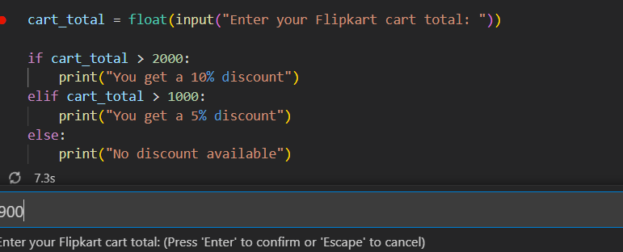  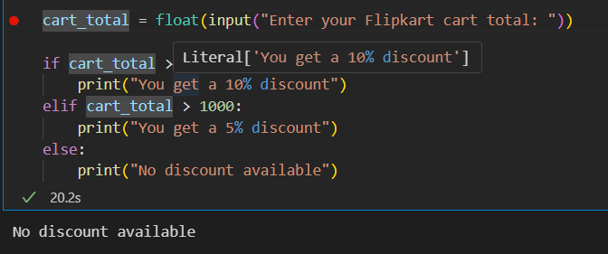

Q4 | Write a Python program that asks the user to enter their IPL fantasy team points and uses nested if-else statements to print: 'Champion' if points > 800, 'Top Performer' if points between 500 and 800, 'Keep Trying' otherwise.<br><br><em><strong>Hint:</strong> Use nested if-else blocks to check the ranges.</em>
Code | points = int(input("Enter your IPL fantasy team points: "))  if points > 500:  if points > 800:  print("Champion")  else:  print("Top Performer")  else:  print("Keep Trying")
Output | 