Q1 | Create a Python script that uses a for loop to print the names of 5 favorite food delivery apps (e.g., Zomato, Swiggy, etc.), one per line.
Code | food_delivery_apps = ["Zomato", "Swiggy", "Uber Eats", "Domino's", "Pizza Hut"]  for app in food_delivery_apps:  print(app)
Output | 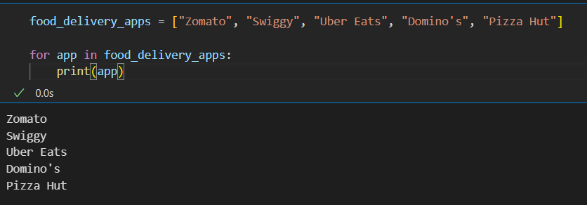

Q2 | Given a list of daily step counts for a week, use a while loop to find and print the first day when you crossed 10,000 steps.<br><br><em><strong>Hint:</strong> Loop through the list and stop as soon as you find a value greater than 10,000.</em>
Code | steps = [6500, 8200, 9800, 10500, 12000, 9500, 11000]  day = 0  while day < len(steps):  if steps[day] > 10000:  print("First day crossing 10,000 steps: Day", day + 1)  print("Steps:", steps[day])  break  day += 1
Output | 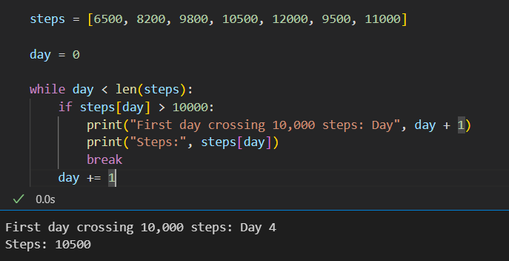

Q3 | Write a Python function that takes a list of IPL team names and prints only those teams whose names are longer than 6 characters, skipping the rest using the continue statement.
Code | def print_long_team_names(teams):  for team in teams:  if len(team) <= 6:  continue  print(team)  ipl_teams = [  "CSK",  "MI",  "RCB",  "KKR",  "Sunrisers",  "Rajasthan",  "Punjab",  "Lucknow",  "Gujarat"  ]  print_long_team_names(ipl_teams)
Output | 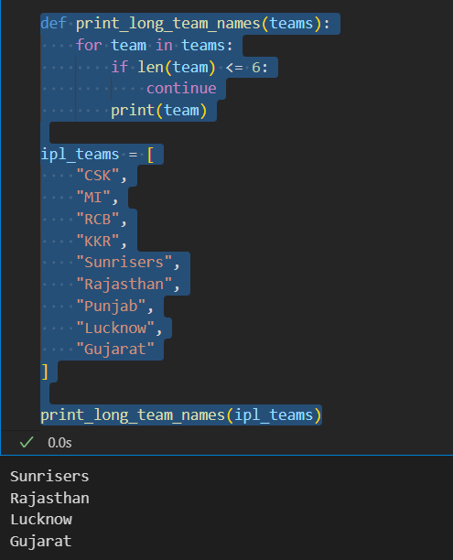

Q4 | You have a list of song durations (in seconds) from your Spotify playlist. Use a for loop with enumerate to print each song's position (starting from 1) and its duration in the format: 'Song 1: 210 seconds'.
Code | song_durations = [210, 185, 240, 195, 220]  for index, duration in enumerate(song_durations, start=1):  print(f"Song {index}: {duration} seconds")
Output | 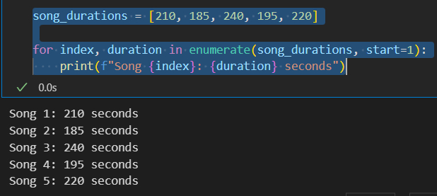

Q5 | Build a simple shopping cart total calculator: Given a list of item prices from a Flipkart cart, use a loop to sum the prices. If an item price is 0 (out of stock), skip it. Stop adding items if the running total crosses ₹2000 using break, and print the final total.<br><br><em><strong>Constraint:</strong> Use both break and continue in your solution.</em>
Code | cart_prices = [500, 700, 0, 900, 300, 400]  total = 0  for price in cart_prices:  if price == 0:  continue  total += price  if total > 2000:  break  print("Final Total: ₹", total)
Output | 