Q1 | Define a function called calculate_final_price(price, discount_rate) that returns the final price after applying the discount rate to the given price.
Code | def calculate_final_price(price, discount_rate):  final_price = price - (price * discount_rate / 100)  return final_price  print(calculate_final_price(1000, 20))
Output | 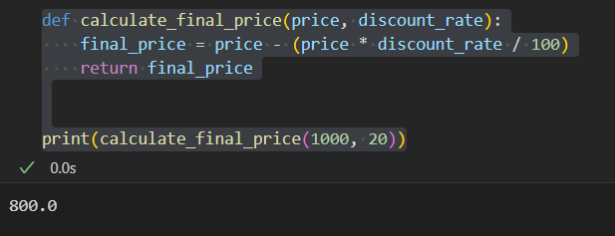

Q2 | Create a function called get_delivery_charge(amount, city='Ahmedabad') that returns 0 if city is 'Ahmedabad', otherwise returns 50 as a delivery charge.<br><br><em><strong>Hint:</strong> Use a default argument for the city parameter.</em>
Code | def get_delivery_charge(amount, city="Ahmedabad"):  if city == "Ahmedabad":  return 0  else:  return 50  print(get_delivery_charge(500))  print(get_delivery_charge(500, "Surat"))
Output | 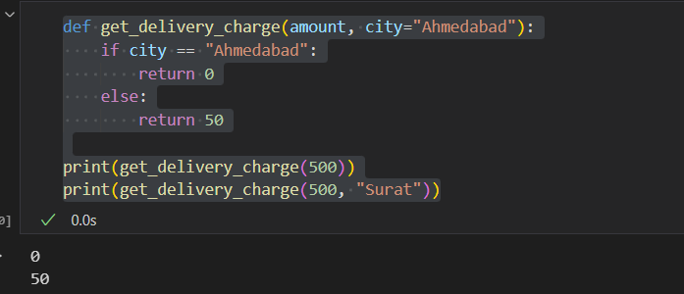

Q3 | Write a function called format_price(price, currency='INR') that returns a string like '₹500' if currency is 'INR', or '$500' if currency is 'USD'.
Code | def format_price(price, currency="INR"):  if currency == "INR":  return f"₹{price}"  elif currency == "USD":  return f"${price}"  print(format_price(500))  print(format_price(500, "USD"))
Output | 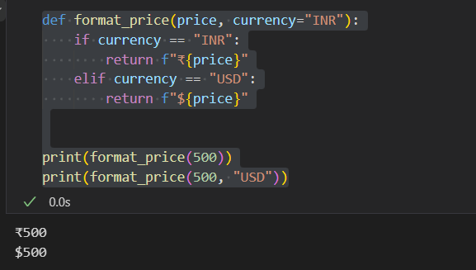

Q4 | Build a function called apply_coupon(price, coupon_code=None) that returns the price after a 10% discount if coupon_code is 'ZOMATO10', otherwise returns the original price.<br><br><em><strong>Constraint:</strong> Use a default argument for coupon_code.</em>
Code | def apply_coupon(price, coupon_code=None):  if coupon_code == "ZOMATO10":  return price - (price * 10 / 100)  else:  return price  print(apply_coupon(1000, "ZOMATO10"))  print(apply_coupon(1000))
Output | 