Q1 | Fetch the latest 24-hour price and volume data for at least 10 popular cryptocurrencies using the Binance API and save the raw JSON response to a file named crypto_data.json.
Code | import requests  import json  url = "https://api.binance.com/api/v3/ticker/24hr"  try:  response = requests.get(url)  response.raise_for_status()  data = response.json()  top_10 = data[:10]  with open("crypto_data.json", "w") as file:  json.dump(top_10, file, indent=4)  print("Data saved successfully in crypto_data.json")  except requests.exceptions.RequestException as e:  print("Error:", e)
Output | 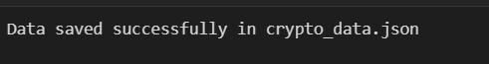

Q2 | Write a Python function find_most_volatile_coin(data) that takes the loaded Binance coin data and returns the symbol of the coin with the highest percentage price change in the last 24 hours.
Code | import json  def find_most_volatile_coin(data):  highest = max(data, key=lambda coin: abs(float(coin["priceChangePercent"])))  return highest["symbol"]  with open("crypto_data.json", "r") as file:  data = json.load(file)  coin = find_most_volatile_coin(data)  print("Most Volatile Coin:", coin)
Output | 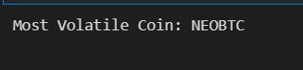

Q3 | Create a script that calculates the average price of all coins in your crypto_data.json, then prints a list of all coins currently trading below this average price.
Code | import json  with open("crypto_data.json", "r") as file:  data = json.load(file)  prices = [float(coin["lastPrice"]) for coin in data]  average_price = sum(prices) / len(prices)  print("Average Price:", round(average_price, 2))  print("\nCoins Below Average Price")  for coin in data:  if float(coin["lastPrice"]) < average_price:  print(coin["symbol"], ":", coin["lastPrice"])
Output | 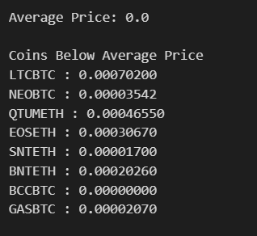

Q4 | Build a function rank_coins_by_volume(data) that sorts all coins by their total traded volume in descending order and prints the top 5 coins with their rank and volume.
Code | import json  def rank_coins_by_volume(data):  sorted_data = sorted(  data,  key=lambda coin: float(coin["volume"]),  reverse=True  )  print("Top 5 Coins by Trading Volume\n")  for i, coin in enumerate(sorted_data[:5], start=1):  print(f"{i}. {coin['symbol']} - Volume: {coin['volume']}")  with open("crypto_data.json", "r") as file:  data = json.load(file)  rank_coins_by_volume(data)
Output | 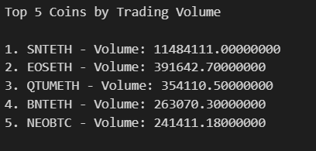

Q5 | Automate your data fetch and analysis by scheduling your script to run every hour using the schedule Python library, and add error handling to gracefully manage Binance API rate limits.<br><br><em><strong>Hint:</strong> Catch HTTP 429 errors and implement a retry with exponential backoff.</em>
Code | import requests  import schedule  import time  import json  url = "https://api.binance.com/api/v3/ticker/24hr"  def fetch_crypto_data():  retry = 0  while retry < 5:  try:  response = requests.get(url)  if response.status_code == 429:  wait = 2 ** retry  print(f"Rate limit reached. Retrying in {wait} seconds...")  time.sleep(wait)  retry += 1  continue  response.raise_for_status()  data = response.json()  with open("crypto_data.json", "w") as file:  json.dump(data[:10], file, indent=4)  print("=" * 40)  print("Data updated successfully.")  print("Top 10 cryptocurrency data saved.")  print("=" * 40)  return  except requests.exceptions.ConnectionError:  print("Error: No internet connection.")  return  except requests.exceptions.Timeout:  print("Error: Request timed out.")  return  except requests.exceptions.RequestException as e:  print("Error:", e)  return  schedule.every(10).seconds.do(fetch_crypto_data)  print("Scheduler Started...")  print("Fetching data every 10 seconds...\n")  fetch_crypto_data()  while True:  schedule.run_pending()  time.sleep(1)
Output | Success  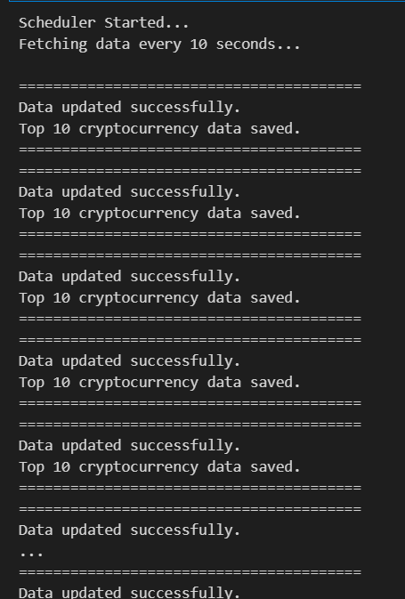  Error:  