
SARVA GYANA KOSHAH BOOKS
The Treasury of All Knowledge
Python for Absolute Beginners
Build a Study Assistant from Your First Line of Code
The First Code Series · Book 1
Akshat Sinha
First Edition · 2026

Python for Absolute Beginners
© 2026 by Akshat Sinha. All rights reserved.
Published by Sarva Gyana Koshah Books, a division of The Sinha Family Group.
No part of this publication may be reproduced, distributed, or transmitted in any form or by any means, including photocopying, recording, or other electronic or mechanical methods, without the prior written permission of the publisher, except for brief quotations in reviews.
Code examples are provided for learning. Test and review code before using it in an important system.
To my parents and grandparents, whose love, patience, and unwavering belief made this journey possible. Everything I build carries your blessings. This first book is for you.

Acknowledgements
My deepest gratitude to my parents and grandparents, my first teachers, for their endless encouragement.
To every reader of Sarva Gyana Koshah: your curiosity is the reason these pages exist.

Contents

In Microsoft Word, right-click this list and choose Update Field if page numbers are not visible.

Preface: Why Was Python Needed?
ARCHITECTURAL BLUEPRINT
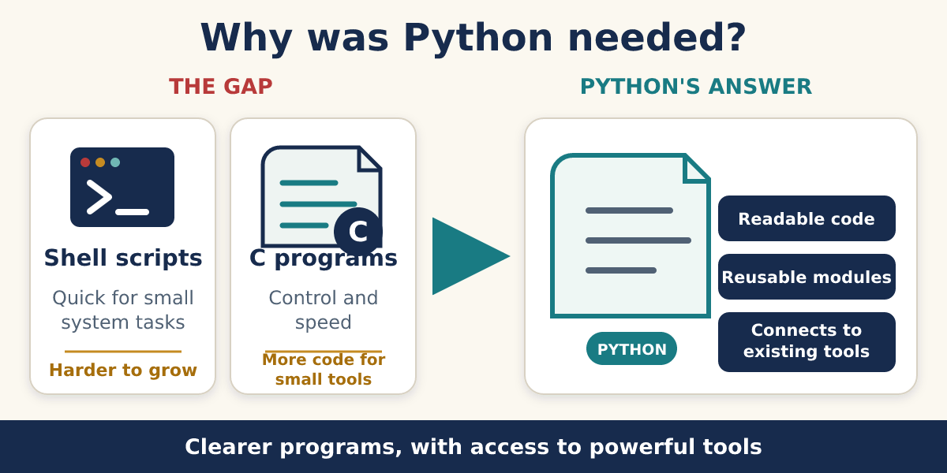
Python offered a practical middle path between quick scripts and larger systems programs.
Python was created to solve a real problem. Programmers wanted to build useful tools without writing a large, difficult program for every small job.
The missing middle path
One option was a quick shell script. It was handy, but some jobs were too large for it.
Another option was a C program. It offered more control, but even a small tool could need much more code.
Guido van Rossum began Python as a clearer path between those choices.

What made the idea useful?
Python code was designed to be readable. It could also connect to existing programs and tools. This meant we could write the simple parts clearly without throwing away powerful work already built elsewhere.
Easy to begin does not mean weak
We can use Python for a five-line file sorter. Teams also use it for websites, data tools, science and AI.
Python is not best for every job. No language is. It is a strong first language because its code leaves more room to see the programming idea.
ARCHITECTURAL BLUEPRINT
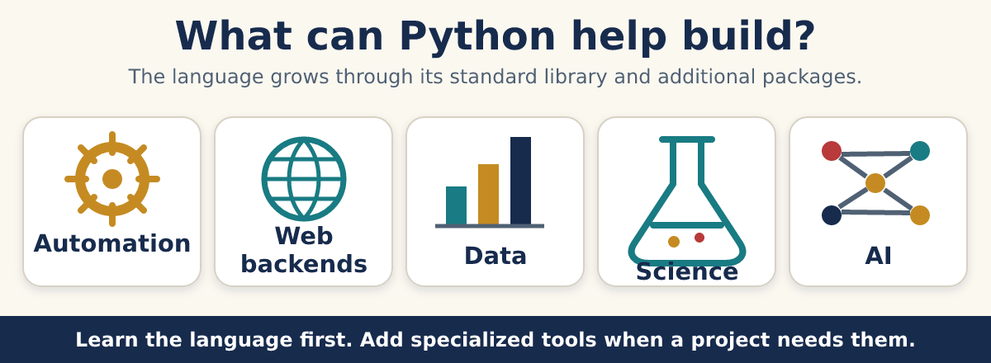
Python starts as a language and gains specialized capabilities through libraries and packages.

Why learn when AI can write code?
AI can suggest code. It cannot remove our need to judge the result. We still need to ask: What should happen? What actually happened? Is the answer safe and correct?

Key takeaways
REMEMBER
- Python was built to make useful programs easier to write and read.
- It can connect simple Python code to powerful existing tools.
- Friendly syntax helps us focus on the idea.
- We will learn by guessing, running and checking.

Keep exploring
Python’s own story: why it was created : https://docs.python.org/3/faq/general.html
Python essay: connecting software pieces : https://www.python.org/doc/essays/omg-darpa-mcc-position/

Chapter 1: Make Python Run
Start with a saved file, display an exact response and follow the route from source code to screen.
LEARNING ARC · Create an Interactive Terminal Assistant
Build one assistant across five connected chapters Step 1 of 5
Our local assistant will greet a learner, understand simple commands, remember useful information and keep running until the learner exits. It follows rules we write. It does not use AI yet.
Starting tools: The Quick Start proved that a saved Python file can run. • The terminal can show program output.
What this arc will unlock: Display the assistant title. • Represent and organize information. • Choose command routes. • Collect and validate input. • Save useful local data.
ARCHITECTURAL BLUEPRINT
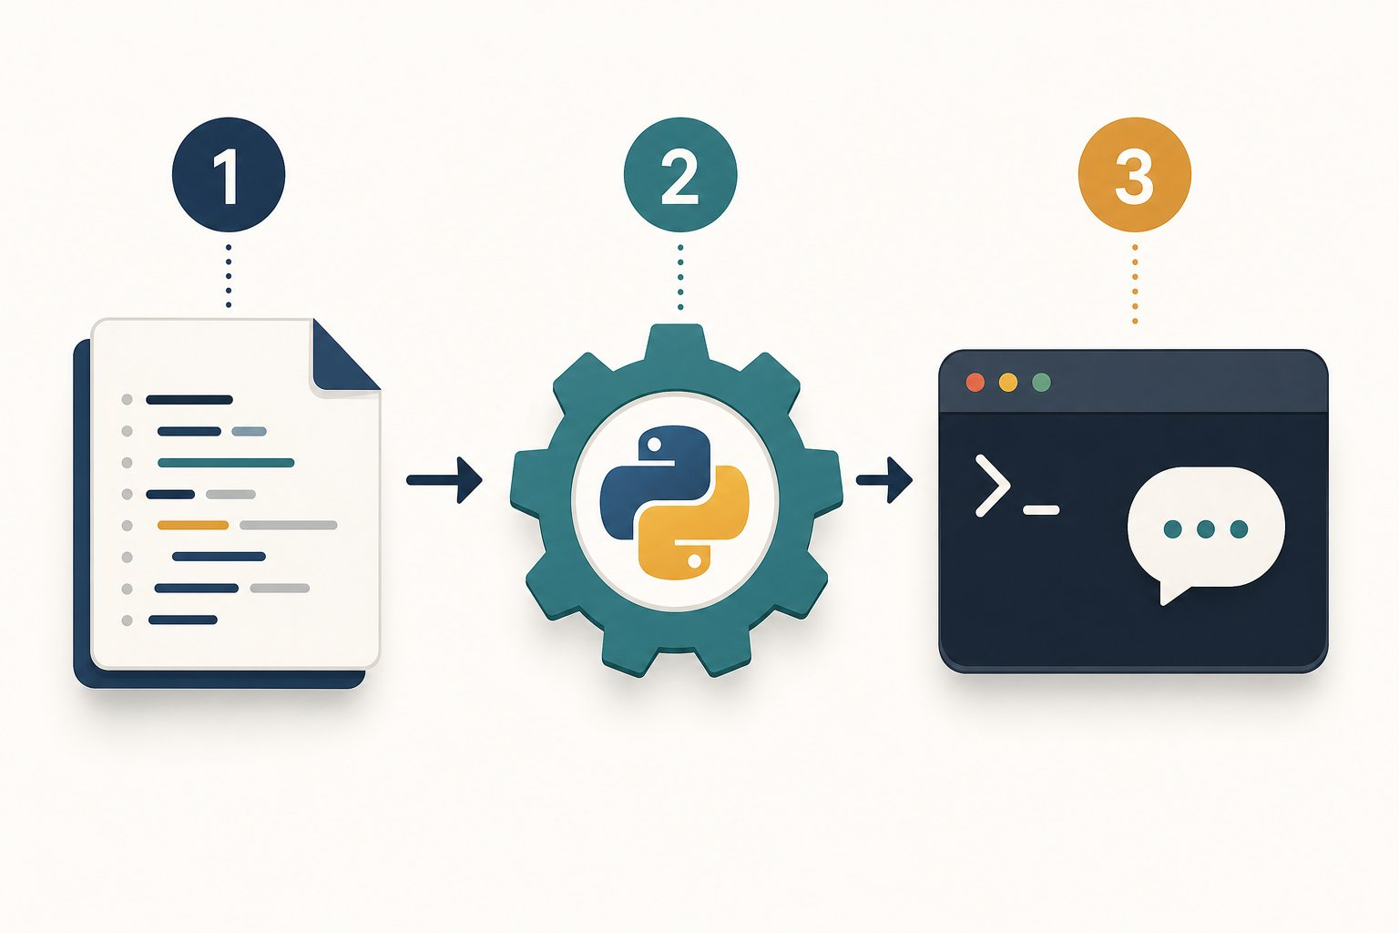
One instruction travels from our file to the screen.
1 We save the instruction in hello.py.
2 Python reads the file and performs the instruction.
3 The terminal receives and displays the result.
PAUSE & THINK
If the word Hello appears in our code, how will Python know it is text and not the name of something?
Answer: We wrap the characters in quotes. Quotes turn Hello into a string, a piece of text.

Step 1: What is a program?
A program is a saved set of instructions. Source code is the text we write to express those instructions. Python is the language whose rules both we and the Python runtime agree to follow.
Precise like a recipe, active like a remote control
A recipe describes actions. It does nothing until someone follows it. Source code is similar: the file stores instructions, and the Python runtime performs them.
Unlike a person, Python does not quietly repair a missing quote or guess a misspelled action. That strictness helps every reader get the same result.

Step 2: Meet every character
print is a built-in function, a ready-made action supplied by Python. The round brackets call that action. The quotes mark text. The exclamation mark and comma inside the quotes are ordinary characters, so Python displays them too.
ARCHITECTURAL BLUEPRINT
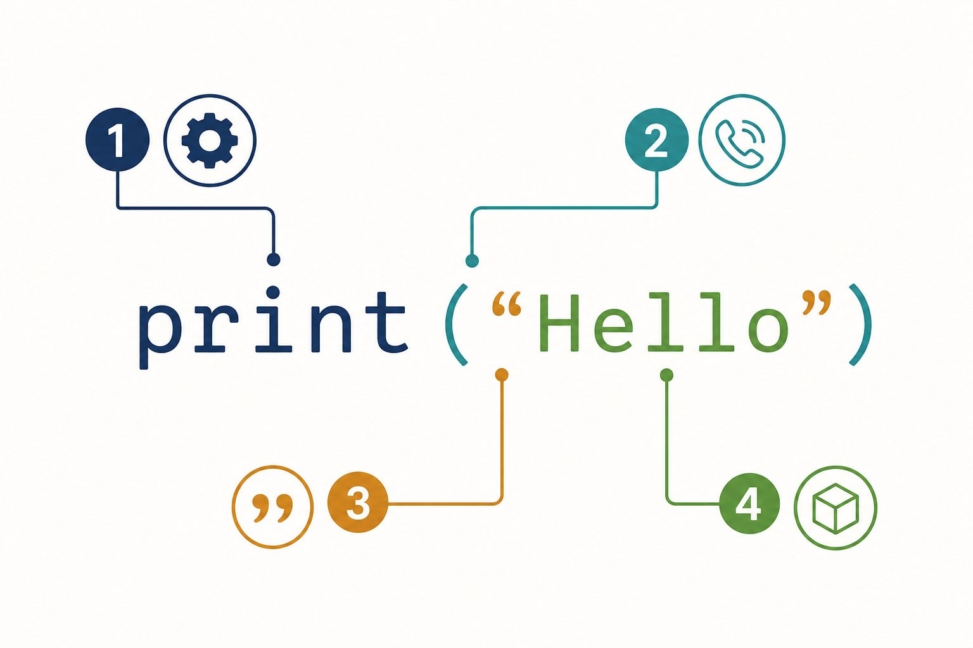
One short line contains four different jobs.
1 print names the ready-made action.
2 The round brackets call that action.
3 The quotes mark where the text begins and ends.
4 Hello is the value given to print().

Step 3: Plan before we type

Plan before we type
PROGRAM BLUEPRINT
Purpose: Prove that Python can run our instruction and show a greeting.
Input: The string "Hello, World!" written inside the program.
Processing: Call print() with that string.
Output: The exact characters Hello, World!
Files: hello.py

Step 4: Write the code

The code
hello.py
1 print("Hello, World!")
MAKE A GUESS
Before we run it: what will appear?
prediction.py
1 print("Hello, World!")
- A. The quote marks and the message
- B. Hello, World! without quote marks
- C. The word print
Answer: Hello, World! without quote marks. Quotes describe the string. They are not part of the string, so print() does not display them.

Step 5: Watch one complete run
The visualizer below tells the whole runtime story once. At the final step, print() writes the message to standard output, often shortened to stdout. Our terminal is connected to that stream, so the message appears on the screen.

Program run: every step
hello.py
1 print("Hello, World!")
1. The command starts Python
The operating system launches the Python runtime and gives it the path to hello.py.
2. Python opens our source file
Python reads the saved characters. Nothing is visible in the console yet.
3. Python checks the instruction (line 1)
The name print, both brackets and both quotes follow Python’s syntax rules.
4. Python creates the string value (line 1)
The characters inside the quotes become one text value.
Memory: value = "Hello, World!"
5. Python calls print() (line 1)
The string is passed to the built-in print function.
Memory: value = "Hello, World!"
6. The console receives the result (line 1)
print() writes the characters to stdout and then starts a new line.
Console: Hello, World!

Expected output
Terminal
1 $ python hello.py
2 Hello, World!
THE AHA MOMENT
We did not ask the computer to understand a greeting. We gave Python one exact value and one exact action, and a visible result came back.

Step 6: Make it yours

Try it yourself
- Create a file named hello.py.
- Type the instruction instead of pasting it.
- Save the file, then run python hello.py.
- Change only the text inside the quotes.
- Add a second print() line and predict the order of the output before running it.

Step 7: Learn from the mistakes
BUG HUNT
Which line asks for an action Python does not know?
bug_hunt.py
1 print("Ready!")
2 Print("Go!")
Answer: line 2. Python names are case-sensitive. Print and print are different names.

Common mistakes and fixes
✗ print(Hello)
Without quotes, Python searches for a name called Hello.
✗ Print("Hello")
The built-in function uses a lowercase p.
✗ print("Hello"
The function call is missing its closing bracket.
✗ python hello
The command should include the file name hello.py.

Check your understanding
1. What makes Hello, World! a string?
Answer: The opening and closing quotes mark it as text.
2. What do the brackets do in print(...)?
Answer: They call the function and hold the value we pass to it.
3. What is stdout?
Answer: The standard output stream. A terminal normally shows it on screen.

Key takeaways
REMEMBER
- Source code stores instructions in a form people can read.
- A string is text marked by quotes.
- print() sends a value to standard output.
- Python follows spelling, case, quotes and brackets exactly.
- Predicting before running turns every example into an experiment.

Keep exploring
Python tutorial: using Python as a calculator : https://docs.python.org/3/tutorial/introduction.html
Python print() reference : https://docs.python.org/3/library/functions.html#print

Look behind the Run button
The program already works. Now follow the same print("Hello, World!") instruction from the saved file to visible output. This is one deeper look, not a second explanation of print().
ARCHITECTURAL BLUEPRINT
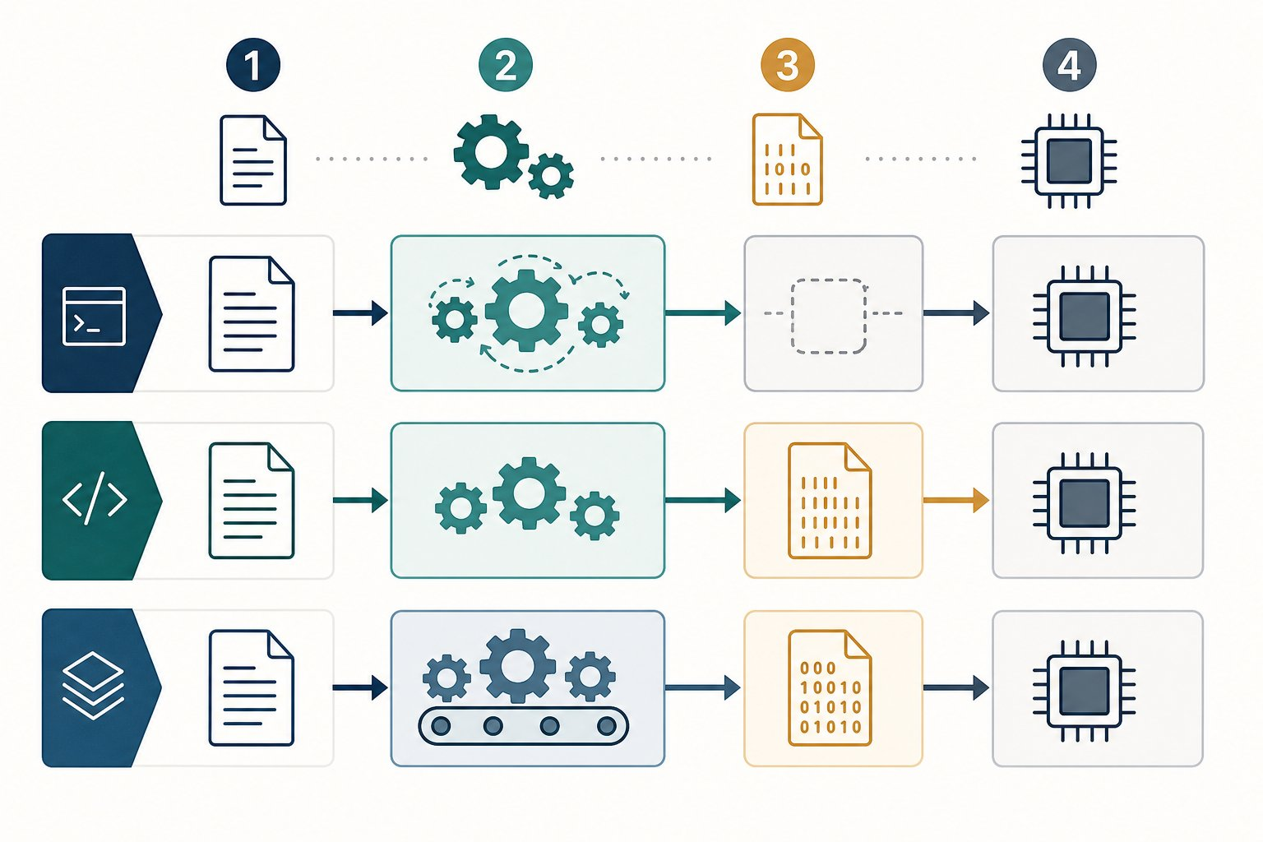
Different routes solve the same translation problem.
1 A person writes a source file.
2 A language tool prepares the instructions.
3 The processor performs machine work.
4 The program produces a result we can see.
PAUSE & THINK
Does the processor understand the word print?
Answer: No. Python is written for people. A language program helps turn our instruction into work the computer can perform.

First, keep one simple picture in your head

Input → Process → Output
Our file  instructions we can read | Language helper  prepares and runs them | Computer result  Hello appears
That middle helper is not identical for every language. The details change, but the reason stays the same: human-friendly code must become machine work.
ARCHITECTURAL BLUEPRINT
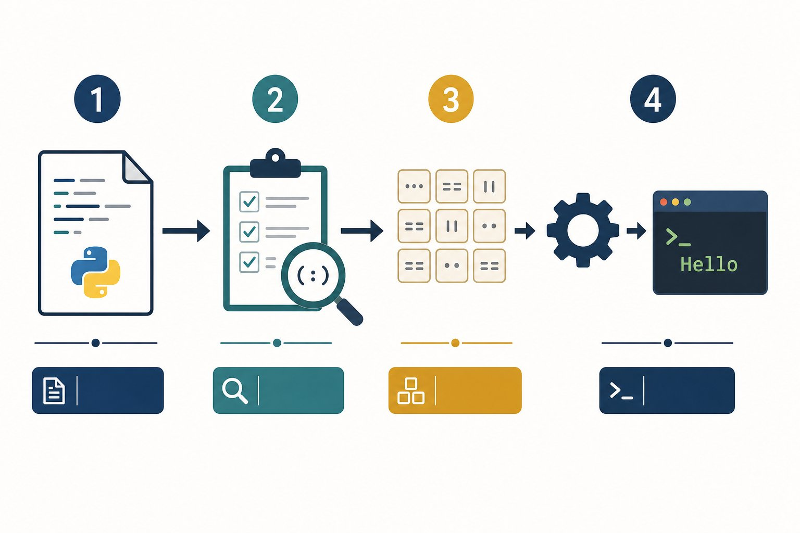
Python handles the hidden middle steps for us.
1 Start with the source file we wrote.
2 Python checks whether the code follows its rules.
3 Python prepares smaller instructions called bytecode.
4 The Python runtime follows them and Hello reaches the terminal.
The note and the musician
Sheet music is useful to a musician, but a piano does not read the paper by itself. The musician reads the notes and presses the keys.
Our source file is like the sheet music. A language tool reads it. The processor performs the final operations.

Now compare three routes, one at a time
Every route below prints Hello. Select a tab. Read only the four numbered cards from left to right. The small box answers one question: what do we have at this step?

Compare the routes

🐍 Python
Python stays with us while the program runs.
1  📝 | We write  What we have now: message.py  The file contains two Python instructions.  message = "Hello"  print(message)
2  🔍 | Python reads  What we have now: checked instructions  Python checks the words, quotes and brackets.  Does the code follow Python rules?
3  ⚙️ | Python runs  What we have now: a running Python program  Python performs the instructions in order.  python message.py
4  🖥️ | We see  What we have now: Hello  The message reaches the terminal.  Hello

🔧 C
C usually builds a runnable app before we open it.
1  📝 | We write  What we have now: message.c  The file contains C instructions.  printf("Hello\n");
2  🏗️ | A compiler builds  What we have now: prepared machine pieces  A compiler translates the C code.  compiler = translator
3  🔗 | A linker joins  What we have now: a runnable app  A linker joins the pieces the program needs.  linker = piece joiner
4  🖥️ | We run  What we have now: Hello  The computer opens the built app.  Hello

☕ Java
Java builds a travel-friendly file, then a Java helper runs it.
1  📝 | We write  What we have now: Message.java  The file contains Java instructions.  println("Hello");
2  📦 | Java builds  What we have now: Message.class  The Java compiler creates a class file.  javac Message.java
3  ⚙️ | The JVM runs  What we have now: a running Java program  The Java Virtual Machine, or JVM, reads the class file.  java Message
4  🖥️ | We see  What we have now: Hello  The message reaches the screen.  Hello
THE AHA MOMENT
Our code does not jump straight into the processor. A language tool helps it cross the gap.

The new words, in plain English
Four labels worth recognising
A compiler is a translator that prepares code. A linker is a joiner that connects prepared pieces.
Bytecode is a simpler instruction format for a language helper. A virtual machine is a program that runs those instructions. JVM means Java Virtual Machine.
You do not need to memorise these words today. Return to the route pictures whenever you meet them again.

Show me: how does source code become bytecode actions?
Read each source line, then travel downward through the smaller CPython actions it creates. The state note shows what changed after that action.
BYTECODE ACTIONS · CPython 3.14 learning map
SOURCE 1: message = "Hello"
1. LOAD_CONST: Pick up the fixed value "Hello".
State: Value stack: ["Hello"]
2. STORE_NAME: Connect that value to the name message.
State: Names: message → "Hello"
SOURCE 2: print(message)
1. LOAD_NAME print: Find the built-in print function.
State: Ready action: print
2. LOAD_NAME message: Find the value connected to message.
State: Argument: "Hello"
3. CALL 1: Call print with one argument.
State: Visible output: Hello
4. POP_TOP: Discard the None value returned by print.
State: The temporary result is no longer needed.
SOURCE 3: end of message.py
1. RETURN_CONST None: Finish running this code object.
State: The script has ended.
Try it: python -m dis message.py
This is bytecode for the Python runtime, not machine code for the processor.
Why might your list look different?
Bytecode is a CPython implementation detail. Instructions can be added, removed or renamed between Python versions.
Your output may include helper actions such as RESUME or PUSH_NULL. Follow the source line and action words instead of memorising every opcode.

Show me: what is inside a Java .class file?
A .class file contains Java bytecode. It is binary, so opening it in a text editor looks like noise. The javap tool can show a readable view:

Expected output
Terminal
1 $ javap -c Message
2 getstatic System.out
3 ldc "Hello"
4 invokevirtual println
5 return
The same idea in a different travel case
ldc loads the text "Hello". invokevirtual println asks Java to print it. The JVM reads these class-file instructions.
Python bytecode and Java bytecode are not the same language. They share one useful idea: a runtime can follow smaller instructions prepared from source code.

Expected output
Terminal
1 $ python message.py
2 Hello

Try it yourself
- Create message.py.
- Type the two lines above.
- Before running it, point to the Python route and say what each card means.
- Run python message.py.
- Change Hello to your name and run it again.
MAKE A GUESS
Which helper joins prepared C pieces into one runnable program?
- A. The print function
- B. The linker
- C. The terminal
Answer: The linker. A linker joins the pieces needed by the final program.
BUG HUNT
Which sentence is incorrect?
bug_hunt.py
1 People can read Python source code.
2 A processor directly understands Python words.
3 Python helps perform our instructions.
Answer: line 2. A processor works with machine instructions. Python and lower-level tools bridge the gap.

Common mistakes and fixes
✗ Python is the processor
Python is a program running on the computer. It is not the hardware.
✗ Compiler means error checker only
A compiler can check code and translate it into another form.
✗ Different route means different result
These three routes can still produce the same visible Hello.

Check your understanding
1. Why do we need a language helper?
Answer: The processor does not directly understand our human-friendly source code.
2. What does a compiler do in our simple picture?
Answer: It translates source code into another form.
3. What does a linker do?
Answer: It joins prepared pieces into a runnable program.
4. What does JVM mean?
Answer: Java Virtual Machine, the program that runs Java class files.

Key takeaways
REMEMBER
- We write source code for people.
- A language tool bridges our code and the processor.
- Python stays involved while a Python program runs.
- C usually builds a runnable program first.
- Java builds a class file for a Java Virtual Machine.
- Understanding the job matters more than memorising the label.

Keep exploring
Python FAQ: a short description of Python : https://docs.python.org/3/faq/general.html#what-is-python
Python bytecode tool, save this for later : https://docs.python.org/3/library/dis.html
GCC build stages, reference for later : https://gcc.gnu.org/onlinedocs/gcc/Overall-Options.html

Assistant build step

The code
assistant.py
1 print("STUDY ASSISTANT")
2 print("Type help to see a command.")

Expected output
Terminal
1 $ python assistant.py
2 STUDY ASSISTANT
3 Type help to see a command.
SKILL TRIAL · Python Launcher · Launch without the training wheels
Create a new saved file and make its exact output appear without copying the chapter program.
- Create launch.py in the project folder.
- Display an assistant title and one instruction.
- Predict the two output lines before running.
- Run the saved file and repair any case, quote or parenthesis error.
Win condition: The terminal output exactly matches your prediction after a fresh run.
Stretch move: Use dis.dis() to inspect the actions for one print() call and identify the call stage.

Check your understanding
1. What is stored in a `.py` file?
Answer: Python source code written as text.
2. Which quoted text becomes output in `print("Ready")`?
Answer: Ready
3. Why does `Print("Hi")` fail?
Answer: Python is case-sensitive. The built-in name is print.
4. Put these in order: screen, Python, saved file.
Answer: Saved file, Python, screen.

Key takeaways
REMEMBER
- A program is a sequence of instructions.
- Python is case-sensitive.
- CPython can compile source to bytecode before its interpreter runs the actions.
RANK EARNED · Python Launcher
You proved that you can:
- Create and run a saved Python file.
- Predict exact terminal output.
- Repair a syntax or capitalization mistake using evidence.
Next target: Give the assistant meaningful values and state.
NEXT DISCOVERY · The assistant needs state
Next, names and values let the assistant remember who is studying and shape a useful status message.

Chapter 2: Work with Values
Represent assistant state, calculate useful values and shape the text a learner sees.
Create an Interactive Terminal Assistant · STEP 2 OF 5
Now: Represent learner state. Add names, number operations, text tools and a formatted status display.
ARCHITECTURAL BLUEPRINT
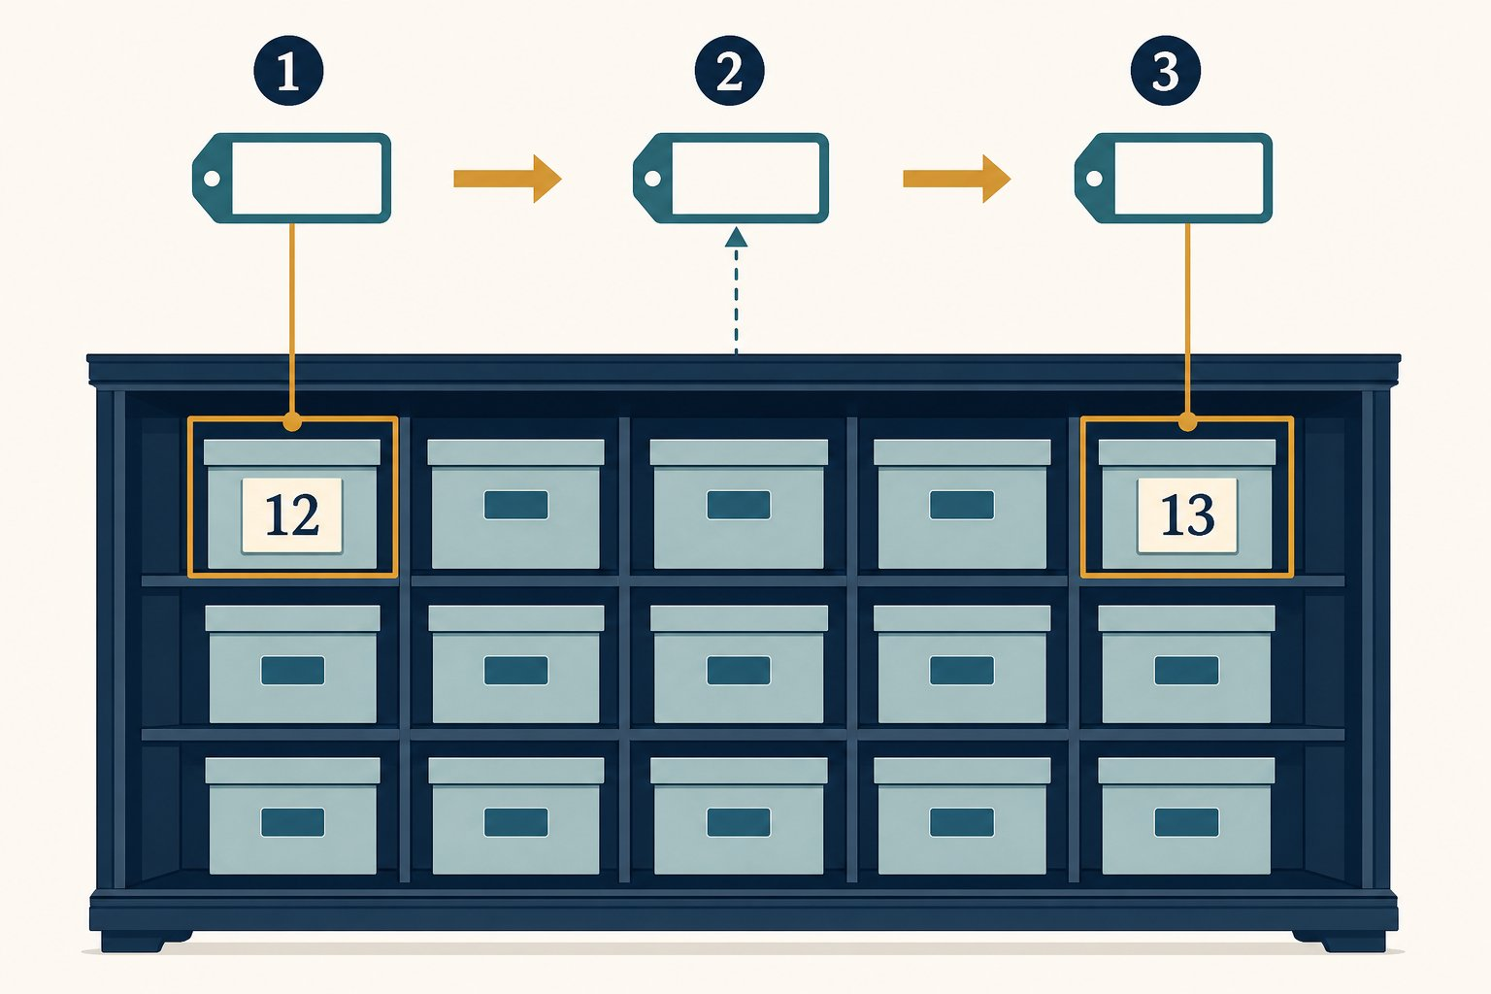
A variable name can refer to a new value.
1 Choose a useful name such as score.
2 Assign the first value to that name.
3 Assign again when the value changes.
PAUSE & THINK
If the score changes, should we edit every old number by hand?
Answer: No. We use one variable name. Later code reads the current value through that name.

Assignment connects a name and a value
A variable is a name that refers to a value. In score = 10, the equals sign means assign. It does not ask a maths question.
A label, not a locked box
Imagine a reusable label named score. First it refers to 10. A later assignment can make the same name refer to 15.
This picture is more accurate than imagining that Python permanently locks one value inside one box. Names and values are separate parts of the story.

Read assignment from right to left
For score = score + 5, Python finishes the right side first. It reads the current value 10. It calculates 10 + 5. Only then does it assign the result 15 back to the name score.
ARCHITECTURAL BLUEPRINT
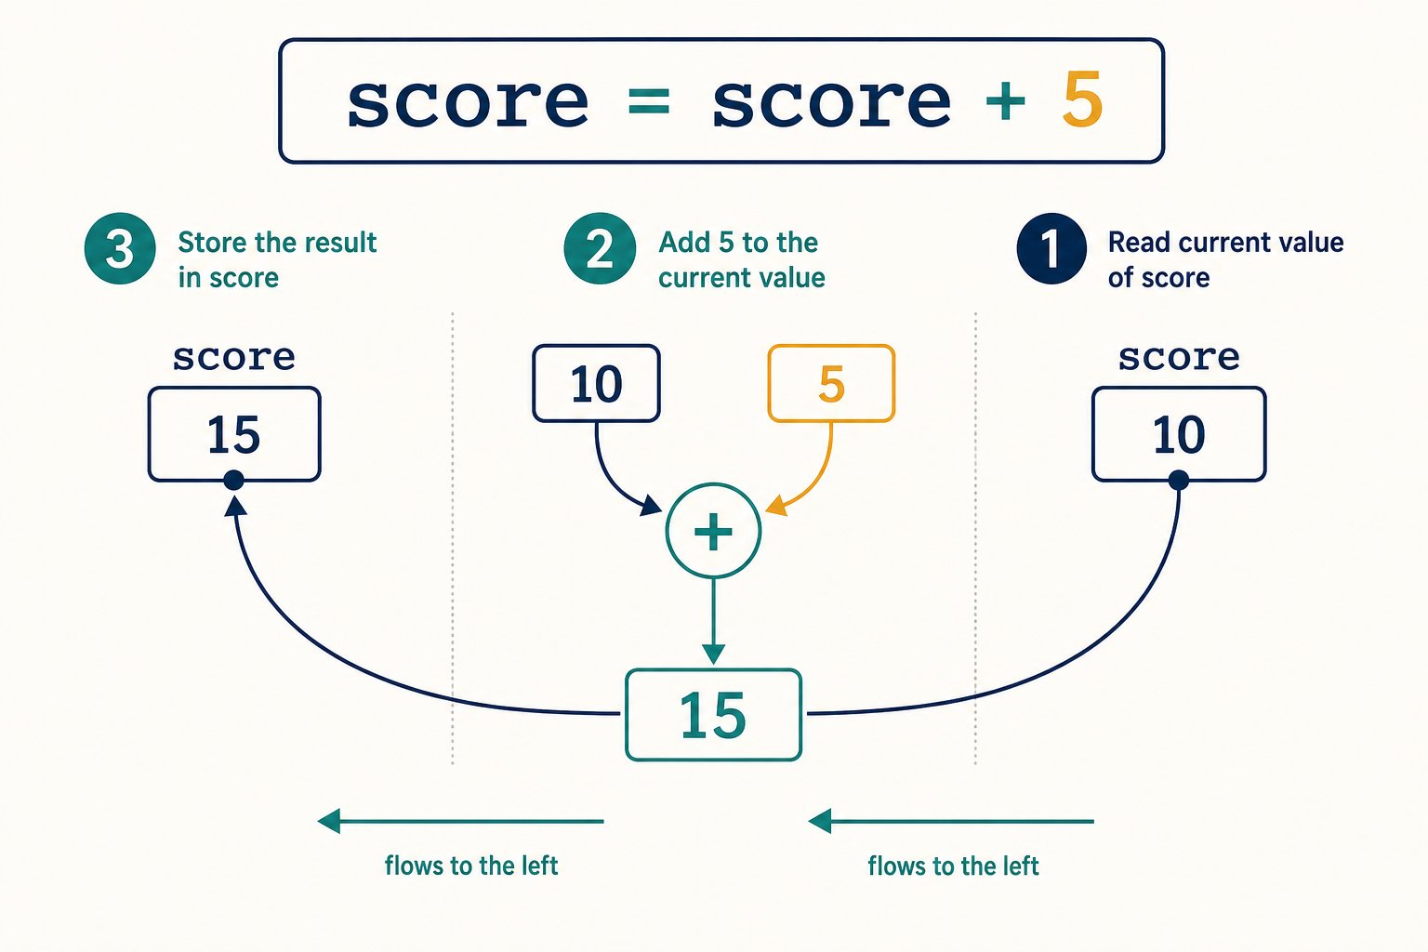
Python finishes the right side before changing the left side.
1 Read the current value of score: 10.
2 Calculate 10 + 5: the result is 15.
3 Assign 15 back to the name score.
Names that help the next reader
A name may use letters, digits and underscores. It cannot begin with a digit. Python treats score and Score as different names.
Choose names that reveal meaning. score helps us more than s, even though both are legal.

Plan before we type
PROGRAM BLUEPRINT
Purpose: Add five to a score.
Input: Starting score: 10.
Processing: Read score, add 5, assign the result back.
Output: 15
Files: score.py

The code
score.py
1 score = 10
2 score = score + 5
3 print(score)

Program run: every step
score.py
1 score = 10
2 score = score + 5
3 print(score)
1. Memory starts empty
No variable names exist yet.
2. Store the first value (line 1)
The name score now refers to the integer 10.
Memory: score = 10
3. Calculate the new value (line 2)
Python reads 10, adds 5 and assigns 15 to score.
Memory: score = 15
4. Read and display score (line 3)
print() receives the current value, which is 15.
Memory: score = 15
Console: 15

Expected output
Terminal
1 $ python score.py
2 15
THE AHA MOMENT
The same variable name can refer to a new value after another assignment.

Try it yourself
- Create score.py.
- Run the example.
- Change the starting score.
- Add another line that subtracts 2.

Common mistakes and fixes
✗ 10 = score
The name belongs on the left side of assignment.
✗ print("score")
Quotes print the word score, not the value stored under that name.
MAKE A GUESS
What is printed?
prediction.py
1 coins = 3
2 coins = coins + 2
3 print(coins)
- A. 2
- B. 3
- C. 5
Answer: 5. Python reads 3, adds 2 and stores 5.
BUG HUNT
Which line uses the wrong variable name?
bug_hunt.py
1 points = 8
2 point = points + 1
3 print(points)
Answer: line 2. Line 2 creates a different name, point. The original points remains 8.

Keep exploring
Python assignment statements : https://docs.python.org/3/reference/simple_stmts.html#assignment-statements
Python identifiers and naming rules : https://docs.python.org/3/reference/lexical_analysis.html#identifiers
PAUSE & THINK
Before looking at the type cards, how would you sort "Asha", 12, 1.52 and True?
Answer: "Asha" is text. 12 is a whole number. 1.52 is a decimal number. True is a truth value. Python names these types str, int, float and bool.
ARCHITECTURAL BLUEPRINT
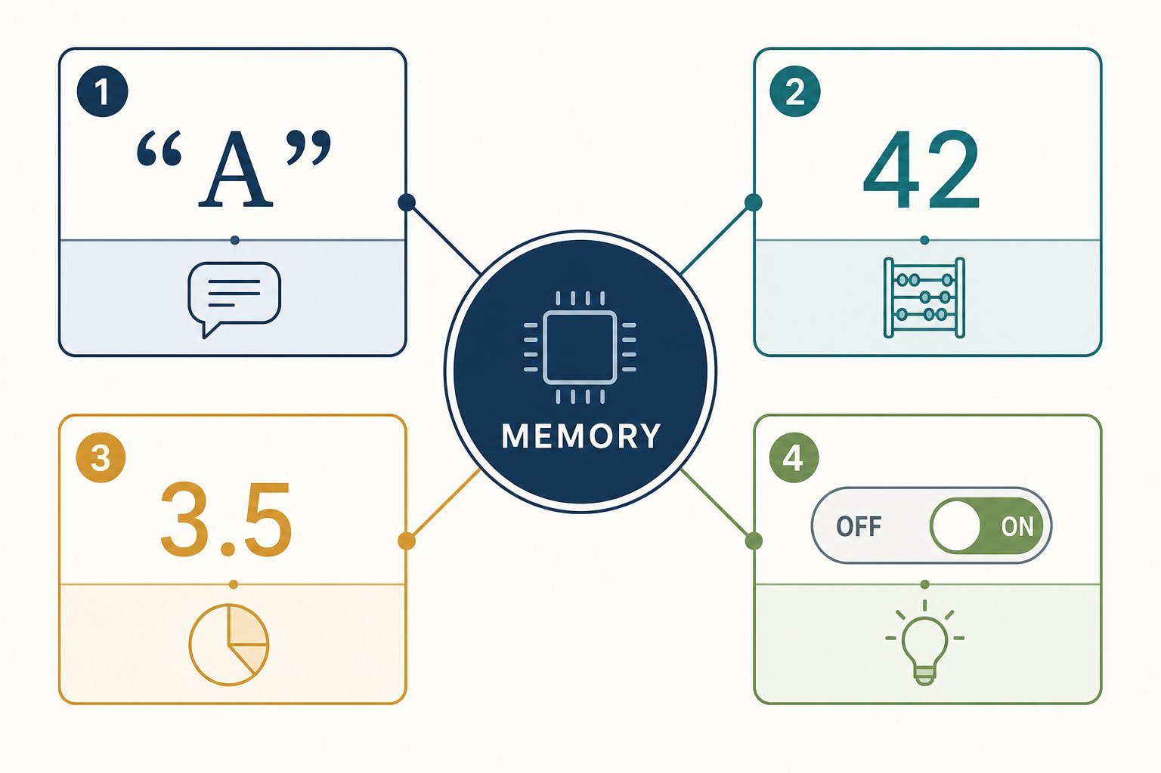
A type tells Python what kind of value it is handling.
1 str stores text.
2 int stores whole numbers.
3 float stores decimal numbers.
4 bool stores True or False.

A type is a value’s category
A data type tells Python what kind of value it has. The type also tells Python which operations make sense.
Four types to begin with
str means string, which is text. int means integer, which is a whole number. float is a number with a decimal point. bool is either True or False.
The type belongs to the value. A variable name can later refer to a value of another type. This is called dynamic typing. Python tracks the type while the program runs.

The same symbol can mean a different operation
For integers, 3 + 4 means number addition and produces 7. For strings, "3" + "4" means joining text and produces "34". Type gives the + symbol enough context to choose the operation.
ARCHITECTURAL BLUEPRINT
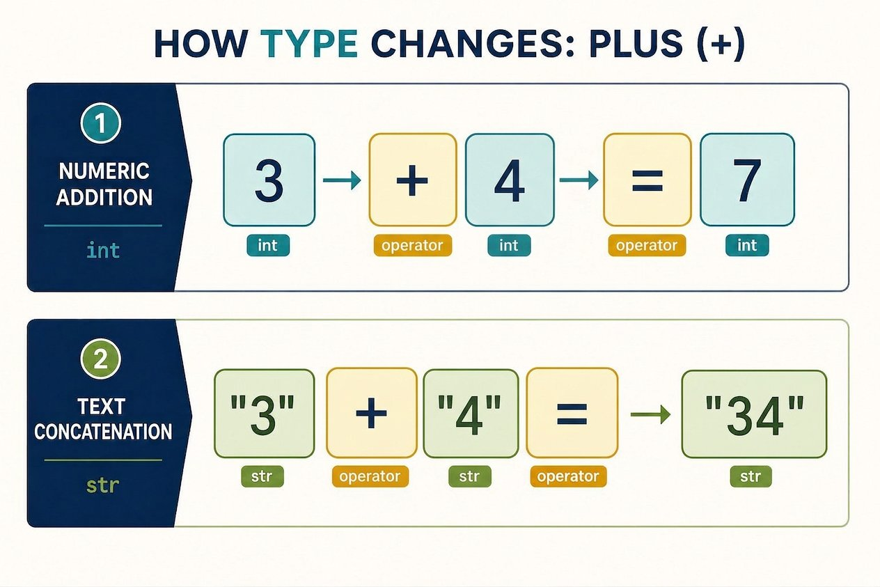
The type changes what the plus sign does.
1 Numbers use + for addition: 3 + 4 becomes 7.
2 Strings use + for joining: "3" + "4" becomes "34".
Type is a safety clue
A label saying “paint” changes how we handle a tin. A type gives Python a similar clue. It prevents unclear requests such as adding the number 1 directly to the text "two".
When types do not match our intention, Python stops with an error instead of silently inventing an answer.

Input → Process → Output
Values  "Asha", 12, 1.52, True | Python  keeps each type | Safe operations  join text, add numbers, test truth

Plan before we type
PROGRAM BLUEPRINT
Purpose: Store a small learner profile.
Input: Text, a whole number, a decimal and a truth value.
Processing: Python stores each value with its type.
Output: The type of name and next year’s age.
Files: types.py

The code
types.py
1 name = "Asha"
2 age = 12
3 height = 1.52
4 is_learning = True
5 print(type(name))
6 print(age + 1)

Program run: every step
types.py
1 name = "Asha"
2 age = 12
3 height = 1.52
4 is_learning = True
5 print(type(name))
6 print(age + 1)
1. Store text (line 1)
Quotes make Asha a string, or str.
Memory: name = "Asha" (str)
2. Store a whole number (line 2)
12 has no quotes and no decimal point, so it is an int.
Memory: name = "Asha" (str), age = 12 (int)
3. Store a decimal (line 3)
1.52 has a decimal point, so it is a float.
Memory: age = 12 (int), height = 1.52 (float)
4. Store truth (line 4)
True is a bool. Its capital T matters.
Memory: height = 1.52 (float), is_learning = True (bool)
5. Inspect a type (line 5)
type(name) reports that name holds a string.
Memory: name = "Asha" (str)
Console: <class 'str'>
6. Add integers (line 6)
age is an int, so Python can add 1 and print 13.
Memory: age = 12 (int)
Console: <class 'str'> | 13

Expected output
Terminal
1 $ python types.py
2 <class 'str'>
3 13
THE AHA MOMENT
A value is more than the characters we see. Its type tells Python what the value means and which operations are allowed.

Convert only when your intention is clear
int("12") creates the integer 12 from numeric text. str(12) creates the string "12" from a number. Conversion is explicit: we tell Python exactly which meaning we want.

Try it yourself
- Create types.py and run it.
- Use type() on age, height and is_learning.
- Try print("12" + "1").
- Then try print(12 + 1) and compare the results.
- Try print(int("12") + 1) and explain why the answer changes.

Common mistakes and fixes
✗ true
Python booleans begin with a capital letter: True and False.
✗ "12" + 1
Python will not mix text and a number automatically. Convert one value first.
✗ height = 1,52
Python decimal numbers use a dot, not a comma.
MAKE A GUESS
What does this print?
prediction.py
1 print("3" + "4")
- A. 7
- B. 34
- C. An error
Answer: 34. Both values are strings. + joins strings, so the result is 34.
BUG HUNT
Which line causes a TypeError?
bug_hunt.py
1 tickets = "2"
2 total = tickets + 1
3 print(total)
Answer: line 2. Line 2 tries to add a string and an integer. Python needs an explicit conversion.

Keep exploring
Python built-in types : https://docs.python.org/3/library/stdtypes.html
PAUSE & THINK
Which two operations could turn 25 into 100?
Answer: One route is 25 * 3, then 75 + 25. The result is 100. Other correct routes are possible.

Meet Python’s seven number operators
An operator is a symbol that tells Python to perform a calculation. Each expression below uses two numbers called operands.

Operator toolkit
Operator | Job | Example | Result
+ | add | 7 + 4 | 11
- | subtract | 7 - 4 | 3
* | multiply | 7 * 4 | 28
/ | true division | 7 / 4 | 1.75
// | floor division | 7 // 4 | 1
% | remainder | 7 % 4 | 3
** | raise to a power | 2 ** 3 | 8
Python symbols are not always textbook symbols
Python uses * for multiplication and ** for powers. A keyboard has both characters.
The / operator returns a floating-point number. For example, 8 / 2 produces 4.0.

One division, three useful questions
PAUSE & THINK
Seven counters are placed in groups of four. How many whole groups fit, and how many counters remain?
Answer: One whole group fits. Three counters remain. Python can report the complete quotient, the number of whole groups or the remainder.
ARCHITECTURAL BLUEPRINT
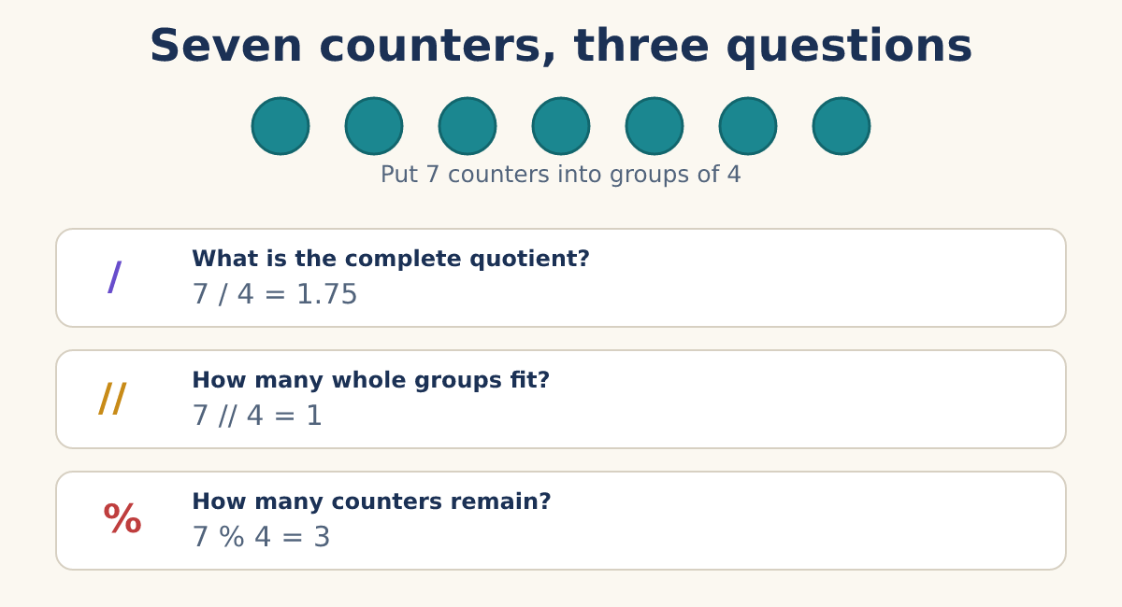
The operators answer different questions about the same seven counters.
WORKED EXAMPLE · Choose the operator that matches the question
Problem: Seven learners form teams of four. Report the exact quotient, complete teams and learners left over.
- Use 7 / 4 for the complete quotient: 1.75.
- Use 7 // 4 for the count of complete teams: 1.
- Use 7 % 4 for the learners left over: 3.
Result: 1.75, 1 and 3 describe different parts of the same grouping.
Floor division has a precise rule
For positive whole numbers, // gives the number of complete groups. More precisely, it rounds the division result down toward negative infinity.
We will practise positive counters here. This keeps our grouping picture simple.

Use the remainder to check even numbers
A positive integer is even when division by 2 leaves no remainder. That makes number % 2 == 0 a useful check. The double equals sign asks whether two values are equal.
WORKED EXAMPLE · Is 24 even?
Problem: Check whether 24 can be split into pairs with nothing left over.
- Calculate 24 % 2.
- The remainder is 0.
- Therefore 24 % 2 == 0 is True.
Result: For this positive-integer check, 24 is even.
MAKE A GUESS
Which expression becomes True?
prediction.py
1 number = 17
- A. number % 2 == 0
- B. number % 2 == 1
- C. number // 2 == 0
Answer: number % 2 == 1. 17 leaves remainder 1 when divided by 2.

Powers mean repeated factors
An exponent tells us how many equal factors to multiply. In 2 ** 3, the base is 2 and the exponent is 3. The expression means 2 * 2 * 2, so its value is 8.
PAUSE & THINK
Is 3 ** 4 the same as 3 * 4?
Answer: No. 3 ** 4 means 3 * 3 * 3 * 3, which is 81. 3 * 4 is 12.

Python follows an order of operations
Python evaluates parentheses first, then powers, then multiplication and division operators, then addition and subtraction. Operators at the same level normally run from left to right. Exponentiation has special right-associative behavior, which we can explore later.
ARCHITECTURAL BLUEPRINT
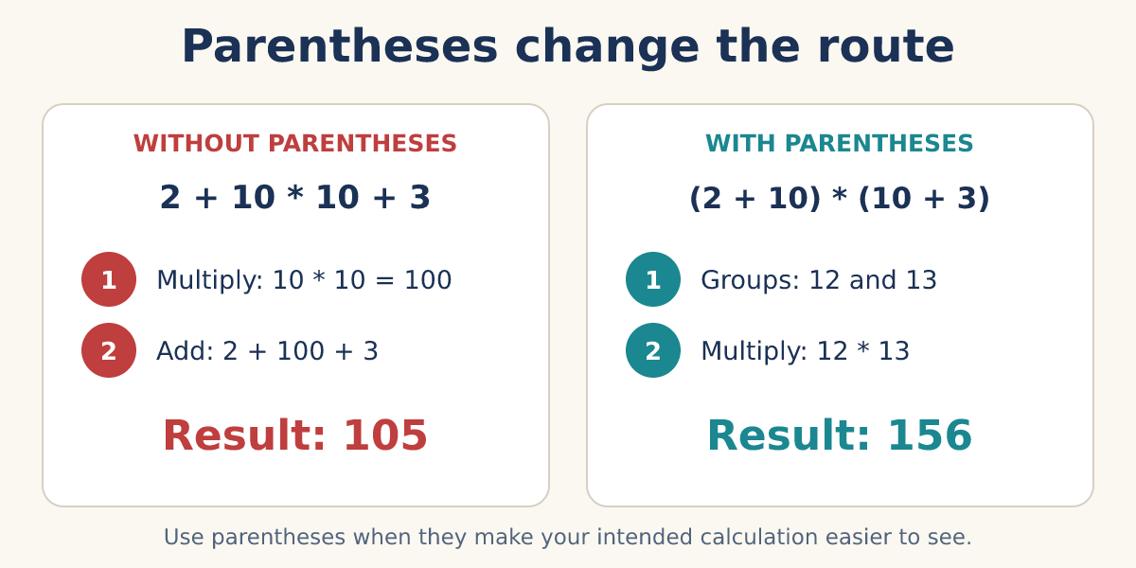
Parentheses make the intended groups visible and can change the result.
Clear code beats a memory trick
Use parentheses when they make your intended calculation easier to read, even when Python would already choose the same order.
Do not add random parentheses. Group the parts that belong together.

Build the 100-point score

Plan before we type
PROGRAM BLUEPRINT
Purpose: Start at 25 and finish at exactly 100.
Input: Starting score: 25.
Processing: Multiply by 3, then add 25.
Output: 100
Files: score_100.py

The code
score_100.py
1 score = 25
2 score = score * 3
3 score = score + 25
4 print(score)
MAKE A GUESS
What value will the program print?
prediction.py
1 score = 25
2 score = score * 3
3 score = score + 25
4 print(score)
- A. 50
- B. 75
- C. 100
Answer: 100. 25 times 3 is 75. Adding 25 gives 100.

Program run: every step
score_100.py
1 score = 25
2 score = score * 3
3 score = score + 25
4 print(score)
1. Memory starts empty
No score exists yet.
2. Store the starting score (line 1)
score refers to 25.
Memory: score = 25
3. Triple the score (line 2)
Python calculates 25 * 3 and assigns 75 back to score.
Memory: score = 75
4. Add the final 25 (line 3)
Python calculates 75 + 25 and assigns 100.
Memory: score = 100
5. Display the result (line 4)
print() displays the current value.
Memory: score = 100
Console: 100

Expected output
Terminal
1 $ python score_100.py
2 100
SIMPLE EXERCISE · Numbers: Simple Arithmetic
Write an expression that equals 100.
Examples: 50 + 50 or 110 - 10.
See if you can use more than one arithmetic operator. Write only one expression and submit only one line of code.
Success check: If your expression results in 100, your solution is correct.
Division by zero stops the calculation
Python cannot calculate 10 / 0, 10 // 0 or 10 % 0. Each raises a ZeroDivisionError.
When a divisor might come from a changing value, check that it is not zero before dividing. We will learn decision-making code in a later lesson.
Some decimal results are approximations
Computers store most floating-point values in a finite binary form. Some familiar decimals cannot be represented exactly.
For example, Python may display 0.1 + 0.2 as 0.30000000000000004. This is normal floating-point approximation, not a broken addition operator. We will learn suitable comparison and rounding tools later.
BUG HUNT
Which line causes the program to stop?
bug_hunt.py
1 points = 100
2 teams = points // 0
3 print(teams)
Answer: line 2. Floor division by zero raises ZeroDivisionError.

Common mistakes and fixes
✗ 2 ^ 3
The power operator is **. The ^ symbol has a different meaning in Python.
✗ 7 / 4 == 1
True division gives 1.75. Use // only when the floor result answers your question.
✗ score * 2 = score
Assignment needs a variable name on the left: score = score * 2.

Keep exploring
Python arithmetic conversions and operators : https://docs.python.org/3/reference/expressions.html#binary-arithmetic-operations
Python numeric types : https://docs.python.org/3/library/stdtypes.html#numeric-types-int-float-complex
Python floating-point tutorial : https://docs.python.org/3/tutorial/floatingpoint.html

Strings shape the conversation
A string is an ordered sequence of text characters. Matching single or double quotes mark its boundaries. Choose double quotes when the text contains an apostrophe, as in "Akshat’s note".

Read parts of `study`
Expression | Result | Reason
word[0] | s | Indexing starts at zero.
word[-1] | y | A negative index counts from the end.
word[1:4] | tud | Start is included. Stop is excluded.
word[::-1] | yduts | A step of -1 moves backward.
Strings are immutable. Their characters cannot be replaced in place. Build a new string instead. Useful methods include upper(), lower(), strip() and split(). A method is a function reached through a value.

The code
status.py
1 learner = "Mira"
2 topic = " fractions "
3 score = 7
4 goal = 10
5 clean_topic = topic.strip().title()
6 print(f"{learner}: {clean_topic} {score}/{goal}")
7 print(f"Progress: {score / goal:.0%}")

Expected output
Terminal
1 $ python status.py
2 Mira: Fractions 7/10
3 Progress: 70%
A small float warning
Most decimal fractions do not have an exact finite binary representation. A result such as 0.1 + 0.2 may display as 0.30000000000000004. This is normal floating-point approximation, not random behavior.

Truth values and no-value state
True and False are Boolean values. Their type is bool, and their capital letters matter. Comparisons produce Boolean results. None is a separate value that means no value is available here. It is not the number zero, an empty string or False.

The code
state.py
1 has_notes = False
2 last_topic = None
3 score = 7
4 goal = 10
5 goal_reached = score == goal
6 print(type(has_notes))
7 print(last_topic)
8 print(goal_reached)

Expected output
Terminal
1 $ python state.py
2 <class 'bool'>
3 None
4 False
SKILL TRIAL · State Operator · Build a status line from raw values
Start with untidy learner data. Produce one exact, readable status without copying the finished example.
- Create names for the learner, topic, score and goal.
- Clean the topic with string methods.
- Calculate whether the goal is reached.
- Print one f-string containing the cleaned topic, score and Boolean result.
Win condition: Your output is correct after changing both the learner name and score.
Stretch move: Add a percentage with no digits after the decimal point.

Check your understanding
1. Why can `score` later refer to a different value?
Answer: Assignment can connect the name to a new object.
2. What does `"python"[1:4]` produce?
Answer: yth, because index 1 is included and index 4 is excluded.
3. Why use an f-string?
Answer: It places expressions inside readable text.
4. What should you avoid naming `list`?
Answer: A variable, because it would shadow Python’s built-in name.

Key takeaways
REMEMBER
- Names refer to values.
- Types affect the operations a value supports.
- Strings support indexing and slicing but cannot be changed in place.
- True, False and None represent distinct program states.
- F-strings create clear status text.
RANK EARNED · State Operator
You proved that you can:
- Choose names that reveal meaning.
- Transform numbers and strings into useful status information.
- Represent yes-or-no and no-value states accurately.
Next target: Organize many related values without losing their purpose.
NEXT DISCOVERY · One value is not enough
Next, collections organize notes, settings, commands and unique tags.

Chapter 3: Organize Data
Choose a collection for commands, fixed records, note lookups and unique tags.
Create an Interactive Terminal Assistant · STEP 3 OF 5
Now: Organize memory. Give each kind of assistant data a structure that matches its job.
PAUSE & THINK
Would one variable per note still be easy to use after fifty notes?
Answer: No. A collection keeps related values together and lets one operation work across them.

Four collection jobs
Structure | Best fit | Can change? | Important rule
List [] | Ordered command history | Yes | Positions use indexes.
Tuple () | Fixed result record | No | The comma forms a tuple.
Dictionary {key: value} | Title-to-note lookup | Yes | Keys must be hashable.
Set {value} | Unique tags and membership | Yes | Positions are not available.

Lists preserve an order
A list is an ordered, mutable collection. Mutable means it can change. A list may mix value types, but one clear purpose usually makes the list easier to use.
WORKED EXAMPLE · Remove one command and keep the evidence
Problem: What changes after last = commands.pop()?
- pop() without an argument selects the final item.
- It removes that item from the list.
- It returns the removed item, so last can still use it.
- A slice such as commands[1:] creates a new list from index 1 onward.
Result: You can report both the returned item and the changed list.
WORKED EXAMPLE · Sort without losing the list
Problem: Why does saved = items.sort() make saved equal None?
- sort() changes the existing list in place.
- Its job is the change, so it returns None.
- Use items.sort() and then read items, or use saved = sorted(items) to build a new sorted list.
Result: Choose an in-place method only when you intend to mutate the original list.

Dictionaries connect keys to values
A dictionary is a mutable mapping. It connects each unique key to a value. notes["maths"] looks up a note by meaning rather than by position. A missing bracket lookup raises KeyError.

List position versus dictionary key
Question | List route | Dictionary route
How do I find it? | Know index 1. | Know key "maths".
Can I slice it? | Yes. | No. It is a mapping.
Does insertion order remain visible? | Yes. | Yes, but lookup still uses keys.
Can I sort it in place? | list.sort() can. | No dictionary sort() method. Sort its keys or items into a list.
Assignment with a new key inserts a pair. Assignment with an existing key updates its value without moving that key. Current Python dictionaries preserve insertion order. They are still mappings, not index-based sequences.
Keys must be hashable, not just strings
Strings make clear assistant labels, but numbers and suitable tuples can also be keys. Lists and dictionaries cannot be keys because they are mutable and unhashable.
key in notes checks dictionary keys. Use notes.keys(), notes.values() and notes.items() when you need views of keys, values or pairs. These views reflect later dictionary changes.
WORKED EXAMPLE · Climb a nested-access ladder
Problem: Find the latest score without guessing one long expression.
- learner = profile["learner"] returns the inner dictionary.
- scores = learner["scores"] returns the list.
- latest = scores[-1] returns its final value.
- Only then combine the proven path as profile["learner"]["scores"][-1].
Result: Each key or index acts on the value returned by the step before it.

The code
lookup_ladder.py
1 profile = {
2 "learner": {
3 "name": "Mira",
4 "scores": [6, 8, 9],
5 }
6 }
7 learner = profile["learner"]
8 scores = learner["scores"]
9 latest = scores[-1]
10 print(latest)

Expected output
Terminal
1 $ python lookup_ladder.py
2 9

Tuples record a fixed group
A tuple is an ordered immutable sequence. Its item references cannot be replaced. The comma creates the tuple: (5,) is a one-item tuple, while (5) is simply the integer 5. Parentheses make tuple boundaries easier to see.
Tuples support indexing, slicing, len(), count() and index(). Packing creates a record such as result = ("maths", 7). Unpacking assigns its parts with topic, score = result.
Immutability is shallow
A tuple item cannot be reassigned. If a tuple contains a mutable list, that list can still change. Use tuples for a fixed record shape, not as a magic lock for every object inside.

Sets keep unique values
A set stores unique hashable elements. It supports fast membership checks and removes duplicate equal values. A set has no indexes and promises no positional order. {} is an empty dictionary, so use set() for an empty set.

Set moves for assistant tags
Move | Example | Result
Add one | tags.add("urgent") | The tag is present once.
Remove duplicates | set(["maths", "maths"]) | One "maths" remains.
Test membership | "maths" in tags | True or False.
Compare groups | mine & yours | Tags found in both sets.
PAUSE & THINK
What letters remain after set("Mississippi")?
Answer: The unique letters are M, i, s and p. Their printed order is not guaranteed, so check membership rather than position.

The code
collections_lab.py
1 from pathlib import Path
2
3 history = ["help", "add maths", "list"]
4 latest = history.pop()
5 remaining = history[1:]
6 profile = ("Mira", 7)
7 name, level = profile
8 notes = {"maths": "Practise fractions"}
9 notes["science"] = "Review cells"
10 tags = set(["urgent", "maths", "maths"])
11
12 path = Path("session.txt")
13 path.write_text("\n".join(history), encoding="utf-8")
14 loaded = path.read_text(encoding="utf-8").splitlines()
15 print(latest, remaining)
16 print(name, level, notes["maths"], sorted(tags), loaded)

Expected output
Terminal
1 $ python collections_lab.py
2 list ['add maths']
3 Mira 7 Practise fractions ['maths', 'urgent'] ['help', 'add maths']

Save state without risking the wrong file
A path describes a file location. A relative path such as notes.txt starts from the current working directory. Open the project folder in VS Code so that starting location stays predictable.

Choose a text-file mode safely
Mode | Purpose | If missing | Main risk
r | Read | Raises FileNotFoundError. | Wrong name or path.
w | Write from the beginning | Creates the file. | Erases existing contents when opened.
a | Append at the end | Creates the file. | Repeated runs may add duplicate lines.

The code
save_note.py
1 from pathlib import Path
2
3 path = Path("notes.txt")
4 path.write_text("maths\tPractise fractions\n", encoding="utf-8")
5
6 with open(path, "a", encoding="utf-8") as file:
7 file.write("science\tReview cells\n")
8
9 text = path.read_text(encoding="utf-8")
10 print(text)
Why `with` and UTF-8 matter
The with statement closes the file even if an exception interrupts the block. Explicit UTF-8 makes the text encoding rule clear across computers.
write() returns the number of characters written. It does not return the text. Use r+ and w+ only after a real task needs combined reading and writing.
BUG HUNT
Which line replaces a useful list with None?
bug_hunt.py
1 topics = ["science", "maths"]
2 topics = topics.sort()
3 print(topics)
Answer: line 2. list.sort() mutates the list and returns None. Use topics.sort() without reassignment.
SKILL TRIAL · Data Strategist · Design the assistant memory pack
Choose structures because of their behavior. Then prove that the saved information survives one program run.
- Use a list for command history.
- Use a dictionary for title-to-note lookup.
- Use a tuple for one fixed result record.
- Use a set for unique tags.
- Save at least two notes with UTF-8 and load them again.
Win condition: A fresh run loads the same note information, and you can explain why every collection was chosen.
Stretch move: Add one safe nested lookup and display its steps before combining them.

Check your understanding
1. After `items = [0, 1, 2]` and `last = items.pop()`, what are `last` and `items`?
Answer: last is 2, and items is [0, 1].
2. Which collection fits note titles mapped to note text?
Answer: A dictionary, because each title acts as a meaningful lookup key.
3. What does `profile["scores"][1]` do when the key holds `[6, 8, 9]`?
Answer: The key returns the list, then index 1 returns 8.
4. Which mode adds text without erasing an existing file?
Answer: a appends. It also creates the file if it is missing.

Key takeaways
REMEMBER
- Choose a collection by behavior, not appearance.
- Dictionary keys must be hashable, and dictionary insertion order is preserved.
- A tuple is formed by commas and is shallowly immutable.
- Sets provide uniqueness and membership, not positions.
- Use explicit UTF-8 and treat write mode as destructive.
RANK EARNED · Data Strategist
You proved that you can:
- Select a collection from the job it must perform.
- Trace nested lookups without guessing.
- Persist and reload text without accidental overwrite.
Next target: Turn organized data into decisions and repeated command routes.

Keep exploring
Python data structures : https://docs.python.org/3/tutorial/datastructures.html
Python built-in types : https://docs.python.org/3/library/stdtypes.html
Python file input and output : https://docs.python.org/3/tutorial/inputoutput.html#reading-and-writing-files
pathlib documentation : https://docs.python.org/3/library/pathlib.html
NEXT DISCOVERY · Stored commands need routes
Next, decisions and loops let the assistant choose an action and continue the conversation.

Chapter 4: Control the Program
Make the assistant choose a command route and continue until the learner exits.
Create an Interactive Terminal Assistant · STEP 4 OF 5
Now: Choose and repeat routes. Add comparisons, Boolean logic, branches and a command loop.

Comparisons ask precise questions
Operator | Question | Example
== | Are the values equal? | 2.0 == 2 is True.
!= | Are they different? | "2" != 2 is True.
< and <= | Is the left value smaller, with or without equality? | 3 <= 3 is True.
> and >= | Is the left value larger, with or without equality? | 8 > 5 is True.
Assignment is not equality
score = 7 assigns a value. score == 7 compares two values and produces True or False.
String comparison is case-sensitive. "Help" == "help" is false. Ordering values that have no meaningful shared order, such as 3 < "4", raises TypeError.

A chained comparison guards a range

Read `0 <= score <= 10` as two gates

Trace two chained questions
Expression | Expanded meaning | Result
2 < 3 > 10 | 2 < 3 and 3 > 10 | False
2 <= 3 >= 1 | 2 <= 3 and 3 >= 1 | True

Combine conditions without wasted work
and requires both conditions to pass. or requires at least one condition to pass. not reverses the truth test. Python short-circuits: it skips the right side when the left side already determines the answer.
WORKED EXAMPLE · Guard an index with short-circuiting
Problem: How can the assistant read the first note only when a note exists?
- bool(notes) is false when the list is empty.
- In notes and notes[0], a false left side stops evaluation.
- Python does not attempt the unsafe index when the list is empty.
- For first-time code, if notes: is often clearer than storing the operand result.
Result: The guard prevents IndexError without doing unnecessary work.
Truthiness comes after real Boolean values
False, None, numeric zero and empty strings or collections are false in a condition. Most other values are true.
and and or actually return one of their operands. In this chapter, use them mainly in conditions so the decision remains easy to read.

A branch selects one route
if tests the first condition. elif tests another only when earlier branches did not run. else catches the remaining case. A colon opens the block. Consistent indentation marks the instructions inside it.

The command decision maze

Loops repeat for different reasons

Choose the loop from the job
Loop | Use it when | Assistant example
for | You have a sequence to visit. | Display every saved note.
while | You repeat while a condition stays true. | Keep accepting commands.
range() produces a sequence of integers. enumerate() pairs each item with a counter, which helps number notes. break exits the nearest loop. continue skips to its next turn. A list comprehension can build a simple new list, but write the equivalent for loop first.

The code
command_loop.py
1 commands = ["help", "add", "list", "quit"]
2 running = True
3
4 while running:
5 command = input("Command: ").strip().lower()
6 if command == "quit":
7 running = False
8 elif command in commands:
9 print(f"Route: {command}")
10 else:
11 print("Unknown command. Type help.")
12
13 print("Goodbye!")
BUG HUNT
Why does this loop never finish?
bug_hunt.py
1 running = True
2 while running:
3 print("Working")
Answer: line 3. Nothing changes running and there is no break. The condition remains true forever.
MAKE A GUESS
Which branch runs when command is list?
prediction.py
1 if command == "quit":
2 running = False
3 elif command in commands:
4 print(f"Route: {command}")
5 else:
6 print("Unknown command. Type help.")
- A. quit branch
- B. known-command branch
- C. else branch
Answer: known-command branch. list belongs to commands, so the elif condition is true.
SKILL TRIAL · Route Commander · Defend the command loop
Build a route system that handles valid commands, bad input and clean exit without falling into an infinite loop.
- Accept and normalize a command.
- Use one chained comparison to validate a score from 0 through 10.
- Use and, or or not in a condition you can explain.
- Route at least four commands with if, elif and else.
- Number saved notes with a for loop and keep commands running with a while loop.
Win condition: Every route is reachable, an unknown command receives help, and quit always ends cleanly.
Stretch move: Add a short-circuit guard that safely displays the first note only when notes exist.

Check your understanding
1. What is the difference between `=` and `==`?
Answer: = assigns. == compares.
2. Why is `2 < 3 > 10` false?
Answer: It means 2 < 3 and 3 > 10. The second comparison is false.
3. When can `and` skip its right side?
Answer: When the left operand is false, because the whole condition cannot then be true.
4. What can stop a `while` loop?
Answer: Its condition becoming false or a break statement.

Key takeaways
REMEMBER
- Comparisons produce Boolean results.
- A chained comparison can guard both boundaries.
- Logical operators short-circuit.
- A branch selects one route.
- A loop repeats work while state changes.
RANK EARNED · Route Commander
You proved that you can:
- Translate requirements into comparisons.
- Protect operations with readable logic.
- Build branches and loops that terminate correctly.
Next target: Package each command route into a focused function and validate live input.

Keep exploring
Python comparisons and Boolean operations : https://docs.python.org/3/library/stdtypes.html#comparisons
Python control flow : https://docs.python.org/3/tutorial/controlflow.html
NEXT DISCOVERY · The routes need reusable jobs
Next, functions organize the command work and validated input completes the first assistant.

Chapter 5: Build with Functions and Input
Turn the separate assistant pieces into one reusable local program.
Create an Interactive Terminal Assistant · STEP 5 OF 5
Now: Assemble the working assistant. Collect learner input, validate it and give each command a focused function.

Input returns text
input() displays a prompt, waits for the user and returns a string. Pressing Enter ends the response. Convert with int() or float() only when a number is required. Invalid numeric text raises ValueError, so a validation loop can explain the problem and ask again.

A function names one job
DEFINITION · function
A reusable group of instructions with a name. A parameter is a name in the definition. An argument is a value supplied by a call.
Example: add_note(notes, "maths", "Practise fractions") supplies three arguments.
return sends a value back to the caller. A function that reaches its end without an explicit return returns None. Names created inside a function are normally local to that call. This local scope keeps one function’s temporary work from leaking everywhere.

The code
assistant_functions.py
1 def add_note(notes, title, text):
2 """Store text under a cleaned title and return the title."""
3 clean_title = title.strip().lower()
4 notes[clean_title] = text.strip()
5 return clean_title
6
7 def read_score():
8 while True:
9 raw = input("Practice score from 0 to 10: ")
10 try:
11 score = int(raw)
12 except ValueError:
13 print("Enter a whole number.")
14 continue
15 if 0 <= score <= 10:
16 return score
17 print("Use a number from 0 to 10.")
WORKED EXAMPLE · Trace one call
Problem: What happens in add_note(notes, " Maths ", " Fractions ")?
- The arguments connect to the three parameters.
- Local name clean_title becomes maths.
- The dictionary receives notes["maths"] = "Fractions".
- The function returns maths to the caller.
Result: The function changes the supplied dictionary and returns the cleaned key.
Useful extensions
A default argument supplies a value when the caller omits it. A keyword argument names the parameter at the call site.
*args collects extra positional arguments. **kwargs collects extra keyword arguments. Lambdas, map() and filter() are optional tools, not requirements for this assistant.

Assemble the local assistant

Plan before we type
PROGRAM BLUEPRINT
Purpose: Run a deterministic study assistant.
Input: Commands and note text from the learner.
Processing: Normalize the command, select a function, validate values and update collections.
Output: Clear responses plus saved local notes.
Files: assistant.py, notes.txt

Try it yourself
- Greet the learner.
- Recognize help, add, list and quit.
- Store notes in a dictionary and command history in a list.
- Keep asking until quit.
- Use functions for focused jobs.
- Validate at least one input.
- Save and load useful data with UTF-8 text.
- End with a clear goodbye message.
BUG HUNT
Why does this print None?
bug_hunt.py
1 def greeting(name):
2 message = f"Hello, {name}"
3 print(greeting("Mira"))
Answer: line 2. The function builds message but never returns it. Add return message.
SKILL TRIAL · Assistant Assembler · Complete the first working assistant
Bring the previous four chapters together. This trial ends only when the program survives real input and closes cleanly.
- Implement help, add, list and quit as focused functions.
- Validate one numeric response with a loop.
- Store notes and command history in suitable collections.
- Load saved notes at startup and save them before exit.
- Run one normal path and two deliberately bad inputs.
Win condition: The assistant recovers from invalid input, preserves useful data and exits only when asked.
Stretch move: Add one original command without changing the existing command functions.

Check your understanding
1. What type does `input()` return?
Answer: A string.
2. How is an argument different from a parameter?
Answer: A parameter is a definition name. An argument is a supplied value.
3. What happens without an explicit return value?
Answer: The function returns None.
4. Why keep a function focused?
Answer: A clear responsibility makes code easier to understand, reuse and test.

Key takeaways
REMEMBER
- Validate text before treating it as a number.
- Functions organize responsibilities.
- The first assistant is deterministic: its rules determine every response.
RANK EARNED · Assistant Assembler
You proved that you can:
- Turn input text into validated values.
- Divide a program into focused functions.
- Finish a deterministic assistant that saves useful state.
Next target: Rescue the working program from tangled data and repeated behavior.

Keep exploring
Python functions : https://docs.python.org/3/tutorial/controlflow.html#defining-functions
Python input : https://docs.python.org/3/library/functions.html#input
NEXT DISCOVERY · Working code can still be tangled
A new repair arc begins next. Objects, modules and tests will make the application easier to extend and trust.

Chapter 6: Model Behavior with Objects
Group related data and actions so the assistant becomes easier to understand and extend.
LEARNING ARC · Rescue and Strengthen an Application
Turn working but tangled code into reliable software Step 1 of 3
The assistant works, but note data and behavior are scattered. A new feature causes repeated code, and invalid data can still stop the program. Over three chapters, we will organize, split and test the same application.
Starting tools: Functions can organize jobs. • Collections can hold application state. • Expected input can be validated.
What this arc will unlock: Objects with clear responsibilities. • Modules and a clear entry point. • Specific exception handling. • Automated behavior tests.
DEFINITION · class and instance
A class describes a kind of object. An instance is one object created from that class. Each note instance can hold its own title and text.
__init__ initializes a new instance. self refers to the instance receiving a method call. Attributes store its data. Instance methods describe actions that use that data.

The code
models.py
1 class Note:
2 category = "study"
3
4 def __init__(self, title, text):
5 self.title = title.strip()
6 self.text = text.strip()
7
8 def preview(self):
9 return f"{self.title}: {self.text[:20]}"
10
11 def __str__(self):
12 return self.preview()
13
14 first = Note("Maths", "Practise fractions")
15 second = Note("Science", "Review plant cells")
16 print(first)
17 print(second)

Expected output
Terminal
1 $ python models.py
2 Maths: Practise fractions
3 Science: Review plant cells
WORKED EXAMPLE · Two instances stay independent
Problem: Does changing first.text also change second.text?
- Each call to Note(...) creates a different instance.
- Each instance receives its own text attribute.
- Changing one attribute affects that instance only.
Result: The second note keeps its original text.

Shared, contained or specialized?

Choose the relationship
Tool | Meaning | Use here
Class attribute | One value found through the class and shared unless overridden. | A common category label.
Composition | One object contains or uses another object. | A notebook contains note objects.
Inheritance | A specialized class extends a broader class. | A reminder note may specialize a note.
Prefer composition when one thing has another thing. Use inheritance for a genuine is-a relationship. Method overriding lets a child class replace inherited behavior. Polymorphism means code can call the same method on different object types and each object can respond appropriately.
Selected special method
__str__ defines useful human-readable text for an object. Special names with double underscores support Python protocols. You do not need to memorize a catalog of them.
BUG HUNT
Which line forgot the instance parameter?
bug_hunt.py
1 class Note:
2 def preview():
3 return self.title
Answer: line 2. An instance method needs self as its first parameter.
SKILL TRIAL · Model Designer · Replace scattered note behavior
Refactor note data into objects without changing what the user sees.
- Create a Note class with validated title and text attributes.
- Give the class one method that produces a useful preview.
- Create two independent instances and change only one.
- Place note objects inside a notebook through composition.
Win condition: Two notes keep independent state, and the existing display behavior still works.
Stretch move: Add a specialized reminder note that overrides one display method.

Check your understanding
1. What is an instance?
Answer: One object created from a class.
2. What does `self` refer to?
Answer: The instance receiving the method call.
3. When is composition usually clearer?
Answer: When one object contains or uses another.
4. What does overriding do?
Answer: A child class supplies a replacement for inherited behavior.

Key takeaways
REMEMBER
- A class groups related state and behavior.
- Instances keep independent state.
- Composition is often simpler than inheritance.
RANK EARNED · Model Designer
You proved that you can:
- Assign one clear responsibility to a class.
- Trace independent instance state.
- Choose composition before unnecessary inheritance.
Next target: Give each application responsibility a clear module.

Keep exploring
Python classes : https://docs.python.org/3/tutorial/classes.html
NEXT DISCOVERY · One file now has too many jobs
Next, modules give each responsibility a clear home and an entry point.

Chapter 7: Split and Share Code
Split one crowded file into understandable modules and run it in an isolated environment.
Rescue and Strengthen an Application · STEP 2 OF 3
Now: Create a clear codebase map. Separate models, application logic, entry code and tests.
DEFINITION · module and package
A module is a Python file that can be imported. A package groups related modules under a package name.

The assistant import map

Import names clearly
import models keeps qualification visible, as in models.Note(...). from models import Note brings one name into the current module. Avoid from models import * because readers cannot easily see where names came from.

The code
main.py
1 from assistant import run
2
3 def main():
4 run()
5
6 if __name__ == "__main__":
7 main()
Python sets __name__ to "__main__" when a file is run directly. When another module imports that file, __name__ is its module name. The guard prevents start-up code from running during import.
MAKE A GUESS
What runs when a test imports main?
prediction.py
1 if __name__ == "__main__":
2 main()
- A. main() always runs
- B. main() does not run during the import
- C. Python raises an error
Answer: main() does not run during the import. During import, the module name is not __main__.

Know where a package comes from

Three sources of imports
Kind | Example | Installed how
Your module | models | It is part of your project.
Standard library | pathlib | It ships with Python.
Third-party package | A reviewed package from PyPI | Install it into the project environment.

Isolate project tools with `.venv`

Try it yourself
- Open the Command Palette in VS Code.
- Choose Python: Create Environment and select Venv.
- Select the Python interpreter. VS Code creates .venv and selects it.
- Use Python: Select Interpreter if you need to select it again.
- Open a VS Code terminal. Use python -m pip install package-name only for a package you have reviewed and need.
- Record exact direct dependencies in the project dependency file. Use the project instructions to rebuild the environment.
pip and PyPI are different
pip is an installer. PyPI is a public package index. Inspect the package name, owner, documentation, release history and project need before installation.
Remove an unneeded package with python -m pip uninstall package-name. Never paste secrets into package commands or project files.
BUG HUNT
Why is this import design risky?
bug_hunt.py
1 # models.py
2 from assistant import run
3 # assistant.py
4 from models import Note
Answer: line 2. The files depend on each other while importing. Move shared definitions into a lower-level module with one-way dependencies.
SKILL TRIAL · Codebase Architect · Split the crowded application
Rebuild the assistant as a small codebase whose import direction can be explained at a glance.
- Move domain objects into models.py.
- Move command behavior into assistant.py.
- Keep startup code behind a main guard in main.py.
- Create .venv through VS Code and select it.
- Run the application from its clear entry point.
Win condition: Imports flow in one direction, importing main does not start the program, and the assistant still runs.
Stretch move: Recreate the environment from a concise dependency record.

Check your understanding
1. What is a module?
Answer: A Python file that can be imported.
2. Why qualify a name as `models.Note`?
Answer: It makes the source module visible.
3. What does the main guard prevent?
Answer: Program start-up code running merely because a module was imported.
4. Why use a virtual environment?
Answer: To isolate project packages from other projects and the system installation.

Key takeaways
REMEMBER
- Modules separate responsibilities.
- A main guard creates a safe entry point.
- A virtual environment isolates dependencies.
RANK EARNED · Codebase Architect
You proved that you can:
- Draw and enforce a one-way import map.
- Protect startup behavior with a main guard.
- Run the project in an isolated environment.
Next target: Attack expected failures and prove behavior with automated tests.

Keep exploring
Python modules : https://docs.python.org/3/tutorial/modules.html
Python packaging guide : https://packaging.python.org/en/latest/tutorials/installing-packages/
VS Code Python environments : https://code.visualstudio.com/docs/python/environments
NEXT DISCOVERY · Organization does not prove correctness
Next, tracebacks, specific exception handling and automated tests complete the reliability trial.

Chapter 8: Handle Problems and Prove Behavior
Handle expected failures and prove that important assistant behavior still works.
Rescue and Strengthen an Application · STEP 3 OF 3
Now: Pass the reliability trial. Read failures, handle expected exceptions and turn behavior claims into automated tests.

Two broad failure times
Kind | When it appears | First move
Syntax error | Python cannot parse the code before normal execution. | Read the location and inspect punctuation or indentation.
Runtime exception | Execution reaches an operation that cannot continue. | Read the final traceback line for the exception type and message.

Try it yourself
- Read the final line first. It names the exception and usually gives a message.
- Move upward to the last frame from your own project.
- Open that file and line.
- Inspect the values and the operation.
- Reproduce the smallest failing case.

Handle only an expected problem

The code
assistant.py
1 def normalize_score(raw):
2 try:
3 score = int(raw)
4 except ValueError as error:
5 raise ValueError("Score must be a whole number") from error
6 else:
7 if not 0 <= score <= 10:
8 raise ValueError("Score must be from 0 to 10")
9 return score
10 finally:
11 pass # Cleanup would belong here if a resource needed it.
Catch a specific exception you can meaningfully handle. Avoid bare except, which can hide unrelated bugs. An else block runs when no exception was raised. A finally block runs whether an exception occurred or not, so it suits required cleanup. Use these clauses only when they clarify a real need.

Debug with a testable hypothesis

Try it yourself
- Reproduce the problem.
- Reduce it to the smallest failing input.
- Inspect state with a debugger or temporary output.
- State one possible cause.
- Change or test one thing.
- Keep the fix only when the evidence supports it.
Linters and assertions
A linter gives automated feedback about code patterns. It is useful evidence, not an authority that replaces judgment.
An assert states a condition that should be true during development. Do not use assertions as the only validation for user input because optimized runs can disable them.

Arrange, act and assert
A test arranges the starting values, acts by calling behavior and asserts the expected result. Test a normal case, a boundary case and an invalid case. Prefer visible behavior over internal implementation details.

The code
tests/test_assistant.py
1 import unittest
2 from assistant import normalize_score
3
4 class ScoreTests(unittest.TestCase):
5 def test_normal_score(self):
6 self.assertEqual(normalize_score("7"), 7)
7
8 def test_boundary_score(self):
9 self.assertEqual(normalize_score("0"), 0)
10
11 def test_invalid_score(self):
12 with self.assertRaises(ValueError):
13 normalize_score("eleven")
14
15 if __name__ == "__main__":
16 unittest.main()

Expected output
Terminal
1 $ python -m unittest discover -v
2 test_boundary_score ... ok
3 test_invalid_score ... ok
4 test_normal_score ... ok
5
6 Ran 3 tests
7
8 OK
WORKED EXAMPLE · Turn a report into proof
Problem: A learner reports that score 0 is rejected.
- Write the smallest test that expects normalize_score("0") to equal 0.
- Run it and see it fail before editing the function.
- Correct the boundary condition.
- Run the full suite to check for regressions.
Result: The passing test now preserves the repaired boundary behavior.

Try it yourself
- Run from a clear entry point.
- Keep domain behavior in at least one object.
- Split responsibilities across modules.
- Handle expected invalid input with specific exceptions.
- Pass normal, boundary and invalid automated tests.
- Include concise setup and run instructions.
SKILL TRIAL · Reliability Engineer · Break it before a user does
Treat every behavior claim as something that must survive evidence, not optimism.
- Write one normal-case test.
- Write tests for both allowed boundaries.
- Write one invalid-case test that expects a specific exception.
- Trigger a real failure and read the final traceback line first.
- Repair the behavior and run the complete suite again.
Win condition: All tests pass, the invalid input fails for the intended reason, and setup instructions work from a fresh folder.
Stretch move: Turn one past bug into a regression test that would fail if the bug returned.

Check your understanding
1. Which traceback line should a beginner read first?
Answer: The final line, which names the exception and message.
2. Why avoid a bare `except`?
Answer: It can hide failures the program does not understand how to handle.
3. What are the three test stages?
Answer: Arrange, act and assert.
4. What is a boundary case?
Answer: An input at an allowed or disallowed edge, such as score 0 or 10.

Key takeaways
REMEMBER
- Specific handling makes expected failures clear.
- A test converts a behavior claim into repeatable evidence.
- Reliable software needs organization, failure handling and proof.
RANK EARNED · Reliability Engineer
You proved that you can:
- Read a traceback from the failure outward.
- Handle only exceptions the program understands.
- Prove normal, boundary and invalid behavior with automated tests.
Next target: Carry this tested assistant core into the next book, where a model adapter adds real language-model behavior.

Keep exploring
Python errors and exceptions : https://docs.python.org/3/tutorial/errors.html
unittest documentation : https://docs.python.org/3/library/unittest.html
THE AHA MOMENT
The assistant is no longer only a script that seems to work. It has clear parts, expected failure behavior and repeatable proof.

About the author
Akshat Sinha is the founder of The Sinha Family Group and the creator of Sarva Gyana Koshah, the treasury of all knowledge, which teaches through books, videos, and hands-on learning.
This book was written for the reader who has never written a line of code and wants to understand what the computer is doing, not just copy and paste.

Keep learning
Keep guessing, running and checking.
Sarva Gyana Koshah Books · The Treasury of All Knowledge

