SARVA GYANA KOSHAH BOOKS
The Treasury of All Knowledge
Python for Absolute Beginners
Learn Programming the Visual Way
The First Code Series · Book 1
Akshat Sinha
First Edition · 2026

Python for Absolute Beginners
© 2026 by Akshat Sinha. All rights reserved.
Published by Sarva Gyana Koshah Books, a division of The Sinha Family Group.
No part of this publication may be reproduced, distributed, or transmitted in any form or by any means, including photocopying, recording, or other electronic or mechanical methods, without the prior written permission of the publisher, except for brief quotations in reviews.
Code examples are provided for learning. Test and review code before using it in an important system.
To my parents and grandparents — whose love, patience, and unwavering belief made this journey possible. Everything I build carries your blessings. This first book is for you.

Acknowledgements
My deepest gratitude to my parents and grandparents, my first teachers, for their endless encouragement.
To every reader of Sarva Gyana Koshah: your curiosity is the reason these pages exist.

Contents

In Microsoft Word, right-click this list and choose Update Field if page numbers are not visible.

Preface — Why Was Python Needed?
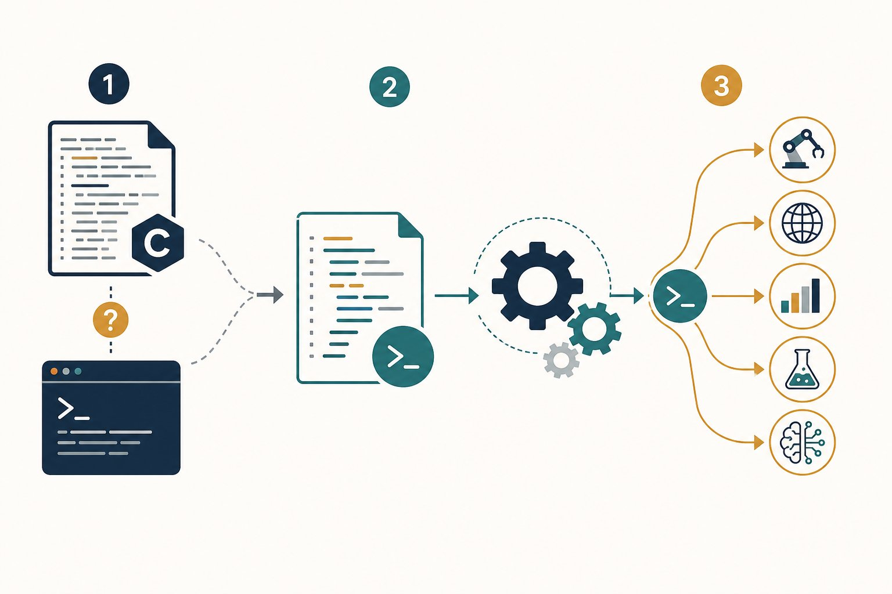
Python filled the missing middle path.
1 Quick scripts were useful, but some jobs outgrew them.
2 C offered more control, but small tools could take much more code.
3 Python made many everyday programs easier to read and build.
4 The same language now supports automation, websites, data, science and AI.
Python was created to solve a real problem. Programmers wanted to build useful tools without writing a large, difficult program for every small job.
The missing middle path
One option was a quick shell script. It was handy, but some jobs were too large for it.
Another option was a C program. It offered more control, but even a small tool could need much more code.
Guido van Rossum began Python as a clearer path between those choices.

What made the idea useful?
Python code was designed to be readable. It could also connect to existing programs and tools. This meant we could write the simple parts clearly without throwing away powerful work already built elsewhere.
Easy to begin does not mean weak
We can use Python for a five-line file sorter. Teams also use it for websites, data tools, science and AI.
Python is not best for every job. No language is. It is a strong first language because its code leaves more room to see the programming idea.

Why learn when AI can write code?
AI can suggest code. It cannot remove our need to judge the result. We still need to ask: What should happen? What actually happened? Is the answer safe and correct?

Key takeaways
REMEMBER
- Python was built to make useful programs easier to write and read.
- It can connect simple Python code to powerful existing tools.
- Friendly syntax helps us focus on the idea.
- We will learn by guessing, running and checking.

Keep exploring
Python’s own story: why it was created — https://docs.python.org/3/faq/general.html
Python essay: connecting software pieces — https://www.python.org/doc/essays/omg-darpa-mcc-position/

How to use this book
Make a guess. Run the code. Compare the result with your guess.
Web View reveals answers and moves through visualizers. Book View shows every answer and every step.

Lesson 1: Your First Program — Hello, World!
We begin with an empty file and end with a real result—understanding every character we typed.
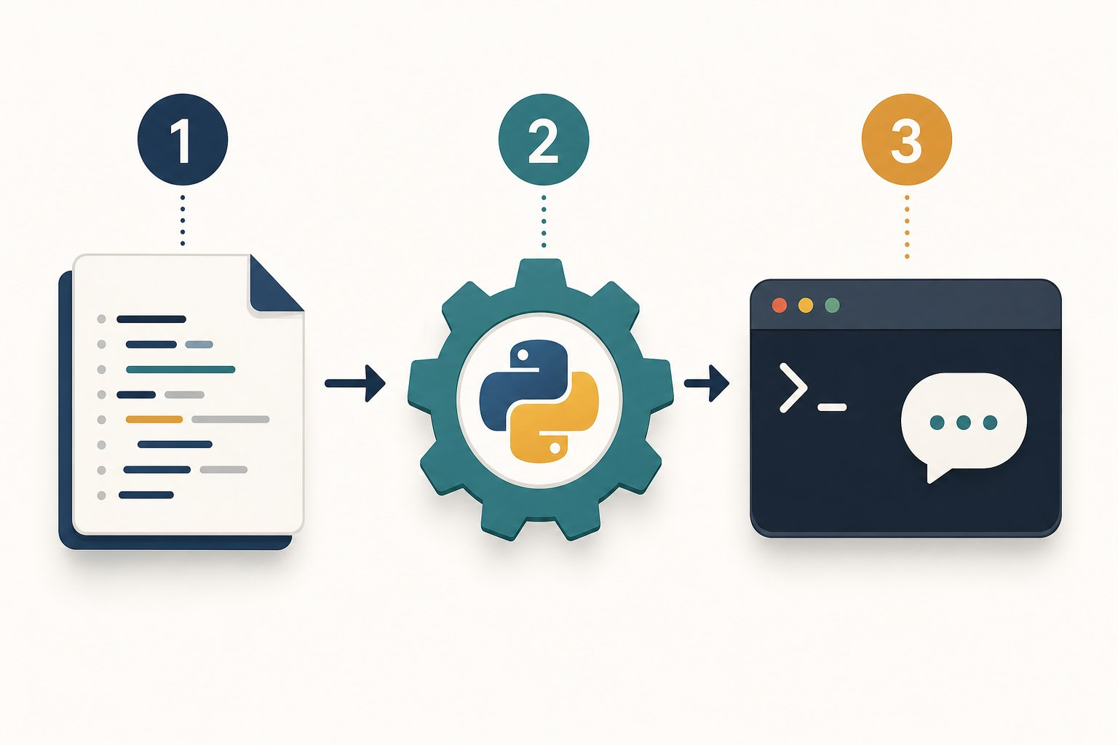
One instruction travels from our file to the screen.
1 We save the instruction in hello.py.
2 Python reads the file and performs the instruction.
3 The terminal receives and displays the result.
OUR MISSION · Make the silent machine answer us
We start with no code and no hidden knowledge. Our first win is simple: ask the computer to show one exact message.
What we know: A computer follows precise instructions. • It will not guess what we meant.
What we need: A way to mark text. • An action that sends text to the screen. • A command that starts our program.
PAUSE & THINK
If the word Hello appears in our code, how will Python know it is text and not the name of something?
Answer: We wrap the characters in quotes. Quotes turn Hello into a string—a piece of text.

Step 1 — What is a program?
A program is a saved set of instructions. Source code is the text we write to express those instructions. Python is the language whose rules both we and the Python runtime agree to follow.
Precise like a recipe, active like a remote control
A recipe describes actions. It does nothing until someone follows it. Source code is similar: the file stores instructions, and the Python runtime performs them.
Unlike a person, Python does not quietly repair a missing quote or guess a misspelled action. That strictness helps every reader get the same result.

Step 2 — Meet every character
print is a built-in function—a ready-made action supplied by Python. The round brackets call that action. The quotes mark text. The exclamation mark and comma inside the quotes are ordinary characters, so Python displays them too.
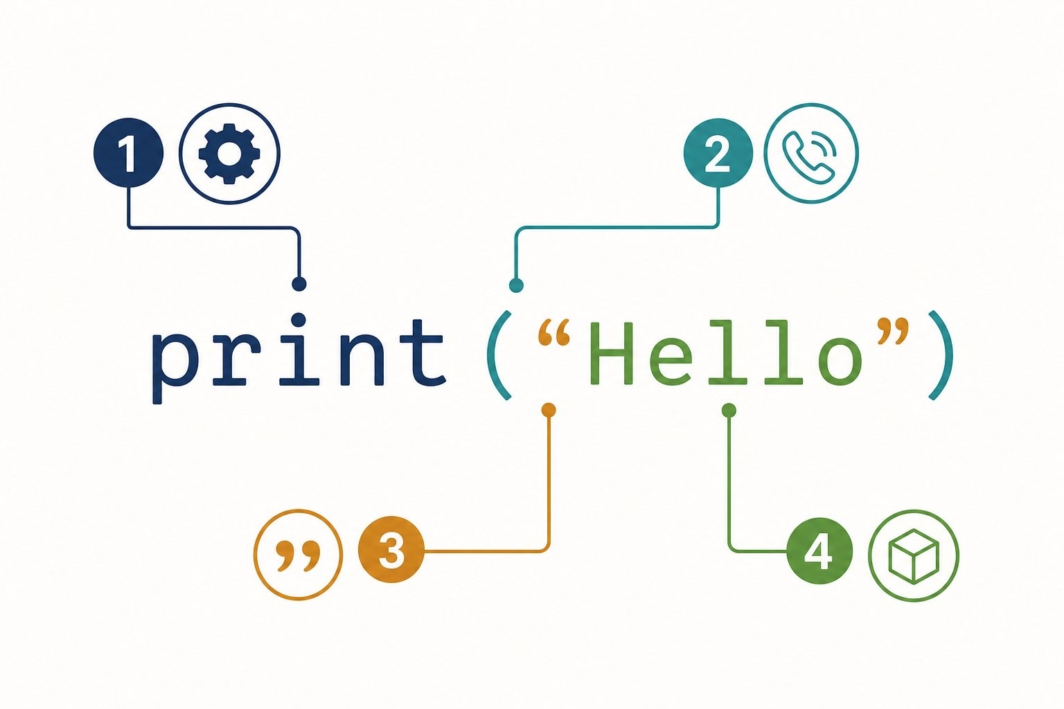
One short line contains four different jobs.
1 print names the ready-made action.
2 The round brackets call that action.
3 The quotes mark where the text begins and ends.
4 Hello is the value given to print().

Input → Process → Output
Value  "Hello, World!" | Function call  print(...) | stdout  Hello, World!
What is stdout?
stdout means standard output. It is the normal stream a program uses to send results outward. In our terminal, that stream appears as text on the screen.

Step 3 — Plan before we type

Plan before we type
PROGRAM BLUEPRINT
Purpose: Prove that Python can run our instruction and show a greeting.
Input: The string "Hello, World!" written inside the program.
Processing: Call print() with that string.
Output: The exact characters Hello, World!
Files: hello.py

Step 4 — Write the code

The code
hello.py
1 print("Hello, World!")
MAKE A GUESS
Before we run it: what will appear?
prediction.py
1 print("Hello, World!")
- A. The quote marks and the message
- B. Hello, World! without quote marks
- C. The word print
Answer: Hello, World! without quote marks. Quotes describe the string. They are not part of the string, so print() does not display them.

Step 5 — Watch the instruction become output

Program run: every step
hello.py
1 print("Hello, World!")
1. The command starts Python
The operating system launches the Python runtime and gives it the path to hello.py.
2. Python opens our source file
Python reads the saved characters. Nothing is visible in the console yet.
3. Python checks the instruction (line 1)
The name print, both brackets and both quotes follow Python’s syntax rules.
4. Python creates the string value (line 1)
The characters inside the quotes become one text value.
Memory: value = "Hello, World!"
5. Python calls print() (line 1)
The string is passed to the built-in print function.
Memory: value = "Hello, World!"
6. The console receives the result (line 1)
print() writes the characters to stdout and then starts a new line.
Console: Hello, World!

Expected output
Terminal
1 $ python hello.py
2 Hello, World!
THE AHA MOMENT
We did not ask the computer to understand a greeting. We gave Python one exact value and one exact action—and a visible result came back.

Step 6 — Make it yours

Try it yourself
- Create a file named hello.py.
- Type the instruction instead of pasting it.
- Save the file, then run python hello.py.
- Change only the text inside the quotes.
- Add a second print() line and predict the order of the output before running it.

Step 7 — Learn from the mistakes
BUG HUNT
Which line asks for an action Python does not know?
bug_hunt.py
1 print("Ready!")
2 Print("Go!")
Answer: line 2. Python names are case-sensitive. Print and print are different names.

Common mistakes and fixes
✗ print(Hello)
Without quotes, Python searches for a name called Hello.
✗ Print("Hello")
The built-in function uses a lowercase p.
✗ print("Hello"
The function call is missing its closing bracket.
✗ python hello
The command should include the file name hello.py.

Check your understanding
1. What makes Hello, World! a string?
Answer: The opening and closing quotes mark it as text.
2. What do the brackets do in print(...)?
Answer: They call the function and hold the value we pass to it.
3. What is stdout?
Answer: The standard output stream. A terminal normally shows it on screen.

Key takeaways
REMEMBER
- Source code stores instructions in a form people can read.
- A string is text marked by quotes.
- print() sends a value to standard output.
- Python follows spelling, case, quotes and brackets exactly.
- Predicting before running turns every example into an experiment.

Keep exploring
Python tutorial: using Python as a calculator — https://docs.python.org/3/tutorial/introduction.html
Python print() reference — https://docs.python.org/3/library/functions.html#print
NEXT DISCOVERY · Who carries our instruction to the processor?
We can see the result. Next, we uncover the hidden route between hello.py and the machine.

Lesson 2: How Does Our Code Reach the Computer?
Follow one tiny message from our file to the screen. No hidden knowledge required.
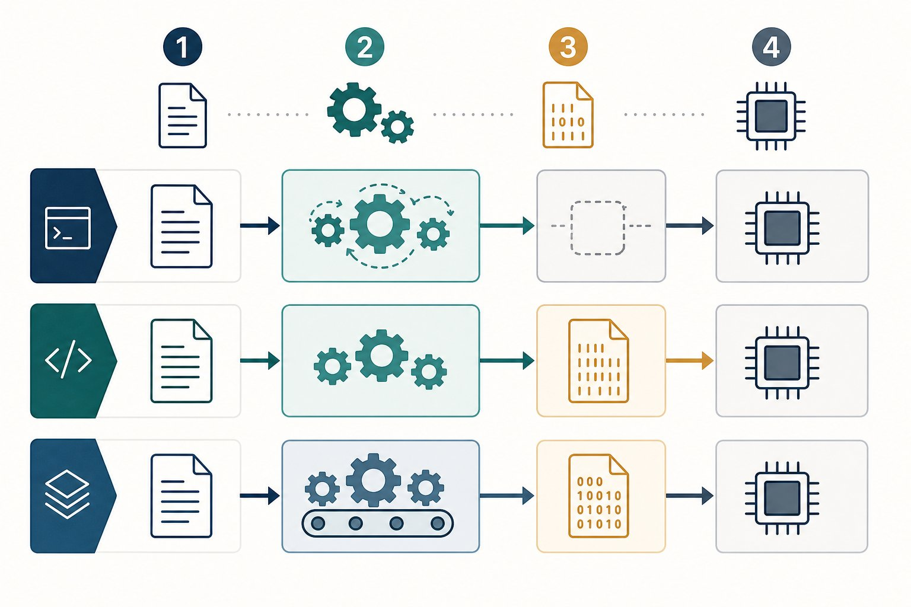
Different routes solve the same translation problem.
1 A person writes a source file.
2 A language tool prepares the instructions.
3 The processor performs machine work.
4 The program produces a result we can see.
OUR MISSION · Find the helper between us and the machine
We can read print("Hello"). The processor cannot read Python words. Something must help in the middle.
What we know: We write instructions in a file. • Running the file produces a result.
What we need: The missing middle step. • A simple reason why languages take different routes.
PAUSE & THINK
Does the processor understand the word print?
Answer: No. Python is written for people. A language program helps turn our instruction into work the computer can perform.

First, keep one simple picture in your head

Input → Process → Output
Our file  instructions we can read | Language helper  prepares and runs them | Computer result  Hello appears
That middle helper is not identical for every language. The details change, but the reason stays the same: human-friendly code must become machine work.
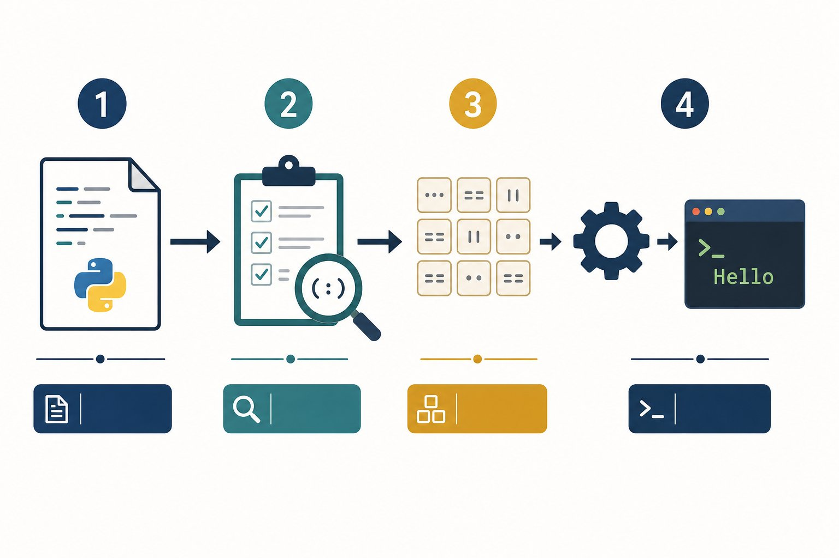
Python handles the hidden middle steps for us.
1 Start with the source file we wrote.
2 Python checks whether the code follows its rules.
3 Python prepares smaller instructions called bytecode.
4 The Python runtime follows them and Hello reaches the terminal.
The note and the musician
Sheet music is useful to a musician, but a piano does not read the paper by itself. The musician reads the notes and presses the keys.
Our source file is like the sheet music. A language tool reads it. The processor performs the final operations.

Now compare three routes—one at a time
Every route below prints Hello. Select a tab. Read only the four numbered cards from left to right. The small box answers one question: what do we have at this step?

Compare the routes

🐍 Python
Python stays with us while the program runs.
1  📝 | We write  What we have now: message.py  The file contains two Python instructions.  message = "Hello"  print(message)
2  🔍 | Python reads  What we have now: checked instructions  Python checks the words, quotes and brackets.  Does the code follow Python rules?
3  ⚙️ | Python runs  What we have now: a running Python program  Python performs the instructions in order.  python message.py
4  🖥️ | We see  What we have now: Hello  The message reaches the terminal.  Hello

🔧 C
C usually builds a runnable app before we open it.
1  📝 | We write  What we have now: message.c  The file contains C instructions.  printf("Hello\n");
2  🏗️ | A compiler builds  What we have now: prepared machine pieces  A compiler translates the C code.  compiler = translator
3  🔗 | A linker joins  What we have now: a runnable app  A linker joins the pieces the program needs.  linker = piece joiner
4  🖥️ | We run  What we have now: Hello  The computer opens the built app.  Hello

☕ Java
Java builds a travel-friendly file, then a Java helper runs it.
1  📝 | We write  What we have now: Message.java  The file contains Java instructions.  println("Hello");
2  📦 | Java builds  What we have now: Message.class  The Java compiler creates a class file.  javac Message.java
3  ⚙️ | The JVM runs  What we have now: a running Java program  The Java Virtual Machine, or JVM, reads the class file.  java Message
4  🖥️ | We see  What we have now: Hello  The message reaches the screen.  Hello
THE AHA MOMENT
Our code does not jump straight into the processor. A language tool helps it cross the gap.

The new words, in plain English
Four labels worth recognising
A compiler is a translator that prepares code. A linker is a joiner that connects prepared pieces.
Bytecode is a simpler instruction format for a language helper. A virtual machine is a program that runs those instructions. JVM means Java Virtual Machine.
You do not need to memorise these words today. Return to the route pictures whenever you meet them again.

Show me: what does Python bytecode look like?
Here is our readable Python file first:

The code
message.py
1 message = "Hello"
2 print(message)
Now we ask CPython to show its smaller instructions. The exact list can change between Python versions. Focus on the action words, not the numbers.

Expected output
Terminal
1 $ python -m dis message.py
2 LOAD_CONST "Hello"
3 STORE_NAME message
4 LOAD_NAME print
5 LOAD_NAME message
6 CALL 1
7 RETURN_VALUE
Read bytecode like a tiny action list
LOAD_CONST picks up the fixed value "Hello". STORE_NAME connects it to message. LOAD_NAME finds print and message. CALL runs print with one value.
This is not processor machine code. It is an instruction list used by the Python runtime.

Show me: what is inside a Java .class file?
A .class file contains Java bytecode. It is binary, so opening it in a text editor looks like noise. The javap tool can show a readable view:

Expected output
Terminal
1 $ javap -c Message
2 getstatic System.out
3 ldc "Hello"
4 invokevirtual println
5 return
The same idea in a different travel case
ldc loads the text "Hello". invokevirtual println asks Java to print it. The JVM reads these class-file instructions.
Python bytecode and Java bytecode are not the same language. They share one useful idea: a runtime can follow smaller instructions prepared from source code.

Expected output
Terminal
1 $ python message.py
2 Hello

Try it yourself
- Create message.py.
- Type the two lines above.
- Before running it, point to the Python route and say what each card means.
- Run python message.py.
- Change Hello to your name and run it again.
MAKE A GUESS
Which helper joins prepared C pieces into one runnable program?
- A. The print function
- B. The linker
- C. The terminal
Answer: The linker. A linker joins the pieces needed by the final program.
BUG HUNT
Which sentence is incorrect?
bug_hunt.py
1 People can read Python source code.
2 A processor directly understands Python words.
3 Python helps perform our instructions.
Answer: line 2. A processor works with machine instructions. Python and lower-level tools bridge the gap.

Common mistakes and fixes
✗ Python is the processor
Python is a program running on the computer. It is not the hardware.
✗ Compiler means error checker only
A compiler can check code and translate it into another form.
✗ Different route means different result
These three routes can still produce the same visible Hello.

Check your understanding
1. Why do we need a language helper?
Answer: The processor does not directly understand our human-friendly source code.
2. What does a compiler do in our simple picture?
Answer: It translates source code into another form.
3. What does a linker do?
Answer: It joins prepared pieces into a runnable program.
4. What does JVM mean?
Answer: Java Virtual Machine, the program that runs Java class files.

Key takeaways
REMEMBER
- We write source code for people.
- A language tool bridges our code and the processor.
- Python stays involved while a Python program runs.
- C usually builds a runnable program first.
- Java builds a class file for a Java Virtual Machine.
- Understanding the job matters more than memorising the label.

Keep exploring
Python FAQ: a short description of Python — https://docs.python.org/3/faq/general.html#what-is-python
Python bytecode tool—save this for later — https://docs.python.org/3/library/dis.html
GCC build stages—reference for later — https://gcc.gnu.org/onlinedocs/gcc/Overall-Options.html
NEXT DISCOVERY · The program can run—but where does it keep a score?
Next, we give a value a name and watch Python remember it.

Lesson 3: Variables: Names for Values
Store a value, change it and inspect memory one line at a time.
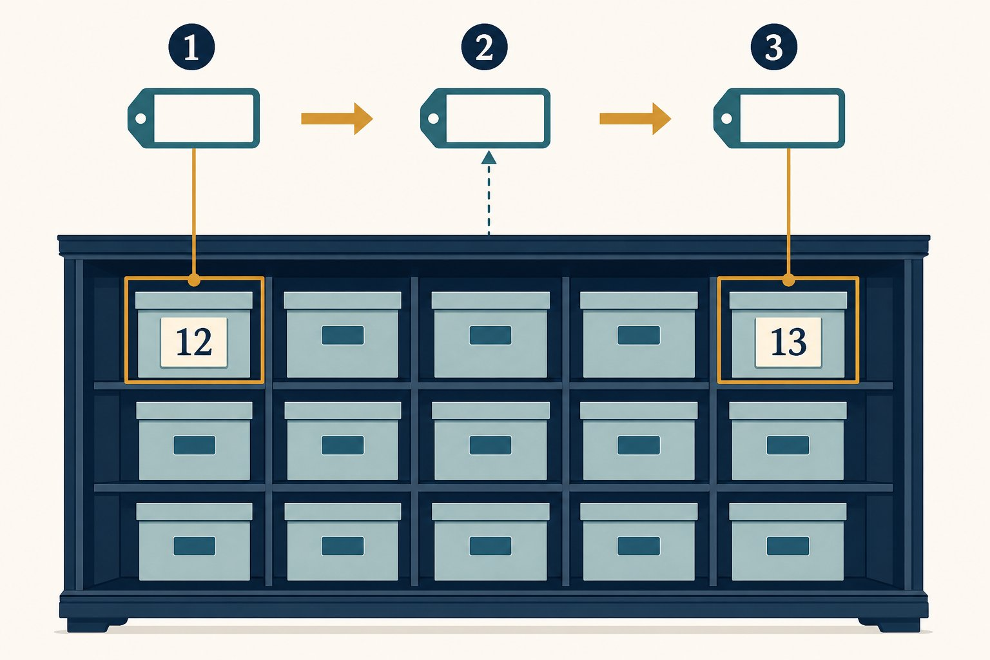
A variable name can refer to a new value.
1 Choose a useful name such as score.
2 Assign the first value to that name.
3 Assign again when the value changes.
OUR MISSION · Keep track of a score
Our program needs to remember a score and then add five.
What we know: Python can display a value.
What we need: A name for the value. • A way to replace the stored value.
PAUSE & THINK
If the score changes, should we edit every old number by hand?
Answer: No. We use one variable name. Later code reads the current value through that name.

Assignment connects a name and a value
A variable is a name that refers to a value. In score = 10, the equals sign means assign. It does not ask a maths question.
A label, not a locked box
Imagine a reusable label named score. First it refers to 10. A later assignment can make the same name refer to 15.
This picture is more accurate than imagining that Python permanently locks one value inside one box. Names and values are separate parts of the story.

Read assignment from right to left
For score = score + 5, Python finishes the right side first. It reads the current value 10. It calculates 10 + 5. Only then does it assign the result 15 back to the name score.
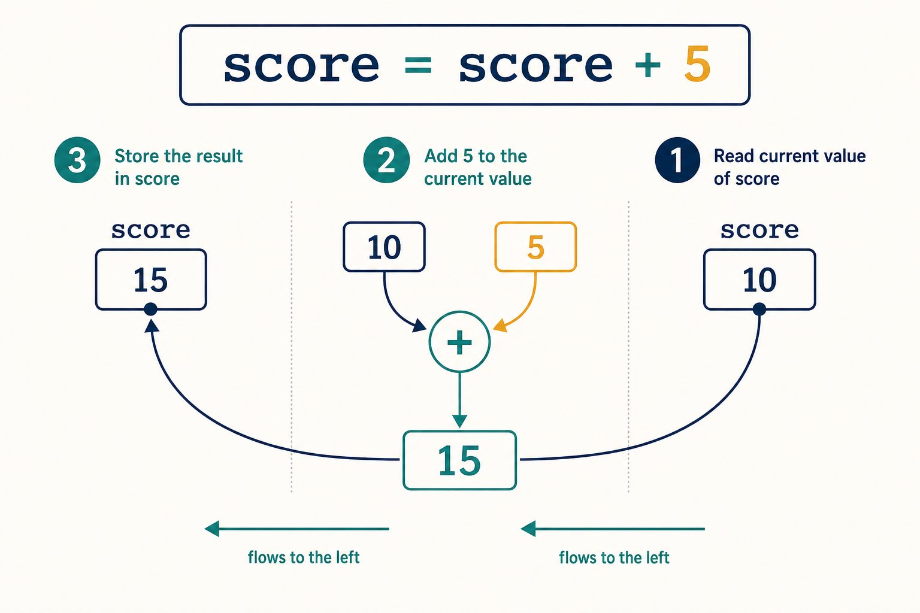
Python finishes the right side before changing the left side.
1 Read the current value of score: 10.
2 Calculate 10 + 5: the result is 15.
3 Assign 15 back to the name score.
Names that help the next reader
A name may use letters, digits and underscores. It cannot begin with a digit. Python treats score and Score as different names.
Choose names that reveal meaning. score helps us more than s, even though both are legal.

Plan before we type
PROGRAM BLUEPRINT
Purpose: Add five to a score.
Input: Starting score: 10.
Processing: Read score, add 5, assign the result back.
Output: 15
Files: score.py

The code
score.py
1 score = 10
2 score = score + 5
3 print(score)

Program run: every step
score.py
1 score = 10
2 score = score + 5
3 print(score)
1. Memory starts empty
No variable names exist yet.
2. Store the first value (line 1)
The name score now refers to the integer 10.
Memory: score = 10
3. Calculate the new value (line 2)
Python reads 10, adds 5 and assigns 15 to score.
Memory: score = 15
4. Read and display score (line 3)
print() receives the current value, which is 15.
Memory: score = 15
Console: 15

Expected output
Terminal
1 $ python score.py
2 15
THE AHA MOMENT
The same variable name can refer to a new value after another assignment.

Try it yourself
- Create score.py.
- Run the example.
- Change the starting score.
- Add another line that subtracts 2.

Common mistakes and fixes
✗ 10 = score
The name belongs on the left side of assignment.
✗ print("score")
Quotes print the word score, not the value stored under that name.
MAKE A GUESS
What is printed?
prediction.py
1 coins = 3
2 coins = coins + 2
3 print(coins)
- A. 2
- B. 3
- C. 5
Answer: 5. Python reads 3, adds 2 and stores 5.
BUG HUNT
Which line uses the wrong variable name?
bug_hunt.py
1 points = 8
2 point = points + 1
3 print(points)
Answer: line 2. Line 2 creates a different name, point. The original points remains 8.

Check your understanding
1. What does = mean in Python?
Answer: It assigns the value on the right to the name on the left.
2. Why does print(score) have no quotes?
Answer: We want Python to read the value named score.

Key takeaways
REMEMBER
- A variable is a name for a value.
- = performs assignment.
- A later assignment can change what a name refers to.

Keep exploring
Python assignment statements — https://docs.python.org/3/reference/simple_stmts.html#assignment-statements
Python identifiers and naming rules — https://docs.python.org/3/reference/lexical_analysis.html#identifiers
NEXT DISCOVERY · Values are not all alike
Next, we discover why 5 and "5" behave differently.

Lesson 4: Data Types: What Kind of Value?
Meet strings, integers, floats and booleans—and see why type changes what Python can do.
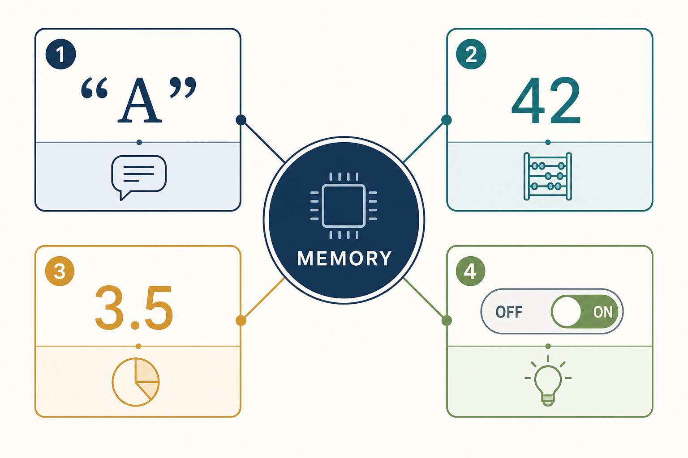
A type tells Python what kind of value it is handling.
1 str stores text.
2 int stores whole numbers.
3 float stores decimal numbers.
4 bool stores True or False.
OUR MISSION · Sort our values
A profile needs a name, age, height and learning status. These values are different kinds of data.
What we know: Variables give values names.
What we need: A way to identify each kind of value. • Rules for what each kind can do.
PAUSE & THINK
Are 12 and "12" the same value?
Answer: No. 12 is a number we can add. "12" is text made of two characters.

A type is a value’s category
A data type tells Python what kind of value it has. The type also tells Python which operations make sense.
Four types to begin with
str means string, which is text. int means integer, which is a whole number. float is a number with a decimal point. bool is either True or False.
The type belongs to the value. A variable name can later refer to a value of another type. This is called dynamic typing. Python tracks the type while the program runs.

The same symbol can mean a different operation
For integers, 3 + 4 means number addition and produces 7. For strings, "3" + "4" means joining text and produces "34". Type gives the + symbol enough context to choose the operation.
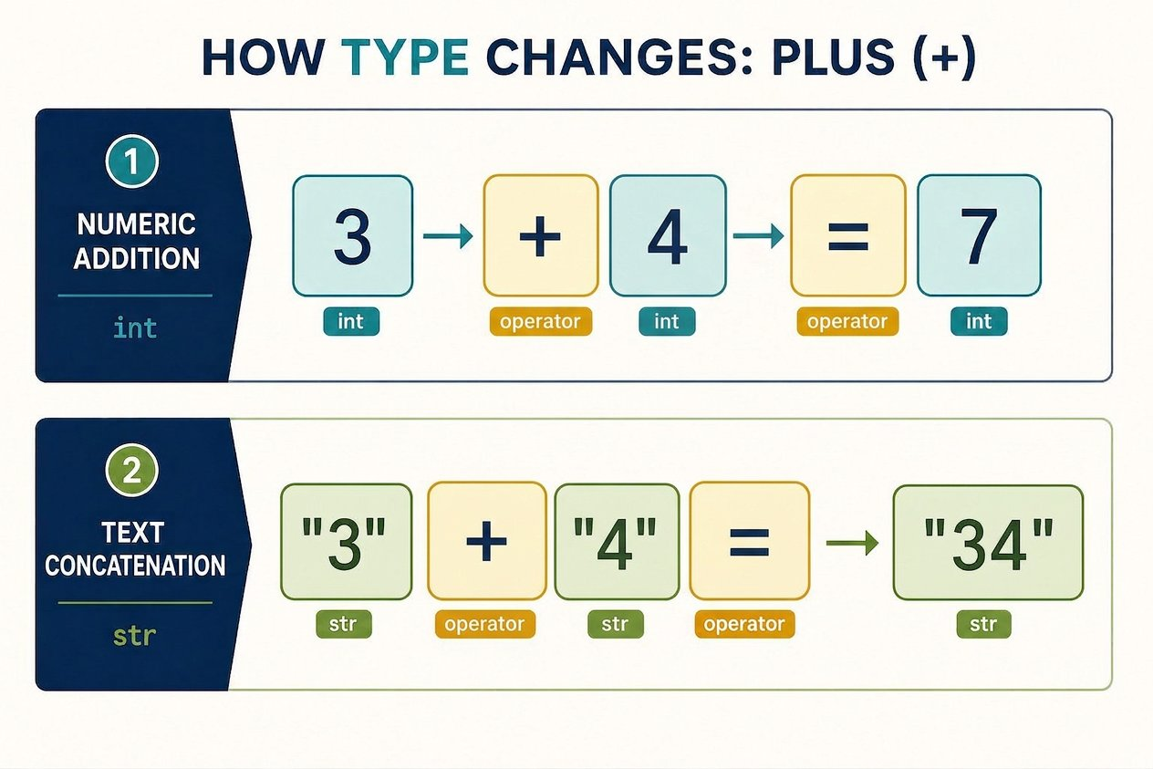
The type changes what the plus sign does.
1 Numbers use + for addition: 3 + 4 becomes 7.
2 Strings use + for joining: "3" + "4" becomes "34".
Type is a safety clue
A label saying “paint” changes how we handle a tin. A type gives Python a similar clue. It prevents unclear requests such as adding the number 1 directly to the text "two".
When types do not match our intention, Python stops with an error instead of silently inventing an answer.

Input → Process → Output
Values  "Asha", 12, 1.52, True | Python  keeps each type | Safe operations  join text, add numbers, test truth

Plan before we type
PROGRAM BLUEPRINT
Purpose: Store a small learner profile.
Input: Text, a whole number, a decimal and a truth value.
Processing: Python stores each value with its type.
Output: The type of name and next year’s age.
Files: types.py

The code
types.py
1 name = "Asha"
2 age = 12
3 height = 1.52
4 is_learning = True
5 print(type(name))
6 print(age + 1)

Program run: every step
types.py
1 name = "Asha"
2 age = 12
3 height = 1.52
4 is_learning = True
5 print(type(name))
6 print(age + 1)
1. Store text (line 1)
Quotes make Asha a string, or str.
Memory: name = "Asha" (str)
2. Store a whole number (line 2)
12 has no quotes and no decimal point, so it is an int.
Memory: name = "Asha" (str), age = 12 (int)
3. Store a decimal (line 3)
1.52 has a decimal point, so it is a float.
Memory: age = 12 (int), height = 1.52 (float)
4. Store truth (line 4)
True is a bool. Its capital T matters.
Memory: height = 1.52 (float), is_learning = True (bool)
5. Inspect a type (line 5)
type(name) reports that name holds a string.
Memory: name = "Asha" (str)
Console: <class 'str'>
6. Add integers (line 6)
age is an int, so Python can add 1 and print 13.
Memory: age = 12 (int)
Console: <class 'str'> | 13

Expected output
Terminal
1 $ python types.py
2 <class 'str'>
3 13
THE AHA MOMENT
A value is more than the characters we see. Its type tells Python what the value means and which operations are allowed.

Convert only when your intention is clear
int("12") creates the integer 12 from numeric text. str(12) creates the string "12" from a number. Conversion is explicit: we tell Python exactly which meaning we want.

Try it yourself
- Create types.py and run it.
- Use type() on age, height and is_learning.
- Try print("12" + "1").
- Then try print(12 + 1) and compare the results.
- Try print(int("12") + 1) and explain why the answer changes.

Common mistakes and fixes
✗ true
Python booleans begin with a capital letter: True and False.
✗ "12" + 1
Python will not mix text and a number automatically. Convert one value first.
✗ height = 1,52
Python decimal numbers use a dot, not a comma.
MAKE A GUESS
What does this print?
prediction.py
1 print("3" + "4")
- A. 7
- B. 34
- C. An error
Answer: 34. Both values are strings. + joins strings, so the result is 34.
BUG HUNT
Which line causes a TypeError?
bug_hunt.py
1 tickets = "2"
2 total = tickets + 1
3 print(total)
Answer: line 2. Line 2 tries to add a string and an integer. Python needs an explicit conversion.

Check your understanding
1. Which type stores a whole number?
Answer: int stores whole numbers such as 0, 12 and -5.
2. What is a bool?
Answer: A truth value: True or False.
3. Why is "5" not an int?
Answer: Quotes make it a string.
4. What does dynamic typing mean here?
Answer: Python tracks types while the program runs, and one name can later refer to a value of another type.

Key takeaways
REMEMBER
- str stores text; int stores whole numbers.
- float stores decimal numbers; bool stores True or False.
- The type belongs to the value and controls valid operations.
- type(value) reports a value’s type.
- int() and str() perform explicit conversions.

Keep exploring
Python built-in types — https://docs.python.org/3/library/stdtypes.html
NEXT DISCOVERY · How does a reader give us a value?
Next, we use input() and learn why typed input begins as a string.

About the author
Akshat Sinha is the founder of The Sinha Family Group and the creator of Sarva Gyana Koshah — the treasury of all knowledge — which teaches through books, videos, and hands-on learning.
This book was written for the reader who has never written a line of code, and wants to finally understand what the computer is doing — not just copy-paste.

Keep learning
Keep guessing, running and checking.
Sarva Gyana Koshah Books · The Treasury of All Knowledge

