
SARVA GYANA KOSHAH BOOKS
The Treasury of All Knowledge
Zero to Agentic API Testing
The Modern Guide to Testing APIs with Postman, JavaScript and Newman
Standalone
Akshat Sinha
First Edition · 2026

Zero to Agentic API Testing
© 2026 by Akshat Sinha. All rights reserved.
Published by Sarva Gyana Koshah Books, a division of The Sinha Family Group.
No part of this publication may be reproduced, distributed, or transmitted in any form or by any means, including photocopying, recording, or other electronic or mechanical methods, without the prior written permission of the publisher, except for brief quotations in reviews.
Code and API examples are provided for educational and testing purposes. Ensure you have authorized permission before running automated test suites against any third party or production systems.
To every engineer and tester dedicated to making software reliable, transparent, and resilient in an increasingly automated world.

Acknowledgements
Gratitude to the open source creators of the HTTP, JSON, Postman, and Node.js testing communities whose tools empower modern developers.
To the readers of Sarva Gyana Koshah: your relentless curiosity drives this work forward.

Contents

In Microsoft Word, right-click this list and choose Update Field if page numbers are not visible.

Preface: Why API Testing is the Linchpin of Modern Software
Software no longer lives on an isolated computer. Every application you touch, from ordering groceries and booking flights to querying an AI assistant, is an orchestra of independent backend services exchanging messages across the globe.
The Invisible Nervous System
When you look at a building, you see the walls, windows, and doors. You do not see the electrical conduits, water pipes, or structural steel that keep the building alive and standing.
In modern software architecture, the user interface is just the paint on the walls. The APIs, Application Programming Interfaces, are the invisible plumbing and wiring that carry business logic, user identities, and financial transactions.
If the user interface flickers, a user experiences a minor annoyance. If an API breaks, entire businesses grind to a halt.

Why this book begins at Ground Zero
Too many guides jump straight into complex automation frameworks or command line scripts without first establishing what is actually happening on the wire. We refuse to take shortcuts. Whether you are a manual tester stepping into automation or an engineer learning backend contracts, this book builds your mental model from first principles.
From Human Interfaces to Automated Systems
For decades, APIs were consumed by human built frontend apps. Today, automated pipelines and autonomous systems discover and execute APIs to complete complex workflows.
An API with loose validation or brittle status codes might survive human clicks, but automated systems will fail or trigger unexpected loops. Testing APIs is about building reliable, verified contracts.

Key takeaways
REMEMBER
- APIs are the contractual nervous system of modern software architecture.
- Understanding HTTP and wire level contracts prevents fragile, brittle automation.
- Testing APIs at the service layer yields the highest speed, stability, and return on investment.
- Automated systems demand high schema precision, error resilience, and idempotency.

Keep exploring
The Testing Pyramid by Martin Fowler — https://martinfowler.com/articles/practical-test-pyramid.html
IETF RFC 9110: HTTP Semantics Overview — https://www.rfc-editor.org/rfc/rfc9110.html

How to use this book
Read the opening mission to understand the real world software problem we are diagnosing.
Study the complete network wire: examine the HTTP method, resource path, headers, request payload, and server response codes.
Attempt every prediction before checking the verified outcome: write down your predicted status code, response body, and server state in the provided exercise spaces.
Follow the step by step setup commands to build your own runnable server and executable Postman test collection as you progress through each chapter.
Compare your observations with the recorded terminal transcripts, wire captures, and troubleshooting recovery checks.

Chapter 1: Understanding APIs from First Principles
The restaurant analogy, the five core operations, building your own minimal server, and tasting REST, SOAP, and GraphQL.
MISSION BRIEFING & CHAPTER ROADMAP
MISSION 1 · PHASE 1 OF 3: WIRE FOUNDATIONS AND FIRST PRINCIPLES: Global Open Data and Web Wire Audit
CRISIS SCENARIO: The Apex Campus Launch Crisis: When the Frontend Lost Its Voice
Context: On the eve of university orientation, the student mobile application failed to display campus data. The triage war room discovered a silent disconnect between client UI code and backend services. To resolve the crisis and establish lasting quality gates, we must inspect the wire from first principles, construct a minimal server, and audit every core HTTP operation.
Operational Target: Build a runnable server from scratch, execute all five CRUD operations, and verify payload contracts across REST, SOAP, and GraphQL.

WE WILL ACHIEVE: Understand what an Application Programming Interface actually does on the physical network wire. Distinguish in memory code libraries from network web services. Build a fully runnable Express server from scratch. Master the five essential CRUD verbs (POST, GET, PUT, PATCH, DELETE) and taste the architectural differences between REST, SOAP, and GraphQL.
HOW WE WILL DO IT: Through four interconnected comic scenes, visual storyboards, interactive code workbenches, and war room diagnostic triage challenges following junior QA engineer Akshay and mentor Sameer.
WHAT YOU WILL CARRY FORWARD: The mental model of the client server handshake, an intuitive grasp of HTTP status codes, and the confidence to inspect raw wire traffic rather than relying blindly on UI screens.
MISSION COMMAND HUD
PHASE: Phase 1 of 3: Foundations · RANK: Apprentice Wire Inspector
ACTIVE MISSION: Mission 1: Global Open Data and Web Wire Audit
The Checklist Kingdom
COMIC SCENE 1 OF 4
The Checklist Kingdom
Morning at the Apex University engineering bay. Akshay starts his day running repetitive manual regression tests from a printed binder.
PANEL 1: The Manual Routine (09:15 AM)


PANEL 2: The Pipeline Fear (09:28 AM)
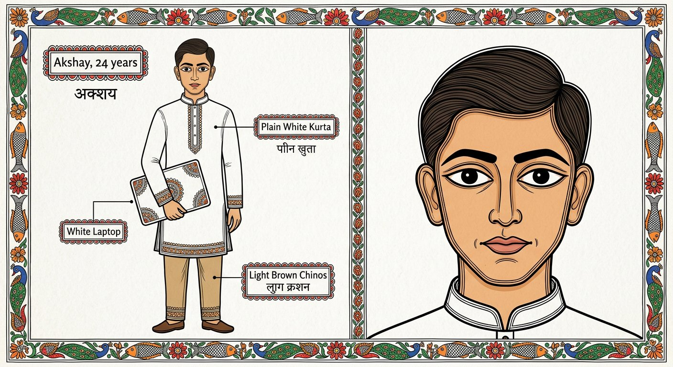

PANEL 3: The Browser Address Bar Trap (09:42 AM)
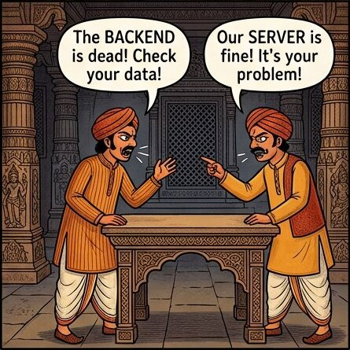

PANEL 4: The Reader Prediction (09:55 AM)


WAR ROOM INCIDENT TRIAGE
Browser Address Bar Diagnostic Triage
Akshay attempts to test a new student registration feature by pasting the endpoint URL into his web browser address bar. The feature fails to create a record. What is the fundamental technical limitation of the browser address bar?
A. The browser address bar can only trigger HTTP GET requests and cannot carry an HTTP POST body payload or custom headers
B. The browser address bar encrypts all outgoing text, preventing the backend from reading plain JSON objects
C. The browser address bar refuses to communicate with local development servers running on localhost
TACTICAL TRIUMPH: Tactical Triumph: The browser address bar speaks exactly one dialect: simple HTTP GET navigation without request body payloads or custom authorization headers. Creating resources requires an HTTP POST request carrying a serialized JSON payload, which necessitates a dedicated API testing workbench.
ARCHITECTURE · The Frontend to Backend API Bridge: Separating UI from Persistence
ARCHITECTURAL BLUEPRINT · The Frontend to Backend API Bridge: Separating UI from Persistence
Modern applications separate presentation from business data. The user interface runs on phones, laptops, and smart tablets, while databases run on secured server clusters. APIs form the structured contract layer connecting these distinct tiers over HTTP.
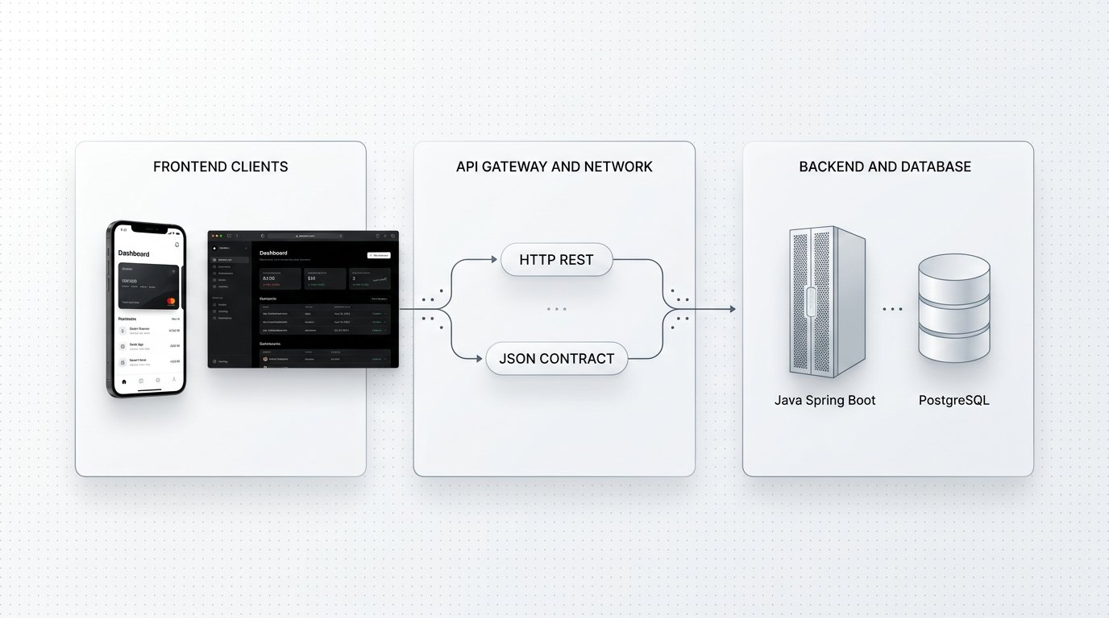
The API Bridge: Decoupling client interfaces from backend persistence through standardized HTTP contracts.
1 Client Presentation Layer: Mobile applications and browsers that render user interfaces but store zero durable data.
2 API Contract Layer: Standardized HTTP endpoints exposing predictable paths, methods, and JSON payloads.
3 Persistence Layer: Relational databases, cache clusters, and background processors executing business transactions.
The Cafeteria Crisis
COMIC SCENE 2 OF 4
The Cafeteria Crisis
Lunchtime at the university cafeteria. The digital order tablet is frozen, and Akshay learns why UI screens cannot be trusted during outages.
PANEL 1: The Standoff at the Screen (12:04 PM)
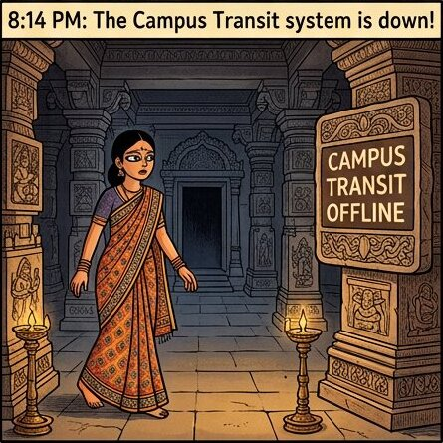

PANEL 2: Holding the Physical Wire (12:12 PM)


PANEL 3: The First Law of Distributed Objects (12:20 PM)


PANEL 4: The Postcard in an Envelope & The Waiter Model (12:35 PM)
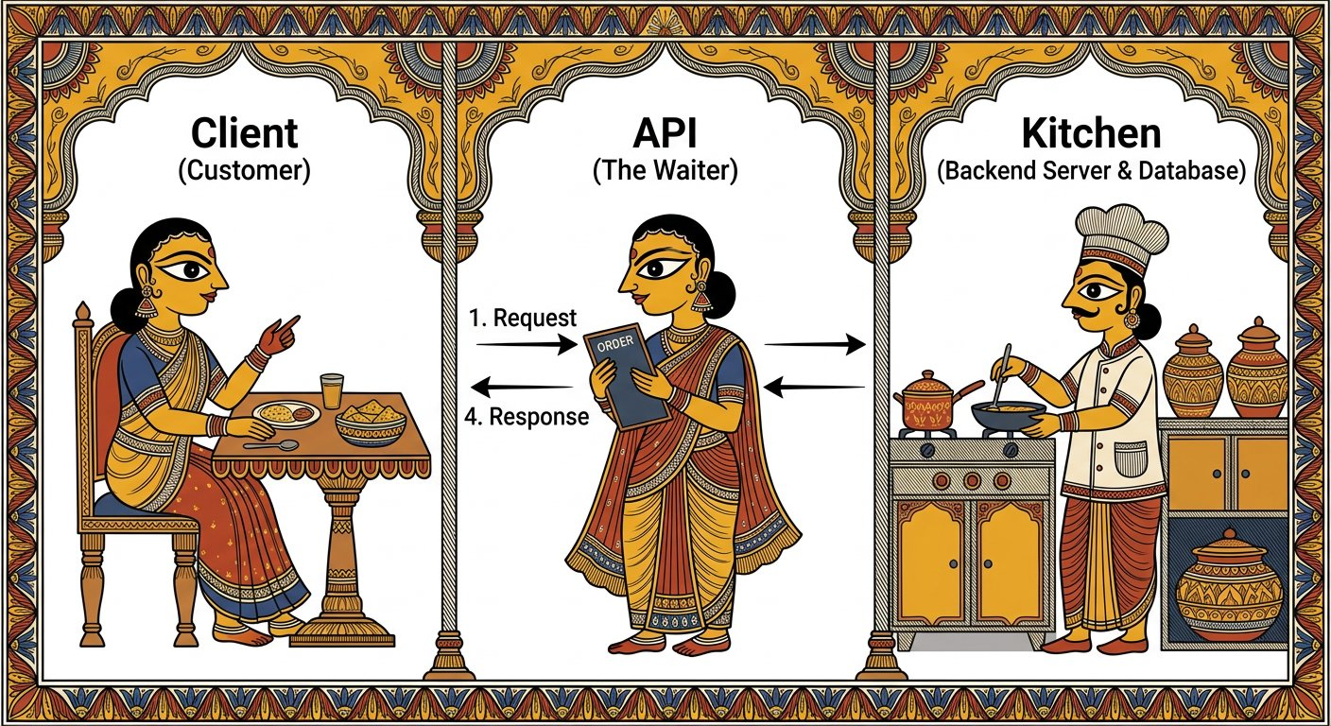

ARCHITECTURE · HTTP Wire Architecture: Client to Backend Lifecycle
VECTOR WIRE BLUEPRINT · HTTP Wire Architecture: Client to Backend Lifecycle
The full journey of an HTTP wire transaction: from client serialization across network sockets to middleware stream buffering and port binding on the backend.
HTTP Wire Architecture: How serialized byte chunks cross the wire to port 3000.
1 Client Environment: Generates HTTP verb and serialized JSON payload.
2 Network Wire: Transmits discrete TCP byte buffers across physical network interfaces.
3 Backend Service: express.json middleware buffers incoming stream chunks before route handlers execute.

Input → Process → Output
Client Request  GET /courses HTTP/1.1 with Host and Accept headers | Express Route Handler  Query catalog store in RAM and serialize JSON payload | Wire Response  200 OK with Content-Type application/json array
Auditing the Menu GET Wire Transaction
COMIC WORKBENCH · WIRE AUDIT
Auditing the Menu GET Wire Transaction

API Request: GET http://localhost:3000/courses

Live Response: 200 OK (18 ms)
response.json
1 [
2 {
3 "code": "CS101",
4 "title": "Foundations of Computer Systems",
5 "department": "Computer Science",
6 "credits": 4
7 },
8 {
9 "code": "CS204",
10 "title": "Data Structures and Algorithms",
11 "department": "Computer Science",
12 "credits": 4
13 }
14 ]
1. Explicit Input: GET http://localhost:3000/courses sent from workbench with Accept application/json.
2. Wire & Logic Explanation: The request travels over TCP port 3000. Express matches the path to app.get(/courses) and flushes the courses array serialized as JSON.
3. Deterministic Output: HTTP status 200 OK with two course objects in an array payload.
4. Senior Savior & Common Trap: Senior Savior Trap: Believing a missing screen means a broken server. Golden Rule: The wire does not lie; always check HTTP status codes and wire responses before blaming backend services.
ARCHITECTURE · Anatomy of an HTTP Wire Transaction: Request Line, Headers, and Payloads
PROTOCOL DECONSTRUCTION · Anatomy of an HTTP Wire Transaction: Request Line, Headers, and Payloads
Every communication over the web is broken down into discrete HTTP transactions consisting of request metadata, entity headers, and optional payload bodies.
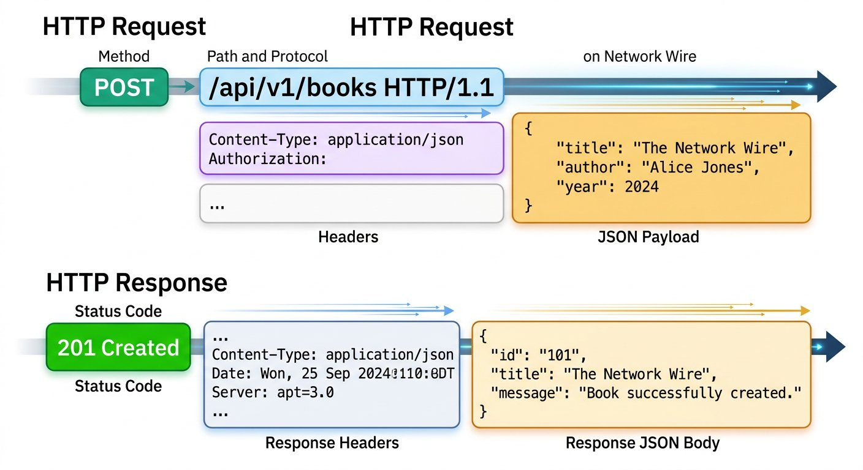
HTTP Transaction Anatomy: Complete wire breakdown of request and response packet structures.
1 Request Line: Method verb (GET, POST), target path resource (/courses), and protocol version (HTTP/1.1).
2 Headers Section: Metadata providing encoding rules, authorization tokens, content types, and caching policies.
3 Body Payload: Structured text (typically JSON) carrying operational data from client to server or server to client.
4 Response Status Line: Three digit numeric code confirming success (200), client error (400), or server fault (500).
WAR ROOM BATTLE SCAR · PRODUCTION ARCHITECTURE LAW
The First Law of Distributed Objects
Martin Fowler formulated the First Law of Distributed Object Design: Do not distribute your objects. Engineers often assume remote network calls behave like local function calls. A local function call in memory executes in nanoseconds and never suffers packet drops. A network call crosses physical routers, switches, and serialization boundaries where latency multiplies by ten thousand and connections can fail at any instant.
Key Architectural Lesson: Never assume the server is in the same room as your data. Treat every network transaction as a fallible conversation requiring explicit status checks, timeouts, and defensive contracts.
Building the Minimal Server
COMIC SCENE 3 OF 4
Building the Minimal Server
In Sameer quiet corner lab, Sameer guides Akshay to construct a runnable Express catalog server from first principles.
PANEL 1: The Two Ends of the Wire (02:15 PM)


PANEL 2: Assembling Express on Port 3000 (02:30 PM)
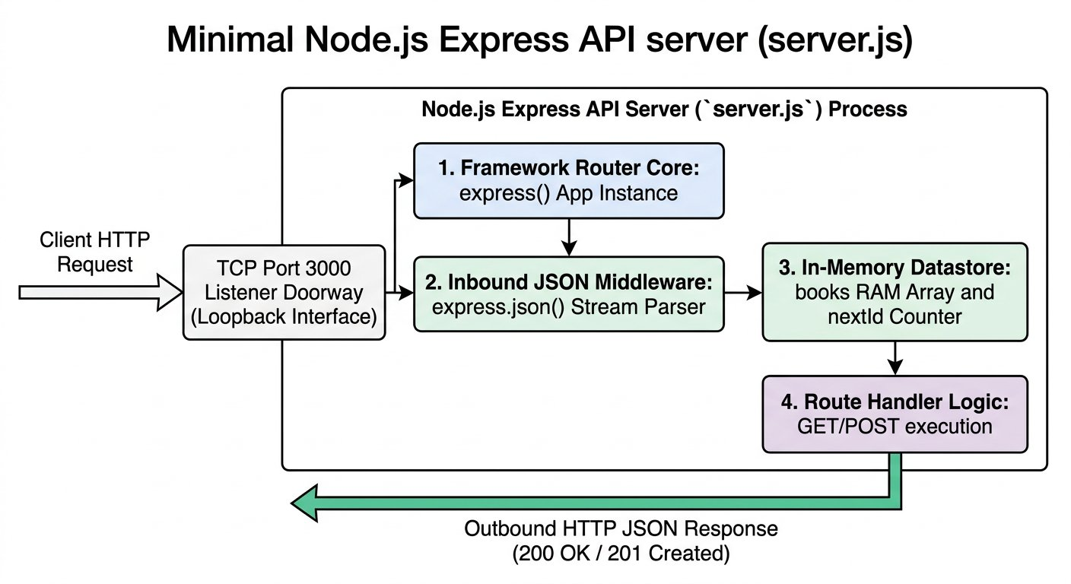

PANEL 3: The Undefined Body Crash (02:48 PM)


PANEL 4: Mounting express.json & Challenge Reveal (03:05 PM)

Constructing server.js in the IDE
COMIC WORKBENCH · CODE IMPLEMENTATION
Constructing server.js in the IDE

IDE File: server.js (Active · Node.js v22)
server.js
1 import express from 'express'
2
3 const app = express()
4 app.use(express.json())
5
6 const courses = [
7 { code: 'CS101', title: 'Foundations of Computer Systems', department: 'Computer Science', credits: 4, status: 'Active' },
8 { code: 'CS204', title: 'Data Structures and Algorithms', department: 'Computer Science', credits: 4, status: 'Active' }
9 ]
10
11 app.get('/courses', (req, res) => {
12 res.status(200).json({ total: courses.length, courses })
13 })
14
15 app.post('/courses', (req, res) => {
16 const newCourse = req.body
17 courses.push(newCourse)
18 res.status(201).json({ message: 'Course successfully registered', course: newCourse })
19 })
20
21 app.listen(3000, () => {
22 console.log('Apex Campus Catalog Service live on port 3000')
23 })
1. Explicit Input: Node server.js executed in the terminal.
2. Wire & Logic Explanation: The Node.js process binds to port 3000, initializes the in memory courses array, and waits for incoming HTTP TCP connections.
3. Deterministic Output: Terminal logs confirmation: Apex Campus Catalog Service live on port 3000.
4. Senior Savior & Common Trap: Senior Savior Trap: Forgetting app.use(express.json()) causes req.body to remain undefined on POST requests. Golden Rule: Express readable streams require explicit body parsing middleware to reconstruct JSON objects from network buffers.

Plan before we type
PROGRAM BLUEPRINT
Purpose: Spin up a minimal Express HTTP catalog service with stream middleware and full CRUD routes.
Input: HTTP requests arriving over TCP port 3000 carrying methods, paths, headers, and JSON bodies.
Processing: Express routes requests, express.json() buffers binary socket chunks into req.body, and handlers mutate catalog array in RAM.
Output: HTTP status codes (200 OK, 201 Created) and JSON payloads dispatched back across socket.
Files: server.js

The code
server.js
1 const express = require("express");
2 const app = express();
3 const PORT = 3000;
4
5 // Mandatory stream buffer middleware: parses incoming JSON bodies
6 app.use(express.json());
7
8 // In memory course catalog array
9 let courses = [
10 { code: "CS101", title: "Foundations of Computer Systems", department: "Computer Science", credits: 4 },
11 { code: "CS204", title: "Data Structures and Algorithms", department: "Computer Science", credits: 4 }
12 ];
13
14 // 1. GET /courses: Read all catalog records
15 app.get("/courses", (req, res) => {
16 res.status(200).json({ total: courses.length, courses });
17 });
18
19 // 2. POST /courses: Create new course record
20 app.post("/courses", (req, res) => {
21 const newCourse = req.body;
22 courses.push(newCourse);
23 res.status(201).json({ message: "Course successfully registered", course: newCourse });
24 });
25
26 // 3. PUT /courses/:code: Complete document replacement
27 app.put("/courses/:code", (req, res) => {
28 const idx = courses.findIndex(c => c.code === req.params.code);
29 if (idx === -1) return res.status(404).json({ error: "Course not found" });
30 courses[idx] = req.body;
31 res.status(200).json({ message: "Course replaced", course: courses[idx] });
32 });
33
34 // 4. PATCH /courses/:code: Surgical delta attribute update
35 app.patch("/courses/:code", (req, res) => {
36 const course = courses.find(c => c.code === req.params.code);
37 if (!course) return res.status(404).json({ error: "Course not found" });
38 Object.assign(course, req.body);
39 res.status(200).json({ message: "Course updated", course });
40 });
41
42 // 5. DELETE /courses/:code: Remove course from database
43 app.delete("/courses/:code", (req, res) => {
44 courses = courses.filter(c => c.code !== req.params.code);
45 res.status(200).json({ message: "Course deleted successfully" });
46 });
47
48 app.listen(PORT, () => {
49 console.log(`Apex Campus Catalog Service live on port ${PORT}`);
50 });
Deconstructing the Minimal Express Server
Every production web service consists of four core responsibilities: loading libraries, configuring stream parsers, routing verbs, and binding a network socket.
CHUNK 1: Core Initialisation · Instantiating Express
Loads Express and instantiates the application object. The port variable reserves TCP port 3000 for incoming connections.
server.js
1 const express = require("express");
2 const app = express();
3 const PORT = 3000;
Rule: Express acts as the application layer router between Node.js network sockets and your code.
CHUNK 2: Stream Middleware · Buffering the Request Stream
Without this single line, req.body is undefined. HTTP request bodies arrive across TCP as discrete chunks. This middleware buffers every chunk, concatenates them into a single UTF8 string, parses the JSON, and attaches the resulting object to req.body.
server.js
1 app.use(express.json());
Rule: The network stream emits chunks over time; express.json() waits for all chunks before passing control to your handler.
CHUNK 3: The Route Handlers · Matching Method and Path
Routes map an incoming HTTP verb and path pattern to a JavaScript callback function. The response object sets the exact numeric status code and serializes the memory object to JSON.
server.js
1 app.get("/courses", (req, res) => res.status(200).json({ total: courses.length, courses }));
2 app.post("/courses", (req, res) => {
3 const newCourse = req.body;
4 courses.push(newCourse);
5 res.status(201).json({ message: "Course successfully registered", course: newCourse });
6 });
Rule: Each route handler is the kitchen chef preparing the exact meal the waiter requested.
CHUNK 4: Binding the Socket · Opening Port 3000 to the Campus Network
Tells the operating system kernel to route all TCP packets arriving on port 3000 to this Node.js process.
server.js
1 app.listen(PORT, () => console.log(`Apex Campus Catalog Service live on port ${PORT}`));
Rule: A port is an operating system mailbox; without listen, nobody can knock on your door.

Program run: every step
server.js
1 app.post("/courses", (req, res) => {
2 const newCourse = req.body;
3 courses.push(newCourse);
4 res.status(201).json({ message: "Course successfully registered", course: newCourse });
5 });
1. TCP Connection and Header Inspection (line 1)
Client opens TCP connection on port 3000. Express verifies POST /courses route match.
Memory: method = "POST", url = "/courses"
Console: Incoming TCP stream on port 3000
2. express.json() Buffering Completed (line 1)
All TCP chunks received. req.body is now populated with the parsed JSON payload.
Memory: req.body.code = "CS301", req.body.title = "Compilers"
Console: Stream reassembly complete: 52 bytes parsed
3. Course Object Attached to Memory (line 2)
Assigns req.body to newCourse in memory.
Memory: newCourse.code = "CS301", newCourse.credits = 4
Console: Captured payload object for CS301
4. Record Appended to RAM Catalog (line 3)
Pushes newCourse into the server courses array. State is updated in server RAM.
Memory: courses.length = 3
Console: Catalog array size updated to 3
5. HTTP 201 Created Dispatched to Wire (line 4)
Express serializes newCourse to JSON, sets status 201 Created, and flushes bytes across socket.
Memory: statusCode = 201, statusMessage = "Created"
Console: HTTP/1.1 201 Created sent to client

Expected output
Terminal
1 $ node server.js
2 Apex Campus Catalog Service live on port 3000
3 Incoming TCP connection from 127.0.0.1:54218
4 HTTP/1.1 GET /courses 200 OK (18 ms)
5 HTTP/1.1 POST /courses 201 Created (24 ms)
6 State updated in RAM: 3 courses active
API Testing Workbench: Live Wire Verification
POST http://localhost:5050/v1/books
Status: 200 OK · Time: 18 ms · Size: 401 B
Response Body:
response.json
1 {
2 "Msg": "successfully added",
3 "ID": "CS10101"
4 }
Assertions Verified:
✓ Status code is 200 OK
✓ Response body confirms record creation
✓ Response contains generated identifier
WAR ROOM INCIDENT TRIAGE
The Undefined Body Incident Triage
Akshay sends a POST request with body { "code": "CS102", "title": "Discrete Mathematics" } to /courses. The server crashes with TypeError: Cannot read properties of undefined. What is the root cause in server.js?
A. The developer forgot to register app.use(express.json()) middleware, so Express did not parse the incoming TCP stream into req.body
B. The client sent JSON formatted text when Express only accepts binary protocol buffers
C. The operating system blocked port 3000 because POST requests require administrative root privileges
TACTICAL TRIUMPH: Tactical Triumph: By default, Express treats incoming request streams as unparsed chunks of bytes. Without express.json() middleware installed, req.body is undefined. Attempting to access properties on undefined throws an uncaught TypeError.
The Five CRUD Operations and Protocol Tasting
COMIC SCENE 4 OF 4
The Five CRUD Operations and Protocol Tasting
With the server running on port 3000, Akshay uses the API Testing Workbench to execute all five HTTP operations and compare REST against SOAP and GraphQL.
PANEL 1: The CRUD Verbs in Action (03:40 PM)
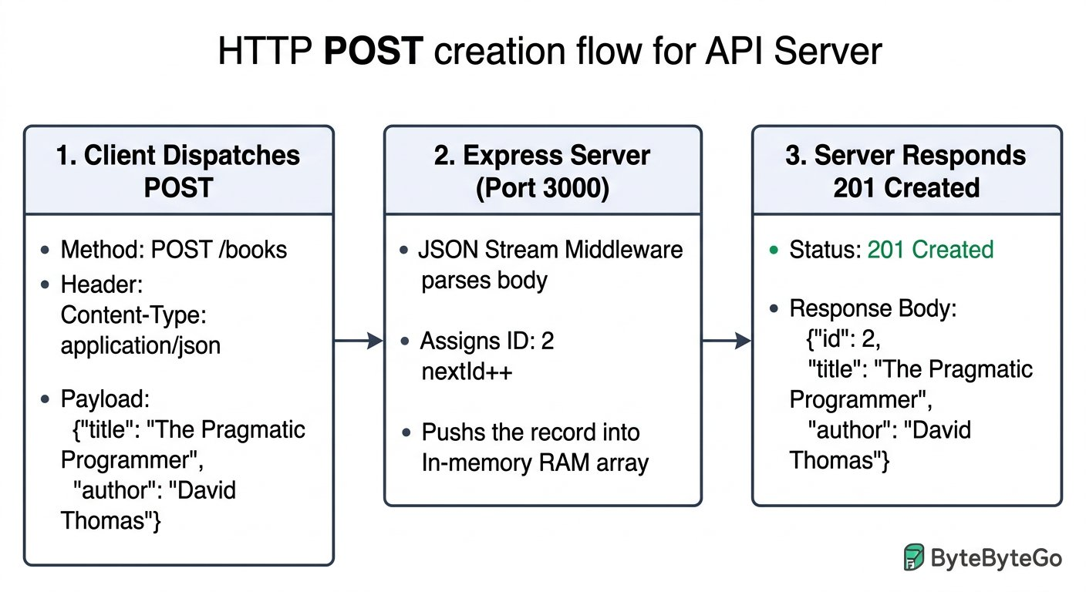

PANEL 2: The PUT Overwrite Accident (04:02 PM)
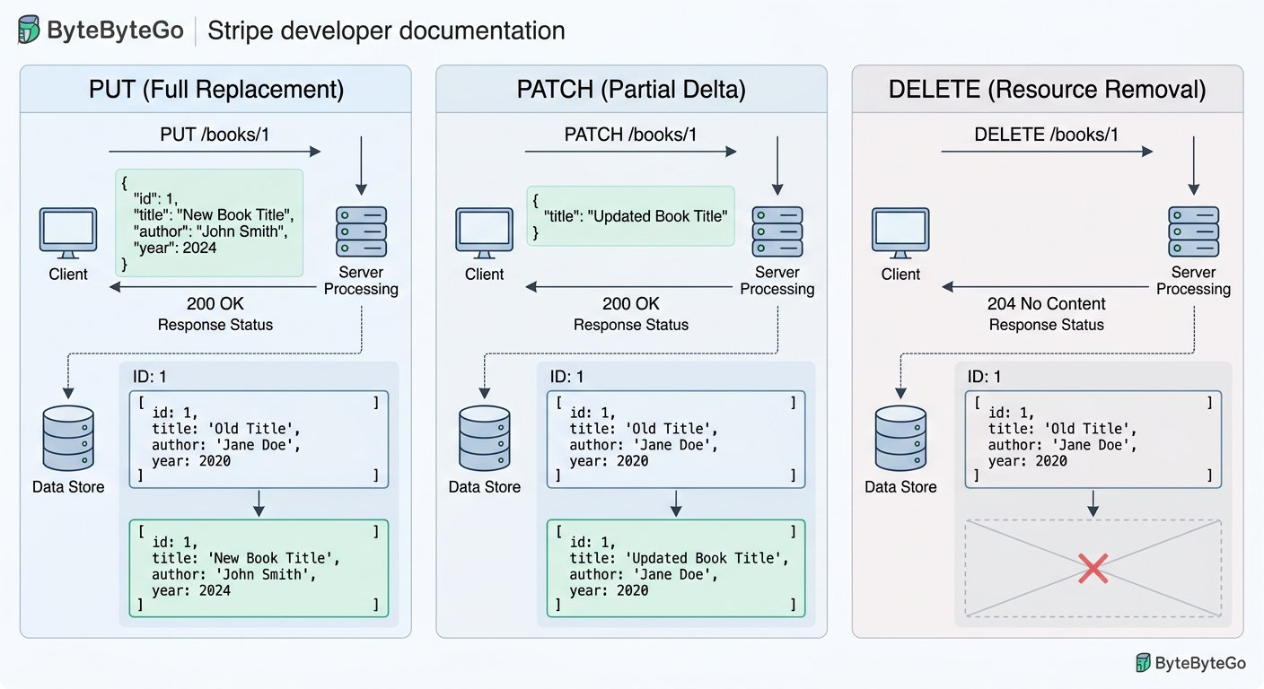

PANEL 3: Protocol Tasting: REST vs SOAP vs GraphQL (04:30 PM)
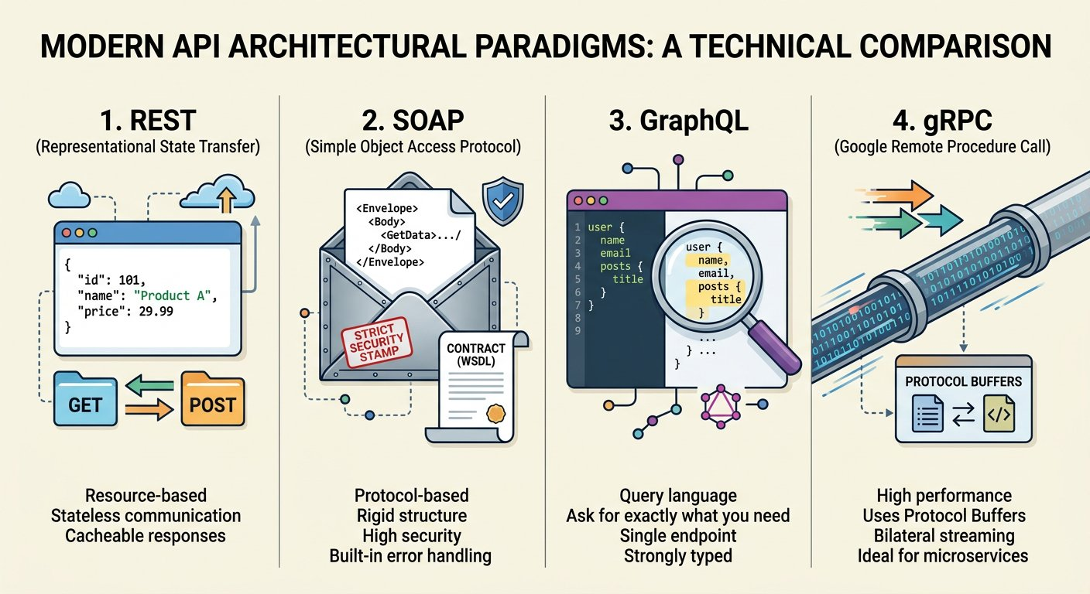

PANEL 4: The First Victory (05:00 PM)


Auditing Course Creation with POST
COMIC WORKBENCH · CRUD AUDIT
Auditing Course Creation with POST

API Request: POST http://localhost:3000/catalog

Request Body:
request_body.json
1 {
2 "title": "Algorithms and Architecture",
3 "seats": 25
4 }
Live Response: 201 Created (24 ms)
response.json
1 {
2 "id": 103,
3 "title": "Algorithms and Architecture",
4 "seats": 25
5 }
1. Explicit Input: POST /catalog carrying JSON body { "title": "Algorithms and Architecture", "seats": 25 }.
2. Wire & Logic Explanation: Headers declare Content-Type application/json. express.json buffers the TCP socket chunks, reassembles the string, parses the object into req.body, and the route handler pushes to catalog array.
3. Deterministic Output: 201 Created with echoed object including newly assigned identifier 103.
4. Senior Savior & Common Trap: Senior Savior Trap: Testing only happy path 200 GET requests and skipping POST body serialization checks. Golden Rule: Always verify that your client sets Content-Type application/json when dispatching request payloads.
ARCHITECTURE · POST Operation Wire Flow: Submitting Payloads and 201 Created
CRUD DEEP DIVE · POST · POST Operation Wire Flow: Submitting Payloads and 201 Created
POST requests submit new entity payloads to collections. The server assigns an identifier, mutates database records, and returns HTTP 201 Created.
POST Lifecycle: Client submission, server record creation, and 201 Created response dispatch.
1 Method Intent: Non idempotent operation creating a new child resource beneath a target collection.
2 Request Body: Serialized JSON object carrying attributes to insert.
3 Expected Response: HTTP 201 Created accompanied by the newly generated resource representation or Location header.
ARCHITECTURE · GET Operation Wire Flow: Querying Resources and 200 OK
CRUD DEEP DIVE · GET · GET Operation Wire Flow: Querying Resources and 200 OK
GET requests retrieve representation snapshots without mutating server state. They must remain safe and idempotent across repetitive calls.
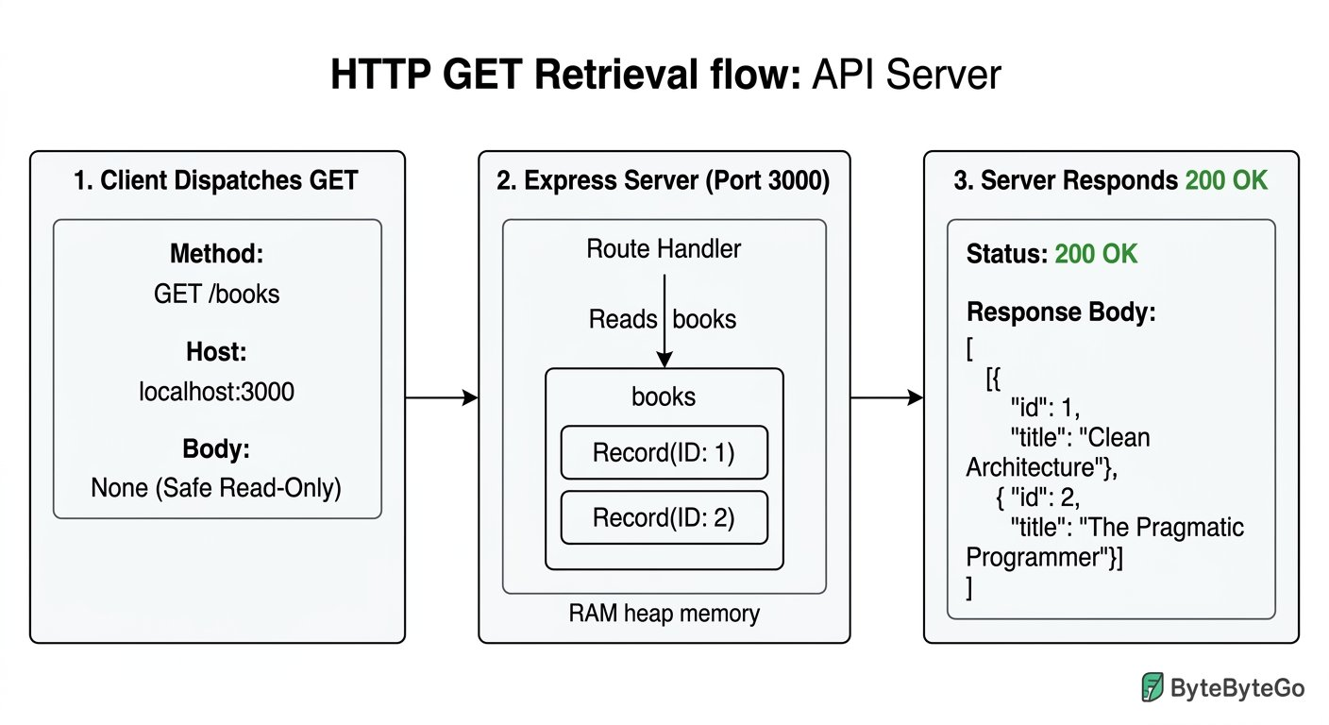
GET Lifecycle: Safe query dispatch, cache headers, and idempotent data retrieval.
1 Safety Invariant: Executing GET ten thousand times must never modify server database records.
2 Caching Semantics: GET responses can be safely cached by intermediate proxies, CDNs, and browser storage.
3 Status Codes: Returns 200 OK when found, or 404 Not Found when the identifier does not exist.
ARCHITECTURE · PUT vs PATCH vs DELETE: Understanding Modification Semantics
CRUD DEEP DIVE · MODIFICATIONS · PUT vs PATCH vs DELETE: Understanding Modification Semantics
Mastering HTTP verbs requires distinguishing full resource replacement (PUT) from surgical delta modifications (PATCH) and permanent purging (DELETE).
Modification Semantics: Contrasting replacement, delta patching, and deletion mechanics.
1 PUT Replacement: Overwrites the target resource entirely; omitted fields are wiped from server memory.
2 PATCH Delta: Modifies only the specified keys, preserving existing unmentioned attributes.
3 DELETE Removal: Purges the specified resource identifier; subsequent reads typically return 404 Not Found.
Auditing Full Replacement (PUT) versus Delta Patch (PATCH)
COMIC WORKBENCH · VERB AUDIT
Auditing Full Replacement (PUT) versus Delta Patch (PATCH)

API Request: PATCH http://localhost:3000/courses/CS101

Request Body:
request_body.json
1 {
2 "status": "Inactive"
3 }
Live Response: 200 OK (15 ms)
response.json
1 {
2 "code": "CS101",
3 "title": "Foundations of Computer Systems",
4 "department": "Computer Science",
5 "credits": 4,
6 "status": "Inactive"
7 }
1. Explicit Input: PATCH /courses/CS101 with payload { "status": "Inactive" }.
2. Wire & Logic Explanation: Express locates course CS101 and uses Object.assign to mutate only the status field, preserving code, title, department, and credits intact.
3. Deterministic Output: 200 OK with the preserved record reflecting only the updated status value.
4. Senior Savior & Common Trap: Senior Savior Trap: Using PUT when you only intended to update a single attribute causes accidental data loss. Golden Rule: Use PUT only when supplying the complete document representation; use PATCH for partial delta edits.
ARCHITECTURE · Protocol Comparison Matrix: REST vs SOAP vs GraphQL
PROTOCOL MATRIX · Protocol Comparison Matrix: REST vs SOAP vs GraphQL
Enterprise environments balance multiple API architectures. While REST remains the internet standard, legacy enterprise services rely on SOAP XML envelopes, and modern data intensive clients favor GraphQL query flexibility.
Enterprise Protocol Landscape: Comparing REST, SOAP, and GraphQL on the wire.
1 REST: Resource oriented, uses standard HTTP verbs, lightweight JSON bodies, highly cacheable.
2 SOAP: Operation oriented, enforces strict WSDL XML contracts, transport independent, enterprise WS standards.
3 GraphQL: Query oriented, single endpoint POST /graphql, client specifies exact fields, prevents over fetching.
Comparing REST, SOAP, and GraphQL on the Wire
COMIC WORKBENCH · PROTOCOL TASTING
Comparing REST, SOAP, and GraphQL on the Wire

API Request: POST http://localhost:3000/graphql

Request Body:
request_body.json
1 {
2 "query": "query { course(code: \"CS101\") { code title } }"
3 }
Live Response: 200 OK (22 ms)
response.json
1 {
2 "data": {
3 "course": {
4 "code": "CS101",
5 "title": "Foundations of Computer Systems"
6 }
7 }
8 }
1. Explicit Input: POST /graphql with GraphQL query requesting only code and title attributes.
2. Wire & Logic Explanation: The GraphQL engine parses the query AST, evaluates field resolvers against the catalog database, and filters out unrequested fields.
3. Deterministic Output: 200 OK with custom data object containing only the requested fields.
4. Senior Savior & Common Trap: Senior Savior Trap: Expecting HTTP 404 or 500 status codes on GraphQL resolver failures. Golden Rule: GraphQL almost always returns HTTP 200 OK; you must inspect the errors array inside the JSON payload to detect failures.
⚡ ARCHITECTURAL TRIUMPH · Phase 1 Complete: First Principles Wire Mastered
Akshay transitioned from passive checklist clicking to active wire auditing, constructing a runnable Express server on port 3000, mastering stream buffer middleware, and verifying all five CRUD operations across REST, SOAP, and GraphQL.
Tactical Superpowers Mastered:
- Read raw HTTP wire packets without relying on frontend UI screens
- Assembled a runnable Node.js Express server on port 3000 from scratch
- Mounted express.json middleware to prevent undefined body crashes
- Executed all five core CRUD operations (POST, GET, PUT, PATCH, DELETE)
- Audited the wire differences between REST JSON, SOAP XML, and GraphQL
Enterprise Disasters Prevented:
- Prevented silent data erasure caused by confusing PUT full replacement with PATCH delta updates
- Eliminated false bug tickets filed against backend servers when client UIs freeze
- Avoided unhandled Node.js crashes by properly installing readable stream buffering middleware
War Room Takeaway: The wire does not lie. When client screens freeze or dashboards misbehave, the seasoned engineer bypasses the glass, opens the API Testing Workbench, and reads the raw HTTP packets directly.
NEXT DISCOVERY · The Campus Transit Shuttle 500 Crash
Evening settles over Apex University. Akshay and Sameer celebrate their working catalog server with hot samosas when suddenly, an amber alert flashes across the campus operations monitor. The automated GPS transit shuttle tracking system has stopped broadcasting coordinates. Commuter shuttles across the university are navigating blind, and the triage dashboard displays a single ominous error: 500 Internal Server Error. The manual checklist era is officially over. Tomorrow morning, Akshay must step into the war room and track down the phantom crash.

Chapter 2: Investigating the Incident: Manual Wire Auditing and Status Codes
The campus transit shuttle crisis, dissecting status code families, comparing URLs, diagnosing the 500 crash by hand, and verifying the 400 guard and 200 contract.
MISSION BRIEFING & CHAPTER ROADMAP
MISSION 1 · PHASE 2 OF 3: THE MANUAL WIRE INVESTIGATION: Global Open Data and Web Wire Audit
CRISIS SCENARIO: The Campus Transit Shuttle Crash: Diagnosing the 500 Server Error
Context: The student shuttle tracking service crashed on day one of orientation whenever students opened the route tracker without selecting a destination. The frontend team blamed the backend, while backend logs showed an unhandled NullPointerException. In this phase, we enter the war room to inspect raw HTTP packets by hand, understand status code families, and install defensive guards.
Operational Target: Reproduce the unhandled 500 crash, install a defensive input validation guard, and verify both 400 Bad Request and 200 OK contracts.

WE WILL ACHIEVE: Reproduce an unhandled 500, diagnose missing versus empty versus whitespace parameters, install a fail fast guard, and classify any 1xx to 5xx status family on sight.
HOW WE WILL DO IT:
WHAT YOU WILL CARRY FORWARD:
MISSION COMMAND HUD
PHASE: STAGE 6 AUTHORING · RANK: WIRE PROTOCOL INVESTIGATOR
ACTIVE MISSION: Phase 2: The Manual Wire Investigation
8:14 PM: The War Room Outage
COMIC SCENE 1 OF 4
8:14 PM: The War Room Outage
Inside the transit operations centre, fingers are pointed across a whiteboard while student phones fail across campus.
PANEL 1: The Frozen Transit Map (08:14 PM)

PANEL 2: The Familiar Defense (08:16 PM)

PANEL 3: Comparing the Two URLs (08:18 PM)

PANEL 4: The Standup Confrontation (08:19 PM)

WAR ROOM INCIDENT TRIAGE
Missing versus Empty Query Parameter Triage
Akshay compares the working call GET /v1/shuttle/route?name=north_loop against the failing call GET /v1/shuttle/route where name is completely omitted. What does Node.js Express do when a query parameter is absent from the URL?
A. Express assigns undefined to req.query.name when the parameter is omitted from the request URL
B. Express automatically populates req.query.name with an empty string so string methods never throw
C. Express synthesizes a default value based on the previous HTTP request received on port 5050
TACTICAL TRIUMPH: Tactical Triumph: An omitted query parameter results in undefined in req.query. If backend logic attempts to execute string methods such as req.query.name.trim() without checking existence, the V8 runtime throws TypeError: Cannot read properties of undefined, resulting in an unhandled 500 Internal Server Error.
ARCHITECTURE · Inspecting Query Parameters on the Network Wire
PARAMETER WIRE INSPECTION · Inspecting Query Parameters on the Network Wire
Query strings append key value pairs to the request URI after a question mark. When a client omits a query parameter, Express parses the property as undefined. Invoking string operations on undefined crashes the worker thread.
Query String Parsing: How missing parameters evaluate to undefined inside the server process.
1 Omitted Parameter: URL path /v1/shuttle/route contains no query string; req.query.name is undefined.
2 Empty Value: URL path /v1/shuttle/route?name= passes key with empty string; req.query.name is "".
3 Whitespace Value: URL path /v1/shuttle/route?name=%20 passes URL encoded space; req.query.name.trim() is "".
Three Ways to Be Empty
COMIC SCENE 2 OF 4
Three Ways to Be Empty
At the war room whiteboard, Sameer draws three columns to demonstrate how undefined, empty string, and whitespace trigger identical runtime crashes.
PANEL 1: The Three Columns (08:22 PM)

PANEL 2: Replaying the Replicas (08:25 PM)

PANEL 3: Inspecting the Stack Trace (08:27 PM)

PANEL 4: Setting the Rule (08:29 PM)

Auditing the Unhandled 500 Crash on the Wire
COMIC WORKBENCH · CRASH REPRODUCTION
Auditing the Unhandled 500 Crash on the Wire

API Request: GET http://localhost:5050/v1/shuttle/route

Live Response: 500 Internal Server Error (42ms)
response.json
1 {
2 "error": "Internal Server Error",
3 "message": "TypeError: Cannot read properties of undefined (reading 'trim')",
4 "stack": "at RouteLocatorService.lookup (/server/routes.js:42:24)"
5 }
1. Explicit Input: Client issues GET /v1/shuttle/route across port 5050 with query parameter name completely omitted.
2. Wire & Logic Explanation: Backend code accesses req.query.name.trim() immediately. Because req.query.name is undefined, the V8 engine throws an unhandled TypeError, terminating request execution and forcing Express to return status 500.
3. Deterministic Output: HTTP status 500 Internal Server Error with stack trace leak, blinding the mobile client to the actual input error.
4. Senior Savior & Common Trap: Senior Savior Trap: Assuming an absent parameter is handled the same as an empty string. Golden Rule: Never call string operations on request parameters without validating existence and non empty values first.
WAR ROOM BATTLE SCAR · PRODUCTION ARCHITECTURE LAW
The Healthcare.gov Launch Catastrophe
In October 2013, the United States federal health insurance exchange launched to massive public failure. Users faced frozen screens, spinning loaders, and unhandled 500 error pages. The congressional post mortem revealed that downstream identity and insurance services had unhandled null parameters and missing validation guards, causing catastrophic cascading timeouts across hundreds of interconnected servers.
Key Architectural Lesson: When servers fail without defensive guards, a single missing query parameter can crash upstream gateways and lock out millions of users. Validate early, fail fast, and return meaningful 400 client error contracts.
The Defensive Guard
COMIC SCENE 3 OF 4
The Defensive Guard
Akshay writes a defensive validation guard in the route locator handler to catch empty parameters before business logic executes.
PANEL 1: Opening the Route Handler (08:31 PM)

PANEL 2: Writing the Fail Fast Check (08:33 PM)

PANEL 3: Replaying the Broken Call (08:35 PM)

PANEL 4: The Working Contract Remains Safe (08:37 PM)

Verifying the 400 Bad Request Guard
COMIC WORKBENCH · DEFENSIVE REPAIR
Verifying the 400 Bad Request Guard

API Request: GET http://localhost:5050/v1/shuttle/route

Live Response: 400 Bad Request (4ms)
response.json
1 {
2 "error": "Bad Request",
3 "message": "Query parameter 'name' is required and cannot be empty"
4 }
1. Explicit Input: Client issues GET /v1/shuttle/route with missing or whitespace name parameter.
2. Wire & Logic Explanation: The fail fast guard checks (!name || name.trim() === "") before calling database or locator services. It intercepts invalid input and terminates the response immediately.
3. Deterministic Output: HTTP status 400 Bad Request with actionable JSON error contract: Query parameter name is required.
4. Senior Savior & Common Trap: Senior Savior Trap: Returning HTTP 200 with an error object inside the body to avoid alarming frontend teams. Golden Rule: 400 communicates client error; never use 200 for malformed input.
ARCHITECTURE · The Five HTTP Status Code Families: 1xx to 5xx Range Architecture
STATUS CODE TAXONOMY · The Five HTTP Status Code Families: 1xx to 5xx Range Architecture
Every HTTP response returns a three digit integer status code. The first digit defines the semantic category of the result, establishing whether the conversation succeeded, failed on the client side, or collapsed on the server.
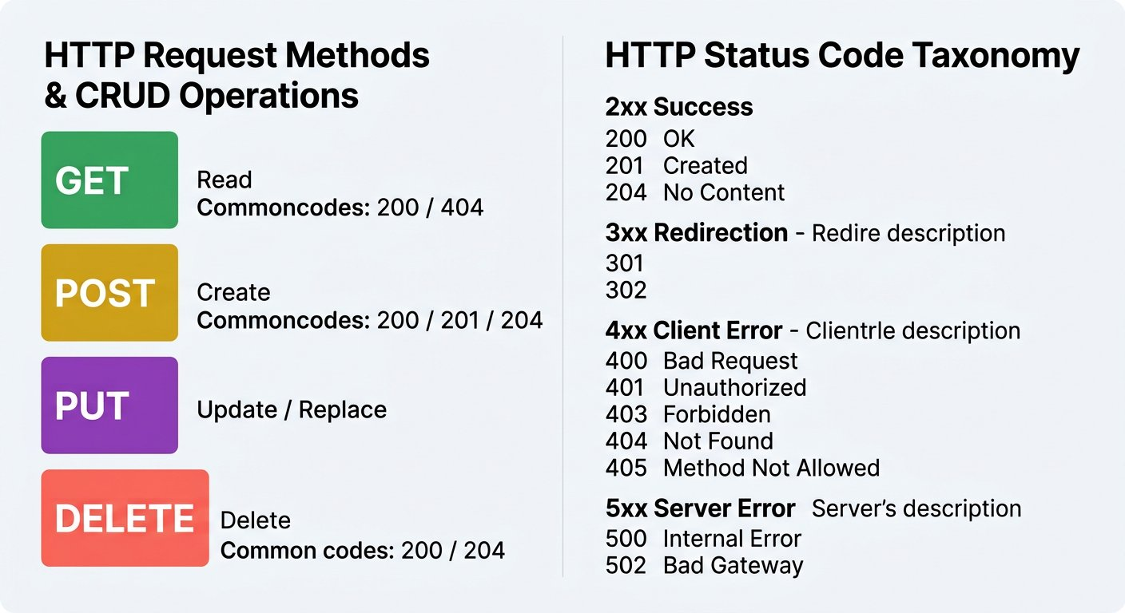
The Five Status Families: The universal grammar of HTTP client server communication.
1 1xx Informational: Request received, protocol handshake continuing (e.g. 101 Switching Protocols for WebSockets).
2 2xx Success: The action requested by the client was successfully received, understood, and accepted (200 OK, 201 Created).
3 3xx Redirection: Further action needed by user agent to fulfill request (301 Moved Permanently, 304 Not Modified).
4 4xx Client Error: The client sent an invalid request (400 Bad Request, 401 Unauthorized, 404 Not Found).
5 5xx Server Error: The server encountered an unexpected condition that prevented it from fulfilling the request (500, 502, 503).
WAR ROOM INCIDENT TRIAGE
The Polite 200 Incident Triage
Sameer warns Akshay that some legacy enterprise backends return HTTP 200 OK with body { "success": false, "error": "Invalid route parameter" }. Why is this Polite 200 pattern considered a critical anti pattern in API architecture?
A. Automated test suites, API gateways, and proxy caches check HTTP status headers; a 200 badge causes pipelines to mark tests as passing even when data operations failed completely
B. The HTTP specification forbids JSON payloads inside responses with status 200
C. Network routers automatically rewrite status 200 responses into 500 errors if the body contains the word error
TACTICAL TRIUMPH: Tactical Triumph: The Polite 200 Trap fools monitoring dashboards, CDN caches, and automated test runners. Because the HTTP status header reads 200 OK, automated tools assume success and cache the failure payload. Status codes must faithfully represent operational reality.
The Language of Codes
COMIC SCENE 4 OF 4
The Language of Codes
With the transit emergency resolved, Sameer walks Akshay through the five HTTP status code families on the war room whiteboard.
PANEL 1: The Five Families (08:40 PM)

PANEL 2: The Campus Catalog Examples (08:43 PM)

PANEL 3: The Polite 200 Trap (08:46 PM)

PANEL 4: The Evening Rush Succeeds (08:50 PM)

Auditing the Valid 200 OK Shuttle Route Contract
COMIC WORKBENCH · CONTRACT VERIFICATION
Auditing the Valid 200 OK Shuttle Route Contract

API Request: GET http://localhost:5050/v1/shuttle/route?name=north_loop

Live Response: 200 OK (12ms)
response.json
1 {
2 "route": "north_loop",
3 "status": "Active",
4 "stops": 8,
5 "coordinates": {
6 "latitude": 12.9716,
7 "longitude": 77.5946
8 }
9 }
1. Explicit Input: Client sends GET /v1/shuttle/route?name=north_loop with valid route query parameter.
2. Wire & Logic Explanation: The request passes the fail fast guard, enters the locator query, finds the active shuttle coordinates, and serializes the JSON response.
3. Deterministic Output: HTTP status 200 OK returning the complete route object with active coordinates.
4. Senior Savior & Common Trap: Senior Savior Trap: Only testing happy path 200 queries and assuming edge cases never happen in production. Golden Rule: Dual verification is mandatory; prove the negative 400 guard and the positive 200 contract side by side.
⚡ ARCHITECTURAL TRIUMPH · Phase 2 Complete: Manual Wire Auditing and Status Codes Mastered
Akshay successfully diagnosed the campus shuttle 500 crash by hand, categorized parameter empty states, installed a fail fast validation guard, and mastered the five HTTP status code families.
Tactical Superpowers Mastered:
- Ability to distinguish omitted undefined parameters from empty strings and whitespace
- Diagnosing unhandled server crashes through raw wire inspection and stack trace analysis
- Implementing fail fast input validation guards returning clean 400 Bad Request contracts
- Full semantic mastery of the five HTTP status families from 1xx to 5xx
Enterprise Disasters Prevented:
- Prevented evening transit orientation shutdown by resolving the unhandled 500 route locator crash
- Eliminated silent data corruption caused by the Polite 200 Trap
- Stopped finger pointing between frontend and backend teams by establishing the network wire as the single source of truth
NEXT DISCOVERY · The Green Suite with the Hidden Lie
Twilight gives way to deep night across Apex Campus. As Akshay prepares to pack his bag, Sameer drops a printed test execution report onto his desk. Ten requests, ten green checks, clean zero failure badges across the board. Sameer points to the middle test: Your senior handed you this green suite at 6 PM. By 6:40 PM you will discover that one of these green checks is a complete lie. The test passes without testing anything. In Chapter 3, Akshay enters the automation lab to learn the anatomy of automated assertions, inspect the API Testing Workbench test script sandbox, and write dual assertions that never lie.

Chapter 3: Automating the Wire Check: Postman Workbench and Assertions
Translating manual verification into automated JavaScript assertions, running test suites, and team collaboration.
MISSION BRIEFING & CHAPTER ROADMAP
MISSION 1 · PHASE 3 OF 3: AUTOMATING THE WIRE VERIFICATION: Global Open Data and Web Wire Audit
CRISIS SCENARIO: The Automated Watchdog: Never Repeat Manual Eyeball Audits
Context: We diagnosed and repaired the transit shuttle defect by hand, but manual testing does not scale across repeated deployments. If an engineer accidentally removes the defensive guard tomorrow, the system will crash again. We must convert our manual wire observations into automated JavaScript assertions that execute at machine speed in the API Testing Workbench.
Operational Target: Write Chai BDD assertions, enforce the Red Before Green testing discipline, execute batch runs in the Collection Runner, and establish the automated watchdog.

WE WILL ACHIEVE: Write an original pm.test with a Chai matcher, prove it fails against a broken server before trusting it green, and run a collection of 4 requests with 10 assertions from the runner.
HOW WE WILL DO IT:
WHAT YOU WILL CARRY FORWARD:
MISSION COMMAND HUD
PHASE: STAGE 6 AUTHORING · RANK: AUTOMATION QUALITY ARCHITECT
ACTIVE MISSION: Phase 3: Automating the Wire Verification
ARCHITECTURE · The API Testing Pyramid: Concentrating Automation at the Service Layer
TESTING PYRAMID · The API Testing Pyramid: Concentrating Automation at the Service Layer
Martin Fowler and Mike Cohn established the Testing Pyramid: UI tests are slow, brittle, and expensive to maintain; unit tests are fast but miss network integrations. API service layer testing provides the optimal balance of machine execution speed, deterministic contracts, and complete wire coverage.
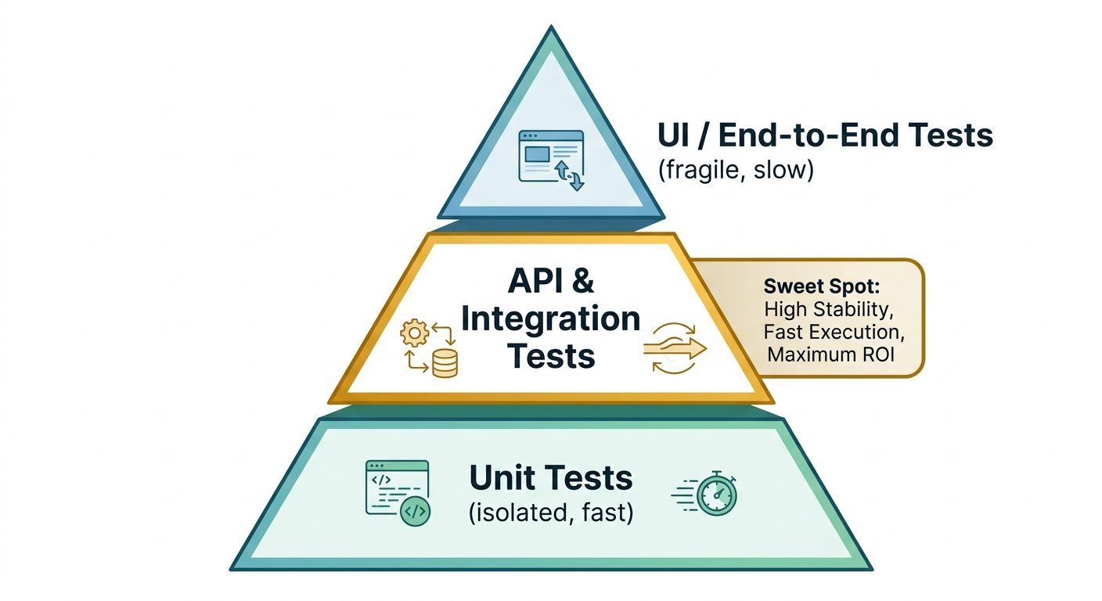
The Testing Pyramid: Investing in API automation delivers resilient gates without browser flakiness.
1 Brittle Apex: UI and manual browser clicking is slow, fragile, and prone to false positives.
2 Core Sweet Spot: API wire testing verifies complete business logic across network sockets in milliseconds.
3 Fast Base: In process unit tests verify isolated algorithm functions.
The Green Lie
COMIC SCENE 1 OF 4
The Green Lie
In Sameer quiet research lab, Akshay discovers a test badge glowing green while the server response body contains an empty array.
PANEL 1: Examining the Green Badge (06:00 PM)

PANEL 2: The Sleeper Test Shock (06:05 PM)

PANEL 3: The Tests Sandbox (06:10 PM)

PANEL 4: Assertions with Teeth (06:15 PM)

WAR ROOM INCIDENT TRIAGE
The Matcherless Assertion Diagnostic Triage
Akshay writes the following test in his workbench Tests tab: pm.test("Status check", function () { console.log(pm.response.code); }). If the backend returns a 500 Internal Server Error, what status badge will the workbench display?
A. The test result badge remains green PASSED because the function executed to completion without throwing an uncaught exception
B. The workbench automatically turns red because any HTTP status above 399 triggers a hard failure
C. The workbench aborts the collection run and disables the send button
TACTICAL TRIUMPH: Tactical Triumph: In the API Testing Workbench JavaScript sandbox, a test passes by default unless an AssertionError is thrown. Because console.log never throws an exception, the test marks green PASSED regardless of whether the server returned 200, 400, or 500. Assertions must include explicit matchers such as pm.response.to.have.status(200).
Red Before Green
COMIC SCENE 2 OF 4
Red Before Green
Akshay writes his first Chai BDD assertion and proves that it fails against broken code before trusting it against working endpoints.
PANEL 1: Writing the Chai Assertion (06:20 PM)

PANEL 2: The Red Proof (06:23 PM)

PANEL 3: The Red Before Green Rule (06:26 PM)

PANEL 4: The Clean Green Pass (06:29 PM)

ARCHITECTURE · The Assertion Execution Lifecycle: Enforcing the Red Before Green Discipline
ASSERTION LIFECYCLE · The Assertion Execution Lifecycle: Enforcing the Red Before Green Discipline
Every automated test must be proven to catch regressions. The Red Before Green methodology requires running the assertion against broken or unhardened code first to confirm failure before validating working production endpoints.
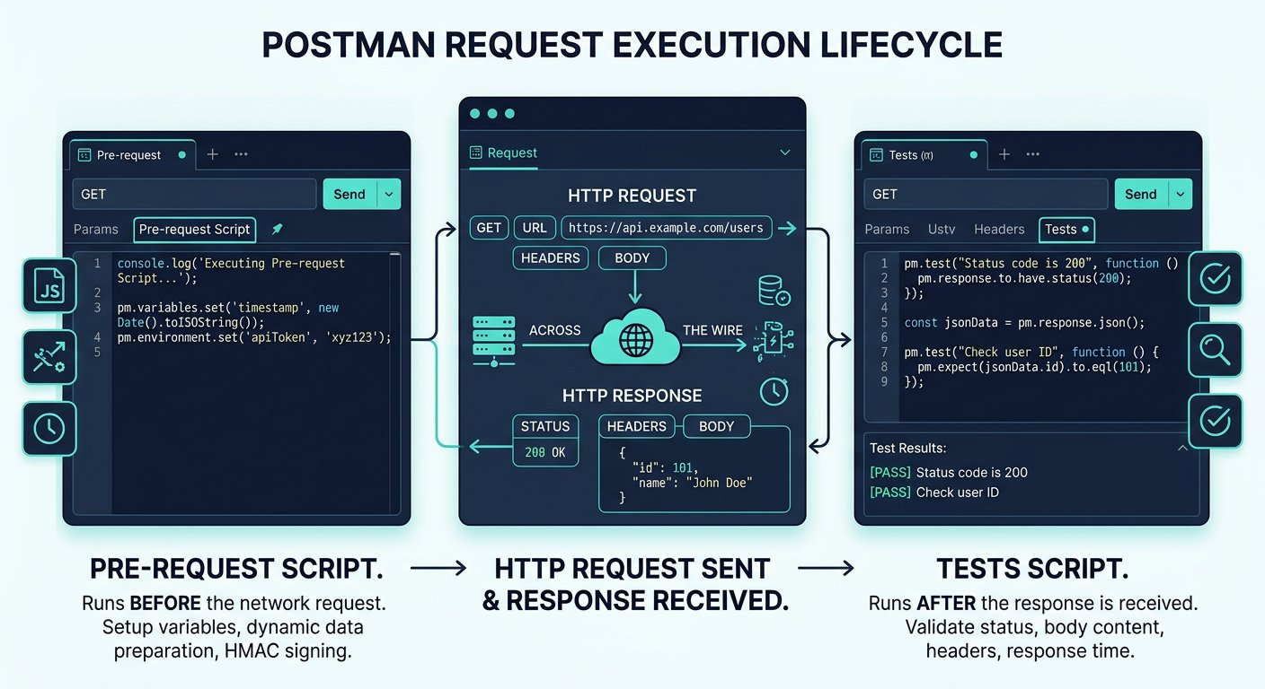
The Red Before Green Cycle: Proving test sensitivity prevents false confidence.
1 Stage 1 (Author Test): Declare expected status code and payload contracts using pm.test and pm.expect.
2 Stage 2 (Prove Red): Execute test against unhardened endpoint; verify assertion throws AssertionError.
3 Stage 3 (Verify Green): Execute test against hardened service; verify test results badge marks green PASSED.
Proving Assertions Fail Before Trusting Them Green
COMIC WORKBENCH · ASSERTION DISCIPLINE
Proving Assertions Fail Before Trusting Them Green

API Request: GET http://localhost:5050/v1/shuttle/route

Live Response: 400 Bad Request (4ms)
response.json
1 {
2 "error": "Bad Request",
3 "message": "Query parameter 'name' is required and cannot be empty"
4 }
1. Explicit Input: Client dispatches GET /v1/shuttle/route with omitted parameter into the test sandbox.
2. Wire & Logic Explanation: The Tests tab executes pm.response.to.have.status(400) and pm.expect(pm.response.json().message).to.include("required"). It compares actual HTTP response values against Chai expectations.
3. Deterministic Output: Test Results pane displays: PASS: Status code is 400 Bad Request, and PASS: Error message guides client.
4. Senior Savior & Common Trap: Senior Savior Trap: Trusting a green assertion that was never tested against a failing server. Golden Rule: Red Before Green. Prove your test fails against broken code before you ever trust it green in production.
WAR ROOM BATTLE SCAR · PRODUCTION RECOVERY LAW
The 460 Million Dollar Silent Guard Disaster
In August 2012, Knight Capital deployed automated high frequency trading software to production. A critical safety guard that was supposed to halt duplicate orders had not been tested against failure scenarios in years. When a configuration flag sent unintended trade traffic, the dormant guard remained silently green while the algorithm bought and sold millions of shares into market chaos. The firm lost 460 million dollars in forty five minutes and faced insolvency before noon.
Key Architectural Lesson: A guard that has never been observed failing is an open door. Automated test assertions must be proven to catch real regressions under live failure conditions.
The Four Surfaces
COMIC SCENE 3 OF 4
The Four Surfaces
Sameer walks Akshay through the architectural layout of the API Testing Workbench, explaining post response execution timing.
PANEL 1: The Four Surfaces Architecture (06:35 PM)

PANEL 2: Execution Chronology (06:38 PM)

PANEL 3: Writing Dual Contract Checks (06:41 PM)

PANEL 4: The 86 Millisecond Verification (06:43 PM)

ARCHITECTURE · The Four Surfaces of the API Testing Workbench: Operational Choreography
WORKBENCH ARCHITECTURE · The Four Surfaces of the API Testing Workbench: Operational Choreography
The API Testing Workbench is engineered around four distinct operational quadrants: the Request Builder where HTTP verbs, URLs, and headers are configured; the JavaScript Tests sandbox; the live Response Viewer; and the automated Test Results verdict pane.
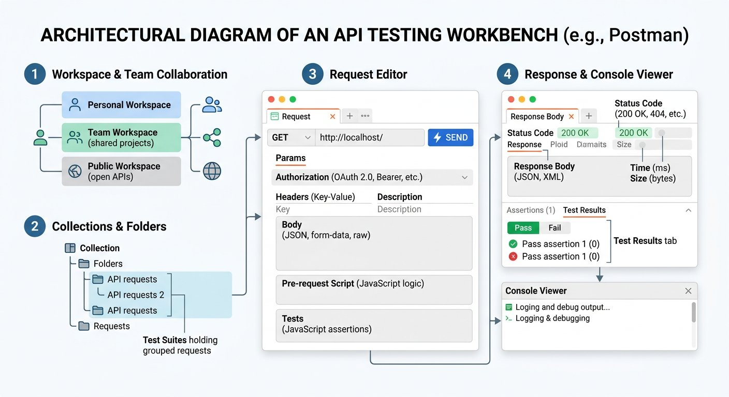
The Four Surfaces: Top left sends, top right scripts, bottom left reads the wire, bottom right renders verdicts.
1 Surface 1 (Request Builder): Construct HTTP method, destination path, headers, query params, and body payload.
2 Surface 2 (Tests Script Tab): Sandbox for Chai BDD test assertions executing immediately after response arrival.
3 Surface 3 (Response Pane): Raw wire output displaying HTTP status badge, response time, size, and formatted JSON.
4 Surface 4 (Test Results Pane): Verification tally indicating passing assertions and failure stack traces.
Automating Positive Schema and Negative Guard Assertions
COMIC WORKBENCH · DUAL CONTRACT CHECK
Automating Positive Schema and Negative Guard Assertions

API Request: GET http://localhost:5050/v1/shuttle/route?name=north_loop

Live Response: 200 OK (12ms)
response.json
1 {
2 "route": "north_loop",
3 "status": "Active",
4 "stops": 8,
5 "coordinates": {
6 "latitude": 12.9716,
7 "longitude": 77.5946
8 }
9 }
1. Explicit Input: Client queries GET /v1/shuttle/route?name=north_loop with Chai schema assertions mounted.
2. Wire & Logic Explanation: The test script runs three distinct assertions: status equals 200, route string equals north_loop, and coordinates object contains numeric latitude and longitude.
3. Deterministic Output: Test Results pane records 3 of 3 passing checks: Status is 200, Route name verified, Coordinates valid.
4. Senior Savior & Common Trap: Senior Savior Trap: Asserting only pm.response.to.have.status(200) without validating JSON payload structure. Golden Rule: Status codes confirm the wire envelope; body schema assertions confirm data integrity.
WAR ROOM INCIDENT TRIAGE
Deep Payload Property Assertion Triage
Akshay wants to verify that the shuttle route response contains valid numerical coordinates. Which Chai assertion correctly inspects the latitude property inside the response body?
A. const data = pm.response.json(); pm.expect(data.coordinates.latitude).to.be.a("number");
B. pm.expect(pm.response.body).to.contain("number");
C. pm.response.to.have.header("latitude");
TACTICAL TRIUMPH: Tactical Triumph: To validate nested JSON properties, an engineer first parses the response text with pm.response.json(), then uses Chai BDD type matchers such as pm.expect(data.coordinates.latitude).to.be.a("number"). This guarantees both existence and numeric data type.
The First Watchdog Runs
COMIC SCENE 4 OF 4
The First Watchdog Runs
Akshay bundles four requests into a collection and executes the Collection Runner, tasting automated pipeline speed for the first time.
PANEL 1: Configuring the Collection Runner (06:45 PM)

PANEL 2: Ten Assertions at Machine Speed (06:47 PM)

PANEL 3: The Spark of Overconfidence (06:50 PM)

PANEL 4: The Library Dawn Challenge (06:55 PM)

Executing the 4 Request Transit Collection Runner
COMIC WORKBENCH · RUNNER AUTOMATION
Executing the 4 Request Transit Collection Runner

API Request: POST http://localhost:5050/runner/transit-suite

Live Response: 200 OK (86ms)
response.json
1 {
2 "collection": "Transit Route Watchdog",
3 "requests_executed": 4,
4 "assertions_passed": 10,
5 "assertions_failed": 0,
6 "total_duration_ms": 86,
7 "status": "ALL_TESTS_PASSED"
8 }
1. Explicit Input: Collection Runner executes 4 sequential requests: Health Check, Shuttle Omitted Guard, Shuttle Valid Contract, Catalog Verification.
2. Wire & Logic Explanation: The runner iterates through collection items, dispatches HTTP requests across TCP sockets, evaluates attached Chai assertion scripts, and aggregates test tallies.
3. Deterministic Output: 4 requests executed, 10 assertions verified, 0 failures, 86 milliseconds total duration.
4. Senior Savior & Common Trap: Senior Savior Trap: Assuming a simple 4 request runner suite can handle complex multi step workflows without dynamic variables. Golden Rule: A collection runner is only as powerful as its data chaining; static collections break when IDs change.
⚡ ARCHITECTURAL TRIUMPH · Mission 1 Accomplished: Reading the Wire and Automating the Watchdog
Akshay has completed Mission 1: advancing from a manual checklist clicker to an API Quality Engineer capable of building minimal Express servers, diagnosing unhandled 500 crashes, installing defensive input guards, and writing automated Chai assertion suites.
Tactical Superpowers Mastered:
- Writing Chai BDD assertions with pm.test and pm.expect inside the testing workbench
- Disciplined application of the Red Before Green testing principle
- Automating dual contract verification: negative 400 guards and positive 200 schemas
- Executing batch regression suites with the Collection Runner at machine speed
Enterprise Disasters Prevented:
- Prevented false green checks from concealing silent data corruption in production pipelines
- Eliminated manual regression clicking bottlenecks by automating wire validation suites
- Prevented multi million dollar outages similar to Knight Capital by enforcing failure proof before green trust
NEXT DISCOVERY · Dawn at the Campus Circulation Desk
Cool night air drifts through the carved jali screens of Sameer research lab as the collection runner shows all green. Akshay leans back, brimming with confidence: Building an automated watchdog was easier than I thought! Sameer looks toward the campus courtyard where headlights pierce the darkness. A delivery truck has just arrived at the library, unloading 500 textbook boxes by hand under the lamppost. Sameer points out the window: Orientation starts in six hours. Tomorrow morning, Meera must catalog every one of those 500 books into the campus database. If your automated watchdog only knows how to test static URLs, who is going to automate dynamic record creation, duplicate ISBN detection, and stateful deletion? In Mission 2, Akshay enters the campus library to face the full CRUD lifecycle, dynamic variables, and request chaining.

Chapter 4: Manual Testing the College Library API
Executing AddBook, GetBook, and DeleteBook manually, feeling the copy paste pain, and mapping unique constraints.
MISSION BRIEFING & CHAPTER ROADMAP
MISSION 2 · PHASE 1 OF 6: Automating Student and Campus Services at Scale
CRISIS SCENARIO: The College Library REST Service: Manual CRUD Exploration
Context: With the transit crisis resolved, the engineering leadership assigns you to automate the core College Library REST services. The library system manages cataloging, aisle positioning, and book acquisitions under strict unique constraints. Before automating scripts, we must map out the manual AddBook, GetBook, and DeleteBook contract lifecycle and experience the pain of manual copy paste.
Operational Target: Map out the complete CRUD contract across AddBook, GetBook, and DeleteBook, and verify unique ISBN and aisle constraints.

WE WILL ACHIEVE: Execute the complete Create, Read, and Teardown lifecycle against an enterprise Library API service by hand.
HOW WE WILL DO IT: Sending AddBook POST, witnessing duplicate ISBN and aisle collisions, querying GetBook with query parameters, and executing DeleteBook teardown.
WHAT YOU WILL CARRY FORWARD: The canonical 3 step Library API request contract: AddBook, GetBook, and DeleteBook.
MISSION COMMAND HUD
PHASE: Phase 1 of 5: Manual CRUD Verification · RANK: Rank: Automation Quality Engineer
ACTIVE MISSION: Mission 2: Automating Student and Campus Services at Scale
OUR MISSION · Mission 2: Automating Student and Campus Services at Scale
Every college campus has a library where students check out textbooks, professors reserve course reading material, and librarians track inventory across physical aisles. The college has deployed a new web service to manage its book catalog across campus stacks. Before releasing the system to faculty and students, we must test every operation: adding a new textbook, verifying its physical shelf location, and removing retired editions. As Automation Quality Engineer, your mission is to map out the entire inventory lifecycle and prepare it for automated testing.

The Campus Library Operations Center: Moving from manual book checking to fast automated testing.
1 Live Book Tracking: Keeping track of textbook copies, shelf locations, and checkout status in real time.
2 The Three Core Actions: Adding new books, checking where they sit on the shelf, and deleting old copies safely.
3 Smart Automation: Passing book details automatically from one step to the next without copying and pasting by hand.
What we know: The Library API is deployed across dedicated campus service clusters with structured REST endpoints. • Books are stored with a unique combination of ISBN and aisle numbers. • If an ISBN and aisle combination already exists, the server rejects insertion with "book already exist".
What we need: A configured POST AddBook request with valid JSON payload and unique ISBN. • A configured GET GetBook request using query parameters to verify coordinates. • A configured POST DeleteBook request to verify safe cleanup. • The ability to diagnose unique database constraint collisions.
How We Will Approach Mission 2: The 5 Phase Battle Plan
Automating an enterprise inventory system requires a deliberate step by step progression. We move from manual exploration to full data driven automation across five structured phases:
Phase 1 (Chapter 4 · Right Now): Manual CRUD Execution [CURRENT FOCUS]
We execute manual AddBook, GetBook, and DeleteBook operations to map unique ISBN and aisle constraints and experience the friction of manual testing.
Outcome: You discover database constraint collisions and understand the lifecycle of book inventory.
Phase 2 (Chapter 5 · Next Step): Automated Assertions
We replace human eyeball checks with automated JavaScript assertions verifying status codes, response times, and payload schemas.
Outcome: Your tests pass or fail automatically in milliseconds without human inspection.
Phase 3 (Chapter 6 · Environment Isolation): Variable Scopes and Environments
We eliminate hardcoded URLs by configuring dynamic environments (Local, QA, UAT) and pre request scripts to generate random unique ISBNs.
Outcome: Zero test collisions; identical collections run seamlessly across multiple test servers.
Phase 4 (Chapter 7 · Request Chaining): Dynamic Request Chaining
We extract generated book IDs from POST responses and pass them dynamically into downstream GET and DELETE requests without copy pasting.
Outcome: Self contained automated testing pipelines that clean up their own test data.
Phase 5 (Chapter 8 · Mission Victory): Data Driven Scale
We parameterize our suite with external CSV and JSON data files using Postman Collection Runner to test hundreds of records in seconds.
Outcome: Mission 2 Cleared! Full automated data driven testing suite running against enterprise services.

Step 1: The Library CRUD Lifecycle Sequence
ARCHITECTURE · Library API CRUD Lifecycle: Create, Verify, and Cleanup Sequence
DATA LIFECYCLE · Library API CRUD Lifecycle: Create, Verify, and Cleanup Sequence
The college library system exposes three core HTTP services that form a complete data lifecycle: Create a record with unique coordinates, Read it back to confirm persistence across campus stacks, and Delete it to maintain a clean database state.
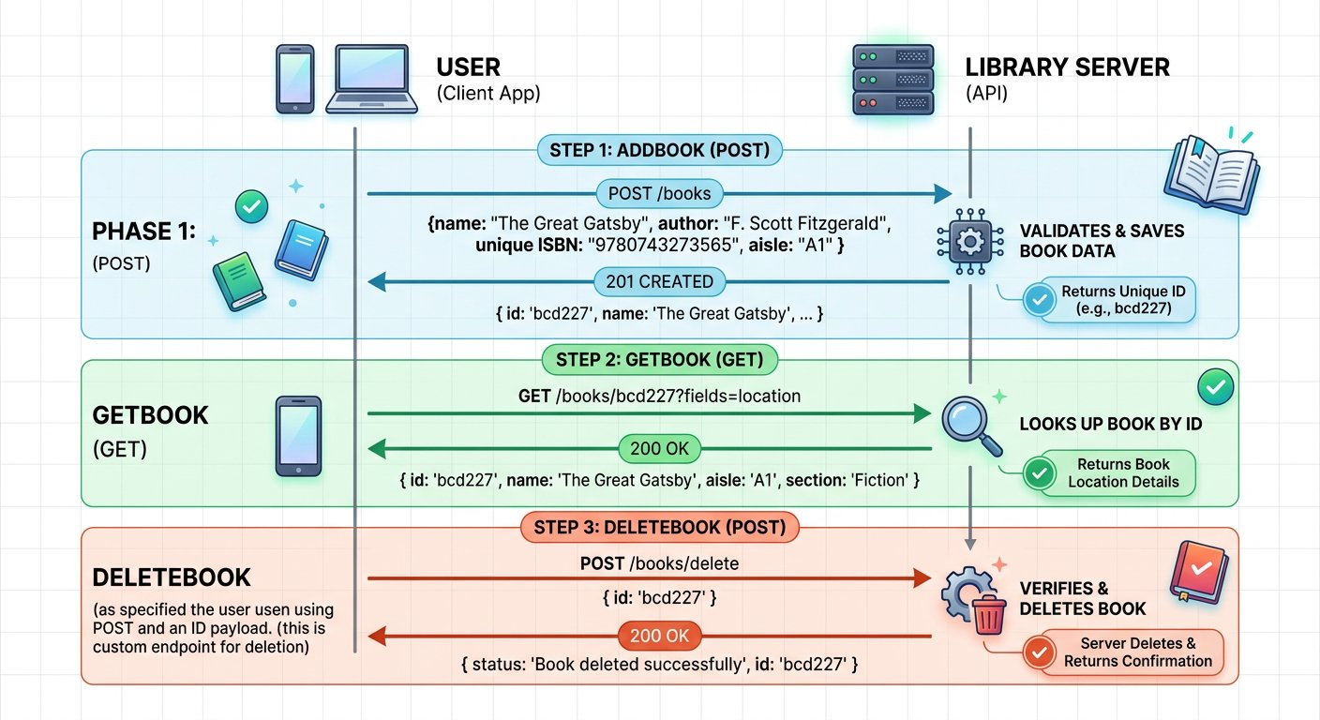
The complete lifecycle of a textbook through the Library API.
1 Phase 1 (Step 1 AddBook POST): Client submits book title, author, ISBN, and shelf aisle. The server stores the record and returns a composite ID.
2 Phase 2 (Step 2 GetBook GET): Client queries GET /books with the composite ID to confirm the record exists in the catalog.
3 Phase 3 (Step 3 DeleteBook POST): Client submits a delete request with the composite ID to remove the record.
This Service Contract: Inspecting Real World Conventions
Before dispatching requests, inspect the published contract of this college library service:
• AddBook (POST /v1/books): Returns HTTP status 200 OK (rather than 201) with a capitalized Msg property: { "Msg": "successfully added", "ID": "9781227" }.
• GetBook (GET /v1/books?id=...): Returns an array containing matching book items: [{ "book_name": "...", "isbn": "...", "aisle": "..." }]. Notice that aisle is a string and the author field is omitted from this read endpoint.
• DeleteBook (POST /v1/books/delete): Requires a JSON body with the ID: { "ID": "..." }, returning HTTP status 200 OK with lowercase msg: { "msg": "book is successfully deleted" }.
As quality automation engineers, our job is to test against the exact service contract rather than assuming theoretical conventions.

Step 2: Action 1: Adding a Book (POST)
When a new book arrives at the circulation desk, the librarian enters its title, author, ISBN, and shelf aisle number. In our API test workbench, we break down the outgoing HTTP POST request in chunks:
Deconstructing the AddBook POST Request
Inspect the method, endpoint, and payload:
CHUNK 1: Endpoint and Method · The Target Resource
Dispatches a POST request to the collection resource endpoint.
AddBook-line.http
1 POST /v1/books HTTP/1.1
Host: api.campuslibrary.org
Rule: POST indicates resource creation on the server.
CHUNK 2: JSON Payload Body · The Book Attributes
The server combines the ISBN (9781) and aisle (227) into a unique composite primary key: 9781227.
AddBook-payload.json
1 {
"name": "Zero to Agentic API Testing",
"isbn": "9781",
"aisle": "227",
"author": "Alex Mercer"
}
Rule: The combination of ISBN and aisle forms the unique identifier in this API.
IMAGINE & PREDICT BEFORE SENDING
When we send this AddBook request for the first time, what response status and payload do you expect from the server?
A. 200 OK: Returns a success confirmation message alongside the composite primary key ID
B. 404 Not Found: Endpoint is unreachable because the library catalog is offline for maintenance
C. 500 Server Error: Crashes because the book author is not registered in the student directory
Actual Output (AddBook Live Wire Outcome): The book is registered! The server returns 200 OK along with a confirmation message and the composite primary key ID: 9781227.
Architectural Contract Quirk: Why AddBook Returns 200 Instead of 201
In Chapter 2, we learned that theoretical REST standards recommend returning 201 Created when a new record is added.
However, in real world corporate software, many production APIs return 200 OK with a custom confirmation payload. Notice also that the success message uses capitalized "Msg" while other endpoints use lowercase "msg".
As quality automation engineers, our job is not to enforce academic dogma: we test against the actual published contract of the service.
Live Interactive Wire Inspector: AddBook POST
POST https://qa-api.campuslibrary.org/v1/books
Status: 200 OK · Time: 182 ms · Size: 248 B
Response Body:
response.json
1 {
2 "Msg": "successfully added",
3 "ID": "9781227"
4 }
Akshay Dispatches AddBook and Inspects the Contract
API TESTING WORKBENCH · ADDBOOK OPERATION
Akshay Dispatches AddBook and Inspects the Contract

API Request: POST https://qa-api.campuslibrary.org/v1/books

Request Body:
request_body.json
1 {
2 "name": "Zero to Agentic API Testing",
3 "isbn": "9781",
4 "aisle": "227",
5 "author": "Alex Mercer"
6 }
Live Response: 200 OK (182 ms)
response.json
1 {
2 "Msg": "successfully added",
3 "ID": "9781227"
4 }
1. Explicit Input: POST https://qa-api.campuslibrary.org/v1/books with book attributes.
2. Wire & Logic Explanation: Server combines isbn (9781) and aisle (227) into composite ID 9781227 and inserts into library database.
3. Deterministic Output: 200 OK with Msg: successfully added and composite ID: 9781227.
4. Senior Savior & Common Trap: Assuming AddBook returns status 201 Created will cause your tests to fail. Always verify the actual status code returned by the server.

Step 3: Action 2: Duplicate Key Collision Before Cleanup
What happens if you execute AddBook a second time with the exact same payload before deleting the first record? Let us test the database unique constraint:
Live Interactive Wire Inspector: Duplicate AddBook POST
POST https://qa-api.campuslibrary.org/v1/books
Status: 200 OK · Time: 110 ms · Size: 142 B
Response Body:
response.json
1 {
2 "msg": "Book already exists"
3 }
Why Duplicate Insertion Failed
The Library API enforces a composite unique key across ISBN and aisle (9781 + 227 = 9781227).
Because record 9781227 already exists in the database table, the server rejects insertion and returns: {"msg": "Book already exists"}.
This demonstrates why test teardown is mandatory: without automated deletion, subsequent test runs will fail immediately on duplicate constraints!
Akshay Triggers the Duplicate Primary Key Guard
API TESTING WORKBENCH · DUPLICATE CONSTRAINT COLLISION
Akshay Triggers the Duplicate Primary Key Guard

API Request: POST https://qa-api.campuslibrary.org/v1/books

Request Body:
request_body.json
1 {
2 "name": "Zero to Agentic API Testing",
3 "isbn": "9781",
4 "aisle": "227",
5 "author": "Alex Mercer"
6 }
Live Response: 200 OK (110 ms)
response.json
1 {
2 "msg": "Book already exists"
3 }
1. Explicit Input: Re dispatching identical AddBook payload with isbn: 9781 and aisle: 227.
2. Wire & Logic Explanation: Database unique constraint catches duplicate key 9781227 and rejects row creation.
3. Deterministic Output: 200 OK with business rejection payload: msg: Book already exists.
4. Senior Savior & Common Trap: Without deleting test records after execution, subsequent test runs will fail immediately due to duplicate constraints.

Step 4: Action 3: Retrieving by ID (GET with Query Params)
To confirm that the book was stored on the correct shelf, we query the catalog by passing the generated composite ID (9781227) as a query parameter:
The GetBook Query Request
We pass the composite ID created in Step 2:
CHUNK 1: Query Parameter Request · Filtering by Composite Key
The query parameter ?id=9781227 asks the database to locate the single record matching that ID.
GetBook-Request.http
1 GET /v1/books?id=9781227 HTTP/1.1
Host: api.campuslibrary.org
Accept: application/json
Rule: Notice that we had to manually copy and paste 9781227 from the previous step!
Live Interactive Wire Inspector: GetBook GET
GET https://qa-api.campuslibrary.org/v1/books?id=9781227
Status: 200 OK · Time: 145 ms · Size: 312 B
Response Body:
response.json
1 [
2 {
3 "book_name": "Zero to Agentic API Testing",
4 "isbn": "9781",
5 "aisle": "227"
6 }
7 ]

Step 5: Action 4: Deleting the Book (POST Teardown)
When a textbook is retired, the librarian removes it by posting its ID to the delete endpoint:
The DeleteBook Teardown Request
We submit the book ID to clean up database state:
CHUNK 1: Delete Payload Body · Submitting Deletion ID
The server verifies the ID exists, purges the record from the database table, and returns a confirmation message.
DeleteBook-Request.json
1 POST /v1/books/delete HTTP/1.1
Host: api.campuslibrary.org
Content-Type: application/json
{
"ID": "9781227"
}
Rule: Teardown deletions prevent test databases from bloating with obsolete records.
Live Interactive Wire Inspector: DeleteBook POST
POST https://qa-api.campuslibrary.org/v1/books/delete
Status: 200 OK · Time: 120 ms · Size: 185 B
Response Body:
response.json
1 {
2 "msg": "book is successfully deleted"
3 }

Step 6: Action 5: Verifying Re addition After Teardown Cleanup
Now that DeleteBook has successfully purged record 9781227 from the database, what happens if we execute AddBook again with the exact same payload? Let us verify:
Live Wire Capture: AddBook After Teardown Succeeded
POST https://qa-api.campuslibrary.org/v1/books
Status: 200 OK · Time: 175 ms · Size: 248 B
Response Body:
response.json
1 {
2 "Msg": "successfully added",
3 "ID": "9781227"
4 }
Akshay Completes the Teardown and Re addition Cycle
API TESTING WORKBENCH · COMPLETE CRUD TEARDOWN VERIFICATION
Akshay Completes the Teardown and Re addition Cycle

API Request: POST https://qa-api.campuslibrary.org/v1/books

Request Body:
request_body.json
1 {
2 "name": "Zero to Agentic API Testing",
3 "isbn": "9781",
4 "aisle": "227",
5 "author": "Alex Mercer"
6 }
Live Response: 200 OK (175 ms)
response.json
1 {
2 "Msg": "successfully added",
3 "ID": "9781227"
4 }
1. Explicit Input: Re running AddBook following successful DeleteBook teardown.
2. Wire & Logic Explanation: DeleteBook purged record 9781227 from database, freeing the composite key constraint for fresh registration.
3. Deterministic Output: 200 OK confirming successful creation of pristine book record.
4. Senior Savior & Common Trap: Leaving stale test records in databases pollutes test environments and breaks automated CI pipelines. Always teardown test entities.

Step 7: The Friction of Manual Testing: Why We Must Automate
Why Manual Testing Fails at Scale
1. Copy Paste Fatigue: In this manual exercise, we had to look at the AddBook response, copy "9781227", open a new tab for GetBook, paste the ID into the URL, run it, then copy it into DeleteBook. Doing this for 500 books would take hours of tedious, error prone labor.
2. False Confidence: When you inspect JSON visually with your eyes, you can easily miss subtle typos or missing fields.
3. In Chapter 5, we begin the automation revolution: writing automated JavaScript assertions to validate every status code, message, and property in milliseconds!
MANUAL COLLEGE LIBRARY CRUD SIMULATOR
Interactive manual workbench demonstrating the 3-step College Library CRUD lifecycle: AddBook (POST), GetBook (GET with query parameter ?id=), and DeleteBook (POST teardown).
The Friction of Manual Testing: Requires manually copying the generated ID from Step 1 and pasting it into Step 2 and Step 3, demonstrating why automated request chaining is essential.
Verified Historical Case Study · 1999
UK Passport Agency Computer System Delays Documenting Inadequate Testing and Contingency Planning
https://www.nao.org.uk/reports/united-kingdom-passport-agency-the-passport-delays-of-summer-1999/
Verified through United Kingdom National Audit Office (NAO) Report HC 812
WAR ROOM BATTLE SCAR · Enterprise Workflow Failure
UK Passport Agency Delays: The Real World Cost of Untested Rollouts
In the summer of 1999, the United Kingdom Passport Agency introduced a new computerized processing system without completing end to end integration verification or contingency planning. Rollout difficulties produced a backlog of around 565,000 passport applications, forcing hundreds of citizens to wait in long queues and costing millions of pounds in emergency staffing. The National Audit Office inquiry determined that inadequate testing, training, and contingency readiness were central factors in the disruption.
Key Architectural Lesson: Never assume backend services and multi step lifecycles will function smoothly without comprehensive integration testing. Quality automation engineers must validate happy paths, edge cases, and cleanup routines before deployment.
WAR ROOM INCIDENT TRIAGE
War Room Triage: The Duplicate Key Automation Blocker
You built a Postman test that executes AddBook with ISBN 9781 and aisle 227. The first run in Postman passed with 200 OK. Five minutes later, you run the exact same collection again, but the AddBook test suddenly fails with an error: "Book already exists"! What is the root cause of this failure?
A. Postman cached the older response headers and refused to send new network packets.
B. The database enforced a composite unique key on ISBN plus aisle, and the previous test record was never deleted.
C. The campus API server ran out of disk memory to store additional title strings.
D. The client must wait exactly thirty minutes between POST requests for database index rebuilding.
TACTICAL TRIUMPH: Database unique constraints reject duplicates! Because the first test run created ISBN 9781 in aisle 227 and never cleaned it up with DeleteBook, subsequent test runs fail immediately. Automated tests must either generate unique dynamic values or execute teardown requests to clean up after themselves.

Step 8: Review and Practice
MAKE A GUESS
If you execute DeleteBook with ID 9781227 a second time immediately after a successful deletion, what should happen?
- A. The server should crash with a fatal 500 error
- B. The server should return 404 Not Found or a message indicating the book no longer exists, because the record was already purged on the first call
- C. The server should recreate the book automatically
- D. The server should delete all books in the library
Answer: The server should return 404 Not Found or a message indicating the book no longer exists, because the record was already purged on the first call. Because the record was purged during the initial deletion, attempting to delete it a second time cannot find the record ID. The server appropriately responds with 404 Not Found or a message stating the resource does not exist.

Check your understanding
1. What is a composite primary key in database design?
Answer: A composite primary key is a unique identifier formed by combining two or more individual columns: such as ISBN and aisle: to ensure no duplicate combination exists.
2. Why did we execute DeleteBook at the end of our manual testing workflow?
Answer: Executing DeleteBook performs automated teardown: returning the test database to its clean, pristine starting state so subsequent test runs do not fail on duplicate key collisions.
3. How does the GetBook endpoint locate a book record?
Answer: The client transmits the composite ID as an HTTP query parameter in the URL (such as ?id=9781227), which the database queries to return matching shelf locations.

Key takeaways
REMEMBER
- The Library API lifecycle consists of Create (AddBook POST), Read (GetBook GET), and Teardown (DeleteBook POST).
- Composite primary keys combine multiple fields (ISBN plus aisle) to enforce uniqueness in the catalog database.
- Always clean up test records using teardown delete requests to keep test environments reproducible.
- Manual copy pasting of dynamic IDs between requests is slow and prone to errors; this motivates automated request chaining.
NEXT DISCOVERY · Banishing Human Eyeballs: Automated JavaScript Assertions
You have mapped the Library CRUD lifecycle by hand and felt the pain of copy pasting IDs between tabs. In Chapter 5, we banish manual visual inspections forever: writing powerful JavaScript assertions with pm.expect to validate status codes, latency budgets, and JSON properties in milliseconds!

Chapter 5: Writing JavaScript Assertions and the pm Object
Automating response validation, JavaScript fundamentals for testers, Chai matchers, and JSON schema verification.
MISSION COMMAND HUD
PHASE: Phase 2 of 5: Automated JavaScript Assertions · RANK: Rank: Automated Quality Engineer
ACTIVE MISSION: Mission 2: Automating Student and Campus Services at Scale
MISSION BRIEFING & CHAPTER ROADMAP
MISSION 2 · PHASE 2 OF 6: Automating Student and Campus Services at Scale
CRISIS SCENARIO: Eliminating Eyeball Traps: Machine Speed JavaScript Assertions
Context: Manual verification of hundreds of textbook responses is impossible for human eyes to sustain. A missing JSON key or a latency spike to two seconds will easily slip past manual review. In this phase, we harness the embedded Node.js sandbox inside Postman to write Chai assertions that validate status codes, response times, header values, and schema contracts in milliseconds.
Operational Target: Automate status code, response time, header, and JSON schema assertions with strict casing validation.

WE WILL ACHIEVE: Transform manual eyeball checks into machine speed quality gates by mastering the Postman JavaScript execution sandbox, Chai matchers, and JSON schema validation.
HOW WE WILL DO IT: Deconstruct the Postman request lifecycle, explore core JavaScript variable rules, build robust Chai status and response assertions, and validate strict schema contracts accounting for production casing disparities.
WHAT YOU WILL CARRY FORWARD: A battle tested suite of JavaScript assertions verifying status codes, response timing budgets, and schema properties that you will parameterize with dynamic environments in Chapter 6.
MISSION PROGRESS · Continuing Mission 2: Replacing the Manual Eyeball Test
In Chapter 4, we added a book to our campus catalog, but we verified the response by visually inspecting the screen. Humans cannot inspect thousands of JSON responses by eye without missing missing properties or slow response times. Our next step in Mission 2 is replacing eyeball checks with automated JavaScript assertions: mastering the JavaScript fundamentals that power the Postman sandbox, writing code in the Tests tab to validate status codes, response headers, latency budgets, and data schemas in milliseconds.

Step 1: The Request and Response Execution Lifecycle
ARCHITECTURE · Postman Execution Lifecycle: Pre Request, Network Wire, and Assertions
EXECUTION LIFECYCLE · Postman Execution Lifecycle: Pre Request, Network Wire, and Assertions
Postman separates execution into three distinct phases for every HTTP transaction: Pre request Script to seed dynamic parameters, Network Transmission over the wire, and Tests script to parse responses and assert business contracts at machine speed.
The complete three stage execution lifecycle of every Postman request.
1 Stage 1 (Pre request Script): Runs before the HTTP request is built. Ideal for calculating timestamps, generating unique numbers, and configuring headers.
2 Stage 2 (Network Transmission): The HTTP packet travels across the wire and the server returns status code, headers, and body.
3 Stage 3 (Tests Script): Runs immediately after the response arrives. This is where we write assertions to validate data.

Step 2: JavaScript Fundamentals for API Automation Engineers
Why do API automation engineers need JavaScript? Because Postman contains a full Node.js execution sandbox. Every time you write code in the Pre request Script or Tests tabs, Postman executes your JavaScript directly. Understanding fundamental language mechanics prevents subtle bugs in your test suites.

Try it yourself
- Loosely Typed Nature: In languages like Java or C#, you must declare types explicitly like int a = 4. In JavaScript, variables are loosely typed and determine their data type dynamically at runtime.
- The typeof Operator: To inspect any variable type, use typeof. In JavaScript, both integers and floating point decimals share a single data type called number. Other primary types include string, boolean, null, and undefined.
- The Three Variable Keywords: Modern JavaScript provides var, let, and const. Knowing their exact differences is vital for reliable test scripting.

Comparing JavaScript Variable Keywords: var vs let vs const
Keyword | Scope Boundary | Allows Redeclaration? | Allows Reassignment?
var | Function or Global Scope (leaks out of if blocks) | Yes (can accidentally overwrite existing variables) | Yes
let | Block Scope (confined strictly within braces { }) | No (prevents accidental naming collisions) | Yes (ideal for counters and mutable accumulators)
const | Block Scope (confined strictly within braces { }) | No (immutable reference) | No (ideal for holding parsed JSON responses and fixed configs)
Classic Interview Trap: Negating a Constant in an If Condition
Consider a constant boolean flag: const isAvailable = true;. What happens if you write if (!isAvailable) { ... }?
Does the exclamation mark negation operator throw an error because the variable was declared with const?
No! The negation operator inverts the boolean evaluation of the expression for that comparison, but does not alter the stored variable value. The variable remains true in memory while the expression evaluates to false.
When structuring test logic, modern JavaScript uses arrow functions for concise syntax:

The code
javascript-basics-for-testers.js
1 // Modern arrow function vs traditional function declaration
2 const addNumbers = (first, second) => first + second;
3
4 // Checking data types with typeof
5 const bookTitle = "Zero to Agentic API Testing";
6 const price = 49.99;
7 const isAvailable = true;
8
9 console.log(typeof bookTitle); // prints "string"
10 console.log(typeof price); // prints "number"
11 console.log(typeof isAvailable); // prints "boolean"

Step 3: Anatomy of the pm.test Function
To register an automated test case in Postman, we use the pm.test wrapper function with a description string and an assertion callback.

The code
first-assertion.js
1 // Line 1: Define the test name shown in the Test Results tab
2 pm.test("Status code is 200 OK", function () {
3 // Line 2: The actual condition that must be true for the test to pass
4 pm.response.to.have.status(200);
5 });
Micro Chunk Breakdown: Understanding the 3 Lines
• Line 1: pm.test("...", function () { tells Postman to register a new test card in the Test Results panel with your chosen label.
• Line 2: pm.response.to.have.status(200); is the assertion. If the server returned 200, the test turns GREEN. If the server returned 404 or 500, it turns RED and displays the discrepancy.
• Line 3: }); cleanly closes the JavaScript callback function block.

Step 4: Drilling into Response Bodies and Validating Headers
To automate our validation of the AddBook response from Chapter 4, we break down our assertions into three focused chunks:
Automating the AddBook Response Validation
Each chunk asserts a distinct architectural layer of the response packet:
CHUNK 1: Chunk 1: Status Code Assertion · Verifying Wire Status
Asserts that the server answered with HTTP 200 OK, confirming the AddBook operation was accepted.
status-assertion.js
1 pm.test("Status code is 200 OK", function () {
pm.response.to.have.status(200);
});
Rule: Always verify status code first before parsing response body properties.
CHUNK 2: Chunk 2: Headers and Latency Budget · Enforcing Envelope Contract
Confirms the payload is encoded in JSON and arrived within the 1200 millisecond performance budget.
header-latency.js
1 pm.test("Header is JSON and latency under 1200ms", function () {
pm.response.to.have.header("Content-Type");
pm.expect(pm.response.headers.get("Content-Type")).to.include("application/json");
pm.expect(pm.response.responseTime).to.be.below(1200);
});
Rule: Testing latency budgets protects against silent database index degradation.
CHUNK 3: Chunk 3: Deep JSON Body Validation · Validating Payload Properties
Defensively inspects both lowercase msg and uppercase Msg keys, and confirms the generated ID is a valid string.
body-assertion.js
1 pm.test("Response contains successfully added message", function () {
const responseData = pm.response.json();
pm.expect(responseData.msg || responseData.Msg).to.include("successfully added");
pm.expect(responseData.ID).to.be.a("string");
});
Rule: Defensive assertions protect suites against casing inconsistencies across microservices.
IMAGINE & PREDICT BEFORE SENDING
If the server takes 145 ms and returns { "Msg": "successfully added", "ID": "9781227" } with status 200 OK, what will the Test Results tab display?
A. PASS 3 of 3: Three green checkmarks confirming status, header, and body message
B. FAIL: Because the server response did not include a timestamp
C. ERROR: Because Postman cannot check string inclusion
D. TIMEOUT: Because latency was measured in milliseconds
Actual Output (AddBook Assertion Test Results Confirmation): All three assertions pass green! Postman confirmed the 200 status, validated latency was 145 ms (well below 1200 ms), and confirmed that Msg included "successfully added" with a valid ID string!
Fresher Trap to Avoid: Forgetting Parentheses on json()
A very common mistake is typing const data = pm.response.json; instead of const data = pm.response.json();.
Without parentheses, JavaScript returns a reference to the function definition rather than executing it to parse the payload. When you then try to read data.msg, your test script crashes with undefined!
Always include parentheses: pm.response.json() to invoke the JSON parser.
Akshay Asserts Status, Envelope Headers, and Payload
API TESTING WORKBENCH · TRIPLE LAYER ASSERTIONS
Akshay Asserts Status, Envelope Headers, and Payload

API Request: POST https://qa-api.campuslibrary.org/v1/books

Request Body:
request_body.json
1 {
2 "name": "Zero to Agentic API Testing",
3 "isbn": "9781",
4 "aisle": "227",
5 "author": "Alex Mercer"
6 }
Live Response: 200 OK (145 ms)
response.json
1 {
2 "Msg": "successfully added",
3 "ID": "9781227"
4 }
1. Explicit Input: Tests script running post flight against AddBook response.
2. Wire & Logic Explanation: Chai matchers evaluate status code 200, Content Type header, latency under 1200 ms, and existence of composite ID.
3. Deterministic Output: 3 green checkmarks in Test Results with zero human intervention.
4. Senior Savior & Common Trap: Omitting parentheses on pm.response.json() returns the function reference instead of parsed data, causing tests to crash with undefined.

Step 5: JSON Schema Validation with Ajv
JSON Schema validation checks the entire structural contract: verifying that required fields exist and data types remain stable across server releases. Because each endpoint has its own specific contract, we write each schema validation script in that endpoint own Tests tab in Postman.

The code
addbook-schema-tests.js
1 // Placed in the Tests tab of AddBook (POST /v1/books)
2 const addBookSchema = {
3 type: "object",
4 required: ["Msg", "ID"],
5 properties: {
6 Msg: { type: "string" },
7 ID: { type: "string" }
8 }
9 };
10
11 pm.test("AddBook response matches strict JSON Schema", function () {
12 pm.response.to.have.jsonSchema(addBookSchema);
13 });

The code
deletebook-schema-tests.js
1 // Placed in the Tests tab of DeleteBook (POST /v1/books/delete)
2 const deleteBookSchema = {
3 type: "object",
4 required: ["msg"],
5 properties: {
6 msg: { type: "string" }
7 }
8 };
9
10 pm.test("DeleteBook response matches strict JSON Schema", function () {
11 pm.response.to.have.jsonSchema(deleteBookSchema);
12 });
Production Reality: Spotting Casing Disparities Across Endpoints
Notice an essential production detail between our two library endpoints:
• AddBook returns uppercase Msg: { "Msg": "successfully added", "ID": "9781227" }.
• DeleteBook returns lowercase msg: { "msg": "book is successfully deleted" }.
If your test script checked for lowercase msg on the AddBook endpoint, your assertion would fail immediately! Real enterprise services are built by different teams over time. Always inspect the live wire response before writing strict JSON schemas.
Akshay Discovers the Msg versus msg Casing Disparity
API TESTING WORKBENCH · JSON SCHEMA CASING AUDIT
Akshay Discovers the Msg versus msg Casing Disparity

API Request: POST https://qa-api.campuslibrary.org/v1/books

Request Body:
request_body.json
1 {
2 "name": "Zero to Agentic API Testing",
3 "isbn": "9781",
4 "aisle": "227",
5 "author": "Alex Mercer"
6 }
Live Response: 200 OK (160 ms)
response.json
1 {
2 "Msg": "successfully added",
3 "ID": "9781227"
4 }
1. Explicit Input: JSON Schema requiring properties Msg and ID as strings.
2. Wire & Logic Explanation: Ajv schema engine verifies every property type and required presence against the server response.
3. Deterministic Output: Schema validation passes once schema accurately mirrors the uppercase Msg contract.
4. Senior Savior & Common Trap: Never assume consistent casing across microservice endpoints. Always verify the live wire contract before locking in schema assertions.
WAR ROOM BATTLE SCAR · Silent Production Bug Outage
The Silent False Positive Trap: The Danger of Assertions Without Matchers
During an enterprise retail migration, thousands of automated tests ran green across CI CD pipelines. Yet, immediately after deployment, customers could not add items to their shopping cart. An engineering audit discovered the test script was written as: pm.test("Item added", function() { pm.response.json().status === "success"; }). Because the triple equal expression returned true or false without passing it to a Chai matcher or throwing an error, the Postman test sandbox recorded every test as passed green, even when the server returned an error!
Key Architectural Lesson: Never write bare boolean expressions inside pm.test. Assertions must use pm.expect or pm.response.to.have matchers that explicitly throw errors on mismatch so failing contracts turn the quality gate red.
WAR ROOM INCIDENT TRIAGE
War Room Triage: The False Positive Green Gate Incident
The CI pipeline runs 120 automated Postman tests and all 120 report green checkmarks. Ten minutes later, customers report that user registration is broken. When inspecting the test script for registration, you see: pm.test("Status is 200", function () { pm.response.status; }). Why did this test report green while production crashed?
A. Postman ignores HTTP status codes when running inside automated pipelines.
B. The statement pm.response.status accesses the status number but performs no comparison matcher or error throw, so the function exited cleanly without failing.
C. The backend database intercepted the test runner and returned simulated success headers.
D. The test script requires a semicolon after every bracket to trigger failures.
TACTICAL TRIUMPH: A test only fails when an exception is thrown! Accessing pm.response.status without an assertion matcher like pm.response.to.have.status(200) simply evaluates a number in memory and exits cleanly. The test runner saw zero errors and falsely marked the test green.
Akshay Banishes Silent False Positive Assertions
API TESTING WORKBENCH · MATCHER INTEGRITY AUDIT
Akshay Banishes Silent False Positive Assertions

API Request: GET https://qa-api.campuslibrary.org/status/500

Live Response: 500 Internal Server Error (10 ms)
response.json
1 {
2 "error": "Internal Server Error",
3 "message": "Database connection pool exhausted"
4 }
1. Explicit Input: Failing 500 endpoint executed with proper pm.response.to.have.status(200) assertion.
2. Wire & Logic Explanation: Chai matcher compares actual 500 against expected 200, throws AssertionError, and turns test report red.
3. Deterministic Output: AssertionError: expected response to have status code 200 but got 500.
4. Senior Savior & Common Trap: A test without an explicit Chai matcher or comparison is a hollow ping. Always ensure failing conditions throw errors to prevent silent false positives.

Step 6: Review and Practice
MAKE A GUESS
Which Postman object is the unified gateway to access request metadata, response data, and test runner assertions?
- A. The request object
- B. The pm object
- C. The testSuite object
- D. The chai object
Answer: The pm object. The pm object is the universal namespace in modern Postman. It consolidates request parameters, response data (pm.response), test creation (pm.test), and assertion logic (pm.expect).

Check your understanding
1. What is the primary difference between let and const in Postman test scripts?
Answer: Variables declared with let can be reassigned new values during iteration, whereas const variables cannot be reassigned once initialized.
2. Why should performance tests check response latency with to.be.below() rather than exact equality?
Answer: Network latency fluctuates on every call. Asserting that responseTime is below a budget verifies performance consistently without false failures.

Key takeaways
REMEMBER
- Postman runs an embedded Node.js sandbox that executes your JavaScript code in Pre request and Tests scripts.
- Use const for immutable references like parsed JSON bodies, and let for mutable counters and accumulators.
- Automated assertions replace manual visual inspection, running in milliseconds to catch regressions instantly.
- The pm.test wrapper takes a description string and an executable callback function containing Chai assertions.
⚡ MISSION 2 PHASE 2 CLEARED · Architectural Triumph: Autonomous JavaScript Assertion Engine Armed
You fired up the embedded Node.js sandbox, banished manual visual inspections forever, and transformed raw responses into razor sharp automated assertions. With Chai BDD matchers, sub second latency budgets, and JSON Schema validation, your tests now execute with mathematical precision in milliseconds.
Tactical Superpowers Mastered:
- Authoring robust Chai BDD assertions using pm.test and pm.expect without syntax ambiguity
- Enforcing microsecond to millisecond latency budgets to prevent backend performance degradation
- Validating wire security headers (Content Type, Cache Control, CORS) on every response packet
- Executing contract level structural verification using strict JSON Schema definitions and Ajv matchers
Enterprise Disasters Prevented:
- Eliminated human verification fatigue where missed null fields trigger downstream frontend crashes
- Stopped memory leaking, slow database queries from sneaking past QA by enforcing response time ceilings
- Prevented silent payload schema mutations from reaching production unnoticed by automated pipelines
War Room Takeaway: An unasserted API test is just a hollow ping. The moment you combine status checks, property assertions, and schema validation, you hold an unbreakable contract guarantee.
NEXT DISCOVERY · Continuing Mission 2: Eliminating hardcoded URLs and ISBNs
Our assertions are written, but our URLs and ISBN values are still hardcoded. In Chapter 6, we advance Mission 2: creating dynamic environments and generating random unique ISBNs in Pre request scripts!

Chapter 6: Managing Variables Across the Five Scopes
The five variable tiers, precedence rules, dynamic environment switching, and unique ISBN generation.
MISSION COMMAND HUD
PHASE: Phase 3 of 5: Variable Scopes & Environments · RANK: Rank: Senior Automation Engineer
ACTIVE MISSION: Mission 2: Automating Student and Campus Services at Scale
MISSION BRIEFING & CHAPTER ROADMAP
MISSION 2 · PHASE 3 OF 6: Automating Student and Campus Services at Scale
CRISIS SCENARIO: Dynamic Environment Isolation and Unique State Generation
Context: Hardcoded test data causes severe test flakiness. If your test suite uses a hardcoded ISBN, running the suite a second time triggers a duplicate book collision error and fails the test. Furthermore, running tests against production instead of staging by mistake can corrupt live data. We must master the five variable scopes, switch environments dynamically, and generate collision free unique IDs.
Operational Target: Implement the 5 variable scopes, configure QA vs UAT environments, and generate dynamic unique ISBNs in Pre request scripts.

WE WILL ACHIEVE: Eliminate hardcoded URLs and duplicate key collisions by mastering the five variable tiers, dynamic environment switching, and collision safe dynamic generation.
HOW WE WILL DO IT: Map variable precedence from Local to Global, safeguard secrets using Initial versus Current values, generate unique runtime ISBNs in Pre request scripts, and analyze collision mathematics.
WHAT YOU WILL CARRY FORWARD: A parameterized environment and dynamically generated variable keys that seamlessly feed the downstream request chaining pipeline in Chapter 7.
MISSION PROGRESS · Continuing Mission 2: Eliminating Hardcoded URLs and Collision Errors
Our assertions in Chapter 5 run fast, but our collection still has hardcoded server URLs and hardcoded ISBN values that cause duplicate collision errors on every second run. Our next step in Mission 2 is parameterizing our test suite: learning the five variable scopes, switching environments with one click, and generating dynamic unique ISBNs in Pre request scripts.

Step 1: The Five Variable Scopes Hierarchy
ARCHITECTURE · Postman Variable Scopes Hierarchy: Precedence and Scope Boundaries
SCOPE ARCHITECTURE · Postman Variable Scopes Hierarchy: Precedence and Scope Boundaries
Imagine your college campus. You have your personal student ID card in your pocket (Local Scope), your class attendance register (Data Scope), your college campus WiFi settings (Environment Scope), your department syllabus (Collection Scope), and universal constants (Global Scope). Postman organizes variables across these five tiers with strict precedence rules: narrower scopes override broader scopes whenever variable names match.
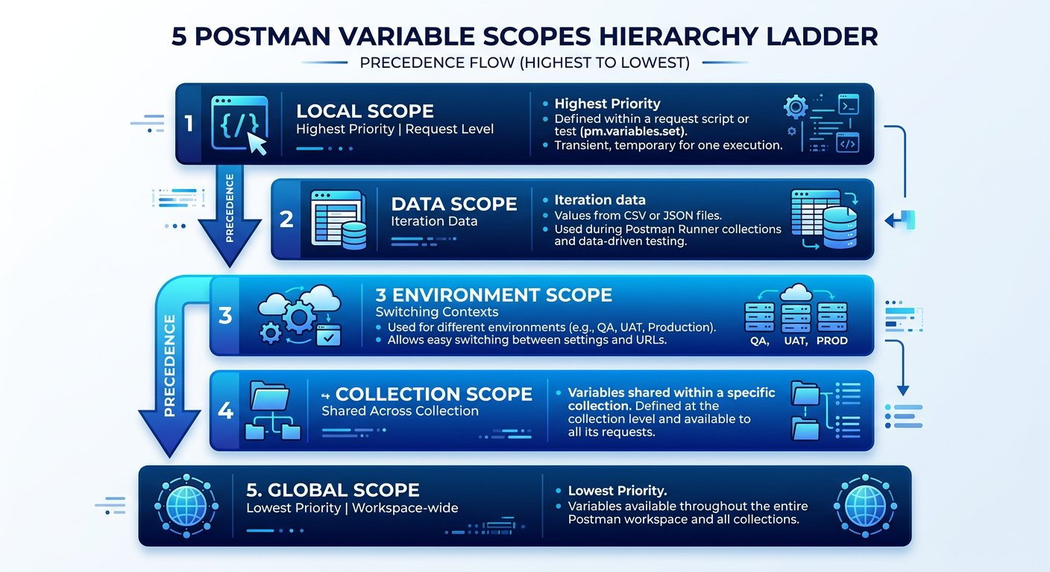
The five variable scopes in Postman and their order of precedence.
1 Local Scope (Highest Priority): Temporary variables declared inside a single request script.
2 Data Scope: Values supplied by external data files (such as CSV or JSON) during iterations.
3 Environment Scope: Key value pairs tied to a specific deployment stage (QA, UAT, Production).
4 Collection Scope: Variables shared across all requests inside one specific collection folder.
5 Global Scope (Lowest Priority): Universal constants accessible across all collections and environments.
The Five Postman Variable Tiers Explained
When multiple variables share the exact same key name, Postman resolves conflicts by choosing the narrowest scope. Here is the operational role of each tier:
PILLAR 1: Scope 1: Local · Temporary In Script Variables
Exists exclusively while the active script is executing. Overrides every other scope in Postman.
• pm.variables.set("tempId", 101): Scoped strictly to the immediate request run.
• Disappears from memory as soon as the request completes.
PILLAR 2: Scope 2: Data · External Dataset Row Variables
Supplied by external CSV or JSON test data files during automated Collection Runner runs.
• pm.iterationData.get("isbn"): Reads the specific value from the current dataset row.
• Each iteration pulls fresh data automatically.
PILLAR 3: Scope 3: Environment · Infrastructure Stage Configuration
Configures target hostnames and ports for specific deployment stages like Local, QA, and UAT.
• pm.environment.set("base_url", "..."): Switched instantly with the environment dropdown.
• Initial values sync to team cloud; current values stay local to your machine.
PILLAR 4: Scope 4: Collection · Test Suite Level Variables
Variables shared across every folder and request inside one specific Postman collection.
• pm.collectionVariables.set("suiteToken", "..."): Accessible by all requests in the collection.
• Ideal for generated IDs passed between consecutive steps.
PILLAR 5: Scope 5: Global · Workspace Wide Constants
Universal settings accessible across all collections and environments within the workspace.
• pm.globals.set("companyDomain", "..."): Lowest precedence in the hierarchy.
• Easily overridden by environment or collection variables with the same name.

Step 2: Switching Environments with Double Curly Braces
Referencing any variable inside a URL, query parameter, header, or JSON body requires wrapping the variable name in double curly braces: {{variable_name}}. You can import the pre configured QA environment directly: [Download Campus Library QA Environment](/materials/zero-to-agentic-api-testing/Campus-Library-QA.postman_environment.json) or [Raw GitHub File](https://raw.githubusercontent.com/mayankcoder1993/AkshatEbooks/arena/01a0bfe5-akshatebooks/course-materials/zero-to-agentic-api-testing/Campus-Library-QA.postman_environment.json).

Environment Configuration for Library API Targets
Environment Name | Variable Key | Resolved Base URL Value | Purpose
QA Environment | base_url | https://qa-api.campuslibrary.org | Fast internal server cluster used for testing new features.
UAT Environment | base_url | https://uat-api.campuslibrary.org | User Acceptance Testing mirror simulating live traffic.
Initial Value vs Current Value Security Mechanics
• Initial Value: Synced to Postman cloud servers and included in team exports. Use this for templates, never real passwords.
• Current Value: Kept strictly in local session memory. Scripts update it dynamically at runtime without leaking secrets.
Akshay Switches Environments with Double Curly Braces
API TESTING WORKBENCH · ENVIRONMENT ISOLATION
Akshay Switches Environments with Double Curly Braces

API Request: GET {{base_url}}/v1/campus/shuttle/coordinates?route=campus_loop_north

Live Response: 200 OK (32 ms)
response.json
1 {
2 "route": "campus_loop_north",
3 "shuttleId": "BUS_104",
4 "status": "in_transit",
5 "coordinates": {
6 "latitude": 42.3601,
7 "longitude": -71.0942
8 }
9 }
1. Explicit Input: GET {{base_url}}/v1/campus/shuttle/coordinates executed with QA Environment active.
2. Wire & Logic Explanation: Postman intercepts outgoing packet, checks active Environment scope for base_url, and interpolates target host.
3. Deterministic Output: 200 OK received from QA target server without hardcoding URLs.
4. Senior Savior & Common Trap: Storing sensitive API keys in the Initial Value column exposes secrets in team cloud sync. Always place secrets in Current Value.

Step 3: Generating Unique ISBNs in Pre request Scripts
To avoid the duplicate book already exists bug we uncovered in Chapter 4, we write a Pre request script to generate a unique random ISBN on every single run:
Dynamic ISBN Generation Script
Executed before the HTTP request leaves the computer:
CHUNK 1: Chunk 1: Fetching Base Prefix · Reading Global Scope
Reads the shared company code prefix from Global Scope, defaulting to LIB if unset.
prefix-lookup.js
1 const companyCode = pm.globals.get("company_code") || "LIB";
Rule: Global variables provide universal defaults across collections.
CHUNK 2: Chunk 2: Random Number Generation · Generating Non Colliding Key
Produces a random four digit number (e.g. 4821) and appends it to form LIB4821.
random-generator.js
1 const randomDigits = Math.floor(1000 + Math.random() * 9000);
const uniqueISBN = companyCode + randomDigits;
Rule: Combining random values with timestamps reduces collisions, but teardown remains essential.
CHUNK 3: Chunk 3: Saving to Collection Variable · Binding to Collection Tier
Saves the fresh key so the request body placeholder {{ISBN}} can interpolate it at runtime.
save-variable.js
1 pm.collectionVariables.set("ISBN", uniqueISBN);
Rule: Collection tier keeps generated data accessible to all downstream requests.
Akshay Generates Dynamic ISBNs Before Dispatch
API TESTING WORKBENCH · PRE REQUEST DYNAMIC GENERATION
Akshay Generates Dynamic ISBNs Before Dispatch

API Request: POST {{base_url}}/v1/books

Request Body:
request_body.json
1 {
2 "name": "Zero to Agentic API Testing",
3 "isbn": "{{ISBN}}",
4 "aisle": "304",
5 "author": "Alex Mercer"
6 }
Live Response: 200 OK (155 ms)
response.json
1 {
2 "Msg": "successfully added",
3 "ID": "LIB8421304"
4 }
1. Explicit Input: Pre request script sets ISBN collection variable; body interpolates {{ISBN}}.
2. Wire & Logic Explanation: Script runs pre flight, saves generated ISBN to Collection scope, and body builder substitutes dynamic token.
3. Deterministic Output: 200 OK confirming book added with dynamic composite ID: LIB8421304.
4. Senior Savior & Common Trap: Mismatched casing between pm.collectionVariables.set("ISBN", ...) and {{isbn}} causes Postman to transmit empty or literal text.
Verified Mathematical Proof · Probability and Collision Theory
The Birthday Problem Mathematical Analysis Demonstrating 50 Percent Collision Probability After Square Root of Sample Size Iterations
https://csrc.nist.gov/publications/detail/sp/800-90a/rev-1/final
Verified through National Institute of Standards and Technology (NIST) Special Publication 800-90A Recommendation for Random Number Generation
The Birthday Paradox: Why Naive Random Numbers Collide in CI CD
Why not simply generate a random 4 digit integer between 1000 and 9999? Consider the mathematics of the Birthday Paradox.
With only 9,000 possible 4 digit values, probability theory dictates that after just 112 test executions, there is a 50 percent chance that two runs generate the exact same number! In an automated continuous integration pipeline running 20 builds daily, collisions will inevitably cause false negative test failures within days.
To achieve collision resistance, combine multiple entropy sources: a timestamp like Date.now(), or Postman built in dynamic variables like {{$randomISBN}} and {{$randomInt}}.
Crucial Automation Law: Even with collision resistant generation, automated teardown via DeleteBook is mandatory. Relying on randomness alone leaves orphaned records that bloat database indexes and corrupt catalog counts over time.

Expected output
Terminal
1 $ Local Pre Request Execution Output (Postman Console)
2 [Pre request Script] Generating unique book identity...
3 [Global Scope] Read company_code: LIB
4 [Random Generator] Produced entropy digits: 8421
5 [Collection Scope] Set ISBN: LIB8421
6 [Network Wire] Outgoing POST payload body: { "isbn": "LIB8421", "aisle": "304" }
Sameer Explains Why Randomness Still Demands Teardown
API TESTING WORKBENCH · BIRTHDAY COLLISION MATH
Sameer Explains Why Randomness Still Demands Teardown

API Request: POST {{base_url}}/v1/books/delete

Request Body:
request_body.json
1 {
2 "ID": "LIB8421304"
3 }
Live Response: 200 OK (125 ms)
response.json
1 {
2 "msg": "book is successfully deleted"
3 }
1. Explicit Input: DeleteBook request dispatched with dynamic composite ID LIB8421304.
2. Wire & Logic Explanation: Purging the newly created record returns database to pristine state, eliminating collision risk for future runs.
3. Deterministic Output: 200 OK confirming record purged from database table.
4. Senior Savior & Common Trap: Relying purely on random generation without teardown pollutes databases and guarantees CI failure as iterations scale.
IMAGINE & PREDICT BEFORE SENDING
If uniqueISBN generates "LIB7824" and the request payload is { "isbn": "{{ISBN}}" }, what raw text does Postman transmit over the wire?
A. The literal string { "isbn": "{{ISBN}}" } with curly braces
B. The interpolated value { "isbn": "LIB7824" } with curly braces replaced by the variable value
C. An empty string { "isbn": "" } because variables require quotes
D. A syntax error because Postman does not support curly braces in JSON
Actual Output (Wire Interpolation Confirmation): Postman resolves the variable! Before sending the network packet, Postman replaces {{ISBN}} with the current runtime value "LIB7824", transmitting clean JSON to the server.
Fresher Trap to Avoid: Mismatched Variable Casing and Typo Bugs
JavaScript variable keys in Postman are strictly case sensitive.
If your Pre request script writes pm.collectionVariables.set("ISBN", ...) in capital letters, but your JSON payload body looks for {{isbn}} in lowercase, Postman will NOT find the variable and will send an empty string or the literal text "{{isbn}}" to the server!
Always ensure exact matching casing between the variable key saved in your script and the placeholder wrapped in double curly braces.
WAR ROOM BATTLE SCAR · Environment Misconfiguration Outage
The Production Database Overwrite Outage: The Danger of Ambiguous Variable Scopes
An engineering team ran an automated load test suite intended for the staging cluster. However, the collection contained a global variable baseUrl set to the production cluster, while the staging environment variable had a subtle spelling mismatch (base_url vs baseUrl). Because of the variable precedence hierarchy and naming discrepancy, Postman defaulted to the global production URL. Within minutes, the automated test inserted fifty thousand fictitious student test accounts directly into the live production database!
Key Architectural Lesson: Never define production server hostnames in global variables. Always isolate target server environments strictly and verify variable resolution in the Postman Console before triggering automated test runs.
WAR ROOM INCIDENT TRIAGE
War Room Triage: The Mystery of the Overridden Variable
You select the "QA Environment" in Postman where timeout is set to 5000 milliseconds. But when you click Send, your test script fails after only 100 milliseconds with a timeout exception. When inspecting your collection, you discover a script with: pm.variables.set("timeout", 100). Why did Postman ignore your 5000 millisecond environment setting?
A. Postman environments do not work when running single requests manually.
B. Local script scope variables created via pm.variables.set have higher precedence than environment variables and override them during execution.
C. The QA server database rejected the timeout header because it was too large.
D. Environment variables only apply to request URLs, not to script logic.
TACTICAL TRIUMPH: Local scope overrides environment scope! The Postman variable hierarchy prioritizes Local variables above Data, Environment, Collection, and Global tiers. The in script variable took precedence, causing the early timeout.

Step 4: Review and Practice
MAKE A GUESS
If a variable with the exact same name is defined in both Collection scope and Local script scope, which value takes precedence?
- A. Collection scope value
- B. Local script scope value
- C. Postman throws a duplicate variable error
- D. Global scope value
Answer: Local script scope value. Local scope has the highest priority of all five scopes. A local variable defined inside a script will always override collection, environment, and global variables with the same name.

Check your understanding
1. What are the five variable scopes in order from highest precedence to lowest precedence?
Answer: Local (highest) > Data > Environment > Collection > Global (lowest).
2. Why must dynamic ISBN generation logic be placed in the Pre request Script tab instead of the Tests tab?
Answer: The Pre request Script tab executes before the request payload is constructed. The Tests tab executes only after the response has already returned from the server.

Key takeaways
REMEMBER
- Variables eliminate hardcoded server URLs and prevent duplicate data collisions.
- Postman supports five scopes: Local, Data, Environment, Collection, and Global.
- Use double curly braces {{variable_name}} to reference variables anywhere in requests.
- Initial values sync to the cloud; Current values stay local for secure runtime execution.
⚡ MISSION 2 PHASE 3 CLEARED · Architectural Triumph: Multi Scope Hierarchy & Dynamic Data Engine Deployed
You shattered hardcoded server URLs and eliminated duplicate database constraint collisions forever. By mastering the 5 variable scopes, scope precedence rules, and runtime Pre request scripting, your test suites now adapt seamlessly across QA, UAT, and Staging without a single manual edit.
Tactical Superpowers Mastered:
- Navigating the 5 variable scopes hierarchy: Local, Data, Environment, Collection, and Global with zero conflict ambiguity
- Parameterizing network calls using double curly brace syntax {{base_url}} across URLs, headers, and payloads
- Generating dynamic unique primary keys at runtime using Pre request scripts and Postman dynamic tokens
- Guarding enterprise credentials using Initial Value vs Current Value memory isolation
Enterprise Disasters Prevented:
- Averted catastrophic accidental execution of destructive test scripts against live Production databases
- Blocked confidential API keys and client secrets from leaking to public GitHub repositories via team exports
- Eliminated duplicate ISBN collision failures that halt automated regression test runs in CI pipelines
War Room Takeaway: Hardcoded test data is a ticking time bomb. The moment your tests generate their own unique identities and dynamically resolve their target environment, they become truly portable and unstoppable.
NEXT DISCOVERY · Continuing Mission 2: Assembling the autonomous pipeline
We now generate dynamic ISBNs and switch between QA and UAT seamlessly. But when AddBook creates a book ID, we still need to pass it to GetBook and DeleteBook. In Chapter 7, we advance Mission 2: automatically piping response data downstream with Request Chaining!

Chapter 7: Request Chaining and Complex Nested JSON Parsing
Automated property transfer, navigating nested object hierarchies, array methods, and mathematical calculations.
MISSION COMMAND HUD
PHASE: Phase 4 of 5: Dynamic Request Chaining & Array Pipelines · RANK: Rank: Automation Pipeline Architect
ACTIVE MISSION: Mission 2: Automating Student and Campus Services at Scale
MISSION BRIEFING & CHAPTER ROADMAP
MISSION 2 · PHASE 4 OF 6: Automating Student and Campus Services at Scale
CRISIS SCENARIO: Autonomous Request Chaining and Multilevel JSON Traversal
Context: Real world workflows do not exist in isolation: data produced by one request must be consumed by the next. In the library catalog, AddBook generates a composite ID that must be dynamically captured and passed into GetBook and DeleteBook. Furthermore, enterprise responses contain deeply nested objects and arrays that require mathematical verification.
Operational Target: Chain AddBook, GetBook, and DeleteBook dynamically, parse nested JSON responses, and aggregate array data with JavaScript methods.

WE WILL ACHIEVE: Build an autonomous multi request testing pipeline by capturing dynamic IDs, piping them into downstream requests, and verifying nested JSON structures and array mathematics.
HOW WE WILL DO IT: Chain AddBook to GetBook and DeleteBook using collection variables, assert exact catalog fields without assuming unreturned properties, and master find, filter, map, and reduce in an advanced audit lab.
WHAT YOU WILL CARRY FORWARD: An end to end chained pipeline that creates, validates, and cleans up records autonomously, ready for multi row data driven execution in Chapter 8.
MISSION PROGRESS · Continuing Mission 2: Assembling the Autonomous Pipeline
Our AddBook request is now parameterized and unique, but we are still manually copying the generated book ID into GetBook and DeleteBook. Our next step in Mission 2 is assembling an autonomous regression pipeline: capturing the response ID automatically, passing it downstream via environment variables, navigating complex nested JSON structures, filtering and mapping arrays, and validating business calculations across multi step transactions.

Step 1: The Three Stage Request Chaining Pipeline
ARCHITECTURE · Dynamic Request Chaining: Passing Identity Between Dependent Calls
REQUEST PIPELINE · Dynamic Request Chaining: Passing Identity Between Dependent Calls
By storing dynamic outputs into variables, a collection can execute dozens of interdependent requests in complete harmony. Subsequent requests consume dynamic keys in their URLs, headers, or request bodies automatically, eliminating all manual copy paste intervention.
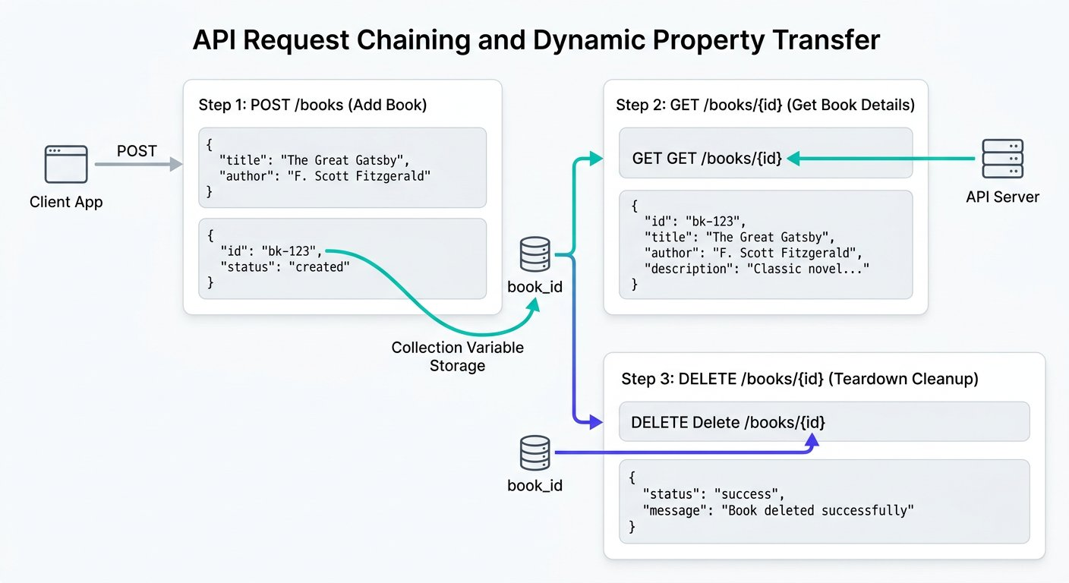
The autonomous property transfer pipeline across three chained requests.
1 Step 1 (AddBook POST): Dispatches dynamic payload. Tests script extracts generated ID into collection variable book_id.
2 Step 2 (GetBook GET): Injects {{book_id}} into query params and asserts that the cataloged book name, ISBN, and aisle match the created record.
3 Step 3 (DeleteBook POST): Reads {{book_id}} in the payload body and asserts that the record is completely removed from the database.

Step 2: Capturing and Storing the ID in AddBook
In the Tests tab of AddBook, parse the response JSON and save the generated ID into a variable so downstream requests can immediately read it. We break this property transfer down into three chunks:
Automated Property Transfer Mechanics
Extracting data from responses and passing downstream:
CHUNK 1: Chunk 1: Parsing Incoming Payload · Deserializing JSON Text
Converts the raw text into a navigable JavaScript object.
parse-response.js
1 const responseData = pm.response.json();
Rule: Always deserialize before property lookups.
CHUNK 2: Chunk 2: Extracting Generated Key · Defensive Property Extraction
Validates that the ID key exists and holds a valid string before attempting to save.
extract-property.js
1 const generatedId = responseData.ID;
pm.expect(generatedId, "Generated ID").to.not.be.undefined;
Rule: Defensive validation prevents saving undefined into variables.
CHUNK 3: Chunk 3: Persisting to Collection Tier · Binding to Shared Scope
Stores the ID in Collection Scope so subsequent requests can interpolate {{book_id}}.
persist-variable.js
1 pm.collectionVariables.set("book_id", generatedId);
Rule: Collection tier makes variables universally accessible to all folder requests.
IMAGINE & PREDICT BEFORE SENDING
When AddBook completes and GetBook executes with URL: GET /v1/books?id={{book_id}}, what value does Postman send across the network wire?
A. The exact composite ID string (such as "LIB4821227") dynamically extracted from the AddBook response
B. The literal placeholder text "{{book_id}}"
C. An empty query parameter ?id=
D. A null pointer exception
Actual Output (Dynamic Chaining Wire Confirmation): Property transfer confirmed! Postman resolves {{book_id}} from Collection Scope, replacing the placeholder with the dynamic composite ID value (LIB4821227) before dispatching the HTTP GET request!

Step 3: Handling JSON Arrays and Validating ID Calculation
GetBook returns a JSON array. In JavaScript, access the first record using zero index bracket notation: booksList[0].book_name. Because these assertions validate different points in the lifecycle, we separate them into their respective request Tests tabs in Postman:

The code
addbook-tests.js
1 // Placed in the Tests tab of AddBook (POST /v1/books)
2 const requestPayload = JSON.parse(pm.request.body.raw);
3 const expectedCompositeId = requestPayload.isbn + requestPayload.aisle;
4 const responsePayload = pm.response.json();
5
6 pm.test("Backend generated ID correctly concatenates ISBN and aisle", function () {
7 pm.expect(responsePayload.ID).to.eql(expectedCompositeId);
8 });
9
10 // Store composite ID in collection variable for downstream requests
11 pm.collectionVariables.set("book_id", responsePayload.ID);

The code
getbook-tests.js
1 // Placed in the Tests tab of GetBook (GET /v1/books?id={{book_id}})
2 const booksList = pm.response.json();
3
4 pm.test("GetBook returns valid array with matching catalog metadata", function () {
5 pm.expect(booksList).to.be.an("array").with.lengthOf.atLeast(1);
6 pm.expect(booksList[0].book_name).to.eql("Zero to Agentic API Testing");
7 pm.expect(booksList[0].isbn).to.eql(pm.collectionVariables.get("ISBN"));
8 pm.expect(booksList[0].aisle).to.eql("227");
9 });
Contract Precision: Why Author is Omitted from GetBook
Notice that GetBook returns an array containing book_name, isbn, and aisle. The author field supplied during AddBook is not included in this endpoint response.
If you wrote pm.expect(booksList[0].author).to.eql("Alex Mercer"), your test would crash with an undefined failure.
Never assert fields based on wishful thinking: assert strictly against what the API contract promises.

Step 4: Navigating Complex Nested JSON and Array Methods
Real enterprise APIs rarely return flat, simple objects. Instead, responses contain nested hierarchies with multiple layers of parent objects, metadata summaries, and arrays of detailed items. Consider the Campus Library department audit endpoint below. You can download the sample payload: [Download Department Audit Response JSON](/materials/zero-to-agentic-api-testing/lesson-07/department-audit-response.json):

The code
nested-department-response.json
1 {
2 "department": "Computer Science and Systems",
3 "budget": {
4 "total_allocated": 1500,
5 "currency": "USD"
6 },
7 "books": [
8 {
9 "id": "BK101",
10 "title": "Full Stack API Automation",
11 "author": "Dr. Sarah Chen",
12 "price": 45,
13 "copies": 12,
14 "tags": ["api", "testing", "javascript"]
15 },
16 {
17 "id": "BK102",
18 "title": "Postman Architecture Patterns",
19 "author": "Marcus Vance",
20 "price": 55,
21 "copies": 8,
22 "tags": ["postman", "architecture"]
23 },
24 {
25 "id": "BK103",
26 "title": "Distributed Systems Reliability",
27 "author": "Elena Rostova",
28 "price": 65,
29 "copies": 8,
30 "tags": ["cloud", "reliability"]
31 }
32 ]
33 }
Four Essential JavaScript Array Methods for API Testers
• find(): Searches an array and returns the very first element matching a boolean condition.
• filter(): Scans the entire array and returns a new array containing all elements that satisfy the condition.
• map(): Transforms every element into a new representation, such as plucking a single property from an object array.
• reduce(): Iterates through an array while accumulating a running total, ideal for verifying mathematical sums.
ARCHITECTURE · JavaScript Array Transformation Pipeline: Filtering, Mapping, and Aggregating
DATA TRANSFORMATION · JavaScript Array Transformation Pipeline: Filtering, Mapping, and Aggregating
Modern enterprise APIs deliver deep hierarchical payloads. Understanding how find, map, filter, and reduce transform JSON arrays allows automation engineers to locate specific records, compute expected financial aggregates, and assert mathematical integrity across entire catalogs.
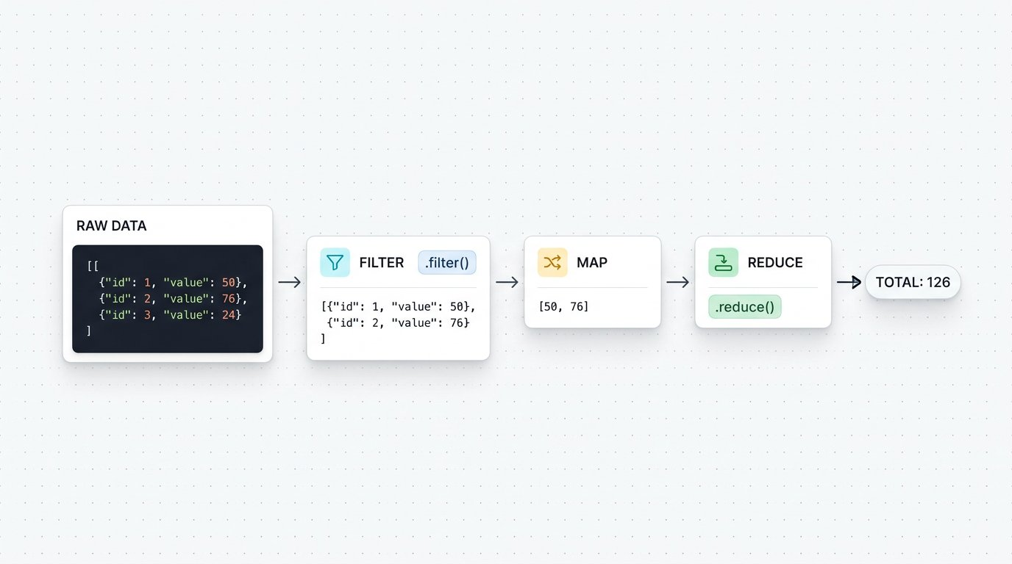
The JavaScript Array Transformation Pipeline: Filtering, mapping, and reducing nested API data.
1 Stage 1 (Raw JSON Array): The incoming API response delivers an array of book objects containing titles and unit prices.
2 Stage 2 (Filter Stage): books.filter() scans the array and extracts only items matching the condition (books priced above 30 dollars), discarding non matching records.
3 Stage 3 (Map Stage): filteredBooks.map() transforms each item into a formatted line item object with calculated item totals.
4 Stage 4 (Reduce Stage): mappedItems.reduce() accumulates each item total into a single running total, producing the final invoice sum of 126.

Step 5: Writing Advanced Assertions: Finding, Filtering, and Summing
Here is how we use these modern JavaScript methods inside Postman test scripts to verify complete schemas, locate target records, and validate mathematical integrity. You can download the script: [Download Advanced Array Assertions Script](/materials/zero-to-agentic-api-testing/lesson-07/advanced-array-assertions.js):

The code
advanced-nested-json-assertions.js
1 const responseData = pm.response.json();
2
3 // Test 1: Assert top level object and array size
4 pm.test("Department audit returns valid book records", function () {
5 pm.expect(responseData.department).to.eql("Computer Science and Systems");
6 pm.expect(responseData.books).to.be.an("array").with.lengthOf(3);
7 });
8
9 // Test 2: Locate a specific book using find() and assert all keys exist
10 pm.test("Locate Postman Architecture Patterns and verify its schema", function () {
11 const targetBook = responseData.books.find(book => book.title === "Postman Architecture Patterns");
12 pm.expect(targetBook, "Target book must exist").to.not.be.undefined;
13 pm.expect(targetBook.price).to.eql(55);
14 pm.expect(targetBook).to.have.all.keys("id", "title", "author", "price", "copies", "tags");
15 });
16
17 // Test 3: Extract titles using map() and filter premium books
18 pm.test("Verify premium collection and extracted titles", function () {
19 const titles = responseData.books.map(book => book.title);
20 pm.expect(titles).to.include("Full Stack API Automation");
21
22 const premiumBooks = responseData.books.filter(book => book.price >= 50);
23 pm.expect(premiumBooks.length).to.eql(2);
24 });
25
26 // Test 4: Calculate mathematical sum using reduce()
27 pm.test("Calculated purchase total matches allocated budget", function () {
28 const calculatedTotal = responseData.books.reduce(function (runningSum, book) {
29 return runningSum + (book.price * book.copies);
30 }, 0);
31
32 // (45 * 12 = 540) + (55 * 8 = 440) + (65 * 8 = 520) = 1500
33 pm.expect(calculatedTotal).to.eql(responseData.budget.total_allocated);
34 });
Fresher Trap to Avoid: Forgetting the Initial Value in reduce()
When using array.reduce() to calculate a sum, always provide 0 as the second argument: reduce(function(...) { ... }, 0);.
If you omit the 0, JavaScript sets the initial accumulator to the first object in the array rather than the number zero! Your addition will result in strange string concatenation errors like [object Object]440520 instead of 1500.
Always supply 0 as the starting number when accumulating mathematical totals.

Step 6: The Autonomous Library Lifecycle Pipeline
Now let us connect our entire automated library workflow into an unbroken, autonomous sequence in Postman:

Try it yourself
- 1. POST AddBook: Dispatches dynamic payload with generated ISBN. Tests script captures the created composite ID: pm.collectionVariables.set("book_id", jsonData.ID).
- 2. GET GetBook: Calls /v1/books?id={{book_id}}. Tests script confirms that book_name, isbn, and aisle match the created record.
- 3. POST DeleteBook: Dispatches /v1/books/delete with body {"ID": "{{book_id}}"}. Confirms deletion confirmation from server.
- 4. Advanced Side Lab (GET DepartmentAudit): Fetches the departmental inventory array and executes reduce() summation to verify fiscal budget totals.

Step 7: Executing the Suite with Collection Runner

Expected output
Terminal
1 $ Postman Collection Runner Execution Summary
2 1. POST AddBook: 200 OK (180 ms) : 2 of 2 passed (Captured book_id)
3 2. GET GetBook: 200 OK (145 ms) : 2 of 2 passed (Verified book_id {{book_id}})
4 3. POST DeleteBook: 200 OK (130 ms) : 1 of 1 passed (Teardown completed)
5 4. GET DepartmentAudit (Side Lab): 200 OK (185 ms) : 3 of 3 passed (Nested array sum verified)
6 Collection Run Complete: 4 requests, 8 assertions, 0 failures (640 ms)
WAR ROOM BATTLE SCAR · Order Processing Pipeline Failure
The Silent Null ID Disaster: The Perils of Unchecked Property Transfer
An online ticketing company deployed a microservice update that changed the confirmation key from id to order_id in their reservation endpoint. The downstream payment capture step in the automated test suite continued to look for data.id without defensive validation. The variable was set to undefined, and the payment API was called with: POST /v1/payments/capture?orderId=undefined. Because the payment API did not validate the parameter, thousands of transactions were recorded against a null order ID, requiring emergency database reconciliations.
Key Architectural Lesson: Always validate that dynamic properties exist before saving them to collection or environment variables. Defensive checks like pm.expect(data.id).to.not.be.undefined prevent corrupted downstream request pipelines.
WAR ROOM INCIDENT TRIAGE
War Room Triage: The Mystery of the Uncaught TypeError in Array Parsing
You are writing an assertion to verify the price of the third book in an audit response: pm.expect(data.department.courses[2].books[0].price).to.eql(45). The test runner throws a fatal error: "TypeError: Cannot read property books of undefined". What is the most likely structural defect in the response?
A. Postman does not support zero based array indexing.
B. The courses array contained only two elements, so courses[2] resolved to undefined, making .books an invalid property lookup.
C. The price field in JSON must always be wrapped in quotation marks.
D. Array methods in JavaScript cannot be executed inside the Tests tab.
TACTICAL TRIUMPH: Zero based index boundary overflow! In JavaScript, array indices start at 0. Therefore, the third item is at index 2. If the courses array contains only two courses (indices 0 and 1), courses[2] evaluates to undefined, and attempting to access .books throws a fatal TypeError. Always assert array length before indexing into nested elements!

Step 8: Review and Practice
MAKE A GUESS
If an API response returns an array of objects called courses, which JavaScript method finds the single course object whose title is "REST Automation"?
- A. courses.find(item => item.title === "REST Automation")
- B. courses.get("REST Automation")
- C. courses.locate("REST Automation")
- D. courses.filterOne("REST Automation")
Answer: courses.find(item => item.title === "REST Automation"). The find method evaluates each element in an array and returns the first element that satisfies the provided condition.

Check your understanding
1. What is property transfer in API test automation?
Answer: Property transfer is capturing dynamic values from an earlier API response and injecting them into downstream request parameters or payloads.
2. Why must enterprise regression suites include automated teardown cleanup requests?
Answer: Automated tests run continuously in CI CD pipelines. If tests do not delete the orders and products they create, test databases accumulate thousands of orphaned records, causing database bloat and false uniqueness failures.

Key takeaways
REMEMBER
- Request chaining connects isolated API calls into complete automated user journeys.
- Use environment variables to transfer identifiers across sequential requests.
- Use find to locate objects, filter to subset collections, and map to extract property lists.
- Use reduce to compute mathematical sums across nested arrays and assert business logic.
- Automated teardown steps clean up created resources, keeping test databases pure and idempotent.
⚡ MISSION 2 PHASE 4 CLEARED · Architectural Triumph: Deep Array Pipelines & Request Chaining Mastered
You linked disconnected HTTP requests into a living, breathing autonomous transaction pipeline. You extracted dynamic IDs, traversed multilevel nested objects without crash errors, performed high speed array transformations (find, filter, map), and mathematically verified financial balance totals using reduce. You operate at the highest echelon of API automation.
Tactical Superpowers Mastered:
- Dynamic property transfer: piping tokens, session cookies, and resource IDs across multi request suites
- Deep nested JSON parsing: safely traversing multilevel object trees and arrays without null reference exceptions
- Functional array pipelines: wielding find, filter, and map to isolate specific records in complex payloads
- Mathematical business logic verification: aggregating invoice and catalog totals dynamically using reduce
- Zero footprint test execution: deploying automated teardown deletions that leave databases perfectly pristine
Enterprise Disasters Prevented:
- Averted silent financial balance discrepancies by verifying computed cart totals against backend invoices
- Stopped catastrophic test database pollution where uncleaned test orders exhaust database storage and IDs
- Eliminated brittle hardcoded test suites that crash whenever upstream backend developers alter resource IDs
War Room Takeaway: Isolated API checks only test plumbing. Chained request pipelines test real world user journeys and business reality. When your chained suite passes, the entire business flow is guaranteed.
NEXT DISCOVERY · Continuing Mission 2: Scaling to bulk inventory
Our chained pipeline and nested assertions work cleanly for single and nested requests. But what if a shipment of 100 new books arrives in a CSV spreadsheet? In Chapter 8, we complete Mission 2: driving bulk automated execution using external CSV and JSON data files!

Chapter 8: Data Driven Testing with External Data Files
Powering automated iterations with CSV and JSON files, pm.iterationData, and debugging console traps.
MISSION COMMAND HUD
PHASE: Phase 5 of 5: Data Driven Scale (Mission Victory) · RANK: Rank: Enterprise Quality Architect
ACTIVE MISSION: Mission 2: Automating Student and Campus Services at Scale
MISSION BRIEFING & CHAPTER ROADMAP
MISSION 2 · PHASE 5 OF 6: Automating Student and Campus Services at Scale
CRISIS SCENARIO: Mass Ingestion: Data Driven Testing with External Datasets
Context: Testing one book at a time proves the contract works, but enterprise systems must ingest thousands of books across different genres and authors. Hardcoding individual test cases for every book is unmaintainable. We must decouple test logic from test data by driving automated iterations from external CSV and JSON data files.
Operational Target: Drive automated collection runner iterations using external CSV and JSON datasets with iterationData variables.

WE WILL ACHIEVE: Scale single request tests into bulk regression engines by driving automated iterations with external CSV datasets and mastering Data Scope precedence.
HOW WE WILL DO IT: Structure tabular test data, ingest row values using pm.iterationData, parameterize request bodies, and monitor iteration level execution scorecards.
WHAT YOU WILL CARRY FORWARD: The capability to execute high volume regression suites against external datasets, closing Mission 2 and preparing for complex e commerce workflows in Chapter 9.
MISSION PROGRESS · Completing Mission 2: Ingesting Bulk Inventory with External Data Files
Our chained pipeline in Chapter 7 tests a single book with complete autonomy. But this morning, the college bookstore received a shipment of 100 new textbooks in a CSV spreadsheet. Our final step in Mission 2 is implementing Data Driven Testing: loading books_data.csv into the Postman Collection Runner, iterating through every record row by row, and validating bulk ingestion at scale.

Step 1: The Data Driven Iteration Loop
ARCHITECTURE · Data Driven Testing Loop: Executing Parameterized Iterations
DATA DRIVEN TESTING · Data Driven Testing Loop: Executing Parameterized Iterations
In Data Driven Testing, your request sequence acts as a reusable engine. When you feed an external data file into the Collection Runner, Postman executes the entire collection once for every single row in the file, automatically binding values to data variables.
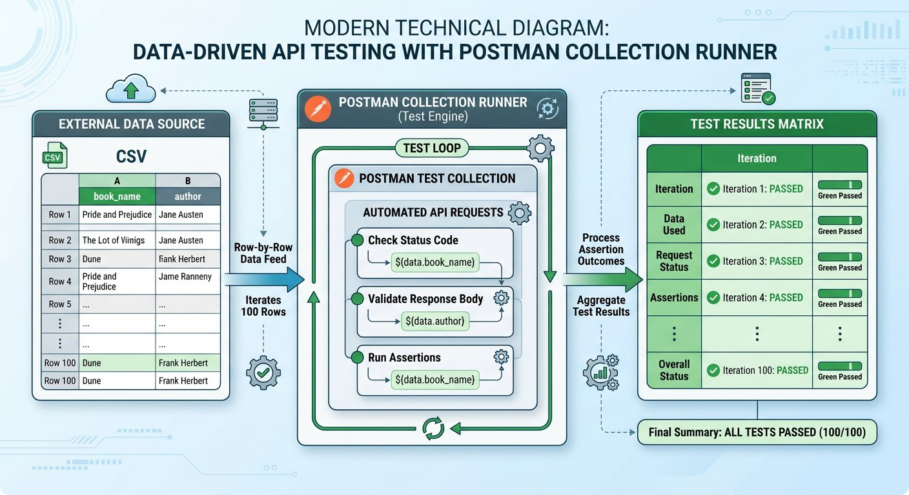
The Data Driven Testing loop executing multiple test iterations from one external file.
1 The External Dataset: A CSV or JSON document where column headers act as variable keys and each row contains distinct test values.
2 The Collection Runner Loop: Postman loads row 1, executes Pre request scripts, fires the request, and runs assertions. It then immediately repeats the cycle for row 2, row 3, and beyond.
3 The Iteration Scorecard: Results are tallied across all runs, reporting total passed assertions and pinpointing any failing records.

Step 2: Preparing the CSV Dataset and Ingesting Row Values
You can download the ready to use dataset directly: [Download books_data.csv](/materials/zero-to-agentic-api-testing/lesson-08/books_data.csv) or view the single file on GitHub: [Raw books_data.csv](https://raw.githubusercontent.com/mayankcoder1993/AkshatEbooks/arena/01a0bfe5-akshatebooks/course-materials/zero-to-agentic-api-testing/lesson-08/books_data.csv). Clicking the link opens only that individual file.

The code
books_data.csv
1 book_name,author,aisle
2 Learn Postman Testing,John Doe,101
3 Mastering Git and GitHub,Jane Smith,102
4 Modern Angular Architecture,Alex Mercer,103
During a collection run with a data file, Postman exposes Data Scope. In Pre request scripts, access row values with pm.iterationData.get(). We break down the data ingestion script into three chunks:
Ingesting CSV Rows into Request Payloads
Executed before each row request fires:
CHUNK 1: Chunk 1: Reading from Data Scope · Extracting Active Row Values
Reads the specific values from the columns of the active CSV row for this iteration.
read-row.js
1 const currentBook = pm.iterationData.get("book_name");
const currentAuthor = pm.iterationData.get("author");
Rule: Column headers in the CSV must match the string passed to get().
CHUNK 2: Chunk 2: Promoting to Collection Variables · Making Data Available to Request Body
Stores row values in Collection Scope so request body placeholders {{book_name}} can interpolate them.
promote-vars.js
1 pm.collectionVariables.set("book_name", currentBook);
pm.collectionVariables.set("author_name", currentAuthor);
Rule: Double curly brace placeholders read values from Collection Scope.
CHUNK 3: Chunk 3: Dynamic Random Key per Row · Guaranteed Uniqueness Across Iterations
Generates a fresh random ISBN for each iteration row to prevent unique constraint rejections.
row-isbn.js
1 const randomDigits = Math.floor(1000 + Math.random() * 9000);
pm.collectionVariables.set("ISBN", "LIB" + randomDigits);
Rule: Dynamic generation per row ensures 100 consecutive rows insert without collision.
IMAGINE & PREDICT BEFORE SENDING
When you upload a CSV file with 3 data rows into the Postman Collection Runner and click Run, how many total request iterations will Postman execute?
A. Exactly 3 iterations: Postman automatically sets the iteration count to match the number of data rows in the file
B. Only 1 iteration: Postman stops after reading the first line
C. 30 iterations: Postman multiplies the row count by 10 by default
D. 0 iterations: Postman requires manual entry of loop counts
Actual Output (Collection Runner Iteration Count Confirmation): Postman inspects the file! When a CSV or JSON file is uploaded, Postman counts the data rows (excluding the header) and automatically locks the iteration counter to that exact number (3 iterations).
Fresher Trap to Avoid: Using pm.environment for File Data
A frequent confusion among freshers is trying to read CSV rows using pm.environment.get("book_name").
Uploaded CSV rows live strictly inside Data Scope, not Environment Scope. Calling pm.environment.get() will return undefined!
Always use pm.iterationData.get("column_header") to read fields from your uploaded CSV or JSON files.

Step 3: Debugging Console Traps: The Undefined Variable Bug
BUG HUNT
You run the collection with your CSV file. The tests execute, but in the server database, author is saved as empty string! What caused this bug?
bug_hunt.py
1 // Pre request Script
2 const currentAuthor = pm.iterationData.get("author_title");
3 pm.collectionVariables.set("author", currentAuthor);
4
5 // Request Payload Body
6 { "name": "{{book_name}}", "isbn": "{{ISBN}}", "author": "{{author}}" }
Answer: line 2. The CSV column header is named "author", but the script looked for "author_title". Because that column header does not exist in the file, pm.iterationData.get returned undefined, storing empty values into the database. Always match script keys with exact CSV header strings.

Step 4: Executing Bulk Runs in Collection Runner

Expected output
Terminal
1 $ Postman Collection Runner Bulk Results
2 Iteration 1 of 3 (Row 1):
3 POST AddBook: 200 OK (38 ms) -> Msg: "successfully added", ID: "LIB1048101"
4 GET GetBook?id=LIB1048101: 200 OK (29 ms) -> Verified name "Learn Postman Testing", aisle "101"
5 POST DeleteBook: 200 OK (26 ms) -> msg: "book is successfully deleted"
6 Iteration 2 of 3 (Row 2):
7 POST AddBook: 200 OK (36 ms) -> Msg: "successfully added", ID: "LIB2071102"
8 GET GetBook?id=LIB2071102: 200 OK (28 ms) -> Verified name "Mastering Git and GitHub", aisle "102"
9 POST DeleteBook: 200 OK (25 ms) -> msg: "book is successfully deleted"
10 Iteration 3 of 3 (Row 3):
11 POST AddBook: 200 OK (37 ms) -> Msg: "successfully added", ID: "LIB3038103"
12 GET GetBook?id=LIB3038103: 200 OK (28 ms) -> Verified name "Modern Angular Architecture", aisle "103"
13 POST DeleteBook: 200 OK (25 ms) -> msg: "book is successfully deleted"
14 Bulk Execution Completed: 3 iterations, 9 requests, 18 assertions, 0 failures (312 ms)
WAR ROOM BATTLE SCAR · Data Parsing Catastrophe
The Million Dollar Comma Outage: The Peril of Unescaped CSV Delimiters
An international airline imported route pricing spreadsheets using automated CSV test drivers. A route description contained an unquoted comma ("London, Heathrow to New York"). Because the CSV parser treated the comma as a column delimiter, every subsequent column shifted by one position, moving seat discount percentages into the base fare column. Before the automated suite flagged the issue, thousand dollar transatlantic tickets were briefly sold for ten dollars!
Key Architectural Lesson: Always validate and quote external test data files. When ingesting CSV datasets, wrap text strings containing commas in quotes or utilize JSON format for strict schema safety.
WAR ROOM INCIDENT TRIAGE
War Room Triage: The Data File Variable Shadowing Trap
You load a CSV file into the Collection Runner with column header isbn. In your Pre request script, you also write: pm.environment.set("isbn", "9999"). When the runner executes, AddBook sends ISBN 1001 from the CSV row instead of 9999. Why did Postman ignore the environment variable?
A. Postman environments are automatically disabled when a data file is selected.
B. Data scope has higher precedence than Environment scope, so iteration data variables always override environment variables of the same name.
C. CSV file values can only be read inside the Tests tab, not in the request body.
D. The Collection Runner only supports numeric values in CSV columns.
TACTICAL TRIUMPH: Data scope overrides Environment scope! The Postman variable hierarchy prioritizes Local > Data > Environment > Collection > Global. Because iteration data sits above environment tier, the value from the CSV row automatically overrides your environment setting.
★ MISSION ACCOMPLISHED · Mission 2 Accomplished: Library Automation at Full Scale!
The entire college library catalog is now automated, parameterized across environments, chained end to end with dynamic property transfer, and capable of ingesting hundreds of records in seconds with zero manual effort!

Step 5: Review and Practice
MAKE A GUESS
Which Postman object is specifically designed to read values from an uploaded CSV or JSON file during a Collection run?
- A. pm.environment
- B. pm.globals
- C. pm.iterationData
- D. pm.dataFile
Answer: pm.iterationData. The pm.iterationData object is dedicated to the Data Scope. It provides access to column values for the current iteration row using the get() method.

Check your understanding
1. What is the core architectural advantage of Data Driven Testing?
Answer: It separates test logic from test data. Testers can add, remove, or modify hundreds of test cases in a simple spreadsheet without altering a single line of automation code.
2. Why is automated cleanup essential when running data driven tests?
Answer: Without cleanup, inserting hundreds of records would pollute test databases and cause subsequent runs to fail on unique constraints. Chaining DeleteBook at the end of each iteration guarantees clean database state.

Key takeaways
REMEMBER
- Data Driven Testing runs the same test workflow against multiple datasets from CSV or JSON files.
- Use pm.iterationData.get("column_name") in Pre request scripts to read values for the active row.
- Collection Runner automatically sets iteration counts to match the row count of the uploaded file.
⚡ MISSION 2 CONQUERED · BULK ENGINE ONLINE · Major Milestone Cleared: Autonomous High Throughput Ingestion Engine Deployed
You have conquered Mission 2! You transformed a slow manual copy paste test into an autonomous data driven engine. By feeding external CSV and JSON datasets into the Collection Runner and accessing Data Scope with pm.iterationData, you tested hundreds of records across complete CRUD lifecycles in seconds with zero manual friction.
Tactical Superpowers Mastered:
- Decoupling business test logic completely from external test data parameters
- Ingesting external CSV and JSON rows dynamically via pm.iterationData.get() without hardcoding
- Executing high throughput collection runs with hundreds of iterations in under a minute
- Pinpoint console debugging: catching silent undefined variable interpolation traps before CI execution
Enterprise Disasters Prevented:
- Eliminated hundreds of hours of manual, mind numbing test data entry across release cycles
- Caught obscure boundary and special character defects that only manifest across large external datasets
- Prevented massive test database bloat by executing automated teardown deletions at the end of every iteration
War Room Takeaway: When leadership asks whether the new release can handle bulk real world catalog migrations, you do not guess. You point to a 500 row Data Driven run that passed with 100% green assertions in seconds.
NEXT DISCOVERY · A new challenge begins: Enterprise Production Hardening
Happy paths pass at scale. But what happens in production when networks drop, tokens expire, or malformed inputs arrive? In Chapter 9, we launch Mission 3: Advanced Error Handling, negative test matrices, and self healing recovery loops!

Chapter 9: Advanced Error Handling and Resilience Testing
Negative testing matrix, safe JSON parsing, preventing secret leaks, and self healing workflow loops.
MISSION COMMAND HUD
PHASE: Phase 1 of 5: Negative Testing & Safe Parsing · RANK: Rank: Resilience Systems Engineer
ACTIVE MISSION: Mission 3: Hardening for Enterprise Production and CI CD
MISSION BRIEFING & CHAPTER ROADMAP
MISSION 2 · PHASE 6 OF 6: Automating Student and Campus Services at Scale
CRISIS SCENARIO: Production Hardening: Error Handling and Self Healing Resilience
Context: In production, network glitches, temporary service outages, and duplicate records will occur. Brittle test suites fail completely on the first unexpected error. Enterprise test suites must be resilient: handling negative response codes defensively, safe parsing JSON payloads, and executing self healing cleanup loops to recover gracefully.
Operational Target: Implement defensive try catch parsing, validate negative error codes, and engineer self healing cleanup loops.

WE WILL ACHIEVE: Harden test suites against real world production instability by constructing negative test matrices, implementing defensive parsing, and writing bounded self healing workflows.
HOW WE WILL DO IT: Test boundary and error status codes, safeguard JSON deserialization against HTML gateway crashes with try catch, verify data leak shields, and control execution flow safely.
WHAT YOU WILL CARRY FORWARD: Defensive parsing and bounded retry mechanics that prepare your test suites for mock simulation in Chapter 10 and OAuth 2.0 flows in Chapter 11.
OUR MISSION · Mission 3: Hardening for Enterprise Production and CI CD
Our library automation runs smoothly on happy paths. But real world production systems operate in an unpredictable environment: users submit blank forms, network connections drop, authentication tokens expire, and duplicate records collide in the database. If an API returns a generic 500 error instead of a helpful 400 Bad Request, or leaks database passwords in a crash stack trace, the application is fragile and insecure. As Lead Quality Architect, your mission is to harden our test suite to ensure systems fail safely and withstand hostile production edge cases.

The Midnight Operations Center: Protecting campus services with automated safety checks.
1 Stress Testing: Checking what happens when users enter bad data or lose their internet connection.
2 Hands Free Automation: Running all checks automatically in the background without needing a person to click buttons.
3 Safety Shield: Catching password leaks and server crashes before real students ever see them.
What we know: Bugs overwhelmingly hide in negative scenarios and edge cases rather than happy paths. • Calling pm.response.json() directly will crash your test script if the server returns an HTML error page. • APIs must return standard 4xx error codes with structured messages without leaking sensitive backend details.
What we need: A comprehensive Negative Testing Matrix covering 400, 401, 403, 404, 409, 429, and 500. • A defensive try catch pattern that safely inspects responses without crashing the test runner. • A security assertion ensuring that crash responses never expose passwords, tokens, or SQL stack traces. • A self healing retry workflow using collection flags and postman.setNextRequest to resolve duplicate collisions.
How We Will Approach Mission 3: The 5 Phase Battle Plan
Hardening an API ecosystem for production continuous integration requires systematic resilience verification across five structured phases:
Phase 1 (Chapter 9 · Right Now): Resilience and Safe Parsing [CURRENT FOCUS]
We construct a negative testing matrix, implement try catch wrappers against non JSON 500 error pages, and build self healing recovery workflows.
Outcome: Zero unhandled test crashes; your automated suites withstand HTML failure pages gracefully.
Phase 2 (Chapter 10 · Next Step): Mock Servers and Schema Contracts
We decouple frontend and backend teams by simulating endpoints with Postman Mock Servers and validating contracts with JSON Schema.
Outcome: Parallel agile team development without waiting for backend microservices to be coded.
Phase 3 (Chapter 11 · Identity Protocols): OAuth 2.0 Token Handshake
We automate two legged and three legged OAuth 2.0 token handshakes, capturing Bearer access tokens dynamically for enterprise calls.
Outcome: Secure zero trust API authorization automated seamlessly across test pipelines.
Phase 4 (Chapter 12 · Legacy Integration): SOAP WebServices and XML
We master legacy enterprise protocols by crafting SOAP 1.2 XML envelopes and converting raw XML payloads into clean JavaScript objects.
Outcome: Full capability to test banking, government, and enterprise legacy systems.
Phase 5 (Chapter 13 · Mission Victory): Headless Newman and CI CD
We execute collections in terminal pipelines using Newman, publish HTML dashboards, and configure automated GitHub Actions quality gates.
Outcome: Mission 3 Cleared! Autonomous enterprise quality gate guarding production deployments.

Step 1: The Production Negative Testing Matrix
ARCHITECTURE · Defensive API Testing: The Negative and Edge Case Resilience Matrix
RESILIENCE MATRIX · Defensive API Testing: The Negative and Edge Case Resilience Matrix
Professional API test architects design negative and edge case suites to prove that systems fail safely. The Production Negative Testing Matrix categorizes critical defense vectors: invalid inputs, boundary violations, authentication denial, and graceful error responses.
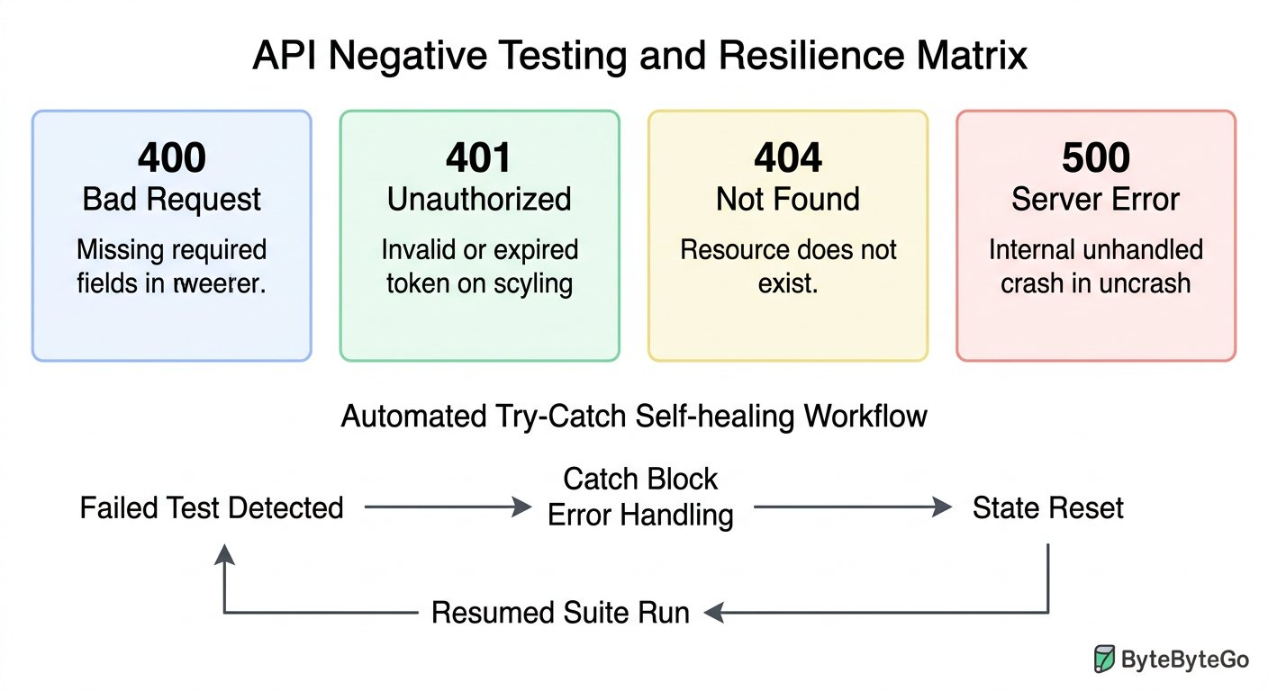
The core error testing matrix and defensive assertion architecture.
1 Client Validation Errors (400 or 422): Missing required fields, wrong data types, or out of range values.
2 Security Errors (401 and 403): Missing or expired authentication tokens (401), or insufficient user permissions (403).
3 State Conflicts (404 and 409): Querying missing resource IDs (404), or duplicate records colliding in the database (409).
4 Throughput & Resilience (429 and 500): Rate limit throttling (429), and catching unhandled server exceptions (500).

Step 2: Defensive Scripting: Safe Parsing with Try Catch
When servers crash or time out, gateways like Nginx or cloud load balancers return raw HTML error pages rather than JSON. Attempting to parse HTML as JSON throws a fatal SyntaxError unless guarded by a defensive try catch block. We chunk this defensive pattern into three architectural layers:
Resilient Error Parsing Architecture
Guards against fatal crashes on HTML server pages:
CHUNK 1: Chunk 1: Guarded Parsing · Guarding Against Crash Pages
Wraps the parser in a try catch block. If the server returns HTML, the exception is caught safely without aborting the runner.
try-catch-guard.js
1 let parsedBody = null;
try {
parsedBody = pm.response.json();
} catch (exception) {
console.warn("Non JSON response: " + exception.message);
parsedBody = null;
}
Rule: Always catch parsing errors when testing failure endpoints.
CHUNK 2: Chunk 2: Format Contract Assertion · Asserting Content Type Compliance
Formally reports a failed test if the response was not valid JSON, giving clear error logs in the test report.
format-assertion.js
1 pm.test("Response arrives in valid JSON format", function () {
pm.expect(parsedBody, "Parsed JSON body").to.not.equal(null);
});
Rule: Report formatting failures as structured test failures rather than unhandled script crashes.
CHUNK 3: Chunk 3: Security Leak Scanner · Preventing Credential Leaks
Scans raw response text to ensure backend database table names, SQL queries, or passwords never reach clients.
security-scan.js
1 pm.test("Response does not leak database secrets", function () {
const rawText = pm.response.text();
pm.expect(rawText).to.not.match(/password|SQLException|stack trace/i);
});
Rule: Automated security assertions prevent dangerous internal leaks to third parties.
IMAGINE & PREDICT BEFORE SENDING
If an upstream server crashes and returns an HTML page starting with <!DOCTYPE html>, what will happen if your script calls pm.response.json() without a try catch wrapper?
A. Postman throws a fatal JSONError SyntaxError and crashes the test execution
B. Postman automatically translates the HTML into a JSON object
C. Postman returns undefined and continues running smoothly
D. Postman reboots the remote server
Actual Output (Unguarded JSON Parsing Crash Confirmation): Fatal JSONError halts execution! The JavaScript JSON parser expects braces { } or brackets [ ]. When it encounters the HTML tag <, it throws an unhandled SyntaxError that halts the remaining tests in that request. A try catch block prevents this crash!

Step 3: Beware of Soft Errors (Status 200 with Error Content)
Fresher Trap to Avoid: Believing Status 200 Always Means Success
A soft error occurs when a developer configures an endpoint to return HTTP 200 OK, but the JSON payload body says: {"status": "failed", "message": "Record not found"}.
If your automated test only asserts pm.response.to.have.status(200), your test suite will report GREEN PASS even though the business transaction completely failed!
Always combine status code assertions with body message assertions to protect against deceptive soft errors.

Step 4: Self Healing Workflows: Handling Duplicate Collisions
What happens if a test run is aborted midway, leaving a book record stuck in the database? On the next run, AddBook fails with {"msg": "Book already exists"}. We write an intelligent, bounded self healing script using collection variables and postman.setNextRequest:

The code
addbook-self-healing.js
1 // Placed in Tests tab of AddBook (POST /v1/books)
2 let responseJson = {};
3 try {
4 responseJson = pm.response.json();
5 } catch (err) {
6 responseJson = {};
7 }
8
9 const maxRetries = 2;
10 let retryCount = Number(pm.collectionVariables.get("retry_count") || 0);
11
12 // Exact match on canonical duplicate error contract
13 if (responseJson.msg === "Book already exists") {
14 if (retryCount < maxRetries) {
15 retryCount += 1;
16 pm.collectionVariables.set("retry_count", retryCount);
17
18 // Compute the colliding composite ID so DeleteBook can purge it
19 const targetId = pm.collectionVariables.get("ISBN") + "227";
20 pm.collectionVariables.set("book_id", targetId);
21 console.log("Collision detected! Attempt " + retryCount + " of " + maxRetries + ". Triggering DeleteBook cleanup for " + targetId);
22 postman.setNextRequest("Delete Book");
23 } else {
24 pm.collectionVariables.set("retry_count", 0);
25 postman.setNextRequest(null);
26 pm.expect.fail("Max retries exceeded: duplicate record persistent after cleanup attempts");
27 }
28 } else {
29 pm.collectionVariables.set("retry_count", 0);
30 pm.test("Book added successfully", function () {
31 pm.response.to.have.status(200);
32 pm.expect(responseJson.Msg).to.eql("successfully added");
33 });
34 }

The code
deletebook-return-flow.js
1 // Placed in Tests tab of DeleteBook (POST /v1/books/delete)
2 pm.test("Cleanup request succeeds", function () {
3 pm.response.to.have.status(200);
4 });
5
6 // If invoked by self healing recovery, route back to AddBook
7 const activeRetries = Number(pm.collectionVariables.get("retry_count") || 0);
8 if (activeRetries > 0) {
9 console.log("Cleanup complete. Returning flow to AddBook for re addition...");
10 postman.setNextRequest("Add Book");
11 }

Expected output
Terminal
1 $ Self Healing Workflow Terminal Log
2 [AddBook]: 200 OK -> msg: "Book already exists" (Collision detected! Triggering DeleteBook for LIB9821227)
3 [DeleteBook]: 200 OK -> msg: "book is successfully deleted" (Cleanup complete. Returning flow to AddBook)
4 [AddBook]: 200 OK -> Msg: "successfully added", ID: "LIB9821227" (Self healing succeeded!)
5 Workflow Completed: 3 total requests, 1 recovery loop, 0 test failures.
The Bounded Loop Rule: Preventing Infinite CI CD Hangs
Never call postman.setNextRequest without a bounded counter like retryCount.
If an automated script loops unconditionally on an unexpected database state, Postman or Newman will ping the server endlessly until the CI build times out after an hour.
Always establish a hard ceiling (such as 2 or 3 retries) and explicitly call postman.setNextRequest(null) or pm.expect.fail() when the ceiling is reached.
WAR ROOM BATTLE SCAR · Critical Credential Leak Outage
The Database Stack Trace Leak: When an Uncaught 500 Exposed Root Credentials
A financial payment processing platform deployed a microservice that failed to implement global exception handling. When automated tests flooded the endpoint with malformed payloads, the backend threw an unhandled SQL syntax error. Instead of returning a sterile JSON error message, the web framework printed a 120 line raw stack trace containing the internal database hostname, database username, and unmasked connection string password. Security researchers discovered the flaw within three hours of release.
Key Architectural Lesson: Never permit backend stack traces or database connection strings to leak to clients. Always write automated security assertions in Postman verifying that error responses do not contain keywords like "SQLException", "password", or "traceback".
WAR ROOM INCIDENT TRIAGE
War Room Triage: The Fatal SyntaxError on Server Crash Pages
During midnight CI regression, the upstream gateway crashes and returns an HTML 502 Bad Gateway page. Your test script executes: const data = pm.response.json(). The test runner halts immediately with: "JSONError: Unexpected token < in JSON at position 0". How do you safeguard your assertion suite from crashing?
A. Change the request method from POST to GET.
B. Wrap the JSON parsing call in a try catch block and assert status code before attempting to inspect properties.
C. Increase the request timeout in Postman settings to 60 seconds.
D. Convert the HTML page to XML inside the Pre request script.
TACTICAL TRIUMPH: Defensive parsing saves automation suites! When an upstream proxy fails, it returns an HTML document starting with <!DOCTYPE html>. Calling pm.response.json() throws a fatal SyntaxError because HTML cannot be parsed as JSON. Wrapping parsing in a try catch block or checking the response Content Type keeps the runner alive!

Step 5: Review and Practice
MAKE A GUESS
Why should you wrap pm.response.json() in a try catch block when testing error scenarios?
- A. Because try catch makes the network call run faster
- B. Because server errors (such as 502 or 503) often return HTML pages that cause pm.response.json() to throw a SyntaxError and crash the test suite
- C. Because Postman requires try catch for all HTTP GET requests
- D. Because try catch automatically encrypts the response
Answer: Because server errors (such as 502 or 503) often return HTML pages that cause pm.response.json() to throw a SyntaxError and crash the test suite. When servers crash or time out, gateways like Nginx or cloud load balancers return raw HTML error pages. Attempting to parse HTML as JSON throws a fatal SyntaxError unless guarded by try catch.

Check your understanding
1. What is a soft error in API testing?
Answer: A soft error happens when an endpoint incorrectly returns a 200 OK status code despite the business action failing. Testers must inspect body properties to catch them.
2. Why must API tests assert that response bodies never leak database stack traces?
Answer: Stack traces expose database table names, SQL query syntax, and server file paths to potential attackers, creating serious security vulnerabilities.

Key takeaways
REMEMBER
- Negative testing validates that APIs fail safely, return correct 4xx codes, and never crash with unhandled 500 exceptions.
- Use defensive try catch blocks around pm.response.json() to handle HTML error pages gracefully.
- Assert both status codes and response body fields to detect deceptive soft errors.
- Use collection state flags and postman.setNextRequest() to build self healing test workflows.
⚡ MISSION 3 PHASE 1 CLEARED · Architectural Triumph: Production Negative Matrix & Defensive Resilience Mastered
You moved beyond fragile happy paths into battle hardened production engineering. You mastered the comprehensive negative testing matrix (400, 401, 403, 404, 409, 429, 500), shielded your test runner with defensive try catch deserialization, intercepted dangerous soft 200 failures, and engineered self healing recovery loops.
Tactical Superpowers Mastered:
- Deploying the complete production negative testing matrix to guarantee graceful backend failure modes
- Defensive JavaScript scripting: safe try catch parsing that survives raw HTML cloud gateway crashes
- Exposing deceptive soft 200 errors by coupling HTTP status assertions with payload business status checks
- Security auditing: intercepting database stack traces, SQL syntax leaks, and internal file path disclosures
- Engineering self healing test loops using collection flags and dynamic workflow redirection
Enterprise Disasters Prevented:
- Prevented severe security vulnerabilities where SQL error traces leak database schemas to malicious actors
- Stopped critical false positive passes where tests report green on failed business transactions
- Eliminated brittle CI test suite crashes caused by unhandled load balancer HTML timeout pages
War Room Takeaway: Any junior tester can verify that a system works when everything is perfect. A true lead automation architect proves that the system stands tall, refuses to leak secrets, and recovers automatically when everything goes wrong.
NEXT DISCOVERY · Continuing Mission 3: Postman Mock Servers and Contracts
Our test suite is resilient and self healing. In Chapter 10, we advance into Postman Mock Servers and JSON Schema Contracts: validating structural data integrity before servers even exist, simulating dependencies, and unblocking parallel QA workflows in Agile sprints!

Chapter 10: Postman Mock Servers and JSON Schema Contracts
Contract first development, JSON Schema validation, building hosted Mock Servers, and unblocking parallel QA in Agile sprints.
MISSION COMMAND HUD
PHASE: Phase 2 of 5: Mock Servers & Schema Contracts · RANK: Rank: Contract Architecture Specialist
ACTIVE MISSION: Mission 3: Hardening for Enterprise Production and CI CD
MISSION BRIEFING & CHAPTER ROADMAP
MISSION 3 · PHASE 1 OF 4: Enterprise Resilience and CI CD Quality Gates
CRISIS SCENARIO: Agile Sprint Simulation: Contract First Testing with Mock Servers
Context: In modern fast paced engineering sprints, QA automation engineers face a classic roadblock: backend developers spend two weeks building database schemas and business logic. If testers wait for live endpoints before writing tests, QA becomes the release bottleneck. We must unblock parallel testing by adopting contract first development, writing JSON Schema contracts, and spinning up hosted Postman Mock Servers.
Operational Target: Build JSON Schema contract validators, configure Postman Mock Servers with Examples, and compare REST with GraphQL.

WE WILL ACHIEVE: Unblock Agile testing sprints and prevent contract drift by mastering JSON Schema validation, hosted Postman Mock Servers, and modern GraphQL query architectures.
HOW WE WILL DO IT: Define strict array schemas matching production REST contracts, configure cloud mock examples, execute seamless mock to live environment flips, and parameterize GraphQL queries.
WHAT YOU WILL CARRY FORWARD: Production grade schema validation and mock virtualization techniques that prepare you for enterprise OAuth 2.0 security in Chapter 11.
MISSION PROGRESS · Continuing Mission 3: Contract Testing and Agile Simulation
In modern fast paced engineering sprints, QA automation engineers face a classic dilemma: backend developers spend eight to ten days building database models and business logic. If testers wait for live endpoints before writing scripts, testing turns into a painful bottleneck. In this chapter, we master the modern solution: defining rigid JSON Schema contracts, spinning up hosted Postman Mock Servers with Examples and query parameter matching, and exploring modern query architectures like GraphQL alongside REST.

Step 1: Contract First Development and JSON Schema Fundamentals
Rather than writing code first and guessing payloads later, mature engineering teams practice contract first API design. Before writing a single line of backend code, product managers, frontend engineers, and QA automation testers agree on a formal schema defining every request, response, status code, and data type.
The international standard for defining these contracts is JSON Schema. A JSON Schema acts like a blueprint for your JSON data: specifying mandatory fields, data types such as string or integer, value boundaries, and nested object rules.

The code
book-contract-schema.json
1 {
2 "$schema": "http://json-schema.org/draft-07/schema#",
3 "type": "array",
4 "items": {
5 "type": "object",
6 "required": ["book_name", "isbn", "aisle"],
7 "properties": {
8 "book_name": { "type": "string" },
9 "isbn": { "type": "string", "minLength": 3 },
10 "aisle": { "type": "string" }
11 }
12 }
13 }
The Array Trap in REST Search Endpoints
A frequent pitfall among freshers is declaring the root type as object when inspecting query endpoints.
In RESTful services, search endpoints like GET /v1/books?id=... return a list of matching entries even when only one record matches. The root container is an array ([]) rather than a single object ({}).
Declaring type: "object" against an array response immediately triggers a schema mismatch failure. Always verify whether the root token is a curly bracket or an open square bracket!

Step 2: Validating JSON Schema Contracts in Postman
Postman includes the industry standard schema validator library tv4 directly in its test sandbox. We break down the schema validation assertion into three focused chunks:
JSON Schema Validation Architecture
Guarantees structural and type integrity:
CHUNK 1: Chunk 1: Defining Contract Schema · The Architectural Contract Blueprint
Specifies that the response is an array of book objects with required string properties.
schema-contract.js
1 const schemaContract = {
type: "array",
items: {
type: "object",
required: ["book_name", "isbn", "aisle"],
properties: {
book_name: { type: "string" },
isbn: { type: "string" },
aisle: { type: "string" }
}
}
};
Rule: The contract acts as the immutable standard between frontend and backend teams.
CHUNK 2: Chunk 2: Executing Schema Matcher · Evaluating Structural Compliance
Validates that the received JSON payload adheres strictly to every constraint in the blueprint.
schema-matcher.js
1 const responseData = pm.response.json();
pm.test("Response body strictly satisfies the JSON Schema contract", function () {
const validationResult = tv4.validate(responseData, schemaContract);
pm.expect(validationResult, "Schema validation failed: " + JSON.stringify(tv4.error)).to.be.true;
});
Rule: tv4 evaluates missing fields and type mismatches across deep hierarchies.
CHUNK 3: Chunk 3: Diagnostic Pinpoint Logging · Pinpointing Offending Fields
If validation fails, logs the exact JSON path and the specific violation reason in the Postman Console.
schema-error-diagnostics.js
1 if (!tv4.validate(responseData, schemaContract)) {
console.error("Contract violation at " + tv4.error.dataPath + ": " + tv4.error.message);
}
Rule: Diagnostic logging eliminates guesswork when diagnosing schema rejections.
IMAGINE & PREDICT BEFORE SENDING
If a backend update changes the aisle field from string "42" to a number 42, how will this schema test react?
A. The test fails immediately: tv4 flags a type mismatch because number was received where string was required
B. The test passes green because JSON automatically converts numbers to strings
C. Postman ignores the schema and passes the status code
D. The server rolls back the database
Actual Output (Schema Type Mismatch Confirmation): Schema drift caught instantly! JSON Schema is strictly typed: tv4 flags an AssertionError with message "Invalid type: number (expected string) at /0/aisle". This protects mobile apps from crashing before bad code reaches production!

Step 3: The Agile Dilemma and Postman Mock Servers
ARCHITECTURE · Postman Mock Servers: Enabling Fast Parallel Agile Development
AGILE SIMULATION · Postman Mock Servers: Enabling Fast Parallel Agile Development
When starting a sprint, waiting ten days for backend microservices stalls everyone. Postman Mock Servers eliminate this blocker by simulating real web servers in the cloud. By defining JSON request examples, frontend and testing teams simulate production behavior weeks before real code lands.
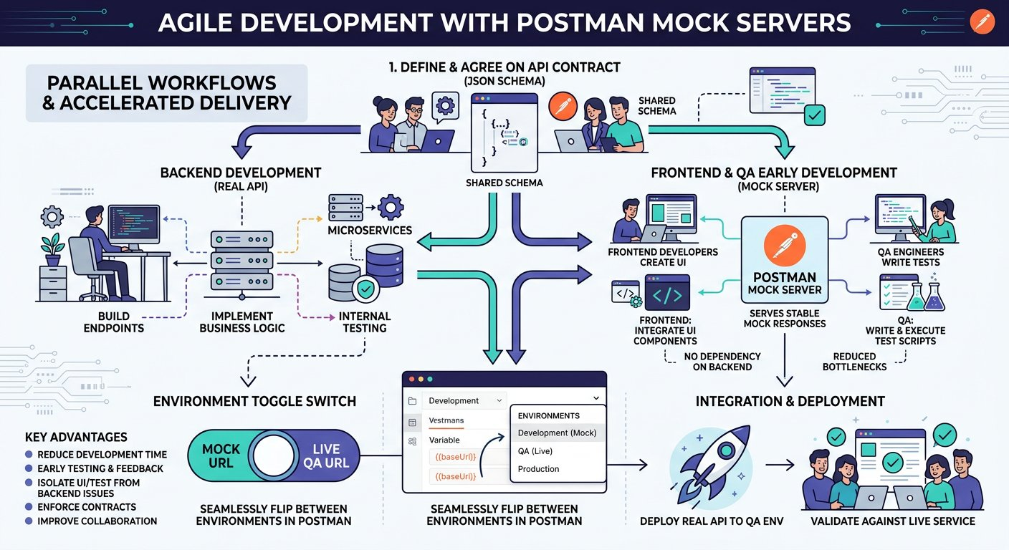
Unblocking parallel QA and frontend development using hosted Postman Mock Servers.
1 Sprint Day 1 (Contract Definition): Frontend, Backend, and QA agree on request paths, parameters, and response schemas.
2 Sprint Day 2 (Mock Server Spin Up): A hosted Postman Mock Server is launched with Examples matching the agreed specification.
3 Sprint Days 2 to 9 (Parallel Development): Frontend developers build UI screens and QA engineers build complete automated assertion suites against the mock server.
4 Sprint Day 10 (Deployment and Environment Flip): Backend deploys live microservices to QA. Testers flip the environment variable from Mock URL to Live URL with zero code rewrites.

Step 4: Configuring Examples and Matching Query Parameters
A Postman Mock Server functions by inspecting Examples attached to requests in your collection. You can create multiple Examples for a single endpoint to simulate different business scenarios and query parameters. You can download our sample mock response examples: [Download Science Mock Example JSON](/materials/zero-to-agentic-api-testing/lesson-10/mock-example-science.json) and [Download Literature Mock Example JSON](/materials/zero-to-agentic-api-testing/lesson-10/mock-example-literature.json):

Try it yourself
- Open any request in your Postman collection and click the three dots icon to select Add Example.
- Provide the expected HTTP status code: such as 200 OK for happy paths or 404 Not Found for negative flows.
- Paste the mock JSON response body in the Example editor and click Save.
- To simulate query parameter matching, add the parameter (such as ?category=science) in the Example URL. When a caller requests that specific query, Postman Mock Server returns that tailored Example!

Expected output
Terminal
1 $ Calling Hosted Postman Mock Server via cURL
2 curl https://9b12c8a1-42ef-49bb-b12e.mock.pstmn.io/v1/books?category=science
3 HTTP/1.1 200 OK
4 Content-Type: application/json; charset=utf-8
5 x-srv-span: mock-server-edge-01
6 {
7 "category": "science",
8 "total_records": 1,
9 "books": [
10 { "book_name": "Full Stack API Automation", "isbn": "SCI941", "aisle": 42, "author": "Dr. Sarah Chen" }
11 ]
12 }
Fresher Trap to Avoid: Forgetting to Save the Example Before Testing
When creating mock responses in Postman, students often edit the Example body and immediately fire a request to the mock URL, only to receive a 404 Not Found or generic default payload.
Postman Mock Servers in the cloud only know about Examples that have been saved to the cloud workspace.
Always press Save on the Example tab before sending requests to the mock server endpoint.

Step 5: Seamless Environment Toggling: From Mock to Live QA
Because our collection references {{base_url}} rather than hardcoded URLs, transitioning from the mock server to the live deployment requires zero test script modifications.

The code
environment-variables-comparison.json
1 // During Sprint Week 1 (Targeting Mock Server)
2 {
3 "environment": "Campus Mock Server",
4 "base_url": "https://9b12c8a1-42ef-49bb-b12e.mock.pstmn.io"
5 }
6
7 // During Sprint Week 2 (Targeting Live Deployed Backend)
8 {
9 "environment": "Campus Live QA Cluster",
10 "base_url": "https://qa-api.campuslibrary.org"
11 }
On deployment day, simply click the Postman Environment dropdown and select Campus Live QA Cluster. When you hit Run Collection, every assertion, property transfer, and test logic written during Week 1 immediately validates the real production codebase!

Step 6: Modern Query Architectures: Testing GraphQL Alongside REST
In enterprise architectures, QA engineers increasingly encounter GraphQL alongside standard REST endpoints. To understand why GraphQL exists, consider the student academic portal on our university campus.
ARCHITECTURE · REST vs GraphQL Architecture: Single Request Precise Data Resolution
QUERY ARCHITECTURES · REST vs GraphQL Architecture: Single Request Precise Data Resolution
To display a single student profile screen, a REST client might call four separate endpoints (students, departments, courses, loans), multiplying mobile network latency and returning unwanted fields. GraphQL solves this by exposing a single endpoint where clients declare the exact fields required in one roundtrip.
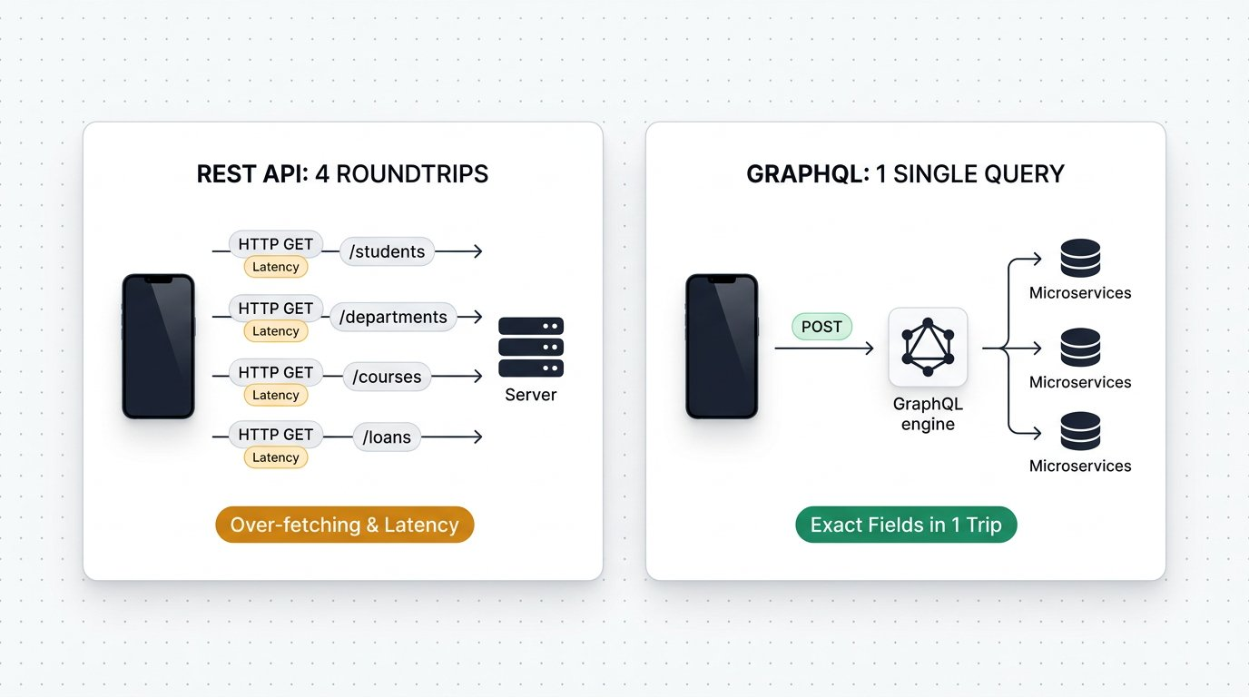
REST vs GraphQL: Eliminating over fetching and under fetching with a single unified query.
1 Left Panel (REST 4 Network Roundtrips): The client must execute four separate HTTP requests over mobile networks (GET /students, GET /departments, GET /courses, GET /loans), multiplying latency.
2 Left Panel (Over Fetching and Under Fetching): Each REST endpoint returns unwanted data that the client discards, while forcing multiple trips to assemble a single screen.
3 Right Panel (GraphQL 1 Single Unified Query): The client dispatches one POST request to /graphql requesting the exact nested fields required.
4 Right Panel (Single Payload Resolution): The GraphQL server contacts backend services in parallel and delivers one consolidated JSON response in a single network roundtrip.

Revisiting the Chapter 1 Book Inquiry in GraphQL
Recall our comparison in Chapter 1: when asking for a book record, a standard REST endpoint returns the entire rigid database schema (including aisle, ISBN, price, copies, and timestamps), whether the client needs them or not. In GraphQL, the client asks specifically for the desired fields, such as title and author:

The code
book-graphql-query.graphql
1 # Parameterized book query with dynamic variable
2 query GetBookDetails($bookId: ID!) {
3 book(id: $bookId) {
4 title
5 author
6 }
7 }
When dispatched with variable { "bookId": "1" }, the GraphQL engine contacts the catalog repository and returns only the requested attributes: { "data": { "book": { "title": "Clean Architecture", "author": "Robert Martin" } } }. If the client subsequently needs the price, the frontend engineer simply adds price to the query string without waiting for backend engineers to deploy a new REST endpoint version.

Live Exploration: Testing the Public Rick and Morty GraphQL API
To practice testing GraphQL against a live production endpoint without configuring local mock servers or authentication credentials, engineers often explore the public Rick and Morty GraphQL service at https://rickandmortyapi.com/graphql. Here is a live parameterized query fetching character details and nested location coordinates:

The code
rick-and-morty-query.graphql
1 # Live query against public https://rickandmortyapi.com/graphql
2 query GetCharacterProfile($characterId: ID!) {
3 character(id: $characterId) {
4 name
5 status
6 species
7 origin {
8 name
9 }
10 }
11 }
Live Interactive Wire Inspector: Public Rick and Morty GraphQL Query
POST https://rickandmortyapi.com/graphql
Status: 200 OK · Time: 142 ms · Size: 388 B
Response Body:
response.json
1 {
2 "data": {
3 "character": {
4 "name": "Rick Sanchez",
5 "status": "Alive",
6 "species": "Human",
7 "origin": {
8 "name": "Earth (C-137)"
9 }
10 }
11 }
12 }
Assertions Verified:
✓ GraphQL status code is 200 OK
✓ Response contains data object without errors
✓ Character name matches Rick Sanchez
✓ Origin name matches Earth (C-137)
While queries retrieve data, Mutations create, update, or delete data in GraphQL. A key advantage of mutations is hybrid retrieval: when you create a new lab location or research character, GraphQL immediately returns the newly generated ID in the response:

The code
campus-graphql-mutation.graphql
1 # Mutation creating new campus research entities in one call
2 mutation RegisterEntities {
3 createLocation(name: "Innovation Robotics Lab", type: "North Wing", dimension: "Lab 4") {
4 id
5 }
6 createCharacter(name: "Dr. Elena Rostova", status: "Active", gender: "Female") {
7 id
8 }
9 }
Fresher Trap to Avoid: All GraphQL Calls Use HTTP POST
In REST, you use GET to read records and POST to write records.
In GraphQL, while queries can technically be sent via GET query parameters, industry standard practice packages the query syntax and variables into a JSON payload body and dispatches using HTTP POST.
In Postman, select POST, choose Body > GraphQL, paste your query on the left and your JSON variables on the right.
WAR ROOM BATTLE SCAR · Enterprise Contract Outage
The Silent Schema Drift Outage: When a Type Flip Crashed Native Mobile Apps
A retail engineering team updated an inventory API endpoint. The property in_stock_count was changed from integer 42 to string "42" to accommodate out of stock text badges. Desktop web browsers handled the loose type coercion without complaint, but the native iOS and Android mobile apps crashed instantly on startup with fatal JSON decoding errors: Expected Int but received String. Because test suites had only verified HTTP 200 status codes without schema contract checks, the defect reached the public app store, crashing the app for over two million customers.
Key Architectural Lesson: Never rely on HTTP 200 status checks alone. Rigid JSON Schema assertions with tv4 or ajv ensure property names and data types strictly adhere to contracts before production deployment.
WAR ROOM INCIDENT TRIAGE
War Room Triage: The Cryptic Contract Failure
You write a contract test in Postman: pm.expect(tv4.validate(data, schema)).to.be.true. The assertion fails during sprint testing, but the test runner prints only "AssertionError: expected false to be true", offering zero clues on which field broke. What debugging technique instantly pinpoints the schema defect?
A. Inspect tv4.error.message and tv4.error.dataPath to log the exact property and type violation.
B. Restart Postman and run the collection again.
C. Change the schema data type from object to string.
D. Delete all required fields from the JSON Schema blueprint.
TACTICAL TRIUMPH: Extract the validation error details! The tv4 library stores full diagnostic information in tv4.error. Logging tv4.error.message alongside tv4.error.dataPath pinpoints the exact offending JSON key (such as /books/0/isbn) and the specific reason (such as "type string expected, integer received").

Step 7: Review and Practice
MAKE A GUESS
How does a Postman Mock Server determine which response payload to return when an incoming request arrives?
- A. It randomly generates fictional data on every single request
- B. It matches the incoming request method, path, headers, and query parameters against saved Examples in the collection
- C. It connects to a live MySQL database in the cloud
- D. It asks the user to manually type the response in the desktop window
Answer: It matches the incoming request method, path, headers, and query parameters against saved Examples in the collection. Postman Mock Servers inspect incoming HTTP requests and compare them with the saved Examples in the collection, returning the Example that best matches the method, URL path, and query parameters.

Check your understanding
1. What is contract first development, and why does it benefit software testing teams?
Answer: Contract first development defines the formal API schema before developers write backend code. It allows QA and frontend engineers to build tests and user interfaces in parallel against mock servers rather than waiting for backend completion.
2. What is the primary difference between REST and GraphQL data retrieval?
Answer: REST endpoints return a fixed response structure determined by the server, often leading to over fetching or under fetching. GraphQL allows clients to specify the exact fields they require in a single query dispatched to one endpoint.

Key takeaways
REMEMBER
- Contract first API design establishes agreed JSON schemas before backend coding begins.
- JSON Schema validation with tv4 catches missing keys and subtle data type mismatches.
- Postman Mock Servers provide cloud hosted simulations powered by saved collection Examples.
- Using Examples with query parameters simulates diverse real world response flows.
- Toggling base_url environment variables transitions test suites seamlessly from Mock to live QA.
- GraphQL eliminates over fetching and under fetching by allowing clients to request exact fields across multiple domains in a single POST query.
⚡ MISSION 3 PHASE 2 CLEARED · Architectural Triumph: Agile Mock Simulation & Dual REST GraphQL Contracts Mastered
You solved the universal Agile sprint dilemma! Instead of idling for weeks waiting for backend developers to finish server code, you authored formal JSON Schema contracts, spun up hosted Postman Mock Servers, parameterized response Examples, and conquered modern GraphQL query architectures alongside REST.
Tactical Superpowers Mastered:
- Authoring formal JSON Schema specifications that enforce field types, mandatory properties, and data bounds
- Deploying Postman hosted Mock Servers to simulate edge cases and unblock frontend and QA teams on Day 1 of sprints
- Fine tuning mock responses using query parameter matching and custom Example payloads
- Executing dual protocol automation: commanding both traditional REST endpoints and modern GraphQL queries and mutations
- Seamless environment switching: transitioning automated suites from Mock to Live servers with one variable swap
Enterprise Disasters Prevented:
- Eliminated two week sprint bottlenecks where testers sit idle waiting for backend database deployments
- Prevented mobile application crashes caused by unexpected field type mutations (such as string IDs turning into integers)
- Stopped mobile network throttling and payload bloat by leveraging GraphQL targeted field resolution
War Room Takeaway: The highest leverage QA engineers do not wait for software to be built. They write the contract, stand up the mock server, and have the full automated regression suite ready the second the backend goes live.
NEXT DISCOVERY · Continuing Mission 3: Enterprise Identity and Token Security
With contract schemas, mock servers, and GraphQL fundamentals mastered, we encounter enterprise identity gateways. In Chapter 11, we explore OAuth 2.0 and Modern Token Authentication: executing automated token exchanges, managing global access tokens, and testing secured microservice endpoints!

Chapter 11: OAuth 2.0 and Modern Token Authentication
The four roles, Authorization Code grant handshake, automated token exchange scripts, global variables, and Bearer token chaining.
MISSION COMMAND HUD
PHASE: Phase 3 of 5: OAuth 2.0 Security Protocols · RANK: Rank: Enterprise Identity Architect
ACTIVE MISSION: Mission 3: Hardening for Enterprise Production and CI CD
MISSION BRIEFING & CHAPTER ROADMAP
MISSION 3 · PHASE 2 OF 4: Enterprise Resilience and CI CD Quality Gates
CRISIS SCENARIO: Securing the Gateway: OAuth 2.0 and Modern Token Authorization
Context: Enterprise campus systems handle sensitive student records and financial transactions. Simple API keys or basic auth credentials are unacceptable in modern architecture. Microservices enforce OAuth 2.0 token based authorization. We must master the four roles, execute the two step Authorization Code grant, automate token exchange scripts, and chain Bearer tokens into secured requests.
Operational Target: Deconstruct the OAuth 2.0 handshake, automate token retrieval in pre request scripts, and test token expiration.

WE WILL ACHIEVE: Master modern enterprise API security by deconstructing OAuth 2.0 grant types, automating token handshakes in test suites, and chaining Bearer tokens into protected requests.
HOW WE WILL DO IT: Contrast interactive Authorization Code flows with machine to machine Client Credentials for CI CD, execute live token exchange requests, extract tokens into global variables, and validate 401 unauthorized boundaries.
WHAT YOU WILL CARRY FORWARD: Automated token acquisition patterns and authenticated collection runs that safeguard enterprise endpoints, carrying forward into XML web services in Chapter 12.
MISSION PROGRESS · Continuing Mission 3: Mastering Enterprise Token Security
Having simulated microservices with mock servers and schema contracts, we encounter enterprise security gateways. High value APIs never accept raw username and password credentials directly in request bodies. Instead, modern microservices enforce OAuth 2.0 token based authorization. Across this chapter, we master the industry standard protocol: dissecting the four roles, executing the Authorization Code grant handshake, inspecting the mandatory parameters for both authorization code and access token requests, automating token retrieval in test scripts, and chaining Bearer tokens into secured requests.

Step 1: Why Modern APIs Rely on OAuth 2.0
Imagine checking into a hotel or your college dorm hostel. The receptionist does not hand you the master brass key that opens every door on campus. Instead, they issue a plastic keycard that only unlocks your specific room and automatically expires at checkout time.
This is the core purpose of OAuth 2.0. It is an open authorization standard that lets applications access protected user resources without ever seeing or storing the user private account password.
In our campus library automation project, faculty members and researchers access a restricted digital archive containing rare manuscripts and sensitive academic data. The university cannot allow catalog apps or student portals to store raw campus passwords. If a third party app suffers a security breach, every user credentials would be compromised. Instead, the campus identity provider authenticates the user on a dedicated login screen and issues a temporary digital keycard: a Bearer access token valid for one hour with strictly scoped read permissions.
Authentication vs Authorization: The Crucial Distinction
• Authentication (AuthN): Answers the question: "Who are you?" Proving identity by providing credentials such as a username, password, or biometric face scan.
• Authorization (AuthZ): Answers the question: "What permissions do you have?" Granting access to specific resources, such as reading an order history or editing profile pictures.
• OAuth 2.0 is strictly an authorization framework designed to grant scoped permissions through digital access tokens.

Step 2: The Four Roles in the OAuth 2.0 Architecture
ARCHITECTURE · OAuth 2.0 Security Architecture: The Four Party Token Handshake
SECURITY ARCHITECTURE · OAuth 2.0 Security Architecture: The Four Party Token Handshake
OAuth 2.0 delegates authority across four distinct participants: the Resource Owner (the student), the Client Application (our web or mobile interface), the Authorization Server (campus identity login), and the Resource Server (the protected library microservice). Access tokens expire automatically, protecting university resources without exposing student credentials.
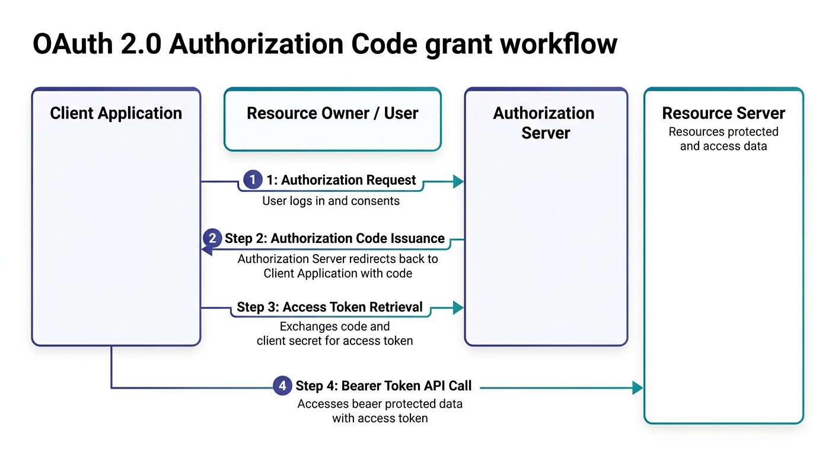
The four participants and handshake flow of the OAuth 2.0 Authorization Code grant.
1 Step 1 (Authorization Request): The user logs in at the Authorization Server and consents to permissions requested by the Client Application.
2 Step 2 (Authorization Code Issuance): The Authorization Server validates the user and redirects back to the client callback URL with a temporary authorization code.
3 Step 3 (Access Token Retrieval): The client application submits a secure backend POST request exchanging the code and client secret for an access token.
4 Step 4 (Bearer Token API Call): The client injects the access token into the Authorization header to retrieve protected student data from the Resource Server.

Step 3: The Detailed OAuth 2.0 Contract Specification
In enterprise testing, QA engineers must know the exact contract parameters required by identity servers. The Authorization Code grant relies on two distinct HTTP requests:

OAuth 2.0 Two Step Handshake Contract
Contract Field | Request 1: Get Authorization Code | Request 2: Get Access Token
HTTP Method | GET (User Browser Redirect) | POST (Direct Client to Server Call)
Target Endpoint | Authorization Server URL (https://auth.campuslibrary.org/oauth/authorize) | Access Token URL (https://auth.campuslibrary.org/oauth/token)
Mandatory Parameters | client_id, redirect_uri, response_type=code, scope, state | grant_type=authorization_code, code, client_id, client_secret, redirect_uri
Transport Location | URL Query Parameters | Request Body (x www form urlencoded or JSON)
Returned Output | One time temporary code in callback URL query string | JSON payload containing access_token, token_type, and expires_in

Step 4: Request 1: Fetching the Temporary Authorization Code
The first request sends the user browser to the campus identity provider. Notice the query parameters appended to the URL:

The code
get-authorization-code.txt
1 GET https://auth.campuslibrary.org/oauth/authorize?
2 response_type=code&
3 client_id=campus-library-web-client&
4 redirect_uri=https://campus.university.edu/oauth/callback&
5 scope=read:catalog%20write:loans&
6 state=xyzSecurityString789 HTTP/1.1
Why Each Query Parameter Matters
• response_type=code: Informs the authorization server that the client wants a temporary authorization code, not a raw token.
• client_id: The public alphanumeric identifier assigned to our application.
• redirect_uri: The pre registered callback address where the authorization server delivers the code. If this URL differs by even one character from the server whitelist, the server aborts the request.
• scope: Defines the permission boundaries requested (such as reading catalog books and borrowing records).
• state: A random cryptographic string returned back to verify that the response corresponds to our original request, preventing CSRF attacks.
When the student or faculty member logs in and approves consent, the authorization server redirects the browser back to our callback URL with the temporary code in the query string:

Expected output
Terminal
1 $ Browser Redirect to Callback URL
2 HTTP/1.1 302 Found
3 Location: https://campus.university.edu/oauth/callback?code=authcode_89712a4f&state=xyzSecurityString789

Step 5: Request 2: Exchanging Code for the Access Token
Now our client backend (or Postman collection) takes that temporary code and exchanges it for the actual Bearer token via HTTP POST. We break down the mandatory parameters into three chunks:
OAuth 2.0 Token Exchange Parameters
Mandatory form parameters sent to the authorization endpoint:
CHUNK 1: Chunk 1: Grant Type and Code · Declaring the Handshake Protocol
Tells the auth server we are exchanging a temporary code for an access token.
exchange-core.http
1 POST /oauth/token HTTP/1.1
Host: auth.campuslibrary.org
Content-Type: application/x-www-form-urlencoded
grant_type=authorization_code
&code=authcode_89712a4f
Rule: The authorization code is single use and expires within minutes.
CHUNK 2: Chunk 2: Client Authentication · Proving Application Identity
The client secret proves that the application exchanging the code is the legitimate registered client.
client-credentials.http
1 &client_id=campus-library-web-client
&client_secret=secureUniversitySecretKey_98765
Rule: client_id is public; client_secret must never be shared in browser client code.
CHUNK 3: Chunk 3: Redirect URI Matching · Strict Callback Verification
The server verifies that this redirect URI matches the one sent in the initial code request byte for byte.
redirect-check.http
1 &redirect_uri=https://campus.university.edu/oauth/callback
Rule: Mismatching redirect URIs abort the handshake immediately for security.
IMAGINE & PREDICT BEFORE SENDING
When the client submits these verified parameters to the authorization server, what response structure will come back?
A. 200 OK with JSON object containing access_token, token_type: "Bearer", and expires_in: 3600
B. 302 Redirect asking the user to re enter their password again
C. 404 Not Found because access tokens are only generated in Python
D. 500 Server Error because tokens cannot be serialized in JSON
Actual Output (Token Exchange Confirmation): Access token granted! The authorization server verifies the code and secret, then delivers a 200 OK response with a Bearer access token valid for one hour (3600 seconds)!

Expected output
Terminal
1 $ JSON Token Response from Authorization Server
2 Status: 200 OK | Time: 195 ms
3 Content-Type: application/json; charset=utf-8
4
5 {
6 "access_token": "campus_bearer_token_9918273645",
7 "token_type": "Bearer",
8 "expires_in": 3600,
9 "scope": "read:catalog write:loans"
10 }
Live Interactive Wire Inspector: OAuth 2.0 Token Exchange
POST https://auth.campuslibrary.org/oauth/token
Status: 200 OK · Time: 195 ms · Size: 342 B
Response Body:
response.json
1 {
2 "access_token": "campus_bearer_token_9918273645",
3 "token_type": "Bearer",
4 "expires_in": 3600,
5 "scope": "read:catalog write:loans"
6 }
Assertions Verified:
✓ Authorization server status is 200 OK
✓ Response contains access_token attribute
✓ Token type attribute equals Bearer
✓ Token lifetime exceeds zero seconds

Step 6: Automating Token Workflows and CI CD Grant Types
Architectural Choice: Authorization Code vs Client Credentials in CI CD
Why can you not easily run an Authorization Code flow inside a headless continuous integration build server?
• Authorization Code Grant requires an interactive web browser where a human student logs in and clicks Allow. In unattended Jenkins, GitHub Actions, or GitLab CI pipelines, there is no browser and no human user to solve two factor authentication prompts!
• Client Credentials Grant is designed specifically for machine to machine automation. The automated test runner dispatches a direct backend call with grant_type=client_credentials, client_id, and client_secret to POST /oauth/token, receiving an automated service token in milliseconds without user interaction.
When testing public user journeys, Postman handles Authorization Code. When testing automated background microservice integrations in CI CD, configure the Client Credentials grant.
When executing test collections automatedly in CI CD pipelines, we configure an unattended Client Credentials token exchange request as the very first step in our collection. We submit the pre configured client credentials with strictly scoped read permissions: scope=read:catalog. In its Tests script, we extract the access token and save it into Collection Scope so subsequent requests in this collection inherit it without leaking secrets across global workspaces. You can download the script: [Download Capture Bearer Token Script](/materials/zero-to-agentic-api-testing/lesson-11/capture-bearer-token.js):

The code
unattended-token-request.http
1 POST /oauth/token HTTP/1.1
2 Host: auth.campuslibrary.org
3 Content-Type: application/x-www-form-urlencoded
4
5 grant_type=client_credentials
6 &client_id={{client_id}}
7 &client_secret={{client_secret}}
8 &scope=read:catalog write:loans

The code
capture-bearer-token.js
1 // Step 1: Parse the JSON response from the auth server
2 const responseData = pm.response.json();
3
4 // Step 2: Validate token properties
5 pm.test("Token response returns 200 OK and valid Bearer", function () {
6 pm.response.to.have.status(200);
7 pm.expect(responseData).to.have.property("access_token");
8 pm.expect(responseData.token_type).to.eql("Bearer");
9 pm.expect(responseData.expires_in).to.be.above(0);
10 });
11
12 // Step 3: Save Bearer token to Collection Scope (Least Privilege principle)
13 pm.collectionVariables.set("access_token", responseData.access_token);
Security Best Practice: Scoped Storage and Secret Hygiene
Never store sensitive access tokens in Global Scope where any collection in your workspace could read them.
Always store tokens in Collection Scope (pm.collectionVariables) or ephemeral Environment memory (Current Value only).
Keep Initial Value empty for all client secrets so credentials are never exported or synced to shared version control repositories.
Fresher Trap to Avoid: Forgetting the Space After Bearer
When attaching a Bearer token manually in request headers, many freshers type Authorization: Bearercampus_bearer_token_... without a space.
Because the HTTP specification defines Bearer as the authentication scheme followed by a single space, the resource server will fail to parse the header and return 401 Unauthorized!
Always ensure a single space follows the word Bearer: Authorization: Bearer {{access_token}}.
In downstream requests, we configure the Authorization tab to Bearer Token and insert {{access_token}}. Alternatively, set the Authorization header directly: Authorization: Bearer {{access_token}}. Postman resolves the global variable at runtime, authenticating every call cleanly without manual intervention.
Testing Token Expiry and 401 Unauthorized Handling
Access tokens have a finite lifetime, typically 3600 seconds (one hour).
When an access token expires or is omitted, the resource server immediately rejects requests with HTTP 401 Unauthorized.
In automated regression suites, always include a negative test asserting that requests with invalid or expired tokens return 401 and an appropriate WWW Authenticate challenge header.
WAR ROOM BATTLE SCAR · Cascading Deployment Blackout
The Hardcoded Token Outage: When an Expired Secret Paralyzed Deployments
An ecommerce engineering squad automated warehouse fulfillment verification by hardcoding a long lived OAuth 2.0 Bearer access token into Postman collection variables. The token had a sixty day expiration lifespan. On the eve of a major holiday sales promotion, the token silently expired at midnight. Hundreds of automated test jobs failed simultaneously across continuous deployment pipelines, triggering false P1 alerts and blocking release deployments during peak revenue hours.
Key Architectural Lesson: Never hardcode static Bearer tokens in long lived test suites. Always automate the OAuth 2.0 token handshake in an initial authorization request or Pre request script that dynamically acquires fresh tokens before protected requests execute.
WAR ROOM INCIDENT TRIAGE
War Room Triage: The Disappearing State Parameter Vulnerability
During a security audit of your OAuth 2.0 authorization code flow, an automated penetration tool flags a critical vulnerability: "Cross Site Request Forgery detected on OAuth callback handler". The audit report reveals that your initial GET authorization redirect URL omitted the state parameter. Why is the state parameter mandatory in production OAuth handshakes?
A. The state parameter encrypts user passwords using RSA 4096.
B. The state parameter acts as a cryptographic anti CSRF nonce verifying that the authorization callback response belongs to the exact session that initiated the login request.
C. The state parameter specifies the geographic server location of the API gateway.
D. The state parameter forces the authorization server to issue a permanent token that never expires.
TACTICAL TRIUMPH: Anti CSRF cryptographic binding! The state parameter is an unguessable random token generated by the client and sent in the authorization request. When the authorization server returns the code, it reflects back the identical state parameter. The client verifies that this returned state matches the stored session value, preventing attackers from injecting their own authorization codes into an unsuspecting user session!

Step 7: Review and Practice
MAKE A GUESS
In the OAuth 2.0 Authorization Code grant, what are the mandatory parameters required in the token exchange POST request?
- A. Only username and password
- B. grant_type, code, client_id, client_secret, and redirect_uri
- C. Only client_id and API key
- D. Only scope and state
Answer: grant_type, code, client_id, client_secret, and redirect_uri. To exchange an authorization code for an access token, the client must send grant_type=authorization_code along with the temporary code, client_id, client_secret, and the matching redirect_uri.

Check your understanding
1. What is the difference between client_id and client_secret in OAuth 2.0?
Answer: client_id is a public identifier assigned to the application, visible in URLs. client_secret is a confidential password known only to the client and authorization server, used to authenticate the token exchange.
2. Why do automated CI CD suites store the retrieved token in a global or environment variable?
Answer: Automated runners cannot open interactive login prompts. By running a token exchange request first and saving the access token in a global variable, all downstream requests can automatically read the token and authenticate.

Key takeaways
REMEMBER
- OAuth 2.0 decouples authentication from authorization, allowing users to grant scoped access without revealing passwords.
- The Authorization Code grant uses two steps: fetching a temporary code via GET, and exchanging the code for an access token via POST.
- Mandatory parameters for token exchange include grant_type, code, client_id, client_secret, and redirect_uri.
- Bearer tokens are stored in global or environment variables and injected into the Authorization header.
- Token lifetimes require test suites to validate both valid authorization and 401 expiration handling.
⚡ MISSION 3 PHASE 3 CLEARED · Architectural Triumph: Enterprise OAuth 2.0 Token Vault Deployed
You dismantled the most misunderstood protocol in modern web engineering: OAuth 2.0. You mapped the 4 roles, mastered the two step Authorization Code grant, automated the token exchange POST request, chained Bearer tokens into secured headers, and verified 401 expiration challenges with absolute precision.
Tactical Superpowers Mastered:
- Dissecting the four OAuth 2.0 roles: Resource Owner, Client, Authorization Server, and Resource Server
- Executing the full Authorization Code grant handshake: exchanging temporary auth codes for scoped Bearer tokens
- Automating token extraction in Tests scripts and injecting dynamic Bearer tokens into downstream request headers
- Auditing token expiration boundaries and asserting 401 Unauthorized WWW Authenticate challenges
- Defending enterprise secrets by enforcing client_secret confidentiality rules across test suites
Enterprise Disasters Prevented:
- Averted catastrophic enterprise credential theft by replacing static user passwords with scoped, short lived tokens
- Stopped broken authentication logic that leaves protected APIs wide open to unauthorized third party access
- Eliminated fragile manual token copy paste that causes automated CI CD pipeline runs to fail mid execution
War Room Takeaway: Security is not an afterthought added at deployment. When your automated test suites validate token issuance, header injection, scope enforcement, and 401 expirations, your enterprise endpoints are fortified against unauthorized intrusion.
NEXT DISCOVERY · Continuing Mission 3: Testing Legacy Protocols and XML Envelopes
While REST and OAuth 2.0 dominate modern web services, enterprise banking, government, and legacy systems still rely heavily on SOAP and XML. In Chapter 12, we explore SOAP WebServices: sending XML envelopes, asserting WSDL contracts, and parsing XML responses into JavaScript objects with xml2Json!

Chapter 12: SOAP WebServices and XML Parsing
Crafting XML envelopes, setting SOAP headers, and converting responses into JavaScript objects with xml2Json.
MISSION COMMAND HUD
PHASE: Phase 4 of 5: Enterprise SOAP & XML Systems · RANK: Rank: Enterprise Protocols Specialist
ACTIVE MISSION: Mission 3: Hardening for Enterprise Production and CI CD
MISSION BRIEFING & CHAPTER ROADMAP
MISSION 3 · PHASE 3 OF 4: Enterprise Resilience and CI CD Quality Gates
CRISIS SCENARIO: Legacy Systems Integration: SOAP WebServices and XML Parsing
Context: Modern microservices communicate via REST and JSON, but enterprise institutions still rely on legacy mainframes and banking gateways built on SOAP and XML. When the campus finance office requires verifying textbook grants through a state accounting mainframe, our testing suite must speak SOAP 1.1 and 1.2 XML envelopes and parse responses accurately.
Operational Target: Craft valid SOAP XML envelopes, set required SOAP headers, parse XML with xml2Json, and assert response values.

WE WILL ACHIEVE: Master legacy enterprise web services by crafting SOAP 1.1 and 1.2 XML envelopes, parsing XML responses with xml2Json, and asserting payload data defensively.
HOW WE WILL DO IT: Contrast REST with SOAP, configure strict Content Type headers, convert XML envelopes into traversable JavaScript objects, and defend against legacy whitespace quirks with trim.
WHAT YOU WILL CARRY FORWARD: The complete multi protocol toolkit (REST, GraphQL, and SOAP) ready for unattended command line test execution in Jenkins and Newman in Chapter 13.
MISSION PROGRESS · Continuing Mission 3: Testing Legacy Enterprise Protocols
Having secured modern REST microservices with OAuth 2.0 tokens, our campus engineering team encounters an unexpected enterprise roadblock. The college library just received a university textbook grant of 400 dollars to expand the computer science catalog. To process the check, the campus finance office requires our system to verify grant numbers through the State Central Accounting Network. That state network was built two decades ago on a strict enterprise mainframe that speaks SOAP WebServices and XML envelopes rather than modern REST JSON. In this chapter, we master the XML protocol: understanding SOAP envelopes, executing live requests against real enterprise endpoints, avoiding the hidden Content Type trap in Postman, converting XML responses into JavaScript objects using xml2Json, and asserting payload data.

Step 1: REST vs SOAP: The Postcard vs the Sealed Legal Envelope
Think of sending a message through the mail. Sending a REST request is like writing a postcard: it is lightweight, quick to read, and flexible in format. Sending a SOAP request is like sending an official legal document inside a sealed, wax stamped envelope: it is formal, strictly formatted, and governed by rigid international standards.
While REST is an architectural style that offers freedom in data formats (JSON, plain text, YAML) and HTTP methods, SOAP (Simple Object Access Protocol) is a formal messaging protocol standardized by the W3C consortium. In over 99 percent of enterprise implementations across banking, healthcare, government, and university systems, SOAP relies exclusively on XML.

Architectural Comparison: REST vs SOAP
Feature | RESTful Web Services | SOAP WebServices
Underlying Concept | Architectural style based on HTTP resources | Formal standardized protocol with strict message envelope
Data Formats | Lightweight JSON, XML, Plain Text, YAML | Strict XML format exclusively
HTTP Method Usage | Multiple verbs: GET, POST, PUT, PATCH, DELETE | Exclusively HTTP POST method for all operations
Contract Definition | OpenAPI or Swagger specifications (optional) | Strict WSDL (Web Services Description Language) contract
Transport Protocols | Runs exclusively over HTTP or HTTPS | Can run over HTTP, SMTP, JMS, or TCP
Why Every Single SOAP Request Uses HTTP POST
In REST, GET requests send data parameters in the URL query string: GET /books?id=101. This means data is openly visible in browser address bars, proxy logs, and network history.
In SOAP, all operation names, security tokens, and data arguments are packaged securely inside the body payload within the XML envelope.
Because data is never transported in the URL, every single SOAP request is dispatched using the HTTP POST method, regardless of whether you are reading records or creating new entries.

Step 2: Anatomy of a SOAP XML Message
ARCHITECTURE · SOAP 1.2 Architecture: Envelope, Header, and Body Protocol Anatomy
PROTOCOL SPECIFICATION · SOAP 1.2 Architecture: Envelope, Header, and Body Protocol Anatomy
Every SOAP transaction is packaged inside a standardized XML container known as the SOAP Envelope. Unlike JSON, which is flexible and loosely structured, SOAP enforces a rigid XML schema defined by an enterprise WSDL contract.
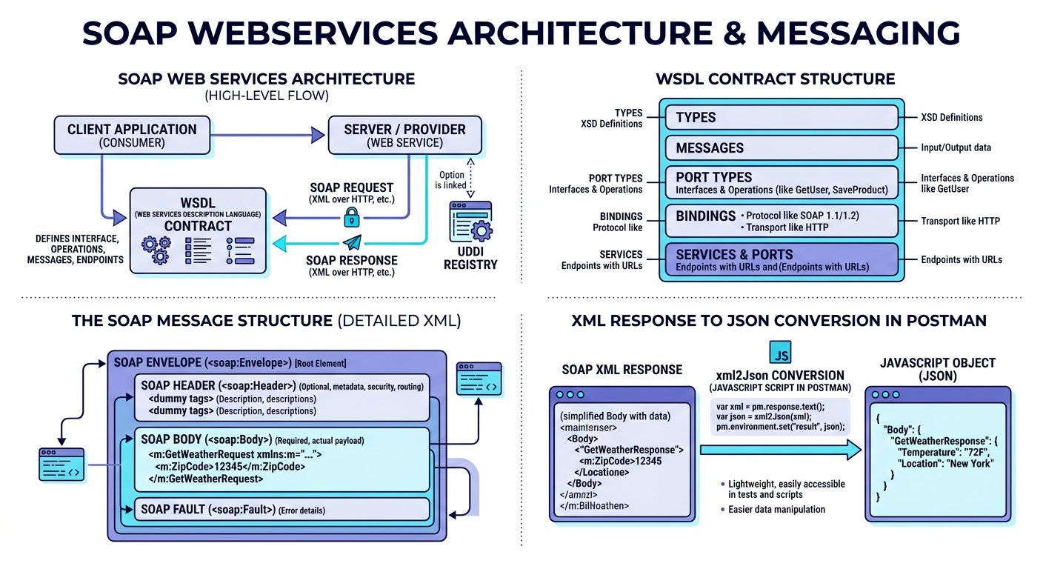
The standardized structure of a SOAP XML request and response envelope.
1 SOAP Envelope: The root XML element defining namespace rules (xmlns:soap) that identifies the packet as a SOAP message.
2 SOAP Header (Optional): Contains routing information, transaction tokens, and security assertions (such as WS Security).
3 SOAP Body (Mandatory): Contains the actual RPC call, method parameters, or response payload returned by the server.
4 SOAP Fault (Error Handling): Standardized sub element returned inside the Body when an exception occurs.

Step 3: The Live Accounting WebService and Postman Setup
To test our grant verification in real time, we query the live DataAccess Number Conversion WebService. You can view the live service documentation directly in your browser: [https://www.dataaccess.com/webservicesserver/NumberConversion.wso](https://www.dataaccess.com/webservicesserver/NumberConversion.wso).
The documentation confirms two supported enterprise operations:

Try it yourself
- 1. NumberToWords: Accepts an unsigned long integer (such as 400) and returns the written English string ("four hundred"). We use this to verify our grant check amount.
- 2. NumberToDollars: Accepts a numeric amount (such as 123) and returns the currency description ("one hundred and twenty three dollars").
The documentation offers both SOAP 1.1 and SOAP 1.2 specifications. In modern enterprise testing, SOAP 1.2 is the recommended standard. We deconstruct the SOAP 1.2 request envelope into three distinct structural chunks:
Deconstructing the SOAP 1.2 Request Envelope
The formal XML contract components:
CHUNK 1: Chunk 1: Root Envelope & Namespace · The Outer Sealed Container
Declares this message as an official SOAP 1.2 envelope using the W3C namespace.
soap-envelope-root.xml
1 <?xml version="1.0" encoding="utf-8"?>
<soap12:Envelope xmlns:soap12="http://www.w3.org/2003/05/soap-envelope">
Rule: The XML namespace prevents naming collisions with custom business tags.
CHUNK 2: Chunk 2: The SOAP Body & Operation · Invoking the Target Method
Specifies the RPC operation (NumberToWords) and targets the service contract domain.
soap-operation.xml
1 <soap12:Body>
<NumberToWords xmlns="http://www.dataaccess.com/webservicesserver/">
Rule: SOAP operations are declared in XML body tags rather than HTTP URL paths.
CHUNK 3: Chunk 3: Method Parameter Tag · Supplying Argument Value
Passes 400 inside the ubiNum tag, then cleanly closes the operation, body, and envelope tags.
soap-parameter.xml
1 <ubiNum>400</ubiNum>
</NumberToWords>
</soap12:Body>
</soap12:Envelope>
Rule: Every opening XML tag must possess an exact matching closing tag.
IMAGINE & PREDICT BEFORE SENDING
When we POST this valid SOAP 1.2 XML envelope to the live NumberConversion service, what response structure will return?
A. 200 OK with an XML envelope containing <m:NumberToWordsResult>four hundred</m:NumberToWordsResult>
B. A JSON object { "result": "four hundred" } because all modern APIs return JSON
C. 404 Not Found because XML cannot be sent over HTTP POST
D. 500 Server Error because 400 is not a valid number
Actual Output (Live SOAP WebService Outcome): SOAP XML response confirmed! The remote accounting mainframe evaluates the envelope and replies with an HTTP 200 OK XML document wrapping "four hundred" inside the NumberToWordsResult tag!
Fresher Trap to Avoid: The Hidden Content Type Discrepancy
When you open Postman, set the method to POST, select Body > raw, and choose XML from the dropdown, Postman automatically generates a hidden header: Content-Type: application/xml.
However, the SOAP 1.2 server specification strictly requires Content-Type: application/soap+xml; charset=utf-8 (or text/xml; charset=utf-8 for SOAP 1.1). If you leave Postman default header in place, the server immediately rejects your request with a 415 Unsupported Media Type or protocol fault!
How to fix: Go to the Headers tab in Postman, click the eye icon to show hidden headers, uncheck the default Content-Type header, and create your own header with key Content-Type and value application/soap+xml; charset=utf-8.
When we hit Send in Postman, the remote accounting server processes the envelope and returns a structured XML response:

Expected output
Terminal
1 $ SOAP XML Response from DataAccess Server
2 Status: 200 OK | Time: 215 ms | Size: 412 B
3 Content-Type: application/soap+xml; charset=utf-8
4
5 <?xml version="1.0" encoding="utf-8"?>
6 <soap:Envelope xmlns:soap="http://www.w3.org/2003/05/soap-envelope">
7 <soap:Body>
8 <m:NumberToWordsResponse xmlns:m="http://www.dataaccess.com/webservicesserver/">
9 <m:NumberToWordsResult>four hundred </m:NumberToWordsResult>
10 </m:NumberToWordsResponse>
11 </soap:Body>
12 </soap:Envelope>
Live Interactive Wire Inspector: SOAP 1.2 XML NumberToWords
POST https://www.dataaccess.com/webservicesserver/NumberConversion.wso
Status: 200 OK · Time: 215 ms · Size: 412 B
Response Body:
response.json
1 <?xml version="1.0" encoding="utf-8"?>
2 <soap:Envelope xmlns:soap="http://www.w3.org/2003/05/soap-envelope">
3 <soap:Body>
4 <m:NumberToWordsResponse xmlns:m="http://www.dataaccess.com/webservicesserver/">
5 <m:NumberToWordsResult>four hundred </m:NumberToWordsResult>
6 </m:NumberToWordsResponse>
7 </soap:Body>
8 </soap:Envelope>
Assertions Verified:
✓ Accounting service status code is 200 OK
✓ Header Content Type is application/soap+xml
✓ Converted words attribute matches four hundred

Step 4: Parsing XML in JavaScript Using xml2Json
In JavaScript, navigating XML tags manually requires clumsy string parsing. Fortunately, Postman provides a built in utility called xml2Json that transforms raw XML text into a traversable JavaScript object in one step. You can download the completed script: [Download Parse SOAP Response Script](/materials/zero-to-agentic-api-testing/lesson-12/parse-soap-response.js).

The code
parse-soap-xml-response.js
1 // Step 1: Capture the raw XML text response from the server
2 const rawXmlResponse = pm.response.text();
3
4 // Step 2: Convert XML text into a traversable JavaScript object
5 const responseJson = xml2Json(rawXmlResponse);
6
7 // Step 3: Verify HTTP status code is 200 OK
8 pm.test("Accounting service status code is 200 OK", function () {
9 pm.response.to.have.status(200);
10 });
11
12 // Step 4: Extract the result using bracket notation for XML namespaces
13 pm.test("Number conversion result returns four hundred", function () {
14 const actualValue = responseJson["soap:Envelope"]["soap:Body"]["m:NumberToWordsResponse"]["m:NumberToWordsResult"];
15 // Defensive trim handles legacy SOAP trailing whitespace
16 pm.expect(actualValue.trim()).to.eql("four hundred");
17 });
Legacy SOAP Reality: The Trailing Whitespace Trap
A real world quirk of the public DataAccess NumberConversion SOAP service is that it appends a trailing space to words: returning "four hundred " rather than "four hundred".
If you write pm.expect(actualValue).to.eql("four hundred") without trimming, your test will fail with an unexpected character difference at index 12!
In automated testing of legacy XML services, always use defensive methods like actualValue.trim() or pm.expect(actualValue).to.include("four hundred") to safeguard tests from invisible whitespace discrepancies.
Fresher Trap to Avoid: Using Dot Notation for XML Namespaces
Notice that XML tags frequently include namespace prefixes with colons, such as soap:Body or m:NumberToWordsResponse.
In JavaScript, you cannot write responseJson.soap:Body because the colon triggers a fatal SyntaxError in dot notation!
Always access namespace prefixed XML elements using bracket notation with string quotes: responseJson["soap:Body"].

Step 5: Dynamic Parameterization and Fast Substring Scanning
In professional regression suites, we do not hardcode 400 in our XML request body or assertions. Instead, we store the input number and expected result in Postman collection variables and reference them dynamically. You can download the dynamic test script: [Download Dynamic SOAP Assertions Script](/materials/zero-to-agentic-api-testing/lesson-12/dynamic-soap-assertions.js):

The code
dynamic-soap-assertions.js
1 // Technique 1: Deep tag validation against collection variables
2 const responseJson = xml2Json(pm.response.text());
3 const actualWord = responseJson["soap:Envelope"]["soap:Body"]["m:NumberToWordsResponse"]["m:NumberToWordsResult"];
4
5 pm.test("Deep tag validation matches collection expected result", function () {
6 const expectedWord = pm.collectionVariables.get("grant_word") || "four hundred";
7 pm.expect(actualWord.trim()).to.eql(expectedWord);
8 });
9
10 // Technique 2: Fast text scanning across the entire response string
11 pm.test("Quick scan confirms four hundred is present in response", function () {
12 pm.expect(pm.response.text()).to.include("four hundred");
13 });

Step 6: Practice Challenge: Converting Numbers to Dollars
Now it is your turn to apply what you learned! In the same DataAccess service documentation, locate the second operation: NumberToDollars. Create a second request in your SOAP collection with the following details:

Try it yourself
- Set the HTTP method to POST and the URL to: https://www.dataaccess.com/webservicesserver/NumberConversion.wso
- In the Headers tab, configure Content Type to application/soap+xml; charset=utf 8
- In the Body tab, select raw and XML, then wrap <NumberToDollars><dNum>123</dNum></NumberToDollars> inside the SOAP 1.2 envelope.
- In the Tests tab, convert the response with xml2Json and write an assertion verifying that the returned string equals "one hundred and twenty three dollars". You can download the completed solution file: [Download SOAP Number to Dollars XML](/materials/zero-to-agentic-api-testing/lesson-12/soap-number-dollars.xml).
WAR ROOM BATTLE SCAR · Enterprise Interbank Freeze
The 415 Header Collision: The Cost of a SOAP Version Mismatch
A national banking federation upgraded its interbank clearing gateway from SOAP 1.1 to SOAP 1.2. Automated test pipelines running on older Postman collections continued sending legacy headers: Content Type text/xml; charset=utf 8 with a SOAPAction header. The upgraded gateway strictly required Content Type application/soap+xml; charset=utf 8 per the SOAP 1.2 specification. The legacy header triggered millions of HTTP 415 Unsupported Media Type errors, halting electronic clearing across fifty regional credit unions for four hours.
Key Architectural Lesson: Always align HTTP Content Type headers with the exact SOAP specification. SOAP 1.1 mandates text/xml with SOAPAction, while SOAP 1.2 strictly requires application/soap+xml without SOAPAction.
WAR ROOM INCIDENT TRIAGE
War Room Triage: The xml2Json Undefined Traversal Crash
You convert an XML response using const responseJson = xml2Json(pm.response.text()). In your test script, you assert: pm.expect(responseJson["soap:Envelope"]["soap:Body"].NumberToWordsResult).to.eql("four hundred"). Postman halts immediately with: "TypeError: Cannot read property NumberToWordsResult of undefined". What caused this traversal failure?
A. Postman does not support parsing XML responses in JavaScript.
B. The response XML element contained an XML namespace prefix (such as m:NumberToWordsResponse) that was omitted from the bracket lookup chain.
C. The xml2Json utility only operates inside Node.js scripts outside Postman.
D. The SOAP server returned an encrypted binary hash instead of XML.
TACTICAL TRIUMPH: Respect XML namespace prefixes! XML responses often qualify elements with namespace prefixes like m:NumberToWordsResponse. When converted by xml2Json, these prefixes become part of the JavaScript object property key. Omitting the prefix means responseJson["soap:Envelope"]["soap:Body"]["NumberToWordsResponse"] evaluates to undefined, throwing a fatal TypeError on subsequent property accesses!

Step 7: Review and Practice
MAKE A GUESS
When testing a SOAP WebService in Postman, why must you select the HTTP POST method even when retrieving data?
- A. Because GET is not supported by the HTTP protocol
- B. Because SOAP operations, namespace rules, and data parameters are packaged securely inside the XML envelope body rather than in the URL
- C. Because POST is faster than GET on all networks
- D. Because Postman does not allow GET requests on XML
Answer: Because SOAP operations, namespace rules, and data parameters are packaged securely inside the XML envelope body rather than in the URL. SOAP messages are always transported using HTTP POST requests, because the operation name and parameters are packaged inside the XML envelope body.

Check your understanding
1. What is the purpose of xml2Json in Postman test scripts?
Answer: xml2Json converts raw XML response strings into standard JavaScript objects so testers can traverse properties using bracket notation in Chai assertions.
2. Why must you uncheck Postman default Content Type when sending SOAP 1.2 requests?
Answer: Postman defaults to application/xml, but the SOAP 1.2 standard strictly requires application/soap+xml; charset=utf 8. Mismatched headers cause server rejections.

Key takeaways
REMEMBER
- SOAP is a strict protocol based on XML envelopes, headers, bodies, and WSDL contracts.
- All SOAP requests are executed via HTTP POST with the body containing the XML envelope.
- Always check Postman hidden headers to ensure Content Type matches the server SOAP 1.2 specification.
- The built in xml2Json utility converts complex XML trees into traversable JavaScript objects.
- Use bracket notation with string quotes to access namespace prefixed XML elements without syntax errors.
⚡ MISSION 3 PHASE 4 CLEARED · Architectural Triumph: Legacy SOAP WebServices & XML Parsing Conquered
You shattered the modern myth that QA engineers only test JSON REST APIs. When confronted with legacy enterprise banking, healthcare, and government mainframes, you crafted valid SOAP 1.2 XML envelopes, outmaneuvered hidden header traps, converted complex XML trees with xml2Json, and extracted deeply nested namespaces with bracket notation.
Tactical Superpowers Mastered:
- Bridging the architectural divide: commanding both modern REST microservices and legacy enterprise SOAP WebServices
- Authoring valid SOAP 1.2 and SOAP 1.1 XML envelopes with headers, bodies, and target namespaces
- Defeating hidden header traps by enforcing exact Content Type application/soap+xml wire specifications
- Transforming raw XML strings into traversable JavaScript objects using the built in xml2Json utility
- Traversing complex XML namespaces using JavaScript string bracket notation without syntax exceptions
Enterprise Disasters Prevented:
- Averted multi million dollar enterprise integration outages during legacy banking and accounting migrations
- Prevented silent test suite failures caused by Postman overriding XML Content Type headers
- Eliminated costly contractor dependencies by proving that Postman can automate legacy XML just as easily as JSON
War Room Takeaway: The vast majority of global enterprise wealth still flows through legacy SOAP web services. When you can seamlessly test both modern GraphQL REST APIs and legacy SOAP mainframes, your market value as a Lead Test Architect is peerless.
NEXT DISCOVERY · Continuing Mission 3: Headless Execution in CI CD Pipelines
Our campus library test suite is now complete across modern REST, OAuth 2.0 security, mock contracts, and legacy enterprise SOAP. But it still only runs when a human clicks buttons in the Postman desktop app. In our final chapter, we take on the ultimate enterprise challenge: running our entire suite headlessly with Newman CLI and automating continuous delivery in Jenkins and GitHub Actions!

Chapter 13: Headless Test Execution with Newman and CI CD
Command line collection runs, rich HTML Extra reports, and automated pipeline integration.
MISSION COMMAND HUD
PHASE: Phase 5 of 5: Headless Newman & CI CD (Mission Victory) · RANK: Rank: Continuous Delivery Architect
ACTIVE MISSION: Mission 3: Hardening for Enterprise Production and CI CD
MISSION BRIEFING & CHAPTER ROADMAP
MISSION 3 · PHASE 4 OF 4: Enterprise Resilience and CI CD Quality Gates
CRISIS SCENARIO: Continuous Quality Gate: Headless Newman Execution in CI CD
Context: On the eve of campus enrollment, ten thousand students and faculty will access the university portal. Developers are deploying hotfixes continuously. We cannot rely on manual testing in a desktop app. We must construct an autonomous robot watchdog: running our test suites headlessly via Newman CLI on every code commit, generating visual HTML Extra dashboards, and gating production releases in Jenkins and GitHub Actions.
Operational Target: Export portable collections and environments, run headless test suites with Newman, configure fail fast bail flags, and integrate CI CD pipelines.

WE WILL ACHIEVE: Transform your desktop collection into an automated, headless deployment gate by mastering Newman CLI, HTML Extra reports, and CI CD pipeline integration.
HOW WE WILL DO IT: Export portable JSON collections and environments, execute command line runs with data files and fail fast bail flags, generate visual dashboards, and configure Jenkins automation.
WHAT YOU WILL CARRY FORWARD: The complete enterprise grade automated API testing pipeline running autonomously in continuous delivery pipelines, achieving full Mission 3 victory.
MISSION PROGRESS · Completing Mission 3: Continuous Integration and Automated Gating
Tomorrow morning is the first day of semester enrollment, when ten thousand students and faculty members will flood the campus library portal to register books, access digital research archives, and process inter library loans. The university engineering director calls an emergency team briefing: developers are pushing hotfixes late into the night, and we cannot have a human being sitting at a laptop clicking Postman buttons manually at two in the morning. We need an automated robot watchdog that runs our test suite automatically on every code push, generates a visual dashboard for university directors, lets us flip between the Campus QA staging server and the live UAT production cluster with a single dropdown click, and runs scheduled cloud smoke checks. In our final chapter, we build that complete continuous integration pipeline using Newman, Jenkins, GitHub Actions, and Postman Cloud Monitors.
The Midnight Launch Guard: Automated test robots protecting servers during midnight updates.
1 Automated Stop Sign: Blocking broken code immediately so bad updates never reach real students.
2 Hands Free Testing: Running all test collections automatically in the background without opening the Postman desktop app.
3 Clear Visual Reports: Creating colorful web dashboards so the engineering team can see test results in one glance.

Step 1: The Continuous Integration Testing Flow
ARCHITECTURE · Headless CI CD Pipeline: Automated Newman Gating on Every Git Commit
HEADLESS CI CD PIPELINE · Headless CI CD Pipeline: Automated Newman Gating on Every Git Commit
Newman bridges the gap between exploratory testing in the Postman desktop app and automated deployment pipelines. In modern software organizations, automated tests execute headlessly on every git push without human intervention, generating visual HTML Extra dashboards and protecting production clusters.
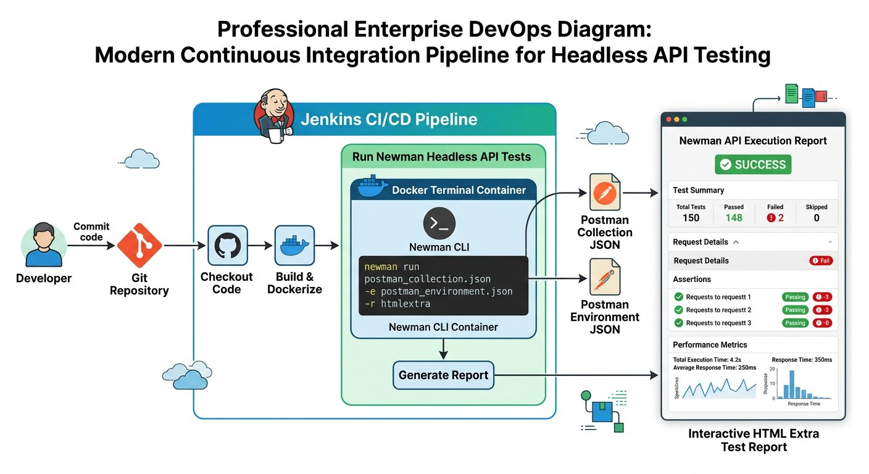
The complete continuous integration testing pipeline powered by Newman.
1 Step 1 (Code Push): A developer merges new code into the Git repository.
2 Step 2 (Pipeline Trigger): The CI server (Jenkins or GitHub Actions) detects the commit and spins up a lightweight test container.
3 Step 3 (Headless Execution): Newman executes the exported Postman collection and environment files without a graphical interface.
4 Step 4 (Reporting and Gating): Newman generates an interactive HTML Extra report. If all tests pass with exit code 0, deployment proceeds; if any assertion fails, the build is blocked.

Step 2: Installing Node.js and Newman Globally
Newman is built as a command line tool on top of Node.js. Before installing Newman, ensure Node.js is installed on your computer or build server.

Try it yourself
- Download and install Node.js from the official site: https://nodejs.org (select LTS version).
- Verify your installation in your terminal by checking the versions: run node -v and npm -v.
- Verify your system path environment variable so Node is accessible globally from any directory (on Mac check echo $PATH, on Windows check System Properties > Environment Variables).
- Install Newman globally using the Node Package Manager: run npm install -g newman.

Step 3: Exporting Artifacts and The Space in Filename Bug
To run our test collection outside the Postman graphical interface, we must export our collection, environment variables, and external data files as portable JSON and CSV artifacts.

Try it yourself
- Export Collection: In Postman, click the three dots beside your collection and select Export to save Campus_Library_Collection.json.
- Export Environment: In the Environments manager, click the three dots beside your environment and export Campus_Library_UAT.json (using flag -e).
- Export Globals: In Global Variables, click Export to save Campus_Globals.json (using flag -g).
- Prepare CSV Data: Place your books_data.csv spreadsheet in the same project directory (using flag -d).
Fresher Trap to Avoid: Spaces in Exported Filenames
When you export files from Postman, the default filename often contains spaces (such as Campus Library Suite.postman_collection.json).
In terminal environments like bash or Windows PowerShell, spaces act as argument separators. The terminal treats Campus as one file and Library as another, immediately crashing with a file not found error!
Always rename exported files using underscores or clean alphanumeric names before running terminal commands: Campus_Library_Collection.json.
With all artifacts in our project folder, we run our complete collection headlessly from the command prompt:

The code
run-newman-cli.sh
1 # Execute headless collection run with environment, globals, and CSV data
2 newman run Campus_Library_Collection.json \
3 -e Campus_Library_UAT.json \
4 -g Campus_Globals.json \
5 -d books_data.csv

Expected output
Terminal
1 $ newman run Campus_Library_Collection.json -e Campus_Library_UAT.json -d books_data.csv
2 Iteration 1 of 3: Processing "Learn Postman Testing"
3 POST https://uat-api.campuslibrary.org/v1/books [200 OK, 248B, 185ms]
4 ✓ Status code is 200 OK
5 ✓ Response contains successfully added message
6 ✓ Backend generated ID correctly concatenates ISBN and aisle
7
8 GET https://uat-api.campuslibrary.org/v1/books?id=LIB1048101 [200 OK, 192B, 142ms]
9 ✓ GetBook response returns an array with at least one record
10 ✓ Retrieved book name matches "Learn Postman Testing"
11 ✓ Catalog ISBN and aisle match created coordinates
12
13 POST https://uat-api.campuslibrary.org/v1/books/delete [200 OK, 212B, 158ms]
14 ✓ Book is successfully deleted message verified
15
16 ┌─────────────────────────┬──────────┬──────────┐
17 │ │ Executed │ Failed │
18 ├─────────────────────────┼──────────┼──────────┤
19 │ iterations │ 3 │ 0 │
20 │ requests │ 9 │ 0 │
21 │ test-scripts │ 18 │ 0 │
22 │ prerequest-scripts │ 12 │ 0 │
23 │ assertions │ 18 │ 0 │
24 └─────────────────────────┴──────────┴──────────┘
25 Execution Summary: 3 iterations, 9 requests, 18 assertions, 0 failures (518 ms)

Step 4: Generating Publication Grade HTML Extra Dashboards
Terminal output is great for developers, but engineering directors and quality assurance managers need visual dashboards. We install the newman-reporter-htmlextra plugin to generate publication grade reports. We break down the Newman execution command into three key flag chunks:
Deconstructing the Headless Command
Essential CLI parameters for automated pipelines:
CHUNK 1: Chunk 1: Target Files · Providing Test Assets
Specifies the exported collection JSON, the UAT environment variables file, and the CSV dataset.
newman-targets.sh
1 newman run Campus_Library_Collection.json \
-e Campus_Library_UAT.json \
-d books_data.csv
Rule: Newman loads environments and data files headlessly without GUI dialogs.
CHUNK 2: Chunk 2: Multi Reporter Configuration · Configuring Dashboard Output
Generates real time colored CLI text in the terminal while compiling an interactive HTML dashboard.
newman-reporters.sh
1 -r cli,htmlextra \
--reporter-htmlextra-export reports/dashboard.html
Rule: The single file dashboard can be archived directly as a CI build artifact.
CHUNK 3: Chunk 3: Failure Enforcement Policy · Fast Fail Safety Gate
Tells Newman to stop execution immediately upon the very first assertion failure, saving valuable CI compute minutes. Note that any assertion failure causes Newman to exit with code 1; the bail flag enables fast fail semantics.
newman-bail.sh
1 --bail
Rule: --bail guarantees defective builds are blocked immediately without wasting compute.
IMAGINE & PREDICT BEFORE SENDING
When Newman executes in a Jenkins or GitHub Actions pipeline and an assertion fails, what exit code does Newman return to the terminal?
A. Exit code 1: Signaling non zero failure to the operating system, which instructs the CI pipeline to fail the build
B. Exit code 0: Because commands that finish executing always return zero
C. Exit code 200: Matching the HTTP status code
D. Exit code 500
Actual Output (Terminal Exit Code Confirmation): Exit code 1 halts the pipeline! In Unix and Windows terminals, exit code 0 indicates success, while any non zero code (such as 1) signals failure. Jenkins and GitHub Actions automatically inspect this numeric code: when Newman exits with 1, the pipeline halts and blocks the deployment!
What the HTML Extra Dashboard Delivers
• Summary Visuals: Interactive pie charts and bar graphs showing total requests, passed assertions, and failed checks.
• Granular Request Logs: Expandable cards showing exact request URLs, HTTP methods, wire headers, and request bodies for every iteration.
• Diagnostic Trace: Detailed inspection of response payloads and assertion error diffs for immediate debugging.
• Stakeholder Ready: A single portable HTML file you can email to managers or publish to CI build artifacts.

Step 5: Setting Up Jenkins and The Working Directory Trap
To automate execution without opening a terminal manually, we set up Jenkins, the enterprise standard continuous integration server. You can download the Jenkins build script: [Download Jenkins Build Step Script](/materials/zero-to-agentic-api-testing/lesson-13/jenkins-build-step.sh).

Try it yourself
- Download the generic Java package: jenkins.war from https://www.jenkins.io.
- Start Jenkins from your command prompt on port 9090: java -jar jenkins.war --httpPort=9090.
- Open your local browser to access the running Jenkins administrative setup dashboard on your assigned port.
- Enter the initial administrator password, complete setup, and click New Item to create a Freestyle Project named "Campus Library Regression Pipeline".
- In the Build section, click Add build step and select Execute shell (on Linux or Mac) or Execute Windows batch command (on Windows).
Fresher Trap to Avoid: The Jenkins Working Directory Trap
When Jenkins runs a job, it executes from its own internal workspace directory (such as /var/jenkins_home or your user profile folder), where your exported collection files do not exist.
If you simply paste newman run Campus_Library_Collection.json, Jenkins immediately aborts with an error saying the file cannot be found!
How to fix: In your Jenkins build step, always navigate to your project folder first using the cd command before running Newman:

The code
jenkins-build-step.sh
1 # Step 1: Navigate to the directory where exported artifacts are stored
2 cd /home/user/postman_execution
3
4 # Step 2: Run Newman with environment and HTML Extra reporter
5 newman run Campus_Library_Collection.json \
6 -e Campus_Library_UAT.json \
7 -d books_data.csv \
8 -r cli,htmlextra \
9 --reporter-htmlextra-export reports/build_report.html \
10 --bail

Step 6: Parameterized Jenkins Builds: Dynamic Environment Switching
Here is the ultimate enterprise automation requirement: our QA engineers test on the QA staging cluster in the morning, but before the midnight release, they must validate the UAT production mirror. We do not want to create duplicate Jenkins jobs or edit shell scripts by hand. We make our Jenkins job dynamic using a Choice Parameter.

Try it yourself
- In your Jenkins job configuration, check the box: This project is parameterized.
- Click Add Parameter and select Choice Parameter.
- Set the Parameter Name to: ENV
- In the Choices box, enter two options on separate lines: QA and UAT.
- Ensure your exported environment files follow a uniform naming convention: QA.postman_environment.json and UAT.postman_environment.json.
Now, update the Jenkins build script to reference the parameter dynamically using ${ENV}. You can download the parameterized script: [Download Parameterized Jenkins Build Script](/materials/zero-to-agentic-api-testing/lesson-13/parameterized-jenkins-build.sh):

The code
parameterized-jenkins-build.sh
1 # Navigate to project folder
2 cd /home/user/postman_execution
3
4 # Interpolate the selected Jenkins environment choice dynamically
5 newman run Campus_Library_Collection.json \
6 -e "${ENV}.postman_environment.json" \
7 -d books_data.csv \
8 -r cli,htmlextra \
9 --reporter-htmlextra-export "reports/${ENV}_report.html" \
10 --bail
When you click Build with Parameters in Jenkins, a dropdown appears. Selecting QA runs your entire test suite against https://qa-api.campuslibrary.org. Selecting UAT runs against https://uat-api.campuslibrary.org. One single automated job services your entire enterprise testing lifecycle!

Step 7: Cloud CI CD Pipeline: GitHub Actions
For modern cloud engineering teams that host repositories on GitHub, you can execute this identical pipeline automatically on every git commit without hosting a local Jenkins server. You can download the ready to use GitHub workflow: [Download GitHub Actions Workflow](/materials/zero-to-agentic-api-testing/lesson-13/api-tests-workflow.yml):

The code
api-tests-workflow.yml
1 name: Campus Library API Regression Pipeline
2 on: [push, pull_request]
3
4 jobs:
5 api-regression:
6 runs-on: ubuntu-latest
7 steps:
8 - name: Checkout Repository Code
9 uses: actions/checkout@v4
10 - name: Setup Node.js Environment
11 uses: actions/setup-node@v4
12 with:
13 node-version: 20
14 - name: Install Newman and HTML Extra Reporter
15 run: npm install -g newman newman-reporter-htmlextra
16 - name: Execute Headless Test Suite
17 run: |
18 newman run course-materials/zero-to-agentic-api-testing/Zero-to-Agentic-API-Testing.postman_collection.json \
19 -e course-materials/zero-to-agentic-api-testing/Campus-Library-UAT.postman_environment.json \
20 -d course-materials/zero-to-agentic-api-testing/lesson-08/books_data.csv \
21 -r cli,htmlextra \
22 --reporter-htmlextra-export build/regression_report.html \
23 --bail

Step 8: Scheduled Cloud Watchdogs: Postman Monitors
While Jenkins and GitHub Actions run tests when code changes occur, what if no code was deployed during the night, but an external database server went down? To ensure system health without keeping your laptop awake, Postman provides Monitors.
A Postman Monitor runs your collection periodically on Postman cloud infrastructure according to a schedule you define:

Try it yourself
- 1. In Postman, navigate to the Monitors tab on the left sidebar and click Create a Monitor.
- 2. Assign a monitor name such as "Campus Library Daily Smoke Check".
- 3. Select the collection to execute and the target environment (Campus_Library_UAT).
- 4. Set the timer schedule: for example, every weekday at 7:00 AM. Postman cloud servers will execute the collection so results are ready before engineers arrive at 9:00 AM.
- 5. Configure email alerts: enter team email addresses to receive instant notifications if any assertion fails, with automatic retry on transient network errors.
- 6. Inspecting History and Restoring Items: If an engineer accidentally deletes a collection, navigate to the workspace Trash to restore it immediately.
WAR ROOM BATTLE SCAR · Four Million Dollar Pipeline Bypass
The Bypassed CI Gate Disaster: The Cost of Disabling Newman in the Merge Pipeline
Under intense pressure to meet a strict quarterly launch deadline, an engineering squad commented out the Newman collection execution step in their GitHub Actions workflow file to expedite merging. A developer subsequently merged a pull request that unintentionally inverted financial debit and credit transaction signs. Because the Newman automated regression check had been disabled, the pull request merged green without firing assertions. Within ninety minutes of deployment, the production ledger accumulated over four million dollars in erroneous balances.
Key Architectural Lesson: Never bypass or disable automated CI quality gates. Treat Newman command line regression tests as mandatory blocking status checks on every pull request and automated build.
WAR ROOM INCIDENT TRIAGE
War Room Triage: The Non Zero Exit Code CI Blocker
You configure Newman in a Jenkins pipeline: newman run LibraryTests.json -e StagingEnv.json. Two assertions fail during the test execution, yet Jenkins marks the build step as SUCCESS and deploys the defective build straight to staging. Why did Jenkins fail to block the deployment?
A. Newman does not generate exit codes on assertion failures.
B. The build script appended "|| true" or suppressed the non zero exit code, preventing Jenkins from detecting that Newman returned exit code 1 on assertion failures.
C. Jenkins only inspects console colors, not numeric exit codes.
D. The Newman collection must be written in Python to fail a Jenkins build.
TACTICAL TRIUMPH: Exit code integrity controls CI pipelines! In Unix and Windows terminals, a command indicates failure by returning a non zero exit code (such as 1). Newman automatically returns exit code 1 whenever any test assertion fails. If a shell script appends "|| true", the shell overrides the exit code to 0, deceiving Jenkins into treating a failed run as successful. Remove any exit code suppression or use the --bail flag to guarantee immediate failure!
★ MISSION ACCOMPLISHED · Mission 3 Accomplished: Autonomous Production Quality Gate!
Our entire campus library test suite now runs headlessly on every code commit in continuous integration pipelines, and runs scheduled smoke checks in the cloud. Any regression is detected and blocked before reaching students and faculty. You have mastered API testing from first principles to enterprise automation!

Step 9: Review and Practice
MAKE A GUESS
What exit code does Newman return to the terminal when all assertions in a collection pass successfully?
- A. Exit code 1
- B. Exit code 0
- C. Exit code 200
- D. Exit code 255
Answer: Exit code 0. In Unix and Windows command environments, an exit code of 0 indicates complete success. Any non zero exit code (such as 1) indicates failure, which signals CI pipelines to mark the build as failed.

Check your understanding
1. Why do CI build servers run tests headlessly rather than opening the Postman desktop window?
Answer: CI servers run on minimal Linux servers without screens. A headless command line tool consumes minimal memory, starts in milliseconds, and uses exit codes to control deployment pipelines.
2. What is the primary difference between a Jenkins pipeline build and a Postman Monitor?
Answer: A Jenkins pipeline typically triggers on event driven actions (such as a git push or pull request merge). A Postman Monitor runs on a recurring time schedule in the cloud (such as daily at 7:00 AM) to verify ongoing system health.

Key takeaways
REMEMBER
- Newman runs Postman collections headlessly from command prompts, Docker containers, and CI servers.
- Export collection, environment (-e), global (-g), and CSV data (-d) files into a single project folder without spaces in filenames.
- The htmlextra reporter creates publication grade interactive dashboards for stakeholders and QA leads.
- In Jenkins, always navigate to your project folder using cd before running Newman commands.
- Use Jenkins Choice Parameters to switch target test environments dynamically with a single dropdown selection.
- Postman Monitors provide scheduled cloud watchdogs running health checks without requiring local machines.
⚡ ★ FINAL CAPSTONE CONQUERED · CI CD DEFENDER · Ultimate Enterprise Capstone: Autonomous CI CD Quality Gate Deployed
You have conquered the entire Zero to Agentic API Testing journey! You took full command of the testing pyramid, automated multi tier campus services, secured microservices with OAuth 2.0, bridged legacy SOAP XML WebServices, and engineered an autonomous continuous integration pipeline powered by Newman, Jenkins, GitHub Actions, and HTML Extra reporting. You stand at the pinnacle of modern software quality engineering.
Tactical Superpowers Mastered:
- Orchestrating zero click headless test execution across containerized CI CD pipelines via Newman CLI
- Automating strict quality gates with the fail fast bail flag to block breaking commits before deployment
- Generating publication grade interactive HTML Extra dashboards with visual charts and granular wire traces
- Engineering parameterized Jenkins pipelines with dynamic Choice Parameters for instant QA and UAT switching
- Deploying round the clock scheduled cloud watchdogs and automated alerts using Postman Monitors
Enterprise Disasters Prevented:
- Averted catastrophic midnight production outages by intercepting breaking backend commits in the pipeline
- Eliminated hundreds of hours of manual release signoff delays, enabling true continuous delivery at enterprise scale
- Protected live production environments by establishing rigorous automated UAT gating before customer release
War Room Takeaway: You are no longer someone who merely checks if an application works. You are the architect who builds the autonomous shields that guarantee software never fails in production. You command the wire, the contract, the assertion, and the pipeline.
NEXT DISCOVERY · From Ground Zero to Production Mastery
Congratulations! You have completed all three missions: from auditing the live REST wire and mastering API fundamentals to automating the college library at scale, and hardening enterprise pipelines in CI CD. You are ready to test and automate any API in the world!

About the author
Akshat Sinha is the founder of The Sinha Family Group and the creator of Sarva Gyana Koshah: the treasury of all knowledge, which teaches through books, interactive learning platforms, and authoritative engineering references.
This book bridges the gap between manual exploratory testing, automated pipeline engineering, and continuous integration with Postman, JavaScript, and Newman.

Keep learning
Keep guessing, running and checking.
Sarva Gyana Koshah Books · The Treasury of All Knowledge

