AKSHAT EBOOKS
Python for Absolute Beginners
See What Your Code Does
Akshat EBooks
First edition · 2026

Python for Absolute Beginners
Copyright © 2026 Akshat EBooks
All rights reserved. No part of this book may be reproduced for sale without written permission.
Code examples are for learning. Test code before using it in an important system.
For every beginner who has ever thought, “Maybe coding is not for me.” It can be.

Contents

In Microsoft Word, right-click this list and choose Update Field if page numbers are not visible.

Preface — Why Did Python Need to Exist?
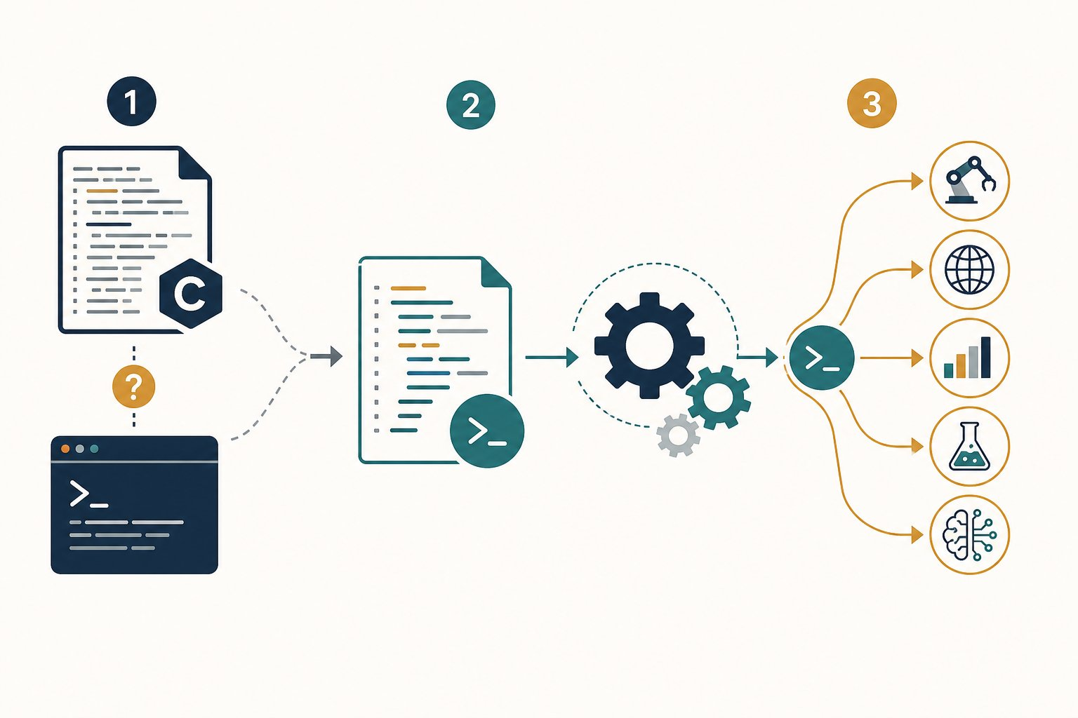
Legend: 1 = shell scripts were convenient but limited, while C gave control but required more work. 2 = Python aimed to be readable and easy to extend. 3 = that bridge now supports automation, web services, data, science and AI.
Python did not appear because the world needed another spelling for code. It appeared because programmers faced an awkward gap.
The gap Python was built to cross
In the late 1980s, Guido van Rossum worked on the Amoeba operating system. The team needed something easier than writing a full C program for every task. Shell scripts were convenient, but they could not easily reach Amoeba’s special system features.
Guido wanted a language that was pleasant to read, useful for everyday scripts and open to extensions written in other languages. Python grew from that practical need.

Why does that old problem still matter?
We still want to turn an idea into a working tool without fighting unnecessary punctuation. We also need a language that can connect to fast libraries and existing systems. Python is often the glue between those pieces.
Friendly does not mean weak
Python trades some low-level control for speed of thought. You can automate a folder today, build a web service later and explore data with the same core language.
Python is not the best tool for every job. C can offer tighter hardware control. Java can provide a strongly structured runtime ecosystem. Learning Python first gives us clear space to learn programming ideas.

What about AI?
AI can produce code quickly. It can also produce code that is confidently wrong. We still need to predict what a program should do, inspect what it actually did and judge whether the result is safe. That is exactly how this book teaches.

Key takeaways
REMEMBER
- Python began as a practical bridge between quick scripts and larger system programs.
- Readable code helps people review, repair and share ideas.
- Python can connect to tools written in other languages.
- Our goal is not to memorise syntax. Our goal is to understand what happens next.

Keep exploring
Python FAQ: why Python was created — https://docs.python.org/3/faq/general.html
Python essay: a language for gluing systems together — https://www.python.org/doc/essays/omg-darpa-mcc-position/

How to use this book
Make a guess. Run the code. Compare the result with your guess.
Web View reveals answers and moves through visualizers. Book View shows every answer and every step.

Lesson 1: Your First Program — Hello, World!
We begin with an empty file and end with a real result—understanding every character we typed.
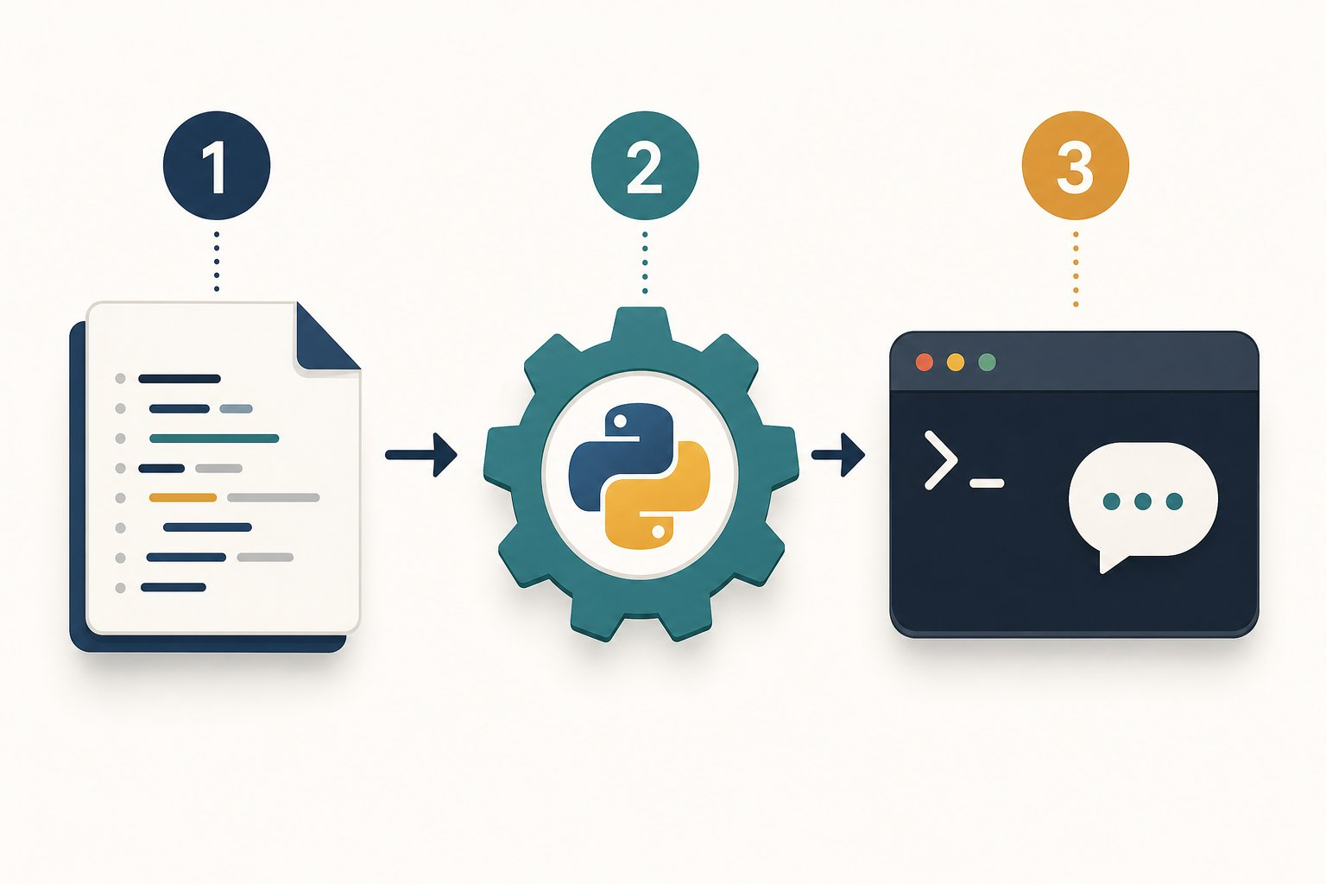
Legend: 1 = we save an instruction in hello.py. 2 = Python reads and performs it. 3 = the terminal shows the result.
OUR MISSION · Make the silent machine answer us
We start with no code and no hidden knowledge. Our first win is simple: ask the computer to show one exact message.
What we know: A computer follows precise instructions. • It will not guess what we meant.
What we need: A way to mark text. • An action that sends text to the screen. • A command that starts our program.
PAUSE & THINK
If the word Hello appears in our code, how will Python know it is text and not the name of something?
Answer: We wrap the characters in quotes. Quotes turn Hello into a string—a piece of text.

Step 1 — What is a program?
A program is a saved set of instructions. Source code is the text we write to express those instructions. Python is the language whose rules both we and the Python runtime agree to follow.
Precise like a recipe, active like a remote control
A recipe describes actions. It does nothing until someone follows it. Source code is similar: the file stores instructions, and the Python runtime performs them.
Unlike a person, Python does not quietly repair a missing quote or guess a misspelled action. That strictness helps every reader get the same result.

Step 2 — Meet every character
print is a built-in function—a ready-made action supplied by Python. The round brackets call that action. The quotes mark text. The exclamation mark and comma inside the quotes are ordinary characters, so Python displays them too.

Input → Process → Output
Value  "Hello, World!" | Function call  print(...) | stdout  Hello, World!
What is stdout?
stdout means standard output. It is the normal stream a program uses to send results outward. In our terminal, that stream appears as text on the screen.

Step 3 — Plan before we type

Plan before we type
PROGRAM BLUEPRINT
Purpose: Prove that Python can run our instruction and show a greeting.
Input: The string "Hello, World!" written inside the program.
Processing: Call print() with that string.
Output: The exact characters Hello, World!
Files: hello.py

Step 4 — Write the code

The code
hello.py
1 print("Hello, World!")
MAKE A GUESS
Before we run it: what will appear?
prediction.py
1 print("Hello, World!")
- A. The quote marks and the message
- B. Hello, World! without quote marks
- C. The word print
Answer: Hello, World! without quote marks. Quotes describe the string. They are not part of the string, so print() does not display them.

Step 5 — Watch the instruction become output

Program run: every step
hello.py
1 print("Hello, World!")
1. The command starts Python
The operating system launches the Python runtime and gives it the path to hello.py.
2. Python opens our source file
Python reads the saved characters. Nothing is visible in the console yet.
3. Python checks the instruction (line 1)
The name print, both brackets and both quotes follow Python’s syntax rules.
4. Python creates the string value (line 1)
The characters inside the quotes become one text value.
Memory: value = "Hello, World!"
5. Python calls print() (line 1)
The string is passed to the built-in print function.
Memory: value = "Hello, World!"
6. The console receives the result (line 1)
print() writes the characters to stdout and then starts a new line.
Console: Hello, World!

Expected output
Terminal
1 $ python hello.py
2 Hello, World!
THE AHA MOMENT
We did not ask the computer to understand a greeting. We gave Python one exact value and one exact action—and a visible result came back.

Step 6 — Make it yours

Try it yourself
- Create a file named hello.py.
- Type the instruction instead of pasting it.
- Save the file, then run python hello.py.
- Change only the text inside the quotes.
- Add a second print() line and predict the order of the output before running it.

Step 7 — Learn from the mistakes
BUG HUNT
Which line asks for an action Python does not know?
bug_hunt.py
1 print("Ready!")
2 Print("Go!")
Answer: line 2. Python names are case-sensitive. Print and print are different names.

Common mistakes and fixes
✗ print(Hello)
Without quotes, Python searches for a name called Hello.
✗ Print("Hello")
The built-in function uses a lowercase p.
✗ print("Hello"
The function call is missing its closing bracket.
✗ python hello
The command should include the file name hello.py.

Check your understanding
1. What makes Hello, World! a string?
Answer: The opening and closing quotes mark it as text.
2. What do the brackets do in print(...)?
Answer: They call the function and hold the value we pass to it.
3. What is stdout?
Answer: The standard output stream. A terminal normally shows it on screen.

Key takeaways
REMEMBER
- Source code stores instructions in a form people can read.
- A string is text marked by quotes.
- print() sends a value to standard output.
- Python follows spelling, case, quotes and brackets exactly.
- Predicting before running turns every example into an experiment.

Keep exploring
Python tutorial: using Python as a calculator — https://docs.python.org/3/tutorial/introduction.html
Python print() reference — https://docs.python.org/3/library/functions.html#print
NEXT DISCOVERY · Who carries our instruction to the processor?
We can see the result. Next, we uncover the hidden route between hello.py and the machine.

Lesson 2: From Code to Machine: The Hidden Journey
Send one tiny greeting through Python, C and Java—and see what each tool creates on the way.
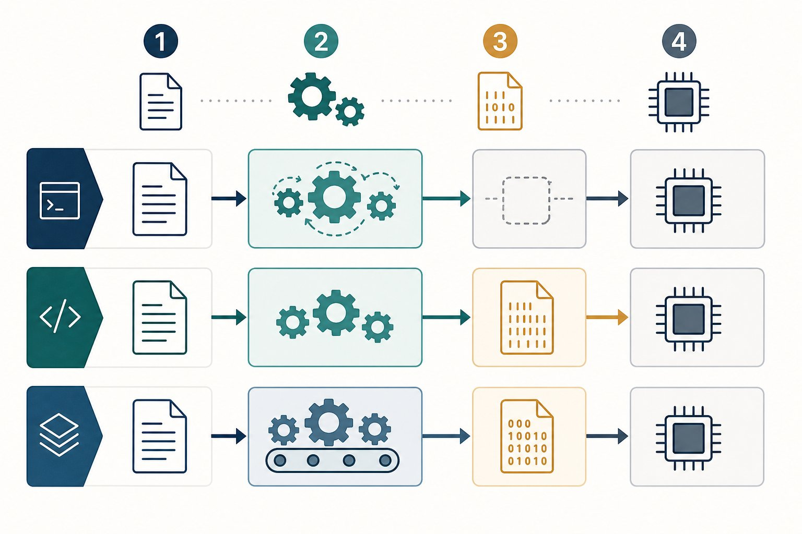
Legend: the top route prepares Python code for the CPython runtime. The middle route builds a native C executable. The bottom route builds Java bytecode for a JVM.
OUR MISSION · Follow one message all the way down
We can read print(message). A processor cannot. Our mission is to find the translators between those two worlds.
What we know: Source code is written for people. • The processor performs machine instructions.
What we need: A clear map of the tools in between. • A real example of what each stage produces.
PAUSE & THINK
When we run python greeting.py, does the processor understand the word print?
Answer: No. The Python implementation reads and prepares our source. Its runtime performs the work using machine instructions that the computer can execute.

The big idea: source code takes a route
A toolchain is the set of tools that changes source code into a running program. Different languages use different toolchains. The destination is the same: work the hardware can perform.
A journey with travel documents
Our idea is the traveller. Source code is the document we can read. Each stage checks or transforms that document until the local machine can act on it.
Some routes prepare a native executable before the trip. Other routes travel with a runtime that translates and manages work along the way.

Compare the routes with one visible result
Each program below prints the same greeting. Select a route in Web View. Follow the numbered cards. The artifact line shows what exists after that stage.

Compare the routes

🐍 Python (CPython)
Run the source with a runtime. CPython first compiles it to bytecode internally.
1  📝 | Source  Artifact: greeting.py  We write readable Python instructions.  message = "Hello"  print(message)
2  🧩 | Compile internally  Artifact: code object + bytecode  CPython checks the syntax and prepares bytecode instructions.  LOAD_NAME · CALL
3  ⚙️ | Python runtime  Artifact: CPython process  The evaluation loop performs each bytecode operation and calls lower-level code.  python greeting.py
4  🖥️ | Visible result  Artifact: stdout  The runtime asks the operating system to write the message to the output stream.  Hello

🔧 C with GCC
Build a machine-specific executable first, then run that file.
1  📝 | Source  Artifact: greeting.c  We write C source and include the declaration for printf.  printf("Hello\n");
2  🧱 | Compile + assemble  Artifact: greeting.o  GCC translates the source through assembly into an object file.  gcc -c greeting.c
3  🔗 | Link  Artifact: greeting executable  The linker joins our object file with required library code.  gcc greeting.o -o greeting
4  🖥️ | Run native code  Artifact: stdout  The operating system loads the executable for this machine.  ./greeting → Hello

☕ Java
Build portable bytecode first, then let a JVM run it on the current machine.
1  📝 | Source  Artifact: Greeting.java  We write source inside a class and main method.  System.out.println("Hello");
2  🏗️ | Compile  Artifact: Greeting.class  javac checks the source and produces Java bytecode.  javac Greeting.java
3  ⚙️ | JVM runtime  Artifact: loaded class  The Java Virtual Machine loads and verifies the class. It can interpret or JIT-compile hot code.  java Greeting
4  🖥️ | Visible result  Artifact: stdout  The JVM works with the operating system to display the message.  Hello
An honest accuracy note
“Compiled” and “interpreted” are not two sealed boxes. CPython compiles source to bytecode. Modern JVMs can compile bytecode to native code while a program runs. C compilers may combine or optimise stages.
The routes above are useful maps, not photographs of every internal detail.
THE AHA MOMENT
The language is not the processor. A toolchain is the bridge between the code we understand and the operations the machine performs.

Open Python’s hidden instruction list
CPython includes dis, a disassembler—a tool that shows bytecode in a readable form. The exact instructions can change between Python versions. That is fine. We are looking for evidence that a hidden stage exists.

The code
greeting.py
1 message = "Hello from the other side"
2 print(message)

Expected output
Terminal
1 $ python -m dis greeting.py
2 ... LOAD_CONST ...
3 ... STORE_NAME ...
4 ... CALL ...
5 ... RETURN_VALUE ...

Try it yourself
- Create greeting.py with the two lines above.
- Run python greeting.py and see the greeting.
- Run python -m dis greeting.py.
- Find an instruction containing LOAD and one containing CALL.
- Change the message. Run both commands again.
MAKE A GUESS
Which route creates Greeting.class before the program runs?
- A. Python with CPython
- B. C with GCC
- C. Java with javac
Answer: Java with javac. javac compiles Java source into a class file containing Java bytecode.
BUG HUNT
Which statement hides an important truth?
bug_hunt.py
1 CPython can compile source to bytecode.
2 Python source runs directly inside the processor.
3 A C linker can join object files and libraries.
Answer: line 2. The processor does not read Python words directly. The Python runtime and lower-level system code stand in between.

Common mistakes and fixes
✗ Interpreted means never compiled
CPython normally compiles source into bytecode before executing it.
✗ Bytecode is CPU machine code
Bytecode targets a virtual machine or runtime, not a specific processor instruction set.
✗ The compiler is the whole toolchain
A real route can also include preprocessing, assembly, linking, loading and runtime work.

Check your understanding
1. What is an artifact?
Answer: A file or internal result created by a stage, such as an object file or bytecode.
2. What does a linker do in the C route?
Answer: It combines object files and required library code into an executable.
3. Why can Java bytecode travel between systems?
Answer: A JVM made for each system can run the shared class-file format.
4. Is Python simply “not compiled”?
Answer: No. CPython normally compiles source into bytecode internally.

Key takeaways
REMEMBER
- Source code is written for people; processors perform machine instructions.
- CPython prepares bytecode and executes it through a runtime.
- A C toolchain can compile, assemble and link a native executable.
- javac creates Java bytecode; a JVM runs and may JIT-compile it.
- Simple diagrams are maps. Real implementations can optimise or combine stages.

Keep exploring
Python `dis`: inspect CPython bytecode — https://docs.python.org/3/library/dis.html
GCC: the four build stages — https://gcc.gnu.org/onlinedocs/gcc/Overall-Options.html
Oracle `javac`: source to bytecode class files — https://docs.oracle.com/en/java/javase/11/tools/javac.html
NEXT DISCOVERY · The route can run code—but where does data wait?
Next, we give a value a name and watch Python’s memory change one line at a time.

Lesson 3: Variables: Names for Values
Store a value, change it and inspect memory one line at a time.
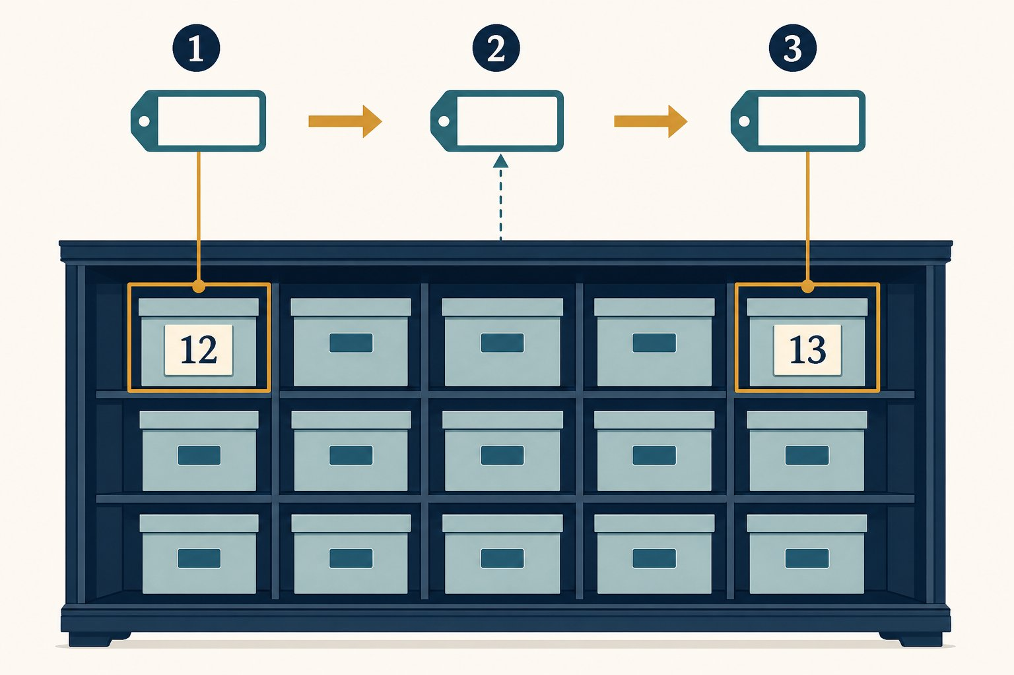
Legend: 1 = choose a name. 2 = store a value. 3 = assign again so the name points to the new value.
OUR MISSION · Keep track of a score
Our program needs to remember a score and then add five.
What we know: Python can display a value.
What we need: A name for the value. • A way to replace the stored value.
PAUSE & THINK
If the score changes, should we edit every old number by hand?
Answer: No. We use one variable name. Later code reads the current value through that name.

Assignment connects a name and a value
A variable is a name that refers to a value. In score = 10, the equals sign means assign. It does not ask a maths question.
A label, not a locked box
Imagine a reusable label named score. First it refers to 10. A later assignment can make the same name refer to 15.
This picture is more accurate than imagining that Python permanently locks one value inside one box. Names and values are separate parts of the story.

Read assignment from right to left
For score = score + 5, Python finishes the right side first. It reads the current value 10. It calculates 10 + 5. Only then does it assign the result 15 back to the name score.
Names that help the next reader
A name may use letters, digits and underscores. It cannot begin with a digit. Python treats score and Score as different names.
Choose names that reveal meaning. score helps us more than s, even though both are legal.

Plan before we type
PROGRAM BLUEPRINT
Purpose: Add five to a score.
Input: Starting score: 10.
Processing: Read score, add 5, assign the result back.
Output: 15
Files: score.py

The code
score.py
1 score = 10
2 score = score + 5
3 print(score)

Program run: every step
score.py
1 score = 10
2 score = score + 5
3 print(score)
1. Memory starts empty
No variable names exist yet.
2. Store the first value (line 1)
The name score now refers to the integer 10.
Memory: score = 10
3. Calculate the new value (line 2)
Python reads 10, adds 5 and assigns 15 to score.
Memory: score = 15
4. Read and display score (line 3)
print() receives the current value, which is 15.
Memory: score = 15
Console: 15

Expected output
Terminal
1 $ python score.py
2 15
THE AHA MOMENT
The same variable name can refer to a new value after another assignment.

Try it yourself
- Create score.py.
- Run the example.
- Change the starting score.
- Add another line that subtracts 2.

Common mistakes and fixes
✗ 10 = score
The name belongs on the left side of assignment.
✗ print("score")
Quotes print the word score, not the value stored under that name.
MAKE A GUESS
What is printed?
prediction.py
1 coins = 3
2 coins = coins + 2
3 print(coins)
- A. 2
- B. 3
- C. 5
Answer: 5. Python reads 3, adds 2 and stores 5.
BUG HUNT
Which line uses the wrong variable name?
bug_hunt.py
1 points = 8
2 point = points + 1
3 print(points)
Answer: line 2. Line 2 creates a different name, point. The original points remains 8.

Check your understanding
1. What does = mean in Python?
Answer: It assigns the value on the right to the name on the left.
2. Why does print(score) have no quotes?
Answer: We want Python to read the value named score.

Key takeaways
REMEMBER
- A variable is a name for a value.
- = performs assignment.
- A later assignment can change what a name refers to.

Keep exploring
Python assignment statements — https://docs.python.org/3/reference/simple_stmts.html#assignment-statements
Python identifiers and naming rules — https://docs.python.org/3/reference/lexical_analysis.html#identifiers
NEXT DISCOVERY · Values are not all alike
Next, we discover why 5 and "5" behave differently.

Lesson 4: Data Types: What Kind of Value?
Meet strings, integers, floats and booleans—and see why type changes what Python can do.
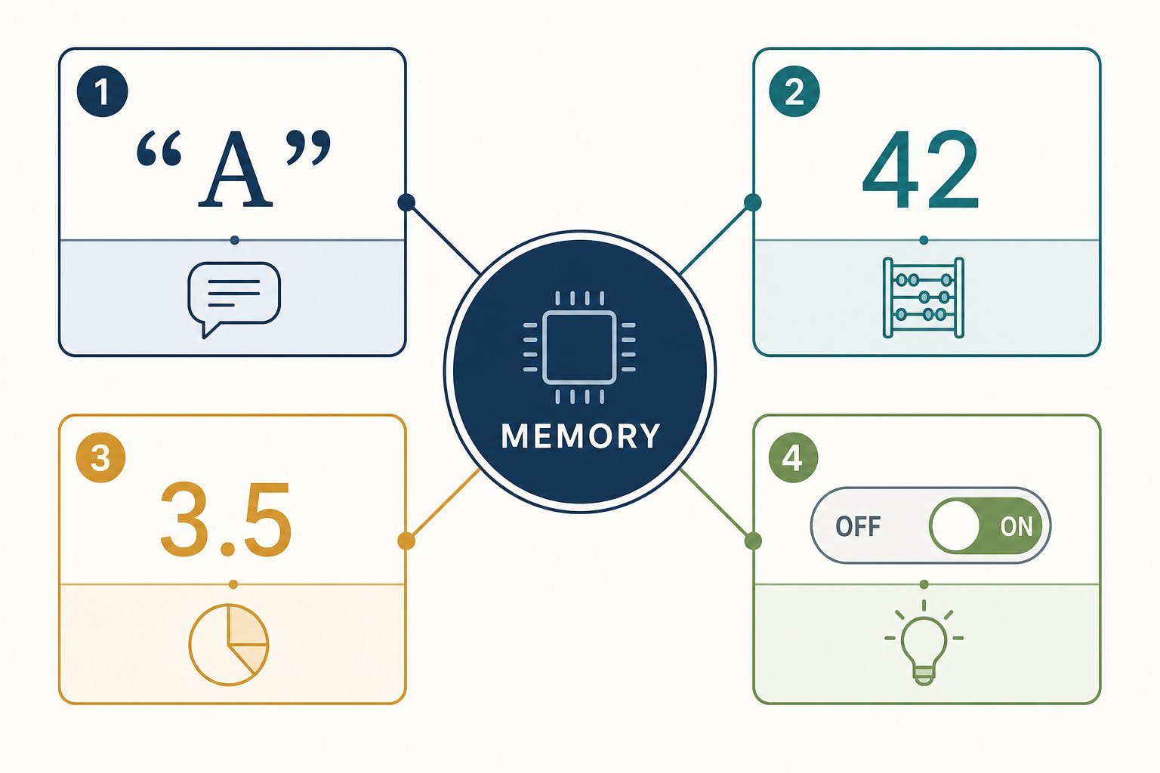
Legend: 1 = str stores text. 2 = int stores whole numbers. 3 = float stores decimal numbers. 4 = bool stores True or False.
OUR MISSION · Sort our values
A profile needs a name, age, height and learning status. These values are different kinds of data.
What we know: Variables give values names.
What we need: A way to identify each kind of value. • Rules for what each kind can do.
PAUSE & THINK
Are 12 and "12" the same value?
Answer: No. 12 is a number we can add. "12" is text made of two characters.

A type is a value’s category
A data type tells Python what kind of value it has. The type also tells Python which operations make sense.
Four types to begin with
str means string, which is text. int means integer, which is a whole number. float is a number with a decimal point. bool is either True or False.
The type belongs to the value. A variable name can later refer to a value of another type. This is called dynamic typing. Python tracks the type while the program runs.

The same symbol can mean a different operation
For integers, 3 + 4 means number addition and produces 7. For strings, "3" + "4" means joining text and produces "34". Type gives the + symbol enough context to choose the operation.
Type is a safety clue
A label saying “paint” changes how we handle a tin. A type gives Python a similar clue. It prevents unclear requests such as adding the number 1 directly to the text "two".
When types do not match our intention, Python stops with an error instead of silently inventing an answer.

Input → Process → Output
Values  "Asha", 12, 1.52, True | Python  keeps each type | Safe operations  join text, add numbers, test truth

Plan before we type
PROGRAM BLUEPRINT
Purpose: Store a small learner profile.
Input: Text, a whole number, a decimal and a truth value.
Processing: Python stores each value with its type.
Output: The type of name and next year’s age.
Files: types.py

The code
types.py
1 name = "Asha"
2 age = 12
3 height = 1.52
4 is_learning = True
5 print(type(name))
6 print(age + 1)

Program run: every step
types.py
1 name = "Asha"
2 age = 12
3 height = 1.52
4 is_learning = True
5 print(type(name))
6 print(age + 1)
1. Store text (line 1)
Quotes make Asha a string, or str.
Memory: name = "Asha" (str)
2. Store a whole number (line 2)
12 has no quotes and no decimal point, so it is an int.
Memory: name = "Asha" (str), age = 12 (int)
3. Store a decimal (line 3)
1.52 has a decimal point, so it is a float.
Memory: age = 12 (int), height = 1.52 (float)
4. Store truth (line 4)
True is a bool. Its capital T matters.
Memory: height = 1.52 (float), is_learning = True (bool)
5. Inspect a type (line 5)
type(name) reports that name holds a string.
Memory: name = "Asha" (str)
Console: <class 'str'>
6. Add integers (line 6)
age is an int, so Python can add 1 and print 13.
Memory: age = 12 (int)
Console: <class 'str'> | 13

Expected output
Terminal
1 $ python types.py
2 <class 'str'>
3 13
THE AHA MOMENT
A value is more than the characters we see. Its type tells Python what the value means and which operations are allowed.

Convert only when your intention is clear
int("12") creates the integer 12 from numeric text. str(12) creates the string "12" from a number. Conversion is explicit: we tell Python exactly which meaning we want.

Try it yourself
- Create types.py and run it.
- Use type() on age, height and is_learning.
- Try print("12" + "1").
- Then try print(12 + 1) and compare the results.
- Try print(int("12") + 1) and explain why the answer changes.

Common mistakes and fixes
✗ true
Python booleans begin with a capital letter: True and False.
✗ "12" + 1
Python will not mix text and a number automatically. Convert one value first.
✗ height = 1,52
Python decimal numbers use a dot, not a comma.
MAKE A GUESS
What does this print?
prediction.py
1 print("3" + "4")
- A. 7
- B. 34
- C. An error
Answer: 34. Both values are strings. + joins strings, so the result is 34.
BUG HUNT
Which line causes a TypeError?
bug_hunt.py
1 tickets = "2"
2 total = tickets + 1
3 print(total)
Answer: line 2. Line 2 tries to add a string and an integer. Python needs an explicit conversion.

Check your understanding
1. Which type stores a whole number?
Answer: int stores whole numbers such as 0, 12 and -5.
2. What is a bool?
Answer: A truth value: True or False.
3. Why is "5" not an int?
Answer: Quotes make it a string.
4. What does dynamic typing mean here?
Answer: Python tracks types while the program runs, and one name can later refer to a value of another type.

Key takeaways
REMEMBER
- str stores text; int stores whole numbers.
- float stores decimal numbers; bool stores True or False.
- The type belongs to the value and controls valid operations.
- type(value) reports a value’s type.
- int() and str() perform explicit conversions.

Keep exploring
Python built-in types — https://docs.python.org/3/library/stdtypes.html
NEXT DISCOVERY · How does a reader give us a value?
Next, we use input() and learn why typed input begins as a string.

About the author
Akshat EBooks turns difficult technical ideas into visual, step-by-step journeys for complete beginners.

Keep learning
Keep guessing, running and checking.

