
SARVA GYANA KOSHAH BOOKS
The Treasury of All Knowledge
Zero to Agentic API Testing
The Modern Guide to Testing APIs with Postman, JavaScript and Newman
Standalone
Akshat Sinha
First Edition · 2026

Zero to Agentic API Testing
© 2026 by Akshat Sinha. All rights reserved.
Published by Sarva Gyana Koshah Books, a division of The Sinha Family Group.
No part of this publication may be reproduced, distributed, or transmitted in any form or by any means, including photocopying, recording, or other electronic or mechanical methods, without the prior written permission of the publisher, except for brief quotations in reviews.
Code and API examples are provided for educational and testing purposes. Ensure you have authorized permission before running automated test suites against any third party or production systems.
To every engineer and tester dedicated to making software reliable, transparent, and resilient in an increasingly automated world.

Acknowledgements
Gratitude to the open source creators of the HTTP, JSON, Postman, and Node.js testing communities whose tools empower modern developers.
To the readers of Sarva Gyana Koshah: your relentless curiosity drives this work forward.

Contents

In Microsoft Word, right-click this list and choose Update Field if page numbers are not visible.

Preface: Why API Testing is the Linchpin of Modern Software
Software no longer lives on an isolated computer. Every application you touch, from ordering groceries and booking flights to querying an AI assistant, is an orchestra of independent backend services exchanging messages across the globe.
The Invisible Nervous System
When you look at a building, you see the walls, windows, and doors. You do not see the electrical conduits, water pipes, or structural steel that keep the building alive and standing.
In modern software architecture, the user interface is just the paint on the walls. The APIs, Application Programming Interfaces, are the invisible plumbing and wiring that carry business logic, user identities, and financial transactions.
If the user interface flickers, a user experiences a minor annoyance. If an API breaks, entire businesses grind to a halt.

Why this book begins at Ground Zero
Too many guides jump straight into complex automation frameworks or command line scripts without first establishing what is actually happening on the wire. We refuse to take shortcuts. Whether you are a manual tester stepping into automation or an engineer learning backend contracts, this book builds your mental model from first principles.
From Human Interfaces to Automated Systems
For decades, APIs were consumed by human built frontend apps. Today, automated pipelines and autonomous systems discover and execute APIs to complete complex workflows.
An API with loose validation or brittle status codes might survive human clicks, but automated systems will fail or trigger unexpected loops. Testing APIs is about building reliable, verified contracts.

Key takeaways
REMEMBER
- APIs are the contractual nervous system of modern software architecture.
- Understanding HTTP and wire level contracts prevents fragile, brittle automation.
- Testing APIs at the service layer yields the highest speed, stability, and return on investment.
- Automated systems demand high schema precision, error resilience, and idempotency.

Keep exploring
The Testing Pyramid by Martin Fowler — https://martinfowler.com/articles/practical-test-pyramid.html
IETF RFC 9110: HTTP Semantics Overview — https://www.rfc-editor.org/rfc/rfc9110.html

How to use this book
Read the opening mission to understand the real world software problem we are diagnosing.
Study the complete network wire: examine the HTTP method, resource path, headers, request payload, and server response codes.
Attempt every prediction before checking the verified outcome: write down your predicted status code, response body, and server state in the provided exercise spaces.
Follow the step by step setup commands to build your own runnable server and executable Postman test collection as you progress through each chapter.
Compare your observations with the recorded terminal transcripts, wire captures, and troubleshooting recovery checks.

Chapter 1: Understanding APIs from First Principles
The restaurant analogy, the five core operations, building your own minimal server, and tasting REST, SOAP, and GraphQL.
MISSION BRIEFING & CHAPTER ROADMAP
MISSION 1 · PHASE 1 OF 3: WIRE FOUNDATIONS AND FIRST PRINCIPLES: Global Open Data and Web Wire Audit
CRISIS SCENARIO: The Apex Campus Launch Crisis: When the Frontend Lost Its Voice
Context: On the eve of university orientation, the student mobile application failed to display campus data. The triage war room discovered a silent disconnect between client UI code and backend services. To resolve the crisis and establish lasting quality gates, we must inspect the wire from first principles, construct a minimal server, and audit every core HTTP operation.
Operational Target: Build a runnable server from scratch, execute all five CRUD operations, and verify payload contracts across REST, SOAP, and GraphQL.

WE WILL ACHIEVE: Build and run a minimal API server from scratch and verify every core HTTP operation over the wire.
HOW WE WILL DO IT: Assembling a runnable Express server step by step, executing POST, GET, PUT, PATCH, and DELETE, and comparing REST, SOAP, and GraphQL using the same book inquiry.
WHAT YOU WILL CARRY FORWARD: The assembled runnable server.js file and the foundational mental model of an HTTP request and response pair.

The Night Akshay and Sameer Entered the War Room
It is 8:14 PM on the eve of campus wide orientation at Apex University. Inside the grand stone pillared mandapa hall, carved Dravidian granite pillars and delicate Nagara stone jali lattice screens frame the bustling engineering command center. Brass lamps cast a warm glow across ancient stone archways while student registration queues begin stalling. Suddenly, the campus transit tracking system goes completely dark. A glowing stone alert tablet on a carved heritage plinth flashes the emergency warning: CAMPUS TRANSIT OFFLINE.
ARCHITECTURE · The Crisis: Campus Transit Drops Offline
INCIDENT TIMELINE: 8:14 PM · The Crisis: Campus Transit Drops Offline
Orientation eve transit tracking vanishes from the student portal moments before arriving shuttles reach campus gates. In the quiet heritage hall, the glowing tablet confirms the outage.
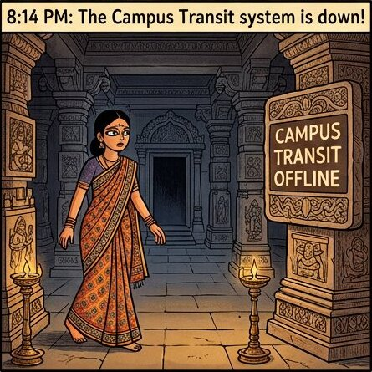
Figure 1.0A: The Outage at 8:14 PM. Orientation transit tracking vanishes across campus moments before student arrival.
1 Orientation Eve Emergency: Real time bus telemetry stops responding as thousands of students arrive.
2 The Heritage Command Hall: Dravidian granite pillars and Nagara pierced stone screens frame the central triage center.
3 The First Observer: Akshay walks into the room as the stone tablet flashes the alert.
Tension across the room erupts immediately. Mobile Lead and Backend Lead stand opposite each other across a carved teakwood table, pointing fingers in furious deadlock. The mobile lead waves a smartphone showing a blank loading spinner and shouts that the backend service is dead and returning nothing. The backend lead pushes back instantly, insisting that database clusters are healthy, server CPU is under twelve percent, and the fault lies entirely within mobile client rendering. Both leads are convinced they are right because each team inspects only their own screen.
ARCHITECTURE · The Standoff: Client versus Backend
THE ARCHITECTURAL IMPASSE: 8:17 PM · The Standoff: Client versus Backend
Under carved Dravidian beams beside a Nagara jali window, mobile and backend engineering leads argue across the table. Each lead points to local metrics while the system remains broken.
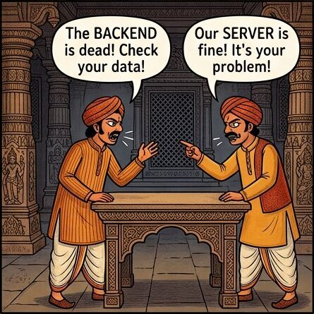
Figure 1.0B: The Standoff at 8:17 PM. Mobile and backend leads debate across the carved stone table, trapped by local perspectives.
1 The Client Perspective: The mobile screen shows an error, so mobile engineers conclude the server crashed.
2 The Server Perspective: Database CPU is low and server health checks succeed, so backend engineers blame client rendering.
3 The Blind Spot: Arguing over symptoms without inspecting what actually passes between the two machines.
Why are both engineering leads deadlocked? Because the real failure is invisible to both of them. Between the mobile device in a student hand and the server clusters in the data center lies the physical transport wire. Deep within conduits running beneath the ancient carved stone flooring, data packets travel between client and server. In the middle of this conduit, an unhandled parameter format drops packets mid flight. The database never crashed, and the mobile UI layout code was intact. But because neither engineer inspected the wire itself, the failure escaped notice.
ARCHITECTURE · The Invisible Wire: Where Network Packets Live and Die
THE ROOT REALITY: 8:21 PM · The Invisible Wire: Where Network Packets Live and Die
A cross section beneath the carved stone floor reveals the transport conduit. While engineers debate above, network packets drop silently along the wire.

Figure 1.0C: The Invisible Wire at 8:21 PM. Packets fail in transit across the physical transport wire while both teams inspect only their own screens.
1 The Transport Conduit: Data packets travel through physical network wires connecting client and server.
2 The Silent Failure: A malformed request or dropped packet causes the mobile client to wait forever.
3 The Wire Truth: System truth does not live in client UI or database CPU; it lives on the wire.
Akshay realizes he cannot solve the crisis by joining the surface debate. Beside him stands Sameer, the principal architect, who smiles calmly: "When two screens disagree, Akshay, truth lives only on the wire. But you cannot audit what you do not understand from first principles. Sit down, open your terminal, and assemble your own minimal API server." Akshay pulls up a carved wooden stool in a quiet stone alcove beside an intricate Nagara jali window, sets his laptop on a low teakwood table, and opens a clean terminal window. He types his first command: mkdir campus_api. Under Sameer guidance, Akshay begins constructing an API server from scratch.
ARCHITECTURE · The Foundation: Building the API from Scratch
FIRST PRINCIPLES: 8:25 PM · The Foundation: Building the API from Scratch
Sitting peacefully in a quiet stone alcove beside a carved Nagara jali window, Akshay opens a laptop terminal under Sameer guidance to construct an API server from first principles.

Figure 1.0D: First Principles at 8:25 PM. Constructing an API server from scratch gives Akshay complete command over every network packet on the wire.
1 The Strategic Choice: Step away from surface speculation and learn client server mechanics directly.
2 The First Command: Initializing a fresh workspace with mkdir campus_api in the terminal.
3 The Path Ahead: Building a minimal server gives Akshay the diagnostic power to resolve distributed outages.

Step 1: The Core Mental Model: What is an API?
Every day you tap buttons on your smartphone: you order food on a delivery app, check the weather forecast, or book a cab. But your phone does not store the global weather database, and it certainly does not store the restaurant kitchen inventory. Your phone is a client, and the computer holding the data miles away in a data center is the server.
How do these two computers talk to each other? They communicate through an API, which stands for Application Programming Interface. In simple English, an API is a digital messenger that takes your request to the server, tells the server what you want, and brings back the reply.
ARCHITECTURE · The Restaurant Analogy: Customer, Waiter, and Kitchen Backend
CLIENT SERVER ARCHITECTURE · The Restaurant Analogy: Customer, Waiter, and Kitchen Backend
Imagine dining in a restaurant. You are the customer sitting at the table. The kitchen is the backend system with all the ingredients and cooking equipment. You cannot walk into the kitchen and cook food yourself. Instead, the waiter takes your order, brings it to the chef, and returns with your meal.
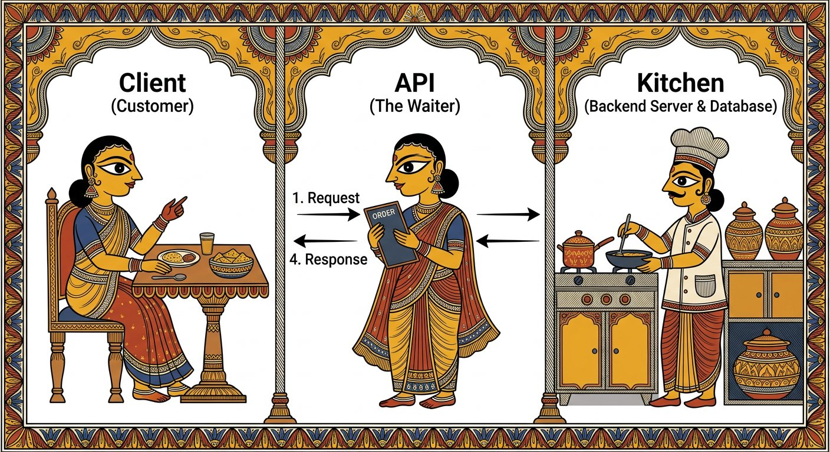
The restaurant mental model: The client asks under agreed rules, and the server answers.
1 The Customer (Client App): Sits in the dining room, browses the menu, and decides what data to request.
2 The Waiter (API Messenger): Delivers your order to the kitchen and brings back your prepared food.
3 The Kitchen (Backend Server): Stores all raw ingredients and processes business logic securely behind the counter.
ARCHITECTURE · The Frontend and Backend Bridge: How Modern Applications Communicate
ENTERPRISE ARCHITECTURE · The Frontend and Backend Bridge: How Modern Applications Communicate
In enterprise software, the frontend client application (iOS, Android, React Web) never connects directly to database servers. Instead, it dispatches structured HTTP requests with JSON contracts across the network wire to an API gateway and backend service.
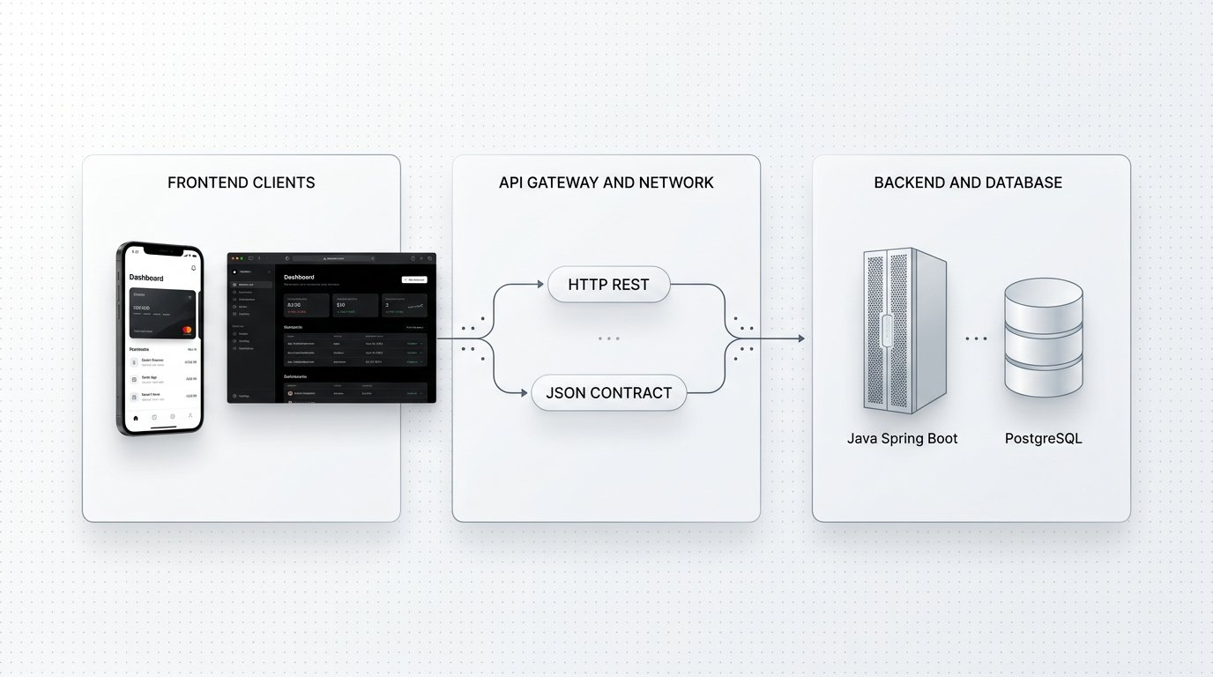
The API bridge: Decoupling user interfaces from backend database clusters across the network wire.
1 Frontend Clients: Mobile applications and web browsers rendering UI components.
2 API Gateway and Network Wire: The HTTP communication layer transmitting standardized JSON payloads.
3 Backend and Database: Enterprise services executing business logic and persisting state to database clusters.
DEFINITION · API (Application Programming Interface)
A structured set of rules and protocols that lets two software applications communicate and exchange data securely without exposing internal database credentials or implementation details.
Example: A mobile library app requesting a list of available textbooks from the campus catalog server.
Distinguishing Local APIs from Network Web Services
A common point of confusion for apprentice engineers is the relationship between an API and a Web Service:
PILLAR 1: Category 1: Local In Process APIs · Functions Calling Functions in RAM
When you call Math.sqrt(16) in JavaScript, or use a spreadsheet library in Java or Python, or use Selenium to drive a local browser driver, you are using an API. Both software components run inside the exact same operating system process in system RAM. Function execution takes two nanoseconds, uses direct memory pointers, and requires zero internet connection.
• Execution Environment: Same physical computer, same CPU process, shared memory RAM.
• Latency and Reliability: Instantaneous memory access; zero dropped network packets.
• Transport Requirement: No network socket, no HTTP protocol, and no internet connection needed.
PILLAR 2: Category 2: Out of Process Web Services · Two Disconnected Computers Communicating via HTTP
When a student opens the transit app on their smartphone, the mobile code runs on an iPhone in their pocket. The transit database runs on an enterprise server thousands of miles away in a cloud data center. These two computers share zero memory. Memory pointers cannot travel through the air. They must communicate over a physical network cable using the HTTP protocol.
• Execution Environment: Two separate machines separated by physical distance.
• Latency and Reliability: Network packets travel across switches and routers; connections can drop or time out.
• The Golden Rule: All Web Services are APIs, but not all APIs are Web Services.
Martin Fowler First Law of Distributed Object Design
Martin Fowler famously documented the First Law of Distributed Object Design: "Do not distribute your objects unless you have to."
Why? Because in local memory, a function call is fast, predictable, and virtually never fails due to physical distance. But the instant you cross a network wire, latency multiplies by millions of times, connections can fail, and objects cannot be passed as live memory references.
To cross the wire, live objects must be disassembled into raw binary streams, transmitted over physical network cables, and reassembled on the other end. That is why we need standardized protocols like HTTP and stream deserializers at the server boundary.
The Format Evolution: Why REST and JSON Won Over SOAP XML
Before building our server, understand why modern web services communicate using JSON instead of legacy XML:
PILLAR 1: Era 1: The SOAP XML Era · Heavy XML Envelopes and Rigid Schemas
In the early days of web services, systems communicated using SOAP (Simple Object Access Protocol). Every message was enclosed inside a massive XML envelope with complex namespaces and rigid WSDL schema contracts. A request asking for a simple book title required hundreds of bytes of XML overhead.
• Heavy Payload: Huge XML envelopes consumed high network bandwidth.
• Mobile Barrier: When smartphones and cellular networks arrived, parsing heavy XML drained mobile battery and CPU.
• Rigid Tooling: Required complex XML parsers and code generators.
PILLAR 2: Era 2: The REST and JSON Revolution · Lightweight Key Value Data over Standard HTTP Verbs
Roy Fielding defined REST (Representational State Transfer) to leverage the native strengths of HTTP. Instead of wrapping everything in heavy XML envelopes, REST treats data as URL resources and uses JSON (JavaScript Object Notation). JSON represents data as clean key value pairs that parse natively in JavaScript and web browsers with seventy percent less overhead.
• Lightweight and Fast: Minimal payload size saves mobile battery and cellular data.
• Browser Native: Parses directly into native JavaScript objects with JSON.parse().
• Human Readable: Clean curly braces and square brackets that developers can inspect without headaches.
Before we touch network protocols, look at how data travels. In modern web APIs, data is represented in JSON (JavaScript Object Notation). A single record is wrapped in curly braces like {"id": 1, "title": "Clean Architecture", "author": "Robert Martin"}. When a server holds multiple records, it groups them inside square brackets as a list: [{ ... }]. Now let us build a real program that serves this data.

Step 2: Assembling Your First API Server Step by Step in Code Chunks
When you are called into an engineering war room to debug a broken system, you cannot treat the API as a mysterious black box. You must understand how a web server is actually constructed from the inside out. Rather than pasting a whole file all at once, let us build server.js progressively in four clean code chunks, explaining the exact technical responsibility of each component as an engineer would expect.

Try it yourself
- Verify Node.js: Open your terminal and run node -v. Any modern LTS version (such as Node 18 or Node 20) is ready to go.
- Create a Project Folder: Run mkdir campus_api, then cd campus_api.
- Initialize Node.js: Run npm init -y to generate a default package.json configuration file.
- Install Express: Run npm install express to pull the lightweight web routing framework into your project node_modules.
- Create server.js: Create a new file named server.js in your campus_api directory. We will now assemble it chunk by chunk.
Step by Step Construction of server.js
Open an empty file named server.js in your campus_api directory and add these four code sections line by line:
CHUNK 1: CHUNK 1: APPLICATION SETUP · Importing Express and Instantiating the Application
Loads the Express web routing library from node_modules and invokes it to instantiate the central application object named app. In Node.js architecture, this app instance manages the HTTP request lifecycle, registers endpoint routes, and controls middleware pipelines.
server.js (Lines 1 to 3)
1 const express = require("express");
const app = express();
Rule: app is the central server instance coordinating all HTTP traffic.
CHUNK 2: CHUNK 2: STREAM PARSING · Configuring JSON Body Deserialization Middleware
In Node.js, incoming HTTP request bodies arrive as raw binary streams split across network TCP packets. Without a deserializer, req.body remains undefined. express.json() acts as stream parsing middleware: it intercepts incoming packets with Content-Type application/json, buffers the data chunks, parses the raw JSON text into structured JavaScript objects, and attaches the parsed object directly to req.body.
server.js (Lines 5 to 7)
1 // Middleware to parse incoming JSON payloads
app.use(express.json());
Rule: Without express.json(), req.body remains completely undefined when receiving JSON payloads.
CHUNK 3: CHUNK 3: IN MEMORY STATE · Allocating the In Memory Datastore and State Counter
Allocates an array directly inside system RAM (Node.js heap memory) seeded with an initial textbook object. Using in memory storage allows rapid local experimentation without external database drivers, and resets cleanly on server restart. The nextId counter advances monotonically from 2 to 3, 4, and beyond, ensuring every newly created resource receives an immutable, collision free ID.
server.js (Lines 9 to 13)
1 // In memory textbook records and monotonically advancing counter
let books = [
{ id: 1, title: "Clean Architecture", author: "Robert Martin" }
];
let nextId = 2;
Rule: In memory state enables zero database friction; monotonic counters prevent ID collisions.
CHUNK 4: CHUNK 4: PORT BINDING · Binding the Process to TCP Port 3000
Binds the Node.js process to TCP communication port 3000 on the local loopback interface (127.0.0.1). Think of your computer as a high rise residential building: localhost is the building address, and port 3000 is the specific apartment door where our catalog service accepts visitors.
server.js (Lines 15 to 18)
1 // Start the server listening on local port 3000
app.listen(3000, () => {
console.log("Book catalog server listening on http://localhost:3000");
});
Rule: Port 3000 is the dedicated communication doorway where our server receives requests.
Here is how your assembled server.js file looks with all four components united. Route handlers will be inserted right above app.listen:

The code
server.js
1 // server.js: Minimal API Server Starter
2 const express = require("express");
3 const app = express();
4
5 // Middleware to parse incoming JSON payloads
6 app.use(express.json());
7
8 // In memory textbook records and monotonically advancing counter
9 let books = [
10 { id: 1, title: "Clean Architecture", author: "Robert Martin" }
11 ];
12 let nextId = 2;
13
14 // =========================================
15 // ROUTE HANDLERS WILL BE ADDED HERE
16 // =========================================
17
18 // Start the server listening on local port 3000
19 app.listen(3000, () => {
20 console.log("Book catalog server listening on http://localhost:3000");
21 });
ARCHITECTURE · Architectural Flow of server.js: Data Journey through TCP and Memory
ARCHITECTURAL ANATOMY · Architectural Flow of server.js: Data Journey through TCP and Memory
Here is how your minimal server processes traffic under the hood: incoming TCP requests enter port 3000, pass through stream parsing middleware, mutate heap memory state, and return formatted JSON.
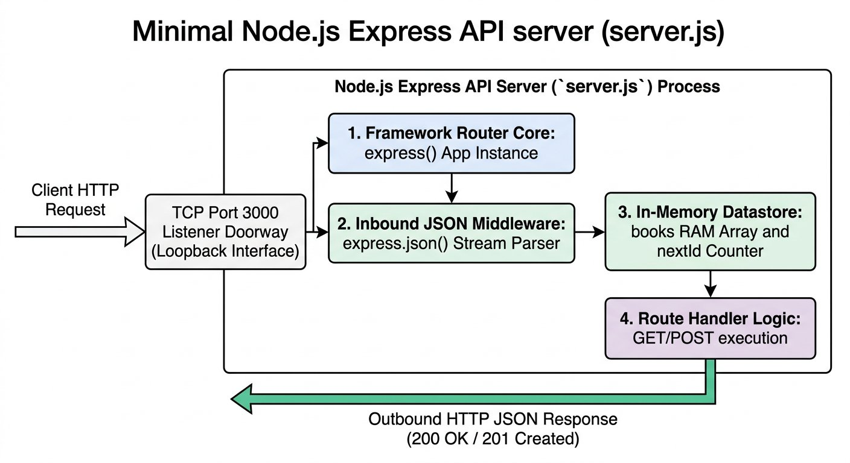
The Architectural Flow of server.js: Client Request entering Port 3000, passing through JSON Middleware, mutating Heap RAM State, and returning formatted JSON.
1 The Client Request: Dispatches an HTTP call over the network wire targeting localhost port 3000.
2 The Port 3000 Listener: Accepts the incoming TCP socket connection on your machine.
3 The JSON Middleware: Intercepts raw stream bytes and populates req.body with a structured JavaScript object.
4 The In Memory Store: Reads and writes textbook records directly inside Node.js heap memory.
Now start the server from your terminal by running the following command:

Expected output
Terminal
1 $ node server.js
2 Book catalog server listening on http://localhost:3000
Terminal Controls and Stopping the Server
• Stopping and Restarting: Whenever you add new route handlers to server.js in subsequent steps, switch to your terminal, press Ctrl+C to stop the process, and run node server.js again to load your changes.
• Connection Refused Check: If your API client ever displays "Error: connect ECONNREFUSED 127.0.0.1:3000", verify that node server.js is actively running in your terminal.
Akshay Assembles the In Memory API Server in the IDE
IDE WORKSPACE · NODE.JS SERVER SETUP
Akshay Assembles the In Memory API Server in the IDE

IDE File: undefined (undefined)
server.js
1 const express = require("express");
2 const app = express();
3
4 // Stream deserializer for incoming JSON
5 app.use(express.json());
6
7 let books = [
8 { id: 1, title: "Clean Architecture", author: "Robert Martin" }
9 ];
10 let nextId = 2;
11
12 app.listen(3000, () => {
13 console.log("Book catalog server listening on http://localhost:3000");
14 });
1. Explicit Input: Terminal command node server.js on local port 3000.
2. Wire & Logic Explanation: Binds process to TCP port 3000. express.json() intercepts incoming TCP byte streams, buffers the chunks, and deserializes JSON into req.body before route handlers execute.
3. Deterministic Output: Server listening on http://localhost:3000 with initial textbook in memory.
4. Senior Savior & Common Trap: Common Trap: Forgetting app.use(express.json()), causing req.body to be undefined on POST requests. Senior Savior: Always configure stream parsing middleware before defining route handlers.

Step 3: The Testing Dilemma: Why the Browser URL Bar Fails
With server.js listening on port 3000, Akshay wonders how to test his new server. His first instinct is natural: open Google Chrome, type http://localhost:3000/books into the browser address bar, and press Enter. The browser displays the initial textbook JSON record! Akshay turns to Sameer with excitement: "It works! Now let me test adding a second textbook using POST!"
Akshay looks closely at the Chrome address bar, but suddenly stops. Where does he type the HTTP method POST? Where does he set the header Content-Type: application/json? And where does he type the JSON request body containing the new book title and author? Akshay hits a fundamental barrier that every web developer encounters:
Why Web Browsers Cannot Test Real APIs
Web browser address bars were engineered for human document viewing, not API automation:
PILLAR 1: Limitation 1: Verb Lockout · The Address Bar Can Only Dispatch GET
When you press Enter in a browser address bar, the browser is hardwired to dispatch an HTTP GET request. You cannot instruct the address bar to send POST, PUT, PATCH, or DELETE.
• Creating resources with POST is impossible from a URL bar.
• Updating resources with PUT or PATCH cannot be performed.
• Deleting resources with DELETE cannot be triggered directly.
PILLAR 2: Limitation 2: Zero Payload Support · Cannot Attach JSON Request Bodies
A browser address bar has no text area for attaching a JSON payload. When creating a textbook record, the title and author data cannot be transmitted.
• No facility to paste JSON objects.
• Cannot set request metadata headers like Content-Type: application/json or auth tokens.
• Raw response data dumps on screen unformatted, causing eye strain.
To work around this limitation, developers historically relied on command line cURL in their terminal:

Expected output
Terminal
1 $ curl -X POST http://localhost:3000/books -H "Content-Type: application/json" -d '{"title": "The Pragmatic Programmer", "author": "David Thomas"}'
2 {"id":2,"title":"The Pragmatic Programmer","author":"David Thomas"}
While cURL successfully sends the POST request, typing escaped quotation marks in a black terminal window is clumsy, error prone, and difficult to organize into shared collections across an engineering team. Furthermore, scanning unformatted terminal text creates severe eye strain.
The Origin of Postman: Solving API Developer Pain
In 2012 in Bangalore, software engineer Abhinav Asthana was developing APIs at Yahoo and later at a startup. Every day, he wrestled with clumsy cURL commands and unformatted browser text dumps.
As Abhinav recalled in interviews: "You would scan through raw server output, and your eyes would start watering. I wanted all of this in a nice visual package." He created Postman as an open source project to solve this exact daily developer friction.
Postman provides a dedicated API Testing Workbench: a visual Request Builder where you can select any HTTP verb, set headers, and attach JSON bodies with zero escaped quotes, paired with a formatted, syntax highlighted Response Viewer.
Now, instead of struggling with browser address bars or command line curl flags, Akshay launches the API Testing Workbench to test all five server operations.

Step 4: Operation 1: Creating a Record with POST /books
Now let us add a new textbook to our catalog. In REST architecture, creating a new resource is performed using the HTTP POST method.
Adding the POST Handler to server.js
Insert this route handler into server.js directly above app.listen:
CHUNK 1: The Creation Handler · Assigning ID and Appending to Memory
Reads title and author from req.body, assigns nextId (which advances from 2 to 3), adds the object to the books array, and returns status 201 Created.
post-books-handler.js
1 app.post("/books", (req, res) => {
const newBook = { id: nextId++, title: req.body.title, author: req.body.author };
books.push(newBook);
res.status(201).json(newBook);
});
Rule: HTTP status 201 Created explicitly confirms a new resource was created.
Save server.js, press Ctrl+C in your terminal, and restart the server with node server.js. Now open your API testing workbench (such as Postman) and configure your request inputs: Method is POST, URL is http://localhost:3000/books, Header is Content-Type: application/json, and Body is set to raw JSON: {"title": "The Pragmatic Programmer", "author": "David Thomas"}.
IMAGINE & PREDICT BEFORE SENDING
When you dispatch this POST request carrying the new textbook data, what status code and ID will the server return?
A. HTTP status 201 Created with ID 2 and the newly created book object: { "id": 2, "title": "The Pragmatic Programmer", "author": "David Thomas" }
B. HTTP status 200 OK with the entire library array
C. HTTP status 400 Bad Request because ID was omitted from the request body
D. HTTP status 204 No Content
Actual Output (Recorded Wire Response for POST /books): Resource created! The server took nextId (2), attached it to the incoming title and author, pushed it into the array, incremented nextId to 3, and returned HTTP 201 Created.
Live Recorded Exchange: POST /books (Create New Record)
POST http://localhost:3000/books
Status: 201 Created · Time: 24 ms · Size: 76 B
Response Body:
response.json
1 {
2 "id": 2,
3 "title": "The Pragmatic Programmer",
4 "author": "David Thomas"
5 }
Akshay Creates a Textbook Record in the API Testing App
API TESTING WORKBENCH · OPERATION 1 POST
Akshay Creates a Textbook Record in the API Testing App

API Request: POST http://localhost:3000/books
Live Response: undefined
1. Explicit Input: POST /books with JSON body carrying title and author.
2. Wire & Logic Explanation: Server increments monotonic counter nextId from 2 to 3, assigns immutable ID 2, appends object to RAM array, and responds with HTTP status 201 Created.
3. Deterministic Output: HTTP status 201 Created with persisted textbook object.
4. Senior Savior & Common Trap: Common Trap: Returning status 200 OK for resource creation instead of 201 Created. Senior Savior: Use status 201 Created to signal successful persistence.
ARCHITECTURE · HTTP POST Creation Flow: From Request to In Memory Persistence
OPERATION 1 WIRE FLOW · HTTP POST Creation Flow: From Request to In Memory Persistence
When a client dispatches a POST request with a JSON payload, Express streams the bytes through middleware, allocates an incremented ID, stores the record in RAM heap memory, and returns HTTP 201 Created.
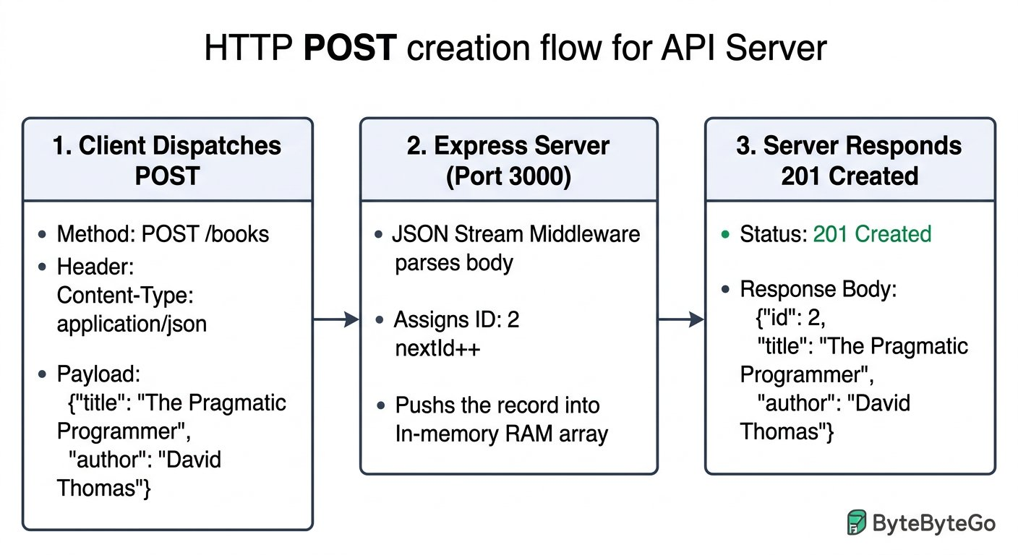
The POST creation flow: Moving data from client request into server memory and returning 201 Created.
1 Client Dispatches POST: Sends method POST /books with Content-Type application/json and raw payload.
2 Express Server Processing: Middleware deserializes JSON, assigns nextId 2, and pushes object into memory.
3 Server Responds 201 Created: Transmits the freshly created record back to the client as confirmation.
First Recovery Check: Connection Refused
If your API tool displays "Error: connect ECONNREFUSED 127.0.0.1:3000", do not panic! This message simply means no program is listening on port 3000.
Check your terminal window: did you forget to run node server.js? Make sure the terminal shows "Book catalog server listening" before sending requests.

Step 5: Operation 2: Reading Records with GET /books
Now let us verify what is stored in server memory based on the record we created in Step 4! In REST architecture, retrieving data without altering server state is performed using the HTTP GET method.
Adding the GET Handler to server.js
Insert this small route handler into server.js below your POST handler:
CHUNK 1: The Route Definition · Replying with the Book List
When a client asks for GET /books, the server responds with HTTP status 200 OK and transmits the books array as JSON.
get-books-handler.js
1 app.get("/books", (req, res) => {
res.status(200).json(books);
});
Rule: res.status(200).json(...) sets the success status code and formats data as JSON.
Save server.js, press Ctrl+C in your terminal, and restart the server with node server.js. Now open your API testing workbench and configure your request inputs: Method is GET, URL is http://localhost:3000/books, and Body is left completely empty.
IMAGINE & PREDICT BEFORE SENDING
When you dispatch this GET request to http://localhost:3000/books based on the book created in Step 4, what status code, payload structure, and book count do you expect to see?
A. HTTP status 200 OK with a JSON array containing both the initial book and the new book created in Step 4: [{ id: 1, title: "Clean Architecture", author: "Robert Martin" }, { id: 2, title: "The Pragmatic Programmer", author: "David Thomas" }]
B. HTTP status 201 Created with a single book object
C. HTTP status 404 Not Found because the server is empty
D. HTTP status 500 Server Error because database connection was not established
Actual Output (Recorded Wire Response for GET /books): Success confirmed! The server finds the books array in RAM, wraps it in status 200 OK, and returns both records inside an array bracket, directly verifying the record created in Step 4!
Live Recorded Exchange: GET /books (Read All Records)
GET http://localhost:3000/books
Status: 200 OK · Time: 18 ms · Size: 128 B
Response Body:
response.json
1 [
2 {
3 "id": 1,
4 "title": "Clean Architecture",
5 "author": "Robert Martin"
6 },
7 {
8 "id": 2,
9 "title": "The Pragmatic Programmer",
10 "author": "David Thomas"
11 }
12 ]
Akshay Verifies In Memory State with GET /books
API TESTING WORKBENCH · OPERATION 2 GET
Akshay Verifies In Memory State with GET /books

API Request: GET http://localhost:3000/books
Live Response: undefined
1. Explicit Input: GET /books with empty body.
2. Wire & Logic Explanation: Server reads system RAM array without mutation, wraps it in status 200 OK, and serializes array to JSON.
3. Deterministic Output: HTTP status 200 OK with two item textbook array.
4. Senior Savior & Common Trap: Common Trap: Sending a request body with GET. Senior Savior: GET requests must never transmit a payload; all query criteria belong in URL query parameters.
Objects versus Lists: Spotting the Data Structure Shift
Notice the structural difference: when you sent POST /books in Step 4, you transmitted a single JSON object wrapped in curly braces { ... } because you were creating one individual record.
When you dispatched GET /books in Step 5, the server returned an array [ ... ] holding both Book 1 and Book 2! An array groups multiple items; an object defines a single item.
ARCHITECTURE · HTTP GET Retrieval Flow: Reading Records from RAM Memory
OPERATION 2 WIRE FLOW · HTTP GET Retrieval Flow: Reading Records from RAM Memory
Retrieving records using HTTP GET is a safe, read only operation. No body is transmitted with the request. The server reads the existing books array from RAM heap memory and returns status 200 OK with both book records.
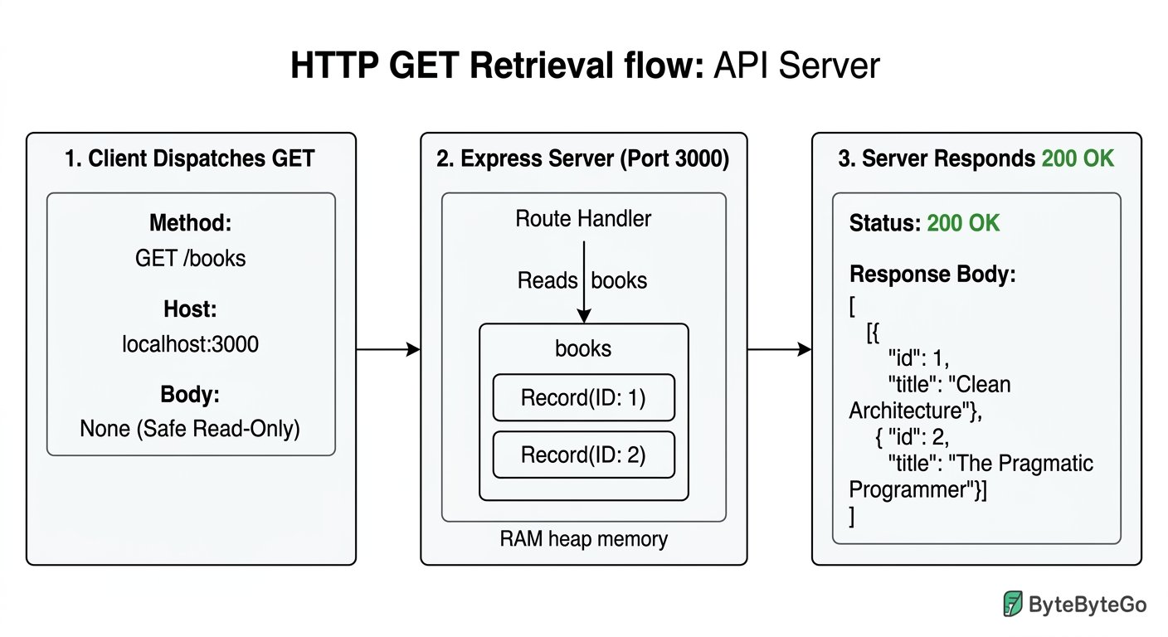
The GET retrieval flow: Safe read operation returning the accumulated catalog in a JSON array.
1 Client Dispatches GET: Requests resource collection /books with no body payload.
2 Express Server Processing: Route handler accesses the in memory books array without modifying state.
3 Server Responds 200 OK: Serializes the two item array and returns it to the client.

Step 6: Operations 3, 4, and 5: PUT, PATCH, and DELETE (Replacement, Delta, and Removal)
Now let us master the remaining three operations: PUT, PATCH, and DELETE. Each operation solves a distinct data modification challenge.

Operation 3: Full Record Replacement with PUT /books/:id
Suppose we need to update record 1 with a new title and author. In REST architecture, PUT represents complete resource replacement. The :id in the URL path is a parameter specifying which record to replace:

The code
put-handler.js
1 // Full replacement (PUT /books/:id)
2 app.put("/books/:id", (req, res) => {
3 const id = Number(req.params.id);
4 const index = books.findIndex(b => b.id === id);
5 if (index === -1) return res.status(404).json({ error: "Book not found" });
6 books[index] = { id: id, title: req.body.title, author: req.body.author };
7 res.status(200).json(books[index]);
8 });
Notice that PUT replaces the entire object. If a client sends a PUT payload omitting the author, the author property becomes undefined! Let us replace Book 1 by sending PUT to http://localhost:3000/books/1 with payload: {"title": "Clean Code", "author": "Robert Martin"}:
Live Recorded Exchange: PUT /books/1 (Full Record Replacement)
PUT http://localhost:3000/books/1
Status: 200 OK · Time: 21 ms · Size: 56 B
Response Body:
response.json
1 {
2 "id": 1,
3 "title": "Clean Code",
4 "author": "Robert Martin"
5 }

Operation 4: Partial Modification with PATCH /books/:id
What if you only want to change the title of Book 1 without touching the author? With PUT, omitting the author wiped it out. This is why PATCH exists: PATCH applies a partial delta modification, updating only the specific fields supplied:

The code
patch-handler.js
1 // Partial modification (PATCH /books/:id)
2 app.patch("/books/:id", (req, res) => {
3 const id = Number(req.params.id);
4 const book = books.find(b => b.id === id);
5 if (!book) return res.status(404).json({ error: "Book not found" });
6 if (req.body.title !== undefined) book.title = req.body.title;
7 if (req.body.author !== undefined) book.author = req.body.author;
8 res.status(200).json(book);
9 });
Let us send a PATCH request to http://localhost:3000/books/1 with only the title: {"title": "Clean Craftsmanship"}. Notice the author is retained intact in server memory:
Live Recorded Exchange: PATCH /books/1 (Partial Delta Update)
PATCH http://localhost:3000/books/1
Status: 200 OK · Time: 19 ms · Size: 64 B
Response Body:
response.json
1 {
2 "id": 1,
3 "title": "Clean Craftsmanship",
4 "author": "Robert Martin"
5 }

Operation 5: Removing a Record with DELETE /books/:id
Finally, we want to remove a textbook from our catalog. In REST architecture, the HTTP DELETE verb purges the targeted resource:

The code
delete-handler.js
1 // Delete a book (DELETE /books/:id)
2 app.delete("/books/:id", (req, res) => {
3 const id = Number(req.params.id);
4 const index = books.findIndex(b => b.id === id);
5 if (index === -1) return res.status(404).json({ error: "Book not found" });
6 books.splice(index, 1);
7 res.status(200).json({ deleted: id });
8 });
Let us dispatch DELETE to http://localhost:3000/books/1. The server purges the record and confirms with {"deleted": 1}:
Live Recorded Exchange: DELETE /books/1 (Remove Record)
DELETE http://localhost:3000/books/1
Status: 200 OK · Time: 15 ms · Size: 15 B
Response Body:
response.json
1 {
2 "deleted": 1
3 }
Now let us run a follow up GET /books request to verify the server data state after deletion:
Live Recorded Exchange: Verification GET /books (Proving Deletion)
GET http://localhost:3000/books
Status: 200 OK · Time: 14 ms · Size: 78 B
Response Body:
response.json
1 [
2 {
3 "id": 2,
4 "title": "The Pragmatic Programmer",
5 "author": "David Thomas"
6 }
7 ]
Monotonic ID Protection: Why Next Book Gets ID 3
Notice that Book 1 was deleted, leaving only Book 2 in the catalog.
If you now execute POST /books to add a third book, what ID will it receive? Because our server relies on nextId (which is now 3), the new record is assigned ID 3.
It does NOT reuse ID 1! Reusing old IDs is a dangerous anti pattern that corrupts historical audit logs and foreign keys in relational databases.

The Five Operations Compared: Safe and Idempotent Behaviors
Now that you have executed all five operations with your own hands, study how their behaviors compare. In API engineering, operations are classified along two core dimensions: Safe and Idempotent:

The Five Universal HTTP Operations
HTTP Method | Everyday Purpose | Payload Body? | Typical Status | Safe? | Idempotent?
GET | Read records without modifying state | No body sent | 200 OK | Yes (Read Only) | Yes
POST | Create a new resource | Requires JSON body | 201 Created | No (Creates state) | No (Repeated POST creates duplicates)
PUT | Completely replace target resource | Requires full body | 200 OK or 201 | No (Modifies state) | Yes (Repeated PUT yields identical state)
PATCH | Partially update selected fields | Requires partial body | 200 OK | No (Modifies state) | Usually Yes (when setting values)
DELETE | Purge target resource | No body needed | 200 OK or 204 | No (Deletes state) | Yes (Subsequent calls leave resource absent)
Understanding Safe vs Idempotent from Your Real Executions
• Safe: Calling GET /books five times in a row never changes the books stored on the server. Safe methods are strictly read only.
• Idempotent: If you send DELETE /books/1 once, the book is deleted. If you send DELETE /books/1 again, the book is still absent from the catalog. The server state remains identical. In contrast, sending POST /books ten times creates ten distinct book records in memory, which is why POST is not idempotent.
ARCHITECTURE · Comparing PUT, PATCH, and DELETE: Complete Replacement, Delta, and Removal
MUTATION COMPARISON · Comparing PUT, PATCH, and DELETE: Complete Replacement, Delta, and Removal
Study how the three data modification operations interact with server state: PUT replaces the whole record, PATCH mutates only specific fields, and DELETE purges the record entirely.
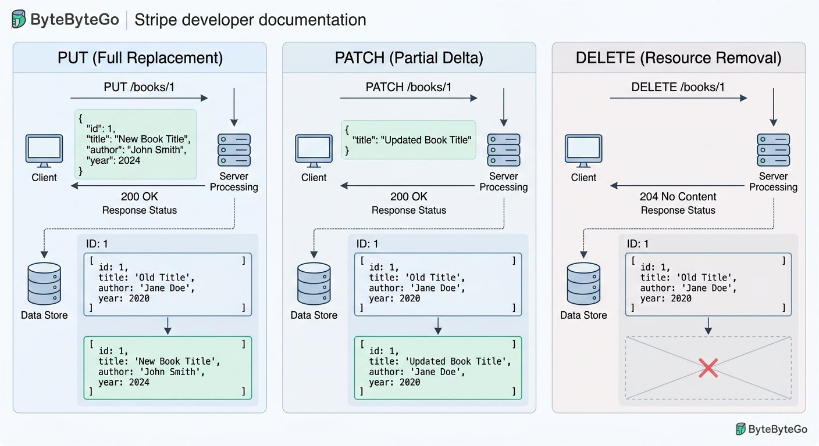
The three mutation verbs compared: Complete replacement with PUT, partial delta with PATCH, and resource purging with DELETE.
1 PUT (Full Replacement): Completely overwrites the existing record in memory with the supplied payload.
2 PATCH (Partial Delta): Modifies only the specified fields while preserving unmentioned fields like author.
3 DELETE (Resource Removal): Purges the target resource from system memory, returning confirmation status 200 or 204.

The Complete Assembled Server and Command Transcript
Here is our complete minimal API server with all five route handlers assembled into one file. Save this complete code as server.js in your project directory:

The code
server.js
1 // Complete Minimal API Server (server.js)
2 const express = require("express");
3 const app = express();
4 app.use(express.json());
5
6 let books = [
7 { id: 1, title: "Clean Architecture", author: "Robert Martin" }
8 ];
9 let nextId = 2;
10
11 // 1. GET /books: Read all books
12 app.get("/books", (req, res) => {
13 res.status(200).json(books);
14 });
15
16 // 2. POST /books: Create a new book
17 app.post("/books", (req, res) => {
18 const newBook = { id: nextId++, title: req.body.title, author: req.body.author };
19 books.push(newBook);
20 res.status(201).json(newBook);
21 });
22
23 // 3. PUT /books/:id: Full resource replacement
24 app.put("/books/:id", (req, res) => {
25 const id = Number(req.params.id);
26 const index = books.findIndex(b => b.id === id);
27 if (index === -1) return res.status(404).json({ error: "Book not found" });
28 books[index] = { id: id, title: req.body.title, author: req.body.author };
29 res.status(200).json(books[index]);
30 });
31
32 // 4. PATCH /books/:id: Partial delta update
33 app.patch("/books/:id", (req, res) => {
34 const id = Number(req.params.id);
35 const book = books.find(b => b.id === id);
36 if (!book) return res.status(404).json({ error: "Book not found" });
37 if (req.body.title !== undefined) book.title = req.body.title;
38 if (req.body.author !== undefined) book.author = req.body.author;
39 res.status(200).json(book);
40 });
41
42 // 5. DELETE /books/:id: Purge a record
43 app.delete("/books/:id", (req, res) => {
44 const id = Number(req.params.id);
45 const index = books.findIndex(b => b.id === id);
46 if (index === -1) return res.status(404).json({ error: "Book not found" });
47 books.splice(index, 1);
48 res.status(200).json({ deleted: id });
49 });
50
51 app.listen(3000, () => {
52 console.log("Book catalog server listening on http://localhost:3000");
53 });

Expected output
Terminal
1 $ Complete Five Operation Execution Transcript
2 $ node server.js
3 Book catalog server listening on http://localhost:3000
4
5 # 1. Read catalog (GET /books)
6 HTTP/1.1 200 OK : [{"id":1,"title":"Clean Architecture","author":"Robert Martin"}]
7
8 # 2. Add second book (POST /books)
9 HTTP/1.1 201 Created : {"id":2,"title":"The Pragmatic Programmer","author":"David Thomas"}
10
11 # 3. Replace book 1 (PUT /books/1)
12 HTTP/1.1 200 OK : {"id":1,"title":"Clean Code","author":"Robert Martin"}
13
14 # 4. Update title only (PATCH /books/1)
15 HTTP/1.1 200 OK : {"id":1,"title":"Clean Craftsmanship","author":"Robert Martin"}
16
17 # 5. Delete book 1 (DELETE /books/1)
18 HTTP/1.1 200 OK : {"deleted":1}
19
20 # Verification GET: Only book 2 remains
21 HTTP/1.1 200 OK : [{"id":2,"title":"The Pragmatic Programmer","author":"David Thomas"}]

Interactive Workbench: In Browser Simulation
For readers reviewing this chapter inside our interactive digital reading environment, you can also experiment dynamically with custom book titles, authors, and target IDs using the in browser simulation below:
In Browser Simulation: Five Handler Book Catalog API
An in-memory API demonstrates core HTTP operations: GET returns records, POST appends records, PUT replaces a record, and DELETE removes records.
Core Mechanics: Memory array serves as the transient database; each HTTP verb triggers a deterministic state transition.

Step 7: Deconstructing Both Sides of the Wire Exchange
When your computer talks to a server over the network, it dispatches an HTTP Request packet and receives an HTTP Response packet. Now let us deconstruct the exact bytes exchanged during our earlier POST request when adding Book 2:
ARCHITECTURE · Anatomy of an HTTP Message: Request and Response Packet Structure
PROTOCOL ANATOMY · Anatomy of an HTTP Message: Request and Response Packet Structure
Every network transaction consists of two halves: the client request specifying method, path, headers, and body, and the server response specifying status code, response headers, and returned data.
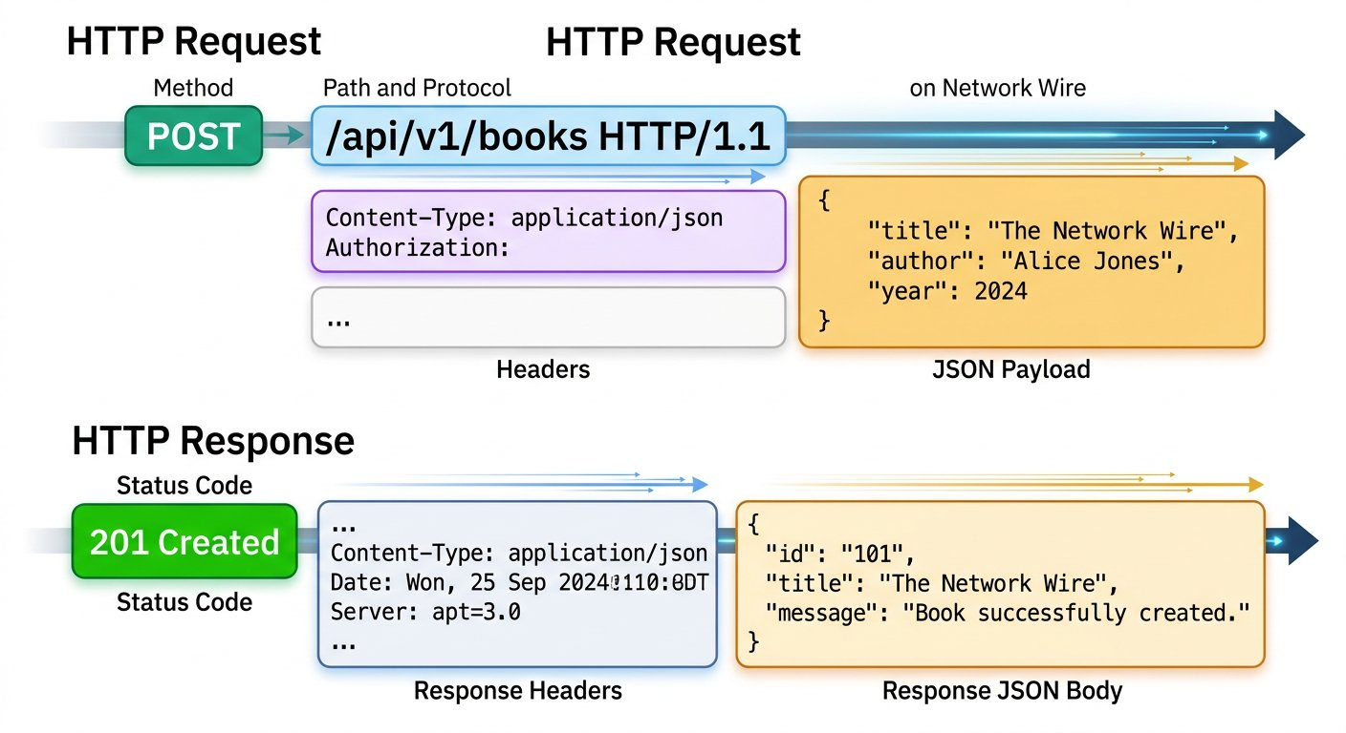
The four fundamental parts of every HTTP request and response.
1 Request Line: Specifies the HTTP verb, resource path (/books), and protocol version.
2 Request Headers: Metadata such as Content-Type telling the server that JSON payload is attached.
3 Request Body: The actual data payload transmitted to the server.
4 Status Line: The numerical status code (such as 201 Created) indicating transaction outcome.
Deconstructing the POST /books Wire Exchange
Inspect each component of the request and response from our earlier execution:
CHUNK 1: Part 1: The Request Line · Specifying Method, Path, and Host
The request line declares the HTTP method, resource path, protocol version, and target host.
request-line.http
1 POST /books HTTP/1.1
Host: localhost:3000
Rule: The method indicates desired action; the path indicates target resource.
CHUNK 2: Part 2: Request Headers & Body · Content Type and Outgoing Data
The Content-Type header informs the server that raw JSON text follows in the request body.
request-body.json
1 Content-Type: application/json
Accept: application/json
{
"title": "The Pragmatic Programmer",
"author": "David Thomas"
}
Rule: Always send Content-Type: application/json when transmitting JSON data.
CHUNK 3: Part 3: The Response Status Line · Server Transaction Result
The server acknowledges receipt and confirms a new resource was created in memory.
response-status.http
1 HTTP/1.1 201 Created
Rule: 2xx family indicates successful transaction completion.
CHUNK 4: Part 4: Response Headers & Body · Returned Data Payload
The server returns the freshly created book record complete with its assigned ID.
response-body.json
1 Content-Type: application/json; charset=utf-8
{
"id": 2,
"title": "The Pragmatic Programmer",
"author": "David Thomas"
}
Rule: The response body contains the structured data requested by the client.

Step 8: Tasting the Three Architectural Worlds: REST, SOAP, and GraphQL
Not all APIs look identical. In enterprise software, you will encounter three major architectural styles: REST, SOAP, and GraphQL. To understand how their shapes differ, let us first ask all three styles the exact same question: "Retrieve the title of book ID 1":
ARCHITECTURE · Comparing API Architectures: REST, SOAP, and GraphQL
ARCHITECTURAL STYLES · Comparing API Architectures: REST, SOAP, and GraphQL
REST treats data as unique URL resources formatted in lightweight JSON. SOAP packages requests in formal XML envelopes with rigid schemas. GraphQL exposes a single endpoint where clients request the exact fields they need.
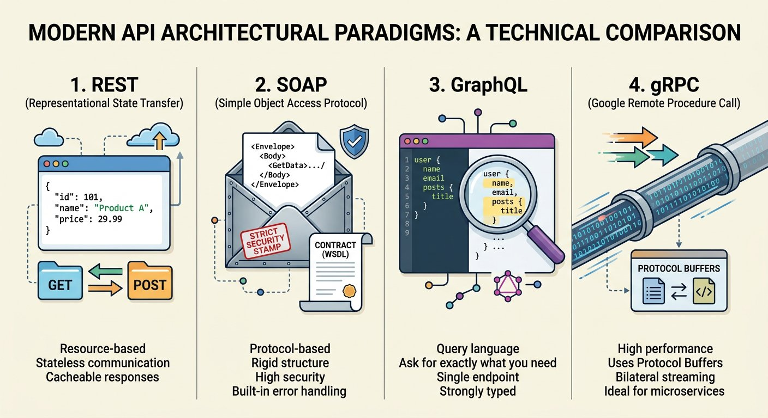
Three architectural styles answering the same inquiry.
1 REST (Representational State Transfer): Targets URL resources like /books/1 using standard HTTP verbs.
2 SOAP (Simple Object Access Protocol): Encloses method calls inside formal XML envelope structures.
3 GraphQL: Sends query documents to a single /graphql endpoint, selecting exact requested fields.
Asking the Same Question: Book ID 1 Across Three Protocols
Observe how the exact same data query is formatted in each architectural style:
CHUNK 1: Style 1: RESTful Query · Resource Centric REST Query
REST targets a specific URL resource path (/books/1) with the GET verb and returns lightweight JSON.
rest-query.http
1 GET /books/1 HTTP/1.1
Host: localhost:3000
Accept: application/json
// Response 200 OK
{
"id": 1,
"title": "Clean Architecture",
"author": "Robert Martin"
}
Rule: REST is resource oriented and leverages standard HTTP verbs and status codes.
CHUNK 2: Style 2: SOAP WebService (Hypothetical Contract) · XML Envelope Wrapper
SOAP wraps every request inside a formal XML Envelope and Body, dispatching via HTTP POST.
soap-envelope.xml
1 POST /BookService HTTP/1.1
Host: localhost:3000
Content-Type: application/soap+xml
<soap:Envelope xmlns:soap="http://www.w3.org/2003/05/soap-envelope">
<soap:Body>
<GetBookTitleRequest xmlns="http://campus.edu/books">
<bookId>1</bookId>
</GetBookTitleRequest>
</soap:Body>
</soap:Envelope>
Rule: SOAP is strict, protocol heavy, and relies exclusively on XML payloads.
CHUNK 3: Style 3: GraphQL Query (Hypothetical Contract) · Field Precise GraphQL Query
GraphQL sends a structured query document to /graphql asking for only the title property.
book-query.graphql
1 POST /graphql HTTP/1.1
Host: localhost:3000
Content-Type: application/json
{
"query": "query { book(id: 1) { title } }"
}
// Response 200 OK
{
"data": {
"book": { "title": "Clean Architecture" }
}
}
Rule: GraphQL prevents over fetching by returning only the exact properties requested.
Architectural Clarification: Conceptual Contracts vs Implemented Route
Notice an essential distinction: our minimal Node server implements the RESTful GET /books route.
The SOAP /BookService and GraphQL /graphql examples shown above are conceptual contract designs illustrating how different protocols structure the same request. Do not attempt to send SOAP or GraphQL packets to our five handler Express server on port 3000!
In Chapters 10 and 12, we will explore dedicated GraphQL and SOAP services in depth.

Public Protocol Spot Checks: Real Public SOAP and GraphQL Endpoints
To prove that SOAP and GraphQL are real protocols used in production today, here are live public services responding on the internet. Note that each public service manages its own distinct dataset:
Public SOAP WebService: DataAccess Number Conversion
POST https://www.dataaccess.com/webservicesserver/NumberConversion.wso
Status: 200 OK · Time: 215 ms · Size: 412 B
Response Body:
response.json
1 <?xml version="1.0" encoding="utf-8"?>
2 <soap:Envelope xmlns:soap="http://www.w3.org/2003/05/soap-envelope">
3 <soap:Body>
4 <m:NumberToWordsResponse xmlns:m="http://www.dataaccess.com/webservicesserver/">
5 <m:NumberToWordsResult>five hundred </m:NumberToWordsResult>
6 </m:NumberToWordsResponse>
7 </soap:Body>
8 </soap:Envelope>
Assertions Verified:
✓ Status code is 200 OK
✓ SOAP body contains written English words
Real World Wire Quirk: The Trailing Space
Inspect the raw XML response from the public DataAccess SOAP service above. Notice that it returned "five hundred " with a trailing space inside the tag!
This real world quirk demonstrates why automated quality engineers exist: real production services often have subtle formatting oddities that unit tests miss. In Chapter 12, we write assertions using trim() to handle this exact quirk defensively.
Public GraphQL Service: Rick and Morty Character Query
POST https://rickandmortyapi.com/graphql
Status: 200 OK · Time: 180 ms · Size: 210 B
Response Body:
response.json
1 {
2 "data": {
3 "character": {
4 "name": "Rick Sanchez",
5 "status": "Alive",
6 "species": "Human"
7 }
8 }
9 }
Assertions Verified:
✓ Status code is 200 OK
✓ Response contains data object without errors
✓ Character name attribute matches Rick Sanchez

Step 9: Prove Readiness and Hand Off
Before moving onward, test your mastery with this hands on exercise:

Try it yourself
- 1. Restart your server: Press Ctrl+C in your terminal and run node server.js.
- 2. Verify catalog: Send GET http://localhost:3000/books. Confirm it returns status 200 OK with Book 1.
- 3. Add a book: Send POST http://localhost:3000/books with title "Modern Operating Systems" and author "Andrew Tanenbaum". Confirm status 201 Created and ID 2.
- 4. Partially update: Send PATCH http://localhost:3000/books/2 with title "Modern Distributed Systems". Confirm author is retained.
- 5. Delete book: Send DELETE http://localhost:3000/books/1. Verify subsequent GET returns only Book 2.

Step 10: Why We Test at the API Layer: The Testing Pyramid
Why do mature engineering organizations invest heavily in API test automation instead of testing exclusively through mobile screens and web browsers?
ARCHITECTURE · The Testing Pyramid: Speed, Cost, and Isolation across Tiers
TESTING ARCHITECTURE · The Testing Pyramid: Speed, Cost, and Isolation across Tiers
Testing exclusively through the user interface is slow, fragile, and prone to false alarms caused by animation lags. Testing at the API layer allows engineers to validate business logic directly over the wire in milliseconds.
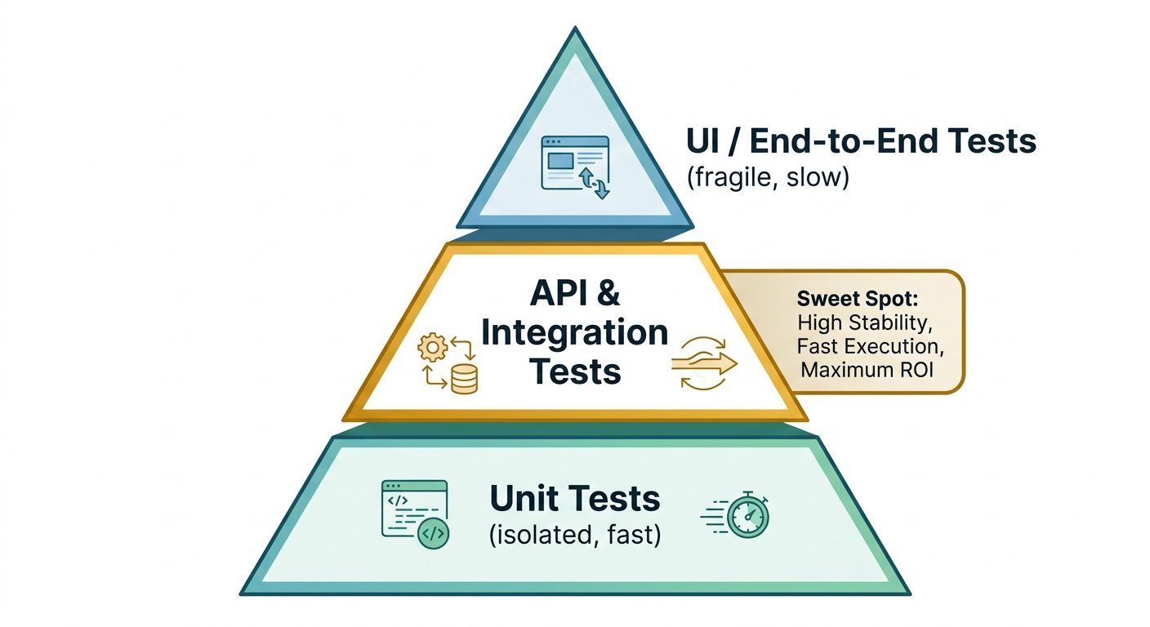
The Testing Pyramid: Balancing fast unit checks, robust API contract tests, and focused UI checks.
1 UI Tests (Top Layer): Slowest and most expensive. High maintenance because UI layout changes break scripts.
2 API Service Layer (Middle Layer): Fast, deterministic, and verifies business rules directly across the wire without browser rendering delays.
3 Unit Tests (Base Layer): Fastest execution testing isolated functions in code.

Step 11: Sourced Architecture Finding: Why Safe Methods Must Not Alter State
Architectural Standard Finding · March 2004
W3C Technical Architecture Group (TAG) Finding on URIs and Safe HTTP Operations
https://www.w3.org/2001/tag/doc/whenToUseGet.html
Verified through World Wide Web Consortium (W3C) TAG Finding on Safe Methods and GET Semantics
Why HTTP Operations Must Follow Semantic Rules
In March 2004, the World Wide Web Consortium (W3C) Technical Architecture Group issued a formal finding on URIs and safe methods.
The finding emphasizes that HTTP GET is designed strictly for safe information retrieval. Clients, search engine crawlers, and network web proxies assume that repeating a GET request causes no destructive side effects.
If a developer improperly binds destructive database actions to a GET request: such as /deleteBook?id=1: web crawlers indexing links can accidentally trigger catastrophic data deletions across an entire company database.
The Architectural Lesson: Always use POST, PUT, or DELETE for operations that modify server state, and keep GET strictly safe and read only.

Step 12: Review and Practice
MAKE A GUESS
If you send an HTTP GET request to a public API endpoint ten times in a row, what should happen to the server database records?
- A. The records should remain completely unchanged because GET is a safe, read only operation
- B. Ten duplicate copies of the database records will be created
- C. The server will delete the records on the tenth call
- D. The network proxy will block the computer permanently
Answer: The records should remain completely unchanged because GET is a safe, read only operation. GET is defined by the HTTP standard as a safe, read only method. Dispatching GET one time or a thousand times must never modify server database state.

Check your understanding
1. What is the fundamental role of an API in client server architecture?
Answer: An API acts as a structured digital messenger that allows a client application to request data and services from a backend server without exposing database internals.
2. What is the difference between a PUT operation and a PATCH operation?
Answer: PUT replaces the entire resource with the incoming payload, overwriting omitted fields. PATCH applies a partial delta modification, updating only the specific fields provided while retaining others.
3. Why are API layer tests considered more reliable and faster than UI browser tests?
Answer: API tests bypass browser rendering, visual layout engines, and network animation delays, verifying business logic and contracts directly over the wire in milliseconds.

Key takeaways
REMEMBER
- An API is a contract allowing clients to communicate securely with backend servers.
- HTTP defines standard methods: GET reads, POST creates, PUT replaces, PATCH updates, and DELETE removes.
- Safe methods (like GET) never alter server data; idempotent methods (like GET, PUT, and DELETE) produce the identical state when repeated.
- REST targets unique URL resources using JSON, SOAP packages calls in formal XML envelopes, and GraphQL queries exact fields.
NEXT DISCOVERY · Entering Mission 1: The Apex Campus Transit Outage
Akshay closes his laptop with a sense of triumph: he built a server from scratch, executed all five operations, and verified every payload. But Sameer smiles knowingly: "Testing five books by hand took five minutes, Akshay. But tomorrow, orientation launch day arrives at Apex Campus. The transit shuttle tracker manages fifty active bus routes and hundreds of student updates every minute. If an unhandled exception crashes the server, can you sit at your computer clicking Send fifty times by hand?" Launch day has arrived: the transit tracker is frozen, students are stranded at campus gates, and Akshay must enter the war room in Chapter 2 to investigate the live crash by hand, before automating everything with Postman in Chapter 3!

Chapter 2: Investigating the Incident: Manual Wire Auditing and Status Codes
The campus transit shuttle crisis, dissecting status code families, comparing URLs, diagnosing the 500 crash by hand, and verifying the 400 guard and 200 contract.
MISSION BRIEFING & CHAPTER ROADMAP
MISSION 1 · PHASE 2 OF 3: THE MANUAL WIRE INVESTIGATION: Global Open Data and Web Wire Audit
CRISIS SCENARIO: The Campus Transit Shuttle Crash: Diagnosing the 500 Server Error
Context: The student shuttle tracking service crashed on day one of orientation whenever students opened the route tracker without selecting a destination. The frontend team blamed the backend, while backend logs showed an unhandled NullPointerException. In this phase, we enter the war room to inspect raw HTTP packets by hand, understand status code families, and install defensive guards.
Operational Target: Reproduce the unhandled 500 crash, install a defensive input validation guard, and verify both 400 Bad Request and 200 OK contracts.

WE WILL ACHIEVE: Find why one shuttle location request fails, make bad input safe, and check that a valid lookup still provides coordinates.
HOW WE WILL DO IT: Compare two URLs, send requests to a local teaching service, examine the client response and server log, write a diagnosis and repair plan, add a defensive validation guard, and replay both requests by hand.
WHAT YOU WILL CARRY FORWARD: The two finished manual request setups and verified response contracts, ready to automate in Chapter 3.
MISSION COMMAND HUD
PHASE: Phase 2 of 3: The Manual Wire Investigation · RANK: Rank: Wire Protocol Investigator
ACTIVE MISSION: Mission 1: The Core Protocol and Campus Cloud Integration
OUR MISSION · Mission 1 Active Incident: The Apex Campus Transit Blackout
Today is launch day for the new Apex Campus student portal. Outside on university avenues, hundreds of students stand at bus stops waiting for the campus shuttle. When they open the mobile app to check the live transit map, the screen locks into an endless spinning circle. In the engineering war room, tension is high: mobile frontend developers argue that their user interface is flawless and blame server outages; backend engineers insist the database cluster is healthy and blame mobile network disconnects. As the API Quality Engineer, you do not guess or take sides: you inspect the invisible network wire directly to discover the truth.

The War Room Command Center: Finding the truth directly on the network wire.
1 The Incident: The campus shuttle locator screen is frozen with endless loading indicators.
2 The Deadlock: Mobile developers and backend server teams blame each other for the crash.
3 The Action Plan: Compare URLs, reproduce the crash locally, write a repair plan, guard the server, and verify both branches.

Step 1: Setting Up the Local Runnable Transit Fixture
To investigate this failure safely without touching production systems, we run a local teaching fixture on port 3001. In Chapter 1, you learned how to start a minimal Node.js server. Here is the complete standalone Express transit service file, which you can run locally: [Download shuttle_service.js](/materials/zero-to-agentic-api-testing/lesson-02/shuttle_service.js):

The code
shuttle_service.js
1 // shuttle_service.js: Runnable Local Transit Fixture (Node.js & Express)
2 const express = require("express");
3 const app = express();
4 app.use(express.json());
5
6 // In memory route coordinate database
7 const activeRoutes = {
8 campus_loop_north: {
9 route: "campus_loop_north",
10 shuttleId: "BUS_104",
11 status: "in_transit",
12 coordinates: { latitude: 42.3601, longitude: -71.0942 },
13 speedMph: 24,
14 nextStop: "Apex Student Union",
15 estimatedArrivalMinutes: 3
16 }
17 };
18
19 // GET /v1/campus/shuttle/coordinates
20 app.get("/v1/campus/shuttle/coordinates", (req, res) => {
21 const route = req.query.route;
22
23 // DEFECT: Attempting to trim without checking if route exists!
24 const normalizedRoute = route.trim().toLowerCase();
25
26 const shuttleData = activeRoutes[normalizedRoute];
27 if (shuttleData) {
28 return res.status(200).json(shuttleData);
29 }
30 res.status(404).json({ statusCode: 404, error: "Unknown shuttle route" });
31 });
32
33 app.listen(3001, () => console.log("Transit Service running on http://localhost:3001"));
To run this service, open a terminal window in your workspace and type node shuttle_service.js. To stop it at any time, press Ctrl + C. Before touching any broken requests, let us perform a baseline check to prove the server is reachable and can serve valid data:

Expected output
Terminal
1 $ curl -s "http://localhost:3001/v1/campus/shuttle/coordinates?route=campus_loop_north"
2 {
3 "route": "campus_loop_north",
4 "shuttleId": "BUS_104",
5 "status": "in_transit",
6 "coordinates": {
7 "latitude": 42.3601,
8 "longitude": -71.0942
9 },
10 "speedMph": 24,
11 "nextStop": "Apex Student Union",
12 "estimatedArrivalMinutes": 3
13 }
The server returns 200 OK with valid GPS coordinates. This confirms that the service is alive and the database contains active shuttle records. Now, what is different about the request that the mobile app actually sent?

Step 2: Comparing the Two URLs: Locating the Missing Piece
Let us place the working baseline URL and the mobile app request side by side:
Comparing the Working URL with the Mobile Request
Notice the exact difference in the request line:
CHUNK 1: Working Baseline URL · Contains the Route Parameter
The question mark begins extra query information. The key route specifies which bus line the map wishes to locate.
working_url.http
1 GET http://localhost:3001/v1/campus/shuttle/coordinates?route=campus_loop_north
Rule: The server requires route to look up matching coordinates.
CHUNK 2: Mobile App Failing Request · Omitted Query Parameter
On initial screen boot, the mobile frontend code dispatched the GET request immediately, omitting the question mark and the route parameter entirely.
failing_url.http
1 GET http://localhost:3001/v1/campus/shuttle/coordinates
Rule: The query string is completely absent from the client call.

Step 3: Imagine and Predict Before Sending
IMAGINE & PREDICT BEFORE SENDING
When this request arrives at the backend server with the route query parameter missing, how will an unhardened backend service respond?
A. A successful response returning GPS coordinates for all campus routes
B. An unhandled 500 server crash caused by attempting to use an absent value
C. A 201 Created code generating a brand new route on the server
D. A 301 redirect forwarding to an external commercial map provider
Actual Output (Raw Server Wire Output): The backend crashed with HTTP 500! When the query parameter was omitted, req.query.route evaluated to undefined in Node.js (and null in Java). Calling .trim() on undefined threw an unhandled TypeError, terminating the request with an internal server error!

Step 4: Manually Reproducing the Crash: Client Response vs Server Log
In your API software (such as Postman or Thunder Client), configure a GET request targeting http://localhost:3001/v1/campus/shuttle/coordinates without any query parameters or request body. Click Send. Now observe the two distinct locations where output appears:
ARCHITECTURE · Distinguishing Client Response from Server Terminal Log
WIRE ARCHITECTURE · Distinguishing Client Response from Server Terminal Log
An API tester must look in two separate places: the client response pane shows what the public caller received, while the server terminal log reveals internal exceptions and call stack traces.
Two distinct perspectives: the client response pane versus the local server console.
1 The Client Response Pane: Shows the HTTP status code and response payload returned to the caller.
2 The Server Terminal Console: Displays internal logs, uncaught exceptions, and line numbers where code broke.
Local Wire Capture: Failing Campus Shuttle Request
GET http://localhost:3001/v1/campus/shuttle/coordinates
Status: 500 Internal Server Error · Time: 14 ms · Size: 228 B
Response Body:
response.json
1 {
2 "statusCode": 500,
3 "error": "Internal Server Error",
4 "message": "Cannot read properties of undefined (reading 'trim')"
5 }

Expected output
Terminal
1 $ Local Server Console Output (shuttle_service.js)
2 Transit Service running on http://localhost:3001
3 GET /v1/campus/shuttle/coordinates
4 TypeError: Cannot read properties of undefined (reading 'trim')
5 at /home/user/campus_api/shuttle_service.js:23:25
6 at Layer.handle [as handle_request] (/node_modules/express/lib/router/layer.js:95:5)
7 at next (/node_modules/express/lib/router/route.js:149:13)
Look at the evidence. The client received 500 Internal Server Error. The server terminal reveals that line 23 crashed with an unhandled TypeError because it called .trim() on an undefined variable. In Java Spring servers, this same defect manifests as java.lang.NullPointerException at RouteLocatorService.java:42. In both ecosystems, the root cause is identical: dereferencing an unchecked input.
Akshay Discovers the Unhandled 500 Server Crash
API TESTING WORKBENCH · REPRODUCING THE 500 CRASH
Akshay Discovers the Unhandled 500 Server Crash

API Request: GET http://localhost:3001/v1/campus/shuttle/coordinates

Live Response: 500 Internal Server Error (14 ms)
response.json
1 {
2 "statusCode": 500,
3 "error": "Internal Server Error",
4 "message": "Cannot read properties of undefined (reading 'trim')"
5 }
1. Explicit Input: GET http://localhost:3001/v1/campus/shuttle/coordinates with route parameter completely omitted.
2. Wire & Logic Explanation: Node.js evaluates req.query.route to undefined. Calling .trim() on undefined throws an uncaught TypeError, terminating the request with HTTP 500.
3. Deterministic Output: 500 Internal Server Error with stack trace showing failure at line 23.
4. Senior Savior & Common Trap: Never call methods on input variables before verifying presence. Always validate with if (!route || route.trim() === "") before dereferencing.
Distinguishing Missing Parameters from Empty Strings
Web application servers make strict semantic distinctions between different parameter states:
PILLAR 1: Case A: Parameter Omitted Completely · Evaluates to undefined or null in Server Memory
When the query string route is absent from the URL, the parameter evaluates to undefined in Node.js or null in Java. Calling methods like trim() without a presence check throws an immediate fatal exception.
• Trigger: The client sent the URL path with zero query parameters.
• Server State: Variable route does not exist in memory.
• Required Defense: Check if (!route) or if (route == null) before dereferencing.
PILLAR 2: Case B: Parameter Present but Empty · Evaluates to an Empty String ("")
When the parameter name is supplied with an empty value, the variable is defined as an empty string. Calling trim() succeeds without throwing, but querying the database for a blank route finds zero records.
• Trigger: The caller included the key but provided no value after the equal sign.
• Server State: Variable is non null but holds zero characters.
• Required Defense: Check if (route.trim() === "") to reject blank queries.
PILLAR 3: Case C: Parameter Whitespace Only · Evaluates to Blank Whitespace (" ")
The parameter contains spaces that pass a simple presence check. If trimmed, its length collapses to zero characters.
• Trigger: The caller provided spaces or blanks.
• Server State: Variable holds spaces; trim() produces an empty string.
• Required Defense: Always trim before checking length.

Step 5: Stop and Plan: Writing the Diagnosis and Repair Card
Before modifying a single line of backend code, professional quality engineers pause to write a concrete repair plan. Guessing and randomly editing code creates secondary bugs. Here is the four part repair card for this incident:
The Four Part Incident Diagnosis and Proof Plan
Write down the diagnosis, the minimal change, and the exact two tests to prove the fix:
PILLAR 1: Part 1: Observed Evidence · Client 500 and Server TypeError
The client omitted the route parameter, causing an uncaught exception on the server when trying to trim undefined.
• The client is at fault for omitting required input.
• The server is also at fault for failing to validate inputs before using them.
PILLAR 2: Part 2: Root Cause · Unchecked Input Dereferencing
The server code assumes route is always a valid string and attempts to call string methods before checking presence.
• Missing input validation guard at controller layer.
• Cascades into unhandled 500 error.
PILLAR 3: Part 3: Proposed Minimal Repair · Defensive Validation Guard
Inspect route first. If route is omitted, empty, or whitespace, immediately return HTTP 400 Bad Request with a clear message.
• Guard must check both absence and blank strings.
• Must return status 400 with { statusCode: 400, error: "route parameter is required" }.
PILLAR 4: Part 4: Proof Checks · Negative Guard Test and Positive Path Test
Verify both execution branches manually to prove stability.
• Check 1 (Negative): Replay the unchanged failing URL and confirm 400 Bad Request without server crash.
• Check 2 (Positive): Send valid route campus_loop_north and confirm 200 OK with coordinates.
Investigator Insight: Why Fixing Only the Client is Insufficient
A junior engineer might suggest: "Why touch the backend? Just update the mobile app to send the route parameter!"
In enterprise systems, hundreds of third party clients, mobile platforms, web portals, and external partners call the same API. If the server does not defend itself, any single bug in any client will crash server threads, exhaust connection pools, and trigger widespread outages.
Robust engineering requires two separate fixes: the server must defend itself with a 400 validation guard, and the client must supply valid parameters to receive 200 data.

Step 6: Applying the Defensive Guard and Replaying the Bad Request
Now open shuttle_service.js in your editor. We install the defensive validation guard at the top of the route handler, before any string manipulation occurs:

The code
shuttle_service_guarded.js
1 // Defensive Guard installed in shuttle_service.js
2 app.get("/v1/campus/shuttle/coordinates", (req, res) => {
3 const route = req.query.route;
4
5 // DEFENSIVE GUARD: Catch omitted, empty, and whitespace strings
6 if (!route || route.trim() === "") {
7 return res.status(400).json({
8 statusCode: 400,
9 error: "route parameter is required"
10 });
11 }
12
13 // Safe to process valid string
14 const normalizedRoute = route.trim().toLowerCase();
15 const shuttleData = activeRoutes[normalizedRoute];
16 if (shuttleData) {
17 return res.status(200).json(shuttleData);
18 }
19 res.status(404).json({ statusCode: 404, error: "Unknown shuttle route" });
20 });
Save the file. In your terminal, stop the running server with Ctrl + C and restart it with node shuttle_service.js. Now, in your API software, replay the exact same failing request without changing the URL: GET http://localhost:3001/v1/campus/shuttle/coordinates:
Local Wire Capture: Guarded Response for Omitted Parameter
GET http://localhost:3001/v1/campus/shuttle/coordinates
Status: 400 Bad Request · Time: 12 ms · Size: 184 B
Response Body:
response.json
1 {
2 "statusCode": 400,
3 "error": "route parameter is required"
4 }
The server did not crash! Instead of an internal 500 error, the service immediately returned 400 Bad Request with an informative JSON payload explaining that the route parameter is required. Notice that the server console log remains completely quiet: zero unhandled exceptions!
Now let us test Case B by sending GET http://localhost:3001/v1/campus/shuttle/coordinates?route=. Because route.trim() === "" evaluates to true, the server returns the exact same defensive 400 Bad Request. Both bad input variations are now safely handled.
Akshay and Sameer Implement the Fail Fast Guard
IDE WORKSPACE · DEFENSIVE INPUT VALIDATION GUARD
Akshay and Sameer Implement the Fail Fast Guard

IDE File: shuttle_service.js (Active • Guard Installed)
shuttle_service.js
1 // Defensive Guard installed at controller perimeter
2 app.get("/v1/campus/shuttle/coordinates", (req, res) => {
3 const route = req.query.route;
4
5 // DEFENSIVE GUARD: Catch omitted, empty, and whitespace strings
6 if (!route || route.trim() === "") {
7 return res.status(400).json({
8 statusCode: 400,
9 error: "route parameter is required"
10 });
11 }
12
13 // Safe to process valid string
14 const normalizedRoute = route.trim().toLowerCase();
15 const shuttleData = activeRoutes[normalizedRoute];
16 if (shuttleData) {
17 return res.status(200).json(shuttleData);
18 }
19 res.status(404).json({ statusCode: 404, error: "Unknown shuttle route" });
20 });
1. Explicit Input: Defensive guard inserted before string normalization.
2. Wire & Logic Explanation: The conditional evaluates both absence (!route) and blank content (route.trim() === ""). If either condition matches, the handler terminates immediately.
3. Deterministic Output: Guarded route returns status 400 with clean error guidance without calling any methods on undefined.
4. Senior Savior & Common Trap: Checking only if (!route) allows blank spaces to pass through and crash database queries. Always trim whitespace before validating length.

Step 7: Repairing the Client Call and Verifying 200 OK
Now let us perform our second proof check: verifying the positive happy path. The backend guard safely rejected bad inputs, but the mobile transit map still needs real coordinates to function. In your API software request builder, add the query parameter ?route=campus_loop_north. Click Send:
Local Wire Capture: Fixed Campus Shuttle Request
GET http://localhost:3001/v1/campus/shuttle/coordinates?route=campus_loop_north
Status: 200 OK · Time: 28 ms · Size: 286 B
Response Body:
response.json
1 {
2 "route": "campus_loop_north",
3 "shuttleId": "BUS_104",
4 "status": "in_transit",
5 "coordinates": {
6 "latitude": 42.3601,
7 "longitude": -71.0942
8 },
9 "speedMph": 24,
10 "nextStop": "Apex Student Union",
11 "estimatedArrivalMinutes": 3
12 }
The map unfreezes! The server returns 200 OK with valid GPS coordinates, shuttle speed, and the estimated arrival time. You proved the exact cause of the crash, added the server defense, and verified the solution with your own eyes on the network wire.
Akshay Verifies the Live GPS Coordinate Contract
API TESTING WORKBENCH · POSITIVE 200 CONTRACT CHECK
Akshay Verifies the Live GPS Coordinate Contract

API Request: GET http://localhost:3001/v1/campus/shuttle/coordinates?route=campus_loop_north

Live Response: 200 OK (28 ms)
response.json
1 {
2 "route": "campus_loop_north",
3 "shuttleId": "BUS_104",
4 "status": "in_transit",
5 "coordinates": {
6 "latitude": 42.3601,
7 "longitude": -71.0942
8 },
9 "speedMph": 24,
10 "nextStop": "Apex Student Union",
11 "estimatedArrivalMinutes": 3
12 }
1. Explicit Input: GET http://localhost:3001/v1/campus/shuttle/coordinates?route=campus_loop_north
2. Wire & Logic Explanation: Server receives valid route string, normalizes it, and performs a successful dictionary lookup in activeRoutes.
3. Deterministic Output: 200 OK with complete bus coordinates, status in_transit, and arrival estimate.
4. Senior Savior & Common Trap: Do not stop testing after verifying the happy path. Always test the negative guard first to ensure edge cases are handled safely.
What We Carry into Chapter 3: The Two Verified Request Contracts
We have verified two distinct requests by hand:
1. Negative Regression Request: GET /v1/campus/shuttle/coordinates (omitted route) returning 400 Bad Request with JSON body { statusCode: 400, error: "route parameter is required" }.
2. Positive Contract Request: GET /v1/campus/shuttle/coordinates?route=campus_loop_north returning 200 OK with valid numeric coordinates { latitude: 42.3601, longitude: -71.0942 }.
In Chapter 3, we take these exact two requests and automate them inside Postman with JavaScript assertions!

Step 8: Generalizing the Five HTTP Status Code Families
Now that you have observed status codes 200, 400, and 500 live on the network wire, we can generalize how web servers communicate. When a client sends an HTTP request, the server begins its response with a standardized three digit numeric code called an HTTP Status Code. The first digit defines the overall family:
ARCHITECTURE · The Five HTTP Status Code Families at a Glance
STATUS CODE MATRIX · The Five HTTP Status Code Families at a Glance
Every HTTP status code belongs to one of five distinct families: 1xx Informational, 2xx Success, 3xx Redirection, 4xx Client Error, and 5xx Server Failure.
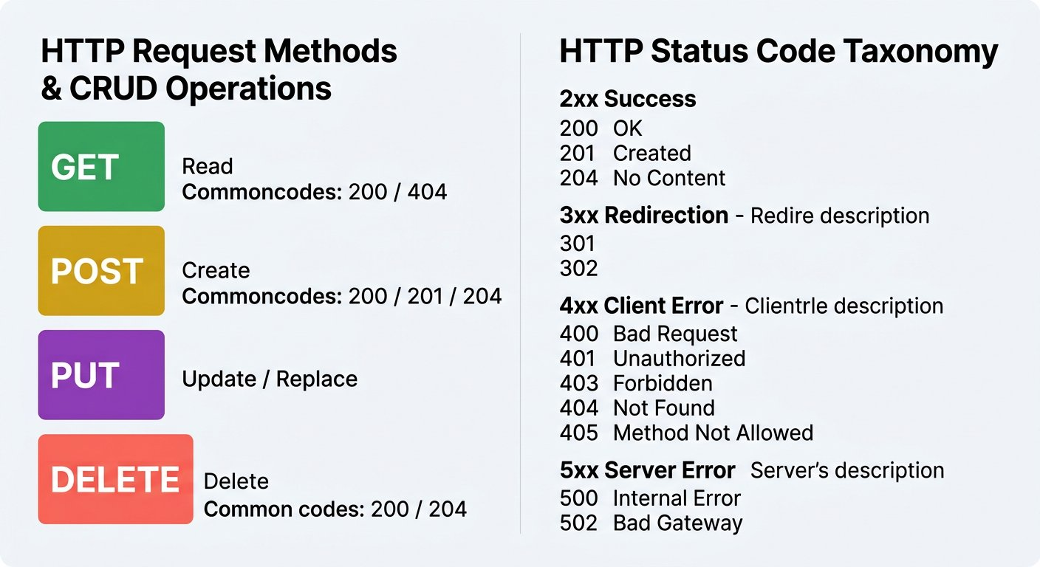
The Status Code Compass: Directing developers to the exact layer of success or failure.
1 2xx (Success): Everything went smoothly and the requested action was fulfilled (observed in our 200 OK coordinate response).
2 4xx (Client Error): The caller made a mistake, such as omitting a required parameter (observed in our 400 Bad Request guard).
3 5xx (Server Error): The server encountered an unhandled crash or exception (observed in our initial 500 TypeError crash).
Deconstructing the Five Status Code Families
Understanding these five ranges lets you instantly identify where a web failure originated:
PILLAR 1: 2xx Series · Success Codes: Action Completed Gracefully
Confirms that the client request was successfully received, understood, and accepted by the backend application.
• 200 OK: Standard successful response for GET, PUT, or general queries.
• 201 Created: The request succeeded and a brand new database record was created (standard for POST).
• 204 No Content: Action succeeded but there is no response body to return (common for DELETE).
PILLAR 2: 4xx Series · Client Error Codes: The Caller Made a Mistake
Indicates that the request contains invalid syntax, missing parameters, or unauthorized tokens.
• 400 Bad Request: Malformed syntax, invalid JSON formatting, or missing required parameters.
• 401 Unauthorized: Caller lacks valid authentication credentials (such as an API token).
• 403 Forbidden: Caller identity is known, but they do not possess permissions to view this resource.
• 404 Not Found: The requested URL endpoint does not exist on this server.
PILLAR 3: 5xx Series · Server Error Codes: The Backend Crashed
Proves that the client sent a request, but the server encountered an internal software crash, null dereference, or database failure.
• 500 Internal Server Error: Unhandled programming exception or fatal software defect on the server.
• 502 Bad Gateway: Upstream server or proxy returned an invalid response.
• 503 Service Unavailable: Server is overloaded or undergoing maintenance.
• 504 Gateway Timeout: Server failed to respond before the network connection expired.
PILLAR 4: 1xx and 3xx Series · Informational and Redirection Codes
Specialized protocol signaling codes for connection handshakes and URL relocations.
• 100 Continue: Server acknowledges the initial headers and tells the client to send the body.
• 301 Moved Permanently: The resource has permanently relocated to a new address.
• 304 Not Modified: Cached client response is still fresh; saves network bandwidth.

Step 9: Sourced Case Study: The Healthcare.gov Launch Outage
Verified Historical Case Study · August 2014
Healthcare.gov Early Outages Case Study Documenting Integration Bottlenecks and Access Failures
https://oig.hhs.gov/documents/evaluation/2981/OEI-06-14-00350-Complete%20Report.pdf
Verified through United States Department of Health and Human Services (HHS) Office of Inspector General Report OEI-06-14-00350
The Real World Cost of Untested Dependencies: Healthcare.gov Launch
On October 1, 2013, the United States federal health insurance exchange opened to the public. Within minutes, the system slowed to a crawl and crashed for millions of citizens.
The Department of Health and Human Services Inspector General report documented capacity bottlenecks, cross agency timeout dependencies, and lack of end to end integration testing before release. When identity verification services became overloaded, downstream systems faced cascading unhandled timeouts and generic 500 crashes instead of graceful degradation or early validation.
The Takeaway: Always test error status codes. An API must handle missing or invalid inputs gracefully with 4xx codes rather than crashing the system with unhandled 5xx server exceptions.

Step 10: Final Understanding Gate: Independent Diagnosis Challenge
Before moving to Chapter 3, test your diagnostic reasoning on a brand new case. Suppose a client sends GET /v1/campus/shuttle/coordinates?route=%20%20 (a present query parameter containing only spaces). Consider the four questions below:
Independent Understanding Challenge
Evaluate this new request against our guarded server code:
PILLAR 1: Question 1: Parameter Condition · Is this parameter omitted, empty, or whitespace only?
The parameter is present in the query string, but its content consists entirely of URL encoded spaces (%20%20). This represents Case C: Whitespace Only.
• Presence check if (!route) evaluates to false because the string exists.
• Trimming the string collapses its length to zero characters.
PILLAR 2: Question 2: Guard Behavior · Which condition catches this request, and what status is returned?
The check route.trim() === "" evaluates to true. The server immediately returns HTTP 400 Bad Request with { statusCode: 400, error: "route parameter is required" }.
• Guards against invisible blank queries that would fail in the database.
• Protects backend resources from executing empty string lookups.
PILLAR 3: Question 3: Client Remediation · What must the caller send to receive active coordinates?
The client must pass a real, non blank route identifier: ?route=campus_loop_north.
• Client must supply valid business identifiers.
• The backend cannot guess which route the student needs.
PILLAR 4: Question 4: Test Philosophy · Why do quality engineers test both bad and valid calls after every fix?
Testing only the valid call proves the feature works under ideal conditions, but misses regression crashes. Testing only the bad call proves error safety, but cannot confirm if real users receive data. You must test both to guarantee total system reliability.
• Negative test proves system resilience against crashes.
• Positive test proves business fulfillment for users.

Step 11: Review and Practice
WAR ROOM INCIDENT TRIAGE
War Room Triage: Distinguishing Client Errors from Server Crashes
A student submits a book loan request through the campus library API. The server returns HTTP status 400 Bad Request with message "Return date cannot be earlier than checkout date". Who is responsible for this failure?
A. The backend database server crashed and needs to be restarted immediately
B. The client application sent invalid request data that violates business rules, so the caller must fix the date parameters
C. The network internet cable was disconnected during transmission
D. The Postman application is missing a software license
TACTICAL TRIUMPH: Client error identified! The 4xx family explicitly signifies client side issues: the caller transmitted data that violated business validation rules. The backend functioned perfectly by rejecting the impossible dates and returning a helpful error message.

Check your understanding
1. What is the fundamental difference between an omitted parameter and an empty parameter?
Answer: An omitted parameter is completely absent from the URL (evaluating to undefined or null in server memory), which can trigger uncaught dereference crashes if not checked. An empty parameter is present as a defined variable with zero characters (such as ?route=), which can still produce invalid database queries if not trimmed and validated.
2. Why did the campus shuttle locator service crash with HTTP 500 when the route parameter was omitted?
Answer: The backend code failed to implement defensive parameter validation. When the query parameter was completely omitted, req.query.route evaluated to undefined. The service attempted to invoke trim() on this undefined reference, triggering an unhandled TypeError that crashed the request.
3. If a client requests a web address that does not exist on the server, what status code should be returned?
Answer: The server should return HTTP 404 Not Found, indicating that the requested URL path could not be mapped to any server resource.

Key takeaways
REMEMBER
- HTTP status codes provide an instant, unambiguous diagnosis of where a transaction succeeded or broke.
- The 2xx series confirms success, 4xx series identifies client caller errors, and 5xx series proves backend server crashes.
- When diagnosing production defects, never rely on frontend screen behavior; inspect the raw request and response wire packets.
- Query parameters in URLs allow clients to filter or specify target resources; omitting required parameters must be handled defensively with 400 Bad Request.
- Always test both branches: verify that bad input is safely rejected with 400, and verify that valid input returns 200 with required data.
NEXT DISCOVERY · From Human Eyes to Automated Test Scripts
You solved the campus transit crisis by hand! But what happens tomorrow when developers deploy code updates at 3:00 AM? You cannot sit at your computer clicking Send manually all night. In Chapter 3, we automate this exact verification using Postman JavaScript test assertions and assemble an executable collection!

Chapter 3: Automating the Wire Check: Postman Workbench and Assertions
Translating manual verification into automated JavaScript assertions, running test suites, and team collaboration.
MISSION BRIEFING & CHAPTER ROADMAP
MISSION 1 · PHASE 3 OF 3: AUTOMATING THE WIRE VERIFICATION: Global Open Data and Web Wire Audit
CRISIS SCENARIO: Automating the Wire Gate: Never Repeat Manual Eyeball Audits
Context: We diagnosed and repaired the shuttle service defect by hand, but manual testing does not scale across repeated deployments. If an engineer accidentally removes the defensive guard tomorrow, the system will crash again. We must convert our manual wire observations into automated JavaScript assertions that run at machine speed in Postman.
Operational Target: Construct automated regression checks for both the 400 guard and 200 contract, execute collection runs, and achieve Mission 1 victory.

WE WILL ACHIEVE: Turn the shuttle investigation we performed by hand into repeatable checks that reveal a broken response.
HOW WE WILL DO IT: Reuse the same local endpoint and inputs, add a small post response check to each request, run the checks against broken and guarded versions, and read actual Test Results.
WHAT YOU WILL CARRY FORWARD: The core automated assertion pattern ready to test library services in Chapter 4.
MISSION COMMAND HUD
PHASE: Phase 3 of 3: Automating the Wire Verification · RANK: Rank: Automation Quality Engineer
ACTIVE MISSION: Mission 1: The Core Protocol and Campus Cloud Integration
MISSION PROGRESS · Completing Mission 1: Turning Manual Inspections into Automated Watchdogs
In Chapter 2, we investigated the campus transit crash and proved the solution by hand. But manual checking has a severe limitation: a human tester cannot sit at a screen clicking Send every fifteen seconds, especially during midnight deployments. If a backend engineer pushes an update that accidentally breaks the route parameter again, real students will be stranded at bus stops before anyone notices. In this chapter, we automate our manual checks into a repeatable Postman collection with JavaScript assertions that validate the wire in milliseconds.

Step 1: The API Testing Workbench Cockpit: The Four Surfaces
Standard web browsers are designed for human browsing, not API automation. A browser address bar cannot run assertions, cannot chain variables between requests, and cannot execute automated regression suites. Professional quality engineers rely on an API Testing Workbench such as Postman.
When working inside an API testing workbench, an engineer interacts with four distinct surfaces:
The Four Surfaces of an API Testing Workbench
Understanding where each action happens prevents confusion during test construction:
PILLAR 1: Surface 1: Request Builder · Configuring the Outgoing HTTP Call
Where you specify the HTTP verb (GET, POST), target URL, query parameters, headers, and request body before sending.
• Enter the endpoint address: http://localhost:3001/v1/campus/shuttle/coordinates.
• Attach query parameters such as route=campus_loop_north in the Params table.
PILLAR 2: Surface 2: Post Response Script Area · Writing Automated Assertion Code
A dedicated JavaScript sandbox that executes automatically the instant a response arrives from the network.
• Where you write pm.test() blocks and assertion logic.
• Executes after the network transfer completes.
PILLAR 3: Surface 3: Response Status and Payload · Inspecting What the Server Returned
Shows the exact raw data received over the wire: HTTP status code, latency, headers, and JSON or HTML body.
• Status line displays 200 OK or 400 Bad Request.
• Body viewer formats returned JSON objects.
PILLAR 4: Surface 4: Test Results Summary · Evaluating Assertion Passes and Failures
Where the workbench tallies your assertions, displaying green PASS badges for successful checks and red FAIL messages for defects.
• Shows named test outcomes with clear descriptions.
• Prints expected versus actual values when a check fails.
ARCHITECTURE · The Postman Testing Cockpit: Navigation, Request Builder, and Response Pane
POSTMAN WORKBENCH · The Postman Testing Cockpit: Navigation, Request Builder, and Response Pane
Postman organizes your testing universe into dedicated zones: the left sidebar for Collections and Environments, the top center builder for URLs and Headers, the Tests script editor, and the bottom pane for live responses and assertion results.
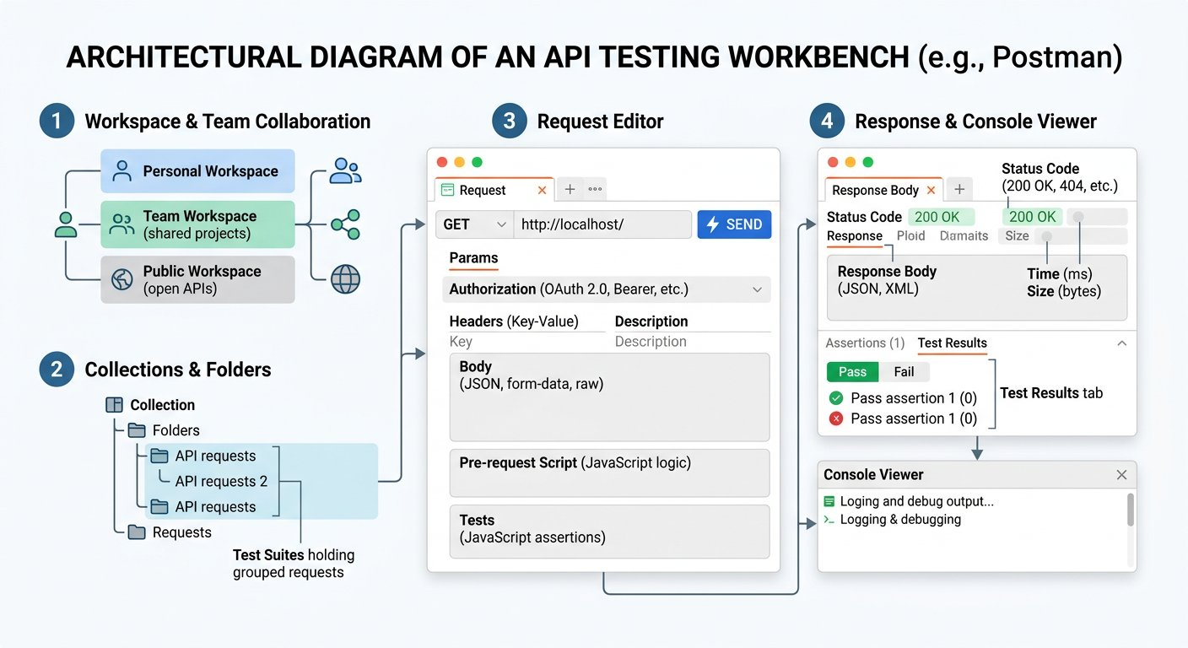
The Automation Cockpit: Collections on the left, request parameters on top, response data and test results on the bottom.
1 Left Sidebar: Houses Collections, Environments, and saved requests organized in folders.
2 Top Center Pane: Where you configure HTTP methods, endpoints, parameters, and post response test scripts.
3 Bottom Pane: Where live server status codes, response bodies, and named test results appear.

Step 2: The JavaScript Test Sandbox: pm.test and pm.expect
Inside Postman, every request includes a dedicated tab labeled Tests. Code typed into this tab runs in an embedded JavaScript engine immediately after the server response arrives.
Postman provides a global JavaScript object named pm that gives your test scripts complete access to the request and response packets. You construct tests using simple, readable matchers:
DEFINITION · Test Assertion
A formal logical condition in code that compares an actual runtime value against an expected outcome. If the condition is true, the test passes with a green indicator; if false, the test halts with an explicit error description.
Example: pm.response.to.have.status(200) asserts that the server returned HTTP status code 200 OK.
Every test begins with pm.test(). It takes two arguments: a descriptive test name, and a callback function containing your assertions:

The code
assertion_syntax.js
1 // Anatomy of a Postman Assertion
2 pm.test("Status code is 200 OK", function () {
3 // Chai assertion matcher
4 pm.response.to.have.status(200);
5 });
Akshay Writes His First Postman Status Assertion
API TESTING WORKBENCH · JAVASCRIPT TEST SANDBOX
Akshay Writes His First Postman Status Assertion

API Request: GET http://localhost:3001/v1/campus/shuttle/coordinates?route=campus_loop_north

Live Response: 200 OK (22 ms)
response.json
1 {
2 "route": "campus_loop_north",
3 "status": "in_transit",
4 "coordinates": {
5 "latitude": 42.3601,
6 "longitude": -71.0942
7 }
8 }
1. Explicit Input: GET http://localhost:3001/v1/campus/shuttle/coordinates?route=campus_loop_north with post response test script.
2. Wire & Logic Explanation: The post response script sandbox executes post flight. The Chai matcher evaluates if actual status equals 200.
3. Deterministic Output: Status code is 200 OK passes with green test badge in Test Results tab.
4. Senior Savior & Common Trap: Writing assertions in the Pre request Script tab instead of the Tests tab fails because the response has not arrived yet.

Step 3: Red Before Green: Detecting Regressions on the Unhardened Server
A test that has never been seen to fail cannot be trusted to protect production. To prove that our test is a genuine watchdog, we first run our missing route check against the deliberately broken fixture from Chapter 2 (where the guard was not yet installed).
First, save the baseline valid request: GET http://localhost:3001/v1/campus/shuttle/coordinates?route=campus_loop_north. In its Tests tab, enter pm.test("Status code is 200 OK", function () { pm.response.to.have.status(200); });. Click Send. The test passes green because the broken server can still fulfill valid queries.
Now create a second request in your collection named Missing Route Check with URL http://localhost:3001/v1/campus/shuttle/coordinates. In its Tests tab, write our expectation that the server should reject missing parameters with 400 Bad Request:

The code
missing_route_status_check.js
1 // Request 02: Missing Route Status Assertion
2 pm.test("Missing route returns 400", function () {
3 pm.response.to.have.status(400);
4 });
When we click Send against the unhardened server, predict what will happen:
IMAGINE & PREDICT BEFORE SENDING
When we send the missing route request against the unhardened server (which crashes with 500), what will the Test Results tab display?
A. A red FAIL indicator: expected response to have status code 400 but got 500
B. A green PASS indicator: Postman treats 500 and 400 as identical error codes
C. The Postman application freezes and closes
D. A timeout error because status assertions only work on status 200
Actual Output (Authentic Red Failure Confirmation): Red before green confirmed! The unhardened server returned HTTP 500. Because our assertion demanded status code 400, Postman flagged the test with a red FAIL badge and printed: AssertionError: expected response to have status code 400 but got 500. The test caught the bug!

Expected output
Terminal
1 $ Postman Test Results Pane (Unhardened Server)
2 FAIL Missing route returns 400
3 AssertionError: expected response to have status code 400 but got 500
Akshay Proves the Test Watchdog by Catching the Bug
API TESTING WORKBENCH · RED BEFORE GREEN VERIFICATION
Akshay Proves the Test Watchdog by Catching the Bug

API Request: GET http://localhost:3001/v1/campus/shuttle/coordinates

Live Response: 500 Internal Server Error (12 ms)
response.json
1 {
2 "statusCode": 500,
3 "error": "Internal Server Error",
4 "message": "Cannot read properties of undefined (reading 'trim')"
5 }
1. Explicit Input: GET http://localhost:3001/v1/campus/shuttle/coordinates sent against unhardened server.
2. Wire & Logic Explanation: Assertion demands status 400, but unhardened server returns 500. Chai matcher throws AssertionError.
3. Deterministic Output: Red test failure badge: expected response to have status code 400 but got 500.
4. Senior Savior & Common Trap: Never deploy a test suite without verifying red failure first. Untested assertions can falsely pass even when bugs exist.
Notice why we assert the status code first: if the server crashes with a 500 error returning HTML or raw text, testing pm.response.to.have.status(400) fails cleanly with an informative message rather than crashing with an unexpected JSON parsing exception!

Step 4: Rerunning After the Server Defense: Green on Negative Guard
Now start the guarded transit service from Chapter 2 (or uncomment the validation guard in shuttle_service.js and restart the server). Without changing a single character of our test script, click Send again in Postman:

Expected output
Terminal
1 $ Postman Test Results Pane (Guarded Server)
2 PASS Missing route returns 400
The test turned green! Next, we expand our post response script to also verify that the server returns our canonical error guidance payload:

The code
negative_guard_full.js
1 // Request 02: Negative Regression Guard (Missing Route)
2 pm.test("Missing route returns 400", function () {
3 pm.response.to.have.status(400);
4 });
5
6 pm.test("Missing route explains why", function () {
7 pm.response.to.have.status(400);
8 const body = pm.response.json();
9 pm.expect(body.error).to.eql("route parameter is required");
10 });
Automated Postman Suite: Request 02 (Negative 400 Guard)
GET http://localhost:3001/v1/campus/shuttle/coordinates
Status: 400 Bad Request · Time: 14 ms · Size: 184 B
Response Body:
response.json
1 {
2 "statusCode": 400,
3 "error": "route parameter is required"
4 }
Assertions Verified:
✓ Missing route returns 400
✓ Missing route explains why

Step 5: Protecting the Positive Path: Deep Data and Coordinate Validation
Rejecting bad requests is only half of quality engineering. We must also verify that when valid parameters are sent, the server returns the complete payload required by the mobile map. Open Request 01 (Valid Route Contract) targeting http://localhost:3001/v1/campus/shuttle/coordinates?route=campus_loop_north:

The code
positive_contract_full.js
1 // Request 01: Positive Contract Verification (Valid Route)
2 pm.test("Status code is 200 OK", function () {
3 pm.response.to.have.status(200);
4 });
5
6 pm.test("Route and status match contract", function () {
7 const data = pm.response.json();
8 pm.expect(data.route).to.eql("campus_loop_north");
9 pm.expect(data.status).to.eql("in_transit");
10 });
11
12 pm.test("Coordinates are valid numbers", function () {
13 const data = pm.response.json();
14 pm.expect(data.coordinates.latitude).to.be.a("number");
15 pm.expect(data.coordinates.longitude).to.be.a("number");
16 });
17
18 pm.test("Response time is under local budget", function () {
19 pm.expect(pm.response.responseTime).to.be.below(1200);
20 });
Automated Postman Suite: Request 01 (Positive 200 Contract)
GET http://localhost:3001/v1/campus/shuttle/coordinates?route=campus_loop_north
Status: 200 OK · Time: 28 ms · Size: 286 B
Response Body:
response.json
1 {
2 "route": "campus_loop_north",
3 "shuttleId": "BUS_104",
4 "status": "in_transit",
5 "coordinates": {
6 "latitude": 42.3601,
7 "longitude": -71.0942
8 },
9 "speedMph": 24,
10 "nextStop": "Apex Student Union",
11 "estimatedArrivalMinutes": 3
12 }
Assertions Verified:
✓ Status code is 200 OK
✓ Route and status match contract
✓ Coordinates are valid numbers
✓ Response time is under local budget
All four assertions pass! Postman validated that the status code is 200, the route matches campus_loop_north, the coordinates are numbers (preventing mobile map render crashes), and the response latency was well under our local testing budget.

Step 6: Covering the Edge Cases: Empty Strings and Spaces Only
In Chapter 2, we discovered that clients do not merely omit parameters: they can also send empty strings (?route=) and whitespace only (?route=%20%20). To ensure complete test coverage, we add two more requests to our collection reusing the exact same defensive assertions:
The Complete Four Request Transit Suite
Here is the full matrix of automated requests carried directly from Chapter 2:
PILLAR 1: Request 01: Valid Route · Positive Contract Verification
Validates successful coordinate delivery for the mobile transit map.
• Asserts status code 200 OK.
• Asserts route equals campus_loop_north and status equals in_transit.
• Asserts latitude and longitude are numbers.
• Asserts latency under 1200 ms.
PILLAR 2: Request 02: Missing Route · Negative Guard (Omitted Key)
Validates that an absent query string is rejected defensively without server crash.
• Asserts status code 400 Bad Request.
• Asserts error message equals route parameter is required.
PILLAR 3: Request 03: Empty Route · Negative Guard (Blank Value)
Validates that a present key with zero characters is rejected with 400.
• Asserts status code 400 Bad Request.
• Asserts error message equals route parameter is required.
PILLAR 4: Request 04: Spaces Only · Negative Guard (Whitespace Value)
Validates that URL encoded spaces are trimmed and rejected with 400.
• Asserts status code 400 Bad Request.
• Asserts error message equals route parameter is required.

Step 7: Running the Entire Suite and Catching a Type Regression
Rather than clicking Send manually on four separate requests, Postman allows you to run the entire collection in sequence using the Collection Runner.
In the left sidebar, click the three dots icon next to your collection and select Run collection. Click Run Zero to Agentic API Testing. Postman executes all four requests sequentially, running all ten assertions in milliseconds:

Expected output
Terminal
1 $ Postman Collection Runner Summary Report
2 Collection: Campus Transit Verification Suite
3 Iterations: 1
4 Requests: 4
5 Assertions: 10
6 -------------------------------------------------------
7 PASS 01 Valid Route: Status code is 200 OK
8 PASS 01 Valid Route: Route and status match contract
9 PASS 01 Valid Route: Coordinates are valid numbers
10 PASS 01 Valid Route: Response time is under local budget
11 PASS 02 Missing Route: Missing route returns 400
12 PASS 02 Missing Route: Missing route explains why
13 PASS 03 Empty Route: Missing route returns 400
14 PASS 03 Empty Route: Missing route explains why
15 PASS 04 Spaces Only: Missing route returns 400
16 PASS 04 Spaces Only: Missing route explains why
17 -------------------------------------------------------
18 Results: 10 passed, 0 failed, 0 skipped (duration: 86 ms)
Akshay and Sameer Achieve 10 Out of 10 Green Assertions
API TESTING WORKBENCH · COLLECTION RUNNER VICTORY
Akshay and Sameer Achieve 10 Out of 10 Green Assertions

API Request: COLLECTION RUN 4 Requests · 10 Assertions · Campus Transit Suite

Live Response: 10 PASSED · 0 FAILED (86 ms)
response.json
1 ✓ 01 Valid Route: Status code is 200 OK
2 ✓ 01 Valid Route: Route and status match contract
3 ✓ 01 Valid Route: Coordinates are valid numbers
4 ✓ 01 Valid Route: Response time is under local budget
5 ✓ 02 Missing Route: Missing route returns 400
6 ✓ 02 Missing Route: Missing route explains why
7 ✓ 03 Empty Route: Missing route returns 400
8 ✓ 03 Empty Route: Missing route explains why
9 ✓ 04 Spaces Only: Missing route returns 400
10 ✓ 04 Spaces Only: Missing route explains why
1. Explicit Input: Automated execution of 4 requests in sequence using Collection Runner.
2. Wire & Logic Explanation: The runner executes each request, awaits response, evaluates all pm.test assertions in sandbox, and aggregates report.
3. Deterministic Output: 10 passing assertions across both positive contract and negative regression guards.
4. Senior Savior & Common Trap: Running requests individually hides cross request state issues. Always execute the entire collection runner to verify full suite health.
Now consider a real regression test: suppose a backend developer updates the database serializer and accidentally converts latitude into a string "42.3601" instead of a number 42.3601. What happens when the collection runs?

Expected output
Terminal
1 $ Postman Collection Runner Type Regression Caught
2 FAIL 01 Valid Route: Coordinates are valid numbers
3 AssertionError: expected '42.3601' to be a number
4 -------------------------------------------------------
5 Results: 9 passed, 1 failed, 0 skipped
The suite immediately catches the defect! The red test warns the team before bad code reaches staging or production. Once the backend serializer is restored to return numbers, the test suite returns to all green.

Step 8: Sourced Case Study: When Code Deploys Without Verification
Verified Historical Case Study · August 2012
Knight Capital Group Incurs Over 460 Million Dollar Loss Following Unverified Deployment
https://www.sec.gov/files/litigation/admin/2013/34-70694.pdf
Verified through United States Securities and Exchange Commission (SEC) Release No. 34-70694
The Real World Cost of Missing Automated Release Checks: Knight Capital
On August 1, 2012, financial trading firm Knight Capital Group deployed updated order router code across eight servers. During the manual deployment, a technician failed to copy the new code to the eighth server, leaving an obsolete feature flag active on that single machine.
When the market opened at 9:30 AM, the unverified server repurposed an obsolete order execution mechanism, processing millions of erroneous share transactions in 45 minutes.
Because the engineering team lacked automated pre release verification suites to validate consistent server configurations and response behavior across all nodes before trading opened, the rogue server operated unnoticed until over 460 million dollars in losses had accumulated.
The Architectural Lesson: Automated verification suites run continuously to catch configuration drift, unverified deployments, and unexpected contract changes before users or downstream services are impacted.

Step 9: Team Collaboration: Workspaces, Forks, and Pull Requests
Now that you have built a working test collection, how do you share it across the engineering team without team members accidentally overwriting each other work?
ARCHITECTURE · Collaborative Testing Workflow: Forking Collections and Reviewing Pull Requests
TEAM COLLABORATION · Collaborative Testing Workflow: Forking Collections and Reviewing Pull Requests
Just like software developers use Git branches to write code safely, API testers use Postman Forks. You fork the parent collection into your personal workspace, add new assertions, and create a Pull Request for your peers to review before merging.
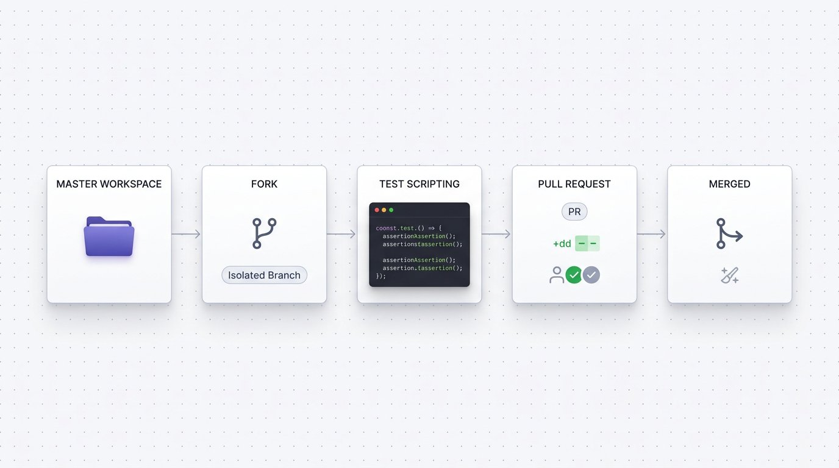
Safe Collaboration: Forking the main collection, writing assertions, and merging through peer review.
1 Parent Collection: The single source of truth shared in the Team Workspace.
2 Personal Fork: Your safe, private playground where you experiment and write new assertions without affecting teammates.
3 Pull Request: A formal review request where teammates inspect your added tests before merging into the main collection.

Step 10: Final Understanding Gate: Independent Assertion Challenge
Before moving into Chapter 4, test your understanding of assertion mechanics on a new scenario:
Independent Assertion Challenge
Evaluate this new testing requirement:
PILLAR 1: Challenge 1: Status Code Validation · Why check status code before parsing JSON?
If a server crashes with an unhandled 500 error returning HTML or raw text, calling pm.response.json() throws a syntax error. Asserting pm.response.to.have.status() first ensures failures report meaningful status code differences.
• Protects tests from crashing with JSON parser errors.
• Gives clear diagnostic messages in Test Results.
PILLAR 2: Challenge 2: Type Assertion · How do you verify speedMph is a number?
Write: pm.expect(data.speedMph).to.be.a("number"). This guarantees that calculations downstream will not encounter string concatenation bugs.
• Chai type matchers: to.be.a("number"), to.be.a("string"), to.be.an("array").
• Prevents mobile mapping components from breaking.
PILLAR 3: Challenge 3: Dual Contract Principle · Why are both 400 and 200 checks required in every regression suite?
Testing only 200 proves the feature works under ideal input, but leaves the system vulnerable to unhandled server crashes when invalid input arrives. Testing only 400 proves defensive error safety, but cannot confirm if real users receive valid data. You must test both to guarantee total system reliability.
• Negative checks prevent unhandled 500 outages.
• Positive checks ensure business feature fulfillment.

Step 11: Review and Practice
MAKE A GUESS
What happens when an assertion inside a pm.test block evaluates to false?
- A. Postman automatically restarts your computer
- B. Postman marks that specific test as failed with a red indicator and prints the exact assertion difference in the console
- C. The entire Postman application deletes the collection
- D. The network server cancels all user accounts
Answer: Postman marks that specific test as failed with a red indicator and prints the exact assertion difference in the console. When an assertion condition fails, Postman catches the AssertionError, flags the test with a red cross badge in the Test Results tab, and prints the expected vs actual value in the test report.

Check your understanding
1. What is the difference between a manual test and an automated API test?
Answer: A manual test requires a human tester to click buttons, inspect screens, and verify status codes with their eyes. An automated API test executes in milliseconds using code assertions that run without human intervention.
2. In Postman, what is the role of the pm.response.json() method?
Answer: It parses the incoming raw HTTP response body text and deserializes it into a traversable JavaScript object that can be queried and asserted.
3. Why should engineering teams use Postman Forks instead of editing the parent collection directly?
Answer: Editing a shared team collection directly can disrupt ongoing automated builds and overwrite teammate changes. Forking provides an isolated workspace where tests can be developed safely and reviewed before merging.

Key takeaways
REMEMBER
- Postman provides a dedicated API testing cockpit combining collections, environment management, and JavaScript assertion sandboxes.
- Use pm.test() to define individual test cases, and pm.expect() to assert status codes, response times, and payload properties.
- The Chai assertion library powers expressive, readable assertions: such as to.have.status(200) and to.be.below(1200).
- Always verify red before green: a test must be proven capable of detecting real failures before trusting its green status.
- Team collaboration relies on forking collections and opening pull requests to review new test cases safely.
★ MISSION ACCOMPLISHED · Mission 1 Completed: Transit Verification Watchdogs Active
You have automated both critical transit checks into repeatable JavaScript assertions: the negative check verifies 400 Bad Request to prevent 500 crashes, and the positive check validates 200 OK with numeric coordinates. These assertions now execute reliably in your local automated collection suite.
NEXT DISCOVERY · Entering Mission 2: Automating Campus Library Services at Scale
Our shuttle bus is rolling and protected by automated tests. But across campus, the University Library catalog is about to launch! In Mission 2 (Chapters 4 through 8), we step up to multi request CRUD workflows: adding books, querying records, handling duplicate constraints, chaining dynamic IDs, and processing hundreds of records using Data Driven Testing with CSV spreadsheets!

Chapter 4: Manual Testing the College Library API
Executing AddBook, GetBook, and DeleteBook manually, feeling the copy paste pain, and mapping unique constraints.
MISSION BRIEFING & CHAPTER ROADMAP
MISSION 2 · PHASE 1 OF 6: Automating Student and Campus Services at Scale
CRISIS SCENARIO: The College Library REST Service: Manual CRUD Exploration
Context: With the transit crisis resolved, the engineering leadership assigns you to automate the core College Library REST services. The library system manages cataloging, aisle positioning, and book acquisitions under strict unique constraints. Before automating scripts, we must map out the manual AddBook, GetBook, and DeleteBook contract lifecycle and experience the pain of manual copy paste.
Operational Target: Map out the complete CRUD contract across AddBook, GetBook, and DeleteBook, and verify unique ISBN and aisle constraints.

WE WILL ACHIEVE: Execute the complete Create, Read, and Teardown lifecycle against an enterprise Library API service by hand.
HOW WE WILL DO IT: Sending AddBook POST, witnessing duplicate ISBN and aisle collisions, querying GetBook with query parameters, and executing DeleteBook teardown.
WHAT YOU WILL CARRY FORWARD: The canonical 3 step Library API request contract: AddBook, GetBook, and DeleteBook.
MISSION COMMAND HUD
PHASE: Phase 1 of 5: Manual CRUD Verification · RANK: Rank: Automation Quality Engineer
ACTIVE MISSION: Mission 2: Automating Student and Campus Services at Scale
OUR MISSION · Mission 2: Automating Student and Campus Services at Scale
Every college campus has a library where students check out textbooks, professors reserve course reading material, and librarians track inventory across physical aisles. The college has deployed a new web service to manage its book catalog across campus stacks. Before releasing the system to faculty and students, we must test every operation: adding a new textbook, verifying its physical shelf location, and removing retired editions. As Automation Quality Engineer, your mission is to map out the entire inventory lifecycle and prepare it for automated testing.

The Campus Library Operations Center: Moving from manual book checking to fast automated testing.
1 Live Book Tracking: Keeping track of textbook copies, shelf locations, and checkout status in real time.
2 The Three Core Actions: Adding new books, checking where they sit on the shelf, and deleting old copies safely.
3 Smart Automation: Passing book details automatically from one step to the next without copying and pasting by hand.
What we know: The Library API is deployed across dedicated campus service clusters with structured REST endpoints. • Books are stored with a unique combination of ISBN and aisle numbers. • If an ISBN and aisle combination already exists, the server rejects insertion with "book already exist".
What we need: A configured POST AddBook request with valid JSON payload and unique ISBN. • A configured GET GetBook request using query parameters to verify coordinates. • A configured POST DeleteBook request to verify safe cleanup. • The ability to diagnose unique database constraint collisions.
How We Will Approach Mission 2: The 5 Phase Battle Plan
Automating an enterprise inventory system requires a deliberate step by step progression. We move from manual exploration to full data driven automation across five structured phases:
Phase 1 (Chapter 4 · Right Now): Manual CRUD Execution [CURRENT FOCUS]
We execute manual AddBook, GetBook, and DeleteBook operations to map unique ISBN and aisle constraints and experience the friction of manual testing.
Outcome: You discover database constraint collisions and understand the lifecycle of book inventory.
Phase 2 (Chapter 5 · Next Step): Automated Assertions
We replace human eyeball checks with automated JavaScript assertions verifying status codes, response times, and payload schemas.
Outcome: Your tests pass or fail automatically in milliseconds without human inspection.
Phase 3 (Chapter 6 · Environment Isolation): Variable Scopes and Environments
We eliminate hardcoded URLs by configuring dynamic environments (Local, QA, UAT) and pre request scripts to generate random unique ISBNs.
Outcome: Zero test collisions; identical collections run seamlessly across multiple test servers.
Phase 4 (Chapter 7 · Request Chaining): Dynamic Request Chaining
We extract generated book IDs from POST responses and pass them dynamically into downstream GET and DELETE requests without copy pasting.
Outcome: Self contained automated testing pipelines that clean up their own test data.
Phase 5 (Chapter 8 · Mission Victory): Data Driven Scale
We parameterize our suite with external CSV and JSON data files using Postman Collection Runner to test hundreds of records in seconds.
Outcome: Mission 2 Cleared! Full automated data driven testing suite running against enterprise services.

Step 1: The Library CRUD Lifecycle Sequence
ARCHITECTURE · Library API CRUD Lifecycle: Create, Verify, and Cleanup Sequence
DATA LIFECYCLE · Library API CRUD Lifecycle: Create, Verify, and Cleanup Sequence
The college library system exposes three core HTTP services that form a complete data lifecycle: Create a record with unique coordinates, Read it back to confirm persistence across campus stacks, and Delete it to maintain a clean database state.
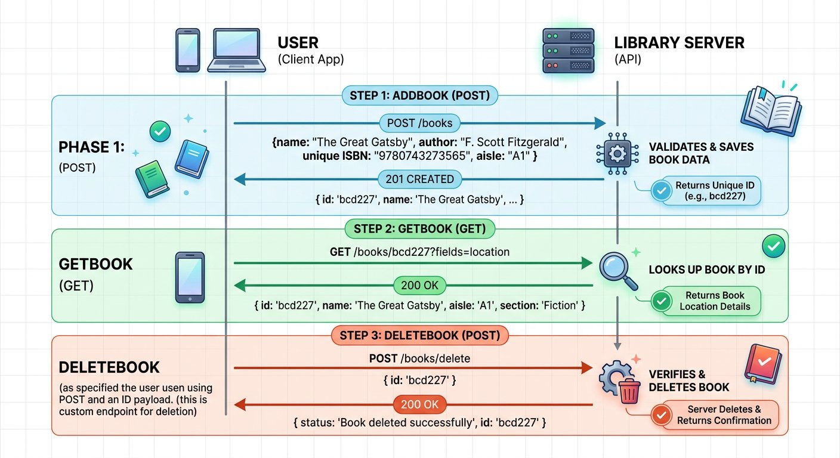
The complete lifecycle of a textbook through the Library API.
1 Phase 1 (Step 1 AddBook POST): Client submits book title, author, ISBN, and shelf aisle. The server stores the record and returns a composite ID.
2 Phase 2 (Step 2 GetBook GET): Client queries GET /books with the composite ID to confirm the record exists in the catalog.
3 Phase 3 (Step 3 DeleteBook POST): Client submits a delete request with the composite ID to remove the record.
This Service Contract: Inspecting Real World Conventions
Before dispatching requests, inspect the published contract of this college library service:
• AddBook (POST /v1/books): Returns HTTP status 200 OK (rather than 201) with a capitalized Msg property: { "Msg": "successfully added", "ID": "9781227" }.
• GetBook (GET /v1/books?id=...): Returns an array containing matching book items: [{ "book_name": "...", "isbn": "...", "aisle": "..." }]. Notice that aisle is a string and the author field is omitted from this read endpoint.
• DeleteBook (POST /v1/books/delete): Requires a JSON body with the ID: { "ID": "..." }, returning HTTP status 200 OK with lowercase msg: { "msg": "book is successfully deleted" }.
As quality automation engineers, our job is to test against the exact service contract rather than assuming theoretical conventions.

Step 2: Action 1: Adding a Book (POST)
When a new book arrives at the circulation desk, the librarian enters its title, author, ISBN, and shelf aisle number. In our API test workbench, we break down the outgoing HTTP POST request in chunks:
Deconstructing the AddBook POST Request
Inspect the method, endpoint, and payload:
CHUNK 1: Endpoint and Method · The Target Resource
Dispatches a POST request to the collection resource endpoint.
AddBook-line.http
1 POST /v1/books HTTP/1.1
Host: api.campuslibrary.org
Rule: POST indicates resource creation on the server.
CHUNK 2: JSON Payload Body · The Book Attributes
The server combines the ISBN (9781) and aisle (227) into a unique composite primary key: 9781227.
AddBook-payload.json
1 {
"name": "Zero to Agentic API Testing",
"isbn": "9781",
"aisle": "227",
"author": "Alex Mercer"
}
Rule: The combination of ISBN and aisle forms the unique identifier in this API.
IMAGINE & PREDICT BEFORE SENDING
When we send this AddBook request for the first time, what response status and payload do you expect from the server?
A. 200 OK: Returns a success confirmation message alongside the composite primary key ID
B. 404 Not Found: Endpoint is unreachable because the library catalog is offline for maintenance
C. 500 Server Error: Crashes because the book author is not registered in the student directory
Actual Output (AddBook Live Wire Outcome): The book is registered! The server returns 200 OK along with a confirmation message and the composite primary key ID: 9781227.
Architectural Contract Quirk: Why AddBook Returns 200 Instead of 201
In Chapter 2, we learned that theoretical REST standards recommend returning 201 Created when a new record is added.
However, in real world corporate software, many production APIs return 200 OK with a custom confirmation payload. Notice also that the success message uses capitalized "Msg" while other endpoints use lowercase "msg".
As quality automation engineers, our job is not to enforce academic dogma: we test against the actual published contract of the service.
Live Interactive Wire Inspector: AddBook POST
POST https://qa-api.campuslibrary.org/v1/books
Status: 200 OK · Time: 182 ms · Size: 248 B
Response Body:
response.json
1 {
2 "Msg": "successfully added",
3 "ID": "9781227"
4 }

Step 3: Action 2: Duplicate Key Collision Before Cleanup
What happens if you execute AddBook a second time with the exact same payload before deleting the first record? Let us test the database unique constraint:
Live Interactive Wire Inspector: Duplicate AddBook POST
POST https://qa-api.campuslibrary.org/v1/books
Status: 200 OK · Time: 110 ms · Size: 142 B
Response Body:
response.json
1 {
2 "msg": "Book already exists"
3 }
Why Duplicate Insertion Failed
The Library API enforces a composite unique key across ISBN and aisle (9781 + 227 = 9781227).
Because record 9781227 already exists in the database table, the server rejects insertion and returns: {"msg": "Book already exists"}.
This demonstrates why test teardown is mandatory: without automated deletion, subsequent test runs will fail immediately on duplicate constraints!

Step 4: Action 3: Retrieving by ID (GET with Query Params)
To confirm that the book was stored on the correct shelf, we query the catalog by passing the generated composite ID (9781227) as a query parameter:
The GetBook Query Request
We pass the composite ID created in Step 2:
CHUNK 1: Query Parameter Request · Filtering by Composite Key
The query parameter ?id=9781227 asks the database to locate the single record matching that ID.
GetBook-Request.http
1 GET /v1/books?id=9781227 HTTP/1.1
Host: api.campuslibrary.org
Accept: application/json
Rule: Notice that we had to manually copy and paste 9781227 from the previous step!
Live Interactive Wire Inspector: GetBook GET
GET https://qa-api.campuslibrary.org/v1/books?id=9781227
Status: 200 OK · Time: 145 ms · Size: 312 B
Response Body:
response.json
1 [
2 {
3 "book_name": "Zero to Agentic API Testing",
4 "isbn": "9781",
5 "aisle": "227"
6 }
7 ]

Step 5: Action 4: Deleting the Book (POST Teardown)
When a textbook is retired, the librarian removes it by posting its ID to the delete endpoint:
The DeleteBook Teardown Request
We submit the book ID to clean up database state:
CHUNK 1: Delete Payload Body · Submitting Deletion ID
The server verifies the ID exists, purges the record from the database table, and returns a confirmation message.
DeleteBook-Request.json
1 POST /v1/books/delete HTTP/1.1
Host: api.campuslibrary.org
Content-Type: application/json
{
"ID": "9781227"
}
Rule: Teardown deletions prevent test databases from bloating with obsolete records.
Live Interactive Wire Inspector: DeleteBook POST
POST https://qa-api.campuslibrary.org/v1/books/delete
Status: 200 OK · Time: 120 ms · Size: 185 B
Response Body:
response.json
1 {
2 "msg": "book is successfully deleted"
3 }

Step 6: Action 5: Verifying Re addition After Teardown Cleanup
Now that DeleteBook has successfully purged record 9781227 from the database, what happens if we execute AddBook again with the exact same payload? Let us verify:
Live Wire Capture: AddBook After Teardown Succeeded
POST https://qa-api.campuslibrary.org/v1/books
Status: 200 OK · Time: 175 ms · Size: 248 B
Response Body:
response.json
1 {
2 "Msg": "successfully added",
3 "ID": "9781227"
4 }

Step 7: The Friction of Manual Testing: Why We Must Automate
Why Manual Testing Fails at Scale
1. Copy Paste Fatigue: In this manual exercise, we had to look at the AddBook response, copy "9781227", open a new tab for GetBook, paste the ID into the URL, run it, then copy it into DeleteBook. Doing this for 500 books would take hours of tedious, error prone labor.
2. False Confidence: When you inspect JSON visually with your eyes, you can easily miss subtle typos or missing fields.
3. In Chapter 5, we begin the automation revolution: writing automated JavaScript assertions to validate every status code, message, and property in milliseconds!
MANUAL COLLEGE LIBRARY CRUD SIMULATOR
Interactive manual workbench demonstrating the 3-step College Library CRUD lifecycle: AddBook (POST), GetBook (GET with query parameter ?id=), and DeleteBook (POST teardown).
The Friction of Manual Testing: Requires manually copying the generated ID from Step 1 and pasting it into Step 2 and Step 3, demonstrating why automated request chaining is essential.
Verified Historical Case Study · 1999
UK Passport Agency Computer System Delays Documenting Inadequate Testing and Contingency Planning
https://www.nao.org.uk/reports/united-kingdom-passport-agency-the-passport-delays-of-summer-1999/
Verified through United Kingdom National Audit Office (NAO) Report HC 812
WAR ROOM BATTLE SCAR · Enterprise Workflow Failure
UK Passport Agency Delays: The Real World Cost of Untested Rollouts
In the summer of 1999, the United Kingdom Passport Agency introduced a new computerized processing system without completing end to end integration verification or contingency planning. Rollout difficulties produced a backlog of around 565,000 passport applications, forcing hundreds of citizens to wait in long queues and costing millions of pounds in emergency staffing. The National Audit Office inquiry determined that inadequate testing, training, and contingency readiness were central factors in the disruption.
Key Architectural Lesson: Never assume backend services and multi step lifecycles will function smoothly without comprehensive integration testing. Quality automation engineers must validate happy paths, edge cases, and cleanup routines before deployment.
WAR ROOM INCIDENT TRIAGE
War Room Triage: The Duplicate Key Automation Blocker
You built a Postman test that executes AddBook with ISBN 9781 and aisle 227. The first run in Postman passed with 200 OK. Five minutes later, you run the exact same collection again, but the AddBook test suddenly fails with an error: "Book already exists"! What is the root cause of this failure?
A. Postman cached the older response headers and refused to send new network packets.
B. The database enforced a composite unique key on ISBN plus aisle, and the previous test record was never deleted.
C. The campus API server ran out of disk memory to store additional title strings.
D. The client must wait exactly thirty minutes between POST requests for database index rebuilding.
TACTICAL TRIUMPH: Database unique constraints reject duplicates! Because the first test run created ISBN 9781 in aisle 227 and never cleaned it up with DeleteBook, subsequent test runs fail immediately. Automated tests must either generate unique dynamic values or execute teardown requests to clean up after themselves.

Step 8: Review and Practice
MAKE A GUESS
If you execute DeleteBook with ID 9781227 a second time immediately after a successful deletion, what should happen?
- A. The server should crash with a fatal 500 error
- B. The server should return 404 Not Found or a message indicating the book no longer exists, because the record was already purged on the first call
- C. The server should recreate the book automatically
- D. The server should delete all books in the library
Answer: The server should return 404 Not Found or a message indicating the book no longer exists, because the record was already purged on the first call. Because the record was purged during the initial deletion, attempting to delete it a second time cannot find the record ID. The server appropriately responds with 404 Not Found or a message stating the resource does not exist.

Check your understanding
1. What is a composite primary key in database design?
Answer: A composite primary key is a unique identifier formed by combining two or more individual columns: such as ISBN and aisle: to ensure no duplicate combination exists.
2. Why did we execute DeleteBook at the end of our manual testing workflow?
Answer: Executing DeleteBook performs automated teardown: returning the test database to its clean, pristine starting state so subsequent test runs do not fail on duplicate key collisions.
3. How does the GetBook endpoint locate a book record?
Answer: The client transmits the composite ID as an HTTP query parameter in the URL (such as ?id=9781227), which the database queries to return matching shelf locations.

Key takeaways
REMEMBER
- The Library API lifecycle consists of Create (AddBook POST), Read (GetBook GET), and Teardown (DeleteBook POST).
- Composite primary keys combine multiple fields (ISBN plus aisle) to enforce uniqueness in the catalog database.
- Always clean up test records using teardown delete requests to keep test environments reproducible.
- Manual copy pasting of dynamic IDs between requests is slow and prone to errors; this motivates automated request chaining.
NEXT DISCOVERY · Banishing Human Eyeballs: Automated JavaScript Assertions
You have mapped the Library CRUD lifecycle by hand and felt the pain of copy pasting IDs between tabs. In Chapter 5, we banish manual visual inspections forever: writing powerful JavaScript assertions with pm.expect to validate status codes, latency budgets, and JSON properties in milliseconds!

Chapter 5: Writing JavaScript Assertions and the pm Object
Automating response validation, JavaScript fundamentals for testers, Chai matchers, and JSON schema verification.
MISSION COMMAND HUD
PHASE: Phase 2 of 5: Automated JavaScript Assertions · RANK: Rank: Automated Quality Engineer
ACTIVE MISSION: Mission 2: Automating Student and Campus Services at Scale
MISSION BRIEFING & CHAPTER ROADMAP
MISSION 2 · PHASE 2 OF 6: Automating Student and Campus Services at Scale
CRISIS SCENARIO: Eliminating Eyeball Traps: Machine Speed JavaScript Assertions
Context: Manual verification of hundreds of textbook responses is impossible for human eyes to sustain. A missing JSON key or a latency spike to two seconds will easily slip past manual review. In this phase, we harness the embedded Node.js sandbox inside Postman to write Chai assertions that validate status codes, response times, header values, and schema contracts in milliseconds.
Operational Target: Automate status code, response time, header, and JSON schema assertions with strict casing validation.

WE WILL ACHIEVE: Transform manual eyeball checks into machine speed quality gates by mastering the Postman JavaScript execution sandbox, Chai matchers, and JSON schema validation.
HOW WE WILL DO IT: Deconstruct the Postman request lifecycle, explore core JavaScript variable rules, build robust Chai status and response assertions, and validate strict schema contracts accounting for production casing disparities.
WHAT YOU WILL CARRY FORWARD: A battle tested suite of JavaScript assertions verifying status codes, response timing budgets, and schema properties that you will parameterize with dynamic environments in Chapter 6.
MISSION PROGRESS · Continuing Mission 2: Replacing the Manual Eyeball Test
In Chapter 4, we added a book to our campus catalog, but we verified the response by visually inspecting the screen. Humans cannot inspect thousands of JSON responses by eye without missing missing properties or slow response times. Our next step in Mission 2 is replacing eyeball checks with automated JavaScript assertions: mastering the JavaScript fundamentals that power the Postman sandbox, writing code in the Tests tab to validate status codes, response headers, latency budgets, and data schemas in milliseconds.

Step 1: The Request and Response Execution Lifecycle
ARCHITECTURE · Postman Execution Lifecycle: Pre Request, Network Wire, and Assertions
EXECUTION LIFECYCLE · Postman Execution Lifecycle: Pre Request, Network Wire, and Assertions
Postman separates execution into three distinct phases for every HTTP transaction: Pre request Script to seed dynamic parameters, Network Transmission over the wire, and Tests script to parse responses and assert business contracts at machine speed.
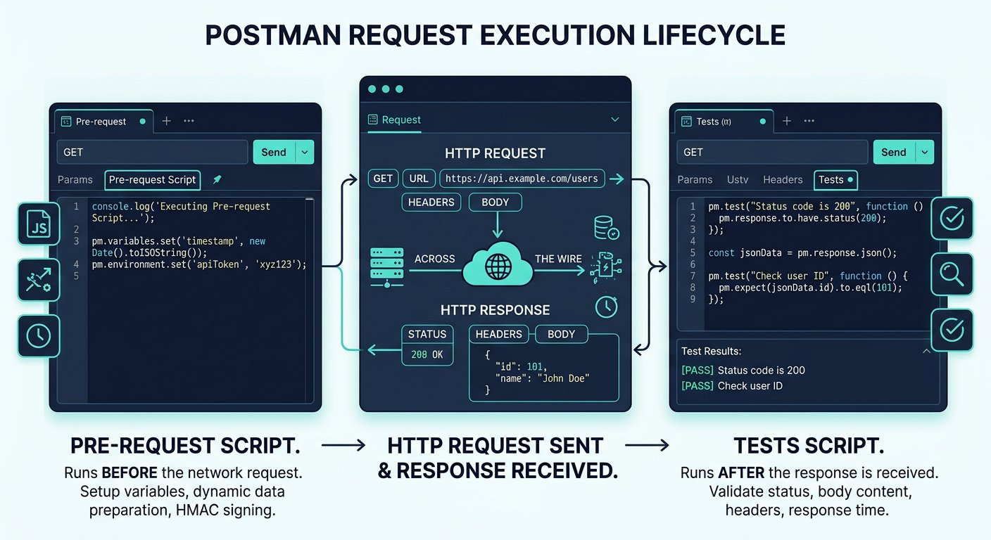
The complete three stage execution lifecycle of every Postman request.
1 Stage 1 (Pre request Script): Runs before the HTTP request is built. Ideal for calculating timestamps, generating unique numbers, and configuring headers.
2 Stage 2 (Network Transmission): The HTTP packet travels across the wire and the server returns status code, headers, and body.
3 Stage 3 (Tests Script): Runs immediately after the response arrives. This is where we write assertions to validate data.

Step 2: JavaScript Fundamentals for API Automation Engineers
Why do API automation engineers need JavaScript? Because Postman contains a full Node.js execution sandbox. Every time you write code in the Pre request Script or Tests tabs, Postman executes your JavaScript directly. Understanding fundamental language mechanics prevents subtle bugs in your test suites.

Try it yourself
- Loosely Typed Nature: In languages like Java or C#, you must declare types explicitly like int a = 4. In JavaScript, variables are loosely typed and determine their data type dynamically at runtime.
- The typeof Operator: To inspect any variable type, use typeof. In JavaScript, both integers and floating point decimals share a single data type called number. Other primary types include string, boolean, null, and undefined.
- The Three Variable Keywords: Modern JavaScript provides var, let, and const. Knowing their exact differences is vital for reliable test scripting.

Comparing JavaScript Variable Keywords: var vs let vs const
Keyword | Scope Boundary | Allows Redeclaration? | Allows Reassignment?
var | Function or Global Scope (leaks out of if blocks) | Yes (can accidentally overwrite existing variables) | Yes
let | Block Scope (confined strictly within braces { }) | No (prevents accidental naming collisions) | Yes (ideal for counters and mutable accumulators)
const | Block Scope (confined strictly within braces { }) | No (immutable reference) | No (ideal for holding parsed JSON responses and fixed configs)
Classic Interview Trap: Negating a Constant in an If Condition
Consider a constant boolean flag: const isAvailable = true;. What happens if you write if (!isAvailable) { ... }?
Does the exclamation mark negation operator throw an error because the variable was declared with const?
No! The negation operator inverts the boolean evaluation of the expression for that comparison, but does not alter the stored variable value. The variable remains true in memory while the expression evaluates to false.
When structuring test logic, modern JavaScript uses arrow functions for concise syntax:

The code
javascript-basics-for-testers.js
1 // Modern arrow function vs traditional function declaration
2 const addNumbers = (first, second) => first + second;
3
4 // Checking data types with typeof
5 const bookTitle = "Zero to Agentic API Testing";
6 const price = 49.99;
7 const isAvailable = true;
8
9 console.log(typeof bookTitle); // prints "string"
10 console.log(typeof price); // prints "number"
11 console.log(typeof isAvailable); // prints "boolean"

Step 3: Anatomy of the pm.test Function
To register an automated test case in Postman, we use the pm.test wrapper function with a description string and an assertion callback.

The code
first-assertion.js
1 // Line 1: Define the test name shown in the Test Results tab
2 pm.test("Status code is 200 OK", function () {
3 // Line 2: The actual condition that must be true for the test to pass
4 pm.response.to.have.status(200);
5 });
Micro Chunk Breakdown: Understanding the 3 Lines
• Line 1: pm.test("...", function () { tells Postman to register a new test card in the Test Results panel with your chosen label.
• Line 2: pm.response.to.have.status(200); is the assertion. If the server returned 200, the test turns GREEN. If the server returned 404 or 500, it turns RED and displays the discrepancy.
• Line 3: }); cleanly closes the JavaScript callback function block.

Step 4: Drilling into Response Bodies and Validating Headers
To automate our validation of the AddBook response from Chapter 4, we break down our assertions into three focused chunks:
Automating the AddBook Response Validation
Each chunk asserts a distinct architectural layer of the response packet:
CHUNK 1: Chunk 1: Status Code Assertion · Verifying Wire Status
Asserts that the server answered with HTTP 200 OK, confirming the AddBook operation was accepted.
status-assertion.js
1 pm.test("Status code is 200 OK", function () {
pm.response.to.have.status(200);
});
Rule: Always verify status code first before parsing response body properties.
CHUNK 2: Chunk 2: Headers and Latency Budget · Enforcing Envelope Contract
Confirms the payload is encoded in JSON and arrived within the 1200 millisecond performance budget.
header-latency.js
1 pm.test("Header is JSON and latency under 1200ms", function () {
pm.response.to.have.header("Content-Type");
pm.expect(pm.response.headers.get("Content-Type")).to.include("application/json");
pm.expect(pm.response.responseTime).to.be.below(1200);
});
Rule: Testing latency budgets protects against silent database index degradation.
CHUNK 3: Chunk 3: Deep JSON Body Validation · Validating Payload Properties
Defensively inspects both lowercase msg and uppercase Msg keys, and confirms the generated ID is a valid string.
body-assertion.js
1 pm.test("Response contains successfully added message", function () {
const responseData = pm.response.json();
pm.expect(responseData.msg || responseData.Msg).to.include("successfully added");
pm.expect(responseData.ID).to.be.a("string");
});
Rule: Defensive assertions protect suites against casing inconsistencies across microservices.
IMAGINE & PREDICT BEFORE SENDING
If the server takes 145 ms and returns { "Msg": "successfully added", "ID": "9781227" } with status 200 OK, what will the Test Results tab display?
A. PASS 3 of 3: Three green checkmarks confirming status, header, and body message
B. FAIL: Because the server response did not include a timestamp
C. ERROR: Because Postman cannot check string inclusion
D. TIMEOUT: Because latency was measured in milliseconds
Actual Output (AddBook Assertion Test Results Confirmation): All three assertions pass green! Postman confirmed the 200 status, validated latency was 145 ms (well below 1200 ms), and confirmed that Msg included "successfully added" with a valid ID string!
Fresher Trap to Avoid: Forgetting Parentheses on json()
A very common mistake is typing const data = pm.response.json; instead of const data = pm.response.json();.
Without parentheses, JavaScript returns a reference to the function definition rather than executing it to parse the payload. When you then try to read data.msg, your test script crashes with undefined!
Always include parentheses: pm.response.json() to invoke the JSON parser.

Step 5: JSON Schema Validation with Ajv
JSON Schema validation checks the entire structural contract: verifying that required fields exist and data types remain stable across server releases. Because each endpoint has its own specific contract, we write each schema validation script in that endpoint own Tests tab in Postman.

The code
addbook-schema-tests.js
1 // Placed in the Tests tab of AddBook (POST /v1/books)
2 const addBookSchema = {
3 type: "object",
4 required: ["Msg", "ID"],
5 properties: {
6 Msg: { type: "string" },
7 ID: { type: "string" }
8 }
9 };
10
11 pm.test("AddBook response matches strict JSON Schema", function () {
12 pm.response.to.have.jsonSchema(addBookSchema);
13 });

The code
deletebook-schema-tests.js
1 // Placed in the Tests tab of DeleteBook (POST /v1/books/delete)
2 const deleteBookSchema = {
3 type: "object",
4 required: ["msg"],
5 properties: {
6 msg: { type: "string" }
7 }
8 };
9
10 pm.test("DeleteBook response matches strict JSON Schema", function () {
11 pm.response.to.have.jsonSchema(deleteBookSchema);
12 });
Production Reality: Spotting Casing Disparities Across Endpoints
Notice an essential production detail between our two library endpoints:
• AddBook returns uppercase Msg: { "Msg": "successfully added", "ID": "9781227" }.
• DeleteBook returns lowercase msg: { "msg": "book is successfully deleted" }.
If your test script checked for lowercase msg on the AddBook endpoint, your assertion would fail immediately! Real enterprise services are built by different teams over time. Always inspect the live wire response before writing strict JSON schemas.
WAR ROOM BATTLE SCAR · Silent Production Bug Outage
The Silent False Positive Trap: The Danger of Assertions Without Matchers
During an enterprise retail migration, thousands of automated tests ran green across CI CD pipelines. Yet, immediately after deployment, customers could not add items to their shopping cart. An engineering audit discovered the test script was written as: pm.test("Item added", function() { pm.response.json().status === "success"; }). Because the triple equal expression returned true or false without passing it to a Chai matcher or throwing an error, the Postman test sandbox recorded every test as passed green, even when the server returned an error!
Key Architectural Lesson: Never write bare boolean expressions inside pm.test. Assertions must use pm.expect or pm.response.to.have matchers that explicitly throw errors on mismatch so failing contracts turn the quality gate red.
WAR ROOM INCIDENT TRIAGE
War Room Triage: The False Positive Green Gate Incident
The CI pipeline runs 120 automated Postman tests and all 120 report green checkmarks. Ten minutes later, customers report that user registration is broken. When inspecting the test script for registration, you see: pm.test("Status is 200", function () { pm.response.status; }). Why did this test report green while production crashed?
A. Postman ignores HTTP status codes when running inside automated pipelines.
B. The statement pm.response.status accesses the status number but performs no comparison matcher or error throw, so the function exited cleanly without failing.
C. The backend database intercepted the test runner and returned simulated success headers.
D. The test script requires a semicolon after every bracket to trigger failures.
TACTICAL TRIUMPH: A test only fails when an exception is thrown! Accessing pm.response.status without an assertion matcher like pm.response.to.have.status(200) simply evaluates a number in memory and exits cleanly. The test runner saw zero errors and falsely marked the test green.

Step 6: Review and Practice
MAKE A GUESS
Which Postman object is the unified gateway to access request metadata, response data, and test runner assertions?
- A. The request object
- B. The pm object
- C. The testSuite object
- D. The chai object
Answer: The pm object. The pm object is the universal namespace in modern Postman. It consolidates request parameters, response data (pm.response), test creation (pm.test), and assertion logic (pm.expect).

Check your understanding
1. What is the primary difference between let and const in Postman test scripts?
Answer: Variables declared with let can be reassigned new values during iteration, whereas const variables cannot be reassigned once initialized.
2. Why should performance tests check response latency with to.be.below() rather than exact equality?
Answer: Network latency fluctuates on every call. Asserting that responseTime is below a budget verifies performance consistently without false failures.

Key takeaways
REMEMBER
- Postman runs an embedded Node.js sandbox that executes your JavaScript code in Pre request and Tests scripts.
- Use const for immutable references like parsed JSON bodies, and let for mutable counters and accumulators.
- Automated assertions replace manual visual inspection, running in milliseconds to catch regressions instantly.
- The pm.test wrapper takes a description string and an executable callback function containing Chai assertions.
⚡ MISSION 2 PHASE 2 CLEARED · Architectural Triumph: Autonomous JavaScript Assertion Engine Armed
You fired up the embedded Node.js sandbox, banished manual visual inspections forever, and transformed raw responses into razor sharp automated assertions. With Chai BDD matchers, sub second latency budgets, and JSON Schema validation, your tests now execute with mathematical precision in milliseconds.
Tactical Superpowers Mastered:
- Authoring robust Chai BDD assertions using pm.test and pm.expect without syntax ambiguity
- Enforcing microsecond to millisecond latency budgets to prevent backend performance degradation
- Validating wire security headers (Content Type, Cache Control, CORS) on every response packet
- Executing contract level structural verification using strict JSON Schema definitions and Ajv matchers
Enterprise Disasters Prevented:
- Eliminated human verification fatigue where missed null fields trigger downstream frontend crashes
- Stopped memory leaking, slow database queries from sneaking past QA by enforcing response time ceilings
- Prevented silent payload schema mutations from reaching production unnoticed by automated pipelines
War Room Takeaway: An unasserted API test is just a hollow ping. The moment you combine status checks, property assertions, and schema validation, you hold an unbreakable contract guarantee.
NEXT DISCOVERY · Continuing Mission 2: Eliminating hardcoded URLs and ISBNs
Our assertions are written, but our URLs and ISBN values are still hardcoded. In Chapter 6, we advance Mission 2: creating dynamic environments and generating random unique ISBNs in Pre request scripts!

Chapter 6: Managing Variables Across the Five Scopes
The five variable tiers, precedence rules, dynamic environment switching, and unique ISBN generation.
MISSION COMMAND HUD
PHASE: Phase 3 of 5: Variable Scopes & Environments · RANK: Rank: Senior Automation Engineer
ACTIVE MISSION: Mission 2: Automating Student and Campus Services at Scale
MISSION BRIEFING & CHAPTER ROADMAP
MISSION 2 · PHASE 3 OF 6: Automating Student and Campus Services at Scale
CRISIS SCENARIO: Dynamic Environment Isolation and Unique State Generation
Context: Hardcoded test data causes severe test flakiness. If your test suite uses a hardcoded ISBN, running the suite a second time triggers a duplicate book collision error and fails the test. Furthermore, running tests against production instead of staging by mistake can corrupt live data. We must master the five variable scopes, switch environments dynamically, and generate collision free unique IDs.
Operational Target: Implement the 5 variable scopes, configure QA vs UAT environments, and generate dynamic unique ISBNs in Pre request scripts.

WE WILL ACHIEVE: Eliminate hardcoded URLs and duplicate key collisions by mastering the five variable tiers, dynamic environment switching, and collision safe dynamic generation.
HOW WE WILL DO IT: Map variable precedence from Local to Global, safeguard secrets using Initial versus Current values, generate unique runtime ISBNs in Pre request scripts, and analyze collision mathematics.
WHAT YOU WILL CARRY FORWARD: A parameterized environment and dynamically generated variable keys that seamlessly feed the downstream request chaining pipeline in Chapter 7.
MISSION PROGRESS · Continuing Mission 2: Eliminating Hardcoded URLs and Collision Errors
Our assertions in Chapter 5 run fast, but our collection still has hardcoded server URLs and hardcoded ISBN values that cause duplicate collision errors on every second run. Our next step in Mission 2 is parameterizing our test suite: learning the five variable scopes, switching environments with one click, and generating dynamic unique ISBNs in Pre request scripts.

Step 1: The Five Variable Scopes Hierarchy
ARCHITECTURE · Postman Variable Scopes Hierarchy: Precedence and Scope Boundaries
SCOPE ARCHITECTURE · Postman Variable Scopes Hierarchy: Precedence and Scope Boundaries
Imagine your college campus. You have your personal student ID card in your pocket (Local Scope), your class attendance register (Data Scope), your college campus WiFi settings (Environment Scope), your department syllabus (Collection Scope), and universal constants (Global Scope). Postman organizes variables across these five tiers with strict precedence rules: narrower scopes override broader scopes whenever variable names match.
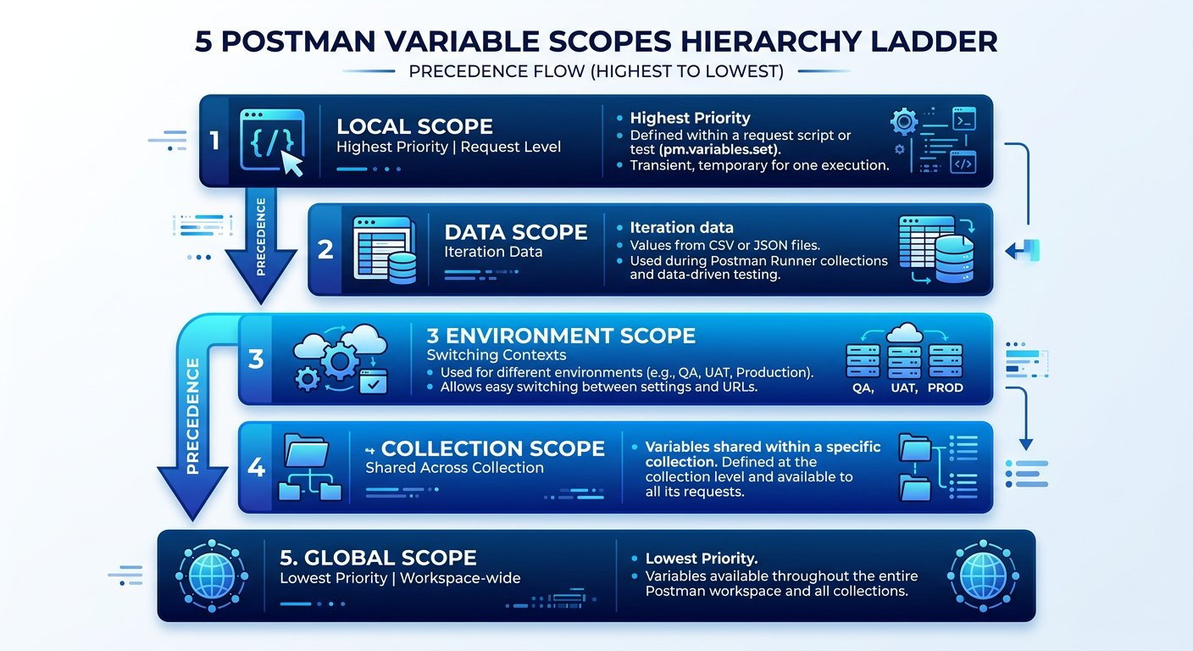
The five variable scopes in Postman and their order of precedence.
1 Local Scope (Highest Priority): Temporary variables declared inside a single request script.
2 Data Scope: Values supplied by external data files (such as CSV or JSON) during iterations.
3 Environment Scope: Key value pairs tied to a specific deployment stage (QA, UAT, Production).
4 Collection Scope: Variables shared across all requests inside one specific collection folder.
5 Global Scope (Lowest Priority): Universal constants accessible across all collections and environments.
The Five Postman Variable Tiers Explained
When multiple variables share the exact same key name, Postman resolves conflicts by choosing the narrowest scope. Here is the operational role of each tier:
PILLAR 1: Scope 1: Local · Temporary In Script Variables
Exists exclusively while the active script is executing. Overrides every other scope in Postman.
• pm.variables.set("tempId", 101): Scoped strictly to the immediate request run.
• Disappears from memory as soon as the request completes.
PILLAR 2: Scope 2: Data · External Dataset Row Variables
Supplied by external CSV or JSON test data files during automated Collection Runner runs.
• pm.iterationData.get("isbn"): Reads the specific value from the current dataset row.
• Each iteration pulls fresh data automatically.
PILLAR 3: Scope 3: Environment · Infrastructure Stage Configuration
Configures target hostnames and ports for specific deployment stages like Local, QA, and UAT.
• pm.environment.set("base_url", "..."): Switched instantly with the environment dropdown.
• Initial values sync to team cloud; current values stay local to your machine.
PILLAR 4: Scope 4: Collection · Test Suite Level Variables
Variables shared across every folder and request inside one specific Postman collection.
• pm.collectionVariables.set("suiteToken", "..."): Accessible by all requests in the collection.
• Ideal for generated IDs passed between consecutive steps.
PILLAR 5: Scope 5: Global · Workspace Wide Constants
Universal settings accessible across all collections and environments within the workspace.
• pm.globals.set("companyDomain", "..."): Lowest precedence in the hierarchy.
• Easily overridden by environment or collection variables with the same name.

Step 2: Switching Environments with Double Curly Braces
Referencing any variable inside a URL, query parameter, header, or JSON body requires wrapping the variable name in double curly braces: {{variable_name}}. You can import the pre configured QA environment directly: [Download Campus Library QA Environment](/materials/zero-to-agentic-api-testing/Campus-Library-QA.postman_environment.json) or [Raw GitHub File](https://raw.githubusercontent.com/mayankcoder1993/AkshatEbooks/arena/01a0bfe5-akshatebooks/course-materials/zero-to-agentic-api-testing/Campus-Library-QA.postman_environment.json).

Environment Configuration for Library API Targets
Environment Name | Variable Key | Resolved Base URL Value | Purpose
QA Environment | base_url | https://qa-api.campuslibrary.org | Fast internal server cluster used for testing new features.
UAT Environment | base_url | https://uat-api.campuslibrary.org | User Acceptance Testing mirror simulating live traffic.
Initial Value vs Current Value Security Mechanics
• Initial Value: Synced to Postman cloud servers and included in team exports. Use this for templates, never real passwords.
• Current Value: Kept strictly in local session memory. Scripts update it dynamically at runtime without leaking secrets.

Step 3: Generating Unique ISBNs in Pre request Scripts
To avoid the duplicate book already exists bug we uncovered in Chapter 4, we write a Pre request script to generate a unique random ISBN on every single run:
Dynamic ISBN Generation Script
Executed before the HTTP request leaves the computer:
CHUNK 1: Chunk 1: Fetching Base Prefix · Reading Global Scope
Reads the shared company code prefix from Global Scope, defaulting to LIB if unset.
prefix-lookup.js
1 const companyCode = pm.globals.get("company_code") || "LIB";
Rule: Global variables provide universal defaults across collections.
CHUNK 2: Chunk 2: Random Number Generation · Generating Non Colliding Key
Produces a random four digit number (e.g. 4821) and appends it to form LIB4821.
random-generator.js
1 const randomDigits = Math.floor(1000 + Math.random() * 9000);
const uniqueISBN = companyCode + randomDigits;
Rule: Combining random values with timestamps reduces collisions, but teardown remains essential.
CHUNK 3: Chunk 3: Saving to Collection Variable · Binding to Collection Tier
Saves the fresh key so the request body placeholder {{ISBN}} can interpolate it at runtime.
save-variable.js
1 pm.collectionVariables.set("ISBN", uniqueISBN);
Rule: Collection tier keeps generated data accessible to all downstream requests.
The Birthday Paradox: Why Naive Random Numbers Collide in CI CD
Why not simply generate a random 4 digit integer between 1000 and 9999? Consider the mathematics of the Birthday Paradox.
With only 9,000 possible 4 digit values, probability theory dictates that after just 112 test executions, there is a 50 percent chance that two runs generate the exact same number! In an automated continuous integration pipeline running 20 builds daily, collisions will inevitably cause false negative test failures within days.
To achieve collision resistance, combine multiple entropy sources: a timestamp like Date.now(), or Postman built in dynamic variables like {{$randomISBN}} and {{$randomInt}}.
Crucial Automation Law: Even with collision resistant generation, automated teardown via DeleteBook is mandatory. Relying on randomness alone leaves orphaned records that bloat database indexes and corrupt catalog counts over time.
IMAGINE & PREDICT BEFORE SENDING
If uniqueISBN generates "LIB7824" and the request payload is { "isbn": "{{ISBN}}" }, what raw text does Postman transmit over the wire?
A. The literal string { "isbn": "{{ISBN}}" } with curly braces
B. The interpolated value { "isbn": "LIB7824" } with curly braces replaced by the variable value
C. An empty string { "isbn": "" } because variables require quotes
D. A syntax error because Postman does not support curly braces in JSON
Actual Output (Wire Interpolation Confirmation): Postman resolves the variable! Before sending the network packet, Postman replaces {{ISBN}} with the current runtime value "LIB7824", transmitting clean JSON to the server.
Fresher Trap to Avoid: Mismatched Variable Casing and Typo Bugs
JavaScript variable keys in Postman are strictly case sensitive.
If your Pre request script writes pm.collectionVariables.set("ISBN", ...) in capital letters, but your JSON payload body looks for {{isbn}} in lowercase, Postman will NOT find the variable and will send an empty string or the literal text "{{isbn}}" to the server!
Always ensure exact matching casing between the variable key saved in your script and the placeholder wrapped in double curly braces.
WAR ROOM BATTLE SCAR · Environment Misconfiguration Outage
The Production Database Overwrite Outage: The Danger of Ambiguous Variable Scopes
An engineering team ran an automated load test suite intended for the staging cluster. However, the collection contained a global variable baseUrl set to the production cluster, while the staging environment variable had a subtle spelling mismatch (base_url vs baseUrl). Because of the variable precedence hierarchy and naming discrepancy, Postman defaulted to the global production URL. Within minutes, the automated test inserted fifty thousand fictitious student test accounts directly into the live production database!
Key Architectural Lesson: Never define production server hostnames in global variables. Always isolate target server environments strictly and verify variable resolution in the Postman Console before triggering automated test runs.
WAR ROOM INCIDENT TRIAGE
War Room Triage: The Mystery of the Overridden Variable
You select the "QA Environment" in Postman where timeout is set to 5000 milliseconds. But when you click Send, your test script fails after only 100 milliseconds with a timeout exception. When inspecting your collection, you discover a script with: pm.variables.set("timeout", 100). Why did Postman ignore your 5000 millisecond environment setting?
A. Postman environments do not work when running single requests manually.
B. Local script scope variables created via pm.variables.set have higher precedence than environment variables and override them during execution.
C. The QA server database rejected the timeout header because it was too large.
D. Environment variables only apply to request URLs, not to script logic.
TACTICAL TRIUMPH: Local scope overrides environment scope! The Postman variable hierarchy prioritizes Local variables above Data, Environment, Collection, and Global tiers. The in script variable took precedence, causing the early timeout.

Step 4: Review and Practice
MAKE A GUESS
If a variable with the exact same name is defined in both Collection scope and Local script scope, which value takes precedence?
- A. Collection scope value
- B. Local script scope value
- C. Postman throws a duplicate variable error
- D. Global scope value
Answer: Local script scope value. Local scope has the highest priority of all five scopes. A local variable defined inside a script will always override collection, environment, and global variables with the same name.

Check your understanding
1. What are the five variable scopes in order from highest precedence to lowest precedence?
Answer: Local (highest) > Data > Environment > Collection > Global (lowest).
2. Why must dynamic ISBN generation logic be placed in the Pre request Script tab instead of the Tests tab?
Answer: The Pre request Script tab executes before the request payload is constructed. The Tests tab executes only after the response has already returned from the server.

Key takeaways
REMEMBER
- Variables eliminate hardcoded server URLs and prevent duplicate data collisions.
- Postman supports five scopes: Local, Data, Environment, Collection, and Global.
- Use double curly braces {{variable_name}} to reference variables anywhere in requests.
- Initial values sync to the cloud; Current values stay local for secure runtime execution.
⚡ MISSION 2 PHASE 3 CLEARED · Architectural Triumph: Multi Scope Hierarchy & Dynamic Data Engine Deployed
You shattered hardcoded server URLs and eliminated duplicate database constraint collisions forever. By mastering the 5 variable scopes, scope precedence rules, and runtime Pre request scripting, your test suites now adapt seamlessly across QA, UAT, and Staging without a single manual edit.
Tactical Superpowers Mastered:
- Navigating the 5 variable scopes hierarchy: Local, Data, Environment, Collection, and Global with zero conflict ambiguity
- Parameterizing network calls using double curly brace syntax {{base_url}} across URLs, headers, and payloads
- Generating dynamic unique primary keys at runtime using Pre request scripts and Postman dynamic tokens
- Guarding enterprise credentials using Initial Value vs Current Value memory isolation
Enterprise Disasters Prevented:
- Averted catastrophic accidental execution of destructive test scripts against live Production databases
- Blocked confidential API keys and client secrets from leaking to public GitHub repositories via team exports
- Eliminated duplicate ISBN collision failures that halt automated regression test runs in CI pipelines
War Room Takeaway: Hardcoded test data is a ticking time bomb. The moment your tests generate their own unique identities and dynamically resolve their target environment, they become truly portable and unstoppable.
NEXT DISCOVERY · Continuing Mission 2: Assembling the autonomous pipeline
We now generate dynamic ISBNs and switch between QA and UAT seamlessly. But when AddBook creates a book ID, we still need to pass it to GetBook and DeleteBook. In Chapter 7, we advance Mission 2: automatically piping response data downstream with Request Chaining!

Chapter 7: Request Chaining and Complex Nested JSON Parsing
Automated property transfer, navigating nested object hierarchies, array methods, and mathematical calculations.
MISSION COMMAND HUD
PHASE: Phase 4 of 5: Dynamic Request Chaining & Array Pipelines · RANK: Rank: Automation Pipeline Architect
ACTIVE MISSION: Mission 2: Automating Student and Campus Services at Scale
MISSION BRIEFING & CHAPTER ROADMAP
MISSION 2 · PHASE 4 OF 6: Automating Student and Campus Services at Scale
CRISIS SCENARIO: Autonomous Request Chaining and Multilevel JSON Traversal
Context: Real world workflows do not exist in isolation: data produced by one request must be consumed by the next. In the library catalog, AddBook generates a composite ID that must be dynamically captured and passed into GetBook and DeleteBook. Furthermore, enterprise responses contain deeply nested objects and arrays that require mathematical verification.
Operational Target: Chain AddBook, GetBook, and DeleteBook dynamically, parse nested JSON responses, and aggregate array data with JavaScript methods.

WE WILL ACHIEVE: Build an autonomous multi request testing pipeline by capturing dynamic IDs, piping them into downstream requests, and verifying nested JSON structures and array mathematics.
HOW WE WILL DO IT: Chain AddBook to GetBook and DeleteBook using collection variables, assert exact catalog fields without assuming unreturned properties, and master find, filter, map, and reduce in an advanced audit lab.
WHAT YOU WILL CARRY FORWARD: An end to end chained pipeline that creates, validates, and cleans up records autonomously, ready for multi row data driven execution in Chapter 8.
MISSION PROGRESS · Continuing Mission 2: Assembling the Autonomous Pipeline
Our AddBook request is now parameterized and unique, but we are still manually copying the generated book ID into GetBook and DeleteBook. Our next step in Mission 2 is assembling an autonomous regression pipeline: capturing the response ID automatically, passing it downstream via environment variables, navigating complex nested JSON structures, filtering and mapping arrays, and validating business calculations across multi step transactions.

Step 1: The Three Stage Request Chaining Pipeline
ARCHITECTURE · Dynamic Request Chaining: Passing Identity Between Dependent Calls
REQUEST PIPELINE · Dynamic Request Chaining: Passing Identity Between Dependent Calls
By storing dynamic outputs into variables, a collection can execute dozens of interdependent requests in complete harmony. Subsequent requests consume dynamic keys in their URLs, headers, or request bodies automatically, eliminating all manual copy paste intervention.
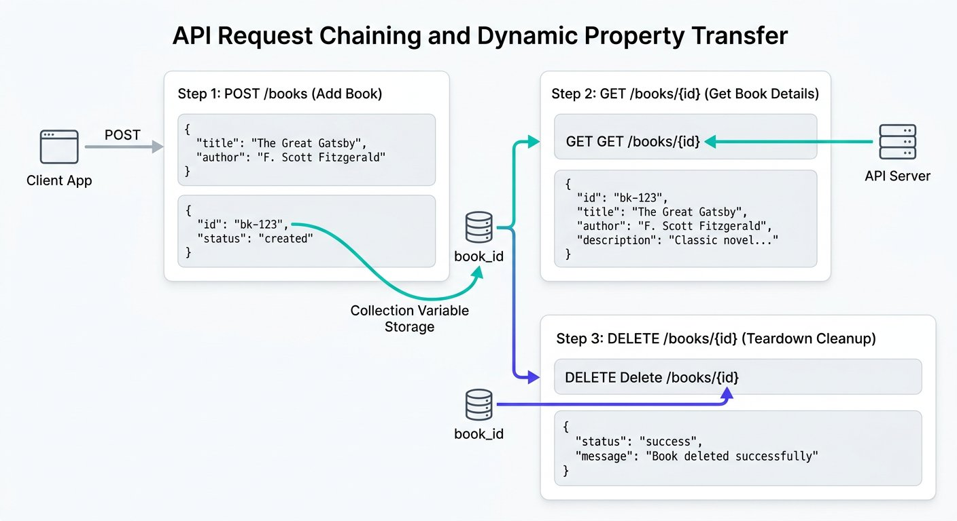
The autonomous property transfer pipeline across three chained requests.
1 Step 1 (AddBook POST): Dispatches dynamic payload. Tests script extracts generated ID into collection variable book_id.
2 Step 2 (GetBook GET): Injects {{book_id}} into query params and asserts that the cataloged book name, ISBN, and aisle match the created record.
3 Step 3 (DeleteBook POST): Reads {{book_id}} in the payload body and asserts that the record is completely removed from the database.

Step 2: Capturing and Storing the ID in AddBook
In the Tests tab of AddBook, parse the response JSON and save the generated ID into a variable so downstream requests can immediately read it. We break this property transfer down into three chunks:
Automated Property Transfer Mechanics
Extracting data from responses and passing downstream:
CHUNK 1: Chunk 1: Parsing Incoming Payload · Deserializing JSON Text
Converts the raw text into a navigable JavaScript object.
parse-response.js
1 const responseData = pm.response.json();
Rule: Always deserialize before property lookups.
CHUNK 2: Chunk 2: Extracting Generated Key · Defensive Property Extraction
Validates that the ID key exists and holds a valid string before attempting to save.
extract-property.js
1 const generatedId = responseData.ID;
pm.expect(generatedId, "Generated ID").to.not.be.undefined;
Rule: Defensive validation prevents saving undefined into variables.
CHUNK 3: Chunk 3: Persisting to Collection Tier · Binding to Shared Scope
Stores the ID in Collection Scope so subsequent requests can interpolate {{book_id}}.
persist-variable.js
1 pm.collectionVariables.set("book_id", generatedId);
Rule: Collection tier makes variables universally accessible to all folder requests.
IMAGINE & PREDICT BEFORE SENDING
When AddBook completes and GetBook executes with URL: GET /v1/books?id={{book_id}}, what value does Postman send across the network wire?
A. The exact composite ID string (such as "LIB4821227") dynamically extracted from the AddBook response
B. The literal placeholder text "{{book_id}}"
C. An empty query parameter ?id=
D. A null pointer exception
Actual Output (Dynamic Chaining Wire Confirmation): Property transfer confirmed! Postman resolves {{book_id}} from Collection Scope, replacing the placeholder with the dynamic composite ID value (LIB4821227) before dispatching the HTTP GET request!

Step 3: Handling JSON Arrays and Validating ID Calculation
GetBook returns a JSON array. In JavaScript, access the first record using zero index bracket notation: booksList[0].book_name. Because these assertions validate different points in the lifecycle, we separate them into their respective request Tests tabs in Postman:

The code
addbook-tests.js
1 // Placed in the Tests tab of AddBook (POST /v1/books)
2 const requestPayload = JSON.parse(pm.request.body.raw);
3 const expectedCompositeId = requestPayload.isbn + requestPayload.aisle;
4 const responsePayload = pm.response.json();
5
6 pm.test("Backend generated ID correctly concatenates ISBN and aisle", function () {
7 pm.expect(responsePayload.ID).to.eql(expectedCompositeId);
8 });
9
10 // Store composite ID in collection variable for downstream requests
11 pm.collectionVariables.set("book_id", responsePayload.ID);

The code
getbook-tests.js
1 // Placed in the Tests tab of GetBook (GET /v1/books?id={{book_id}})
2 const booksList = pm.response.json();
3
4 pm.test("GetBook returns valid array with matching catalog metadata", function () {
5 pm.expect(booksList).to.be.an("array").with.lengthOf.atLeast(1);
6 pm.expect(booksList[0].book_name).to.eql("Zero to Agentic API Testing");
7 pm.expect(booksList[0].isbn).to.eql(pm.collectionVariables.get("ISBN"));
8 pm.expect(booksList[0].aisle).to.eql("227");
9 });
Contract Precision: Why Author is Omitted from GetBook
Notice that GetBook returns an array containing book_name, isbn, and aisle. The author field supplied during AddBook is not included in this endpoint response.
If you wrote pm.expect(booksList[0].author).to.eql("Alex Mercer"), your test would crash with an undefined failure.
Never assert fields based on wishful thinking: assert strictly against what the API contract promises.

Step 4: Navigating Complex Nested JSON and Array Methods
Real enterprise APIs rarely return flat, simple objects. Instead, responses contain nested hierarchies with multiple layers of parent objects, metadata summaries, and arrays of detailed items. Consider the Campus Library department audit endpoint below. You can download the sample payload: [Download Department Audit Response JSON](/materials/zero-to-agentic-api-testing/lesson-07/department-audit-response.json):

The code
nested-department-response.json
1 {
2 "department": "Computer Science and Systems",
3 "budget": {
4 "total_allocated": 1500,
5 "currency": "USD"
6 },
7 "books": [
8 {
9 "id": "BK101",
10 "title": "Full Stack API Automation",
11 "author": "Dr. Sarah Chen",
12 "price": 45,
13 "copies": 12,
14 "tags": ["api", "testing", "javascript"]
15 },
16 {
17 "id": "BK102",
18 "title": "Postman Architecture Patterns",
19 "author": "Marcus Vance",
20 "price": 55,
21 "copies": 8,
22 "tags": ["postman", "architecture"]
23 },
24 {
25 "id": "BK103",
26 "title": "Distributed Systems Reliability",
27 "author": "Elena Rostova",
28 "price": 65,
29 "copies": 8,
30 "tags": ["cloud", "reliability"]
31 }
32 ]
33 }
Four Essential JavaScript Array Methods for API Testers
• find(): Searches an array and returns the very first element matching a boolean condition.
• filter(): Scans the entire array and returns a new array containing all elements that satisfy the condition.
• map(): Transforms every element into a new representation, such as plucking a single property from an object array.
• reduce(): Iterates through an array while accumulating a running total, ideal for verifying mathematical sums.
ARCHITECTURE · JavaScript Array Transformation Pipeline: Filtering, Mapping, and Aggregating
DATA TRANSFORMATION · JavaScript Array Transformation Pipeline: Filtering, Mapping, and Aggregating
Modern enterprise APIs deliver deep hierarchical payloads. Understanding how find, map, filter, and reduce transform JSON arrays allows automation engineers to locate specific records, compute expected financial aggregates, and assert mathematical integrity across entire catalogs.
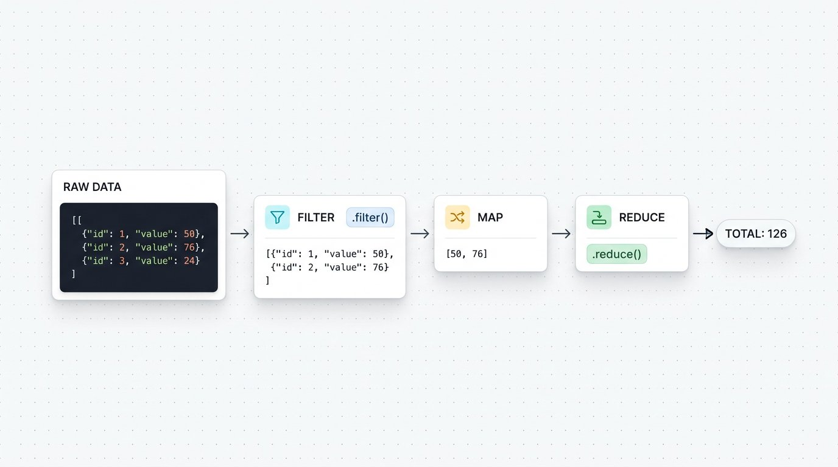
The JavaScript Array Transformation Pipeline: Filtering, mapping, and reducing nested API data.
1 Stage 1 (Raw JSON Array): The incoming API response delivers an array of book objects containing titles and unit prices.
2 Stage 2 (Filter Stage): books.filter() scans the array and extracts only items matching the condition (books priced above 30 dollars), discarding non matching records.
3 Stage 3 (Map Stage): filteredBooks.map() transforms each item into a formatted line item object with calculated item totals.
4 Stage 4 (Reduce Stage): mappedItems.reduce() accumulates each item total into a single running total, producing the final invoice sum of 126.

Step 5: Writing Advanced Assertions: Finding, Filtering, and Summing
Here is how we use these modern JavaScript methods inside Postman test scripts to verify complete schemas, locate target records, and validate mathematical integrity. You can download the script: [Download Advanced Array Assertions Script](/materials/zero-to-agentic-api-testing/lesson-07/advanced-array-assertions.js):

The code
advanced-nested-json-assertions.js
1 const responseData = pm.response.json();
2
3 // Test 1: Assert top level object and array size
4 pm.test("Department audit returns valid book records", function () {
5 pm.expect(responseData.department).to.eql("Computer Science and Systems");
6 pm.expect(responseData.books).to.be.an("array").with.lengthOf(3);
7 });
8
9 // Test 2: Locate a specific book using find() and assert all keys exist
10 pm.test("Locate Postman Architecture Patterns and verify its schema", function () {
11 const targetBook = responseData.books.find(book => book.title === "Postman Architecture Patterns");
12 pm.expect(targetBook, "Target book must exist").to.not.be.undefined;
13 pm.expect(targetBook.price).to.eql(55);
14 pm.expect(targetBook).to.have.all.keys("id", "title", "author", "price", "copies", "tags");
15 });
16
17 // Test 3: Extract titles using map() and filter premium books
18 pm.test("Verify premium collection and extracted titles", function () {
19 const titles = responseData.books.map(book => book.title);
20 pm.expect(titles).to.include("Full Stack API Automation");
21
22 const premiumBooks = responseData.books.filter(book => book.price >= 50);
23 pm.expect(premiumBooks.length).to.eql(2);
24 });
25
26 // Test 4: Calculate mathematical sum using reduce()
27 pm.test("Calculated purchase total matches allocated budget", function () {
28 const calculatedTotal = responseData.books.reduce(function (runningSum, book) {
29 return runningSum + (book.price * book.copies);
30 }, 0);
31
32 // (45 * 12 = 540) + (55 * 8 = 440) + (65 * 8 = 520) = 1500
33 pm.expect(calculatedTotal).to.eql(responseData.budget.total_allocated);
34 });
Fresher Trap to Avoid: Forgetting the Initial Value in reduce()
When using array.reduce() to calculate a sum, always provide 0 as the second argument: reduce(function(...) { ... }, 0);.
If you omit the 0, JavaScript sets the initial accumulator to the first object in the array rather than the number zero! Your addition will result in strange string concatenation errors like [object Object]440520 instead of 1500.
Always supply 0 as the starting number when accumulating mathematical totals.

Step 6: The Autonomous Library Lifecycle Pipeline
Now let us connect our entire automated library workflow into an unbroken, autonomous sequence in Postman:

Try it yourself
- 1. POST AddBook: Dispatches dynamic payload with generated ISBN. Tests script captures the created composite ID: pm.collectionVariables.set("book_id", jsonData.ID).
- 2. GET GetBook: Calls /v1/books?id={{book_id}}. Tests script confirms that book_name, isbn, and aisle match the created record.
- 3. POST DeleteBook: Dispatches /v1/books/delete with body {"ID": "{{book_id}}"}. Confirms deletion confirmation from server.
- 4. Advanced Side Lab (GET DepartmentAudit): Fetches the departmental inventory array and executes reduce() summation to verify fiscal budget totals.

Step 7: Executing the Suite with Collection Runner

Expected output
Terminal
1 $ Postman Collection Runner Execution Summary
2 1. POST AddBook: 200 OK (180 ms) : 2 of 2 passed (Captured book_id)
3 2. GET GetBook: 200 OK (145 ms) : 2 of 2 passed (Verified book_id {{book_id}})
4 3. POST DeleteBook: 200 OK (130 ms) : 1 of 1 passed (Teardown completed)
5 4. GET DepartmentAudit (Side Lab): 200 OK (185 ms) : 3 of 3 passed (Nested array sum verified)
6 Collection Run Complete: 4 requests, 8 assertions, 0 failures (640 ms)
WAR ROOM BATTLE SCAR · Order Processing Pipeline Failure
The Silent Null ID Disaster: The Perils of Unchecked Property Transfer
An online ticketing company deployed a microservice update that changed the confirmation key from id to order_id in their reservation endpoint. The downstream payment capture step in the automated test suite continued to look for data.id without defensive validation. The variable was set to undefined, and the payment API was called with: POST /v1/payments/capture?orderId=undefined. Because the payment API did not validate the parameter, thousands of transactions were recorded against a null order ID, requiring emergency database reconciliations.
Key Architectural Lesson: Always validate that dynamic properties exist before saving them to collection or environment variables. Defensive checks like pm.expect(data.id).to.not.be.undefined prevent corrupted downstream request pipelines.
WAR ROOM INCIDENT TRIAGE
War Room Triage: The Mystery of the Uncaught TypeError in Array Parsing
You are writing an assertion to verify the price of the third book in an audit response: pm.expect(data.department.courses[2].books[0].price).to.eql(45). The test runner throws a fatal error: "TypeError: Cannot read property books of undefined". What is the most likely structural defect in the response?
A. Postman does not support zero based array indexing.
B. The courses array contained only two elements, so courses[2] resolved to undefined, making .books an invalid property lookup.
C. The price field in JSON must always be wrapped in quotation marks.
D. Array methods in JavaScript cannot be executed inside the Tests tab.
TACTICAL TRIUMPH: Zero based index boundary overflow! In JavaScript, array indices start at 0. Therefore, the third item is at index 2. If the courses array contains only two courses (indices 0 and 1), courses[2] evaluates to undefined, and attempting to access .books throws a fatal TypeError. Always assert array length before indexing into nested elements!

Step 8: Review and Practice
MAKE A GUESS
If an API response returns an array of objects called courses, which JavaScript method finds the single course object whose title is "REST Automation"?
- A. courses.find(item => item.title === "REST Automation")
- B. courses.get("REST Automation")
- C. courses.locate("REST Automation")
- D. courses.filterOne("REST Automation")
Answer: courses.find(item => item.title === "REST Automation"). The find method evaluates each element in an array and returns the first element that satisfies the provided condition.

Check your understanding
1. What is property transfer in API test automation?
Answer: Property transfer is capturing dynamic values from an earlier API response and injecting them into downstream request parameters or payloads.
2. Why must enterprise regression suites include automated teardown cleanup requests?
Answer: Automated tests run continuously in CI CD pipelines. If tests do not delete the orders and products they create, test databases accumulate thousands of orphaned records, causing database bloat and false uniqueness failures.

Key takeaways
REMEMBER
- Request chaining connects isolated API calls into complete automated user journeys.
- Use environment variables to transfer identifiers across sequential requests.
- Use find to locate objects, filter to subset collections, and map to extract property lists.
- Use reduce to compute mathematical sums across nested arrays and assert business logic.
- Automated teardown steps clean up created resources, keeping test databases pure and idempotent.
⚡ MISSION 2 PHASE 4 CLEARED · Architectural Triumph: Deep Array Pipelines & Request Chaining Mastered
You linked disconnected HTTP requests into a living, breathing autonomous transaction pipeline. You extracted dynamic IDs, traversed multilevel nested objects without crash errors, performed high speed array transformations (find, filter, map), and mathematically verified financial balance totals using reduce. You operate at the highest echelon of API automation.
Tactical Superpowers Mastered:
- Dynamic property transfer: piping tokens, session cookies, and resource IDs across multi request suites
- Deep nested JSON parsing: safely traversing multilevel object trees and arrays without null reference exceptions
- Functional array pipelines: wielding find, filter, and map to isolate specific records in complex payloads
- Mathematical business logic verification: aggregating invoice and catalog totals dynamically using reduce
- Zero footprint test execution: deploying automated teardown deletions that leave databases perfectly pristine
Enterprise Disasters Prevented:
- Averted silent financial balance discrepancies by verifying computed cart totals against backend invoices
- Stopped catastrophic test database pollution where uncleaned test orders exhaust database storage and IDs
- Eliminated brittle hardcoded test suites that crash whenever upstream backend developers alter resource IDs
War Room Takeaway: Isolated API checks only test plumbing. Chained request pipelines test real world user journeys and business reality. When your chained suite passes, the entire business flow is guaranteed.
NEXT DISCOVERY · Continuing Mission 2: Scaling to bulk inventory
Our chained pipeline and nested assertions work cleanly for single and nested requests. But what if a shipment of 100 new books arrives in a CSV spreadsheet? In Chapter 8, we complete Mission 2: driving bulk automated execution using external CSV and JSON data files!

Chapter 8: Data Driven Testing with External Data Files
Powering automated iterations with CSV and JSON files, pm.iterationData, and debugging console traps.
MISSION COMMAND HUD
PHASE: Phase 5 of 5: Data Driven Scale (Mission Victory) · RANK: Rank: Enterprise Quality Architect
ACTIVE MISSION: Mission 2: Automating Student and Campus Services at Scale
MISSION BRIEFING & CHAPTER ROADMAP
MISSION 2 · PHASE 5 OF 6: Automating Student and Campus Services at Scale
CRISIS SCENARIO: Mass Ingestion: Data Driven Testing with External Datasets
Context: Testing one book at a time proves the contract works, but enterprise systems must ingest thousands of books across different genres and authors. Hardcoding individual test cases for every book is unmaintainable. We must decouple test logic from test data by driving automated iterations from external CSV and JSON data files.
Operational Target: Drive automated collection runner iterations using external CSV and JSON datasets with iterationData variables.

WE WILL ACHIEVE: Scale single request tests into bulk regression engines by driving automated iterations with external CSV datasets and mastering Data Scope precedence.
HOW WE WILL DO IT: Structure tabular test data, ingest row values using pm.iterationData, parameterize request bodies, and monitor iteration level execution scorecards.
WHAT YOU WILL CARRY FORWARD: The capability to execute high volume regression suites against external datasets, closing Mission 2 and preparing for complex e commerce workflows in Chapter 9.
MISSION PROGRESS · Completing Mission 2: Ingesting Bulk Inventory with External Data Files
Our chained pipeline in Chapter 7 tests a single book with complete autonomy. But this morning, the college bookstore received a shipment of 100 new textbooks in a CSV spreadsheet. Our final step in Mission 2 is implementing Data Driven Testing: loading books_data.csv into the Postman Collection Runner, iterating through every record row by row, and validating bulk ingestion at scale.

Step 1: The Data Driven Iteration Loop
ARCHITECTURE · Data Driven Testing Loop: Executing Parameterized Iterations
DATA DRIVEN TESTING · Data Driven Testing Loop: Executing Parameterized Iterations
In Data Driven Testing, your request sequence acts as a reusable engine. When you feed an external data file into the Collection Runner, Postman executes the entire collection once for every single row in the file, automatically binding values to data variables.
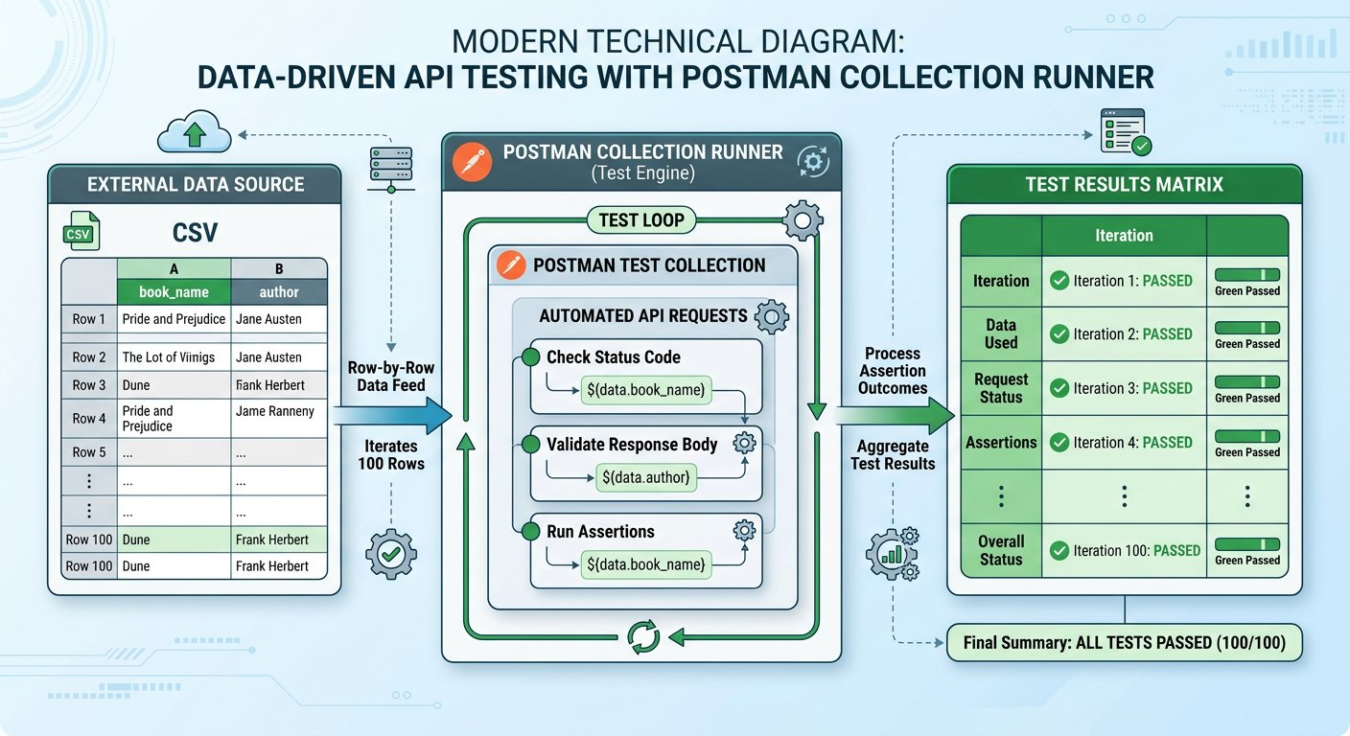
The Data Driven Testing loop executing multiple test iterations from one external file.
1 The External Dataset: A CSV or JSON document where column headers act as variable keys and each row contains distinct test values.
2 The Collection Runner Loop: Postman loads row 1, executes Pre request scripts, fires the request, and runs assertions. It then immediately repeats the cycle for row 2, row 3, and beyond.
3 The Iteration Scorecard: Results are tallied across all runs, reporting total passed assertions and pinpointing any failing records.

Step 2: Preparing the CSV Dataset and Ingesting Row Values
You can download the ready to use dataset directly: [Download books_data.csv](/materials/zero-to-agentic-api-testing/lesson-08/books_data.csv) or view the single file on GitHub: [Raw books_data.csv](https://raw.githubusercontent.com/mayankcoder1993/AkshatEbooks/arena/01a0bfe5-akshatebooks/course-materials/zero-to-agentic-api-testing/lesson-08/books_data.csv). Clicking the link opens only that individual file.

The code
books_data.csv
1 book_name,author,aisle
2 Learn Postman Testing,John Doe,101
3 Mastering Git and GitHub,Jane Smith,102
4 Modern Angular Architecture,Alex Mercer,103
During a collection run with a data file, Postman exposes Data Scope. In Pre request scripts, access row values with pm.iterationData.get(). We break down the data ingestion script into three chunks:
Ingesting CSV Rows into Request Payloads
Executed before each row request fires:
CHUNK 1: Chunk 1: Reading from Data Scope · Extracting Active Row Values
Reads the specific values from the columns of the active CSV row for this iteration.
read-row.js
1 const currentBook = pm.iterationData.get("book_name");
const currentAuthor = pm.iterationData.get("author");
Rule: Column headers in the CSV must match the string passed to get().
CHUNK 2: Chunk 2: Promoting to Collection Variables · Making Data Available to Request Body
Stores row values in Collection Scope so request body placeholders {{book_name}} can interpolate them.
promote-vars.js
1 pm.collectionVariables.set("book_name", currentBook);
pm.collectionVariables.set("author_name", currentAuthor);
Rule: Double curly brace placeholders read values from Collection Scope.
CHUNK 3: Chunk 3: Dynamic Random Key per Row · Guaranteed Uniqueness Across Iterations
Generates a fresh random ISBN for each iteration row to prevent unique constraint rejections.
row-isbn.js
1 const randomDigits = Math.floor(1000 + Math.random() * 9000);
pm.collectionVariables.set("ISBN", "LIB" + randomDigits);
Rule: Dynamic generation per row ensures 100 consecutive rows insert without collision.
IMAGINE & PREDICT BEFORE SENDING
When you upload a CSV file with 3 data rows into the Postman Collection Runner and click Run, how many total request iterations will Postman execute?
A. Exactly 3 iterations: Postman automatically sets the iteration count to match the number of data rows in the file
B. Only 1 iteration: Postman stops after reading the first line
C. 30 iterations: Postman multiplies the row count by 10 by default
D. 0 iterations: Postman requires manual entry of loop counts
Actual Output (Collection Runner Iteration Count Confirmation): Postman inspects the file! When a CSV or JSON file is uploaded, Postman counts the data rows (excluding the header) and automatically locks the iteration counter to that exact number (3 iterations).
Fresher Trap to Avoid: Using pm.environment for File Data
A frequent confusion among freshers is trying to read CSV rows using pm.environment.get("book_name").
Uploaded CSV rows live strictly inside Data Scope, not Environment Scope. Calling pm.environment.get() will return undefined!
Always use pm.iterationData.get("column_header") to read fields from your uploaded CSV or JSON files.

Step 3: Debugging Console Traps: The Undefined Variable Bug
BUG HUNT
You run the collection with your CSV file. The tests execute, but in the server database, author is saved as empty string! What caused this bug?
bug_hunt.py
1 // Pre request Script
2 const currentAuthor = pm.iterationData.get("author_title");
3 pm.collectionVariables.set("author", currentAuthor);
4
5 // Request Payload Body
6 { "name": "{{book_name}}", "isbn": "{{ISBN}}", "author": "{{author}}" }
Answer: line 2. The CSV column header is named "author", but the script looked for "author_title". Because that column header does not exist in the file, pm.iterationData.get returned undefined, storing empty values into the database. Always match script keys with exact CSV header strings.

Step 4: Executing Bulk Runs in Collection Runner

Expected output
Terminal
1 $ Postman Collection Runner Bulk Results
2 Iteration 1 of 3 (Row 1):
3 POST AddBook: 200 OK (38 ms) -> Msg: "successfully added", ID: "LIB1048101"
4 GET GetBook?id=LIB1048101: 200 OK (29 ms) -> Verified name "Learn Postman Testing", aisle "101"
5 POST DeleteBook: 200 OK (26 ms) -> msg: "book is successfully deleted"
6 Iteration 2 of 3 (Row 2):
7 POST AddBook: 200 OK (36 ms) -> Msg: "successfully added", ID: "LIB2071102"
8 GET GetBook?id=LIB2071102: 200 OK (28 ms) -> Verified name "Mastering Git and GitHub", aisle "102"
9 POST DeleteBook: 200 OK (25 ms) -> msg: "book is successfully deleted"
10 Iteration 3 of 3 (Row 3):
11 POST AddBook: 200 OK (37 ms) -> Msg: "successfully added", ID: "LIB3038103"
12 GET GetBook?id=LIB3038103: 200 OK (28 ms) -> Verified name "Modern Angular Architecture", aisle "103"
13 POST DeleteBook: 200 OK (25 ms) -> msg: "book is successfully deleted"
14 Bulk Execution Completed: 3 iterations, 9 requests, 18 assertions, 0 failures (312 ms)
WAR ROOM BATTLE SCAR · Data Parsing Catastrophe
The Million Dollar Comma Outage: The Peril of Unescaped CSV Delimiters
An international airline imported route pricing spreadsheets using automated CSV test drivers. A route description contained an unquoted comma ("London, Heathrow to New York"). Because the CSV parser treated the comma as a column delimiter, every subsequent column shifted by one position, moving seat discount percentages into the base fare column. Before the automated suite flagged the issue, thousand dollar transatlantic tickets were briefly sold for ten dollars!
Key Architectural Lesson: Always validate and quote external test data files. When ingesting CSV datasets, wrap text strings containing commas in quotes or utilize JSON format for strict schema safety.
WAR ROOM INCIDENT TRIAGE
War Room Triage: The Data File Variable Shadowing Trap
You load a CSV file into the Collection Runner with column header isbn. In your Pre request script, you also write: pm.environment.set("isbn", "9999"). When the runner executes, AddBook sends ISBN 1001 from the CSV row instead of 9999. Why did Postman ignore the environment variable?
A. Postman environments are automatically disabled when a data file is selected.
B. Data scope has higher precedence than Environment scope, so iteration data variables always override environment variables of the same name.
C. CSV file values can only be read inside the Tests tab, not in the request body.
D. The Collection Runner only supports numeric values in CSV columns.
TACTICAL TRIUMPH: Data scope overrides Environment scope! The Postman variable hierarchy prioritizes Local > Data > Environment > Collection > Global. Because iteration data sits above environment tier, the value from the CSV row automatically overrides your environment setting.
★ MISSION ACCOMPLISHED · Mission 2 Accomplished: Library Automation at Full Scale!
The entire college library catalog is now automated, parameterized across environments, chained end to end with dynamic property transfer, and capable of ingesting hundreds of records in seconds with zero manual effort!

Step 5: Review and Practice
MAKE A GUESS
Which Postman object is specifically designed to read values from an uploaded CSV or JSON file during a Collection run?
- A. pm.environment
- B. pm.globals
- C. pm.iterationData
- D. pm.dataFile
Answer: pm.iterationData. The pm.iterationData object is dedicated to the Data Scope. It provides access to column values for the current iteration row using the get() method.

Check your understanding
1. What is the core architectural advantage of Data Driven Testing?
Answer: It separates test logic from test data. Testers can add, remove, or modify hundreds of test cases in a simple spreadsheet without altering a single line of automation code.
2. Why is automated cleanup essential when running data driven tests?
Answer: Without cleanup, inserting hundreds of records would pollute test databases and cause subsequent runs to fail on unique constraints. Chaining DeleteBook at the end of each iteration guarantees clean database state.

Key takeaways
REMEMBER
- Data Driven Testing runs the same test workflow against multiple datasets from CSV or JSON files.
- Use pm.iterationData.get("column_name") in Pre request scripts to read values for the active row.
- Collection Runner automatically sets iteration counts to match the row count of the uploaded file.
⚡ MISSION 2 CONQUERED · BULK ENGINE ONLINE · Major Milestone Cleared: Autonomous High Throughput Ingestion Engine Deployed
You have conquered Mission 2! You transformed a slow manual copy paste test into an autonomous data driven engine. By feeding external CSV and JSON datasets into the Collection Runner and accessing Data Scope with pm.iterationData, you tested hundreds of records across complete CRUD lifecycles in seconds with zero manual friction.
Tactical Superpowers Mastered:
- Decoupling business test logic completely from external test data parameters
- Ingesting external CSV and JSON rows dynamically via pm.iterationData.get() without hardcoding
- Executing high throughput collection runs with hundreds of iterations in under a minute
- Pinpoint console debugging: catching silent undefined variable interpolation traps before CI execution
Enterprise Disasters Prevented:
- Eliminated hundreds of hours of manual, mind numbing test data entry across release cycles
- Caught obscure boundary and special character defects that only manifest across large external datasets
- Prevented massive test database bloat by executing automated teardown deletions at the end of every iteration
War Room Takeaway: When leadership asks whether the new release can handle bulk real world catalog migrations, you do not guess. You point to a 500 row Data Driven run that passed with 100% green assertions in seconds.
NEXT DISCOVERY · A new challenge begins: Enterprise Production Hardening
Happy paths pass at scale. But what happens in production when networks drop, tokens expire, or malformed inputs arrive? In Chapter 9, we launch Mission 3: Advanced Error Handling, negative test matrices, and self healing recovery loops!

Chapter 9: Advanced Error Handling and Resilience Testing
Negative testing matrix, safe JSON parsing, preventing secret leaks, and self healing workflow loops.
MISSION COMMAND HUD
PHASE: Phase 1 of 5: Negative Testing & Safe Parsing · RANK: Rank: Resilience Systems Engineer
ACTIVE MISSION: Mission 3: Hardening for Enterprise Production and CI CD
MISSION BRIEFING & CHAPTER ROADMAP
MISSION 2 · PHASE 6 OF 6: Automating Student and Campus Services at Scale
CRISIS SCENARIO: Production Hardening: Error Handling and Self Healing Resilience
Context: In production, network glitches, temporary service outages, and duplicate records will occur. Brittle test suites fail completely on the first unexpected error. Enterprise test suites must be resilient: handling negative response codes defensively, safe parsing JSON payloads, and executing self healing cleanup loops to recover gracefully.
Operational Target: Implement defensive try catch parsing, validate negative error codes, and engineer self healing cleanup loops.

WE WILL ACHIEVE: Harden test suites against real world production instability by constructing negative test matrices, implementing defensive parsing, and writing bounded self healing workflows.
HOW WE WILL DO IT: Test boundary and error status codes, safeguard JSON deserialization against HTML gateway crashes with try catch, verify data leak shields, and control execution flow safely.
WHAT YOU WILL CARRY FORWARD: Defensive parsing and bounded retry mechanics that prepare your test suites for mock simulation in Chapter 10 and OAuth 2.0 flows in Chapter 11.
OUR MISSION · Mission 3: Hardening for Enterprise Production and CI CD
Our library automation runs smoothly on happy paths. But real world production systems operate in an unpredictable environment: users submit blank forms, network connections drop, authentication tokens expire, and duplicate records collide in the database. If an API returns a generic 500 error instead of a helpful 400 Bad Request, or leaks database passwords in a crash stack trace, the application is fragile and insecure. As Lead Quality Architect, your mission is to harden our test suite to ensure systems fail safely and withstand hostile production edge cases.

The Midnight Operations Center: Protecting campus services with automated safety checks.
1 Stress Testing: Checking what happens when users enter bad data or lose their internet connection.
2 Hands Free Automation: Running all checks automatically in the background without needing a person to click buttons.
3 Safety Shield: Catching password leaks and server crashes before real students ever see them.
What we know: Bugs overwhelmingly hide in negative scenarios and edge cases rather than happy paths. • Calling pm.response.json() directly will crash your test script if the server returns an HTML error page. • APIs must return standard 4xx error codes with structured messages without leaking sensitive backend details.
What we need: A comprehensive Negative Testing Matrix covering 400, 401, 403, 404, 409, 429, and 500. • A defensive try catch pattern that safely inspects responses without crashing the test runner. • A security assertion ensuring that crash responses never expose passwords, tokens, or SQL stack traces. • A self healing retry workflow using collection flags and postman.setNextRequest to resolve duplicate collisions.
How We Will Approach Mission 3: The 5 Phase Battle Plan
Hardening an API ecosystem for production continuous integration requires systematic resilience verification across five structured phases:
Phase 1 (Chapter 9 · Right Now): Resilience and Safe Parsing [CURRENT FOCUS]
We construct a negative testing matrix, implement try catch wrappers against non JSON 500 error pages, and build self healing recovery workflows.
Outcome: Zero unhandled test crashes; your automated suites withstand HTML failure pages gracefully.
Phase 2 (Chapter 10 · Next Step): Mock Servers and Schema Contracts
We decouple frontend and backend teams by simulating endpoints with Postman Mock Servers and validating contracts with JSON Schema.
Outcome: Parallel agile team development without waiting for backend microservices to be coded.
Phase 3 (Chapter 11 · Identity Protocols): OAuth 2.0 Token Handshake
We automate two legged and three legged OAuth 2.0 token handshakes, capturing Bearer access tokens dynamically for enterprise calls.
Outcome: Secure zero trust API authorization automated seamlessly across test pipelines.
Phase 4 (Chapter 12 · Legacy Integration): SOAP WebServices and XML
We master legacy enterprise protocols by crafting SOAP 1.2 XML envelopes and converting raw XML payloads into clean JavaScript objects.
Outcome: Full capability to test banking, government, and enterprise legacy systems.
Phase 5 (Chapter 13 · Mission Victory): Headless Newman and CI CD
We execute collections in terminal pipelines using Newman, publish HTML dashboards, and configure automated GitHub Actions quality gates.
Outcome: Mission 3 Cleared! Autonomous enterprise quality gate guarding production deployments.

Step 1: The Production Negative Testing Matrix
ARCHITECTURE · Defensive API Testing: The Negative and Edge Case Resilience Matrix
RESILIENCE MATRIX · Defensive API Testing: The Negative and Edge Case Resilience Matrix
Professional API test architects design negative and edge case suites to prove that systems fail safely. The Production Negative Testing Matrix categorizes critical defense vectors: invalid inputs, boundary violations, authentication denial, and graceful error responses.
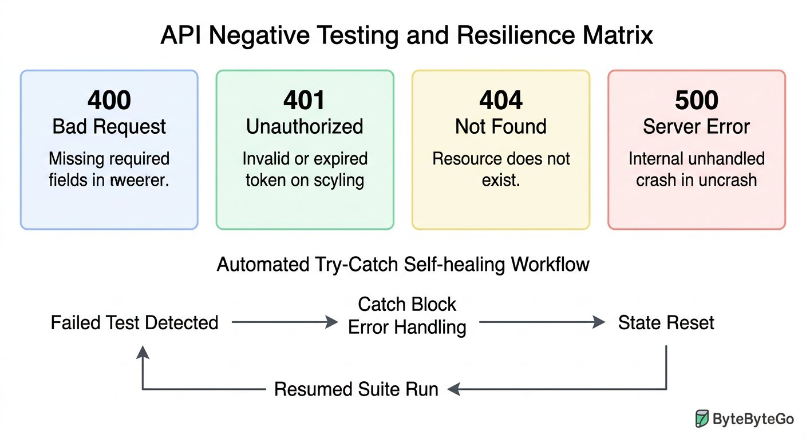
The core error testing matrix and defensive assertion architecture.
1 Client Validation Errors (400 or 422): Missing required fields, wrong data types, or out of range values.
2 Security Errors (401 and 403): Missing or expired authentication tokens (401), or insufficient user permissions (403).
3 State Conflicts (404 and 409): Querying missing resource IDs (404), or duplicate records colliding in the database (409).
4 Throughput & Resilience (429 and 500): Rate limit throttling (429), and catching unhandled server exceptions (500).

Step 2: Defensive Scripting: Safe Parsing with Try Catch
When servers crash or time out, gateways like Nginx or cloud load balancers return raw HTML error pages rather than JSON. Attempting to parse HTML as JSON throws a fatal SyntaxError unless guarded by a defensive try catch block. We chunk this defensive pattern into three architectural layers:
Resilient Error Parsing Architecture
Guards against fatal crashes on HTML server pages:
CHUNK 1: Chunk 1: Guarded Parsing · Guarding Against Crash Pages
Wraps the parser in a try catch block. If the server returns HTML, the exception is caught safely without aborting the runner.
try-catch-guard.js
1 let parsedBody = null;
try {
parsedBody = pm.response.json();
} catch (exception) {
console.warn("Non JSON response: " + exception.message);
parsedBody = null;
}
Rule: Always catch parsing errors when testing failure endpoints.
CHUNK 2: Chunk 2: Format Contract Assertion · Asserting Content Type Compliance
Formally reports a failed test if the response was not valid JSON, giving clear error logs in the test report.
format-assertion.js
1 pm.test("Response arrives in valid JSON format", function () {
pm.expect(parsedBody, "Parsed JSON body").to.not.equal(null);
});
Rule: Report formatting failures as structured test failures rather than unhandled script crashes.
CHUNK 3: Chunk 3: Security Leak Scanner · Preventing Credential Leaks
Scans raw response text to ensure backend database table names, SQL queries, or passwords never reach clients.
security-scan.js
1 pm.test("Response does not leak database secrets", function () {
const rawText = pm.response.text();
pm.expect(rawText).to.not.match(/password|SQLException|stack trace/i);
});
Rule: Automated security assertions prevent dangerous internal leaks to third parties.
IMAGINE & PREDICT BEFORE SENDING
If an upstream server crashes and returns an HTML page starting with <!DOCTYPE html>, what will happen if your script calls pm.response.json() without a try catch wrapper?
A. Postman throws a fatal JSONError SyntaxError and crashes the test execution
B. Postman automatically translates the HTML into a JSON object
C. Postman returns undefined and continues running smoothly
D. Postman reboots the remote server
Actual Output (Unguarded JSON Parsing Crash Confirmation): Fatal JSONError halts execution! The JavaScript JSON parser expects braces { } or brackets [ ]. When it encounters the HTML tag <, it throws an unhandled SyntaxError that halts the remaining tests in that request. A try catch block prevents this crash!

Step 3: Beware of Soft Errors (Status 200 with Error Content)
Fresher Trap to Avoid: Believing Status 200 Always Means Success
A soft error occurs when a developer configures an endpoint to return HTTP 200 OK, but the JSON payload body says: {"status": "failed", "message": "Record not found"}.
If your automated test only asserts pm.response.to.have.status(200), your test suite will report GREEN PASS even though the business transaction completely failed!
Always combine status code assertions with body message assertions to protect against deceptive soft errors.

Step 4: Self Healing Workflows: Handling Duplicate Collisions
What happens if a test run is aborted midway, leaving a book record stuck in the database? On the next run, AddBook fails with {"msg": "Book already exists"}. We write an intelligent, bounded self healing script using collection variables and postman.setNextRequest:

The code
addbook-self-healing.js
1 // Placed in Tests tab of AddBook (POST /v1/books)
2 let responseJson = {};
3 try {
4 responseJson = pm.response.json();
5 } catch (err) {
6 responseJson = {};
7 }
8
9 const maxRetries = 2;
10 let retryCount = Number(pm.collectionVariables.get("retry_count") || 0);
11
12 // Exact match on canonical duplicate error contract
13 if (responseJson.msg === "Book already exists") {
14 if (retryCount < maxRetries) {
15 retryCount += 1;
16 pm.collectionVariables.set("retry_count", retryCount);
17
18 // Compute the colliding composite ID so DeleteBook can purge it
19 const targetId = pm.collectionVariables.get("ISBN") + "227";
20 pm.collectionVariables.set("book_id", targetId);
21 console.log("Collision detected! Attempt " + retryCount + " of " + maxRetries + ". Triggering DeleteBook cleanup for " + targetId);
22 postman.setNextRequest("Delete Book");
23 } else {
24 pm.collectionVariables.set("retry_count", 0);
25 postman.setNextRequest(null);
26 pm.expect.fail("Max retries exceeded: duplicate record persistent after cleanup attempts");
27 }
28 } else {
29 pm.collectionVariables.set("retry_count", 0);
30 pm.test("Book added successfully", function () {
31 pm.response.to.have.status(200);
32 pm.expect(responseJson.Msg).to.eql("successfully added");
33 });
34 }

The code
deletebook-return-flow.js
1 // Placed in Tests tab of DeleteBook (POST /v1/books/delete)
2 pm.test("Cleanup request succeeds", function () {
3 pm.response.to.have.status(200);
4 });
5
6 // If invoked by self healing recovery, route back to AddBook
7 const activeRetries = Number(pm.collectionVariables.get("retry_count") || 0);
8 if (activeRetries > 0) {
9 console.log("Cleanup complete. Returning flow to AddBook for re addition...");
10 postman.setNextRequest("Add Book");
11 }

Expected output
Terminal
1 $ Self Healing Workflow Terminal Log
2 [AddBook]: 200 OK -> msg: "Book already exists" (Collision detected! Triggering DeleteBook for LIB9821227)
3 [DeleteBook]: 200 OK -> msg: "book is successfully deleted" (Cleanup complete. Returning flow to AddBook)
4 [AddBook]: 200 OK -> Msg: "successfully added", ID: "LIB9821227" (Self healing succeeded!)
5 Workflow Completed: 3 total requests, 1 recovery loop, 0 test failures.
The Bounded Loop Rule: Preventing Infinite CI CD Hangs
Never call postman.setNextRequest without a bounded counter like retryCount.
If an automated script loops unconditionally on an unexpected database state, Postman or Newman will ping the server endlessly until the CI build times out after an hour.
Always establish a hard ceiling (such as 2 or 3 retries) and explicitly call postman.setNextRequest(null) or pm.expect.fail() when the ceiling is reached.
WAR ROOM BATTLE SCAR · Critical Credential Leak Outage
The Database Stack Trace Leak: When an Uncaught 500 Exposed Root Credentials
A financial payment processing platform deployed a microservice that failed to implement global exception handling. When automated tests flooded the endpoint with malformed payloads, the backend threw an unhandled SQL syntax error. Instead of returning a sterile JSON error message, the web framework printed a 120 line raw stack trace containing the internal database hostname, database username, and unmasked connection string password. Security researchers discovered the flaw within three hours of release.
Key Architectural Lesson: Never permit backend stack traces or database connection strings to leak to clients. Always write automated security assertions in Postman verifying that error responses do not contain keywords like "SQLException", "password", or "traceback".
WAR ROOM INCIDENT TRIAGE
War Room Triage: The Fatal SyntaxError on Server Crash Pages
During midnight CI regression, the upstream gateway crashes and returns an HTML 502 Bad Gateway page. Your test script executes: const data = pm.response.json(). The test runner halts immediately with: "JSONError: Unexpected token < in JSON at position 0". How do you safeguard your assertion suite from crashing?
A. Change the request method from POST to GET.
B. Wrap the JSON parsing call in a try catch block and assert status code before attempting to inspect properties.
C. Increase the request timeout in Postman settings to 60 seconds.
D. Convert the HTML page to XML inside the Pre request script.
TACTICAL TRIUMPH: Defensive parsing saves automation suites! When an upstream proxy fails, it returns an HTML document starting with <!DOCTYPE html>. Calling pm.response.json() throws a fatal SyntaxError because HTML cannot be parsed as JSON. Wrapping parsing in a try catch block or checking the response Content Type keeps the runner alive!

Step 5: Review and Practice
MAKE A GUESS
Why should you wrap pm.response.json() in a try catch block when testing error scenarios?
- A. Because try catch makes the network call run faster
- B. Because server errors (such as 502 or 503) often return HTML pages that cause pm.response.json() to throw a SyntaxError and crash the test suite
- C. Because Postman requires try catch for all HTTP GET requests
- D. Because try catch automatically encrypts the response
Answer: Because server errors (such as 502 or 503) often return HTML pages that cause pm.response.json() to throw a SyntaxError and crash the test suite. When servers crash or time out, gateways like Nginx or cloud load balancers return raw HTML error pages. Attempting to parse HTML as JSON throws a fatal SyntaxError unless guarded by try catch.

Check your understanding
1. What is a soft error in API testing?
Answer: A soft error happens when an endpoint incorrectly returns a 200 OK status code despite the business action failing. Testers must inspect body properties to catch them.
2. Why must API tests assert that response bodies never leak database stack traces?
Answer: Stack traces expose database table names, SQL query syntax, and server file paths to potential attackers, creating serious security vulnerabilities.

Key takeaways
REMEMBER
- Negative testing validates that APIs fail safely, return correct 4xx codes, and never crash with unhandled 500 exceptions.
- Use defensive try catch blocks around pm.response.json() to handle HTML error pages gracefully.
- Assert both status codes and response body fields to detect deceptive soft errors.
- Use collection state flags and postman.setNextRequest() to build self healing test workflows.
⚡ MISSION 3 PHASE 1 CLEARED · Architectural Triumph: Production Negative Matrix & Defensive Resilience Mastered
You moved beyond fragile happy paths into battle hardened production engineering. You mastered the comprehensive negative testing matrix (400, 401, 403, 404, 409, 429, 500), shielded your test runner with defensive try catch deserialization, intercepted dangerous soft 200 failures, and engineered self healing recovery loops.
Tactical Superpowers Mastered:
- Deploying the complete production negative testing matrix to guarantee graceful backend failure modes
- Defensive JavaScript scripting: safe try catch parsing that survives raw HTML cloud gateway crashes
- Exposing deceptive soft 200 errors by coupling HTTP status assertions with payload business status checks
- Security auditing: intercepting database stack traces, SQL syntax leaks, and internal file path disclosures
- Engineering self healing test loops using collection flags and dynamic workflow redirection
Enterprise Disasters Prevented:
- Prevented severe security vulnerabilities where SQL error traces leak database schemas to malicious actors
- Stopped critical false positive passes where tests report green on failed business transactions
- Eliminated brittle CI test suite crashes caused by unhandled load balancer HTML timeout pages
War Room Takeaway: Any junior tester can verify that a system works when everything is perfect. A true lead automation architect proves that the system stands tall, refuses to leak secrets, and recovers automatically when everything goes wrong.
NEXT DISCOVERY · Continuing Mission 3: Postman Mock Servers and Contracts
Our test suite is resilient and self healing. In Chapter 10, we advance into Postman Mock Servers and JSON Schema Contracts: validating structural data integrity before servers even exist, simulating dependencies, and unblocking parallel QA workflows in Agile sprints!

Chapter 10: Postman Mock Servers and JSON Schema Contracts
Contract first development, JSON Schema validation, building hosted Mock Servers, and unblocking parallel QA in Agile sprints.
MISSION COMMAND HUD
PHASE: Phase 2 of 5: Mock Servers & Schema Contracts · RANK: Rank: Contract Architecture Specialist
ACTIVE MISSION: Mission 3: Hardening for Enterprise Production and CI CD
MISSION BRIEFING & CHAPTER ROADMAP
MISSION 3 · PHASE 1 OF 4: Enterprise Resilience and CI CD Quality Gates
CRISIS SCENARIO: Agile Sprint Simulation: Contract First Testing with Mock Servers
Context: In modern fast paced engineering sprints, QA automation engineers face a classic roadblock: backend developers spend two weeks building database schemas and business logic. If testers wait for live endpoints before writing tests, QA becomes the release bottleneck. We must unblock parallel testing by adopting contract first development, writing JSON Schema contracts, and spinning up hosted Postman Mock Servers.
Operational Target: Build JSON Schema contract validators, configure Postman Mock Servers with Examples, and compare REST with GraphQL.

WE WILL ACHIEVE: Unblock Agile testing sprints and prevent contract drift by mastering JSON Schema validation, hosted Postman Mock Servers, and modern GraphQL query architectures.
HOW WE WILL DO IT: Define strict array schemas matching production REST contracts, configure cloud mock examples, execute seamless mock to live environment flips, and parameterize GraphQL queries.
WHAT YOU WILL CARRY FORWARD: Production grade schema validation and mock virtualization techniques that prepare you for enterprise OAuth 2.0 security in Chapter 11.
MISSION PROGRESS · Continuing Mission 3: Contract Testing and Agile Simulation
In modern fast paced engineering sprints, QA automation engineers face a classic dilemma: backend developers spend eight to ten days building database models and business logic. If testers wait for live endpoints before writing scripts, testing turns into a painful bottleneck. In this chapter, we master the modern solution: defining rigid JSON Schema contracts, spinning up hosted Postman Mock Servers with Examples and query parameter matching, and exploring modern query architectures like GraphQL alongside REST.

Step 1: Contract First Development and JSON Schema Fundamentals
Rather than writing code first and guessing payloads later, mature engineering teams practice contract first API design. Before writing a single line of backend code, product managers, frontend engineers, and QA automation testers agree on a formal schema defining every request, response, status code, and data type.
The international standard for defining these contracts is JSON Schema. A JSON Schema acts like a blueprint for your JSON data: specifying mandatory fields, data types such as string or integer, value boundaries, and nested object rules.

The code
book-contract-schema.json
1 {
2 "$schema": "http://json-schema.org/draft-07/schema#",
3 "type": "array",
4 "items": {
5 "type": "object",
6 "required": ["book_name", "isbn", "aisle"],
7 "properties": {
8 "book_name": { "type": "string" },
9 "isbn": { "type": "string", "minLength": 3 },
10 "aisle": { "type": "string" }
11 }
12 }
13 }
The Array Trap in REST Search Endpoints
A frequent pitfall among freshers is declaring the root type as object when inspecting query endpoints.
In RESTful services, search endpoints like GET /v1/books?id=... return a list of matching entries even when only one record matches. The root container is an array ([]) rather than a single object ({}).
Declaring type: "object" against an array response immediately triggers a schema mismatch failure. Always verify whether the root token is a curly bracket or an open square bracket!

Step 2: Validating JSON Schema Contracts in Postman
Postman includes the industry standard schema validator library tv4 directly in its test sandbox. We break down the schema validation assertion into three focused chunks:
JSON Schema Validation Architecture
Guarantees structural and type integrity:
CHUNK 1: Chunk 1: Defining Contract Schema · The Architectural Contract Blueprint
Specifies that the response is an array of book objects with required string properties.
schema-contract.js
1 const schemaContract = {
type: "array",
items: {
type: "object",
required: ["book_name", "isbn", "aisle"],
properties: {
book_name: { type: "string" },
isbn: { type: "string" },
aisle: { type: "string" }
}
}
};
Rule: The contract acts as the immutable standard between frontend and backend teams.
CHUNK 2: Chunk 2: Executing Schema Matcher · Evaluating Structural Compliance
Validates that the received JSON payload adheres strictly to every constraint in the blueprint.
schema-matcher.js
1 const responseData = pm.response.json();
pm.test("Response body strictly satisfies the JSON Schema contract", function () {
const validationResult = tv4.validate(responseData, schemaContract);
pm.expect(validationResult, "Schema validation failed: " + JSON.stringify(tv4.error)).to.be.true;
});
Rule: tv4 evaluates missing fields and type mismatches across deep hierarchies.
CHUNK 3: Chunk 3: Diagnostic Pinpoint Logging · Pinpointing Offending Fields
If validation fails, logs the exact JSON path and the specific violation reason in the Postman Console.
schema-error-diagnostics.js
1 if (!tv4.validate(responseData, schemaContract)) {
console.error("Contract violation at " + tv4.error.dataPath + ": " + tv4.error.message);
}
Rule: Diagnostic logging eliminates guesswork when diagnosing schema rejections.
IMAGINE & PREDICT BEFORE SENDING
If a backend update changes the aisle field from string "42" to a number 42, how will this schema test react?
A. The test fails immediately: tv4 flags a type mismatch because number was received where string was required
B. The test passes green because JSON automatically converts numbers to strings
C. Postman ignores the schema and passes the status code
D. The server rolls back the database
Actual Output (Schema Type Mismatch Confirmation): Schema drift caught instantly! JSON Schema is strictly typed: tv4 flags an AssertionError with message "Invalid type: number (expected string) at /0/aisle". This protects mobile apps from crashing before bad code reaches production!

Step 3: The Agile Dilemma and Postman Mock Servers
ARCHITECTURE · Postman Mock Servers: Enabling Fast Parallel Agile Development
AGILE SIMULATION · Postman Mock Servers: Enabling Fast Parallel Agile Development
When starting a sprint, waiting ten days for backend microservices stalls everyone. Postman Mock Servers eliminate this blocker by simulating real web servers in the cloud. By defining JSON request examples, frontend and testing teams simulate production behavior weeks before real code lands.
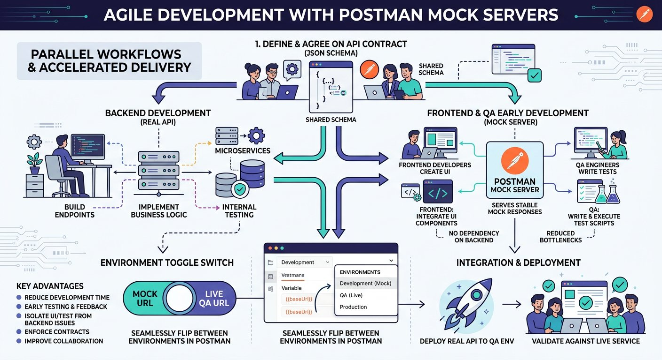
Unblocking parallel QA and frontend development using hosted Postman Mock Servers.
1 Sprint Day 1 (Contract Definition): Frontend, Backend, and QA agree on request paths, parameters, and response schemas.
2 Sprint Day 2 (Mock Server Spin Up): A hosted Postman Mock Server is launched with Examples matching the agreed specification.
3 Sprint Days 2 to 9 (Parallel Development): Frontend developers build UI screens and QA engineers build complete automated assertion suites against the mock server.
4 Sprint Day 10 (Deployment and Environment Flip): Backend deploys live microservices to QA. Testers flip the environment variable from Mock URL to Live URL with zero code rewrites.

Step 4: Configuring Examples and Matching Query Parameters
A Postman Mock Server functions by inspecting Examples attached to requests in your collection. You can create multiple Examples for a single endpoint to simulate different business scenarios and query parameters. You can download our sample mock response examples: [Download Science Mock Example JSON](/materials/zero-to-agentic-api-testing/lesson-10/mock-example-science.json) and [Download Literature Mock Example JSON](/materials/zero-to-agentic-api-testing/lesson-10/mock-example-literature.json):

Try it yourself
- Open any request in your Postman collection and click the three dots icon to select Add Example.
- Provide the expected HTTP status code: such as 200 OK for happy paths or 404 Not Found for negative flows.
- Paste the mock JSON response body in the Example editor and click Save.
- To simulate query parameter matching, add the parameter (such as ?category=science) in the Example URL. When a caller requests that specific query, Postman Mock Server returns that tailored Example!

Expected output
Terminal
1 $ Calling Hosted Postman Mock Server via cURL
2 curl https://9b12c8a1-42ef-49bb-b12e.mock.pstmn.io/v1/books?category=science
3 HTTP/1.1 200 OK
4 Content-Type: application/json; charset=utf-8
5 x-srv-span: mock-server-edge-01
6 {
7 "category": "science",
8 "total_records": 1,
9 "books": [
10 { "book_name": "Full Stack API Automation", "isbn": "SCI941", "aisle": 42, "author": "Dr. Sarah Chen" }
11 ]
12 }
Fresher Trap to Avoid: Forgetting to Save the Example Before Testing
When creating mock responses in Postman, students often edit the Example body and immediately fire a request to the mock URL, only to receive a 404 Not Found or generic default payload.
Postman Mock Servers in the cloud only know about Examples that have been saved to the cloud workspace.
Always press Save on the Example tab before sending requests to the mock server endpoint.

Step 5: Seamless Environment Toggling: From Mock to Live QA
Because our collection references {{base_url}} rather than hardcoded URLs, transitioning from the mock server to the live deployment requires zero test script modifications.

The code
environment-variables-comparison.json
1 // During Sprint Week 1 (Targeting Mock Server)
2 {
3 "environment": "Campus Mock Server",
4 "base_url": "https://9b12c8a1-42ef-49bb-b12e.mock.pstmn.io"
5 }
6
7 // During Sprint Week 2 (Targeting Live Deployed Backend)
8 {
9 "environment": "Campus Live QA Cluster",
10 "base_url": "https://qa-api.campuslibrary.org"
11 }
On deployment day, simply click the Postman Environment dropdown and select Campus Live QA Cluster. When you hit Run Collection, every assertion, property transfer, and test logic written during Week 1 immediately validates the real production codebase!

Step 6: Modern Query Architectures: Testing GraphQL Alongside REST
In enterprise architectures, QA engineers increasingly encounter GraphQL alongside standard REST endpoints. To understand why GraphQL exists, consider the student academic portal on our university campus.
ARCHITECTURE · REST vs GraphQL Architecture: Single Request Precise Data Resolution
QUERY ARCHITECTURES · REST vs GraphQL Architecture: Single Request Precise Data Resolution
To display a single student profile screen, a REST client might call four separate endpoints (students, departments, courses, loans), multiplying mobile network latency and returning unwanted fields. GraphQL solves this by exposing a single endpoint where clients declare the exact fields required in one roundtrip.
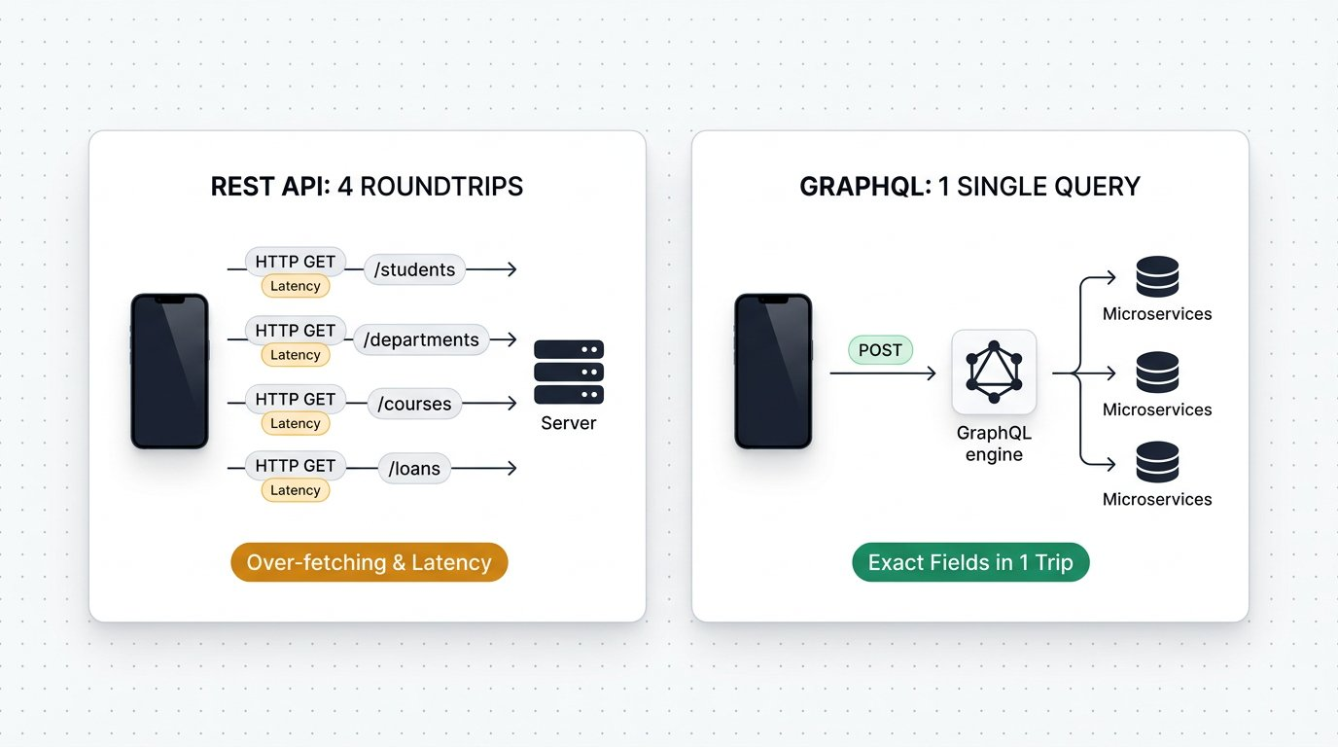
REST vs GraphQL: Eliminating over fetching and under fetching with a single unified query.
1 Left Panel (REST 4 Network Roundtrips): The client must execute four separate HTTP requests over mobile networks (GET /students, GET /departments, GET /courses, GET /loans), multiplying latency.
2 Left Panel (Over Fetching and Under Fetching): Each REST endpoint returns unwanted data that the client discards, while forcing multiple trips to assemble a single screen.
3 Right Panel (GraphQL 1 Single Unified Query): The client dispatches one POST request to /graphql requesting the exact nested fields required.
4 Right Panel (Single Payload Resolution): The GraphQL server contacts backend services in parallel and delivers one consolidated JSON response in a single network roundtrip.

Revisiting the Chapter 1 Book Inquiry in GraphQL
Recall our comparison in Chapter 1: when asking for a book record, a standard REST endpoint returns the entire rigid database schema (including aisle, ISBN, price, copies, and timestamps), whether the client needs them or not. In GraphQL, the client asks specifically for the desired fields, such as title and author:

The code
book-graphql-query.graphql
1 # Parameterized book query with dynamic variable
2 query GetBookDetails($bookId: ID!) {
3 book(id: $bookId) {
4 title
5 author
6 }
7 }
When dispatched with variable { "bookId": "1" }, the GraphQL engine contacts the catalog repository and returns only the requested attributes: { "data": { "book": { "title": "Clean Architecture", "author": "Robert Martin" } } }. If the client subsequently needs the price, the frontend engineer simply adds price to the query string without waiting for backend engineers to deploy a new REST endpoint version.

Live Exploration: Testing the Public Rick and Morty GraphQL API
To practice testing GraphQL against a live production endpoint without configuring local mock servers or authentication credentials, engineers often explore the public Rick and Morty GraphQL service at https://rickandmortyapi.com/graphql. Here is a live parameterized query fetching character details and nested location coordinates:

The code
rick-and-morty-query.graphql
1 # Live query against public https://rickandmortyapi.com/graphql
2 query GetCharacterProfile($characterId: ID!) {
3 character(id: $characterId) {
4 name
5 status
6 species
7 origin {
8 name
9 }
10 }
11 }
Live Interactive Wire Inspector: Public Rick and Morty GraphQL Query
POST https://rickandmortyapi.com/graphql
Status: 200 OK · Time: 142 ms · Size: 388 B
Response Body:
response.json
1 {
2 "data": {
3 "character": {
4 "name": "Rick Sanchez",
5 "status": "Alive",
6 "species": "Human",
7 "origin": {
8 "name": "Earth (C-137)"
9 }
10 }
11 }
12 }
Assertions Verified:
✓ GraphQL status code is 200 OK
✓ Response contains data object without errors
✓ Character name matches Rick Sanchez
✓ Origin name matches Earth (C-137)
While queries retrieve data, Mutations create, update, or delete data in GraphQL. A key advantage of mutations is hybrid retrieval: when you create a new lab location or research character, GraphQL immediately returns the newly generated ID in the response:

The code
campus-graphql-mutation.graphql
1 # Mutation creating new campus research entities in one call
2 mutation RegisterEntities {
3 createLocation(name: "Innovation Robotics Lab", type: "North Wing", dimension: "Lab 4") {
4 id
5 }
6 createCharacter(name: "Dr. Elena Rostova", status: "Active", gender: "Female") {
7 id
8 }
9 }
Fresher Trap to Avoid: All GraphQL Calls Use HTTP POST
In REST, you use GET to read records and POST to write records.
In GraphQL, while queries can technically be sent via GET query parameters, industry standard practice packages the query syntax and variables into a JSON payload body and dispatches using HTTP POST.
In Postman, select POST, choose Body > GraphQL, paste your query on the left and your JSON variables on the right.
WAR ROOM BATTLE SCAR · Enterprise Contract Outage
The Silent Schema Drift Outage: When a Type Flip Crashed Native Mobile Apps
A retail engineering team updated an inventory API endpoint. The property in_stock_count was changed from integer 42 to string "42" to accommodate out of stock text badges. Desktop web browsers handled the loose type coercion without complaint, but the native iOS and Android mobile apps crashed instantly on startup with fatal JSON decoding errors: Expected Int but received String. Because test suites had only verified HTTP 200 status codes without schema contract checks, the defect reached the public app store, crashing the app for over two million customers.
Key Architectural Lesson: Never rely on HTTP 200 status checks alone. Rigid JSON Schema assertions with tv4 or ajv ensure property names and data types strictly adhere to contracts before production deployment.
WAR ROOM INCIDENT TRIAGE
War Room Triage: The Cryptic Contract Failure
You write a contract test in Postman: pm.expect(tv4.validate(data, schema)).to.be.true. The assertion fails during sprint testing, but the test runner prints only "AssertionError: expected false to be true", offering zero clues on which field broke. What debugging technique instantly pinpoints the schema defect?
A. Inspect tv4.error.message and tv4.error.dataPath to log the exact property and type violation.
B. Restart Postman and run the collection again.
C. Change the schema data type from object to string.
D. Delete all required fields from the JSON Schema blueprint.
TACTICAL TRIUMPH: Extract the validation error details! The tv4 library stores full diagnostic information in tv4.error. Logging tv4.error.message alongside tv4.error.dataPath pinpoints the exact offending JSON key (such as /books/0/isbn) and the specific reason (such as "type string expected, integer received").

Step 7: Review and Practice
MAKE A GUESS
How does a Postman Mock Server determine which response payload to return when an incoming request arrives?
- A. It randomly generates fictional data on every single request
- B. It matches the incoming request method, path, headers, and query parameters against saved Examples in the collection
- C. It connects to a live MySQL database in the cloud
- D. It asks the user to manually type the response in the desktop window
Answer: It matches the incoming request method, path, headers, and query parameters against saved Examples in the collection. Postman Mock Servers inspect incoming HTTP requests and compare them with the saved Examples in the collection, returning the Example that best matches the method, URL path, and query parameters.

Check your understanding
1. What is contract first development, and why does it benefit software testing teams?
Answer: Contract first development defines the formal API schema before developers write backend code. It allows QA and frontend engineers to build tests and user interfaces in parallel against mock servers rather than waiting for backend completion.
2. What is the primary difference between REST and GraphQL data retrieval?
Answer: REST endpoints return a fixed response structure determined by the server, often leading to over fetching or under fetching. GraphQL allows clients to specify the exact fields they require in a single query dispatched to one endpoint.

Key takeaways
REMEMBER
- Contract first API design establishes agreed JSON schemas before backend coding begins.
- JSON Schema validation with tv4 catches missing keys and subtle data type mismatches.
- Postman Mock Servers provide cloud hosted simulations powered by saved collection Examples.
- Using Examples with query parameters simulates diverse real world response flows.
- Toggling base_url environment variables transitions test suites seamlessly from Mock to live QA.
- GraphQL eliminates over fetching and under fetching by allowing clients to request exact fields across multiple domains in a single POST query.
⚡ MISSION 3 PHASE 2 CLEARED · Architectural Triumph: Agile Mock Simulation & Dual REST GraphQL Contracts Mastered
You solved the universal Agile sprint dilemma! Instead of idling for weeks waiting for backend developers to finish server code, you authored formal JSON Schema contracts, spun up hosted Postman Mock Servers, parameterized response Examples, and conquered modern GraphQL query architectures alongside REST.
Tactical Superpowers Mastered:
- Authoring formal JSON Schema specifications that enforce field types, mandatory properties, and data bounds
- Deploying Postman hosted Mock Servers to simulate edge cases and unblock frontend and QA teams on Day 1 of sprints
- Fine tuning mock responses using query parameter matching and custom Example payloads
- Executing dual protocol automation: commanding both traditional REST endpoints and modern GraphQL queries and mutations
- Seamless environment switching: transitioning automated suites from Mock to Live servers with one variable swap
Enterprise Disasters Prevented:
- Eliminated two week sprint bottlenecks where testers sit idle waiting for backend database deployments
- Prevented mobile application crashes caused by unexpected field type mutations (such as string IDs turning into integers)
- Stopped mobile network throttling and payload bloat by leveraging GraphQL targeted field resolution
War Room Takeaway: The highest leverage QA engineers do not wait for software to be built. They write the contract, stand up the mock server, and have the full automated regression suite ready the second the backend goes live.
NEXT DISCOVERY · Continuing Mission 3: Enterprise Identity and Token Security
With contract schemas, mock servers, and GraphQL fundamentals mastered, we encounter enterprise identity gateways. In Chapter 11, we explore OAuth 2.0 and Modern Token Authentication: executing automated token exchanges, managing global access tokens, and testing secured microservice endpoints!

Chapter 11: OAuth 2.0 and Modern Token Authentication
The four roles, Authorization Code grant handshake, automated token exchange scripts, global variables, and Bearer token chaining.
MISSION COMMAND HUD
PHASE: Phase 3 of 5: OAuth 2.0 Security Protocols · RANK: Rank: Enterprise Identity Architect
ACTIVE MISSION: Mission 3: Hardening for Enterprise Production and CI CD
MISSION BRIEFING & CHAPTER ROADMAP
MISSION 3 · PHASE 2 OF 4: Enterprise Resilience and CI CD Quality Gates
CRISIS SCENARIO: Securing the Gateway: OAuth 2.0 and Modern Token Authorization
Context: Enterprise campus systems handle sensitive student records and financial transactions. Simple API keys or basic auth credentials are unacceptable in modern architecture. Microservices enforce OAuth 2.0 token based authorization. We must master the four roles, execute the two step Authorization Code grant, automate token exchange scripts, and chain Bearer tokens into secured requests.
Operational Target: Deconstruct the OAuth 2.0 handshake, automate token retrieval in pre request scripts, and test token expiration.

WE WILL ACHIEVE: Master modern enterprise API security by deconstructing OAuth 2.0 grant types, automating token handshakes in test suites, and chaining Bearer tokens into protected requests.
HOW WE WILL DO IT: Contrast interactive Authorization Code flows with machine to machine Client Credentials for CI CD, execute live token exchange requests, extract tokens into global variables, and validate 401 unauthorized boundaries.
WHAT YOU WILL CARRY FORWARD: Automated token acquisition patterns and authenticated collection runs that safeguard enterprise endpoints, carrying forward into XML web services in Chapter 12.
MISSION PROGRESS · Continuing Mission 3: Mastering Enterprise Token Security
Having simulated microservices with mock servers and schema contracts, we encounter enterprise security gateways. High value APIs never accept raw username and password credentials directly in request bodies. Instead, modern microservices enforce OAuth 2.0 token based authorization. Across this chapter, we master the industry standard protocol: dissecting the four roles, executing the Authorization Code grant handshake, inspecting the mandatory parameters for both authorization code and access token requests, automating token retrieval in test scripts, and chaining Bearer tokens into secured requests.

Step 1: Why Modern APIs Rely on OAuth 2.0
Imagine checking into a hotel or your college dorm hostel. The receptionist does not hand you the master brass key that opens every door on campus. Instead, they issue a plastic keycard that only unlocks your specific room and automatically expires at checkout time.
This is the core purpose of OAuth 2.0. It is an open authorization standard that lets applications access protected user resources without ever seeing or storing the user private account password.
In our campus library automation project, faculty members and researchers access a restricted digital archive containing rare manuscripts and sensitive academic data. The university cannot allow catalog apps or student portals to store raw campus passwords. If a third party app suffers a security breach, every user credentials would be compromised. Instead, the campus identity provider authenticates the user on a dedicated login screen and issues a temporary digital keycard: a Bearer access token valid for one hour with strictly scoped read permissions.
Authentication vs Authorization: The Crucial Distinction
• Authentication (AuthN): Answers the question: "Who are you?" Proving identity by providing credentials such as a username, password, or biometric face scan.
• Authorization (AuthZ): Answers the question: "What permissions do you have?" Granting access to specific resources, such as reading an order history or editing profile pictures.
• OAuth 2.0 is strictly an authorization framework designed to grant scoped permissions through digital access tokens.

Step 2: The Four Roles in the OAuth 2.0 Architecture
ARCHITECTURE · OAuth 2.0 Security Architecture: The Four Party Token Handshake
SECURITY ARCHITECTURE · OAuth 2.0 Security Architecture: The Four Party Token Handshake
OAuth 2.0 delegates authority across four distinct participants: the Resource Owner (the student), the Client Application (our web or mobile interface), the Authorization Server (campus identity login), and the Resource Server (the protected library microservice). Access tokens expire automatically, protecting university resources without exposing student credentials.
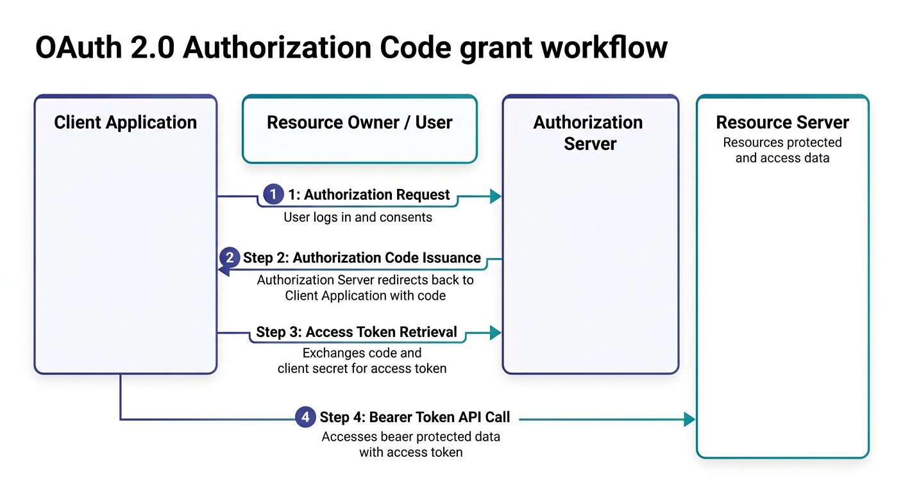
The four participants and handshake flow of the OAuth 2.0 Authorization Code grant.
1 Step 1 (Authorization Request): The user logs in at the Authorization Server and consents to permissions requested by the Client Application.
2 Step 2 (Authorization Code Issuance): The Authorization Server validates the user and redirects back to the client callback URL with a temporary authorization code.
3 Step 3 (Access Token Retrieval): The client application submits a secure backend POST request exchanging the code and client secret for an access token.
4 Step 4 (Bearer Token API Call): The client injects the access token into the Authorization header to retrieve protected student data from the Resource Server.

Step 3: The Detailed OAuth 2.0 Contract Specification
In enterprise testing, QA engineers must know the exact contract parameters required by identity servers. The Authorization Code grant relies on two distinct HTTP requests:

OAuth 2.0 Two Step Handshake Contract
Contract Field | Request 1: Get Authorization Code | Request 2: Get Access Token
HTTP Method | GET (User Browser Redirect) | POST (Direct Client to Server Call)
Target Endpoint | Authorization Server URL (https://auth.campuslibrary.org/oauth/authorize) | Access Token URL (https://auth.campuslibrary.org/oauth/token)
Mandatory Parameters | client_id, redirect_uri, response_type=code, scope, state | grant_type=authorization_code, code, client_id, client_secret, redirect_uri
Transport Location | URL Query Parameters | Request Body (x www form urlencoded or JSON)
Returned Output | One time temporary code in callback URL query string | JSON payload containing access_token, token_type, and expires_in

Step 4: Request 1: Fetching the Temporary Authorization Code
The first request sends the user browser to the campus identity provider. Notice the query parameters appended to the URL:

The code
get-authorization-code.txt
1 GET https://auth.campuslibrary.org/oauth/authorize?
2 response_type=code&
3 client_id=campus-library-web-client&
4 redirect_uri=https://campus.university.edu/oauth/callback&
5 scope=read:catalog%20write:loans&
6 state=xyzSecurityString789 HTTP/1.1
Why Each Query Parameter Matters
• response_type=code: Informs the authorization server that the client wants a temporary authorization code, not a raw token.
• client_id: The public alphanumeric identifier assigned to our application.
• redirect_uri: The pre registered callback address where the authorization server delivers the code. If this URL differs by even one character from the server whitelist, the server aborts the request.
• scope: Defines the permission boundaries requested (such as reading catalog books and borrowing records).
• state: A random cryptographic string returned back to verify that the response corresponds to our original request, preventing CSRF attacks.
When the student or faculty member logs in and approves consent, the authorization server redirects the browser back to our callback URL with the temporary code in the query string:

Expected output
Terminal
1 $ Browser Redirect to Callback URL
2 HTTP/1.1 302 Found
3 Location: https://campus.university.edu/oauth/callback?code=authcode_89712a4f&state=xyzSecurityString789

Step 5: Request 2: Exchanging Code for the Access Token
Now our client backend (or Postman collection) takes that temporary code and exchanges it for the actual Bearer token via HTTP POST. We break down the mandatory parameters into three chunks:
OAuth 2.0 Token Exchange Parameters
Mandatory form parameters sent to the authorization endpoint:
CHUNK 1: Chunk 1: Grant Type and Code · Declaring the Handshake Protocol
Tells the auth server we are exchanging a temporary code for an access token.
exchange-core.http
1 POST /oauth/token HTTP/1.1
Host: auth.campuslibrary.org
Content-Type: application/x-www-form-urlencoded
grant_type=authorization_code
&code=authcode_89712a4f
Rule: The authorization code is single use and expires within minutes.
CHUNK 2: Chunk 2: Client Authentication · Proving Application Identity
The client secret proves that the application exchanging the code is the legitimate registered client.
client-credentials.http
1 &client_id=campus-library-web-client
&client_secret=secureUniversitySecretKey_98765
Rule: client_id is public; client_secret must never be shared in browser client code.
CHUNK 3: Chunk 3: Redirect URI Matching · Strict Callback Verification
The server verifies that this redirect URI matches the one sent in the initial code request byte for byte.
redirect-check.http
1 &redirect_uri=https://campus.university.edu/oauth/callback
Rule: Mismatching redirect URIs abort the handshake immediately for security.
IMAGINE & PREDICT BEFORE SENDING
When the client submits these verified parameters to the authorization server, what response structure will come back?
A. 200 OK with JSON object containing access_token, token_type: "Bearer", and expires_in: 3600
B. 302 Redirect asking the user to re enter their password again
C. 404 Not Found because access tokens are only generated in Python
D. 500 Server Error because tokens cannot be serialized in JSON
Actual Output (Token Exchange Confirmation): Access token granted! The authorization server verifies the code and secret, then delivers a 200 OK response with a Bearer access token valid for one hour (3600 seconds)!

Expected output
Terminal
1 $ JSON Token Response from Authorization Server
2 Status: 200 OK | Time: 195 ms
3 Content-Type: application/json; charset=utf-8
4
5 {
6 "access_token": "campus_bearer_token_9918273645",
7 "token_type": "Bearer",
8 "expires_in": 3600,
9 "scope": "read:catalog write:loans"
10 }
Live Interactive Wire Inspector: OAuth 2.0 Token Exchange
POST https://auth.campuslibrary.org/oauth/token
Status: 200 OK · Time: 195 ms · Size: 342 B
Response Body:
response.json
1 {
2 "access_token": "campus_bearer_token_9918273645",
3 "token_type": "Bearer",
4 "expires_in": 3600,
5 "scope": "read:catalog write:loans"
6 }
Assertions Verified:
✓ Authorization server status is 200 OK
✓ Response contains access_token attribute
✓ Token type attribute equals Bearer
✓ Token lifetime exceeds zero seconds

Step 6: Automating Token Workflows and CI CD Grant Types
Architectural Choice: Authorization Code vs Client Credentials in CI CD
Why can you not easily run an Authorization Code flow inside a headless continuous integration build server?
• Authorization Code Grant requires an interactive web browser where a human student logs in and clicks Allow. In unattended Jenkins, GitHub Actions, or GitLab CI pipelines, there is no browser and no human user to solve two factor authentication prompts!
• Client Credentials Grant is designed specifically for machine to machine automation. The automated test runner dispatches a direct backend call with grant_type=client_credentials, client_id, and client_secret to POST /oauth/token, receiving an automated service token in milliseconds without user interaction.
When testing public user journeys, Postman handles Authorization Code. When testing automated background microservice integrations in CI CD, configure the Client Credentials grant.
When executing test collections automatedly in CI CD pipelines, we configure an unattended Client Credentials token exchange request as the very first step in our collection. We submit the pre configured client credentials with strictly scoped read permissions: scope=read:catalog. In its Tests script, we extract the access token and save it into Collection Scope so subsequent requests in this collection inherit it without leaking secrets across global workspaces. You can download the script: [Download Capture Bearer Token Script](/materials/zero-to-agentic-api-testing/lesson-11/capture-bearer-token.js):

The code
unattended-token-request.http
1 POST /oauth/token HTTP/1.1
2 Host: auth.campuslibrary.org
3 Content-Type: application/x-www-form-urlencoded
4
5 grant_type=client_credentials
6 &client_id={{client_id}}
7 &client_secret={{client_secret}}
8 &scope=read:catalog write:loans

The code
capture-bearer-token.js
1 // Step 1: Parse the JSON response from the auth server
2 const responseData = pm.response.json();
3
4 // Step 2: Validate token properties
5 pm.test("Token response returns 200 OK and valid Bearer", function () {
6 pm.response.to.have.status(200);
7 pm.expect(responseData).to.have.property("access_token");
8 pm.expect(responseData.token_type).to.eql("Bearer");
9 pm.expect(responseData.expires_in).to.be.above(0);
10 });
11
12 // Step 3: Save Bearer token to Collection Scope (Least Privilege principle)
13 pm.collectionVariables.set("access_token", responseData.access_token);
Security Best Practice: Scoped Storage and Secret Hygiene
Never store sensitive access tokens in Global Scope where any collection in your workspace could read them.
Always store tokens in Collection Scope (pm.collectionVariables) or ephemeral Environment memory (Current Value only).
Keep Initial Value empty for all client secrets so credentials are never exported or synced to shared version control repositories.
Fresher Trap to Avoid: Forgetting the Space After Bearer
When attaching a Bearer token manually in request headers, many freshers type Authorization: Bearercampus_bearer_token_... without a space.
Because the HTTP specification defines Bearer as the authentication scheme followed by a single space, the resource server will fail to parse the header and return 401 Unauthorized!
Always ensure a single space follows the word Bearer: Authorization: Bearer {{access_token}}.
In downstream requests, we configure the Authorization tab to Bearer Token and insert {{access_token}}. Alternatively, set the Authorization header directly: Authorization: Bearer {{access_token}}. Postman resolves the global variable at runtime, authenticating every call cleanly without manual intervention.
Testing Token Expiry and 401 Unauthorized Handling
Access tokens have a finite lifetime, typically 3600 seconds (one hour).
When an access token expires or is omitted, the resource server immediately rejects requests with HTTP 401 Unauthorized.
In automated regression suites, always include a negative test asserting that requests with invalid or expired tokens return 401 and an appropriate WWW Authenticate challenge header.
WAR ROOM BATTLE SCAR · Cascading Deployment Blackout
The Hardcoded Token Outage: When an Expired Secret Paralyzed Deployments
An ecommerce engineering squad automated warehouse fulfillment verification by hardcoding a long lived OAuth 2.0 Bearer access token into Postman collection variables. The token had a sixty day expiration lifespan. On the eve of a major holiday sales promotion, the token silently expired at midnight. Hundreds of automated test jobs failed simultaneously across continuous deployment pipelines, triggering false P1 alerts and blocking release deployments during peak revenue hours.
Key Architectural Lesson: Never hardcode static Bearer tokens in long lived test suites. Always automate the OAuth 2.0 token handshake in an initial authorization request or Pre request script that dynamically acquires fresh tokens before protected requests execute.
WAR ROOM INCIDENT TRIAGE
War Room Triage: The Disappearing State Parameter Vulnerability
During a security audit of your OAuth 2.0 authorization code flow, an automated penetration tool flags a critical vulnerability: "Cross Site Request Forgery detected on OAuth callback handler". The audit report reveals that your initial GET authorization redirect URL omitted the state parameter. Why is the state parameter mandatory in production OAuth handshakes?
A. The state parameter encrypts user passwords using RSA 4096.
B. The state parameter acts as a cryptographic anti CSRF nonce verifying that the authorization callback response belongs to the exact session that initiated the login request.
C. The state parameter specifies the geographic server location of the API gateway.
D. The state parameter forces the authorization server to issue a permanent token that never expires.
TACTICAL TRIUMPH: Anti CSRF cryptographic binding! The state parameter is an unguessable random token generated by the client and sent in the authorization request. When the authorization server returns the code, it reflects back the identical state parameter. The client verifies that this returned state matches the stored session value, preventing attackers from injecting their own authorization codes into an unsuspecting user session!

Step 7: Review and Practice
MAKE A GUESS
In the OAuth 2.0 Authorization Code grant, what are the mandatory parameters required in the token exchange POST request?
- A. Only username and password
- B. grant_type, code, client_id, client_secret, and redirect_uri
- C. Only client_id and API key
- D. Only scope and state
Answer: grant_type, code, client_id, client_secret, and redirect_uri. To exchange an authorization code for an access token, the client must send grant_type=authorization_code along with the temporary code, client_id, client_secret, and the matching redirect_uri.

Check your understanding
1. What is the difference between client_id and client_secret in OAuth 2.0?
Answer: client_id is a public identifier assigned to the application, visible in URLs. client_secret is a confidential password known only to the client and authorization server, used to authenticate the token exchange.
2. Why do automated CI CD suites store the retrieved token in a global or environment variable?
Answer: Automated runners cannot open interactive login prompts. By running a token exchange request first and saving the access token in a global variable, all downstream requests can automatically read the token and authenticate.

Key takeaways
REMEMBER
- OAuth 2.0 decouples authentication from authorization, allowing users to grant scoped access without revealing passwords.
- The Authorization Code grant uses two steps: fetching a temporary code via GET, and exchanging the code for an access token via POST.
- Mandatory parameters for token exchange include grant_type, code, client_id, client_secret, and redirect_uri.
- Bearer tokens are stored in global or environment variables and injected into the Authorization header.
- Token lifetimes require test suites to validate both valid authorization and 401 expiration handling.
⚡ MISSION 3 PHASE 3 CLEARED · Architectural Triumph: Enterprise OAuth 2.0 Token Vault Deployed
You dismantled the most misunderstood protocol in modern web engineering: OAuth 2.0. You mapped the 4 roles, mastered the two step Authorization Code grant, automated the token exchange POST request, chained Bearer tokens into secured headers, and verified 401 expiration challenges with absolute precision.
Tactical Superpowers Mastered:
- Dissecting the four OAuth 2.0 roles: Resource Owner, Client, Authorization Server, and Resource Server
- Executing the full Authorization Code grant handshake: exchanging temporary auth codes for scoped Bearer tokens
- Automating token extraction in Tests scripts and injecting dynamic Bearer tokens into downstream request headers
- Auditing token expiration boundaries and asserting 401 Unauthorized WWW Authenticate challenges
- Defending enterprise secrets by enforcing client_secret confidentiality rules across test suites
Enterprise Disasters Prevented:
- Averted catastrophic enterprise credential theft by replacing static user passwords with scoped, short lived tokens
- Stopped broken authentication logic that leaves protected APIs wide open to unauthorized third party access
- Eliminated fragile manual token copy paste that causes automated CI CD pipeline runs to fail mid execution
War Room Takeaway: Security is not an afterthought added at deployment. When your automated test suites validate token issuance, header injection, scope enforcement, and 401 expirations, your enterprise endpoints are fortified against unauthorized intrusion.
NEXT DISCOVERY · Continuing Mission 3: Testing Legacy Protocols and XML Envelopes
While REST and OAuth 2.0 dominate modern web services, enterprise banking, government, and legacy systems still rely heavily on SOAP and XML. In Chapter 12, we explore SOAP WebServices: sending XML envelopes, asserting WSDL contracts, and parsing XML responses into JavaScript objects with xml2Json!

Chapter 12: SOAP WebServices and XML Parsing
Crafting XML envelopes, setting SOAP headers, and converting responses into JavaScript objects with xml2Json.
MISSION COMMAND HUD
PHASE: Phase 4 of 5: Enterprise SOAP & XML Systems · RANK: Rank: Enterprise Protocols Specialist
ACTIVE MISSION: Mission 3: Hardening for Enterprise Production and CI CD
MISSION BRIEFING & CHAPTER ROADMAP
MISSION 3 · PHASE 3 OF 4: Enterprise Resilience and CI CD Quality Gates
CRISIS SCENARIO: Legacy Systems Integration: SOAP WebServices and XML Parsing
Context: Modern microservices communicate via REST and JSON, but enterprise institutions still rely on legacy mainframes and banking gateways built on SOAP and XML. When the campus finance office requires verifying textbook grants through a state accounting mainframe, our testing suite must speak SOAP 1.1 and 1.2 XML envelopes and parse responses accurately.
Operational Target: Craft valid SOAP XML envelopes, set required SOAP headers, parse XML with xml2Json, and assert response values.

WE WILL ACHIEVE: Master legacy enterprise web services by crafting SOAP 1.1 and 1.2 XML envelopes, parsing XML responses with xml2Json, and asserting payload data defensively.
HOW WE WILL DO IT: Contrast REST with SOAP, configure strict Content Type headers, convert XML envelopes into traversable JavaScript objects, and defend against legacy whitespace quirks with trim.
WHAT YOU WILL CARRY FORWARD: The complete multi protocol toolkit (REST, GraphQL, and SOAP) ready for unattended command line test execution in Jenkins and Newman in Chapter 13.
MISSION PROGRESS · Continuing Mission 3: Testing Legacy Enterprise Protocols
Having secured modern REST microservices with OAuth 2.0 tokens, our campus engineering team encounters an unexpected enterprise roadblock. The college library just received a university textbook grant of 400 dollars to expand the computer science catalog. To process the check, the campus finance office requires our system to verify grant numbers through the State Central Accounting Network. That state network was built two decades ago on a strict enterprise mainframe that speaks SOAP WebServices and XML envelopes rather than modern REST JSON. In this chapter, we master the XML protocol: understanding SOAP envelopes, executing live requests against real enterprise endpoints, avoiding the hidden Content Type trap in Postman, converting XML responses into JavaScript objects using xml2Json, and asserting payload data.

Step 1: REST vs SOAP: The Postcard vs the Sealed Legal Envelope
Think of sending a message through the mail. Sending a REST request is like writing a postcard: it is lightweight, quick to read, and flexible in format. Sending a SOAP request is like sending an official legal document inside a sealed, wax stamped envelope: it is formal, strictly formatted, and governed by rigid international standards.
While REST is an architectural style that offers freedom in data formats (JSON, plain text, YAML) and HTTP methods, SOAP (Simple Object Access Protocol) is a formal messaging protocol standardized by the W3C consortium. In over 99 percent of enterprise implementations across banking, healthcare, government, and university systems, SOAP relies exclusively on XML.

Architectural Comparison: REST vs SOAP
Feature | RESTful Web Services | SOAP WebServices
Underlying Concept | Architectural style based on HTTP resources | Formal standardized protocol with strict message envelope
Data Formats | Lightweight JSON, XML, Plain Text, YAML | Strict XML format exclusively
HTTP Method Usage | Multiple verbs: GET, POST, PUT, PATCH, DELETE | Exclusively HTTP POST method for all operations
Contract Definition | OpenAPI or Swagger specifications (optional) | Strict WSDL (Web Services Description Language) contract
Transport Protocols | Runs exclusively over HTTP or HTTPS | Can run over HTTP, SMTP, JMS, or TCP
Why Every Single SOAP Request Uses HTTP POST
In REST, GET requests send data parameters in the URL query string: GET /books?id=101. This means data is openly visible in browser address bars, proxy logs, and network history.
In SOAP, all operation names, security tokens, and data arguments are packaged securely inside the body payload within the XML envelope.
Because data is never transported in the URL, every single SOAP request is dispatched using the HTTP POST method, regardless of whether you are reading records or creating new entries.

Step 2: Anatomy of a SOAP XML Message
ARCHITECTURE · SOAP 1.2 Architecture: Envelope, Header, and Body Protocol Anatomy
PROTOCOL SPECIFICATION · SOAP 1.2 Architecture: Envelope, Header, and Body Protocol Anatomy
Every SOAP transaction is packaged inside a standardized XML container known as the SOAP Envelope. Unlike JSON, which is flexible and loosely structured, SOAP enforces a rigid XML schema defined by an enterprise WSDL contract.
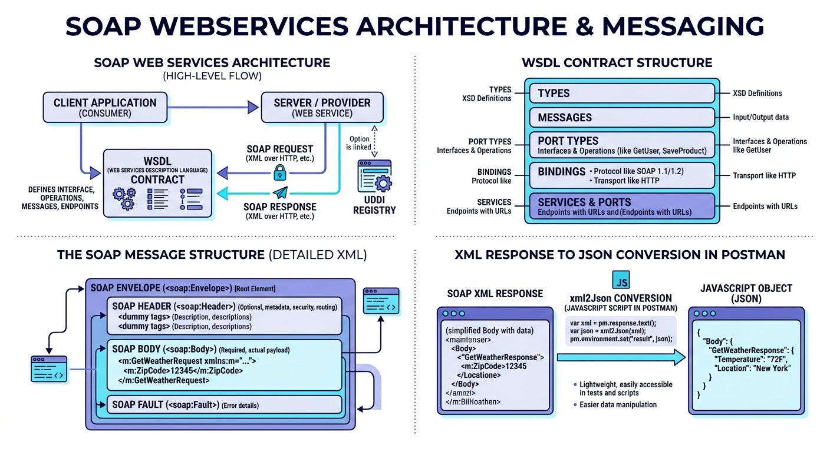
The standardized structure of a SOAP XML request and response envelope.
1 SOAP Envelope: The root XML element defining namespace rules (xmlns:soap) that identifies the packet as a SOAP message.
2 SOAP Header (Optional): Contains routing information, transaction tokens, and security assertions (such as WS Security).
3 SOAP Body (Mandatory): Contains the actual RPC call, method parameters, or response payload returned by the server.
4 SOAP Fault (Error Handling): Standardized sub element returned inside the Body when an exception occurs.

Step 3: The Live Accounting WebService and Postman Setup
To test our grant verification in real time, we query the live DataAccess Number Conversion WebService. You can view the live service documentation directly in your browser: [https://www.dataaccess.com/webservicesserver/NumberConversion.wso](https://www.dataaccess.com/webservicesserver/NumberConversion.wso).
The documentation confirms two supported enterprise operations:

Try it yourself
- 1. NumberToWords: Accepts an unsigned long integer (such as 400) and returns the written English string ("four hundred"). We use this to verify our grant check amount.
- 2. NumberToDollars: Accepts a numeric amount (such as 123) and returns the currency description ("one hundred and twenty three dollars").
The documentation offers both SOAP 1.1 and SOAP 1.2 specifications. In modern enterprise testing, SOAP 1.2 is the recommended standard. We deconstruct the SOAP 1.2 request envelope into three distinct structural chunks:
Deconstructing the SOAP 1.2 Request Envelope
The formal XML contract components:
CHUNK 1: Chunk 1: Root Envelope & Namespace · The Outer Sealed Container
Declares this message as an official SOAP 1.2 envelope using the W3C namespace.
soap-envelope-root.xml
1 <?xml version="1.0" encoding="utf-8"?>
<soap12:Envelope xmlns:soap12="http://www.w3.org/2003/05/soap-envelope">
Rule: The XML namespace prevents naming collisions with custom business tags.
CHUNK 2: Chunk 2: The SOAP Body & Operation · Invoking the Target Method
Specifies the RPC operation (NumberToWords) and targets the service contract domain.
soap-operation.xml
1 <soap12:Body>
<NumberToWords xmlns="http://www.dataaccess.com/webservicesserver/">
Rule: SOAP operations are declared in XML body tags rather than HTTP URL paths.
CHUNK 3: Chunk 3: Method Parameter Tag · Supplying Argument Value
Passes 400 inside the ubiNum tag, then cleanly closes the operation, body, and envelope tags.
soap-parameter.xml
1 <ubiNum>400</ubiNum>
</NumberToWords>
</soap12:Body>
</soap12:Envelope>
Rule: Every opening XML tag must possess an exact matching closing tag.
IMAGINE & PREDICT BEFORE SENDING
When we POST this valid SOAP 1.2 XML envelope to the live NumberConversion service, what response structure will return?
A. 200 OK with an XML envelope containing <m:NumberToWordsResult>four hundred</m:NumberToWordsResult>
B. A JSON object { "result": "four hundred" } because all modern APIs return JSON
C. 404 Not Found because XML cannot be sent over HTTP POST
D. 500 Server Error because 400 is not a valid number
Actual Output (Live SOAP WebService Outcome): SOAP XML response confirmed! The remote accounting mainframe evaluates the envelope and replies with an HTTP 200 OK XML document wrapping "four hundred" inside the NumberToWordsResult tag!
Fresher Trap to Avoid: The Hidden Content Type Discrepancy
When you open Postman, set the method to POST, select Body > raw, and choose XML from the dropdown, Postman automatically generates a hidden header: Content-Type: application/xml.
However, the SOAP 1.2 server specification strictly requires Content-Type: application/soap+xml; charset=utf-8 (or text/xml; charset=utf-8 for SOAP 1.1). If you leave Postman default header in place, the server immediately rejects your request with a 415 Unsupported Media Type or protocol fault!
How to fix: Go to the Headers tab in Postman, click the eye icon to show hidden headers, uncheck the default Content-Type header, and create your own header with key Content-Type and value application/soap+xml; charset=utf-8.
When we hit Send in Postman, the remote accounting server processes the envelope and returns a structured XML response:

Expected output
Terminal
1 $ SOAP XML Response from DataAccess Server
2 Status: 200 OK | Time: 215 ms | Size: 412 B
3 Content-Type: application/soap+xml; charset=utf-8
4
5 <?xml version="1.0" encoding="utf-8"?>
6 <soap:Envelope xmlns:soap="http://www.w3.org/2003/05/soap-envelope">
7 <soap:Body>
8 <m:NumberToWordsResponse xmlns:m="http://www.dataaccess.com/webservicesserver/">
9 <m:NumberToWordsResult>four hundred </m:NumberToWordsResult>
10 </m:NumberToWordsResponse>
11 </soap:Body>
12 </soap:Envelope>
Live Interactive Wire Inspector: SOAP 1.2 XML NumberToWords
POST https://www.dataaccess.com/webservicesserver/NumberConversion.wso
Status: 200 OK · Time: 215 ms · Size: 412 B
Response Body:
response.json
1 <?xml version="1.0" encoding="utf-8"?>
2 <soap:Envelope xmlns:soap="http://www.w3.org/2003/05/soap-envelope">
3 <soap:Body>
4 <m:NumberToWordsResponse xmlns:m="http://www.dataaccess.com/webservicesserver/">
5 <m:NumberToWordsResult>four hundred </m:NumberToWordsResult>
6 </m:NumberToWordsResponse>
7 </soap:Body>
8 </soap:Envelope>
Assertions Verified:
✓ Accounting service status code is 200 OK
✓ Header Content Type is application/soap+xml
✓ Converted words attribute matches four hundred

Step 4: Parsing XML in JavaScript Using xml2Json
In JavaScript, navigating XML tags manually requires clumsy string parsing. Fortunately, Postman provides a built in utility called xml2Json that transforms raw XML text into a traversable JavaScript object in one step. You can download the completed script: [Download Parse SOAP Response Script](/materials/zero-to-agentic-api-testing/lesson-12/parse-soap-response.js).

The code
parse-soap-xml-response.js
1 // Step 1: Capture the raw XML text response from the server
2 const rawXmlResponse = pm.response.text();
3
4 // Step 2: Convert XML text into a traversable JavaScript object
5 const responseJson = xml2Json(rawXmlResponse);
6
7 // Step 3: Verify HTTP status code is 200 OK
8 pm.test("Accounting service status code is 200 OK", function () {
9 pm.response.to.have.status(200);
10 });
11
12 // Step 4: Extract the result using bracket notation for XML namespaces
13 pm.test("Number conversion result returns four hundred", function () {
14 const actualValue = responseJson["soap:Envelope"]["soap:Body"]["m:NumberToWordsResponse"]["m:NumberToWordsResult"];
15 // Defensive trim handles legacy SOAP trailing whitespace
16 pm.expect(actualValue.trim()).to.eql("four hundred");
17 });
Legacy SOAP Reality: The Trailing Whitespace Trap
A real world quirk of the public DataAccess NumberConversion SOAP service is that it appends a trailing space to words: returning "four hundred " rather than "four hundred".
If you write pm.expect(actualValue).to.eql("four hundred") without trimming, your test will fail with an unexpected character difference at index 12!
In automated testing of legacy XML services, always use defensive methods like actualValue.trim() or pm.expect(actualValue).to.include("four hundred") to safeguard tests from invisible whitespace discrepancies.
Fresher Trap to Avoid: Using Dot Notation for XML Namespaces
Notice that XML tags frequently include namespace prefixes with colons, such as soap:Body or m:NumberToWordsResponse.
In JavaScript, you cannot write responseJson.soap:Body because the colon triggers a fatal SyntaxError in dot notation!
Always access namespace prefixed XML elements using bracket notation with string quotes: responseJson["soap:Body"].

Step 5: Dynamic Parameterization and Fast Substring Scanning
In professional regression suites, we do not hardcode 400 in our XML request body or assertions. Instead, we store the input number and expected result in Postman collection variables and reference them dynamically. You can download the dynamic test script: [Download Dynamic SOAP Assertions Script](/materials/zero-to-agentic-api-testing/lesson-12/dynamic-soap-assertions.js):

The code
dynamic-soap-assertions.js
1 // Technique 1: Deep tag validation against collection variables
2 const responseJson = xml2Json(pm.response.text());
3 const actualWord = responseJson["soap:Envelope"]["soap:Body"]["m:NumberToWordsResponse"]["m:NumberToWordsResult"];
4
5 pm.test("Deep tag validation matches collection expected result", function () {
6 const expectedWord = pm.collectionVariables.get("grant_word") || "four hundred";
7 pm.expect(actualWord.trim()).to.eql(expectedWord);
8 });
9
10 // Technique 2: Fast text scanning across the entire response string
11 pm.test("Quick scan confirms four hundred is present in response", function () {
12 pm.expect(pm.response.text()).to.include("four hundred");
13 });

Step 6: Practice Challenge: Converting Numbers to Dollars
Now it is your turn to apply what you learned! In the same DataAccess service documentation, locate the second operation: NumberToDollars. Create a second request in your SOAP collection with the following details:

Try it yourself
- Set the HTTP method to POST and the URL to: https://www.dataaccess.com/webservicesserver/NumberConversion.wso
- In the Headers tab, configure Content Type to application/soap+xml; charset=utf 8
- In the Body tab, select raw and XML, then wrap <NumberToDollars><dNum>123</dNum></NumberToDollars> inside the SOAP 1.2 envelope.
- In the Tests tab, convert the response with xml2Json and write an assertion verifying that the returned string equals "one hundred and twenty three dollars". You can download the completed solution file: [Download SOAP Number to Dollars XML](/materials/zero-to-agentic-api-testing/lesson-12/soap-number-dollars.xml).
WAR ROOM BATTLE SCAR · Enterprise Interbank Freeze
The 415 Header Collision: The Cost of a SOAP Version Mismatch
A national banking federation upgraded its interbank clearing gateway from SOAP 1.1 to SOAP 1.2. Automated test pipelines running on older Postman collections continued sending legacy headers: Content Type text/xml; charset=utf 8 with a SOAPAction header. The upgraded gateway strictly required Content Type application/soap+xml; charset=utf 8 per the SOAP 1.2 specification. The legacy header triggered millions of HTTP 415 Unsupported Media Type errors, halting electronic clearing across fifty regional credit unions for four hours.
Key Architectural Lesson: Always align HTTP Content Type headers with the exact SOAP specification. SOAP 1.1 mandates text/xml with SOAPAction, while SOAP 1.2 strictly requires application/soap+xml without SOAPAction.
WAR ROOM INCIDENT TRIAGE
War Room Triage: The xml2Json Undefined Traversal Crash
You convert an XML response using const responseJson = xml2Json(pm.response.text()). In your test script, you assert: pm.expect(responseJson["soap:Envelope"]["soap:Body"].NumberToWordsResult).to.eql("four hundred"). Postman halts immediately with: "TypeError: Cannot read property NumberToWordsResult of undefined". What caused this traversal failure?
A. Postman does not support parsing XML responses in JavaScript.
B. The response XML element contained an XML namespace prefix (such as m:NumberToWordsResponse) that was omitted from the bracket lookup chain.
C. The xml2Json utility only operates inside Node.js scripts outside Postman.
D. The SOAP server returned an encrypted binary hash instead of XML.
TACTICAL TRIUMPH: Respect XML namespace prefixes! XML responses often qualify elements with namespace prefixes like m:NumberToWordsResponse. When converted by xml2Json, these prefixes become part of the JavaScript object property key. Omitting the prefix means responseJson["soap:Envelope"]["soap:Body"]["NumberToWordsResponse"] evaluates to undefined, throwing a fatal TypeError on subsequent property accesses!

Step 7: Review and Practice
MAKE A GUESS
When testing a SOAP WebService in Postman, why must you select the HTTP POST method even when retrieving data?
- A. Because GET is not supported by the HTTP protocol
- B. Because SOAP operations, namespace rules, and data parameters are packaged securely inside the XML envelope body rather than in the URL
- C. Because POST is faster than GET on all networks
- D. Because Postman does not allow GET requests on XML
Answer: Because SOAP operations, namespace rules, and data parameters are packaged securely inside the XML envelope body rather than in the URL. SOAP messages are always transported using HTTP POST requests, because the operation name and parameters are packaged inside the XML envelope body.

Check your understanding
1. What is the purpose of xml2Json in Postman test scripts?
Answer: xml2Json converts raw XML response strings into standard JavaScript objects so testers can traverse properties using bracket notation in Chai assertions.
2. Why must you uncheck Postman default Content Type when sending SOAP 1.2 requests?
Answer: Postman defaults to application/xml, but the SOAP 1.2 standard strictly requires application/soap+xml; charset=utf 8. Mismatched headers cause server rejections.

Key takeaways
REMEMBER
- SOAP is a strict protocol based on XML envelopes, headers, bodies, and WSDL contracts.
- All SOAP requests are executed via HTTP POST with the body containing the XML envelope.
- Always check Postman hidden headers to ensure Content Type matches the server SOAP 1.2 specification.
- The built in xml2Json utility converts complex XML trees into traversable JavaScript objects.
- Use bracket notation with string quotes to access namespace prefixed XML elements without syntax errors.
⚡ MISSION 3 PHASE 4 CLEARED · Architectural Triumph: Legacy SOAP WebServices & XML Parsing Conquered
You shattered the modern myth that QA engineers only test JSON REST APIs. When confronted with legacy enterprise banking, healthcare, and government mainframes, you crafted valid SOAP 1.2 XML envelopes, outmaneuvered hidden header traps, converted complex XML trees with xml2Json, and extracted deeply nested namespaces with bracket notation.
Tactical Superpowers Mastered:
- Bridging the architectural divide: commanding both modern REST microservices and legacy enterprise SOAP WebServices
- Authoring valid SOAP 1.2 and SOAP 1.1 XML envelopes with headers, bodies, and target namespaces
- Defeating hidden header traps by enforcing exact Content Type application/soap+xml wire specifications
- Transforming raw XML strings into traversable JavaScript objects using the built in xml2Json utility
- Traversing complex XML namespaces using JavaScript string bracket notation without syntax exceptions
Enterprise Disasters Prevented:
- Averted multi million dollar enterprise integration outages during legacy banking and accounting migrations
- Prevented silent test suite failures caused by Postman overriding XML Content Type headers
- Eliminated costly contractor dependencies by proving that Postman can automate legacy XML just as easily as JSON
War Room Takeaway: The vast majority of global enterprise wealth still flows through legacy SOAP web services. When you can seamlessly test both modern GraphQL REST APIs and legacy SOAP mainframes, your market value as a Lead Test Architect is peerless.
NEXT DISCOVERY · Continuing Mission 3: Headless Execution in CI CD Pipelines
Our campus library test suite is now complete across modern REST, OAuth 2.0 security, mock contracts, and legacy enterprise SOAP. But it still only runs when a human clicks buttons in the Postman desktop app. In our final chapter, we take on the ultimate enterprise challenge: running our entire suite headlessly with Newman CLI and automating continuous delivery in Jenkins and GitHub Actions!

Chapter 13: Headless Test Execution with Newman and CI CD
Command line collection runs, rich HTML Extra reports, and automated pipeline integration.
MISSION COMMAND HUD
PHASE: Phase 5 of 5: Headless Newman & CI CD (Mission Victory) · RANK: Rank: Continuous Delivery Architect
ACTIVE MISSION: Mission 3: Hardening for Enterprise Production and CI CD
MISSION BRIEFING & CHAPTER ROADMAP
MISSION 3 · PHASE 4 OF 4: Enterprise Resilience and CI CD Quality Gates
CRISIS SCENARIO: Continuous Quality Gate: Headless Newman Execution in CI CD
Context: On the eve of campus enrollment, ten thousand students and faculty will access the university portal. Developers are deploying hotfixes continuously. We cannot rely on manual testing in a desktop app. We must construct an autonomous robot watchdog: running our test suites headlessly via Newman CLI on every code commit, generating visual HTML Extra dashboards, and gating production releases in Jenkins and GitHub Actions.
Operational Target: Export portable collections and environments, run headless test suites with Newman, configure fail fast bail flags, and integrate CI CD pipelines.

WE WILL ACHIEVE: Transform your desktop collection into an automated, headless deployment gate by mastering Newman CLI, HTML Extra reports, and CI CD pipeline integration.
HOW WE WILL DO IT: Export portable JSON collections and environments, execute command line runs with data files and fail fast bail flags, generate visual dashboards, and configure Jenkins automation.
WHAT YOU WILL CARRY FORWARD: The complete enterprise grade automated API testing pipeline running autonomously in continuous delivery pipelines, achieving full Mission 3 victory.
MISSION PROGRESS · Completing Mission 3: Continuous Integration and Automated Gating
Tomorrow morning is the first day of semester enrollment, when ten thousand students and faculty members will flood the campus library portal to register books, access digital research archives, and process inter library loans. The university engineering director calls an emergency team briefing: developers are pushing hotfixes late into the night, and we cannot have a human being sitting at a laptop clicking Postman buttons manually at two in the morning. We need an automated robot watchdog that runs our test suite automatically on every code push, generates a visual dashboard for university directors, lets us flip between the Campus QA staging server and the live UAT production cluster with a single dropdown click, and runs scheduled cloud smoke checks. In our final chapter, we build that complete continuous integration pipeline using Newman, Jenkins, GitHub Actions, and Postman Cloud Monitors.
The Midnight Launch Guard: Automated test robots protecting servers during midnight updates.
1 Automated Stop Sign: Blocking broken code immediately so bad updates never reach real students.
2 Hands Free Testing: Running all test collections automatically in the background without opening the Postman desktop app.
3 Clear Visual Reports: Creating colorful web dashboards so the engineering team can see test results in one glance.

Step 1: The Continuous Integration Testing Flow
ARCHITECTURE · Headless CI CD Pipeline: Automated Newman Gating on Every Git Commit
HEADLESS CI CD PIPELINE · Headless CI CD Pipeline: Automated Newman Gating on Every Git Commit
Newman bridges the gap between exploratory testing in the Postman desktop app and automated deployment pipelines. In modern software organizations, automated tests execute headlessly on every git push without human intervention, generating visual HTML Extra dashboards and protecting production clusters.
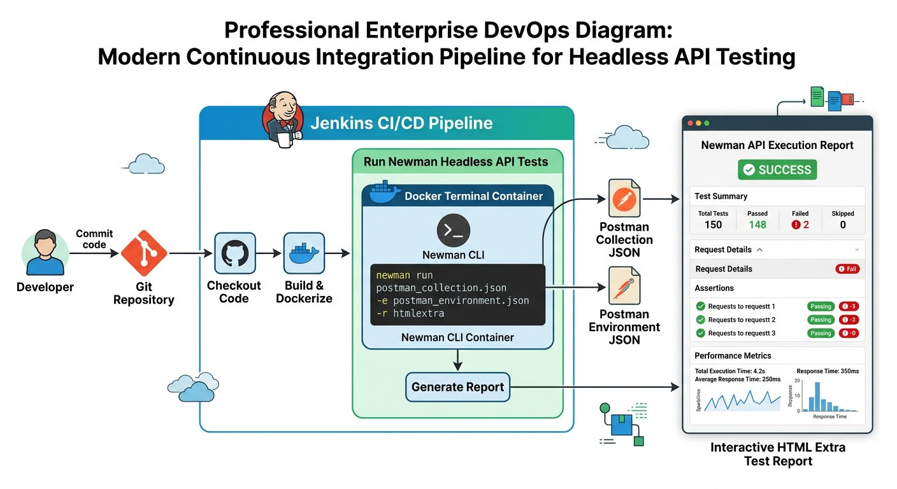
The complete continuous integration testing pipeline powered by Newman.
1 Step 1 (Code Push): A developer merges new code into the Git repository.
2 Step 2 (Pipeline Trigger): The CI server (Jenkins or GitHub Actions) detects the commit and spins up a lightweight test container.
3 Step 3 (Headless Execution): Newman executes the exported Postman collection and environment files without a graphical interface.
4 Step 4 (Reporting and Gating): Newman generates an interactive HTML Extra report. If all tests pass with exit code 0, deployment proceeds; if any assertion fails, the build is blocked.

Step 2: Installing Node.js and Newman Globally
Newman is built as a command line tool on top of Node.js. Before installing Newman, ensure Node.js is installed on your computer or build server.

Try it yourself
- Download and install Node.js from the official site: https://nodejs.org (select LTS version).
- Verify your installation in your terminal by checking the versions: run node -v and npm -v.
- Verify your system path environment variable so Node is accessible globally from any directory (on Mac check echo $PATH, on Windows check System Properties > Environment Variables).
- Install Newman globally using the Node Package Manager: run npm install -g newman.

Step 3: Exporting Artifacts and The Space in Filename Bug
To run our test collection outside the Postman graphical interface, we must export our collection, environment variables, and external data files as portable JSON and CSV artifacts.

Try it yourself
- Export Collection: In Postman, click the three dots beside your collection and select Export to save Campus_Library_Collection.json.
- Export Environment: In the Environments manager, click the three dots beside your environment and export Campus_Library_UAT.json (using flag -e).
- Export Globals: In Global Variables, click Export to save Campus_Globals.json (using flag -g).
- Prepare CSV Data: Place your books_data.csv spreadsheet in the same project directory (using flag -d).
Fresher Trap to Avoid: Spaces in Exported Filenames
When you export files from Postman, the default filename often contains spaces (such as Campus Library Suite.postman_collection.json).
In terminal environments like bash or Windows PowerShell, spaces act as argument separators. The terminal treats Campus as one file and Library as another, immediately crashing with a file not found error!
Always rename exported files using underscores or clean alphanumeric names before running terminal commands: Campus_Library_Collection.json.
With all artifacts in our project folder, we run our complete collection headlessly from the command prompt:

The code
run-newman-cli.sh
1 # Execute headless collection run with environment, globals, and CSV data
2 newman run Campus_Library_Collection.json \
3 -e Campus_Library_UAT.json \
4 -g Campus_Globals.json \
5 -d books_data.csv

Expected output
Terminal
1 $ newman run Campus_Library_Collection.json -e Campus_Library_UAT.json -d books_data.csv
2 Iteration 1 of 3: Processing "Learn Postman Testing"
3 POST https://uat-api.campuslibrary.org/v1/books [200 OK, 248B, 185ms]
4 ✓ Status code is 200 OK
5 ✓ Response contains successfully added message
6 ✓ Backend generated ID correctly concatenates ISBN and aisle
7
8 GET https://uat-api.campuslibrary.org/v1/books?id=LIB1048101 [200 OK, 192B, 142ms]
9 ✓ GetBook response returns an array with at least one record
10 ✓ Retrieved book name matches "Learn Postman Testing"
11 ✓ Catalog ISBN and aisle match created coordinates
12
13 POST https://uat-api.campuslibrary.org/v1/books/delete [200 OK, 212B, 158ms]
14 ✓ Book is successfully deleted message verified
15
16 ┌─────────────────────────┬──────────┬──────────┐
17 │ │ Executed │ Failed │
18 ├─────────────────────────┼──────────┼──────────┤
19 │ iterations │ 3 │ 0 │
20 │ requests │ 9 │ 0 │
21 │ test-scripts │ 18 │ 0 │
22 │ prerequest-scripts │ 12 │ 0 │
23 │ assertions │ 18 │ 0 │
24 └─────────────────────────┴──────────┴──────────┘
25 Execution Summary: 3 iterations, 9 requests, 18 assertions, 0 failures (518 ms)

Step 4: Generating Publication Grade HTML Extra Dashboards
Terminal output is great for developers, but engineering directors and quality assurance managers need visual dashboards. We install the newman-reporter-htmlextra plugin to generate publication grade reports. We break down the Newman execution command into three key flag chunks:
Deconstructing the Headless Command
Essential CLI parameters for automated pipelines:
CHUNK 1: Chunk 1: Target Files · Providing Test Assets
Specifies the exported collection JSON, the UAT environment variables file, and the CSV dataset.
newman-targets.sh
1 newman run Campus_Library_Collection.json \
-e Campus_Library_UAT.json \
-d books_data.csv
Rule: Newman loads environments and data files headlessly without GUI dialogs.
CHUNK 2: Chunk 2: Multi Reporter Configuration · Configuring Dashboard Output
Generates real time colored CLI text in the terminal while compiling an interactive HTML dashboard.
newman-reporters.sh
1 -r cli,htmlextra \
--reporter-htmlextra-export reports/dashboard.html
Rule: The single file dashboard can be archived directly as a CI build artifact.
CHUNK 3: Chunk 3: Failure Enforcement Policy · Fast Fail Safety Gate
Tells Newman to stop execution immediately upon the very first assertion failure, saving valuable CI compute minutes. Note that any assertion failure causes Newman to exit with code 1; the bail flag enables fast fail semantics.
newman-bail.sh
1 --bail
Rule: --bail guarantees defective builds are blocked immediately without wasting compute.
IMAGINE & PREDICT BEFORE SENDING
When Newman executes in a Jenkins or GitHub Actions pipeline and an assertion fails, what exit code does Newman return to the terminal?
A. Exit code 1: Signaling non zero failure to the operating system, which instructs the CI pipeline to fail the build
B. Exit code 0: Because commands that finish executing always return zero
C. Exit code 200: Matching the HTTP status code
D. Exit code 500
Actual Output (Terminal Exit Code Confirmation): Exit code 1 halts the pipeline! In Unix and Windows terminals, exit code 0 indicates success, while any non zero code (such as 1) signals failure. Jenkins and GitHub Actions automatically inspect this numeric code: when Newman exits with 1, the pipeline halts and blocks the deployment!
What the HTML Extra Dashboard Delivers
• Summary Visuals: Interactive pie charts and bar graphs showing total requests, passed assertions, and failed checks.
• Granular Request Logs: Expandable cards showing exact request URLs, HTTP methods, wire headers, and request bodies for every iteration.
• Diagnostic Trace: Detailed inspection of response payloads and assertion error diffs for immediate debugging.
• Stakeholder Ready: A single portable HTML file you can email to managers or publish to CI build artifacts.

Step 5: Setting Up Jenkins and The Working Directory Trap
To automate execution without opening a terminal manually, we set up Jenkins, the enterprise standard continuous integration server. You can download the Jenkins build script: [Download Jenkins Build Step Script](/materials/zero-to-agentic-api-testing/lesson-13/jenkins-build-step.sh).

Try it yourself
- Download the generic Java package: jenkins.war from https://www.jenkins.io.
- Start Jenkins from your command prompt on port 9090: java -jar jenkins.war --httpPort=9090.
- Open your local browser to access the running Jenkins administrative setup dashboard on your assigned port.
- Enter the initial administrator password, complete setup, and click New Item to create a Freestyle Project named "Campus Library Regression Pipeline".
- In the Build section, click Add build step and select Execute shell (on Linux or Mac) or Execute Windows batch command (on Windows).
Fresher Trap to Avoid: The Jenkins Working Directory Trap
When Jenkins runs a job, it executes from its own internal workspace directory (such as /var/jenkins_home or your user profile folder), where your exported collection files do not exist.
If you simply paste newman run Campus_Library_Collection.json, Jenkins immediately aborts with an error saying the file cannot be found!
How to fix: In your Jenkins build step, always navigate to your project folder first using the cd command before running Newman:

The code
jenkins-build-step.sh
1 # Step 1: Navigate to the directory where exported artifacts are stored
2 cd /home/user/postman_execution
3
4 # Step 2: Run Newman with environment and HTML Extra reporter
5 newman run Campus_Library_Collection.json \
6 -e Campus_Library_UAT.json \
7 -d books_data.csv \
8 -r cli,htmlextra \
9 --reporter-htmlextra-export reports/build_report.html \
10 --bail

Step 6: Parameterized Jenkins Builds: Dynamic Environment Switching
Here is the ultimate enterprise automation requirement: our QA engineers test on the QA staging cluster in the morning, but before the midnight release, they must validate the UAT production mirror. We do not want to create duplicate Jenkins jobs or edit shell scripts by hand. We make our Jenkins job dynamic using a Choice Parameter.

Try it yourself
- In your Jenkins job configuration, check the box: This project is parameterized.
- Click Add Parameter and select Choice Parameter.
- Set the Parameter Name to: ENV
- In the Choices box, enter two options on separate lines: QA and UAT.
- Ensure your exported environment files follow a uniform naming convention: QA.postman_environment.json and UAT.postman_environment.json.
Now, update the Jenkins build script to reference the parameter dynamically using ${ENV}. You can download the parameterized script: [Download Parameterized Jenkins Build Script](/materials/zero-to-agentic-api-testing/lesson-13/parameterized-jenkins-build.sh):

The code
parameterized-jenkins-build.sh
1 # Navigate to project folder
2 cd /home/user/postman_execution
3
4 # Interpolate the selected Jenkins environment choice dynamically
5 newman run Campus_Library_Collection.json \
6 -e "${ENV}.postman_environment.json" \
7 -d books_data.csv \
8 -r cli,htmlextra \
9 --reporter-htmlextra-export "reports/${ENV}_report.html" \
10 --bail
When you click Build with Parameters in Jenkins, a dropdown appears. Selecting QA runs your entire test suite against https://qa-api.campuslibrary.org. Selecting UAT runs against https://uat-api.campuslibrary.org. One single automated job services your entire enterprise testing lifecycle!

Step 7: Cloud CI CD Pipeline: GitHub Actions
For modern cloud engineering teams that host repositories on GitHub, you can execute this identical pipeline automatically on every git commit without hosting a local Jenkins server. You can download the ready to use GitHub workflow: [Download GitHub Actions Workflow](/materials/zero-to-agentic-api-testing/lesson-13/api-tests-workflow.yml):

The code
api-tests-workflow.yml
1 name: Campus Library API Regression Pipeline
2 on: [push, pull_request]
3
4 jobs:
5 api-regression:
6 runs-on: ubuntu-latest
7 steps:
8 - name: Checkout Repository Code
9 uses: actions/checkout@v4
10 - name: Setup Node.js Environment
11 uses: actions/setup-node@v4
12 with:
13 node-version: 20
14 - name: Install Newman and HTML Extra Reporter
15 run: npm install -g newman newman-reporter-htmlextra
16 - name: Execute Headless Test Suite
17 run: |
18 newman run course-materials/zero-to-agentic-api-testing/Zero-to-Agentic-API-Testing.postman_collection.json \
19 -e course-materials/zero-to-agentic-api-testing/Campus-Library-UAT.postman_environment.json \
20 -d course-materials/zero-to-agentic-api-testing/lesson-08/books_data.csv \
21 -r cli,htmlextra \
22 --reporter-htmlextra-export build/regression_report.html \
23 --bail

Step 8: Scheduled Cloud Watchdogs: Postman Monitors
While Jenkins and GitHub Actions run tests when code changes occur, what if no code was deployed during the night, but an external database server went down? To ensure system health without keeping your laptop awake, Postman provides Monitors.
A Postman Monitor runs your collection periodically on Postman cloud infrastructure according to a schedule you define:

Try it yourself
- 1. In Postman, navigate to the Monitors tab on the left sidebar and click Create a Monitor.
- 2. Assign a monitor name such as "Campus Library Daily Smoke Check".
- 3. Select the collection to execute and the target environment (Campus_Library_UAT).
- 4. Set the timer schedule: for example, every weekday at 7:00 AM. Postman cloud servers will execute the collection so results are ready before engineers arrive at 9:00 AM.
- 5. Configure email alerts: enter team email addresses to receive instant notifications if any assertion fails, with automatic retry on transient network errors.
- 6. Inspecting History and Restoring Items: If an engineer accidentally deletes a collection, navigate to the workspace Trash to restore it immediately.
WAR ROOM BATTLE SCAR · Four Million Dollar Pipeline Bypass
The Bypassed CI Gate Disaster: The Cost of Disabling Newman in the Merge Pipeline
Under intense pressure to meet a strict quarterly launch deadline, an engineering squad commented out the Newman collection execution step in their GitHub Actions workflow file to expedite merging. A developer subsequently merged a pull request that unintentionally inverted financial debit and credit transaction signs. Because the Newman automated regression check had been disabled, the pull request merged green without firing assertions. Within ninety minutes of deployment, the production ledger accumulated over four million dollars in erroneous balances.
Key Architectural Lesson: Never bypass or disable automated CI quality gates. Treat Newman command line regression tests as mandatory blocking status checks on every pull request and automated build.
WAR ROOM INCIDENT TRIAGE
War Room Triage: The Non Zero Exit Code CI Blocker
You configure Newman in a Jenkins pipeline: newman run LibraryTests.json -e StagingEnv.json. Two assertions fail during the test execution, yet Jenkins marks the build step as SUCCESS and deploys the defective build straight to staging. Why did Jenkins fail to block the deployment?
A. Newman does not generate exit codes on assertion failures.
B. The build script appended "|| true" or suppressed the non zero exit code, preventing Jenkins from detecting that Newman returned exit code 1 on assertion failures.
C. Jenkins only inspects console colors, not numeric exit codes.
D. The Newman collection must be written in Python to fail a Jenkins build.
TACTICAL TRIUMPH: Exit code integrity controls CI pipelines! In Unix and Windows terminals, a command indicates failure by returning a non zero exit code (such as 1). Newman automatically returns exit code 1 whenever any test assertion fails. If a shell script appends "|| true", the shell overrides the exit code to 0, deceiving Jenkins into treating a failed run as successful. Remove any exit code suppression or use the --bail flag to guarantee immediate failure!
★ MISSION ACCOMPLISHED · Mission 3 Accomplished: Autonomous Production Quality Gate!
Our entire campus library test suite now runs headlessly on every code commit in continuous integration pipelines, and runs scheduled smoke checks in the cloud. Any regression is detected and blocked before reaching students and faculty. You have mastered API testing from first principles to enterprise automation!

Step 9: Review and Practice
MAKE A GUESS
What exit code does Newman return to the terminal when all assertions in a collection pass successfully?
- A. Exit code 1
- B. Exit code 0
- C. Exit code 200
- D. Exit code 255
Answer: Exit code 0. In Unix and Windows command environments, an exit code of 0 indicates complete success. Any non zero exit code (such as 1) indicates failure, which signals CI pipelines to mark the build as failed.

Check your understanding
1. Why do CI build servers run tests headlessly rather than opening the Postman desktop window?
Answer: CI servers run on minimal Linux servers without screens. A headless command line tool consumes minimal memory, starts in milliseconds, and uses exit codes to control deployment pipelines.
2. What is the primary difference between a Jenkins pipeline build and a Postman Monitor?
Answer: A Jenkins pipeline typically triggers on event driven actions (such as a git push or pull request merge). A Postman Monitor runs on a recurring time schedule in the cloud (such as daily at 7:00 AM) to verify ongoing system health.

Key takeaways
REMEMBER
- Newman runs Postman collections headlessly from command prompts, Docker containers, and CI servers.
- Export collection, environment (-e), global (-g), and CSV data (-d) files into a single project folder without spaces in filenames.
- The htmlextra reporter creates publication grade interactive dashboards for stakeholders and QA leads.
- In Jenkins, always navigate to your project folder using cd before running Newman commands.
- Use Jenkins Choice Parameters to switch target test environments dynamically with a single dropdown selection.
- Postman Monitors provide scheduled cloud watchdogs running health checks without requiring local machines.
⚡ ★ FINAL CAPSTONE CONQUERED · CI CD DEFENDER · Ultimate Enterprise Capstone: Autonomous CI CD Quality Gate Deployed
You have conquered the entire Zero to Agentic API Testing journey! You took full command of the testing pyramid, automated multi tier campus services, secured microservices with OAuth 2.0, bridged legacy SOAP XML WebServices, and engineered an autonomous continuous integration pipeline powered by Newman, Jenkins, GitHub Actions, and HTML Extra reporting. You stand at the pinnacle of modern software quality engineering.
Tactical Superpowers Mastered:
- Orchestrating zero click headless test execution across containerized CI CD pipelines via Newman CLI
- Automating strict quality gates with the fail fast bail flag to block breaking commits before deployment
- Generating publication grade interactive HTML Extra dashboards with visual charts and granular wire traces
- Engineering parameterized Jenkins pipelines with dynamic Choice Parameters for instant QA and UAT switching
- Deploying round the clock scheduled cloud watchdogs and automated alerts using Postman Monitors
Enterprise Disasters Prevented:
- Averted catastrophic midnight production outages by intercepting breaking backend commits in the pipeline
- Eliminated hundreds of hours of manual release signoff delays, enabling true continuous delivery at enterprise scale
- Protected live production environments by establishing rigorous automated UAT gating before customer release
War Room Takeaway: You are no longer someone who merely checks if an application works. You are the architect who builds the autonomous shields that guarantee software never fails in production. You command the wire, the contract, the assertion, and the pipeline.
NEXT DISCOVERY · From Ground Zero to Production Mastery
Congratulations! You have completed all three missions: from auditing the live REST wire and mastering API fundamentals to automating the college library at scale, and hardening enterprise pipelines in CI CD. You are ready to test and automate any API in the world!

About the author
Akshat Sinha is the founder of The Sinha Family Group and the creator of Sarva Gyana Koshah: the treasury of all knowledge, which teaches through books, interactive learning platforms, and authoritative engineering references.
This book bridges the gap between manual exploratory testing, automated pipeline engineering, and continuous integration with Postman, JavaScript, and Newman.

Keep learning
Keep guessing, running and checking.
Sarva Gyana Koshah Books · The Treasury of All Knowledge

