Neural Networks and Fuzzy Logic — Assignment
Multilayer Perceptron Classifiers Built from Scratch
Iris Flower Classification · Breast Cancer (Wisconsin Diagnostic) Classification
Group members
# | Name | Roll number
1 | Mayank Das | 110123064
2 | Mukund Badsewal | 110123068
3 | Nikhil Saini | 110123071

Course: Neural Networks and Fuzzy Logic
Date of submission: 01/11/2026
Contents
1. Introduction 3
1.1 Deliverables 3
2. Implementation of the MLP from scratch 4
2.1 Input feeding and preprocessing 4
2.2 Weight and bias initialisation 4
2.3 Forward propagation 4
2.4 Loss functions 4
2.5 Backpropagation and gradient calculation 4
2.6 Weight and bias update (gradient descent) 5
2.7 Hyperparameters 5
3. Question 1 — Iris flower classification 6
3.1 Dataset 6
3.2 Performance metrics of the six experiments 6
3.3 Confusion matrices 6
3.4 Training loss curves 7
3.5 Initial and updated weights 8
3.6 Discussion 9
4. Question 2 — Breast cancer classification 11
4.1 Dataset 11
4.2 Performance metrics of the six experiments 11
4.3 Confusion matrices 11
4.4 Training loss curves 12
4.5 Initial and updated weights 13
4.6 Discussion 15
5. Extension A — deeper networks from scratch (2–5 hidden layers) 16
5.1 Iris 16
5.2 Breast cancer 16
5.3 Discussion 17
6. Extension B — deep MLPs with PyTorch (5–10 hidden layers) 18
6.1 Results 18
6.2 Discussion 20
7. Conclusions 21
Appendix A — Initial and updated weight matrices 22
A.1 Iris (Question 1) 22
A.2 Breast cancer (Question 2): hidden → output weights W2 24
A.3 Breast cancer: input → hidden weights W1 of 30–8–1 (70:30) 26

1. Introduction
This report presents two classification tasks solved with a Multilayer Perceptron (MLP) implemented from scratch in NumPy, without any predefined neural-network library:
- Question 1: Iris flower classification (3 classes, 4 features) with architectures 4–6–3, 4–10–3 and 4–20–3, a ReLU hidden layer, softmax output and categorical cross-entropy loss.
- Question 2: Breast cancer diagnosis (benign / malignant, 30 features) with architectures 30–8–1, 30–15–1 and 30–25–1, a ReLU hidden layer, sigmoid output and binary cross-entropy loss.
Each architecture is trained and tested on a 70:30 and an 80:20 train–test split, giving six experiments per question. For every experiment we report accuracy, precision, recall, F1-score, the confusion matrix, the training loss curve and the initial and updated weight matrices.
As discussed in class, two extensions were added: (i) the same from-scratch code with 2–5 hidden layers, and (ii) deep MLPs with 5–10 hidden layers in PyTorch.

1.1 Deliverables
File | Content
mlp_scratch.py | MLP class in pure NumPy: initialisation, forward pass, activations, losses, backpropagation, gradient-descent update, gradient check
helpers.py | Data loading, stratified split, standardisation, metrics, plotting
Q1_Iris_MLP.ipynb | Question 1, all experiments with outputs, plus the 2–5 hidden-layer extension
Q2_BreastCancer_MLP.ipynb | Question 2, all experiments with outputs, plus the 2–5 hidden-layer extension
Q3_PyTorch_Deep_MLP.ipynb | Extension: PyTorch deep MLPs with 5, 7 and 10 hidden layers on both datasets
results/ | All figures and CSV tables used in this report

2. Implementation of the MLP from scratch
The network is a single Python class, MLP(layer_sizes, output), written with NumPy only. layer_sizes lists the neurons per layer, for example [4, 6, 3] or [30, 25, 15, 8, 1], so the same code serves the one-hidden-layer networks required by the assignment and the deeper extension. Training is plain full-batch gradient descent: in every epoch the entire training set is fed forward, the loss is computed, gradients are back-propagated, and all weights and biases are updated once.

2.1 Input feeding and preprocessing
The input is a matrix X of shape (m samples × n features), and each row is one sample. Before training the data is split stratified (the class proportions in the training and test sets match the full dataset, random_state = 42). Each feature is then standardised, x′ = (x − μ) / σ, with μ and σ computed on the training set only and reused for the test set, so no information leaks from the test data. Standardisation is essential for the breast-cancer data, whose raw features range from about 0.001 to about 4000.

2.2 Weight and bias initialisation
Layer l has a weight matrix W⁽ˡ⁾ of shape (n_in × n_out) and a bias row-vector b⁽ˡ⁾ of shape (1 × n_out). Hidden layers, which are followed by ReLU, use He initialisation, W ~ N(0, 2/n_in). This keeps the activation variance roughly constant from layer to layer. The output layer uses Xavier initialisation, W ~ N(0, 1/n_in). All biases start at 0, since the random weights already break the symmetry between neurons. A fixed seed (42) makes every run reproducible, and a copy of the initial parameters is stored so they can be compared with the trained ones.

2.3 Forward propagation
A⁽⁰⁾ = X
Z⁽ˡ⁾ = A⁽ˡ⁻¹⁾ W⁽ˡ⁾ + b⁽ˡ⁾
A⁽ˡ⁾ = ReLU(Z⁽ˡ⁾) = max(0, Z⁽ˡ⁾) (hidden layers)
Ŷ = softmax(Z⁽ᴸ⁾), ŷᵢₖ = exp(zᵢₖ) / Σⱼ exp(zᵢⱼ) (Iris, 3 outputs)
ŷ = σ(Z⁽ᴸ⁾) = 1 / (1 + e^(−Z⁽ᴸ⁾)) (breast cancer, 1 output = P(malignant))
For numerical stability the row maximum is subtracted before the softmax exponent, and the sigmoid input is clipped.

2.4 Loss functions
Categorical cross-entropy: L = −(1/m) Σᵢ Σₖ yᵢₖ log ŷᵢₖ (yᵢₖ one-hot)
Binary cross-entropy: L = −(1/m) Σᵢ [ yᵢ log ŷᵢ + (1 − yᵢ) log(1 − ŷᵢ) ]

2.5 Backpropagation and gradient calculation
For both softmax + categorical cross-entropy and sigmoid + binary cross-entropy, the gradient of the loss with respect to the output pre-activation reduces to the same simple expression. The chain rule then gives every other gradient, layer by layer, from the output back to the input:
dZ⁽ᴸ⁾ = (Ŷ − Y) / m
dW⁽ˡ⁾ = A⁽ˡ⁻¹⁾ᵀ dZ⁽ˡ⁾, db⁽ˡ⁾ = Σᵢ dZ⁽ˡ⁾ᵢ
dA⁽ˡ⁻¹⁾ = dZ⁽ˡ⁾ W⁽ˡ⁾ᵀ, dZ⁽ˡ⁻¹⁾ = dA⁽ˡ⁻¹⁾ ⊙ ReLU′(Z⁽ˡ⁻¹⁾), ReLU′(z) = 1 if z > 0 else 0
To confirm the implementation, every analytical gradient was compared with a numerical finite-difference estimate [L(θ+ε) − L(θ−ε)] / 2ε. The relative error was about 10⁻¹¹ for all weights and biases, so the backpropagation is correct.

2.6 Weight and bias update (gradient descent)
W⁽ˡ⁾ ← W⁽ˡ⁾ − η · dW⁽ˡ⁾, b⁽ˡ⁾ ← b⁽ˡ⁾ − η · db⁽ˡ⁾

2.7 Hyperparameters
 | Question 1 (Iris) | Question 2 (Breast cancer)
Architectures | 4–6–3, 4–10–3, 4–20–3 | 30–8–1, 30–15–1, 30–25–1
Hidden / output activation | ReLU / softmax | ReLU / sigmoid
Loss | Categorical cross-entropy | Binary cross-entropy
Learning rate η | 0.1 | 0.05
Epochs (full batch) | 1000 | 1000
Splits | 70:30 (105/45), 80:20 (120/30) | 70:30 (398/171), 80:20 (455/114)
Positive class for precision/recall | macro average over 3 classes | malignant = 1

3. Question 1 — Iris flower classification

3.1 Dataset
The Iris dataset has 150 flowers, 50 per species (Setosa, Versicolor, Virginica), each described by sepal length, sepal width, petal length and petal width in cm. Figure 1 shows that Setosa is clearly separated from the other two species, especially on the petal features, while Versicolor and Virginica overlap slightly.
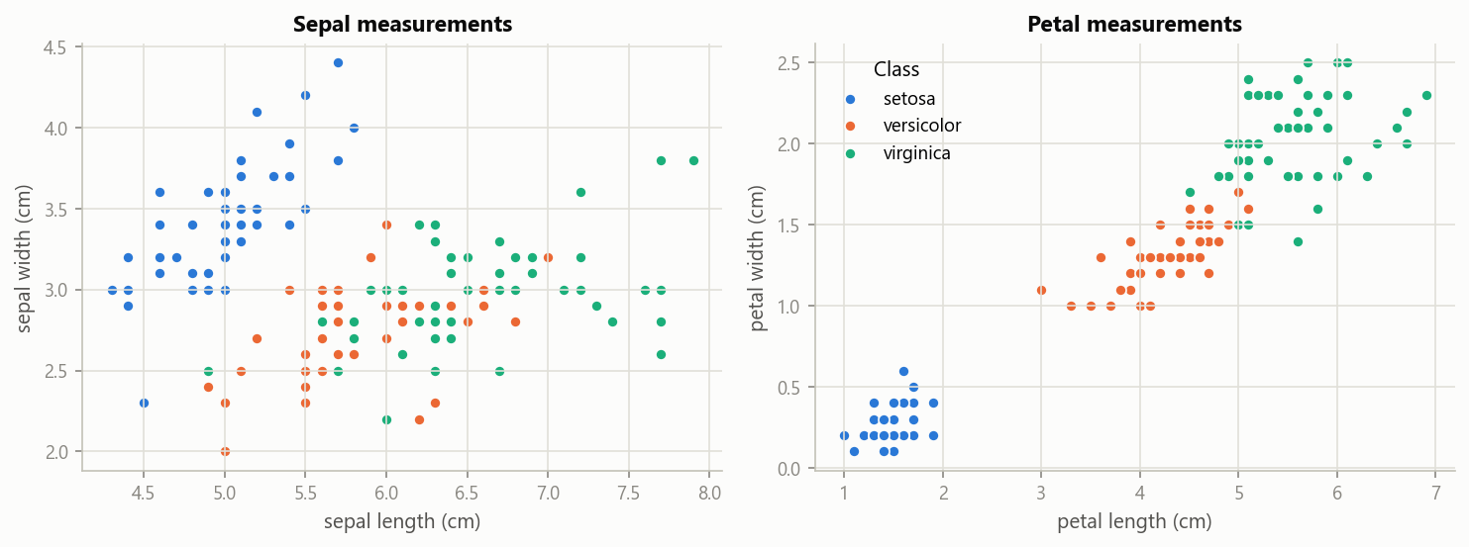
Figure 1 — Iris dataset: sepal and petal measurements by species.

3.2 Performance metrics of the six experiments
Table 1 lists the test-set metrics. Precision, recall and F1 are macro-averaged over the three classes. The best test accuracy is highlighted.
Exp | Architecture | Split | Train / Test | Params | Final loss | Train acc | Test acc | Precision | Recall | F1
1 | 4-6-3 | 70:30 | 105 / 45 | 51 | 0.0365 | 100.00 % | 91.11 % | 0.9155 | 0.9111 | 0.9107
2 | 4-10-3 | 70:30 | 105 / 45 | 83 | 0.0374 | 99.05 % | 91.11 % | 0.9155 | 0.9111 | 0.9107
3 | 4-20-3 | 70:30 | 105 / 45 | 163 | 0.0350 | 100.00 % | 91.11 % | 0.9155 | 0.9111 | 0.9107
4 | 4-6-3 | 80:20 | 120 / 30 | 51 | 0.0508 | 97.50 % | 96.67 % | 0.9697 | 0.9667 | 0.9666
5 | 4-10-3 | 80:20 | 120 / 30 | 83 | 0.0483 | 98.33 % | 93.33 % | 0.9333 | 0.9333 | 0.9333
6 | 4-20-3 | 80:20 | 120 / 30 | 163 | 0.0459 | 98.33 % | 96.67 % | 0.9697 | 0.9667 | 0.9666

Table 1 — Iris: performance metrics of the six experiments (test set).
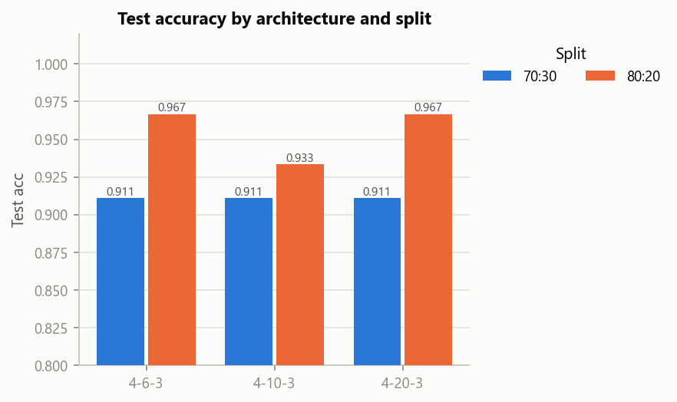
Figure 2 — Iris: test accuracy by architecture and split.

3.3 Confusion matrices
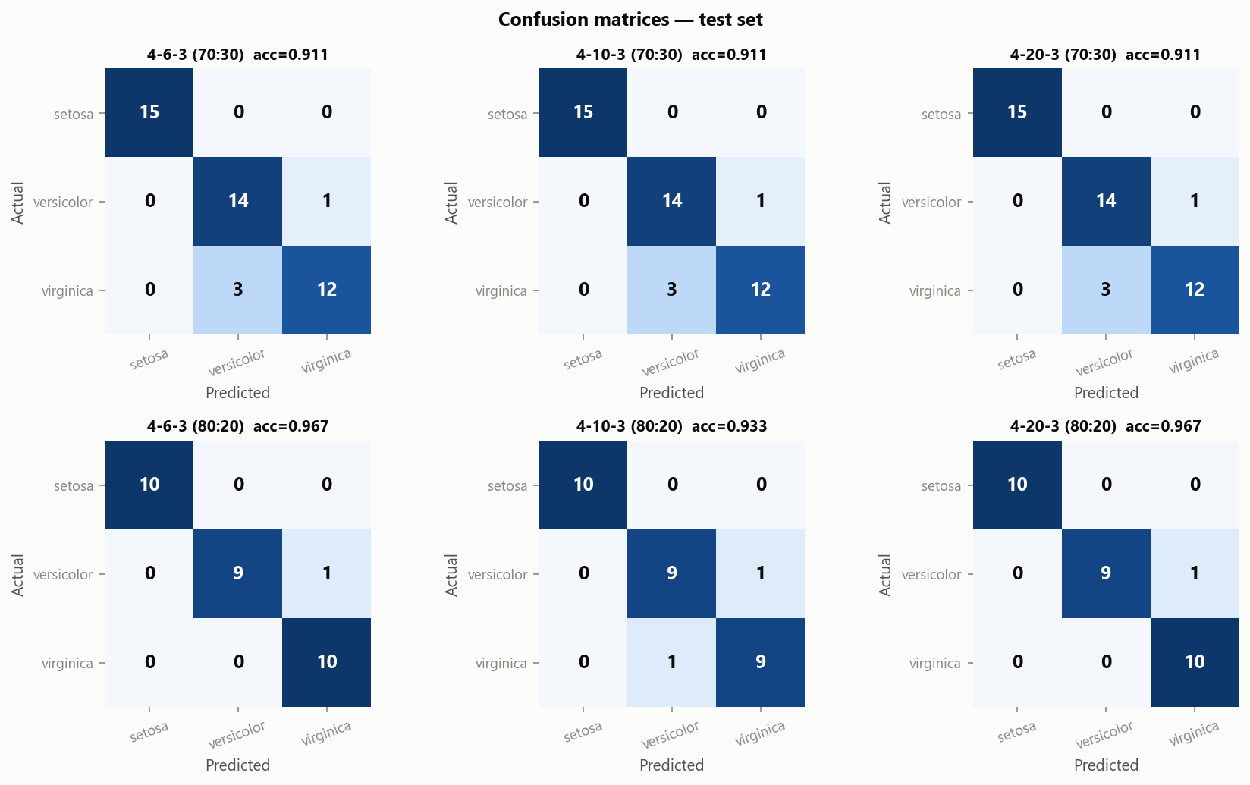
Figure 3 — Iris: confusion matrices on the test set (rows = actual, columns = predicted).
Setosa is classified perfectly in all six experiments, and every error is a Versicolor ↔ Virginica confusion. On the 70:30 split all three architectures make exactly the same four mistakes: one Versicolor predicted as Virginica and three Virginica predicted as Versicolor.

3.4 Training loss curves
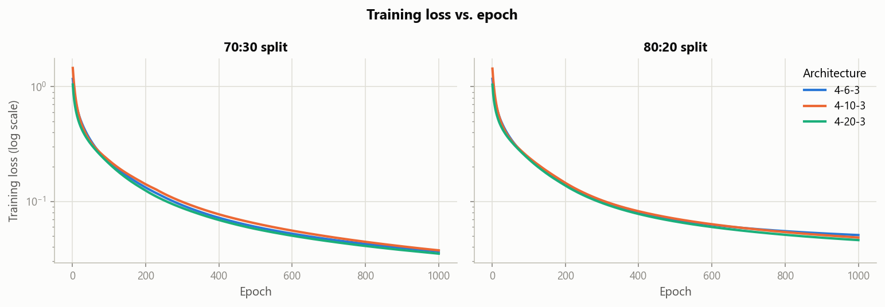
Figure 4 — Iris: training loss vs. epoch (log scale) for the three architectures.
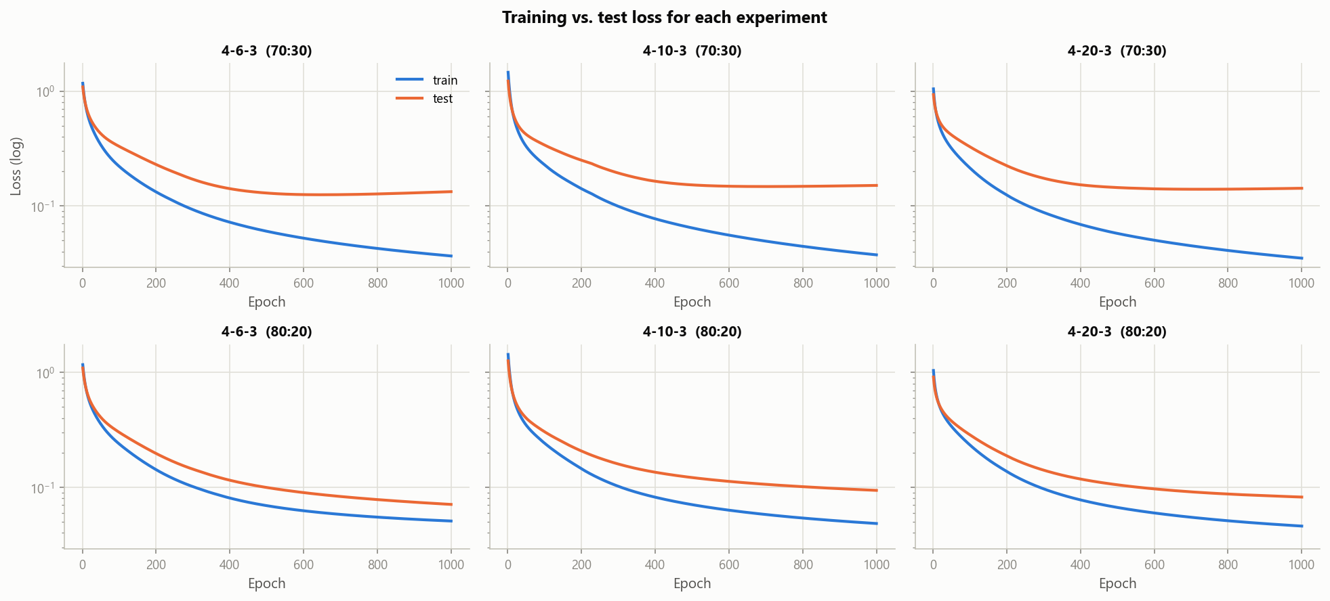
Figure 5 — Iris: training vs. test loss for each experiment.
The loss falls quickly during the first ≈100 epochs and then decreases slowly. The three architectures follow almost the same curve. At 70:30 the test loss stops improving after ≈500–600 epochs while the training loss keeps decreasing, a mild sign of overfitting. At 80:20 the test loss is still falling at epoch 1000.

3.5 Initial and updated weights
Table 2 shows the complete weights of the 4–6–3 network (70:30) before and after training. Figure 6 shows the same matrices as heatmaps together with their change. The weights of all six experiments are listed in Appendix A.1.
 | W1 initial (input → neuron) |  |  |  | W1 after training |  |  |  |  | W2 initial |  |  | W2 after training
neuron | s.length | s.width | p.length | p.width | s.length | s.width | p.length | p.width | b1 final | out1 | out2 | out3 | out1 | out2 | out3
h1 | 0.215 | 0.090 | 0.047 | 0.621 | 0.538 | -0.788 | 1.353 | 2.237 | -1.161 | -0.175 | -0.144 | 0.217 | -0.866 | -1.581 | 2.346
h2 | -0.735 | -0.224 | 0.797 | -0.035 | -0.832 | -0.294 | 0.845 | -0.032 | 0.469 | 0.149 | 0.168 | 0.176 | -0.318 | 0.669 | 0.143
h3 | 0.531 | -0.012 | 0.331 | -0.131 | 0.267 | -0.002 | 0.134 | -0.301 | -0.246 | 0.874 | -0.166 | -0.209 | 0.784 | -0.195 | -0.089
h4 | 0.665 | -0.603 | -0.608 | -0.481 | 1.054 | -0.685 | -0.289 | -0.365 | 1.477 | -0.332 | 0.251 | 0.461 | -0.698 | 1.510 | -0.431
h5 | -1.380 | 0.622 | 0.261 | 0.864 | -1.553 | 0.767 | -0.056 | 0.550 | 0.013 | -0.047 | -0.343 | -0.337 | 0.099 | -0.209 | -0.616
h6 | -0.921 | 0.550 | -0.678 | -0.109 | -1.371 | 0.656 | -1.411 | -0.838 | 0.122 | 0.266 | 0.303 | 0.222 | 1.759 | -0.669 | -0.300
b2 |  |  |  |  |  |  |  |  |  | 0.000 | 0.000 | 0.000 | -0.604 | 1.572 | -0.968

Table 2 — Iris 4–6–3 (70:30): weights per hidden neuron before and after training (s. = sepal, p. = petal).
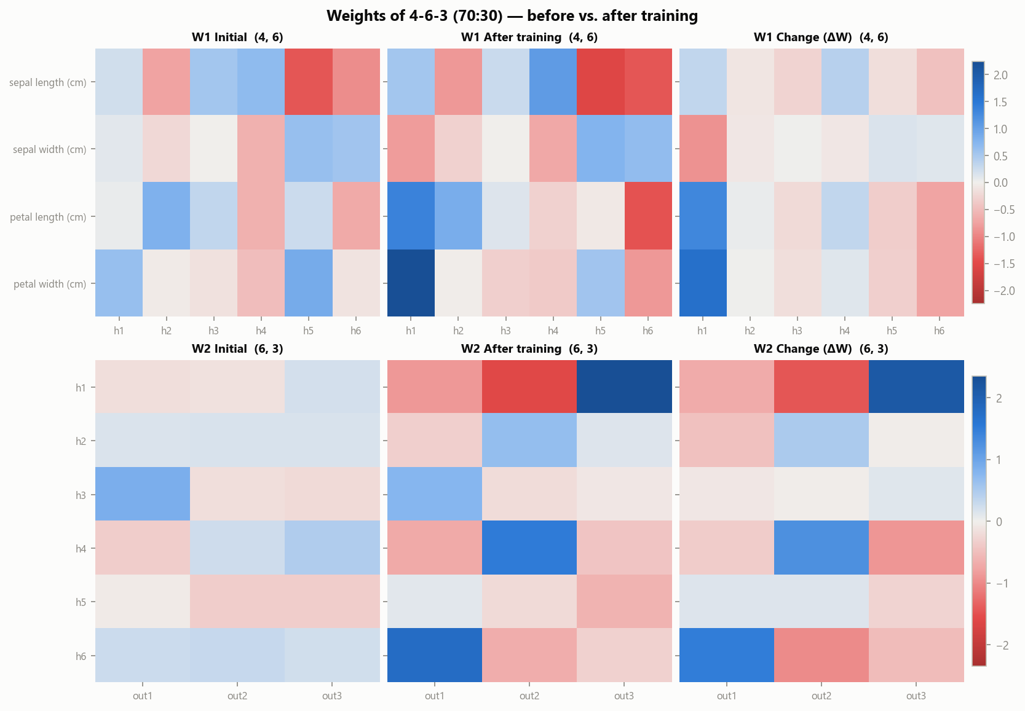
Figure 6 — Iris 4–6–3: initial weights, trained weights and their change ΔW (blue = positive, red = negative).
Learning is clearly visible. The weights from petal length and petal width change the most; for example, petal width → h1 grows from 0.62 to 2.24, consistent with the petal features being the most discriminative. The output weights W2 grow by roughly a factor of three (‖W2‖ from 1.36 to 4.12), and the biases move away from 0. Table 3 summarises the change for every layer of every experiment.
Architecture | Split | Layer | ‖W initial‖ | ‖W final‖ | ‖ΔW‖ | mean |ΔW| | ‖b final‖
4-6-3 | 70:30 | W1 (4, 6) | 2.8657 | 4.4183 | 2.6740 | 0.3689 | 1.9563
4-6-3 | 70:30 | W2 (6, 3) | 1.3589 | 4.1231 | 3.6941 | 0.6423 | 1.9428
4-10-3 | 70:30 | W1 (4, 10) | 3.6509 | 4.8851 | 2.4938 | 0.2918 | 1.8960
4-10-3 | 70:30 | W2 (10, 3) | 1.2479 | 3.9697 | 3.7521 | 0.5442 | 2.1134
4-20-3 | 70:30 | W1 (4, 20) | 4.8696 | 5.8875 | 2.2460 | 0.1871 | 2.1550
4-20-3 | 70:30 | W2 (20, 3) | 1.6419 | 4.2814 | 3.6861 | 0.3471 | 1.5992
4-6-3 | 80:20 | W1 (4, 6) | 2.8657 | 4.3761 | 2.6395 | 0.3646 | 1.8514
4-6-3 | 80:20 | W2 (6, 3) | 1.3589 | 4.0286 | 3.5970 | 0.6136 | 2.0218
4-10-3 | 80:20 | W1 (4, 10) | 3.6509 | 4.8666 | 2.4928 | 0.2969 | 1.8562
4-10-3 | 80:20 | W2 (10, 3) | 1.2479 | 3.9275 | 3.6793 | 0.5470 | 2.0665
4-20-3 | 80:20 | W1 (4, 20) | 4.8696 | 5.8642 | 2.2404 | 0.1902 | 2.1153
4-20-3 | 80:20 | W2 (20, 3) | 1.6419 | 4.2291 | 3.6411 | 0.3448 | 1.6887

Table 3 — Iris: size of the initial weights, the trained weights and the change per layer.

3.6 Discussion

Effect of hidden-layer size
- All three sizes perform practically the same. At 70:30 they reach an identical 91.11 %, and their final training losses are almost equal (0.0365 / 0.0374 / 0.0350). With four input features and almost separable classes, 6 hidden ReLU neurons already give enough capacity. 20 neurons triple the parameter count (51 → 163) without adding anything useful.
- At 80:20, 4–6–3 and 4–20–3 make one error and 4–10–3 makes two. A difference of one flower in a 30-sample test set is not a meaningful difference between the architectures.
- With more hidden neurons, each individual weight changes less: the mean |ΔW1| is 0.37, 0.29 and 0.19 for 6, 10 and 20 neurons. The learning is spread over more units.

Effect of training-data proportion
- 80:20 gives higher test accuracy than 70:30 for all three architectures (93–97 % vs. 91 %). With more training examples (120 vs. 105), the networks see more of the Versicolor/Virginica boundary.
- Part of the gap comes from the different test sets. The 70:30 test set contains three Virginica flowers lying inside the Versicolor region, and all networks misclassify them. With only 30 test samples, each 80:20 error is worth 3.3 % accuracy (vs. 2.2 % at 70:30), so the 80:20 figures are less precise.
Conclusion (Q1). A from-scratch MLP with a single hidden layer of 6 ReLU neurons classifies Iris with 91–97 % test accuracy. Larger hidden layers give no improvement, and a larger training share (80:20) gives better test accuracy. The remaining errors come from the natural overlap of Versicolor and Virginica, not from a lack of model capacity.

4. Question 2 — Breast cancer classification

4.1 Dataset
The Breast Cancer Wisconsin (Diagnostic) dataset contains 569 tumours: 357 benign (63 %) and 212 malignant (37 %). Each tumour is described by 30 real-valued features (mean, standard error and worst value of ten nucleus properties such as radius, texture, perimeter, area, concavity). The classes are imbalanced, so the split is stratified and precision, recall and F1 are reported alongside accuracy, with malignant as the positive class. Figure 7 shows why standardisation is needed: the raw feature spreads differ by about five orders of magnitude.
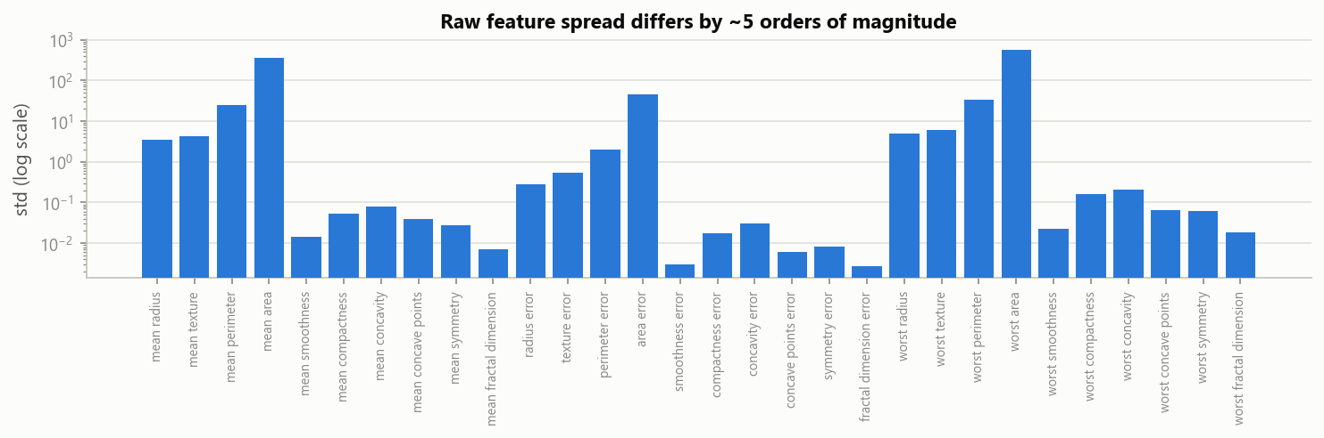
Figure 7 — Breast cancer: standard deviation of the 30 raw features (log scale).

4.2 Performance metrics of the six experiments
Exp | Architecture | Split | Train / Test | Params | Final loss | Train acc | Test acc | Precision | Recall | F1
1 | 30-8-1 | 70:30 | 398 / 171 | 257 | 0.0430 | 99.25 % | 97.08 % | 1.0000 | 0.9219 | 0.9593
2 | 30-15-1 | 70:30 | 398 / 171 | 481 | 0.0473 | 98.74 % | 98.25 % | 1.0000 | 0.9531 | 0.9760
3 | 30-25-1 | 70:30 | 398 / 171 | 801 | 0.0486 | 98.49 % | 98.83 % | 1.0000 | 0.9688 | 0.9841
4 | 30-8-1 | 80:20 | 455 / 114 | 257 | 0.0423 | 99.34 % | 98.25 % | 1.0000 | 0.9524 | 0.9756
5 | 30-15-1 | 80:20 | 455 / 114 | 481 | 0.0467 | 98.68 % | 97.37 % | 1.0000 | 0.9286 | 0.9630
6 | 30-25-1 | 80:20 | 455 / 114 | 801 | 0.0477 | 98.68 % | 98.25 % | 1.0000 | 0.9524 | 0.9756

Table 4 — Breast cancer: performance metrics of the six experiments (test set, positive class = malignant).
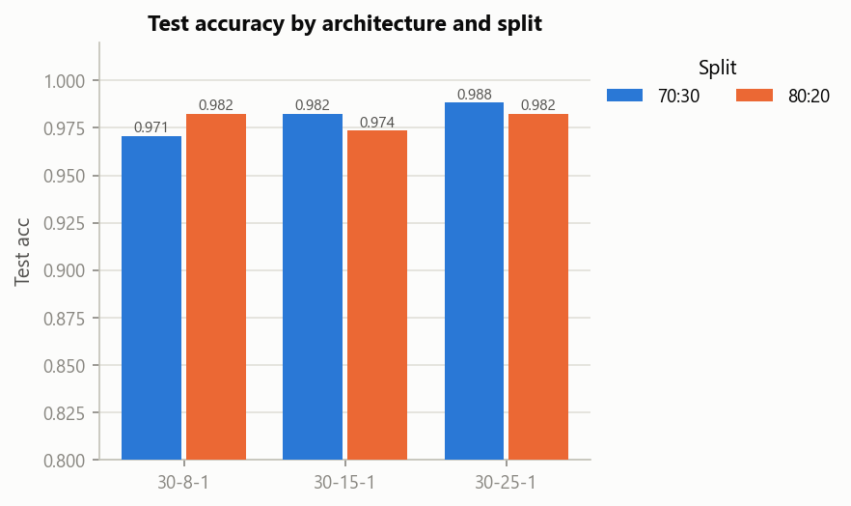
Figure 8 — Breast cancer: test accuracy by architecture and split.

4.3 Confusion matrices
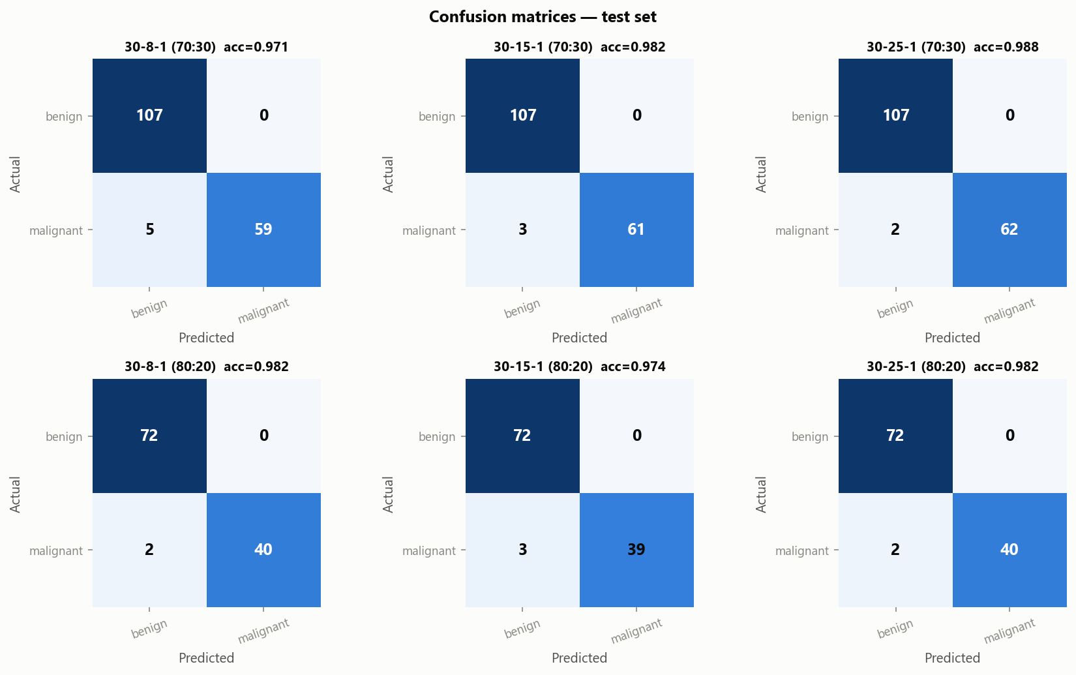
Figure 9 — Breast cancer: confusion matrices on the test set.
Precision is 1.000 in all six experiments. No benign tumour was ever labelled malignant, so every error is a missed malignant tumour (false negative). In a diagnostic setting this is the costly kind of error, which makes recall (0.92–0.97) the key metric.

4.4 Training loss curves
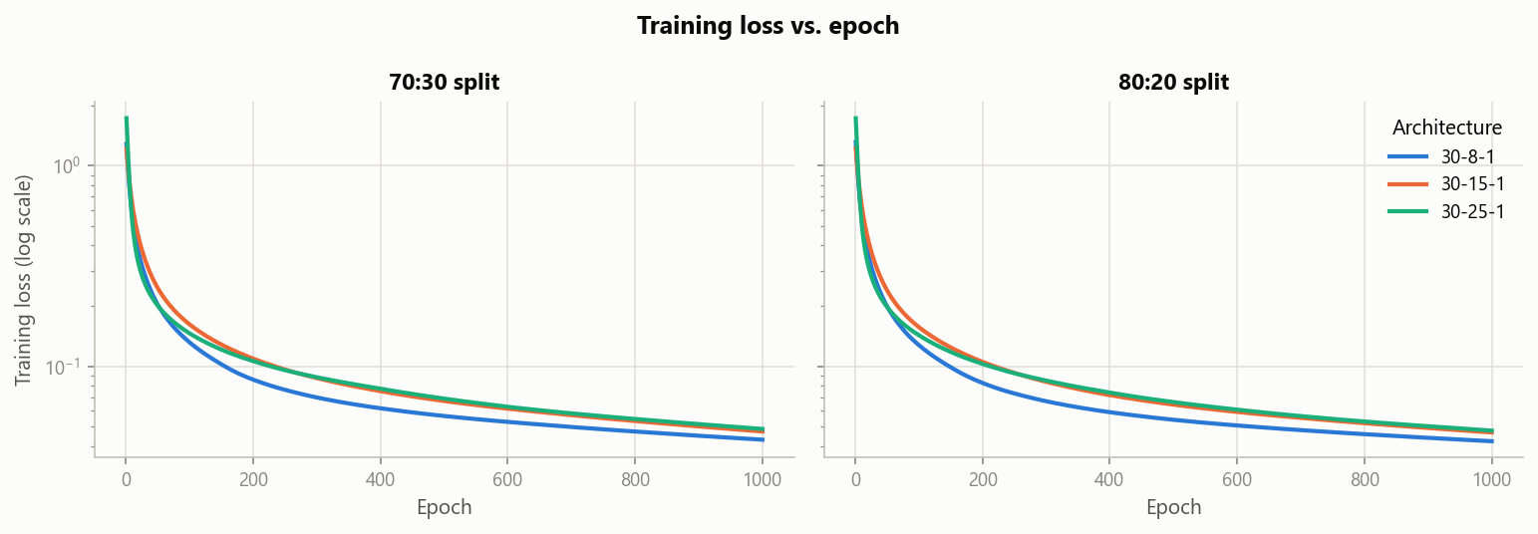
Figure 10 — Breast cancer: training loss vs. epoch (log scale).
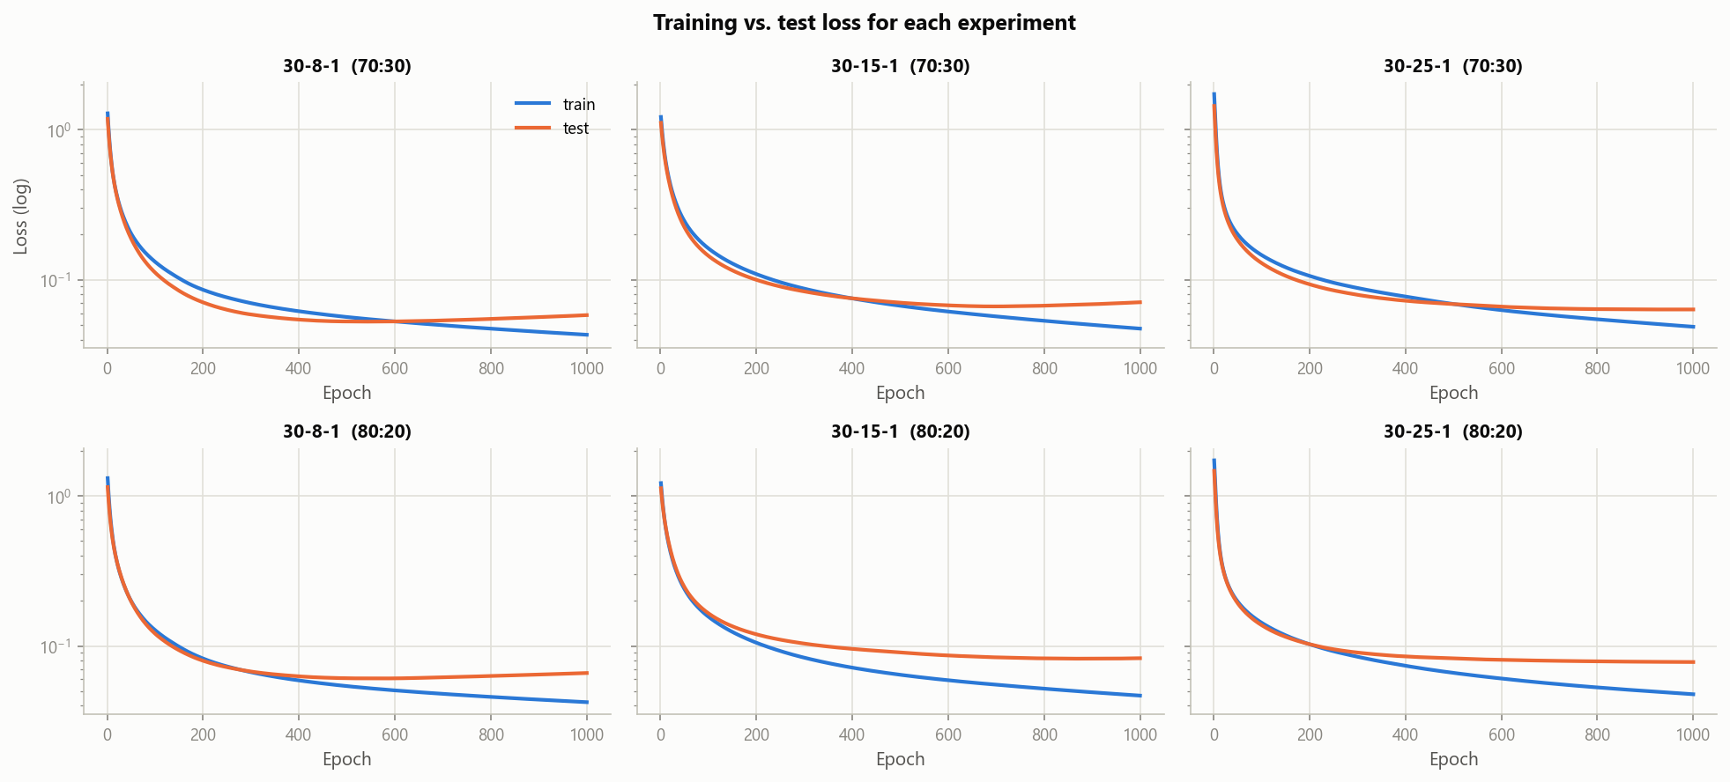
Figure 11 — Breast cancer: training vs. test loss for each experiment.
The binary cross-entropy falls from 1.2–1.7 to ≈0.045. For 30–8–1 and 30–15–1 the test loss reaches its minimum after ≈500–700 epochs and then rises slightly while the training loss keeps decreasing, which is mild overfitting. Within 1000 epochs test accuracy is not affected.

4.5 Initial and updated weights
Table 5 lists the hidden-to-output weights of 30–8–1 (70:30) before and after training, together with the trained hidden biases. Figure 12 shows all weight matrices of the network as heatmaps. Appendix A.2–A.3 contain W2 for all six experiments and the full 30 × 8 matrix W1.
hidden neuron | W2 initial | W2 after training | change | b1 after training
h1 | -0.310 | -0.566 | -0.256 | 0.112
h2 | -0.033 | 0.632 | 0.665 | -0.037
h3 | -0.621 | -0.561 | 0.060 | 0.079
h4 | -0.519 | -0.860 | -0.341 | 0.222
h5 | 0.753 | 0.872 | 0.119 | -0.130
h6 | -0.455 | -1.267 | -0.812 | 0.613
h7 | -0.388 | -0.728 | -0.340 | 0.052
h8 | 0.649 | 1.511 | 0.862 | 0.243
output bias b2 | 0.000 | -0.107 | -0.107

Table 5 — Breast cancer 30–8–1 (70:30): hidden → output weights W2 before and after training.
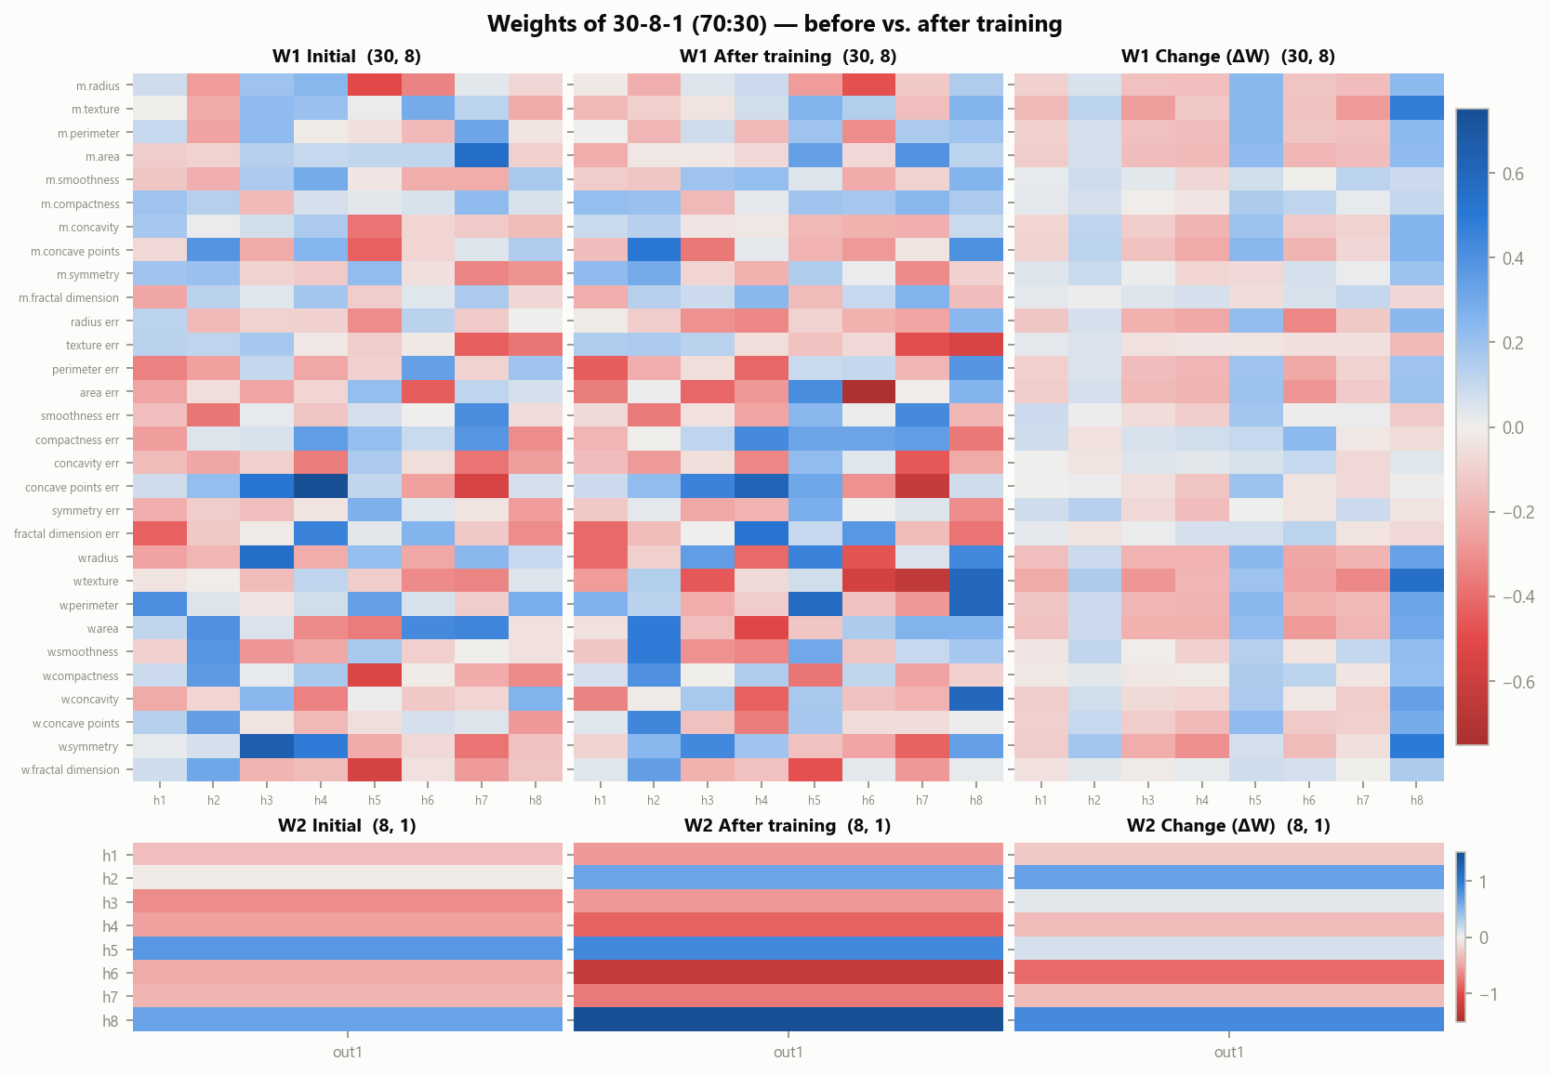
Figure 12 — Breast cancer 30–8–1: initial weights, trained weights and change ΔW.
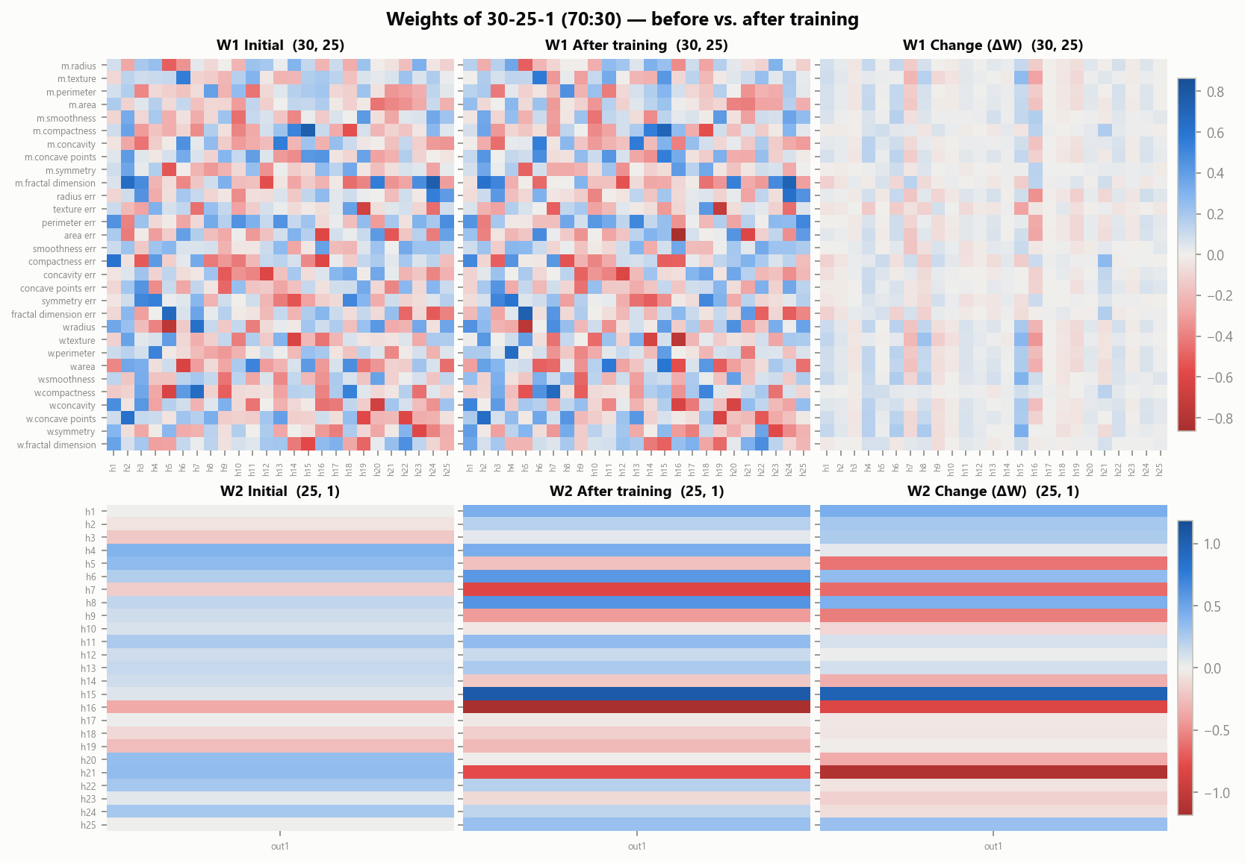
Figure 13 — Breast cancer 30–25–1: initial weights, trained weights and change ΔW.
Training turns the small, random output weights into a clear pattern: some hidden neurons acquire large positive weights (evidence for malignant) and others large negative ones (evidence for benign). ‖W2‖ grows from 1.45 to 2.64 for 30–8–1. The input weights change less in relative terms, and the change per weight shrinks with width: mean |ΔW1| is 0.127, 0.083 and 0.050 for 8, 15 and 25 hidden neurons (Table 6).
Architecture | Split | Layer | ‖W initial‖ | ‖W final‖ | ‖ΔW‖ | mean |ΔW| | ‖b final‖
30-8-1 | 70:30 | W1 (30, 8) | 3.6000 | 4.1638 | 2.4229 | 0.1268 | 0.7237
30-8-1 | 70:30 | W2 (8, 1) | 1.4486 | 2.6373 | 1.4700 | 0.4321 | 0.1069
30-15-1 | 70:30 | W1 (30, 15) | 5.2141 | 5.6365 | 2.5325 | 0.0826 | 0.6753
30-15-1 | 70:30 | W2 (15, 1) | 1.1296 | 2.5085 | 1.8825 | 0.4181 | 0.1852
30-25-1 | 70:30 | W1 (30, 25) | 6.9654 | 7.2554 | 1.9942 | 0.0498 | 0.5894
30-25-1 | 70:30 | W2 (25, 1) | 1.0900 | 2.3853 | 2.2398 | 0.3298 | 0.2858
30-8-1 | 80:20 | W1 (30, 8) | 3.6000 | 4.1562 | 2.4155 | 0.1266 | 0.7197
30-8-1 | 80:20 | W2 (8, 1) | 1.4486 | 2.6240 | 1.4712 | 0.4328 | 0.0778
30-15-1 | 80:20 | W1 (30, 15) | 5.2141 | 5.6317 | 2.4976 | 0.0815 | 0.6733
30-15-1 | 80:20 | W2 (15, 1) | 1.1296 | 2.4971 | 1.8818 | 0.4218 | 0.1526
30-25-1 | 80:20 | W1 (30, 25) | 6.9654 | 7.2516 | 1.9822 | 0.0498 | 0.5991
30-25-1 | 80:20 | W2 (25, 1) | 1.0900 | 2.3761 | 2.2514 | 0.3367 | 0.2492

Table 6 — Breast cancer: size of the initial weights, the trained weights and the change per layer.

4.6 Discussion

Effect of hidden-layer size
- At 70:30, accuracy and recall increase with width (97.08 % → 98.25 % → 98.83 %; recall 0.92 → 0.95 → 0.97). The wider networks miss fewer malignant tumours (5 → 3 → 2).
- At 80:20 there is no such trend (98.25 % → 97.37 % → 98.25 %), so the effect of width is small. Once the features are standardised the classes are close to linearly separable, so 8 hidden neurons already give enough capacity. 25 neurons give about 3× more parameters (257 → 801) for at most 1–2 extra correct predictions.

Effect of training-data proportion
- The two splits give similar results (97–99 % in both). 80:20 is better for 30–8–1 (+1.2 percentage points), worse for 30–15–1 (−0.9) and slightly worse for 30–25–1 (−0.6). There is no consistent effect.
- With 569 samples, 70 % (398 samples) is already enough to learn the decision boundary, and the 57 extra training samples at 80:20 add little. The 80:20 test set is also smaller (114 vs. 171), so each error costs 0.88 % instead of 0.58 %.
Conclusion (Q2). A from-scratch MLP with one hidden layer and a sigmoid output diagnoses tumours with 97–99 % test accuracy and perfect precision. A wider hidden layer slightly improves recall on the 70:30 split. A larger training share brings no consistent improvement on this dataset.

5. Extension A — deeper networks from scratch (2–5 hidden layers)
Because the MLP class accepts any list of layer sizes, the identical NumPy implementation was used with 2 to 5 hidden layers of decreasing width. The learning rate, number of epochs and splits are unchanged, so the comparison with the one-hidden-layer networks is fair.

5.1 Iris
Exp | Architecture | Hidden layers | Split | Train / Test | Params | Final loss | Train acc | Test acc | Precision | Recall | F1
1 | 4-10-10-3 | 2 | 70:30 | 105 / 45 | 193 | 0.0182 | 100.00 % | 91.11 % | 0.9155 | 0.9111 | 0.9107
2 | 4-12-10-8-3 | 3 | 70:30 | 105 / 45 | 305 | 0.0065 | 100.00 % | 93.33 % | 0.9444 | 0.9333 | 0.9327
3 | 4-16-12-8-6-3 | 4 | 70:30 | 105 / 45 | 463 | 0.0022 | 100.00 % | 91.11 % | 0.9155 | 0.9111 | 0.9107
4 | 4-20-16-12-8-6-3 | 5 | 70:30 | 105 / 45 | 819 | 0.0080 | 100.00 % | 93.33 % | 0.9345 | 0.9333 | 0.9333
5 | 4-10-10-3 | 2 | 80:20 | 120 / 30 | 193 | 0.0360 | 98.33 % | 96.67 % | 0.9697 | 0.9667 | 0.9666
6 | 4-12-10-8-3 | 3 | 80:20 | 120 / 30 | 305 | 0.0078 | 100.00 % | 93.33 % | 0.9333 | 0.9333 | 0.9333
7 | 4-16-12-8-6-3 | 4 | 80:20 | 120 / 30 | 463 | 0.0029 | 100.00 % | 96.67 % | 0.9697 | 0.9667 | 0.9666
8 | 4-20-16-12-8-6-3 | 5 | 80:20 | 120 / 30 | 819 | 0.0082 | 100.00 % | 93.33 % | 0.9333 | 0.9333 | 0.9333

Table 7 — Iris: deeper from-scratch networks (test set).
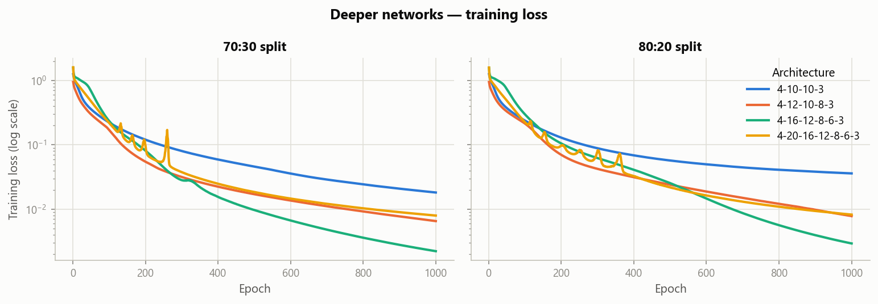
Figure 14 — Iris: training loss of the deeper networks.

5.2 Breast cancer
Exp | Architecture | Hidden layers | Split | Train / Test | Params | Final loss | Train acc | Test acc | Precision | Recall | F1
1 | 30-15-8-1 | 2 | 70:30 | 398 / 171 | 602 | 0.0224 | 99.25 % | 98.25 % | 1.0000 | 0.9531 | 0.9760
2 | 30-25-15-8-1 | 3 | 70:30 | 398 / 171 | 1302 | 0.0083 | 100.00 % | 97.66 % | 1.0000 | 0.9375 | 0.9677
3 | 30-25-15-8-4-1 | 4 | 70:30 | 398 / 171 | 1334 | 0.0259 | 99.50 % | 96.49 % | 1.0000 | 0.9063 | 0.9508
4 | 30-32-25-15-8-4-1 | 5 | 70:30 | 398 / 171 | 2376 | 0.0016 | 100.00 % | 97.08 % | 0.9683 | 0.9531 | 0.9606
5 | 30-15-8-1 | 2 | 80:20 | 455 / 114 | 602 | 0.0232 | 99.12 % | 99.12 % | 1.0000 | 0.9762 | 0.9880
6 | 30-25-15-8-1 | 3 | 80:20 | 455 / 114 | 1302 | 0.0092 | 100.00 % | 96.49 % | 1.0000 | 0.9048 | 0.9500
7 | 30-25-15-8-4-1 | 4 | 80:20 | 455 / 114 | 1334 | 0.0248 | 99.56 % | 95.61 % | 0.9744 | 0.9048 | 0.9383
8 | 30-32-25-15-8-4-1 | 5 | 80:20 | 455 / 114 | 2376 | 0.0086 | 99.56 % | 96.49 % | 0.9524 | 0.9524 | 0.9524

Table 8 — Breast cancer: deeper from-scratch networks (test set).
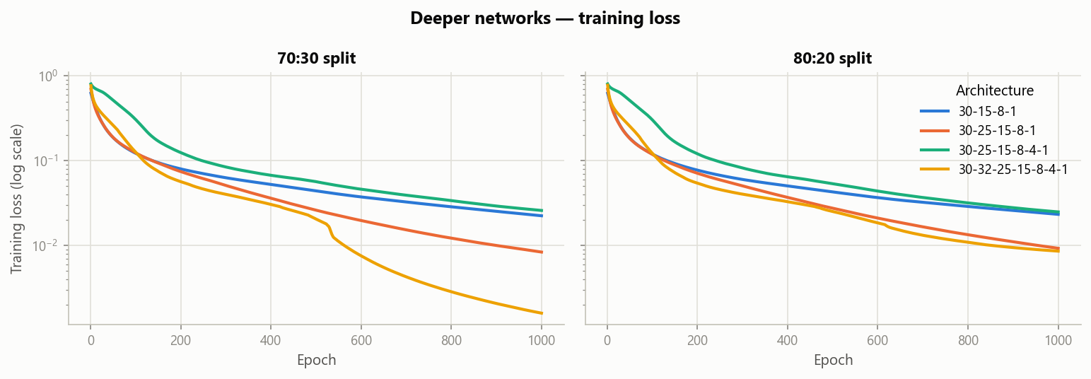
Figure 15 — Breast cancer: training loss of the deeper networks.

5.3 Discussion
- Deeper networks fit the training data much better. Their training loss ends one to two orders of magnitude lower (down to ≈0.002), and training accuracy reaches 99–100 %.
- This does not carry over to the test set. Iris: 91–97 %, the same range as one hidden layer. Breast cancer: 95.6–99.1 %, where the 4-hidden-layer networks are the weakest (96.5 % and 95.6 %).
- Both datasets are small and almost linearly separable, so the extra layers add capacity that is mostly used to memorise the training set (overfitting).

6. Extension B — deep MLPs with PyTorch (5–10 hidden layers)
The same two tasks, with the same stratified splits and standardisation, were solved with much deeper networks built in PyTorch: 5, 7 and 10 hidden layers of 32 ReLU neurons each, a softmax or sigmoid output (via CrossEntropyLoss / BCEWithLogitsLoss), and the Adam optimiser (learning rate 0.001, full batch, 300 epochs).

6.1 Results
Exp | Hidden layers × width | Split | Params | Final loss | Train acc | Test acc | Precision | Recall | F1
1 | 5×32 | 70:30 | 4483 | 2.8e-4 | 100.00 % | 93.33 % | 0.9345 | 0.9333 | 0.9333
2 | 7×32 | 70:30 | 6595 | 6.9e-5 | 100.00 % | 91.11 % | 0.9155 | 0.9111 | 0.9107
3 | 10×32 | 70:30 | 9763 | 7.1e-5 | 100.00 % | 91.11 % | 0.9155 | 0.9111 | 0.9107
4 | 5×32 | 80:20 | 4483 | 8.3e-4 | 100.00 % | 96.67 % | 0.9697 | 0.9667 | 0.9666
5 | 7×32 | 80:20 | 6595 | 2.1e-4 | 100.00 % | 96.67 % | 0.9697 | 0.9667 | 0.9666
6 | 10×32 | 80:20 | 9763 | 9.0e-5 | 100.00 % | 96.67 % | 0.9697 | 0.9667 | 0.9666

Table 9 — Iris: deep PyTorch MLPs (test set).
Exp | Hidden layers × width | Split | Params | Final loss | Train acc | Test acc | Precision | Recall | F1
1 | 5×32 | 70:30 | 5249 | 1.9e-4 | 100.00 % | 97.66 % | 0.9839 | 0.9531 | 0.9683
2 | 7×32 | 70:30 | 7361 | 1.5e-5 | 100.00 % | 96.49 % | 0.9677 | 0.9375 | 0.9524
3 | 10×32 | 70:30 | 10529 | 2.5e-5 | 100.00 % | 97.08 % | 0.9683 | 0.9531 | 0.9606
4 | 5×32 | 80:20 | 5249 | 2.2e-4 | 100.00 % | 97.37 % | 0.9756 | 0.9524 | 0.9639
5 | 7×32 | 80:20 | 7361 | 3.4e-5 | 100.00 % | 98.25 % | 0.9762 | 0.9762 | 0.9762
6 | 10×32 | 80:20 | 10529 | 2.0e-5 | 100.00 % | 98.25 % | 0.9762 | 0.9762 | 0.9762

Table 10 — Breast cancer: deep PyTorch MLPs (test set).
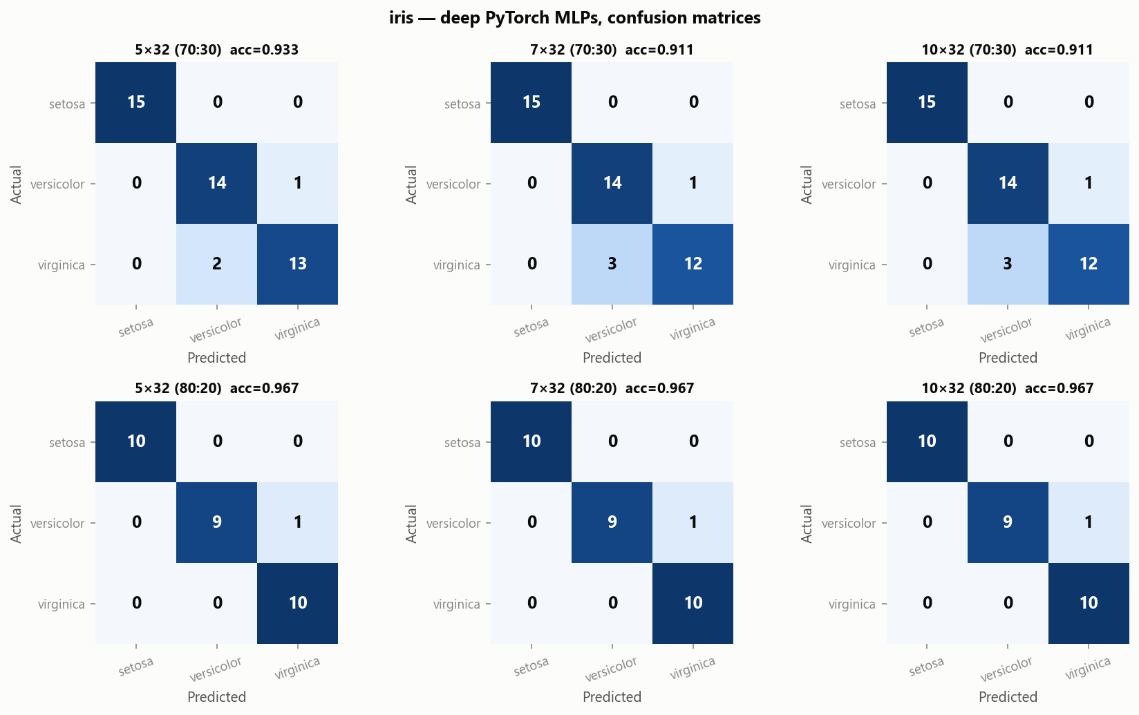
Figure 16 — Iris: confusion matrices of the deep PyTorch MLPs.
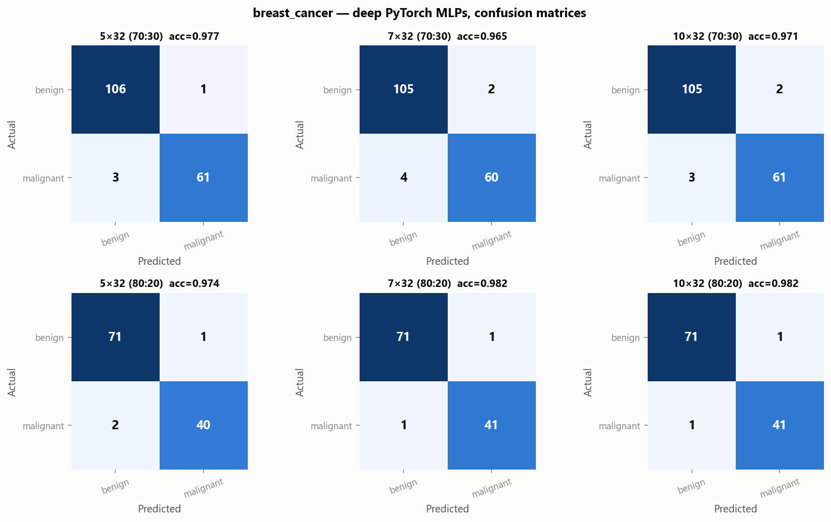
Figure 17 — Breast cancer: confusion matrices of the deep PyTorch MLPs.
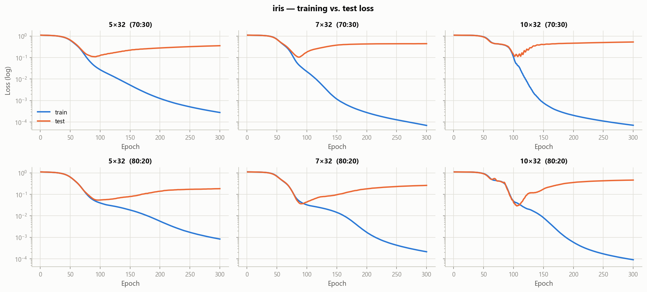
Figure 18 — Iris: training vs. test loss of the deep PyTorch MLPs.
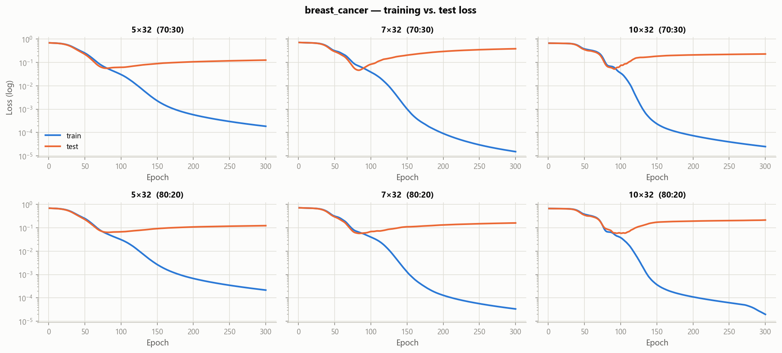
Figure 19 — Breast cancer: training vs. test loss of the deep PyTorch MLPs.

6.2 Discussion
- The deep networks (4,500–10,500 parameters) fit the training data perfectly: the training loss falls to 10⁻⁴ or lower and training accuracy reaches 100 %.
- Their test accuracy stays in the same range as the one-hidden-layer networks: 91–97 % on Iris and 96.5–98.3 % on breast cancer. The test loss reaches its minimum after ≈75–110 epochs and then rises while the training loss keeps falling, which shows the networks memorising the 105–455 training samples.
- On small tabular datasets like these, extra depth adds thousands of parameters without improving generalisation. A one-hidden-layer MLP remains the right model for both tasks.

7. Conclusions
- An MLP was implemented entirely from scratch in NumPy, including initialisation, forward propagation, ReLU, softmax and sigmoid outputs, cross-entropy losses, backpropagation and gradient-descent updates. A numerical gradient check confirmed the backpropagation.
- Iris: all three architectures reach 91–97 % test accuracy. Every error is a Versicolor ↔ Virginica confusion.
- Breast cancer: all three architectures reach 97–99 % test accuracy with perfect precision. The errors are missed malignant tumours.
- Hidden-layer size: on both datasets the smallest network (4–6–3, 30–8–1) is about as good as the larger ones. Extra hidden layers (2–5 from scratch, 5–10 in PyTorch) lower the training loss but do not improve test performance.
- Training proportion: 80:20 gives better test accuracy on the small Iris dataset, while on the larger breast-cancer dataset both splits perform the same.

Appendix A — Initial and updated weight matrices
Each Iris table lists, for every hidden neuron, its incoming weights from the four inputs (W1, initial and after training), its trained bias, and its outgoing weights to the three output neurons (W2, initial and after training). The last row gives the output biases b2. All biases were initialised to 0. For the breast-cancer networks, the hidden-to-output weights W2 are listed for all six experiments, and the full 30 × 8 input weight matrix W1 for the 30–8–1 network. The larger W1 matrices (30 × 15 and 30 × 25) are shown as heatmaps in Figures 12–13 and printed in full in the Q2 notebook.

A.1 Iris (Question 1)

Exp 1: 4-6-3 (70:30)
 | W1 initial (input → neuron) |  |  |  | W1 after training |  |  |  |  | W2 initial |  |  | W2 after training
neuron | s.length | s.width | p.length | p.width | s.length | s.width | p.length | p.width | b1 final | out1 | out2 | out3 | out1 | out2 | out3
h1 | 0.215 | 0.090 | 0.047 | 0.621 | 0.538 | -0.788 | 1.353 | 2.237 | -1.161 | -0.175 | -0.144 | 0.217 | -0.866 | -1.581 | 2.346
h2 | -0.735 | -0.224 | 0.797 | -0.035 | -0.832 | -0.294 | 0.845 | -0.032 | 0.469 | 0.149 | 0.168 | 0.176 | -0.318 | 0.669 | 0.143
h3 | 0.531 | -0.012 | 0.331 | -0.131 | 0.267 | -0.002 | 0.134 | -0.301 | -0.246 | 0.874 | -0.166 | -0.209 | 0.784 | -0.195 | -0.089
h4 | 0.665 | -0.603 | -0.608 | -0.481 | 1.054 | -0.685 | -0.289 | -0.365 | 1.477 | -0.332 | 0.251 | 0.461 | -0.698 | 1.510 | -0.431
h5 | -1.380 | 0.622 | 0.261 | 0.864 | -1.553 | 0.767 | -0.056 | 0.550 | 0.013 | -0.047 | -0.343 | -0.337 | 0.099 | -0.209 | -0.616
h6 | -0.921 | 0.550 | -0.678 | -0.109 | -1.371 | 0.656 | -1.411 | -0.838 | 0.122 | 0.266 | 0.303 | 0.222 | 1.759 | -0.669 | -0.300
b2 |  |  |  |  |  |  |  |  |  | 0.000 | 0.000 | 0.000 | -0.604 | 1.572 | -0.968

Exp 2: 4-10-3 (70:30)
 | W1 initial (input → neuron) |  |  |  | W1 after training |  |  |  |  | W2 initial |  |  | W2 after training
neuron | s.length | s.width | p.length | p.width | s.length | s.width | p.length | p.width | b1 final | out1 | out2 | out3 | out1 | out2 | out3
h1 | 0.215 | 0.622 | -0.131 | 1.514 | 0.185 | -0.217 | 0.643 | 2.265 | -0.821 | 0.235 | 0.172 | -0.210 | -0.408 | -0.994 | 1.599
h2 | -0.735 | 0.550 | -0.481 | -0.287 | -1.234 | 0.608 | -1.192 | -0.975 | 0.156 | 0.073 | 0.037 | 0.069 | 1.473 | -0.931 | -0.363
h3 | 0.531 | 0.047 | 0.864 | -0.362 | 0.669 | -0.322 | 1.443 | 0.248 | -0.419 | 0.276 | 0.071 | 0.215 | -0.415 | -0.285 | 1.261
h4 | 0.665 | 0.797 | -0.109 | -0.575 | 0.667 | 0.801 | -0.107 | -0.556 | 0.004 | 0.021 | 0.091 | 0.200 | 0.107 | 0.149 | 0.057
h5 | -1.380 | 0.331 | -0.303 | 0.436 | -1.469 | 0.354 | -0.396 | 0.355 | 0.130 | -0.461 | -0.101 | -0.149 | 0.214 | -0.275 | -0.650
h6 | -0.921 | -0.608 | -0.249 | 0.798 | -0.364 | -0.843 | 0.520 | 1.530 | -0.358 | -0.202 | -0.087 | 0.473 | -0.636 | -0.363 | 1.183
h7 | 0.090 | 0.261 | 0.376 | -0.081 | 0.152 | 0.366 | 0.132 | -0.322 | 1.124 | -0.274 | 0.306 | -0.532 | -0.433 | 0.854 | -0.922
h8 | -0.224 | -0.678 | 0.258 | -0.594 | 0.085 | -0.791 | 0.013 | -1.013 | 0.785 | -0.106 | 0.051 | 0.185 | -0.220 | 0.978 | -0.627
h9 | -0.012 | 0.621 | 0.292 | -0.583 | -0.241 | 0.631 | 0.019 | -0.840 | 0.186 | 0.225 | 0.251 | -0.110 | 0.673 | -0.070 | -0.238
h10 | -0.603 | -0.035 | 0.305 | 0.460 | -0.479 | -0.219 | 0.450 | 0.523 | 0.812 | -0.146 | 0.271 | -0.060 | -0.603 | 0.691 | -0.024
b2 |  |  |  |  |  |  |  |  |  | 0.000 | 0.000 | 0.000 | -0.611 | 1.703 | -1.092

Exp 3: 4-20-3 (70:30)
 | W1 initial (input → neuron) |  |  |  | W1 after training |  |  |  |  | W2 initial |  |  | W2 after training
neuron | s.length | s.width | p.length | p.width | s.length | s.width | p.length | p.width | b1 final | out1 | out2 | out3 | out1 | out2 | out3
h1 | 0.215 | -0.131 | 0.526 | -1.190 | 0.005 | -0.056 | 0.266 | -1.424 | 0.096 | 0.102 | -0.148 | -0.081 | 0.466 | -0.293 | -0.300
h2 | -0.735 | -0.481 | 0.384 | -0.237 | -0.758 | -0.396 | 0.380 | -0.205 | -0.089 | -0.085 | -0.267 | 0.109 | -0.047 | -0.200 | 0.003
h3 | 0.531 | 0.864 | -0.471 | 0.115 | 0.589 | 0.842 | -0.392 | 0.188 | -0.030 | -0.105 | 0.003 | 0.107 | -0.055 | -0.004 | 0.064
h4 | 0.665 | -0.109 | 0.164 | 0.415 | 0.650 | -0.320 | 0.511 | 0.802 | -0.329 | 0.100 | 0.149 | -0.022 | -0.232 | -0.388 | 0.846
h5 | -1.380 | -0.303 | 0.083 | 0.503 | -1.469 | -0.137 | -0.073 | 0.289 | 0.301 | -0.095 | -0.018 | -0.377 | 0.085 | -0.087 | -0.488
h6 | -0.921 | -0.249 | 0.155 | 0.561 | -0.822 | -0.360 | 0.343 | 0.813 | -0.123 | -0.324 | -0.296 | -0.223 | -0.535 | -0.514 | 0.207
h7 | 0.090 | 0.376 | 0.616 | -0.247 | 0.123 | 0.352 | 0.709 | -0.189 | -0.173 | 0.089 | -0.202 | -0.085 | 0.004 | -0.377 | 0.176
h8 | -0.224 | 0.258 | 0.158 | -0.327 | -0.492 | 0.342 | -0.227 | -0.701 | 0.085 | 0.291 | -0.080 | 0.165 | 0.757 | -0.449 | 0.068
h9 | -0.012 | 0.292 | 0.480 | 0.607 | -0.003 | -0.234 | 1.178 | 1.382 | -0.741 | -0.209 | -0.046 | -0.212 | -0.510 | -1.214 | 1.257
h10 | -0.603 | 0.305 | 0.048 | -0.135 | -0.759 | 0.242 | 0.062 | -0.159 | 0.582 | -0.076 | 0.188 | -0.386 | 0.322 | 0.169 | -0.765
h11 | 0.622 | 1.514 | 0.204 | -0.902 | 0.431 | 1.577 | -0.041 | -1.121 | 0.143 | 0.097 | 0.053 | -0.133 | 0.530 | -0.118 | -0.395
h12 | 0.550 | -0.287 | 0.446 | -0.801 | 0.803 | -0.375 | 0.256 | -1.118 | 1.620 | -0.323 | 0.016 | -0.118 | -0.618 | 1.364 | -1.172
h13 | 0.047 | -0.362 | -1.030 | -0.650 | -0.206 | -0.111 | -1.395 | -0.987 | -0.011 | 0.052 | 0.005 | 0.358 | 1.040 | -0.645 | 0.021
h14 | 0.797 | -0.575 | -0.226 | 0.352 | 0.833 | -0.670 | 0.239 | 0.915 | -0.495 | -0.054 | -0.229 | 0.040 | -0.383 | -0.652 | 0.793
h15 | 0.331 | 0.436 | -0.333 | 0.101 | 0.372 | 0.412 | -0.280 | 0.171 | 0.078 | 0.049 | 0.304 | 0.187 | 0.064 | 0.325 | 0.151
h16 | -0.608 | 0.798 | -0.452 | 0.488 | -0.782 | 0.861 | -0.568 | 0.409 | 0.300 | 0.080 | 0.327 | -0.266 | 0.556 | 0.166 | -0.581
h17 | 0.261 | -0.081 | -0.195 | -0.302 | 0.154 | -0.027 | -0.301 | -0.391 | -0.010 | -0.143 | -0.207 | -0.087 | 0.045 | -0.334 | -0.149
h18 | -0.678 | -0.594 | 1.057 | 0.112 | -0.575 | -0.818 | 1.239 | 0.196 | 0.673 | -0.308 | 0.142 | -0.050 | -0.960 | 0.411 | 0.334
h19 | 0.621 | -0.583 | -0.612 | 0.442 | 0.714 | -0.689 | -0.261 | 0.856 | -0.067 | -0.329 | -0.227 | 0.070 | -0.648 | -0.255 | 0.416
h20 | -0.035 | 0.460 | 0.685 | -0.219 | 0.047 | 0.121 | 1.198 | 0.382 | -0.210 | 0.187 | 0.446 | 0.652 | -0.021 | 0.055 | 1.251
b2 |  |  |  |  |  |  |  |  |  | 0.000 | 0.000 | 0.000 | -0.336 | 1.261 | -0.925

Exp 4: 4-6-3 (80:20)
 | W1 initial (input → neuron) |  |  |  | W1 after training |  |  |  |  | W2 initial |  |  | W2 after training
neuron | s.length | s.width | p.length | p.width | s.length | s.width | p.length | p.width | b1 final | out1 | out2 | out3 | out1 | out2 | out3
h1 | 0.215 | 0.090 | 0.047 | 0.621 | 0.392 | -0.813 | 1.487 | 2.090 | -1.129 | -0.175 | -0.144 | 0.217 | -0.893 | -1.504 | 2.295
h2 | -0.735 | -0.224 | 0.797 | -0.035 | -0.720 | -0.272 | 0.937 | 0.084 | 0.507 | 0.149 | 0.168 | 0.176 | -0.401 | 0.567 | 0.328
h3 | 0.531 | -0.012 | 0.331 | -0.131 | 0.267 | 0.004 | 0.134 | -0.301 | -0.245 | 0.874 | -0.166 | -0.209 | 0.784 | -0.193 | -0.092
h4 | 0.665 | -0.603 | -0.608 | -0.481 | 1.087 | -0.768 | -0.393 | -0.343 | 1.344 | -0.332 | 0.251 | 0.461 | -0.691 | 1.477 | -0.406
h5 | -1.380 | 0.622 | 0.261 | 0.864 | -1.537 | 0.705 | -0.053 | 0.543 | -0.054 | -0.047 | -0.343 | -0.337 | 0.028 | -0.364 | -0.391
h6 | -0.921 | 0.550 | -0.678 | -0.109 | -1.370 | 0.665 | -1.386 | -0.812 | 0.161 | 0.266 | 0.303 | 0.222 | 1.742 | -0.645 | -0.306
b2 |  |  |  |  |  |  |  |  |  | 0.000 | 0.000 | 0.000 | -0.668 | 1.641 | -0.974

Exp 5: 4-10-3 (80:20)
 | W1 initial (input → neuron) |  |  |  | W1 after training |  |  |  |  | W2 initial |  |  | W2 after training
neuron | s.length | s.width | p.length | p.width | s.length | s.width | p.length | p.width | b1 final | out1 | out2 | out3 | out1 | out2 | out3
h1 | 0.215 | 0.622 | -0.131 | 1.514 | 0.069 | -0.277 | 0.732 | 2.169 | -0.688 | 0.235 | 0.172 | -0.210 | -0.431 | -0.874 | 1.501
h2 | -0.735 | 0.550 | -0.481 | -0.287 | -1.200 | 0.646 | -1.151 | -0.940 | 0.175 | 0.073 | 0.037 | 0.069 | 1.435 | -0.879 | -0.376
h3 | 0.531 | 0.047 | 0.864 | -0.362 | 0.825 | -0.137 | 1.442 | 0.086 | -0.563 | 0.276 | 0.071 | 0.215 | -0.396 | -0.376 | 1.333
h4 | 0.665 | 0.797 | -0.109 | -0.575 | 0.672 | 0.799 | -0.113 | -0.562 | 0.011 | 0.021 | 0.091 | 0.200 | 0.110 | 0.191 | 0.012
h5 | -1.380 | 0.331 | -0.303 | 0.436 | -1.478 | 0.299 | -0.435 | 0.308 | -0.023 | -0.461 | -0.101 | -0.149 | 0.195 | -0.641 | -0.264
h6 | -0.921 | -0.608 | -0.249 | 0.798 | -0.438 | -0.835 | 0.641 | 1.547 | -0.360 | -0.202 | -0.087 | 0.473 | -0.644 | -0.428 | 1.256
h7 | 0.090 | 0.261 | 0.376 | -0.081 | 0.215 | 0.327 | 0.079 | -0.276 | 1.198 | -0.274 | 0.306 | -0.532 | -0.469 | 0.899 | -0.930
h8 | -0.224 | -0.678 | 0.258 | -0.594 | 0.162 | -0.889 | -0.018 | -0.950 | 0.663 | -0.106 | 0.051 | 0.185 | -0.252 | 0.948 | -0.565
h9 | -0.012 | 0.621 | 0.292 | -0.583 | -0.225 | 0.664 | 0.040 | -0.819 | 0.208 | 0.225 | 0.251 | -0.110 | 0.666 | -0.017 | -0.283
h10 | -0.603 | -0.035 | 0.305 | 0.460 | -0.465 | -0.207 | 0.430 | 0.534 | 0.760 | -0.146 | 0.271 | -0.060 | -0.604 | 0.605 | 0.064
b2 |  |  |  |  |  |  |  |  |  | 0.000 | 0.000 | 0.000 | -0.617 | 1.669 | -1.051

Exp 6: 4-20-3 (80:20)
 | W1 initial (input → neuron) |  |  |  | W1 after training |  |  |  |  | W2 initial |  |  | W2 after training
neuron | s.length | s.width | p.length | p.width | s.length | s.width | p.length | p.width | b1 final | out1 | out2 | out3 | out1 | out2 | out3
h1 | 0.215 | -0.131 | 0.526 | -1.190 | 0.011 | -0.058 | 0.269 | -1.423 | 0.121 | 0.102 | -0.148 | -0.081 | 0.469 | -0.265 | -0.331
h2 | -0.735 | -0.481 | 0.384 | -0.237 | -0.803 | -0.343 | 0.346 | -0.216 | -0.171 | -0.085 | -0.267 | 0.109 | -0.069 | -0.249 | 0.075
h3 | 0.531 | 0.864 | -0.471 | 0.115 | 0.574 | 0.854 | -0.396 | 0.201 | -0.006 | -0.105 | 0.003 | 0.107 | -0.092 | 0.088 | 0.009
h4 | 0.665 | -0.109 | 0.164 | 0.415 | 0.798 | -0.194 | 0.498 | 0.664 | -0.392 | 0.100 | 0.149 | -0.022 | -0.233 | -0.379 | 0.838
h5 | -1.380 | -0.303 | 0.083 | 0.503 | -1.376 | -0.341 | 0.018 | 0.341 | 0.360 | -0.095 | -0.018 | -0.377 | 0.032 | -0.174 | -0.348
h6 | -0.921 | -0.249 | 0.155 | 0.561 | -0.784 | -0.388 | 0.447 | 0.855 | -0.142 | -0.324 | -0.296 | -0.223 | -0.553 | -0.571 | 0.281
h7 | 0.090 | 0.376 | 0.616 | -0.247 | 0.186 | 0.306 | 0.691 | -0.235 | -0.195 | 0.089 | -0.202 | -0.085 | -0.018 | -0.363 | 0.183
h8 | -0.224 | 0.258 | 0.158 | -0.327 | -0.499 | 0.361 | -0.237 | -0.711 | 0.099 | 0.291 | -0.080 | 0.165 | 0.776 | -0.463 | 0.062
h9 | -0.012 | 0.292 | 0.480 | 0.607 | -0.084 | -0.303 | 1.234 | 1.291 | -0.669 | -0.209 | -0.046 | -0.212 | -0.553 | -1.149 | 1.235
h10 | -0.603 | 0.305 | 0.048 | -0.135 | -0.591 | 0.455 | 0.027 | -0.155 | 0.448 | -0.076 | 0.188 | -0.386 | 0.321 | 0.032 | -0.627
h11 | 0.622 | 1.514 | 0.204 | -0.902 | 0.429 | 1.571 | -0.065 | -1.144 | 0.144 | 0.097 | 0.053 | -0.133 | 0.526 | -0.056 | -0.452
h12 | 0.550 | -0.287 | 0.446 | -0.801 | 0.815 | -0.417 | 0.181 | -1.033 | 1.624 | -0.323 | 0.016 | -0.118 | -0.618 | 1.335 | -1.142
h13 | 0.047 | -0.362 | -1.030 | -0.650 | -0.193 | -0.049 | -1.397 | -0.987 | 0.004 | 0.052 | 0.005 | 0.358 | 1.048 | -0.624 | -0.009
h14 | 0.797 | -0.575 | -0.226 | 0.352 | 1.011 | -0.442 | 0.264 | 0.799 | -0.493 | -0.054 | -0.229 | 0.040 | -0.366 | -0.625 | 0.749
h15 | 0.331 | 0.436 | -0.333 | 0.101 | 0.398 | 0.439 | -0.261 | 0.189 | 0.129 | 0.049 | 0.304 | 0.187 | 0.036 | 0.415 | 0.089
h16 | -0.608 | 0.798 | -0.452 | 0.488 | -0.689 | 0.997 | -0.529 | 0.435 | 0.385 | 0.080 | 0.327 | -0.266 | 0.527 | 0.294 | -0.680
h17 | 0.261 | -0.081 | -0.195 | -0.302 | 0.156 | -0.013 | -0.302 | -0.391 | -0.011 | -0.143 | -0.207 | -0.087 | 0.048 | -0.332 | -0.153
h18 | -0.678 | -0.594 | 1.057 | 0.112 | -0.585 | -0.780 | 1.311 | 0.277 | 0.598 | -0.308 | 0.142 | -0.050 | -0.979 | 0.258 | 0.505
h19 | 0.621 | -0.583 | -0.612 | 0.442 | 0.695 | -0.665 | -0.223 | 0.860 | -0.038 | -0.329 | -0.227 | 0.070 | -0.637 | -0.212 | 0.364
h20 | -0.035 | 0.460 | 0.685 | -0.219 | 0.026 | 0.097 | 1.196 | 0.306 | -0.077 | 0.187 | 0.446 | 0.652 | -0.072 | 0.158 | 1.199
b2 |  |  |  |  |  |  |  |  |  | 0.000 | 0.000 | 0.000 | -0.380 | 1.338 | -0.958

A.2 Breast cancer (Question 2): hidden → output weights W2

Exp 1: 30-8-1 (70:30)
hidden neuron | W2 initial | W2 after training | change | b1 after training
h1 | -0.310 | -0.566 | -0.256 | 0.112
h2 | -0.033 | 0.632 | 0.665 | -0.037
h3 | -0.621 | -0.561 | 0.060 | 0.079
h4 | -0.519 | -0.860 | -0.341 | 0.222
h5 | 0.753 | 0.872 | 0.119 | -0.130
h6 | -0.455 | -1.267 | -0.812 | 0.613
h7 | -0.388 | -0.728 | -0.340 | 0.052
h8 | 0.649 | 1.511 | 0.862 | 0.243
output bias b2 | 0.000 | -0.107 | -0.107

Exp 2: 30-15-1 (70:30)
hidden neuron | W2 initial | W2 after training | change | b1 after training
h1 | -0.034 | 0.365 | 0.399 | -0.037
h2 | 0.090 | -0.666 | -0.756 | 0.152
h3 | 0.504 | 0.810 | 0.306 | 0.066
h4 | 0.536 | 1.068 | 0.532 | 0.219
h5 | 0.018 | -0.759 | -0.777 | 0.268
h6 | 0.041 | 0.053 | 0.012 | 0.001
h7 | 0.278 | 0.674 | 0.396 | 0.146
h8 | -0.218 | -0.658 | -0.440 | 0.130
h9 | 0.086 | 0.683 | 0.597 | 0.178
h10 | -0.007 | 0.195 | 0.202 | -0.001
h11 | 0.081 | 0.088 | 0.007 | -0.011
h12 | -0.215 | -0.006 | 0.209 | -0.012
h13 | -0.410 | 0.009 | 0.419 | -0.061
h14 | -0.535 | -1.391 | -0.856 | 0.482
h15 | -0.289 | 0.077 | 0.366 | -0.024
output bias b2 | 0.000 | -0.185 | -0.185

Exp 3: 30-25-1 (70:30)
hidden neuron | W2 initial | W2 after training | change | b1 after training
h1 | 0.002 | 0.437 | 0.435 | 0.078
h2 | -0.060 | 0.212 | 0.272 | -0.004
h3 | -0.203 | 0.044 | 0.247 | -0.011
h4 | 0.410 | 0.448 | 0.038 | -0.141
h5 | 0.357 | -0.239 | -0.596 | -0.037
h6 | 0.227 | 0.576 | 0.349 | 0.064
h7 | -0.184 | -0.814 | -0.630 | 0.243
h8 | 0.171 | 0.603 | 0.432 | 0.103
h9 | 0.128 | -0.418 | -0.546 | 0.125
h10 | 0.089 | -0.036 | -0.125 | 0.007
h11 | 0.250 | 0.343 | 0.093 | 0.018
h12 | 0.127 | 0.144 | 0.017 | -0.010
h13 | 0.148 | 0.256 | 0.108 | -0.010
h14 | 0.127 | -0.202 | -0.329 | -0.006
h15 | 0.068 | 1.063 | 0.995 | 0.138
h16 | -0.357 | -1.181 | -0.824 | 0.435
h17 | 0.017 | -0.029 | -0.046 | 0.005
h18 | -0.111 | -0.160 | -0.049 | 0.008
h19 | -0.256 | -0.274 | -0.018 | 0.043
h20 | 0.336 | -0.012 | -0.348 | -0.054
h21 | 0.346 | -0.776 | -1.122 | 0.113
h22 | 0.272 | 0.208 | -0.064 | -0.035
h23 | 0.051 | -0.105 | -0.156 | 0.033
h24 | 0.270 | 0.178 | -0.092 | -0.040
h25 | 0.002 | 0.317 | 0.315 | 0.021
output bias b2 | 0.000 | -0.286 | -0.286

Exp 4: 30-8-1 (80:20)
hidden neuron | W2 initial | W2 after training | change | b1 after training
h1 | -0.310 | -0.562 | -0.252 | 0.093
h2 | -0.033 | 0.673 | 0.706 | -0.038
h3 | -0.621 | -0.545 | 0.076 | 0.052
h4 | -0.519 | -0.852 | -0.333 | 0.214
h5 | 0.753 | 0.877 | 0.124 | -0.107
h6 | -0.455 | -1.275 | -0.820 | 0.603
h7 | -0.388 | -0.704 | -0.316 | 0.045
h8 | 0.649 | 1.485 | 0.836 | 0.287
output bias b2 | 0.000 | -0.078 | -0.078

Exp 5: 30-15-1 (80:20)
hidden neuron | W2 initial | W2 after training | change | b1 after training
h1 | -0.034 | 0.395 | 0.429 | -0.009
h2 | 0.090 | -0.623 | -0.713 | 0.143
h3 | 0.504 | 0.790 | 0.286 | 0.077
h4 | 0.536 | 1.050 | 0.514 | 0.181
h5 | 0.018 | -0.774 | -0.792 | 0.277
h6 | 0.041 | 0.017 | -0.024 | -0.002
h7 | 0.278 | 0.645 | 0.367 | 0.144
h8 | -0.218 | -0.655 | -0.437 | 0.140
h9 | 0.086 | 0.718 | 0.632 | 0.201
h10 | -0.007 | 0.232 | 0.239 | 0.004
h11 | 0.081 | 0.116 | 0.035 | -0.008
h12 | -0.215 | -0.002 | 0.213 | -0.013
h13 | -0.410 | 0.022 | 0.432 | -0.062
h14 | -0.535 | -1.390 | -0.855 | 0.481
h15 | -0.289 | 0.070 | 0.359 | -0.026
output bias b2 | 0.000 | -0.153 | -0.153

Exp 6: 30-25-1 (80:20)
hidden neuron | W2 initial | W2 after training | change | b1 after training
h1 | 0.002 | 0.464 | 0.462 | 0.078
h2 | -0.060 | 0.277 | 0.337 | 0.006
h3 | -0.203 | 0.010 | 0.213 | -0.017
h4 | 0.410 | 0.438 | 0.028 | -0.124
h5 | 0.357 | -0.242 | -0.599 | -0.040
h6 | 0.227 | 0.564 | 0.337 | 0.076
h7 | -0.184 | -0.776 | -0.592 | 0.227
h8 | 0.171 | 0.594 | 0.423 | 0.111
h9 | 0.128 | -0.470 | -0.598 | 0.136
h10 | 0.089 | -0.043 | -0.132 | 0.006
h11 | 0.250 | 0.336 | 0.086 | 0.025
h12 | 0.127 | 0.143 | 0.016 | -0.010
h13 | 0.148 | 0.263 | 0.115 | -0.011
h14 | 0.127 | -0.228 | -0.355 | -0.003
h15 | 0.068 | 1.046 | 0.978 | 0.182
h16 | -0.357 | -1.189 | -0.832 | 0.441
h17 | 0.017 | -0.022 | -0.039 | 0.005
h18 | -0.111 | -0.180 | -0.069 | 0.005
h19 | -0.256 | -0.223 | 0.033 | 0.031
h20 | 0.336 | -0.055 | -0.391 | -0.050
h21 | 0.346 | -0.755 | -1.101 | 0.105
h22 | 0.272 | 0.202 | -0.070 | -0.033
h23 | 0.051 | -0.151 | -0.202 | 0.037
h24 | 0.270 | 0.169 | -0.101 | -0.035
h25 | 0.002 | 0.311 | 0.309 | 0.034
output bias b2 | 0.000 | -0.249 | -0.249

A.3 Breast cancer: input → hidden weights W1 of 30–8–1 (70:30)

Initial W1 (30 × 8)
input feature | h1 | h2 | h3 | h4 | h5 | h6 | h7 | h8
m. radius | 0.079 | -0.269 | 0.194 | 0.243 | -0.504 | -0.336 | 0.033 | -0.082
m. texture | -0.004 | -0.220 | 0.227 | 0.201 | 0.017 | 0.291 | 0.121 | -0.222
m. perimeter | 0.095 | -0.248 | 0.227 | -0.013 | -0.048 | -0.176 | 0.316 | -0.040
m. area | -0.111 | -0.091 | 0.137 | 0.094 | 0.107 | 0.111 | 0.553 | -0.105
m. smoothness | -0.132 | -0.210 | 0.159 | 0.291 | -0.029 | -0.217 | -0.213 | 0.168
m. compactness | 0.192 | 0.140 | -0.172 | 0.060 | 0.030 | 0.056 | 0.225 | 0.058
m. concavity | 0.175 | 0.017 | 0.075 | 0.163 | -0.376 | -0.083 | -0.121 | -0.165
m. concave points | -0.071 | 0.386 | -0.224 | 0.250 | -0.435 | -0.086 | 0.042 | 0.151
m. symmetry | 0.184 | 0.205 | -0.090 | -0.119 | 0.222 | -0.049 | -0.329 | -0.293
m. fractal dimension | -0.237 | 0.128 | 0.037 | 0.178 | -0.110 | 0.041 | 0.162 | -0.080
radius err | 0.118 | -0.171 | -0.094 | -0.099 | -0.309 | 0.126 | -0.121 | 0.003
texture err | 0.124 | 0.115 | 0.172 | -0.025 | -0.109 | -0.021 | -0.436 | -0.374
perimeter err | -0.342 | -0.257 | 0.103 | -0.234 | -0.098 | 0.335 | -0.092 | 0.190
area err | -0.241 | -0.053 | -0.245 | -0.088 | 0.217 | -0.446 | 0.112 | 0.061
smoothness err | -0.153 | -0.373 | 0.019 | -0.137 | 0.060 | 0.006 | 0.414 | -0.062
compactness err | -0.264 | 0.046 | 0.057 | 0.351 | 0.216 | 0.092 | 0.378 | -0.307
concavity err | -0.165 | -0.239 | -0.101 | -0.355 | 0.164 | -0.057 | -0.380 | -0.262
concave points err | 0.081 | 0.216 | 0.516 | 0.752 | 0.107 | -0.255 | -0.550 | 0.069
symmetry err | -0.210 | -0.107 | -0.158 | -0.036 | 0.275 | 0.041 | -0.041 | -0.267
fractal dimension err | -0.432 | -0.126 | -0.014 | 0.456 | 0.034 | 0.254 | -0.129 | -0.306
w. radius | -0.249 | -0.187 | 0.550 | -0.212 | 0.216 | -0.233 | 0.241 | 0.099
w. texture | -0.040 | -0.011 | -0.169 | 0.115 | -0.117 | -0.316 | -0.330 | 0.045
w. perimeter | 0.408 | 0.041 | -0.031 | 0.074 | 0.337 | 0.057 | -0.106 | 0.286
w. area | 0.111 | 0.397 | 0.047 | -0.316 | -0.353 | 0.426 | 0.445 | -0.046
w. smoothness | -0.099 | 0.377 | -0.286 | -0.231 | 0.166 | -0.102 | -0.001 | -0.042
w. compactness | 0.087 | 0.363 | 0.023 | 0.166 | -0.529 | -0.013 | -0.218 | -0.315
w. concavity | -0.227 | -0.086 | 0.236 | -0.342 | 0.008 | -0.125 | -0.085 | 0.259
w. concave points | 0.139 | 0.345 | -0.040 | -0.180 | -0.058 | 0.063 | 0.046 | -0.280
w. symmetry | 0.023 | 0.059 | 0.650 | 0.485 | -0.220 | -0.074 | -0.378 | -0.153
w. fractal dimension | 0.081 | 0.311 | -0.188 | -0.169 | -0.554 | -0.042 | -0.274 | -0.137

W1 after training (30 × 8)
input feature | h1 | h2 | h3 | h4 | h5 | h6 | h7 | h8
m. radius | -0.019 | -0.210 | 0.043 | 0.087 | -0.267 | -0.477 | -0.126 | 0.150
m. texture | -0.176 | -0.100 | -0.037 | 0.073 | 0.256 | 0.146 | -0.154 | 0.258
m. perimeter | 0.001 | -0.184 | 0.078 | -0.172 | 0.192 | -0.311 | 0.163 | 0.191
m. area | -0.217 | -0.028 | -0.027 | -0.076 | 0.335 | -0.075 | 0.389 | 0.120
m. smoothness | -0.112 | -0.132 | 0.191 | 0.213 | 0.044 | -0.222 | -0.094 | 0.255
m. compactness | 0.217 | 0.203 | -0.181 | 0.025 | 0.183 | 0.171 | 0.244 | 0.162
m. concavity | 0.088 | 0.133 | -0.035 | -0.025 | -0.180 | -0.205 | -0.211 | 0.093
m. concave points | -0.163 | 0.507 | -0.365 | 0.025 | -0.195 | -0.276 | -0.040 | 0.405
m. symmetry | 0.228 | 0.294 | -0.083 | -0.203 | 0.148 | 0.014 | -0.316 | -0.095
m. fractal dimension | -0.210 | 0.138 | 0.082 | 0.238 | -0.169 | 0.099 | 0.263 | -0.159
radius err | -0.015 | -0.108 | -0.294 | -0.328 | -0.088 | -0.203 | -0.246 | 0.240
texture err | 0.151 | 0.163 | 0.126 | -0.056 | -0.150 | -0.071 | -0.487 | -0.546
perimeter err | -0.444 | -0.210 | -0.056 | -0.417 | 0.094 | 0.103 | -0.183 | 0.383
area err | -0.352 | 0.008 | -0.417 | -0.280 | 0.417 | -0.730 | -0.009 | 0.258
smoothness err | -0.066 | -0.362 | -0.043 | -0.245 | 0.239 | 0.014 | 0.426 | -0.184
compactness err | -0.186 | 0.000 | 0.115 | 0.425 | 0.314 | 0.322 | 0.352 | -0.370
concavity err | -0.163 | -0.275 | -0.055 | -0.324 | 0.220 | 0.038 | -0.456 | -0.224
concave points err | 0.083 | 0.223 | 0.458 | 0.611 | 0.306 | -0.295 | -0.621 | 0.078
symmetry err | -0.128 | 0.027 | -0.232 | -0.198 | 0.281 | 0.003 | 0.044 | -0.306
fractal dimension err | -0.408 | -0.166 | 0.003 | 0.519 | 0.100 | 0.375 | -0.169 | -0.380
w. radius | -0.402 | -0.102 | 0.350 | -0.411 | 0.456 | -0.470 | 0.050 | 0.433
w. texture | -0.270 | 0.147 | -0.453 | -0.067 | 0.072 | -0.567 | -0.650 | 0.597
w. perimeter | 0.267 | 0.127 | -0.216 | -0.116 | 0.575 | -0.144 | -0.277 | 0.603
w. area | -0.042 | 0.484 | -0.155 | -0.516 | -0.130 | 0.154 | 0.260 | 0.257
w. smoothness | -0.130 | 0.485 | -0.296 | -0.325 | 0.305 | -0.139 | 0.099 | 0.176
w. compactness | 0.064 | 0.397 | -0.003 | 0.152 | -0.372 | 0.110 | -0.250 | -0.098
w. concavity | -0.337 | -0.015 | 0.167 | -0.430 | 0.170 | -0.152 | -0.199 | 0.599
w. concave points | 0.038 | 0.440 | -0.151 | -0.353 | 0.171 | -0.059 | -0.060 | 0.011
w. symmetry | -0.094 | 0.239 | 0.435 | 0.184 | -0.151 | -0.243 | -0.426 | 0.337
w. fractal dimension | 0.036 | 0.342 | -0.201 | -0.151 | -0.476 | 0.026 | -0.277 | 0.018

