1. Create a directory gfg_docker_compose that holds the our project



1. Switch to gfg_docker_compose
2. Create the requirements.txt file

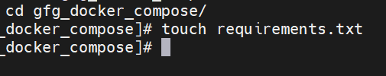

1. Add flast and redis in requirements.txt file
2. Add app.py file.  It will used to have the code for our [flask app](https://www.geeksforgeeks.org/flask-creating-first-simple-application).

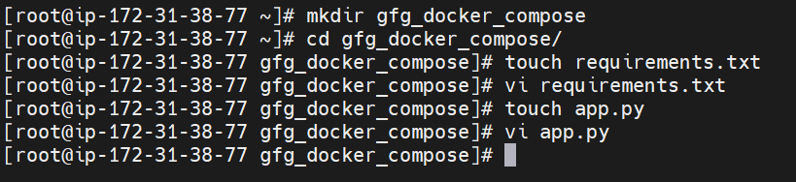

1. Create the [Dockerfile](https://www.geeksforgeeks.org/what-is-dockerfile) named file.
2. create the docker-compose.yml file.

