-Can we place the Create button on the top bar where the status dropdown currently is. We can move the status dropdown bar to the left of the create button. The create button can be the same color that we use in the total clients box on the CRM overview.

-For the dropdown in the create option, it should drop down when hovered over and please add the options for “Task” and “Event”.

-When lead, opportunity, client, task or event is selected from the “Create” button, a pop up should appear asking for the required info only that we request in the add lead, opportunity, client forms. An example of this is on Nutshell when click create lead or people.

-On CRM dashboard, can we list the “Recent Clients” starting with most recent at the top. And only list 10.

-Leads, opportunities and client listings should be redesigned to be listed like the “Recent Clients” listing on the CRM overview.

- Add “Columns” Option found in the “people” section on Nutshell to the leads, opportunities and client sections of our CRM. This will allow the agent to customize the columns they wish to display.

-The floating header Menu should be pushed up to the right of the logo when floating and when a tab is scrolled over, it should display the sub-menu for that tab.

-Default leads, opportunities, and clients listing columns to Name, Phone number, Email address, City/ST, Last Contact. They can change this at will using the Columns option described above.

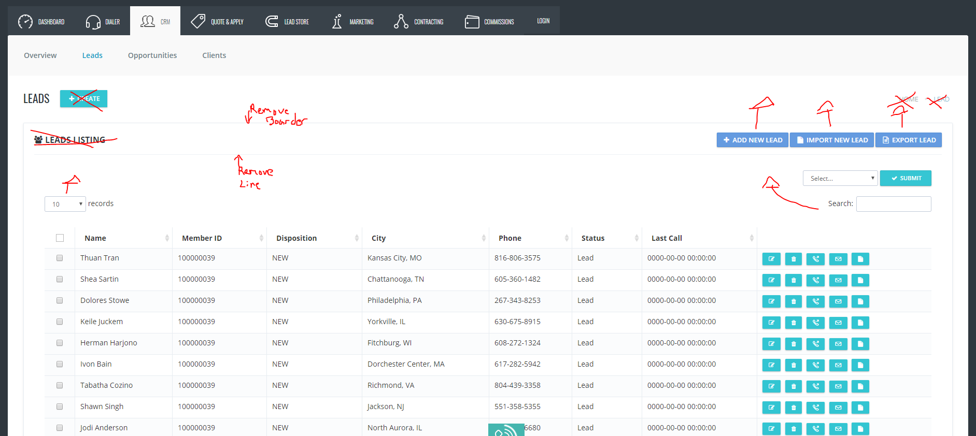

-In the above image we have laid out some changes that will apply to the Leads, Opportunities and Clients sections. I will use the leads section as an example but please apply changes to all 3 listing sections. They are as follows:

-Remove “Leads Listing” and icon.

-Move up three buttons on top right so they are aligned with the large word that says “Leads”: Add new lead, import new lead, Export new lead.

-Move the search button up next to the select drop down as indicated in image

-Move the 10 records per page drop down up on the top left to align with the search/select/submit options.

-Move up the listing to be directly below the Records/search/select/submit buttons

-Remove the icons on the right and replace according to Clayton’s instructions.