**Gohil Sanjay A RESUME**

**Address:** **Phone:** 7878182232

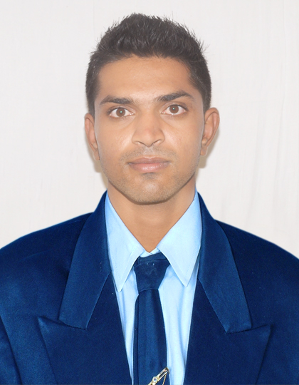

At.541, 542, Varasha society-2

Varachha, Surat **Email:**[gohilsanjay133@gmail.com](mailto:gohilsanjay133@gmail.com)

Surat:-395006(Gujarat)

**OBJECTIVE**

Seeking a computer programming level job. Working with company as Android Developer to enhancing and grow my skill and company also will grow.

**QUALIFICATION**

**Academic:**

|  |  |  |  |
| --- | --- | --- | --- |
| **Degree** | **Board/University** | **Year of passing** | **Percentile/CGPI** |
| BCA | Bhavnagar Univ. | 2015 | 48.62% |
| MCA | GTU | 2017 | 7.04 CGPI |

**Additional:**

|  |  |  |
| --- | --- | --- |
| **COURCE** | **YEAR** | **GRADE** |
| **CCC** | **2010** | **C GRADE** |

**PROJECT WORK**

|  |  |  |  |  |
| --- | --- | --- | --- | --- |
| **Title** | **Company Name** | **Description** | **Start Date** | **End Date** |
| Bus Reservation | MEFGI | Online Bus Reservation System | 01/07/2016 | 12/10/2016 |
| Event Management | Cygnus Softtech | Event Management System | 15/1/2017 | 14/4/2017 |

**KEY SKILLS**

**Technical**

* Android, C, C++, PHP,JAVA,HTML

**Soft Skills**

* Time Management
* Interpersonal skill
* Leadership
* Accountability

**EXPEREANCE**

|  |  |
| --- | --- |
| **Experience** | **Company Name** |
| 1 Year | Cygnus Softtech |

**EXTRA-CURRICULAR & CO-CURRICULAR ACTIVITIES**

* Volunteer in Synergy event – 2016 in Marwadi college

**PERSONAL DETAILS**

Date of Birth : September 24th 1994

Languages known : English, Hindi & Gujarati

**REFERENCES**

Name : Mr. Manish Dabhi

Address : Ahmadabad

Designation : ASP.net and MVC Developers

Contact No : 9016426328

Name : Prof. Vinod Makwana

Address : Smt. K.B Parekh College Of Computer Science-Mahuva

Designation : Assistant Professor

Contact No : 9904010366

**DECLARATION**

I hereby declare that the information furnished above is true to the best of my knowledge and belief.

Place : Surat

Date:

**Signature**