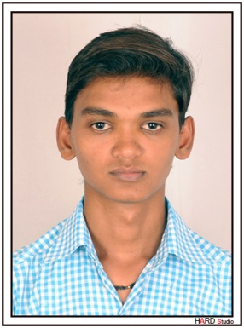**CHETAN D. MORDIYA**

**Address:** Near Ramji Mandir Temple,**To:** Surka,

**Ta**: Gadhada (Swami), **Dist:** Bhavnagar – 364 765

**E-Mail:**mordiyachetan96@gmail.com

Contact No: +91-7046365682

**CAREER OBJECTIVE**

To seek full time internship with responsibility and to develop my professional as well as personal skills and to contribute the maximum share in the success journey of the organization, And to get interest in comprehensive problems and try to solve it with better effort. I always ready to adept latest technology.

**STRENGTHS**

* **Ability towork in team**
* **Hard working**
* **Sincere**
* **Positive Attitude**
* **Can Take Initiative**
* **Innovative**
* **Skill of Management & Marketing**

**PERSONAL DETAILS**

|  |  |
| --- | --- |
| **Name** | MordiyaChetankumarDhanjibhai |
| **Father’s Name** | * MordiyaDhanjibhaiHirabhai |
| **Present Address** | B/50,Madhu Park Soc., Near Krupa Hospital, ,Singanpur char rasta,surat-395004 |
| **Date of Birth** | 05th Aug 1994 |
| **Sex** | Male |
| **Marital Status** | Unmarried |
| * **Religion** | Hindu |
| **Nationality** | Indian |
| **Hobbies** | Music, Chess, Cricket. |
| **Languages Known** | English, Hindi, Gujarati. |
| **College** | Shree Swami Vivekanand College Of Computer Science,Bhavnagar |

**ACADEMIC QUALIFICATIONS**

|  |  |  |  |
| --- | --- | --- | --- |
| Examination | **Year** | Board / University | Percentage |
| BCA | May-2014 | Bhavnagar University | 61.34% |
| HSC | March - 2011 | GSHEB | 69.00% |
| SSC | March - 2009 | GSEB | 61.39% |

**TECHNICAL SKILLS**

|  |  |
| --- | --- |
| **Web Technology** | HTML,PHP, Ajax,MySQL. |
| **OS** | Windows XP, Windows 7, Windows 8. |
| **Office Tools** | Microsoft word , Excel. |

**WORK EXPERIENCE**

* I have working at last 29 months Experience for IT company.that company is Harikrushna InfoTech PVT.LTD., 104, Laxmi Enclave, Katargam, Surat.

**AREAS OF INTEREST**

* “Website Develop”.
* Accounting Web App.

**CTC**

* **Current CTC :** 18000 / Month
* **Exp. CTC :** 20000 / Month

**DECLARATION**

I hereby declare that the information mentioned above is correct to the best of my knowledge.

**Date : 10/09/2018 Signature**

**Place : Surat** ChetanMordiya