

TRUSTY TOUR: A

Platform for Verified Tourism Guides

TRUSTY TOUR addresses the issue of fraudulent tourist guides by connecting travelers with certified and verified professionals. This platform aims to enhance the tourist experience by ensuring safety, trust, and authenticity.

## Group ID: TRUSTY TOUR

#### Mayank Gaur

1

Student ID: 2201 9201 30099

#### Mayank Yadav

Student ID: 2201 9201 301 00

2

#### Mohd Anas



3

Student ID: 2201 9201 301 03

#### Mohd Laraib

Student ID: 2201 9201 301 07

4

## Problem Statement

#### Unverified Guides

Tourists often encounter individuals claiming to be guides without proper credentials, leading to fraud and exploitation.

#### Mistrust and Poor Experiences

Unverified guides can result in scams, overpriced services, and a compromised tourist experience.

#### Goal

TRUSTY TOUR aims to provide tourists with access to certified guides, ensuring safety, fairness, and an enjoyable experience.

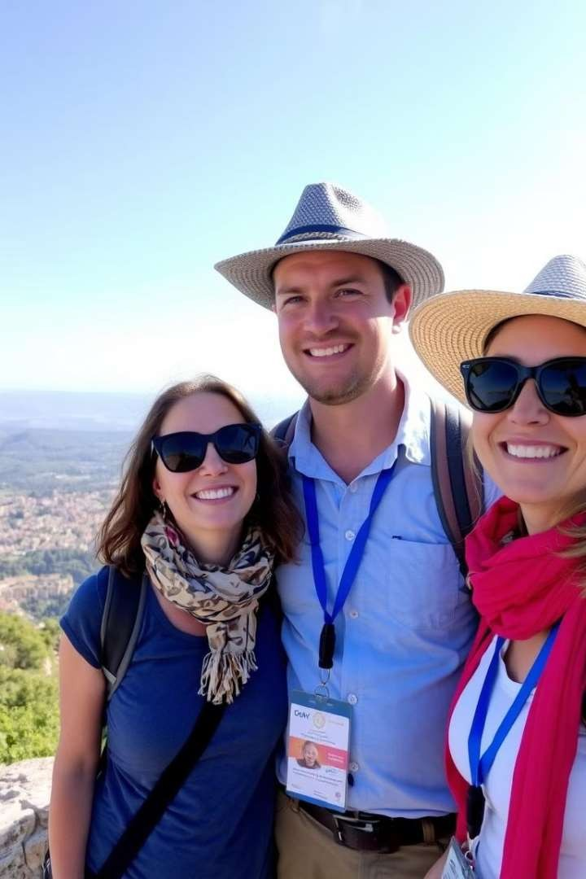

Motivation

Enhanced Safety

By verifying guides, TRUSTY TOUR ensures the safety and security of tourists, mitigating potential risks associated with fraudulent practices.

Cost Reduction

TRUSTY TOUR helps tourists avoid scams and overpriced services, leading to cost savings on tours and travel expenses.

Improved Experience

TRUSTY TOUR promotes trust and transparency, resulting in a more positive and enjoyable tourist experience.

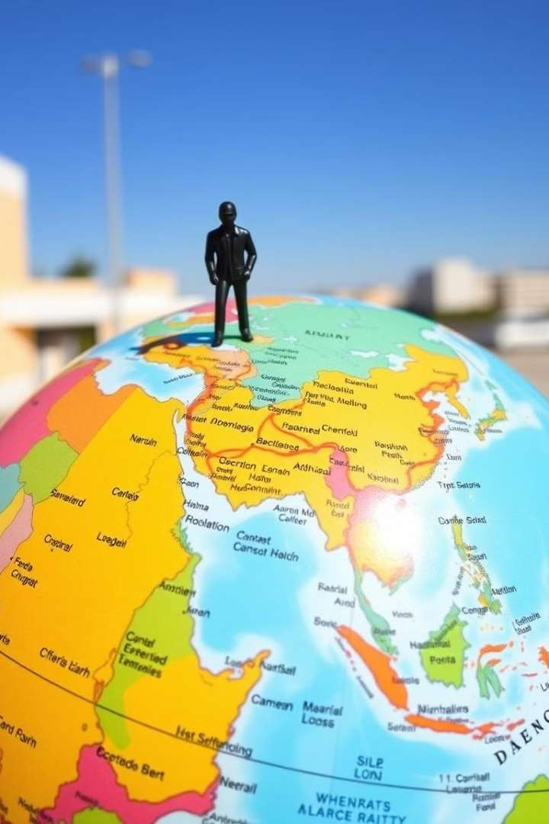

# Objectives

### Verified Guide Access

**1**

**2**

**3**

Tourists can find certified guides based on location and language preferences.

### Fraud Prevention

TRUSTY TOUR eliminates fraudulent activities by verifying guide credentials and providing a secure platform.

### Transparency and Accountability

The platform encourages transparency and accountability in tourism, promoting ethical practices among guides.

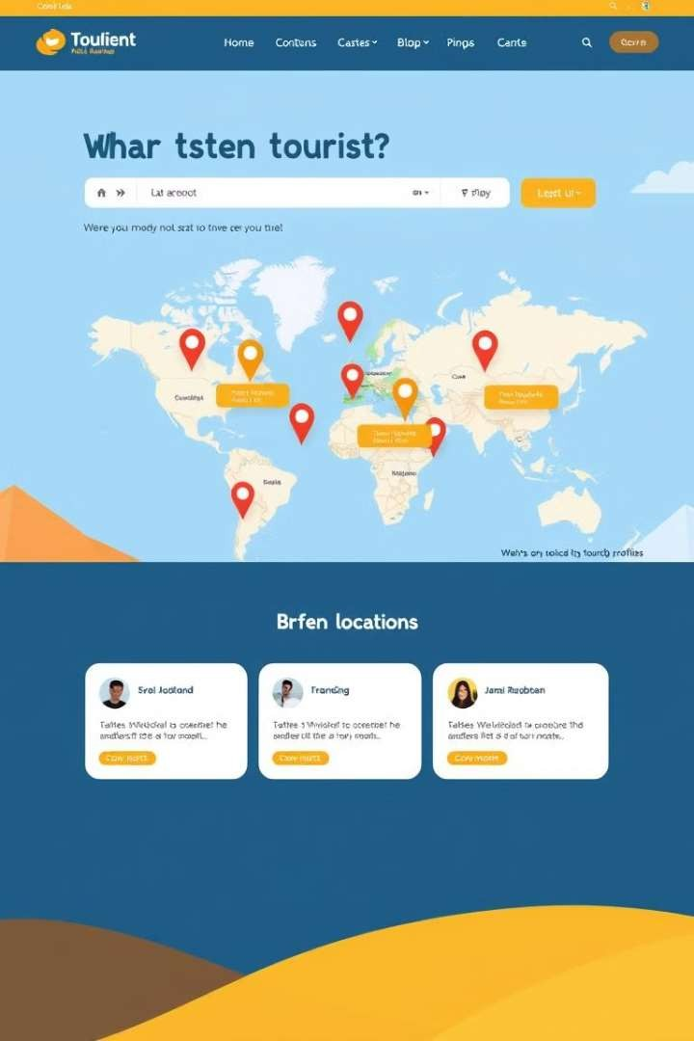

# Proposed Idea/Solution

### Website Development

TRUSTY TOUR is a web-based platform providing a user-

friendly interface for connecting tourists and verified guides.

### Guide Verification

The platform ensures guide verification through background

checks, credentials, and reviews.

### Location-Based Search

Tourists can search for guides based on their location and preferred languages.



Technologies Us ed

|  |  |
| --- | --- |
| Frontend | HTML, CSS, JavaScript |
| Backend | Node.js, Express.js |
| Database | MongoDB with Mongoose |

**Solution Environment**



##### Real-time Location Services

TRUSTY TOUR integrates real-time location tracking to connect tourists with guides in their current vicinity.

##### Security and Certification

The platform prioritizes security by verifying guide credentials and implementing secure data management practices.

preencoded.png 

##### Secure Data Management



TRUSTY TOUR ensures the privacy and security of user data through robust data management protocols.

##### Global Accessibility

TRUSTY TOUR aims to be accessible to tourists worldwide, providing a global network of verified guides.

## Impact & Benefits

#### Safer Tourism

1

TRUSTY TOUR promotes a safer and more secure travel experience by eliminating fraudulent practices and ensuring the safety of tourists.

#### Language Proficiency

The platform incentivizes guides to enhance their language skills, broadening their appeal and increasing their chances of employment.

2

#### Positive Economic Impact

TRUSTY TOUR contributes to the economic well-being of the tourism industry by promoting responsible and ethical practices.

3



# Sustainability Goals

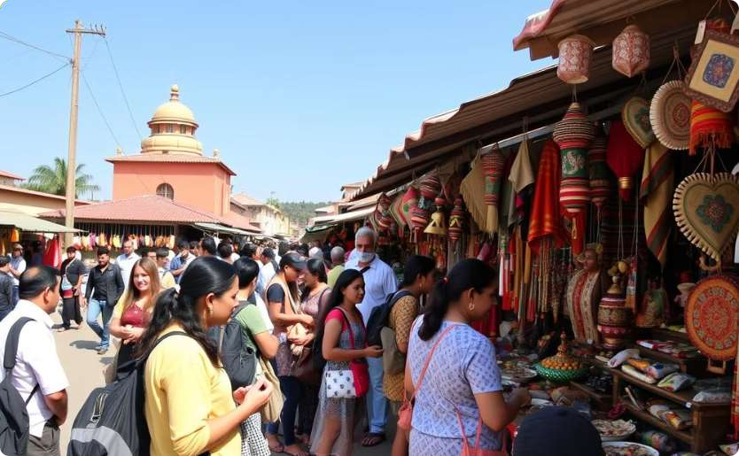

### Cultural Diversity

TRUSTY TOUR promotes cultural understanding and appreciation by connecting tourists with local guides who offer authentic experiences.

### Economic Growth

By supporting certified guides, TRUSTY TOUR contributes to the economic growth of local communities and fosters sustainable tourism.