## Bansilal Ramnath Agarwal Charitable Trust’s

Vishwakarma Institute of Technology, Pune-37

*(An Autonomous Institute of Savitribai Phule Pune University)*



**Department of AIDS**

|  |  |
| --- | --- |
| **Division** | A |
| **Roll Number** | 78 |
| **PRN Number** | 12320056 |
| **Name** | Mayank Kulkarni |

**Title:** Implementation of basic commands in Linux.

**Theory:**

**How to set up the Linux OS?**

For installing Linux, I have used VirtualBox which provides a virtual environment through which we can use the Linux OS let it be Ubuntu, or various other flavors of Linux like Linux Mint or Kali Linux, etc.

**Basic Commands in Linux**

* **ls command:** The “ls” command is used to list out the directories as well as the files in the current working directory. It is one of the most used commands in Linux.
* **pwd command:** The “pwd” command is used to describe the directory we are presently working in. It is one of the basic commands in Linux.

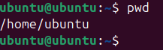

* **mkdir command:** The mkdir command is used to create a new directory. This can be done through the terminal itself. We just need to provide the directory name. For example: mkdir OsStudy.As we can see, the folder has been created in desktop directory.





* **cd command:** cd stands for change directory. This command helps the user to change his present working directory and shift to a new one. Now suppose if I want to work in the OsStudy directory, the command should look something like:



* **rmdir command:** The rmdir command is used to remove the directory that we don’t want to use anymore. It is used simultaneously with the mkdir command.



* **cat command:** The cat command is used to display the contents of a specific file in a particular directory.



* **ps command:** The ps command is used to display the active currently running processes in the terminal.

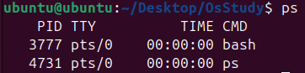

* **grep command:** The grep command is used to find a specific string of characters in a particular file. It is used with the cat command.



* **echo command:** The echo command is specifically used to print a statement in the terminal.



* **whoami command:** The whoami command is used to determine the name of the user or the system. It is useful while working in a network of multiple systems.



* **sort command:** The sort command is used to sort the output of a file in the terminal. It is usually sorted in alphabetical order.

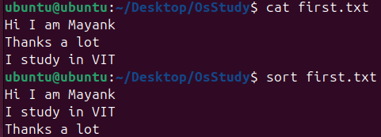

* **cal command:** The cal command is used to display the calendar of a particular month. It is not available by default. We need to install it using the following command: sudo apt install ncal

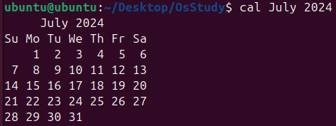

* **mv command:** The mv command is used to rename a file in a particular directory.

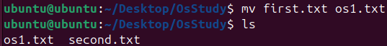

**Conclusion:**

Thus, in this practical we have successfully performed the implementation of basic commands in Linux.