A

Project Report

On

**PHONE BOOK**

Submitted in partial fulfilment of

The requirements for the 4th Semester Sessional Examination of

BACHELOR OF TECHNOLOGY

IN

**COMPUTER SCIENCE & ENGINEERING**

Session: 2019-23

Submitted by:

Mayank Mohak, Registration No: 1901060170

1. Himadri Prasad Achary, Regd. No.- 1901070008

Md. Faizan Ansari, Regd. No- 1901060164

Under the guidance of

Mr. P Sudheer Babu



Department of Computer Science & Engineering

GIET UNIVERSITY, Gunupur, Odisha

2020-2021

CERTIFICATE

**This is to certify that the project work entitled “PHONE BOOK” is done by Mayank Mohak (Regd. No.- 1901060170), A. Himadri Prasad Achary (Regd. No.- 1901070008), Md. Faizan Ansari, Regd. No- 1901060164, in partial fulfilment of the requirements for the 4th Semester Sessional Examination of Bachelor of Technology in Computer Science and Engineering during the academic year 2020-21.This work is submitted to the department as a Part of evaluation of 4th Semester Project.**

Mr. P Sudheer Babu Prof. (Dr) .Sanjay Kumar Kuanar

Class Teacher HoD, CSE

**ACKNOWLEDGEMENT**

We deem it a pleasure to acknowledge your sense of gratitude our project guide Mr. P Sudheer Babu under whom we have carried out the project work, her incisive and objective guidance timely advice encouraged constant flow of energy to continue the work. We wish to reciprocate in full measure the kindness shown by Mr. P Sudheer Babu who inspired us with her suggestions in successfully completing the project work.

We are also grateful to our HOD Prof. (Dr) Sanjay Kumar Kuanar of CSE department for providing

Moral support and adequate facility in completing this project.

Finally we must say that no height is ever achieved without some sacrifice made at some end and it is here where we owe our special debt to our parents and our friends for showing their generous love and care throughout the entire period of time.

GIETU, ODISHA

MD. FAIZAN ANSARI

A. HIMADRI PRASAD ACHARY

MAYANK MOHAK

**ABSTRACTION:**

This project (**PHONE BOOK**) deals with the maintenance of the Contact details. It generates the Contact on basis of Data Entered. Phone Contact can be Entered Edited and Deleted with input validation.

We have made this project by using **PYTHON ( tkinter ).** The main purpose of this project is to easily manage contacts on desktop.

This is built on python’s GUI tool tkinter and is very easy to handle and secure as we use SQLite as database.

Hence It was just the briefly description of the project. Let’s discuss about the project thoroughly.

INTRODUCTION:

* Purpose:-

This project solves problem of checking contacts on phone and tough to manage two device.

* Project Scope:-

The project is very simple to understand, And the main point is, it will take very less time to manage contacts and do irritating task in a fun way.

* Product Features:-

This project is made by using PYTHON (tkinter).

First upon when we run the code a graphical user interface will be shown. That’s the home page or we can say main page of our Application. There is a panel to enter Edit and delete contact separately.

System Analysis

Software Requirements:-

* OS: as PYTHON is platform independent so we can run on any platform
* Language used: PYTHON 3
* Graphic user interface: tkinter
* Any Terminal

Brief overview of the Technology:

PYTHON:- Python is an interpreted high-level general-purpose programming language. Python's design philosophy emphasizes code readability with its notable use of significant indentation.

Tkinter:- Tkinter is a Python binding to the Tk GUI toolkit. It is the standard Python interface to the Tk GUI toolkit, and is Python's de facto standard GUI. Tkinter is included with standard Linux, Microsoft Windows and Mac OS X installs of Python. The name Tkinter comes from Tk interface.

SQLite:- SQLite is a relational database management system contained in a C library. In contrast to many other database management systems, SQLite is not a client–server database engine. Rather, it is embedded into the end program. SQLite generally follows PostgreSQL syntax.

System Design and Specifications

**FLOW CHART**

**save**

**Enter Details**

**Select**

**Edit**

**Select**

**HOME**

**WINDOW**

**Save**

**Delete**

Process Specification:

* **Screenshot Diagrams:-**
* Command line Terminal from where we execute this program.

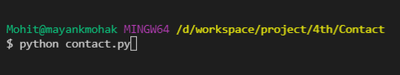

* Home Screen.

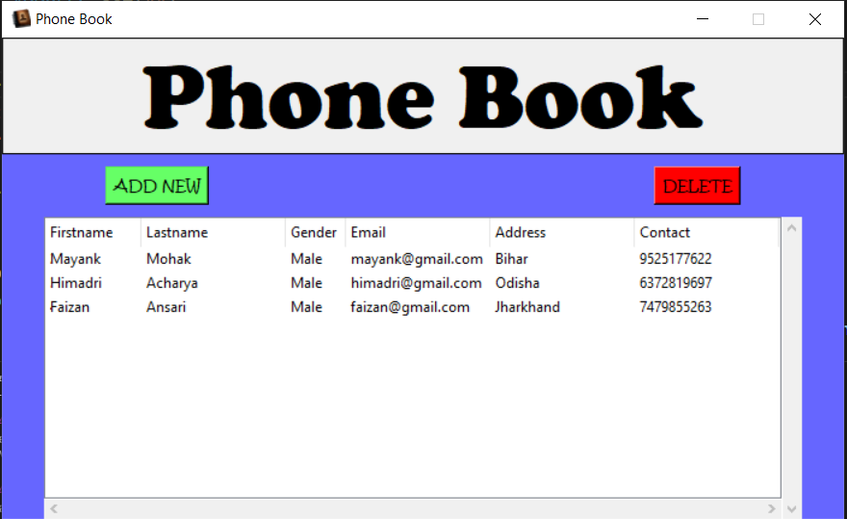

* New Entry Screen.

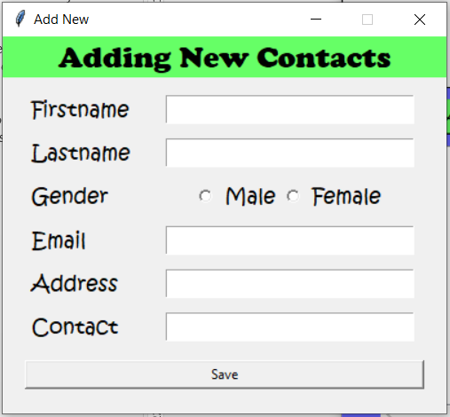

* Edit Entry Screen.

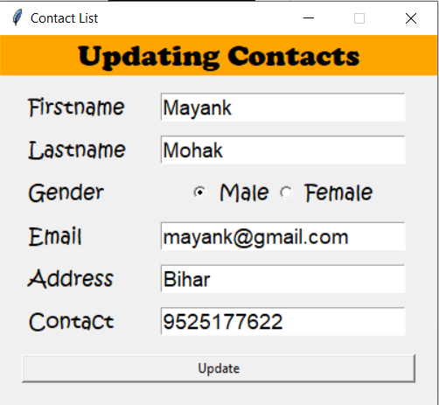

* Wrong Entry

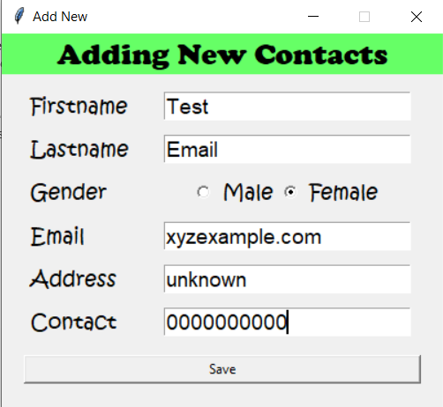

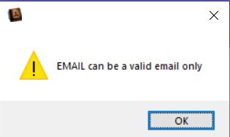

* Delete Entry Screen.

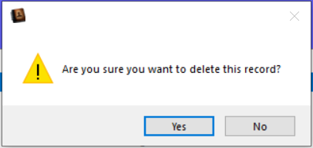

* CODES :

As previously mentioned we have used JAVA’s Abstract Windowing ToolKit along with e basic of JAVA(swing) to make this project . Following we have mentioned the codes here.

from tkinter import *

import sqlite3

import tkinter.ttk as ttk

import tkinter.messagebox as tkMessageBox

from inputvalidation import *

root = Tk()

root.title("Phone Book")

root.iconbitmap('icon/contact.ico')

width = 700

height = 400

screen_width = root.winfo_screenwidth()

screen_height = root.winfo_screenheight()

x = (screen_width/2) - (width/2)

y = (screen_height/2) - (height/2)

root.geometry("%dx%d+%d+%d" % (width, height, x, y))

root.resizable(0, 0)

root.config(bg="#6666ff")

#============================VARIABLES=========================

FIRSTNAME = StringVar()

LASTNAME = StringVar()

GENDER = StringVar()

AGE = StringVar()

ADDRESS = StringVar()

CONTACT = StringVar()

#============================METHODS===========================

def Database():

    conn = sqlite3.connect("db/contact.db")

    cursor = conn.cursor()

    cursor.execute("CREATE TABLE IF NOT EXISTS `member` (mem_id INTEGER NOT NULL  PRIMARY KEY AUTOINCREMENT, firstname TEXT, lastname TEXT, gender TEXT, age TEXT, address TEXT, contact TEXT)")

    cursor.execute("SELECT * FROM `member` ORDER BY `firstname` ASC")

    fetch = cursor.fetchall()

    for data in fetch:

        tree.insert('', 'end', values=(data))

    cursor.close()

    conn.close()

def SubmitData():

    if  FIRSTNAME.get() == "" or LASTNAME.get() == "" or GENDER.get() == "" or AGE.get() == "" or ADDRESS.get() == "" or CONTACT.get() == "":

        result = tkMessageBox.showwarning('', 'Please Complete The Required Field', icon="warning")

    else:

        tree.delete(*tree.get_children())

        conn = sqlite3.connect("db/contact.db")

        cursor = conn.cursor()

        #input validation

        fname = str(FIRSTNAME.get())

        lname = str(LASTNAME.get())

        gen = str(GENDER.get())

        age = int(AGE.get())

        addr = str(ADDRESS.get())

        cont = str(CONTACT.get())

        if not checkname(fname):

            tkMessageBox.showwarning('', 'Only A-Z in name', icon="warning")

        elif not checkname(lname):

            tkMessageBox.showwarning('', 'Only A-Z in name', icon="warning")

        elif not checkgender(gen):

            tkMessageBox.showwarning('', 'gender can only be Male or Female', icon="warning")

        elif not checkage(age):

            tkMessageBox.showwarning('', 'age can be number only', icon="warning")

        elif not checkcontact(cont):

            tkMessageBox.showwarning('', 'Ph Number 10 digits only', icon="warning")

        else:

            cursor.execute("INSERT INTO `member` (firstname, lastname, gender, age, address, contact) VALUES(?, ?, ?, ?, ?, ?)", (fname, lname, gen, age, addr, cont))

            conn.commit()

            FIRSTNAME.set("")

            LASTNAME.set("")

            GENDER.set("-")

            AGE.set("")

            ADDRESS.set("")

            CONTACT.set("")

            NewWindow.destroy()

        cursor.execute("SELECT * FROM `member` ORDER BY `firstname` ASC")

        fetch = cursor.fetchall()

        for data in fetch:

            tree.insert('', 'end', values=(data))

        cursor.close()

        conn.close()

def UpdateData():

    if GENDER.get() == "":

        result = tkMessageBox.showwarning('', 'Please Complete The Required Field', icon="warning")

    else:

        tree.delete(*tree.get_children())

        conn = sqlite3.connect("db/contact.db")

        cursor = conn.cursor()

        #input validation

        fname = str(FIRSTNAME.get())

        lname = str(LASTNAME.get())

        gen = str(GENDER.get())

        age = int(AGE.get())

        addr = str(ADDRESS.get())

        cont = str(CONTACT.get())

        if not checkname(fname):

            tkMessageBox.showwarning('', 'Only A-Z in name', icon="warning")

        elif not checkname(lname):

            tkMessageBox.showwarning('', 'Only A-Z in name', icon="warning")

        elif not checkgender(gen):

            tkMessageBox.showwarning('', 'gender can only be Male or Female', icon="warning")

        elif not checkage(age):

            tkMessageBox.showwarning('', 'age can be number only', icon="warning")

        elif not checkcontact(cont):

            tkMessageBox.showwarning('', 'Ph Number 10 digits only', icon="warning")

        else:

            cursor.execute("UPDATE `member` SET `firstname` = ?, `lastname` = ?, `gender` =?, `age` = ?,  `address` = ?, `contact` = ? WHERE `mem_id` = ?", (fname, lname, gen, age, addr, cont, int(mem_id)))

            conn.commit()

            FIRSTNAME.set("")

            LASTNAME.set("")

            GENDER.set("-")

            AGE.set("")

            ADDRESS.set("")

            CONTACT.set("")

            UpdateWindow.destroy()

        cursor.execute("SELECT * FROM `member` ORDER BY `firstname` ASC")

        fetch = cursor.fetchall()

        for data in fetch:

            tree.insert('', 'end', values=(data))

        cursor.close()

        conn.close()

def OnSelected(event):

    global mem_id, UpdateWindow

    curItem = tree.focus()

    contents =(tree.item(curItem))

    selecteditem = contents['values']

    mem_id = selecteditem[0]

    FIRSTNAME.set("")

    LASTNAME.set("")

    GENDER.set("")

    AGE.set("")

    ADDRESS.set("")

    CONTACT.set("")

    FIRSTNAME.set(selecteditem[1])

    LASTNAME.set(selecteditem[2])

    GENDER.set(selecteditem[3])

    AGE.set(selecteditem[4])

    ADDRESS.set(selecteditem[5])

    CONTACT.set(selecteditem[6])

    UpdateWindow = Toplevel()

    UpdateWindow.title("Contact List")

    width = 400

    height = 340

    screen_width = root.winfo_screenwidth()

    screen_height = root.winfo_screenheight()

    x = ((screen_width/2) + 450) - (width/2)

    y = ((screen_height/2) + 20) - (height/2)

    UpdateWindow.resizable(0, 0)

    UpdateWindow.geometry("%dx%d+%d+%d" % (width, height, x, y))

    if 'NewWindow' in globals():

        NewWindow.destroy()

#=========================FRAMES===============================

    FormTitle = Frame(UpdateWindow)

    FormTitle.pack(side=TOP)

    ContactForm = Frame(UpdateWindow)

    ContactForm.pack(side=TOP, pady=10)

    RadioGroup = Frame(ContactForm)

    Male  =  Radiobutton(RadioGroup, text="Male", variable=GENDER, value="Male",  font=('Kristen ITC', 14)).pack(side=LEFT)

    Female = Radiobutton(RadioGroup, text="Female", variable=GENDER, value="Female",  font=('Kristen ITC', 14)).pack(side=LEFT)

#=========================LABELS===============================

    lbl_title = Label(FormTitle, text="Updating Contacts", font=('cooper black', 20), bg="orange",  width = 300)

    lbl_title.pack(fill=X)

    lbl_firstname = Label(ContactForm, text="Firstname", font=('Kristen ITC', 14), bd=5)

    lbl_firstname.grid(row=0, sticky=W)

    lbl_lastname = Label(ContactForm, text="Lastname", font=('Kristen ITC', 14), bd=5)

    lbl_lastname.grid(row=1, sticky=W)

    lbl_gender = Label(ContactForm, text="Gender", font=('Kristen ITC', 14), bd=5)

    lbl_gender.grid(row=2, sticky=W)

    lbl_age = Label(ContactForm, text="Age", font=('Kristen ITC', 14), bd=5)

    lbl_age.grid(row=3, sticky=W)

    lbl_address = Label(ContactForm, text="Address", font=('Kristen ITC', 14), bd=5)

    lbl_address.grid(row=4, sticky=W)

    lbl_contact = Label(ContactForm, text="Contact", font=('Kristen ITC', 14), bd=5)

    lbl_contact.grid(row=5, sticky=W)

#==========================ENTRY===============================

    firstname = Entry(ContactForm, textvariable=FIRSTNAME, font=('Arial', 14))

    firstname.grid(row=0, column=1)

    lastname = Entry(ContactForm, textvariable=LASTNAME, font=('Arial', 14))

    lastname.grid(row=1, column=1)

    RadioGroup.grid(row=2, column=1)

    age = Entry(ContactForm, textvariable=AGE,  font=('Arial', 14))

    age.grid(row=3, column=1)

    address = Entry(ContactForm, textvariable=ADDRESS,  font=('Arial', 14))

    address.grid(row=4, column=1)

    contact = Entry(ContactForm, textvariable=CONTACT,  font=('Arial', 14))

    contact.grid(row=5, column=1)

#========================BUTTONS===============================

    btn_updatecon = Button(ContactForm, text="Update", width=50, command=UpdateData)

    btn_updatecon.grid(row=6, columnspan=2, pady=10)

#fn1353p

def DeleteData():

    if not tree.selection():

       result = tkMessageBox.showwarning('', 'Please Select Something First!', icon="warning")

    else:

        result = tkMessageBox.askquestion('', 'Are you sure you want to delete this record?', icon="warning")

        if result == 'yes':

            curItem = tree.focus()

            contents =(tree.item(curItem))

            selecteditem = contents['values']

            tree.delete(curItem)

            conn = sqlite3.connect("db/contact.db")

            cursor = conn.cursor()

            cursor.execute("DELETE FROM `member` WHERE `mem_id` = %d" % selecteditem[0])

            conn.commit()

            cursor.close()

            conn.close()

def AddNewWindow():

    global NewWindow

    FIRSTNAME.set("")

    LASTNAME.set("")

    GENDER.set("-")

    AGE.set("")

    ADDRESS.set("")

    CONTACT.set("")

    NewWindow = Toplevel()

    NewWindow.title("Add New")

    width = 400

    height = 340

    screen_width = root.winfo_screenwidth()

    screen_height = root.winfo_screenheight()

    x = ((screen_width/2) - 455) - (width/2)

    y = ((screen_height/2) + 20) - (height/2)

    NewWindow.resizable(0, 0)

    NewWindow.geometry("%dx%d+%d+%d" % (width, height, x, y))

    if 'UpdateWindow' in globals():

        UpdateWindow.destroy()

#==========================FRAMES==============================

    FormTitle = Frame(NewWindow)

    FormTitle.pack(side=TOP)

    ContactForm = Frame(NewWindow)

    ContactForm.pack(side=TOP, pady=10)

    RadioGroup = Frame(ContactForm)

    Male = Radiobutton(RadioGroup, text="Male", variable=GENDER, value="Male",  font=('Kristen ITC', 14)).pack(side=LEFT)

    Female = Radiobutton(RadioGroup, text="Female", variable=GENDER, value="Female",  font=('Kristen ITC', 14)).pack(side=LEFT)

#==========================LABELS==============================

    lbl_title = Label(FormTitle, text="Adding New Contacts", font=('cooper black', 20), bg="#66ff66",  width = 300)

    lbl_title.pack(fill=X)

    lbl_firstname = Label(ContactForm, text="Firstname", font=('Kristen ITC', 14), bd=5)

    lbl_firstname.grid(row=0, sticky=W)

    lbl_lastname = Label(ContactForm, text="Lastname", font=('Kristen ITC', 14), bd=5)

    lbl_lastname.grid(row=1, sticky=W)

    lbl_gender = Label(ContactForm, text="Gender", font=('Kristen ITC', 14), bd=5)

    lbl_gender.grid(row=2, sticky=W)

    lbl_age = Label(ContactForm, text="Age", font=('Kristen ITC', 14), bd=5)

    lbl_age.grid(row=3, sticky=W)

    lbl_address = Label(ContactForm, text="Address", font=('Kristen ITC', 14), bd=5)

    lbl_address.grid(row=4, sticky=W)

    lbl_contact = Label(ContactForm, text="Contact", font=('Kristen ITC', 14), bd=5)

    lbl_contact.grid(row=5, sticky=W)

#==========================ENTRY===============================

    firstname = Entry(ContactForm, textvariable=FIRSTNAME, font=('Arial', 14))

    firstname.grid(row=0, column=1)

    lastname = Entry(ContactForm, textvariable=LASTNAME, font=('Arial', 14))

    lastname.grid(row=1, column=1)

    RadioGroup.grid(row=2, column=1)

    age = Entry(ContactForm, textvariable=AGE,  font=('Arial', 14))

    age.grid(row=3, column=1)

    address = Entry(ContactForm, textvariable=ADDRESS,  font=('Arial', 14))

    address.grid(row=4, column=1)

    contact = Entry(ContactForm, textvariable=CONTACT,  font=('Arial', 14))

    contact.grid(row=5, column=1)

#=======================BUTTONS================================

    btn_addcon = Button(ContactForm, text="Save", width=50, command=SubmitData)

    btn_addcon.grid(row=6, columnspan=2, pady=10)

#============================FRAMES============================

Top = Frame(root, width=500, bd=1, relief=SOLID)

Top.pack(side=TOP)

Mid = Frame(root, width=500,  bg="#6666ff")

Mid.pack(side=TOP)

MidLeft = Frame(Mid, width=100)

MidLeft.pack(side=LEFT, pady=10)

MidLeftPadding = Frame(Mid, width=370, bg="#6666ff")

MidLeftPadding.pack(side=LEFT)

MidRight = Frame(Mid, width=100)

MidRight.pack(side=RIGHT, pady=10)

TableMargin = Frame(root, width=500)

TableMargin.pack(side=TOP)

#============================LABELS============================

lbl_title = Label(Top, text="Phone Book", font=('Cooper Black', 58), width=500)

lbl_title.pack(fill=X)

#============================ENTRY=============================

#============================BUTTONS===========================

btn_add = Button(MidLeft, text="ADD NEW", font=('Kristen ITC',10), bg="#66ff66", command=AddNewWindow)

btn_add.pack()

btn_delete = Button(MidRight, text="DELETE", font=('Kristen ITC',10), bg="red", command=DeleteData)

btn_delete.pack(side=RIGHT)

#============================TABLES============================

scrollbarx = Scrollbar(TableMargin, orient=HORIZONTAL)

scrollbary = Scrollbar(TableMargin, orient=VERTICAL)

tree = ttk.Treeview(TableMargin, columns=("MemberID", "Firstname", "Lastname", "Gender", "Age", "Address", "Contact"), height=400, selectmode="extended", yscrollcommand=scrollbary.set, xscrollcommand=scrollbarx.set)

scrollbary.config(command=tree.yview)

scrollbary.pack(side=RIGHT, fill=Y)

scrollbarx.config(command=tree.xview)

scrollbarx.pack(side=BOTTOM, fill=X)

tree.heading('MemberID', text="MemberID", anchor=W)

tree.heading('Firstname', text="Firstname", anchor=W)

tree.heading('Lastname', text="Lastname", anchor=W)

tree.heading('Gender', text="Gender", anchor=W)

tree.heading('Age', text="Age", anchor=W)

tree.heading('Address', text="Address", anchor=W)

tree.heading('Contact', text="Contact", anchor=W)

tree.column('#0', stretch=NO, minwidth=0, width=0)

tree.column('#1', stretch=NO, minwidth=0, width=0)

tree.column('#2', stretch=NO, minwidth=0, width=80)

tree.column('#3', stretch=NO, minwidth=0, width=120)

tree.column('#4', stretch=NO, minwidth=0, width=90)

tree.column('#5', stretch=NO, minwidth=0, width=80)

tree.column('#6', stretch=NO, minwidth=0, width=120)

tree.column('#7', stretch=NO, minwidth=0, width=120)

tree.pack()

tree.bind('<Double-Button-1>', OnSelected)

#============================INITIALIZATION====================

if __name__ == '__main__':

    Database()

    root.mainloop()

CONCLUSION

At last we want to say this project is very simple to use. It can be also modified later by using database work. We hope it will be helpful and it’s also very simple to understand.

LIMITATIONS

We have implemented as per our knowledge so we may not say that our project is 100 % perfect but we have tried to put it 100% accuracy from our end. Some of limitation according to us would be that

1. We are unable to add sync feature
2. Our application is window based so we cannot implement it on paper to maintain records
3. This project can only be used by someone who is able to handle computer.

REFERENCE

For making this project we had taken help from these web sources:

* **javaTpoint (***for**learning* ***tkinter*)**
* **Our Teachers for concept of GUI and PYTHON**
* **Wikipedia(***wikipedia.org***)**
* **GeekforGeeks**
* **The PYTHON Tutorials (***from https://docs.python.org/3/***)**
* **Stack Overflow for getting solution of doubts(***stackoverflow.com***)**
* **Our special thanks to getting our relevant document and doubts.**