PROJECT REPORT ON WEB PORTAL DEVELOPMENT FOR "CCL KE LAL · CCL KI LAADLI"

____________________________________________________

TABLE OF CONTENTS
1. Acknowledgments
2. Abstract
3. Introduction
4. Company Profile: Central Coalfields Limited
5. Problem Statement & Objectives
6. System Requirements & Technology Stack
7. System Architecture & File Structure
8. Frontend Design & Implementation
9. Backend Development & PHP Logic
10. Database Design & Schema
11. Module Descriptions (Features)
12. Security & Session Management
13. Software Development Life Cycle (SDLC)
14. Challenges Encountered & Solutions
15. Future Enhancements & Scope
16. Conclusion
____________________________________________________

1. Acknowledgments
I would like to express my profound gratitude to Central Coalfields Limited (CCL) for providing me with the opportunity to undertake my internship and work on the CSR web portal project. The practical exposure gained during this period has been invaluable in bridging the gap between theoretical academic concepts and real-world software engineering practices.
I extend my sincere thanks to my project guides and mentors within the CCL IT and CSR departments, whose guidance, technical expertise, and continuous feedback were instrumental in the successful completion and modernization of this web application.
____________________________________________________

2. Abstract

The “CCL Ke Lal – CCL Ki Laadli” is a Corporate Social Responsibility (CSR) initiative of Central Coalfields Limited (CCL) aimed at identifying and supporting meritorious students from different, including remote, regions of Jharkhand by providing them coaching for competitive examinations such as JEE Main and JEE Advanced. Traditionally, the student selection test was conducted through an offline process, creating scope for digitalization and centralized management.
During my internship in the System Department of CCL, Ranchi, I developed a centralized web portal for the initiative to integrate essential student and program-related activities into a single platform. The portal provides initiative information, student registration, secure login/authentication, student data management, and an online quiz/assessment module.
The system was developed using HTML, CSS, JavaScript, PHP, MySQL, and XAMPP. PHP and MySQL were used for server-side and database management, while HTML, CSS, and JavaScript were used to develop an interactive and user-friendly interface. The online quiz module enables students to attempt assessments digitally, with automated evaluation and result storage in the database.
The proposed system reduces dependence on manual processes, improves organization of student information, simplifies registration and assessment, and provides a centralized digital platform for the initiative. The project also provided practical exposure to full-stack web development, database management, authentication, session handling, form validation, and client-server architecture.
____________________________________________________

3. Introduction

Corporate Social Responsibility (CSR) has become an integral part of modern corporate governance, enabling organizations to contribute meaningfully to social and economic development. Central Coalfields Limited (CCL), through its flagship educational initiative “CCL Ke Lal – CCL Ki Laadli,” supports meritorious students from different regions of Jharkhand by providing them with educational opportunities and specialized coaching for competitive examinations such as JEE Main and JEE Advanced.
As the initiative involves students from diverse and often remote locations, efficient management of student information, registration, communication, and assessment becomes increasingly important. Traditional offline processes and static information sources can result in fragmented data management, increased administrative effort, and limited accessibility for students and their parents or guardians.
The project demonstrates how web-based technologies can be utilized to modernize an educational CSR initiative, streamline its processes, and establish a scalable digital foundation for future expansion.
____________________________________________________

4. Company Profile: Central Coalfields Limited

Central Coalfields Limited (CCL) is a Category-I Mini-Ratna Company and a subsidiary of Coal India Limited (CIL), the largest coal-producing company in the world. Formed on November 1, 1975, CCL operates primarily in the state of Jharkhand, managing numerous coal mines, washeries, and central workshops.
Beyond its core industrial operations, CCL is deeply committed to the socio-economic upliftment of the communities residing in its command areas. The CSR initiatives undertaken by CCL span healthcare, infrastructure development, and education. The *CCL Ke Lal · CCL Ki Laadli* scheme is the crown jewel of their educational outreach, boasting a stellar track record of transforming the lives of underprivileged students by granting them access to premier engineering institutions.
____________________________________________________

5. Problem Statement & Objectives

5.1 Problem Statement

The existing digital presence of the CCL Ke Lal – CCL Ki Laadli initiative was limited by a static and fragmented web structure that did not adequately support the growing requirements of the program. The website primarily consisted of disconnected HTML pages with outdated design practices, resulting in limited usability, responsiveness, and maintainability.
Furthermore, essential functionalities such as student registration and login were not operational, due to improper PHP configuration and the absence of a structured database architecture. Server-side PHP scripts were not being processed correctly, causing source code to be delivered to the client browser instead of being executed on the server.
These limitations highlighted the need for a modern, centralized, database-driven web portal capable of providing reliable student registration and authentication, organized information management, and a foundation for integrating online assessment functionality. The project therefore aimed to modernize the existing platform and establish a functional and scalable digital system for the initiative.

5.2 Objectives
The primary objectives of the project were to modernize and digitize the CCL Ke Lal – CCL Ki Laadli web platform and provide an integrated, user-friendly system for students and administrators.
- Modernize the UI/UX: Redesign and refactor the existing frontend using modern HTML5 and CSS3 standards to create a responsive, intuitive, and visually appealing interface.
- Develop a Dynamic Backend: Implement robust server-side functionality using PHP to process user requests, manage forms, and handle application workflows efficiently.
- Database Integration: Design and implement a structured MySQL database to securely store student registration details, credentials, academic information, quiz data, and assessment results.
- Student Registration System: Develop an online registration module to enable students to submit and manage their required personal and academic information digitally.
- Authentication and Session Management: Implement a secure login and authentication system using PHP sessions to provide controlled access to student-specific resources.
- Interactive Student Dashboard: Create a personalized dashboard where authenticated students can access relevant program information, participate in online quizzes, and view their performance.
- Online Assessment Module: Develop an interactive quiz system to digitize the existing offline assessment process, including question presentation, answer submission, automated evaluation, and result storage.
- Centralized Information Platform: Consolidate important information related to the CCL Ke Lal – CCL Ki Laadli initiative into a single accessible web portal for students and other stakeholders.
- Data Accuracy and Process Efficiency: Reduce manual data handling and minimize errors by automating registration, assessment, evaluation, and result-recording processes.
- Scalable and Maintainable Architecture: Establish a structured application architecture that can be maintained easily and extended with additional features as the initiative evolves.
____________________________________________________

6. System Requirements & Technology Stack

6.1 Hardware Requirements

- Processor: Intel Core i3 / AMD Ryzen 3 (or equivalent) minimum.
- RAM: 4GB minimum (8GB recommended for running Apache/MySQL servers locally alongside an IDE).
- Storage: 500MB free disk space for XAMPP installation and project files.

6.2 Software & Technology Stack (WAMP /XAMPP Environment)

The project utilizes the classic client-server model heavily reliant on the WAMP stack:
- Operating System: Windows 10/11
- Web Server (Apache): Handles incoming HTTP/HTTPS requests and serves static assets and parsed PHP scripts.
- Database (MySQL / MariaDB): A relational database management system (RDBMS) utilizing the InnoDB storage engine for ACID compliance.
- Backend Language (PHP 8.x): Hypertext Preprocessor, a server-side scripting language used to connect the UI with the database.
- Frontend Languages:
- HTML5: For semantic Document Object Model (DOM) structuring.
- CSS3: For styling, Flexbox/Grid layouts, and CSS variables.
- Vanilla JavaScript (ES6): For client-side interactivity and carousel logic.
- IDE / Environment: Visual Studio Code / Antigravity IDE.
____________________________________________________

7. System Architecture & File Structure

7.1 Architecture Pattern
The application follows a standard Client-Server Architecture.
1. The Client (Web Browser) sends an HTTP GET/POST request.
2. The Apache Server intercepts the request. If the requested file is `.php`, it routes it to the PHP preprocessor.
3. The PHP Engine executes the logic, communicates with the MySQL Database (if querying/inserting data is required), and compiles the output into standard HTML.
4. The Server sends the compiled HTML back to the Client as an HTTP Response.
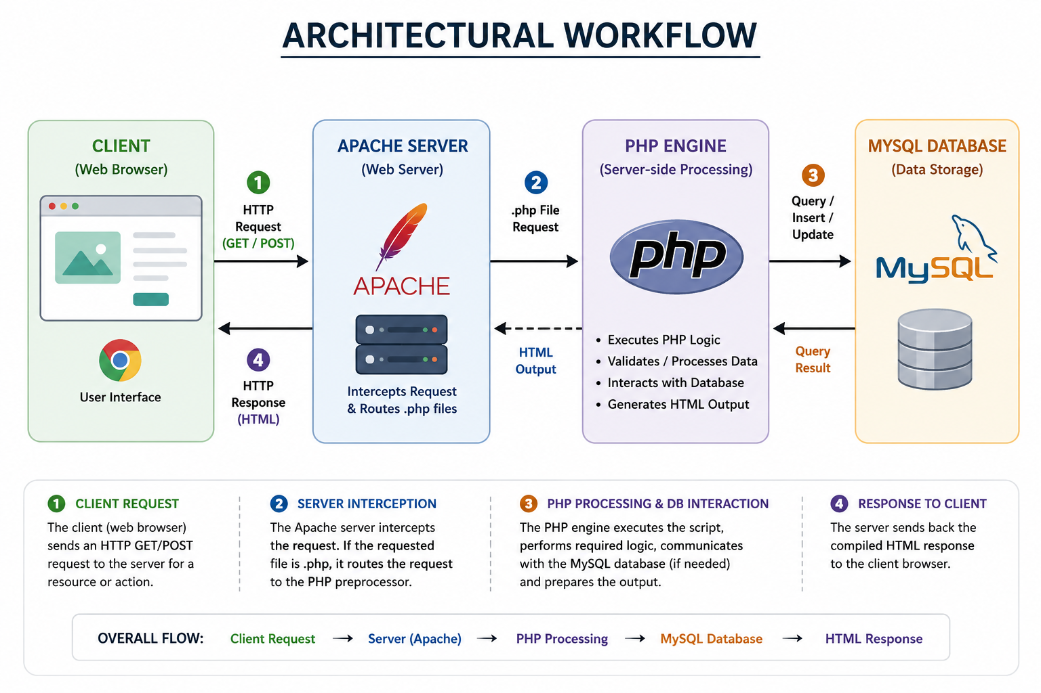

7.2 Directory Structure

/htdocs/CCL-Internship-Project-main/Home/
├── index.html # Landing Page / Hero Section
├── aboutccl.html # Information regarding CCL history
├── aboutscheme.html # Details regarding the CSR scheme
├── aboutschool.html # Information on DAV Public School
├── contact.html # Contact & Social links
├── global-theme.css # Centralized UI Design System (CSS3)
├── form1.php # Registration Form & Backend Insertion Logic
├── form2.php # Login Form & Authentication Logic
├── register.php # Secured Student Dashboard & Quiz History
├── Quiz1.php / Quiz2.php # Interactive Quiz Modules
├── dashboard.php # Quiz Submission Handler
├── connection1.php # Database Connection Middleware
├── logout.php # Session Destruction Script
├── database_setup.sql # DDL Script for Database Provisioning
└── [Image Assets] # Various .jpg and .png files for UI

____________________________________________________

8. Frontend Design & Implementation

8.1 The Global Theme (`global-theme.css`)
To achieve a highly professional and cohesive aesthetic, a singular global stylesheet was engineered. This adhered to the DRY (Don't Repeat Yourself) principle of software engineering.
- CSS Variables (Custom Properties): Defined at the `:root` level to maintain consistent primary (`#4F46E5`), secondary (`#EC4899`), and background colors.

- Typography: Integrated Google Fonts. `Inter` was utilized for body text due to its excellent legibility on digital screens, while `Poppins` was reserved for high-impact headings.

8.2 Glassmorphism & UI Cards
The outdated layout utilizing horizontal rules (`<hr>`) was completely replaced with a modern "Glassmorphism" UI.
- Implementation: Content sections were encapsulated in `<section class="card">`. These cards utilized a semi-transparent background (`rgba(255, 255, 255, 0.85)`), soft border radiuses (16px - 20px), and CSS filters (`backdrop-filter: blur(16px)`) to create a frosted glass effect over the underlying radial-gradient body background.

- Micro-interactions: CSS transitions were applied to hover states (`transform: translateY(-5px)`) to provide tactile, responsive feedback to the user.

8.3 Responsive Web Design (RWD)
The UI was built to be responsive across desktop and mobile devices. Rather than relying on heavy CSS frameworks like Bootstrap, native CSS Grid and Flexbox were utilized.
- Example: `.grid-2 { display: grid; grid-template-columns: repeat(auto-fit, minmax(300px, 1fr)); }` ensures that content cards automatically reflow from a multi-column layout on desktops to a single-column layout on mobile devices.
____________________________________________________

9. Backend Development & PHP Logic

9.1 Database Connectivity (`connection1.php`)
A middleware script was written to establish a persistent connection between the PHP runtime and the MySQL server using the `mysqli_connect()` function. It passes the `$servername`, `$username`, `$password`, and `$dbname` parameters and returns a connection object (`$conn`) used globally across the application.

9.2 Registration Pipeline (`form1.php`)
- Data Ingestion: The HTML form collects 15 unique data points (Name, DOB, Category, Board, etc.) utilizing the `POST` method.
- Payload Extraction: PHP extracts this payload via the `$_POST` superglobal array. Null coalescing operators (`??`) were used to prevent undefined index errors.
- Query Execution: An `INSERT INTO form1 (...) VALUES (...)` SQL query is dynamically constructed and executed via `mysqli_query()`.
- Dynamic Feedback: Upon successful execution, a success alert box is injected into the DOM; otherwise, an error state is displayed.
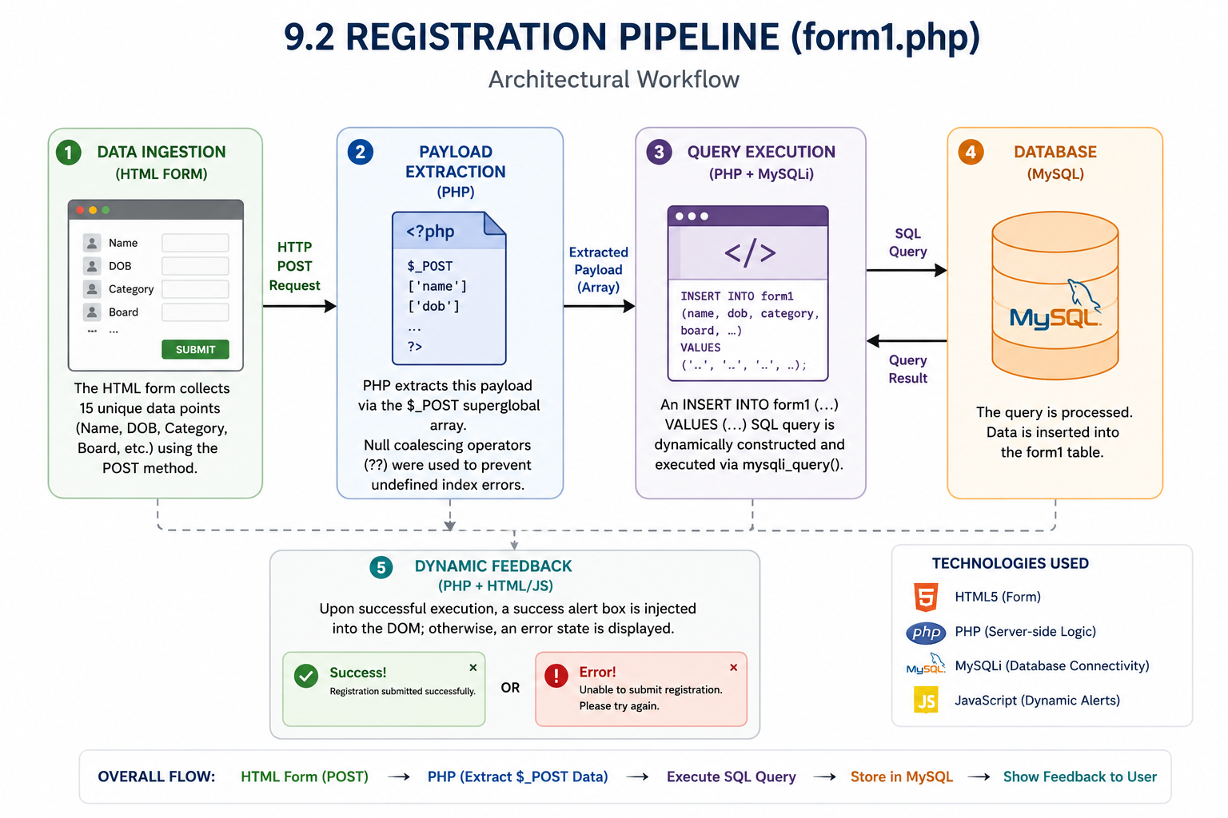

9.3 Quiz Submission Logic (`dashboard.php`)
When a student completes a quiz via the JS-driven interface in `Quiz1.php`, the final score is passed via a GET request (`?id=score`) to `dashboard.php`.
- Data Sanitization: Before insertion, `mysqli_real_escape_string()` is applied to the user ID and score to sanitize inputs and prevent basic SQL injection vectors.
- Persistence: The score and the active student's email are inserted into the `result` database table.
____________________________________________________

10. Database Design & Schema
The relational database (`registrationform`) was provisioned using a custom Data Definition Language (DDL) script (`database_setup.sql`).

10.1 Table 1: `form1` (Student Records)
This table acts as the master record for all applicants.
- `id`: INT, Primary Key, Auto Increment.
- `fname`, `lname`: VARCHAR(50), stores applicant's name.
- `dob`: DATE, serves as the authentication password.
- `student_email`: VARCHAR(100), UNIQUE constraint applied to prevent duplicate registrations and act as the User ID.
- `category`, `boardname`, `per`, `ccl`: Stores academic and demographic data for eligibility filtering.
- `created_at`: TIMESTAMP, defaults to `CURRENT_TIMESTAMP`.

10.2 Table 2: `result` (Quiz Analytics)
This table records the performance of students in internal assessments.
- `id`: INT, Primary Key, Auto Increment.
- `student_email`: VARCHAR(100), acts as a Foreign Key linking to the `form1` table.
- `test`: VARCHAR(10), stores the numerical score achieved.
- `submitted_at`: TIMESTAMP, records the exact date and time the quiz was completed.
____________________________________________________

11. Module Descriptions (Features)
1. Information Dissemination Module: Static but visually engaging pages (`aboutccl.html`, `aboutscheme.html`, `aboutschool.html`) that detail the history, selection methodology, syllabus, and contact information.
2. Registration Module: A comprehensive, multi-field form equipped with HTML5 validation (required fields, email formatting, date pickers) that routes data to the MySQL backend.
3. Authentication Module: A login portal verifying credentials against the `form1` table and initiating server sessions.
4. Student Dashboard Module: A secured, private route (`register.php`) accessible only to logged-in users. Features include:
- Dynamic welcome greeting using the active Session ID.
- An automated table that queries the `result` table and renders the student's historical quiz scores and timestamps.
5. Interactive Quiz Module: Client-side JavaScript quizzes featuring pagination, dynamic scoring, and automated redirection to the backend submission handler.
____________________________________________________

12. Security & Session Management

12.1 Stateful Sessions
Because the HTTP protocol is inherently stateless, PHP Sessions were utilized to maintain authentication state.
- Login: Upon verified credentials, `session_start()` is invoked. `$_SESSION['flag'] = 1` and `$_SESSION['userid'] = $email` are set in the server memory.
- Route Protection: The dashboard (`register.php`) begins by checking `if(!isset($_SESSION['flag']) || $_SESSION['flag'] != 1)`. If unauthorized, it executes an HTTP 302 Redirect (`header('Location: form2.php')`) kicking the user back to the login page.
- Logout: `logout.php` safely terminates the connection by invoking `session_unset()` (clearing variables) and `session_destroy()` (deleting the session file from the server), before redirecting to the login screen.

12.2 Data Integrity
- Unique Constraints: The database utilizes a `UNIQUE` index on the `student_email` column, structurally preventing malicious or accidental duplicate account creation.
- Sanitization: `mysqli_real_escape_string()` was implemented during database insertions (e.g., the quiz submission) to neutralize special characters that could alter SQL logic, providing a baseline defense against SQL Injection (SQLi).
____________________________________________________

13. Software Development Life Cycle (SDLC)
The project followed an Agile-Iterative Methodology:
1. Requirement Analysis: Understanding the legacy code, identifying the bugs (static vs. dynamic server issues), and charting the goals of the CSR scheme.
2. Design Phase: Architecting the database schema, selecting the color palette, and mapping out the user journey.
3. Development (Iteration 1): Overhauling the frontend HTML/CSS to implement the glassmorphic design system.
4. Development (Iteration 2): Developing the PHP backend, writing the SQL queries, and integrating the database connection.
5. Testing & Debugging: Running the application on XAMPP, fixing case-sensitivity errors in file inclusions, resolving port conflicts, and verifying session integrity.
6. Deployment & Review: Finalizing the UI/UX, removing redundant elements (e.g., legacy "Apply Now" buttons), and packaging the SQL setup script.
____________________________________________________

14. Challenges Encountered & Solutions

14.1 Static vs. Dynamic Server Conflict
Challenge: The initial environment was running on a basic Python static HTTP server (`python -m http.server`), causing PHP files to download as raw text rather than executing.
Solution: Migrated the entire workspace into the `htdocs` directory of an Apache HTTP Server via XAMPP. This enabled the PHP preprocessor to compile server-side logic before serving it to the client browser.

14.2 Outdated Legacy UI
Challenge: The provided HTML lacked responsiveness, making it unreadable on mobile devices, and relied on deprecated alignment tags.
Solution: Completely refactored the DOM. Wrote a `global-theme.css` utilizing modern Flexbox/Grid layouts, fluid typography, and standardized padding/margins, resulting in a premium corporate aesthetic.

14.3 Unlinked Quiz Results
Challenge: The quizzes calculated scores via JavaScript but failed to persist that data to the student's profile, limiting administrative tracking.
Solution: Rewrote the quiz submission logic to pass data to a PHP handler. Altered the database schema to include a `result` table, and modified the student dashboard to actively query and display these results associated with the active session's User ID.
____________________________________________________

15. Future Enhancements & Scope
While the current portal successfully meets the operational requirements of the CSR initiative, several enhancements can be integrated in future iterations:
1. Password Hashing: Currently, the system uses the student's Date of Birth (DOB) in plaintext as a password. Future versions must implement the `password_hash()` (Bcrypt/Argon2) function for cryptographic security.
2. Prepared Statements: Transitioning from concatenated `mysqli_query` statements to PDO (PHP Data Objects) or `mysqli_prepare()` to provide robust, enterprise-grade protection against SQL Injection.
3. Admin Dashboard: Creating a separate portal (`admin.php`) where CCL executives can view aggregated analytics, download student applicant data in CSV format, and manage quiz content dynamically without altering source code.
4. Email Integration: Implementing PHPMailer or SMTP protocols to automatically send confirmation emails and admit cards to students upon successful registration.
____________________________________________________

16. Conclusion
The development of the web portal for the CCL Ke Lal · CCL Ki Laadli initiative proved to be a highly successful and educational endeavor. The project evolved from a fragmented, static prototype into a cohesive, secure, and visually stunning Full-Stack Web Application.
By implementing modern UI/UX principles alongside a robust LAMP/WAMP architecture, the portal now provides a frictionless experience for underprivileged, meritorious students seeking to apply for this transformative CSR program. Furthermore, the robust backend ensures that CCL administrators can reliably capture, store, and process applicant data. This internship project not only fulfilled the technical requirements of the organization but also provided profound, hands-on experience in modern web engineering, database architecture, and system deployment.

