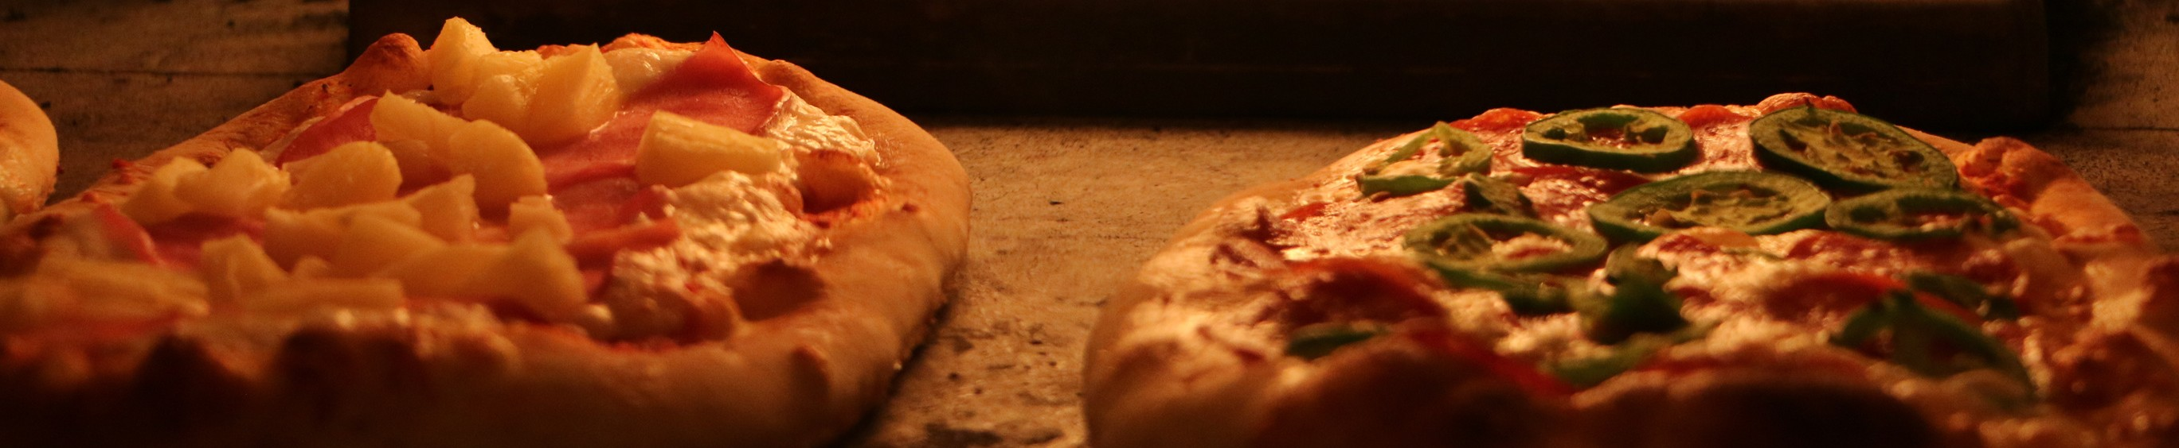

*By Shivam sujan*

BORCELLE

P I Z Z A H U B

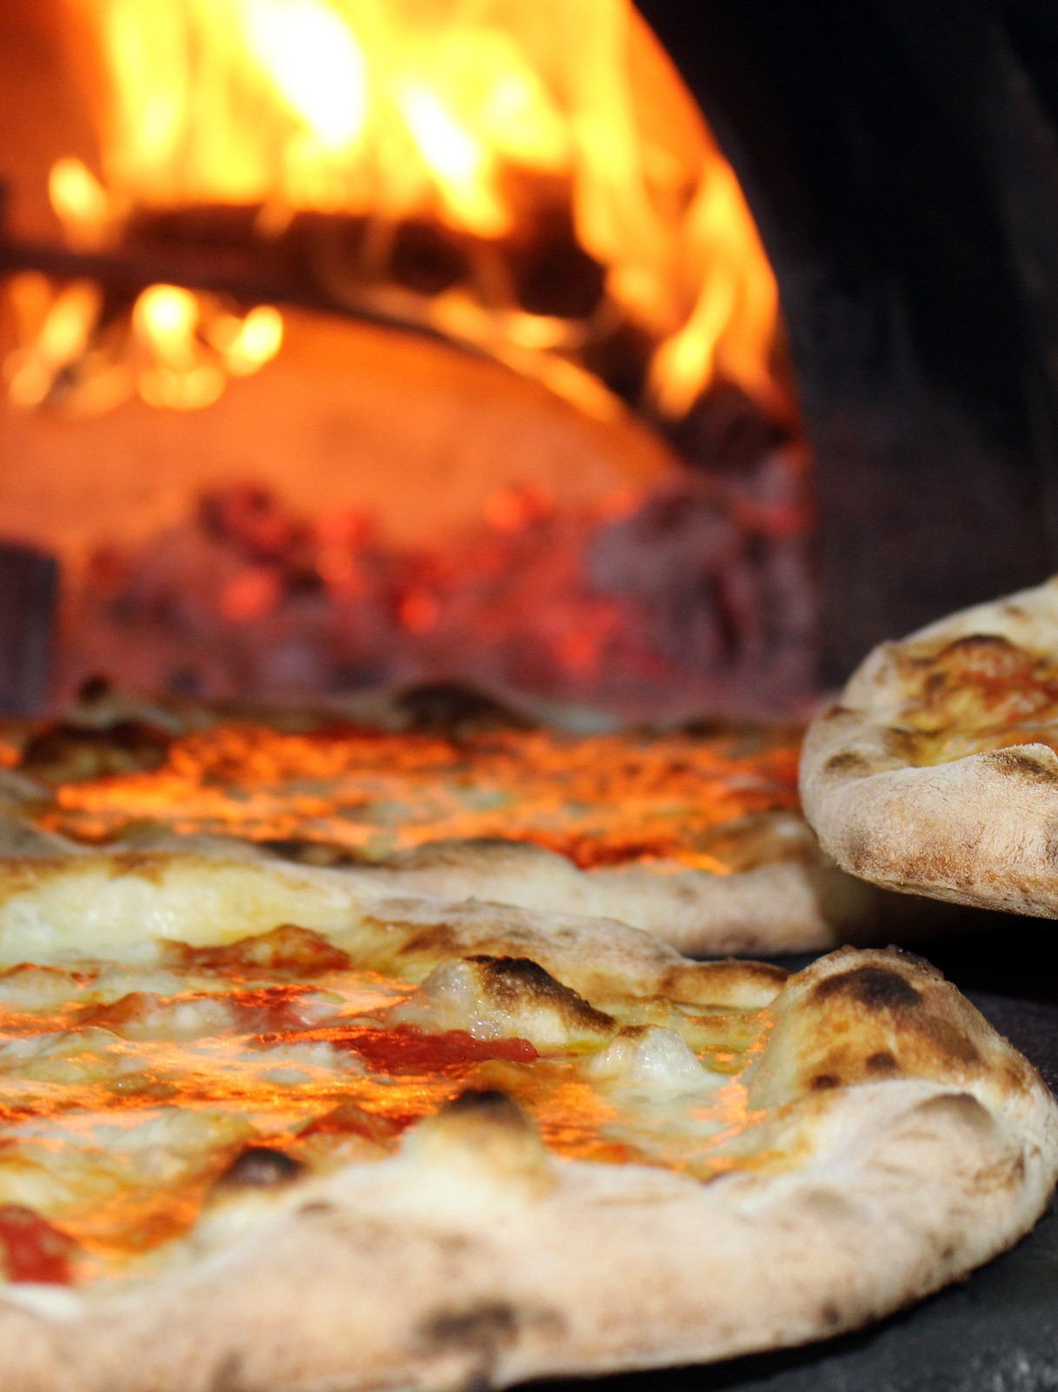

BORCELLE

R E S T A U R A N T

This SQL project analyzes pizza sales data to uncover trends, improve inventory management, and enhance customer satisfaction. Key metrics include sales volume, peak times, and popular toppings.



Retrieve the total number of orders placed.

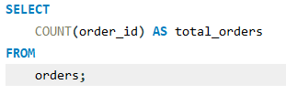



Calculate the total revenue generated from pizza sales.

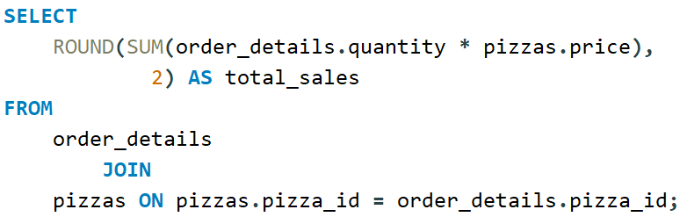



Identify the highest-priced pizza.

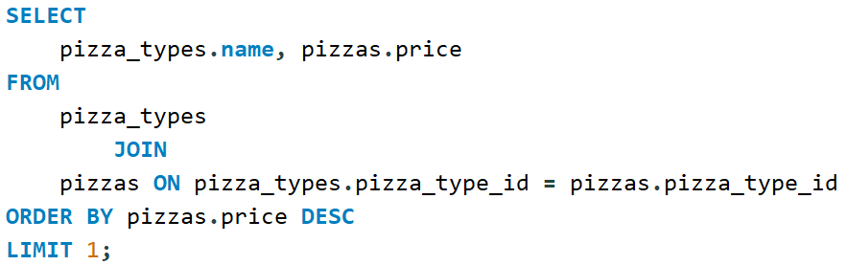



Identify the most common pizza size ordered.

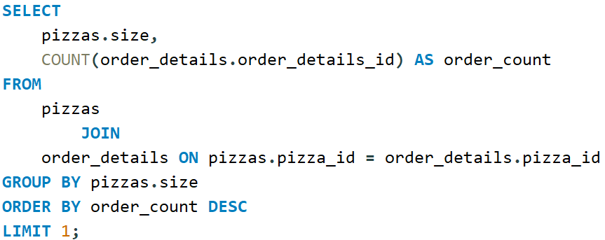



List the top 5 most ordered pizza types along with their quantities.

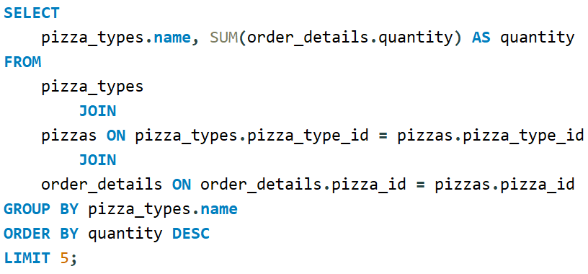

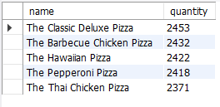

Join the necessary tables to find the total quantity of each pizza category ordered.

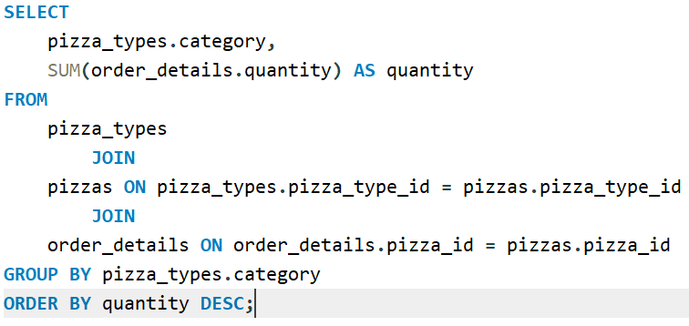

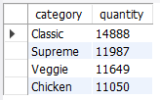

Determine the distribution of orders by hour of the day.

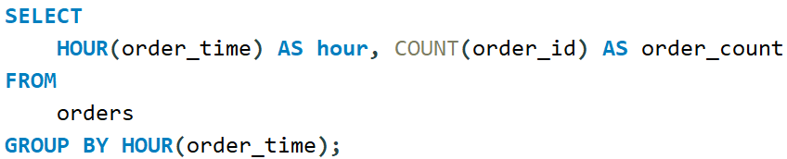

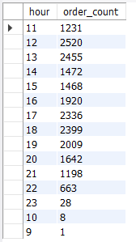

Join relevant tables to find the category-wise distribution of pizzas.

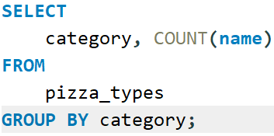

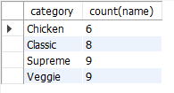

Group the orders by date and calculate the average number of pizzas ordered per day.

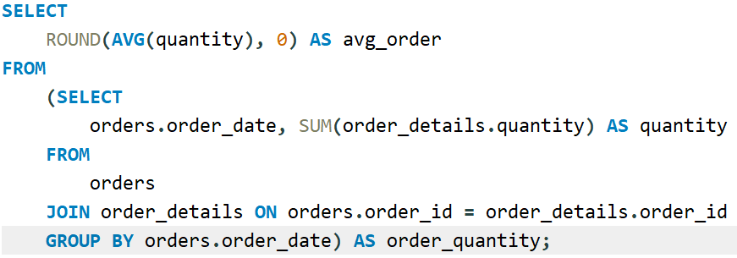



Determine the top 3 most ordered pizza types based on revenue.

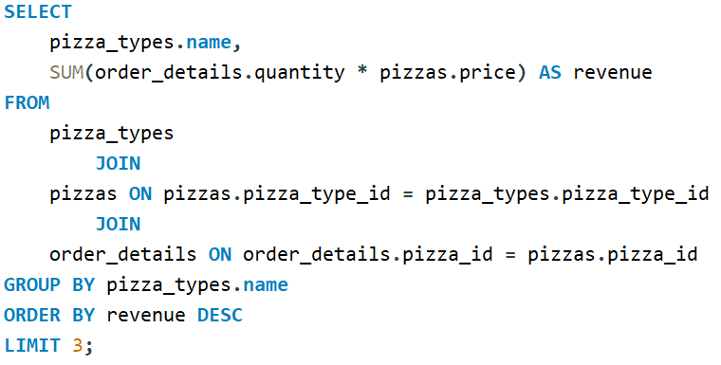

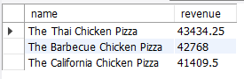

Calculate the percentage contribution of each pizza type to total revenue.

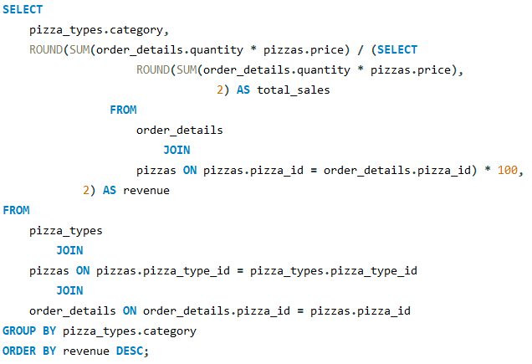

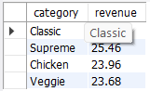

Analyze the cumulative revenue generated over time.

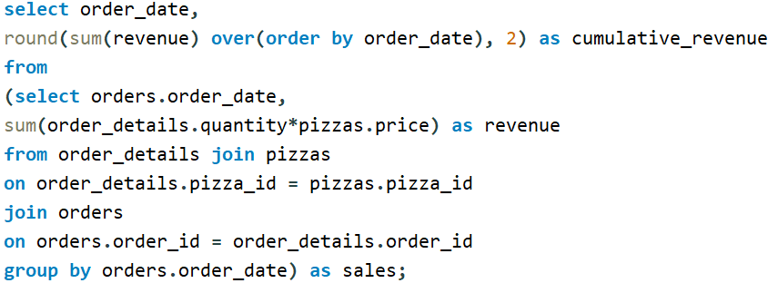

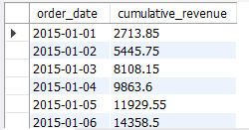

Determine the top 3 most ordered pizza types based on revenue for each pizza category.

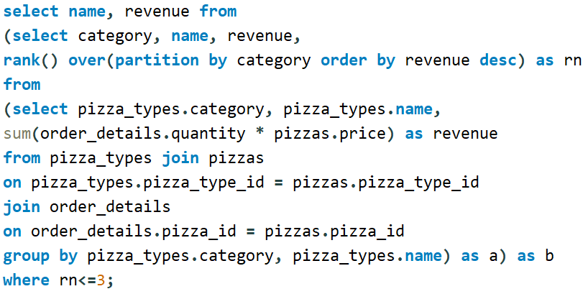

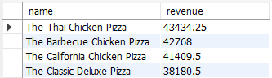

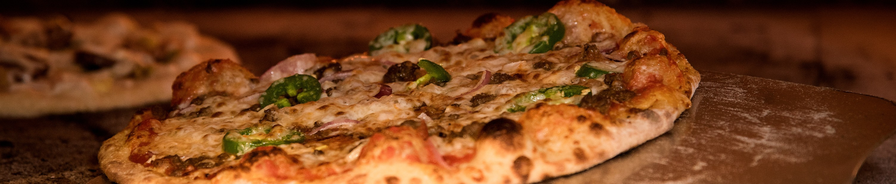

BORCELLE

P I Z Z A H U B

**THANK YOU**