NEOBANK LITE
Requirements Document
Digital banking platform — learning project scope
Version: 0.1 — Draft
Date: 12 August 2026
Author: Mayank
Status: In development

1. Purpose
NeoBank Lite is a learning-focused digital banking platform used to practice building a realistic BFS microservices system: synchronous and asynchronous inter-service communication, database-per-service with Postgres, caching with Redis, and a React frontend behind a single API gateway. This document captures the functional and non-functional requirements for the current scope.

2. Scope
In scope for this phase:
- Customer accounts: creation, lookup, balance retrieval
- Account funding operations: credit and debit with optimistic-lock safety
- KYC status tracking per customer
- Fund transfers between accounts (Transaction Service, sync gRPC call into Account Service)
- Loan applications and EMI calculation (Loan Service)
- Event-driven notifications on transaction, loan, and KYC events (Kafka + Notification Service)
- React frontend for viewing accounts, balances, KYC status, and moving money

Out of scope for this phase:
- Authentication/authorization (no login flow yet — customer ID entered manually)
- Real email/SMS delivery (Notification Service mocks sends)
- Multi-currency support
- Production-grade observability (tracing/metrics are a stretch goal, not required)

3. Architecture Overview
React calls a single API gateway over REST, which routes to four microservices. Transaction Service and Loan Service call Account Service synchronously over gRPC when they need an immediate, consistent answer (e.g. debiting a balance before confirming a transfer). All three producer services publish domain events to Kafka asynchronously; Notification Service is the sole consumer. Each service owns its own Postgres schema; Redis is used for cache-aside reads on account balances and loan interest-rate reference data.
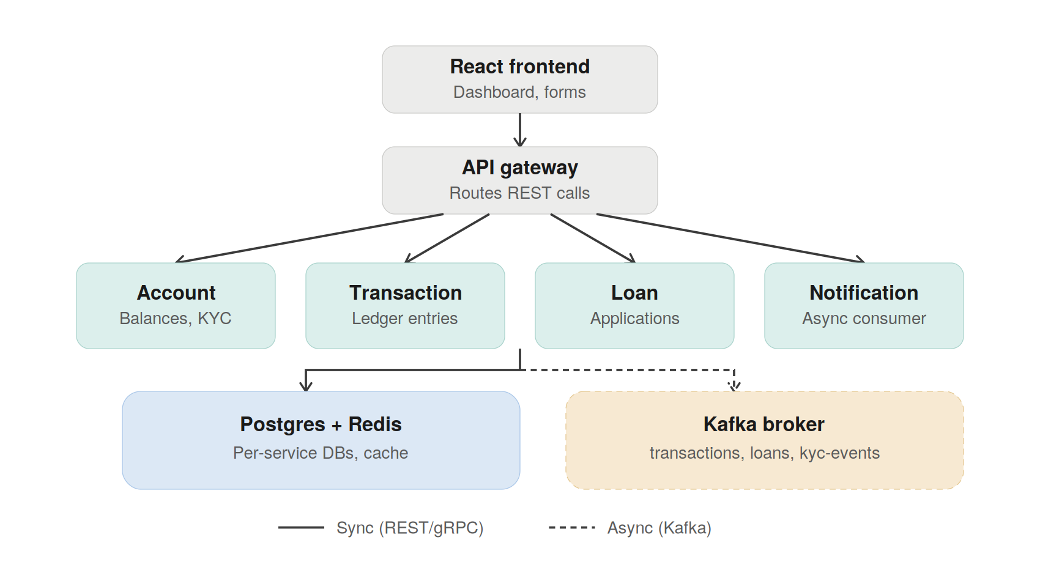
Figure 1 — High-level system architecture

4. Functional Requirements

4.1 Account Service
ID | Requirement | Notes
FR-1.1 | Create a customer record | POST /api/customers
FR-1.2 | Retrieve an account by ID | GET /api/accounts/{accountId}
FR-1.3 | Retrieve all accounts for a customer | GET /api/customers/{customerId}/accounts
FR-1.4 | Retrieve current balance | GET /api/accounts/{accountId}/balance
FR-1.5 | Debit an account | Optimistic lock via version column; rejects on insufficient funds or version conflict
FR-1.6 | Credit an account | Optimistic lock via version column
FR-1.7 | Retrieve KYC status for a customer | GET /api/customers/{customerId}/kyc — absence is a valid "not submitted" state, not an error
FR-1.8 | Expose account standing over gRPC | Consumed by Loan Service before approval decisions

4.2 Transaction Service
ID | Requirement | Notes
FR-2.1 | Record a fund transfer between two accounts | Debits source via gRPC call to Account Service before marking COMPLETED
FR-2.2 | Record a deposit or withdrawal | Single-sided ledger entry
FR-2.3 | Guarantee idempotency on writes | Client-supplied idempotencyKey, unique constraint enforced
FR-2.4 | Publish a TransactionCompleted/Failed event | Written to outbox table in the same DB transaction, published to Kafka by a separate poller

4.3 Loan Service
ID | Requirement | Notes
FR-3.1 | Accept a loan application | Validates account standing via gRPC call to Account Service
FR-3.2 | Calculate EMI from principal, tenure, and rate | Interest rate slabs cached in Redis, ~1hr TTL
FR-3.3 | Approve or reject an application | Publishes LoanApproved/LoanRejected to Kafka
FR-3.4 | Generate an EMI repayment schedule on approval | One row per installment

4.4 Notification Service
ID | Requirement | Notes
FR-4.1 | Consume transaction, loan, and KYC events from Kafka | Three topics, one consumer group
FR-4.2 | Record a notification per event | Deduplicated on (source_event_id, channel) — Kafka delivery is at-least-once
FR-4.3 | Expose recent notifications for a customer | Powers the React toast/bell UI

4.5 Frontend (React)
ID | Requirement | Notes
FR-5.1 | Look up a customer's accounts by customer ID | No auth yet — manual ID entry
FR-5.2 | Display account balance, status, and KYC status | Balance polled fresh on account selection
FR-5.3 | Submit a credit or debit against the selected account | Inline validation and error display; balance updates from the API response, no refetch

5. Non-Functional Requirements
ID | Requirement | Notes
NFR-1 | Debit/credit operations must be safe under concurrent requests | Optimistic locking via a version column; conflicting writes are rejected, not silently lost
NFR-2 | Notification delivery is eventually consistent | Async via Kafka — acceptable latency is seconds, not milliseconds
NFR-3 | Each service owns its own schema | No cross-service joins; services only reach other services' data via their API or gRPC contract
NFR-4 | Balance reads are cached with a short TTL | 30s cache-aside on Redis; write paths always read Postgres directly, never the cache
NFR-5 | All write endpoints return actionable error reasons | e.g. distinguishing insufficient funds from a concurrency conflict, not a generic failure
NFR-6 | Local environment must run fully via Docker Compose | Postgres, Redis, Kafka, all services, and the frontend

6. Open Items
- Authentication/session handling — not yet designed
- Outbox-to-Kafka poller — table exists, publishing worker not yet implemented
- Redis cache-aside on GetBalance — currently bypassed in the Account Service controller, needs to be re-enabled
- Distributed tracing (OpenTelemetry + Jaeger) — stretch goal, not committed

7. Revision History
Version | Date | Change
0.1 | 12 Aug 2026 | Initial draft covering Account, Transaction, Loan, and Notification services plus React frontend

