**BigFirmAdvisors Admin Panel Guide**

In general, to add an entry to a table you must click on the table’s tab at the top, then click the Create button. This will bring you to a form that will allow you to populate the fields of your new entry.

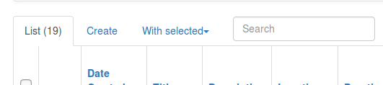

To edit a certain entry, you can click the small pencil icon in the first column of the entry. To delete one entry, you can click the trash icon in the first column of the entry.

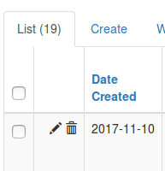

**Note:** Advisors cannot be created or deleted in the manners described above. Because we are using Auth0 to handle user creation and management, we must create and delete Advisors from the Auth0 dashboard or through our Advisor Approval view (which goes through Auth0). This avoids inconsistencies in what Auth0 sees and what is in our database.

**Advisors**

To create an Advisor by approving an Advisor Applicant, you can go to the “Advisor Approval” tab at the top of the admin panel. The drop down will show a list of all applicants who have Applied or been Declined (allowing you to change your mind on an applicant if you so desire).

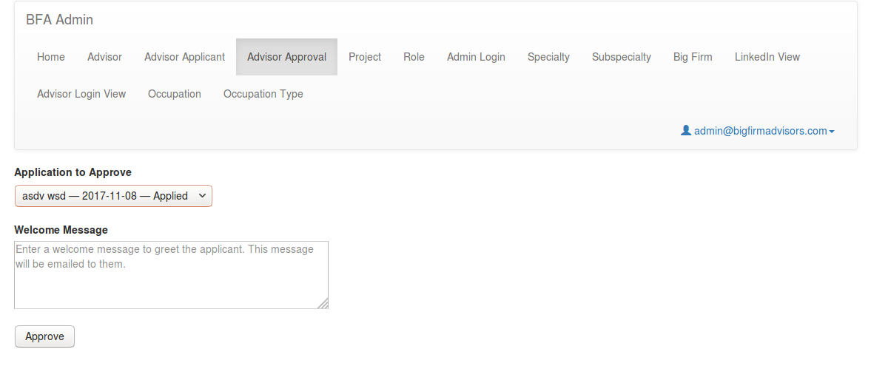

Simply select one of the entries in the list and then enter a welcome message for that person. The welcome message will be emailed as-is to the Advisor, so ensure you draft it as a regular email. Once both of these things are done, press the Approve button. An Advisor account will be created, and the system will send them two emails: one to provide them with their default password, and another to greet them with your welcome message.

To delete an Advisor, you must navigate to the Auth0 management dashboard at manage.auth0.com, navigate to the “Users” page, and delete the Advisor from there.

**Advisor Applicants**

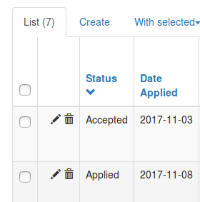

To decline an Advisor Applicant, you can go to the “Advisor Applicant” tab and search for the applicant you want to decline. Once you have located the appropriate entry in the table, click on the small pencil icon in the first column. This will bring you to a page that allows you to edit the fields of the Applicant. From here, simply find the “Status” field and change it to “Declined.” Press the “Save” button at the bottom of the page to finalize your changes.

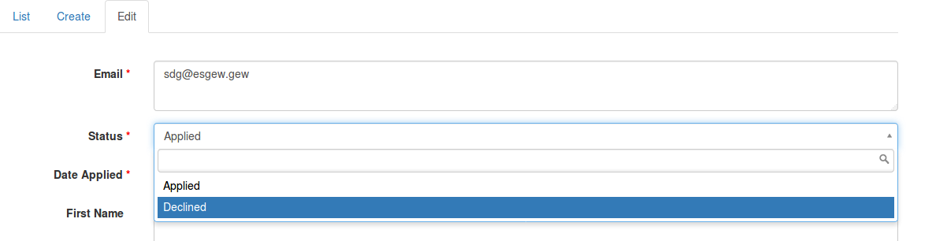

**Referential Fields**

Sometimes, a table will have a field that references another field. For example, a Project will have a Specialty field. To set this field in your edit/create forms, you can click on the drop-down and the page will automatically show you all of the specialties that are found in the database in the Specialty table. You can simply select any of these and set the field in that manner.

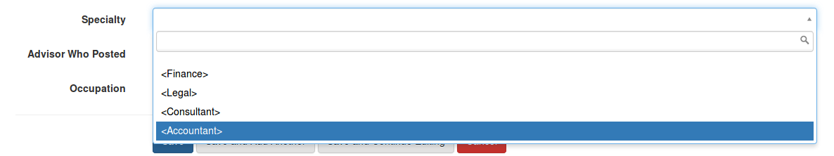

If the value you want does not appear in the drop down, that means the database has no entry for the value you want! In this example, let’s say you wanted to set the Specialty of the Project to “Software.” Given that there is no “Software” entry in the Specialty table, it does not appear in the drop-down. To solve this, you must go into the Specialty tab in the Admin Panel, and create an entry for “Software” in that Specialty table. You can then go back to the Project you were editing, and the entry will appear in the drop-down!

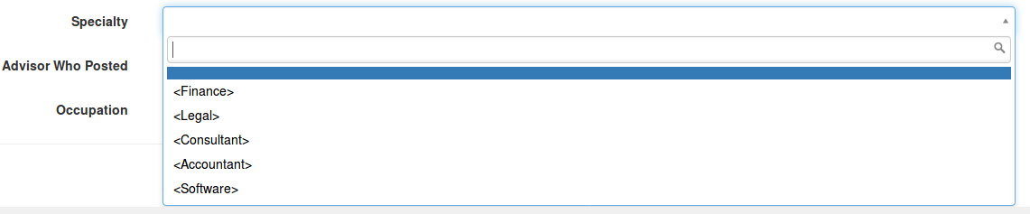

You can then select that value and save the Project.

**Permissions and Roles**

For security reasons, the tables in the database are guarded by permissions. Each Admin must have the relevant permission to perform a certain action on a table.

There are four permissions: can_read, can_edit, can_create, and can_delete.

Can_read allows an Admin to view a table and its rows.

Can_edit allows an Admin to update/modify rows that exist in a table.

Can_create allows an Admin to create new rows in a table.

Can_delete allows an Admin to delete rows in a table.

These permissions are bundled into ‘roles.’ Each role has the four permission fields and the name of the table for which those permission settings apply.

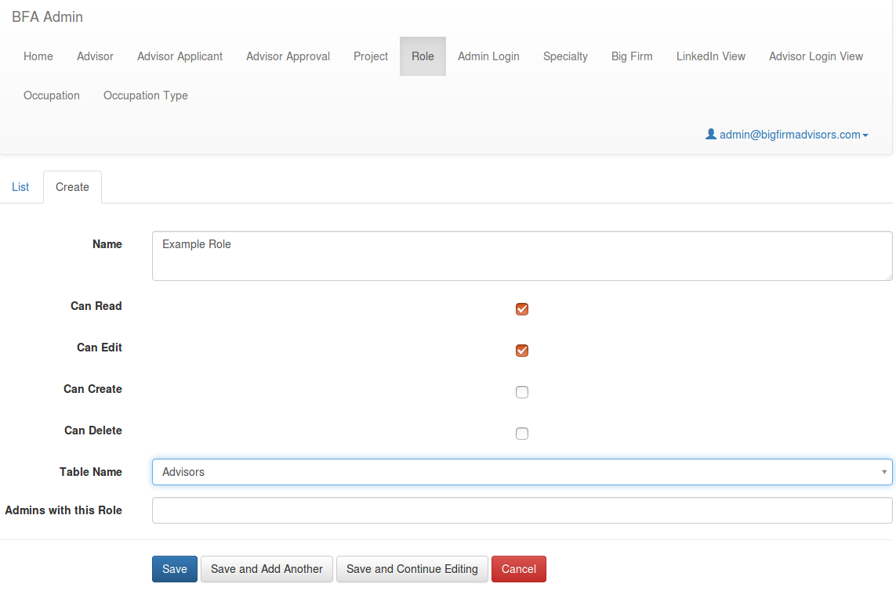For example, let’s say we want to make a role that is only allowed to read and edit rows in the ‘Advisors’ table. We would create a role in the Roles table where the table name is ‘Advisors’, Can Read = True, Can Edit = True, Can Create = False, Can Delete = False. We can leave ‘Admins with this Role’ blank for now, we’ll review that in a moment. Click ‘Save’ to create the role.

Now that we have created this role, we must give it to at least one Admin. There are two ways to do this.

1. (Best approach for quickly assigning multiple roles to a single admin.) You can go to the ‘Admin Login’ tab at the top to see the Admins table. Find the row corresponding to the Admin whose permissions you want to change, and click on the pencil icon in the leftmost column to edit their information. From here, you can simply click on the ‘Roles’ field and select the name of the Role you want to give them.

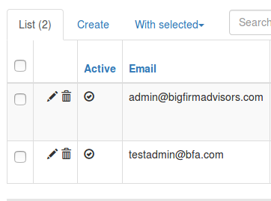

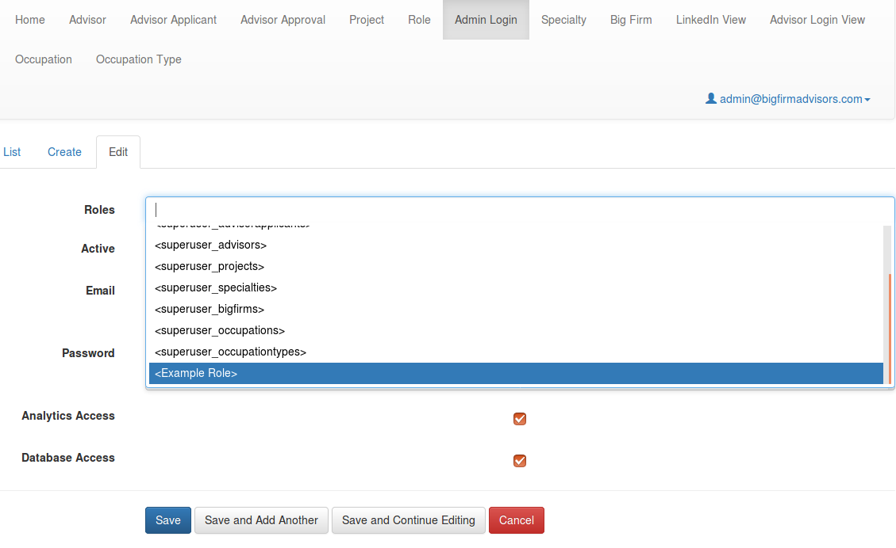

You can add as many roles from the list as you want, then click ‘Save.’

1. (Best option for assigning a single role to multiple admins quickly.) You can also assign roles to admins by going to the ‘Role’ tab at the top of the admin panel, clicking the pencil icon for the relevant role you want to modify, and selecting all of the admins you want to give this role to.

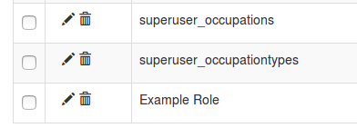

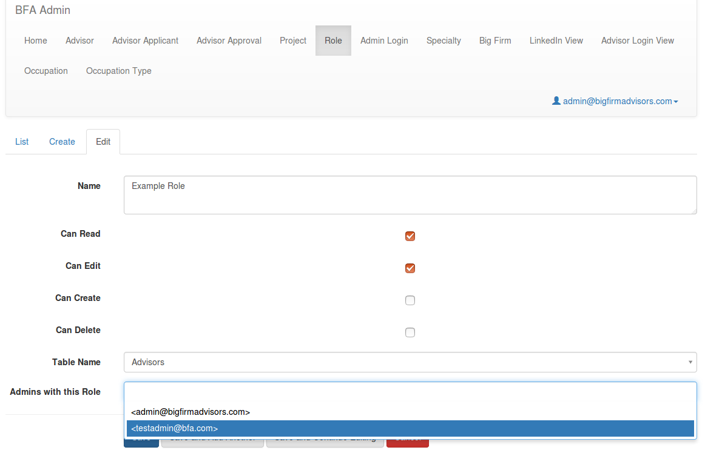

You can add as many admins from the list as you want, then click ‘Save.’

**Important Information about Roles and Admins:**

* By default, there is already an Admin account in the database called ‘admin@bigfirmadvisors.com.’ There are also “superuser” roles for each of the tables in the database—these roles allow full permissions on their respective tables. The ‘admin@bigfirmadvisors.com’ admin has been assigned all of these superuser roles, giving full permission on all tables in the database.
* Reusing roles is encouraged—avoid creating a new role if there is already a role that has those settings. For example, let’s say you want to give an admin full permissions on the Specialties table. Instead of creating a new role, you can just assign the existing ‘superuser_specialties’ role to that admin (because it gives full permissions on the Specialties table).
* Ideally, each Admin should have exactly one role for each of the tables in the database (one for Projects, one for Specialties, etc). This establishes strict and specific permissions for that Admin on every table.
* If an Admin has not been given a role for a certain table, they will have no access to that table by default.
* Avoid giving an Admin multiple roles for the same table. This can lead to more confusion than necessary. If you do give an Admin multiple roles for the same table, they will be allowed to perform an action if any of their roles allow the action.

For example, let’s say an admin has been given two roles on the Projects table:

Role_Projects1 = (table_name = ‘Projects’, can_read = True, can_edit = True, can_delete = False, can_create = False)

Role_Projects2 = (table_name = ‘Projects’, can_read = True, can_edit = False, can_delete = True, can_create = False)

Both roles allow reading, so the admin will be able to read the Projects table. Role_Projects2 does not allow editing, but Role_Projects1 does allow it, so the admin will be able to edit the Projects table. Similarly, Role_Projects1 does not allow deletion, but Role_Projects2 does allow it, so the admin will be able to delete entries in the Projects table. Both roles don’t allow creation, so the admin will not be able to create new entries in the Projects table.