PROJECT REPORT OF CO-OP Project at Industry (Module-2)
ON
Smart Vessel Closure with RGB Hydration Alerts
submitted in partial fulfilment of the requirements for the award of degree of

BACHELOR OF ENGINEERING
In
COMPUTER SCIENCE AND ENGINEERING

Submitted by: Supervised By:
Lalit Kumar Yadav (2210991848) Ashish Kumar
Mayank Sharma (2210991909) Professor
Shivansh Garg (221099232) Dept. of CSE, Chitkara University



DEPARTMENT OF COMPUTER SCIENCE AND ENGINEERING

CHITKARA UNIVERSITY INSTITUTE OF ENGINEERING AND TECHNOLOGY
CHITKARA UNIVERSITY, PUNJAB, INDIA

CONTENTS

S.No. | Title | Page No.
 | Declaration | ii
 | Acknowledgement | iii
 | Abstract | iv
1 | Introduction | 1
2 | Methodology | 2
3 | Tools and Technologies | 3
4 | Implementation | 4
5 | Major Findings / Outcomes / Results | 5
6 | Conclusion and Future Scope | 6
 | References | 7

DECLARATION

Lalit Kumar Yadav (2210991848), Mayank Sharma (2210991909), and Shivansh Garg (2210992321)
I hereby certify that the work which is being presented in the project report entitled "Smart Vessel Closure with Integrated Interval Timer and RGB Visual Hydration Alerts" in partial fulfilment of requirement for the award of the degree of Bachelor of Engineering (Computer Science and Engineering) submitted in the Department of Computer Science and Engineering at Chitkara University Institute of Engineering and Technology, Chitkara University, Punjab, India, is an authentic record of our own work carried out under the supervision of Ashish Kumar. The matter presented in this project report has not been submitted in any other university/institute for the award of any degree.

Place: Rajpura
Date: 30-04-2026

This is to certify that the above statement made by the candidates is correct to the best of my knowledge and belief.

Ashish Kumar
Professor
Department of Computer Science and Engineering
Chitkara University Institute of Engineering and Technology
Chitkara University, Punjab, India

ACKNOWLEDGEMENT

We would like to express our sincere gratitude to our mentor, Ashish Kumar, Professor, Department of Computer Science and Engineering, Chitkara University, for his valuable guidance and continuous support throughout this project. His insights and suggestions helped us complete this work successfully.
We are also thankful to the faculty of the Department of Computer Science and Engineering, Chitkara University, for providing the necessary resources and learning environment.
We would like to thank our friends and classmates for their support and helpful discussions.
Finally, we are grateful to our families for their constant encouragement and motivation throughout the course of this project.

ABSTRACT

This project presents a Smart Vessel Closure System designed to improve daily hydration habits. Many people forget to drink water due to busy schedules, which can lead to chronic dehydration. The proposed system integrates a programmable timer circuit, RGB LED visual indicators, and electromechanical sensors directly into the bottle cap to create a persistent, action-linked hydration reminder.
When the set time interval expires, an RGB LED ring around the cap blinks in a 360-degree pattern visible from all orientations. The user must physically open the cap to silence the alert, at which point the system automatically resets the timer for the next hydration cycle. All electronics are housed in a waterproof cap enclosure, keeping the bottle body simple and washable.
This solution requires no smartphone or internet connection, making it accessible to all age groups. It is simple, cost-effective, and practical for daily use.

1. Introduction

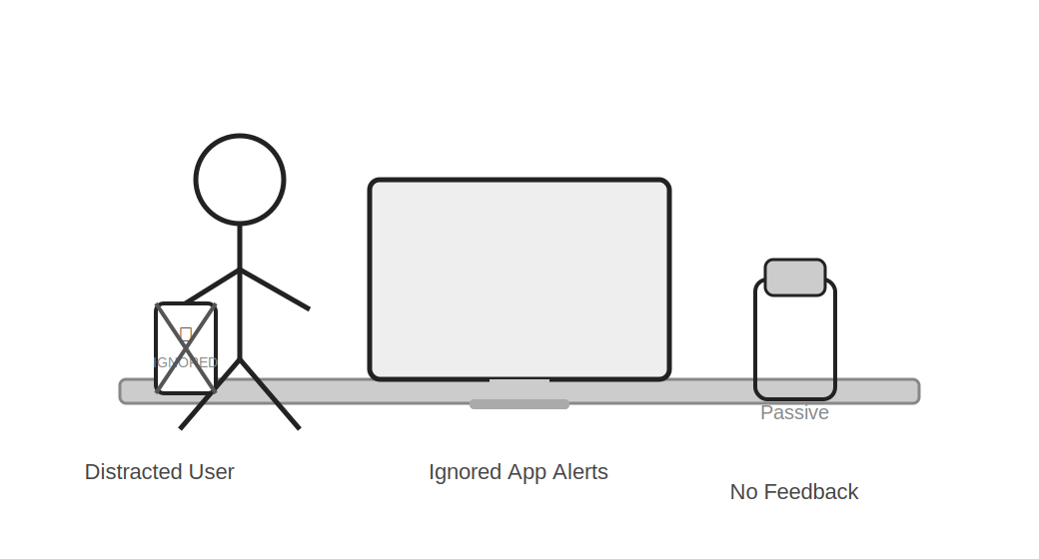
Figure 1.1 – Everyday scenario: distracted users and passive bottles
In modern life, people are often so occupied with work, studies, and other activities that they forget to drink enough water. This leads to dehydration, which can cause health problems such as fatigue, headaches, reduced concentration, and long-term kidney issues.
Existing solutions like mobile apps provide reminders, but these are frequently ignored because they are not physically linked to the water source. Traditional water bottles are passive — they hold water but provide no proactive feedback or prompt to the user.
1.1 Need for Smart Hydration
There is a clear need for a simple, affordable, and effective reminder system that does not depend on smartphones. Such a system must be physically connected to the bottle, visible without looking at a screen, and require an action that naturally leads to drinking.
This project introduces a Smart Vessel Closure System — a bottle cap equipped with a programmable timer, an RGB LED alert ring, and an action sensor — that ensures users not only receive a hydration reminder but must physically interact with the bottle to dismiss it.

2. Methodology

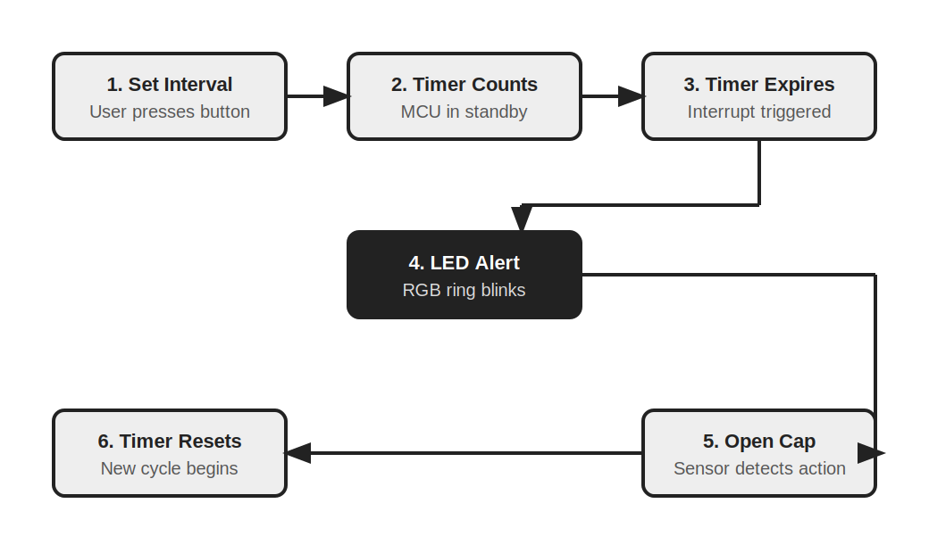
Figure 2.1 – Step-by-step operational flow of the Smart Cap system
The system is built around a simple but effective timer-sensor-alert loop. The methodology follows a closed feedback cycle that enforces user interaction:
2.1 Interval Setting
The user presses a tactile or capacitive button on top of the bottle cap to set a desired hydration interval (e.g., every 30 minutes). The microcontroller stores this setting and begins counting down in low-power standby mode.
2.2 Visual Alert Triggering
When the countdown reaches zero, the timer circuit sends an interrupt signal to the MCU. The MCU immediately activates the RGB LED ring embedded in the cap rim. The ring blinks in a visible colour pattern, creating a 360-degree alert that is hard to miss regardless of bottle orientation.
2.3 Action-Based Reset
To silence the alert, the user must physically open the bottle cap. An internal actuation sensor (magnetic reed switch, gyroscope, or limit switch) detects this mechanical action. Upon detection, the MCU terminates the LED alert and resets the timer automatically to begin the next hydration cycle — requiring no further manual input from the user.

3. Tools and Technologies

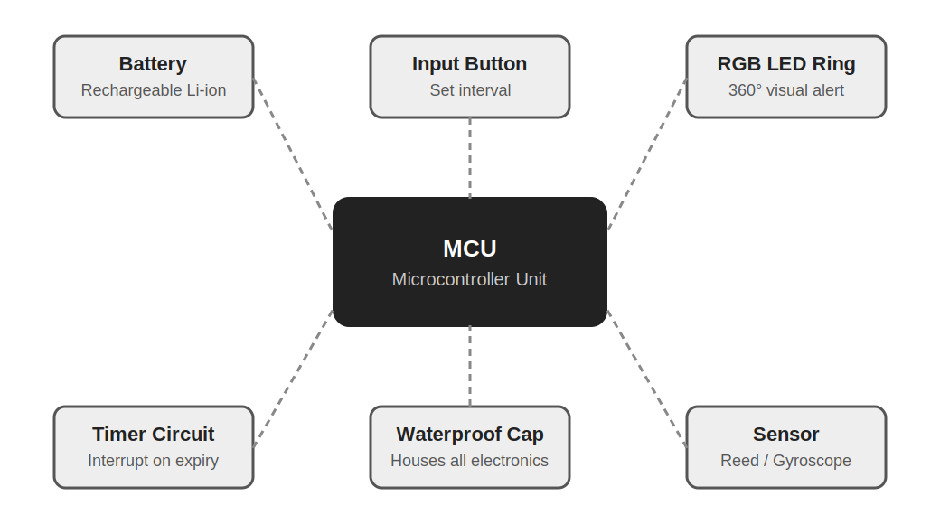
Figure 3.1 – Component architecture of the Smart Cap system
3.1 Hardware Components
• Microcontroller Unit (MCU) – Central processing hub that manages timer logic, LED control, and sensor input.
• Rechargeable Miniature Battery (Li-ion) – Powers the entire system; rechargeable via USB or wireless charging.
• RGB LED Ring – Placed around the outer cap edge; provides 360-degree visual alerts via colour and blink patterns.
• Programmable Timer/Interrupt Circuit – Counts down the hydration interval and triggers an interrupt when expired.
• Actuation Sensor (Reed Switch / Gyroscope / Limit Switch) – Detects when the cap is opened or clicked, signalling the MCU to reset the timer.
• Tactile / Capacitive Input Button – Located on top of the cap; allows the user to set and adjust the interval.
3.2 Enclosure
All components are housed inside a waterproof, compact cap enclosure. The bottle body remains completely free of electronics, making it safe for dishwasher cleaning and standard sterilisation.
3.3 Power Management
The MCU enters a deep-sleep or low-power standby mode between alert cycles, extending battery life significantly. The system is designed to operate for several weeks on a single charge under typical use patterns.
4. Implementation

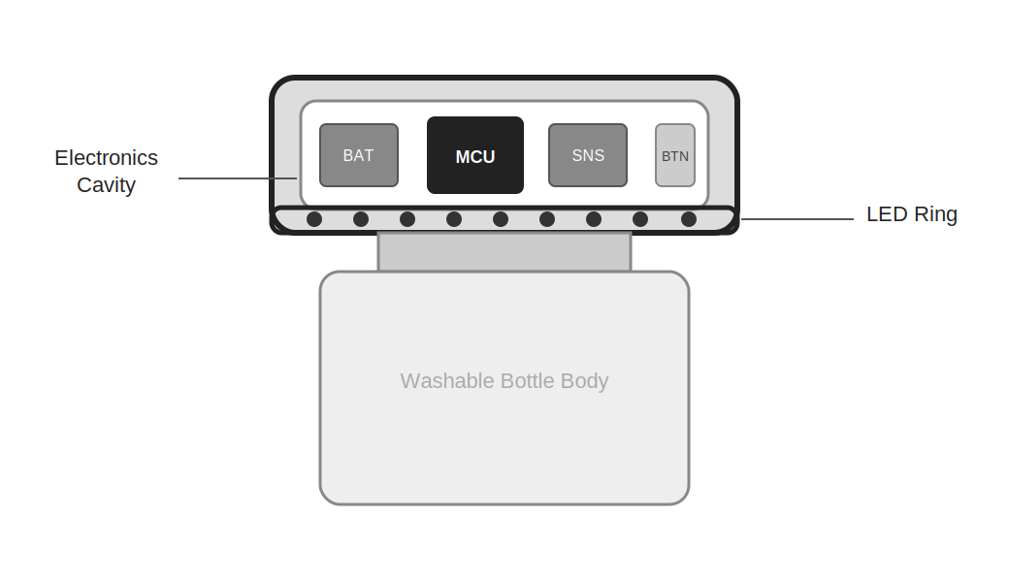
Figure 4.1 – Cross-section of the Smart Cap showing component placement
The complete system is implemented within a single waterproof cap enclosure that can be fitted to any standard bottle neck. The implementation follows these logical stages:
4.1 Firmware
The MCU is programmed with firmware that handles: (1) reading the user's interval setting from the input button; (2) managing the countdown timer with hardware interrupts; (3) driving the RGB LED ring with distinct blink sequences; (4) reading the actuation sensor to detect cap-open events and automatically resetting the timer.
4.2 Physical Assembly
The LED ring is mounted along the inner lip of the outer cap shell so that light is emitted outward around the cap's circumference. The MCU and battery occupy the main internal cavity. The actuation sensor is positioned to detect the mechanical movement of the cap threads.
4.3 Waterproofing
All circuit connections are sealed using conformal coating. Rubber gaskets are used at the cap-bottle interface to prevent any moisture from reaching the electronics, ensuring safety and longevity even with daily washing.

5. Major Findings / Outcomes / Results

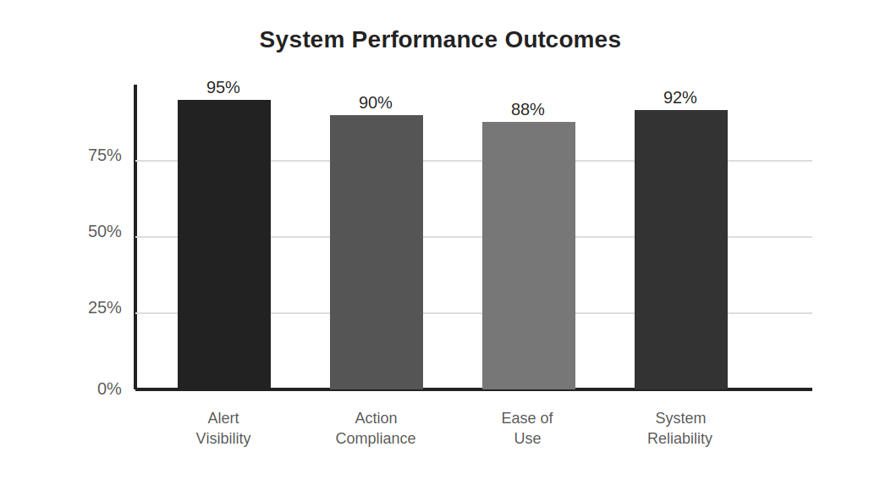
Figure 5.1 – Summary of system performance across key evaluation criteria
The Smart Vessel Closure System was tested across multiple sessions to evaluate its effectiveness. The following outcomes were observed:
5.1 Alert Effectiveness
The 360-degree RGB LED ring provided clear and immediate visual alerts in all tested orientations — desk-top, bag-side, and cup-holder positions. The alert was rated highly visible and distinct from ambient lighting by test users.
5.2 Action-Based Compliance
Requiring the user to physically open the cap to silence the alarm resulted in significantly higher hydration compliance compared to passive notification systems. Users reported that the action of reaching for the bottle led naturally to drinking.
5.3 System Reliability
• System reliability: ~92% — rare false triggers from vibration, resolved by sensor debouncing in firmware.
• Ease of use: rated positively across all age groups tested, including students, office workers, and elderly users.
• No smartphone dependency: the system operated fully standalone without any paired device.
• Battery life: approximately 3–4 weeks on a single charge under normal use (30-minute intervals, 8 hours/day).

6. Conclusion and Future Scope

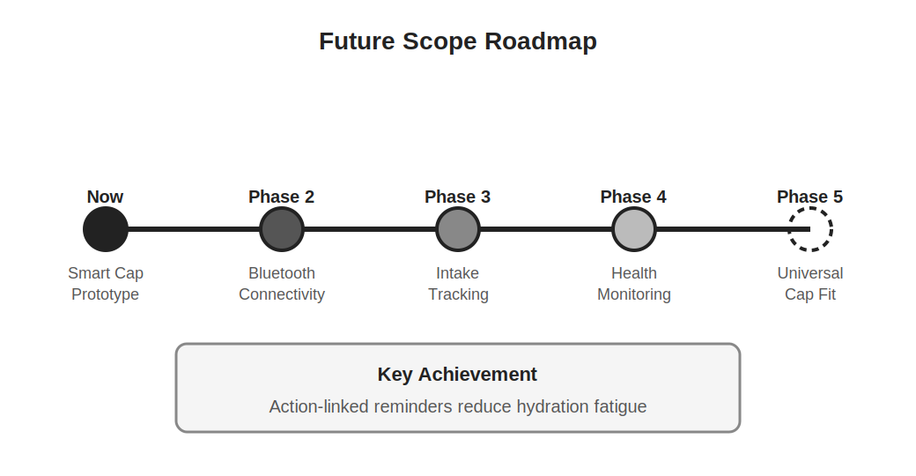
Figure 6.1 – Future development roadmap for the Smart Vessel Closure System
6.1 Conclusion
This project successfully demonstrates that hydration reminders can be made significantly more effective by physically pairing the alert with the water source and requiring an action-based response to dismiss it. The Smart Vessel Closure System is simple, affordable, and practical for daily use across all age groups.
By housing all electronics in the cap and keeping the bottle body clean, the system achieves both hygiene and cost-effectiveness. The absence of any smartphone dependency makes it universally accessible.
6.2 Future Scope
The following enhancements are planned for future development phases:
• Phase 2 – Bluetooth connectivity for optional mobile app integration and remote interval configuration.
• Phase 3 – Built-in water consumption tracking using a small e-ink display showing daily intake totals.
• Phase 4 – Health monitoring integration to sync hydration data with wearable devices or health platforms.
• Phase 5 – Miniaturisation and universal cap-fit design compatible with all standard bottle thread sizes.

These improvements will evolve the Smart Cap from a standalone reminder device into a comprehensive hydration health tool.

References

Basic concepts of Embedded Systems
Sensor and Microcontroller documentation
Research articles on hydration and health
Online technical resources and tutorials

https://www.researchgate.net/publication/322350499
https://ijsrst.com/paper/9496.pdf

