Loan Payment Data Analysis
College Data Analytics Project Report

Dataset: Loan payments data.csv | Records: 500 | Features: 11
Tools: Python · Pandas · NumPy · Matplotlib · Seaborn · SciPy

1. Executive Summary
This report presents a comprehensive data analytics study of a loan payments dataset comprising 500 loan records. The analysis covers data cleaning, exploratory data analysis, statistical hypothesis testing, and actionable business insights. Key findings include a 60% full repayment rate, higher repayment discipline among female borrowers, and a mean overdue period of 36 days for delinquent loans.

2. Dataset Overview
The dataset contains 11 columns: Loan_ID, loan_status, Principal, terms, effective_date, due_date, paid_off_time, past_due_days, age, education, and Gender. There are three loan statuses: PAIDOFF (300), COLLECTION (100), and COLLECTION_PAIDOFF (100). No duplicate records were found.

2.1 Missing Value Analysis
Column | Missing Count | Missing %
paid_off_time | 100 | 20.0%
past_due_days | 300 | 60.0%
days_to_payoff | 100 | 20.0%

3. Exploratory Data Analysis
Key distributional characteristics of the dataset:
Variable | Statistic | Value
Principal | Mean | $943.20
Principal | Std Dev | $115.24
Age | Mean | 31.1 years
Age | Min / Max | 18 / 51
Terms | Most common | 30 days (54.4%)
Loan Status | PAIDOFF | 300 (60.0%)
Loan Status | COLLECTION | 100 (20.0%)
Loan Status | COLLECTION_PAIDOFF | 100 (20.0%)
Gender | Male | 423 (84.6%)
Gender | Female | 77 (15.4%)

4. Statistical Analysis
Welch's T-test — Principal: PAIDOFF vs COLLECTION
t-statistic = -1.6809, p-value = 0.0940
Interpretation: No statistically significant difference in Principal amount between PAIDOFF and COLLECTION groups at the 5% significance level.
Chi-square Test — Gender vs Loan Status
chi2 = 3.5717, p-value = 0.1677, dof = 2
Interpretation: Gender is NOT significantly associated with loan status.

5. Visualisations & Findings

5.1 Loan Status Distribution
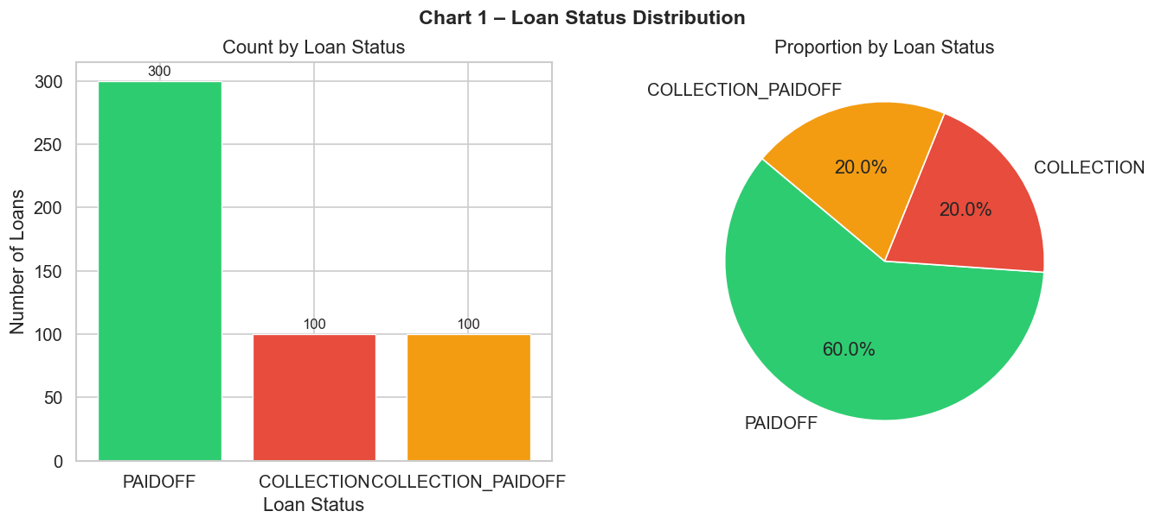
Figure 1 – Loan Status Distribution: Bar chart and pie chart showing the count and proportion of each loan status.

5.2 Principal Analysis
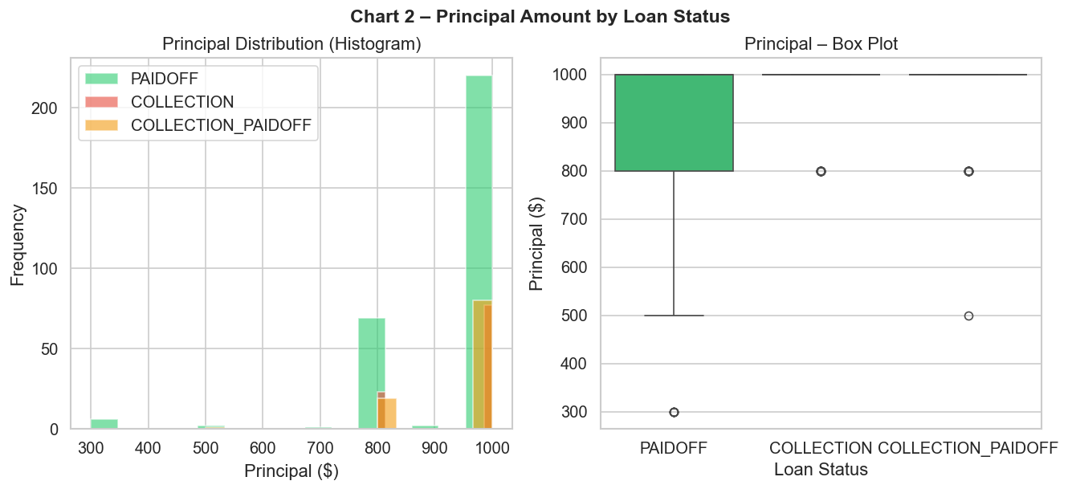
Figure 2 – Principal Amount by Loan Status: Histogram and box plot of principal for each status.

5.3 Gender Analysis
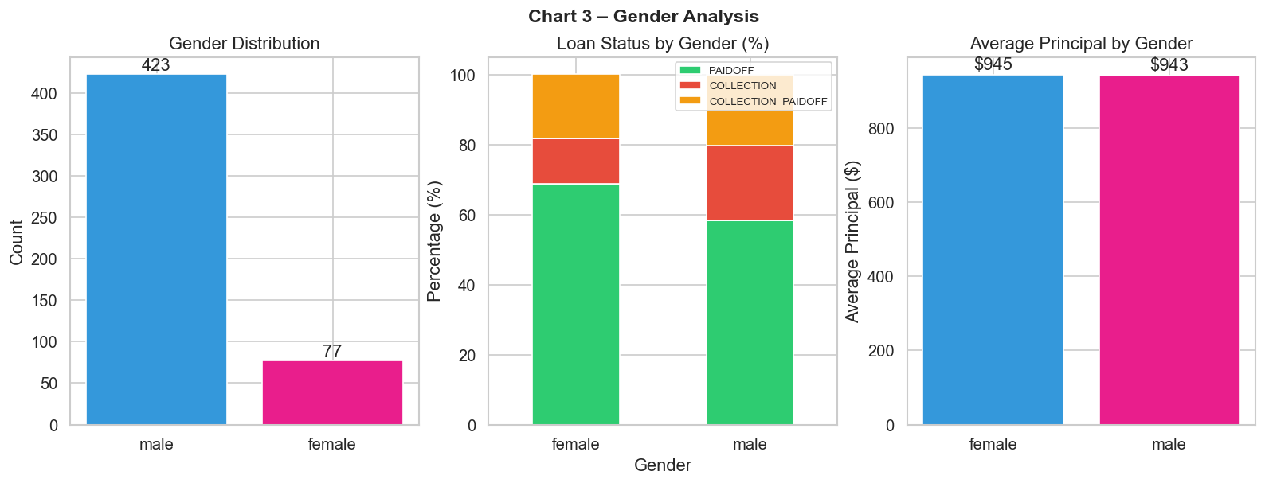
Figure 3 – Gender Analysis: Distribution, loan status breakdown, and average principal by gender.

5.4 Education Analysis
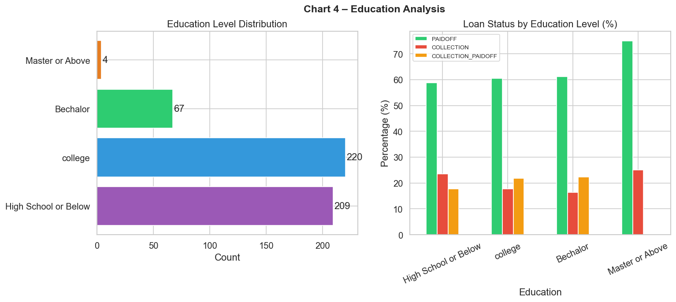
Figure 4 – Education Analysis: Distribution of education levels and loan status breakdown.

5.5 Age Analysis
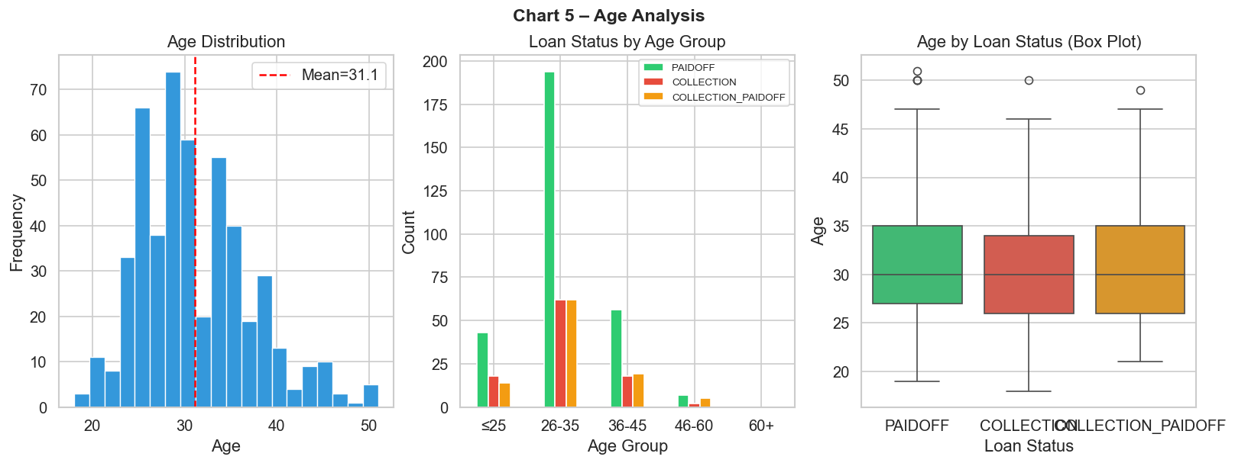
Figure 5 – Age Analysis: Age distribution, loan status by age group, and box plot.

5.6 Loan Term Analysis
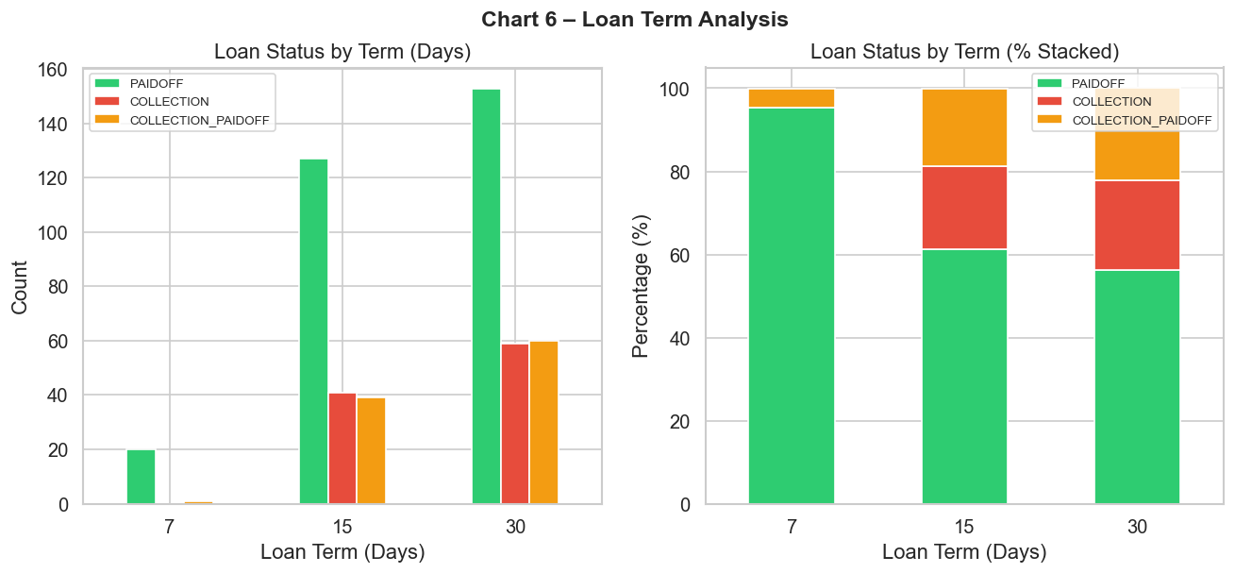
Figure 6 – Loan Term Analysis: Count and stacked percentage of loan status per term.

5.7 Correlation Analysis
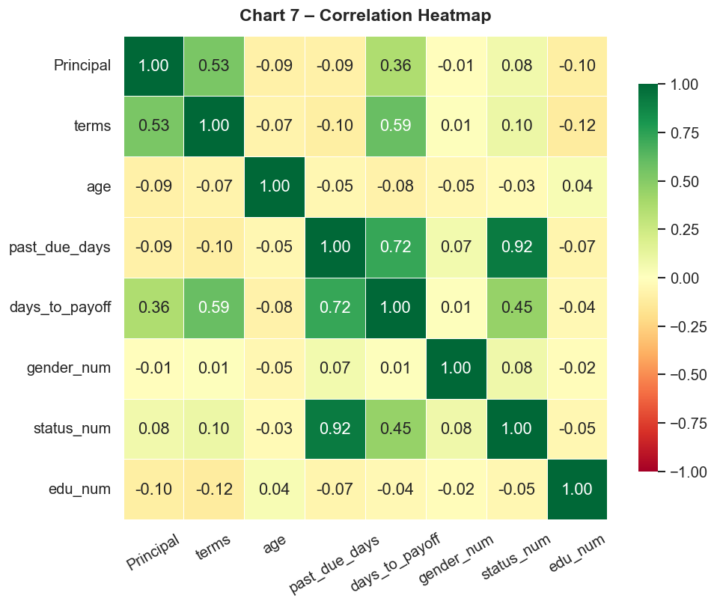
Figure 7 – Correlation Heatmap: Pearson correlations between encoded numeric variables.

5.8 Days to Payoff
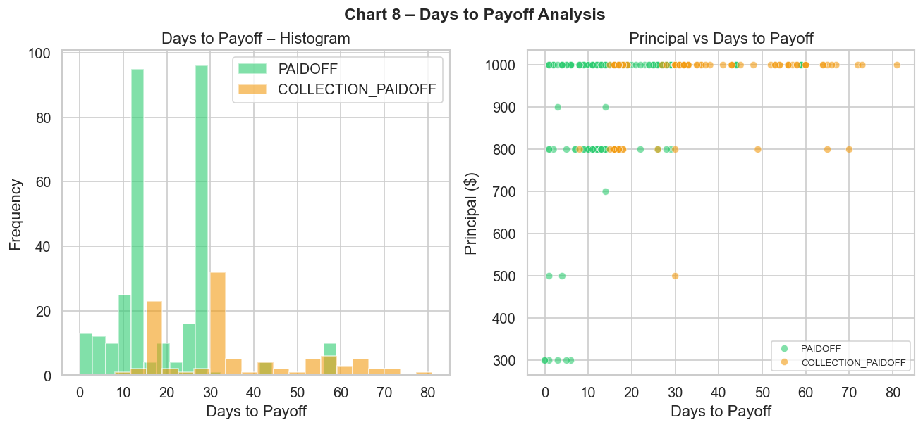
Figure 8 – Days to Payoff: Distribution and scatter plot of days to payoff vs principal.

5.9 Past Due Days
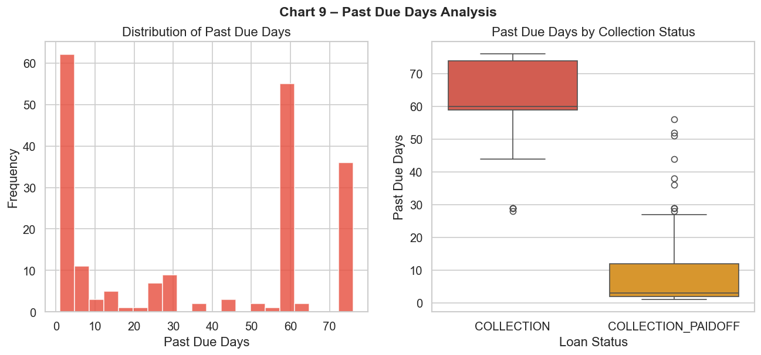
Figure 9 – Past Due Days: Distribution and box plot of overdue days for collection loans.

5.10 Principal by Education & Gender
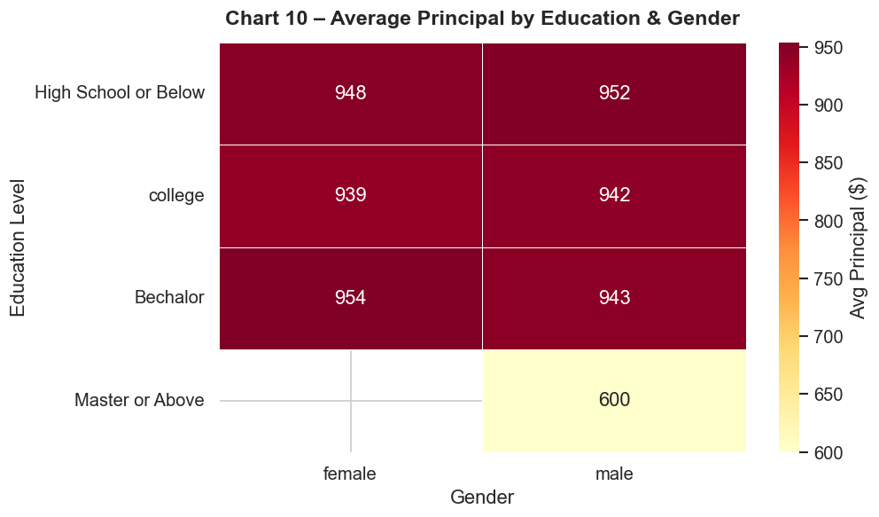
Figure 10 – Avg Principal by Education & Gender: Heatmap of average principal amounts.

6. Business Insights
# | Category | Insight
1 | Overall Repayment | 60% of loans are fully PAIDOFF — indicating a relatively healthy loan portfolio.
2 | Gender Repayment | Female borrowers show a higher PAIDOFF rate (68.8%) compared to males (58.4%), representing lower credit risk.
3 | Age Segment | The 26–35 age group is the largest borrower segment and shows reasonable repayment rates.
4 | Popular Product | $1,000 / 30-day loans constitute the dominant product. 75.4% of all loans are for $1,000.
5 | Overdue Severity | The average overdue period for delinquent loans is 36 days; the maximum is 76 days, representing significant collection risk.
6 | Education Risk | Master or Above (25%) and High School or Below (23.4%) show the highest collection rates.
7 | Statistical Tests | Neither principal amount nor gender significantly predicts loan status (p > 0.05 in both tests).
8 | Short-term Loans | 7-day term loans have the lowest volume (4.2%) but may represent an untapped niche.

7. Recommendations
- Implement an automated early-intervention reminder system triggered at Day 1–3 past due, as most COLLECTION_PAIDOFF loans were recovered within 1–7 days.
- Apply stricter initial credit limits for first-time High-School-level borrowers given their elevated 23.4% collection rate.
- Consider preferential or loyalty rates for female borrowers aged 26–35, who demonstrate the highest repayment discipline.
- Investigate borrowers with 50+ past-due days individually — they represent outlier credit risk requiring case-by-case management.
- Expand the 7-day micro-loan product to capture demand for very short-term credit.
- Conduct follow-up data collection on loan purpose to improve default risk modelling.

8. Conclusion
This analysis of 500 loan records demonstrates a well-functioning short-term lending portfolio with a 60% full repayment rate. Statistical tests confirm that principal amount and gender are not significant predictors of default in isolation, suggesting that multi-variable credit scoring models may yield better predictive accuracy. The findings provide a data-driven foundation for portfolio risk management, targeted marketing, and product development decisions.

