Flutter app Report

Submitted by: Mayank Patidar

Roll no. BT20ECE064

Course: IT workshop (FLutter)

Submitted to : Shishupal sir and Gaurav Malode sir

**Flutter Food delivery app**

**(E-commerce app)**

Features:-

1. Home page (shows popuplar product and recommended products)
2. Sign in and Sign up (sign up with mobile)
3. Shopping cart (a real shopping cart with add and remove items on the fly)
4. Local cart history page (using a local storage)
5. Popular food page (view popular food, add or remove items from the cart)
6. Recommended food page (view recommended food, add or remove from the cart)
7. Order more function(newly added feature, it helps you order)
8. Go to sign in page (sign in page authentication before you place order)

Future possibilities:-

1. Server cart history page (sync with database)
2. Profile page (personal information)
3. Address page (address with authentication before you place order)
4. Google map page (for picking up location and save address)
5. Backend (backend to show user info and order detail)
6. Creating new items (backend you can create new items of food)
7. Paypal payment (Paypal payment sync with database)

We can use [Laravel](https://www.laravel.com/" \t "_blank) for building the backend of this app. We can use the same framework for building Restful Api for the app. Laravel is the most popular web application framework both for backend and api building. Backend shows users' orders, total orders, users' info, payment info etc.

Database and Server:-

Firebase is used for login and signup purpose. Authentication feature of firebase is used. It is working as server and database.

State management:-

This e-commerce app is based on flutter [Getx Package](https://pub.dev/packages/get" \t "_blank). We used Getx package to manage the state and routing of the app. We have also used Getx for api client.

Getx is a great package for managing your app states, routes and http client. It does more than that. If you are trying to build a complex mobile or web app using flutter, Getx would be your best choice. And it's also beginners friendly reactive state management app package.

We used Getx for products display, maintaining the state of the shopping cart, profile page, google map and many other features of this e-commerce app or shopping app.

Home page

Home page displays food category. You can click on it and go to new page to view food and add to the cart.

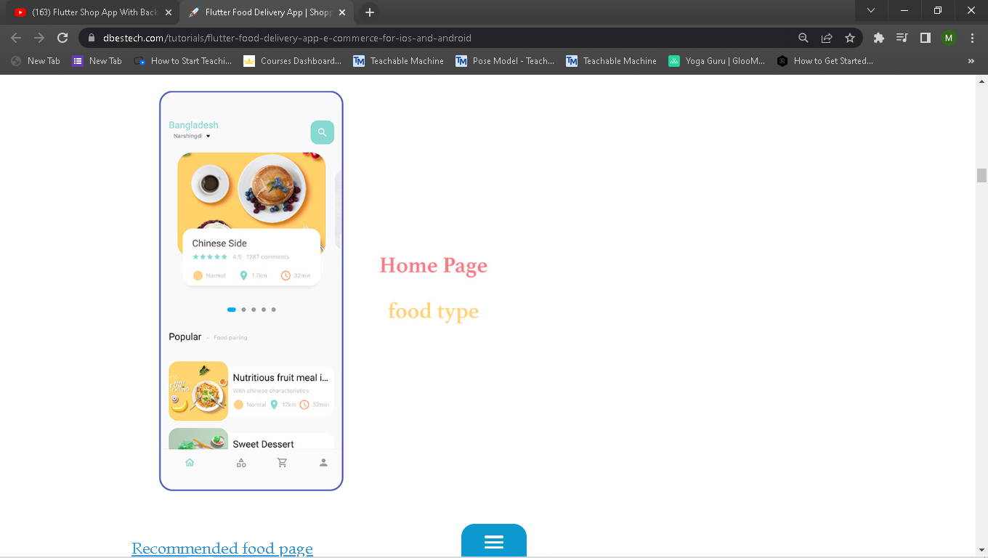

Recommended food page

This page comes from the home page and you can add the item to the cart. The introuduce text about food is collapsible. It also show the product price. And you can add items to the cart.

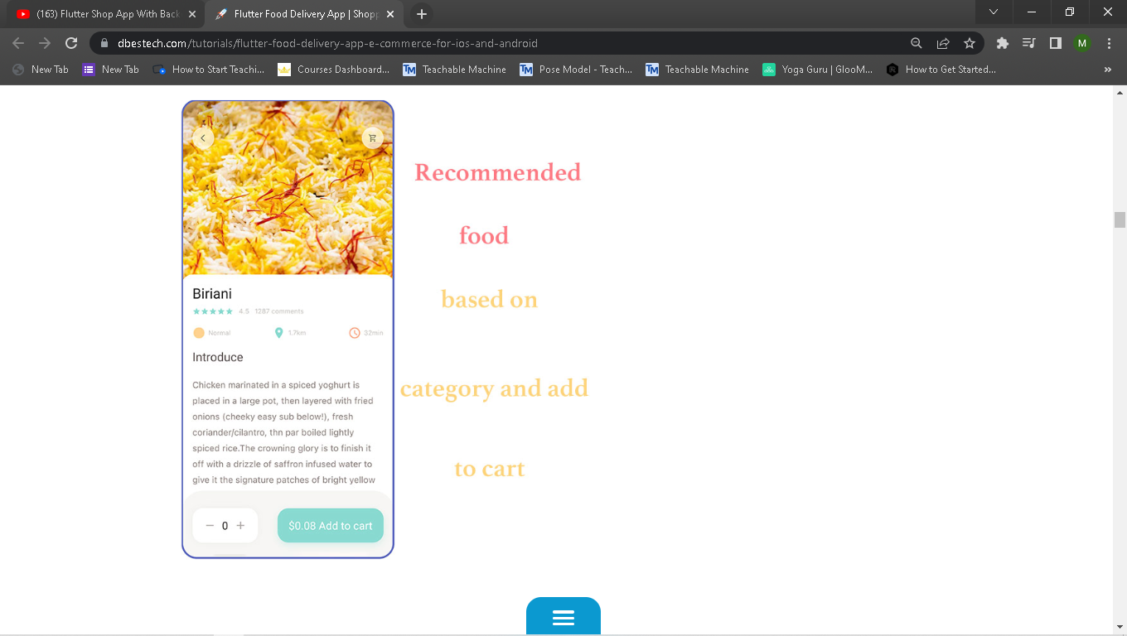

Popular food page

This page comes from the home page and you can add the item to the cart. The text about food is collapsible. It also show the product price. And you can add items to your shopping cart.

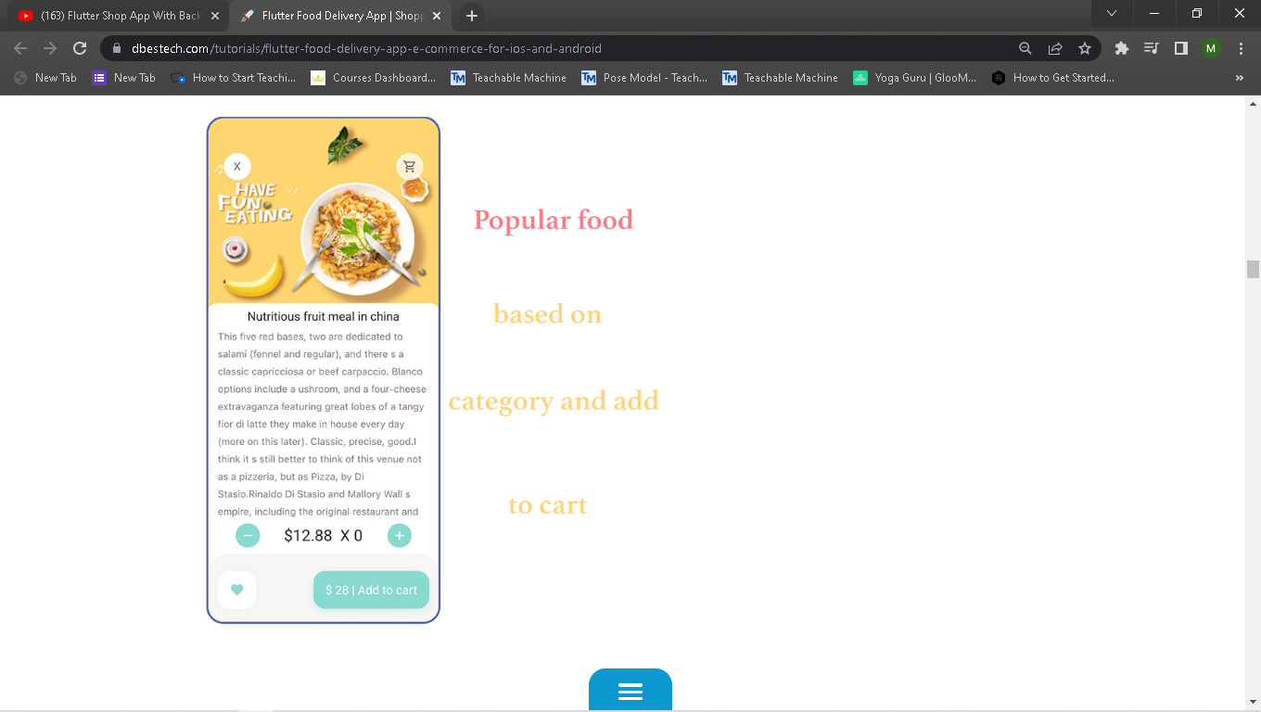

Cart page

In this page you place the order. You can also add or remove the items from the cart. As you add or remove you also see the total price changes. This page is dynamic since it removes and add items on user click.

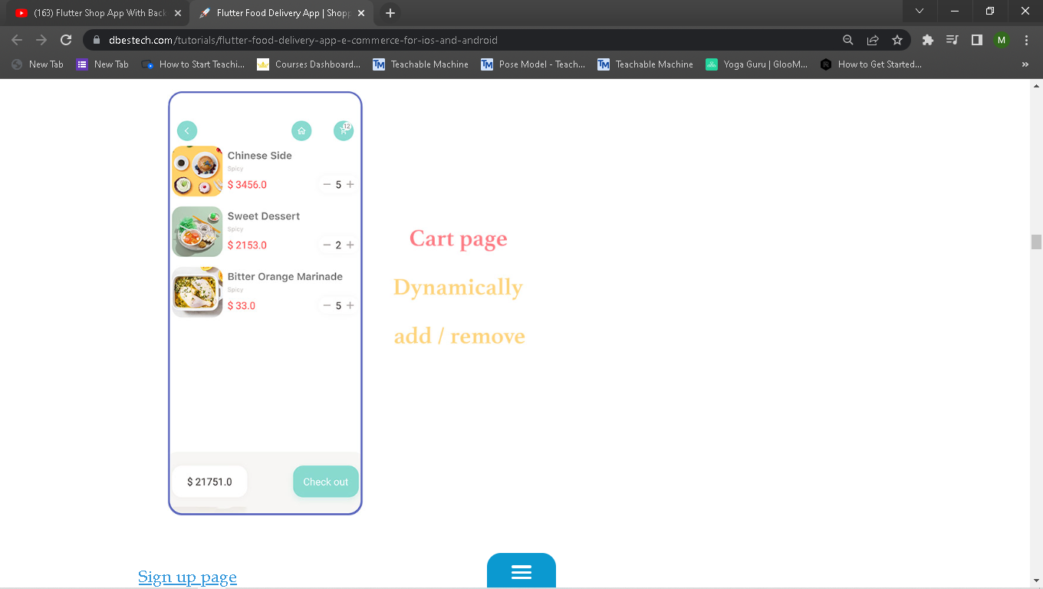

Sign up page

Sign up using your credential. Once you sign up, the information is submitted to the database.

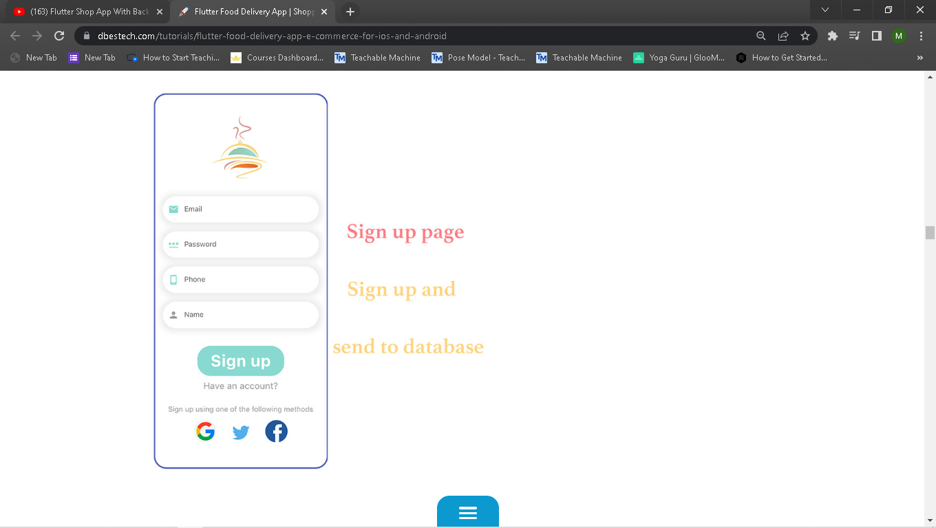

Sign in page

Sign in based on your email. Firebase authentication feature is used.

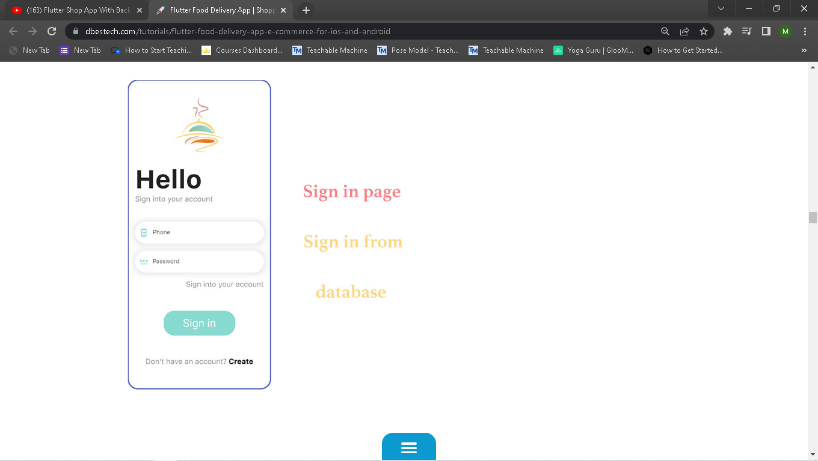

Local history page

Local history page. It saves in the device itself. You can reorder the item you ordered.

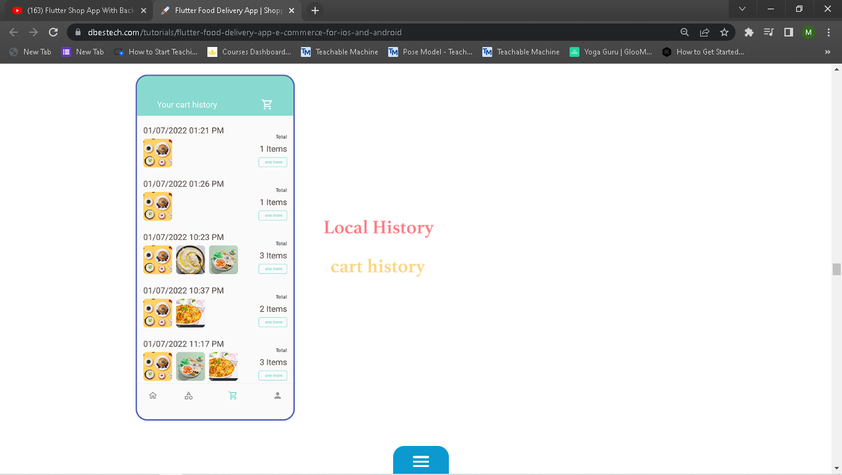

And few more….like About Us page

and Feedback Page

!!! Thank You !!!