1. What does RGBA stand for?

Ans1

RGBA stands for Red, Green, Blue, and Alpha. It is a color model that is used to represent colors in digital images, particularly on computer screens.

2.From the Pillow module, how do you get the RGBA value of any images?

Ans2

from PIL import Image

image = Image.open("C:/Users/lenovo/Desktop/asg/ram.png ")

pixel_rgba = image.getpixel((100, 200))

print(pixel_rgba)

3. What is a box tuple, and how does it work?

Ans3

Python Imaging Library (PIL) and its fork Pillow, a "box tuple" is a tuple that defines a rectangular region within an image. The tuple contains four integer values, representing the left, upper, right, and lower boundaries of the rectangular region in that order. The left and upper values represent the x and y coordinates of the top-left corner of the rectangle, while the right and lower values represent the x and y coordinates of the bottom-right corner of the rectangle.

4. Use your image and load in notebook then, How can you find out the width and height of an Image object?

Ans4

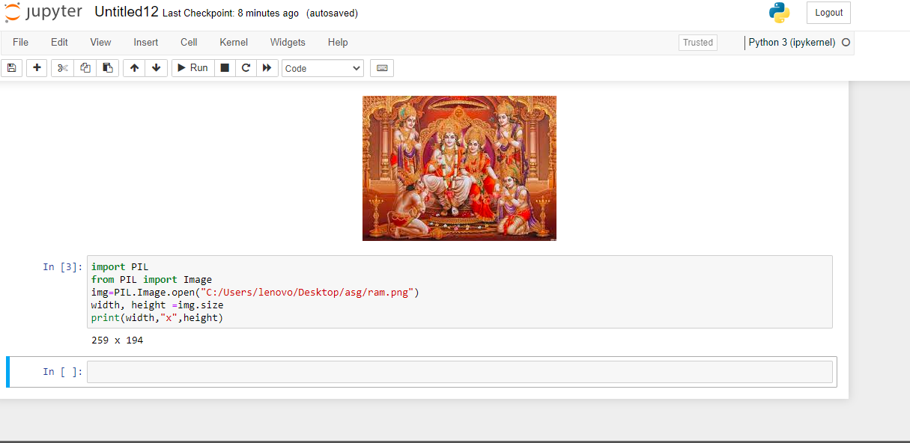

5. What method would you call to get Image object for a 100×100 image, excluding the lower-left quarter of it?

Ans5

crop() method of the original Image

from PIL import Image

original_image = Image.open("C:/Users/lenovo/Desktop/asg/ram.png ")

box = (0, 50, 50, 100)

cropped_image = original_image.crop(box)

return cropped_image

6. After making changes to an Image object, how could you save it as an image file?

Ans6

using the save() method.

from PIL import Image

image = Image.open("C:/Users/lenovo/Desktop/asg/ ram.png ")

image = image.resize((200, 200))

image = image.convert("L")

image.save("C:/Users/lenovo/Desktop/asg/ ram.png", "JPEG")

7. What module contains Pillow’s shape-drawing code?

Ans7

Pillow's shape-drawing code is contained in the ImageDraw module

8. Image objects do not have drawing methods. What kind of object does? How do you get this kind of object?

Ans8

from PIL import Image, ImageDraw

image = Image.open("C:/Users/lenovo/Desktop/asg/ram.png ")

draw = ImageDraw.Draw(image)

draw.rectangle((100, 100, 200, 200), outline="red")

image.save("C:/Users/lenovo/Desktop/asg/ ram.jpg ")