ConstructionSite 10k: Data Analysis
Mayank Sali, M.Tech, Nirma University | October 2026

1. The dataset
- 10,013 photos of real construction sites: 7,009 for training, 3,004 for testing.
- 4 safety rules: PPE, harness at height, edge protection, excavator blind spot.
- For each rule, every photo is marked violated or not, with a short reason and a box around the problem.
- Each photo also has a caption and tags for lighting, camera distance and view.

2. Data quality
Check | Result
Duplicate photos | 0
Same photo in both train and test | 0
Empty captions | 0
Missing camera distance tag | 1
Violation with reason but no box (or the reverse) | 3
Broken boxes (zero size) | 4

What it shows: the data is clean. Only 8 small issues in 10,013 photos, so no cleaning is needed.

3. Violations per rule
Rule | Train | Test | % of all photos
PPE | 677 | 324 | 10.0%
Harness at height | 59 | 25 | 0.8%
Edge protection | 109 | 63 | 1.7%
Excavator blind spot | 46 | 24 | 0.7%
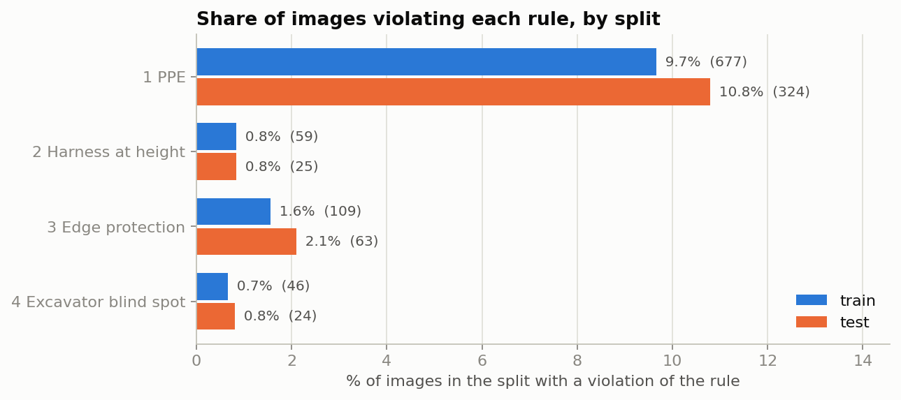
Figure 1. Share of photos violating each rule (train and test)
- Violations are rare. Three of the four rules appear in less than 2% of photos.
- PPE is about 75% of all violations.
- Train and test have similar rates, and our counts match the paper (except one PPE test photo: 324 vs 323).

4. Violations per photo
Rules broken in a photo | Train | Test
0 (safe) | 6,143 | 2,592
1 | 841 | 390
2 | 25 | 20
3 | 0 | 2

What it shows: 87% of photos are safe. When a photo has a violation, it is almost always just one rule. The most common pair is PPE with blind spot (21 photos).

5. Photo conditions
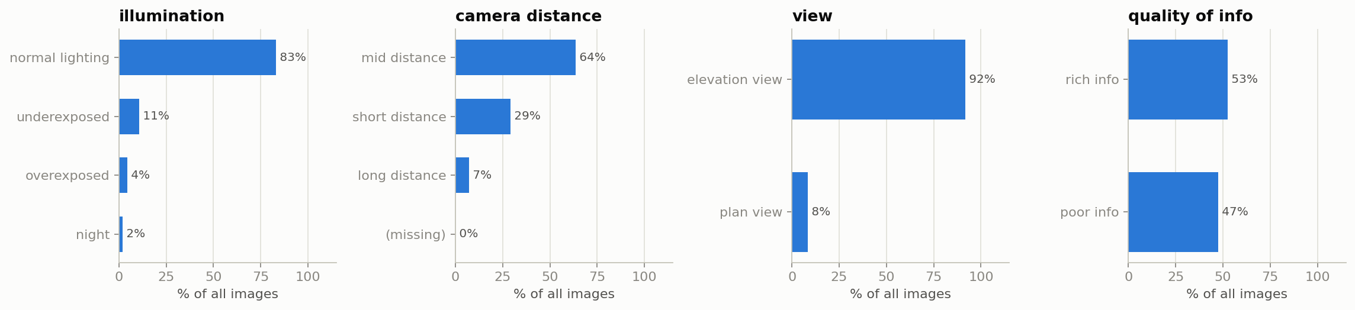
Figure 2. Share of photos by lighting, camera distance, view and amount of detail
Condition | % of all photos | % with a violation
Normal lighting | 83.0% | 11.6%
Night | 2.0% | 56.9%
Plan view (from above) | 8.3% | 4.8%
Long distance | 7.2% | 8.2%

What it shows: most photos are daytime, ground-level, mid-distance shots. Night photos are few (202), but more than half show a violation. Photos from far away or from above have fewer violations marked, likely because workers look too small.

6. Size of the problem area
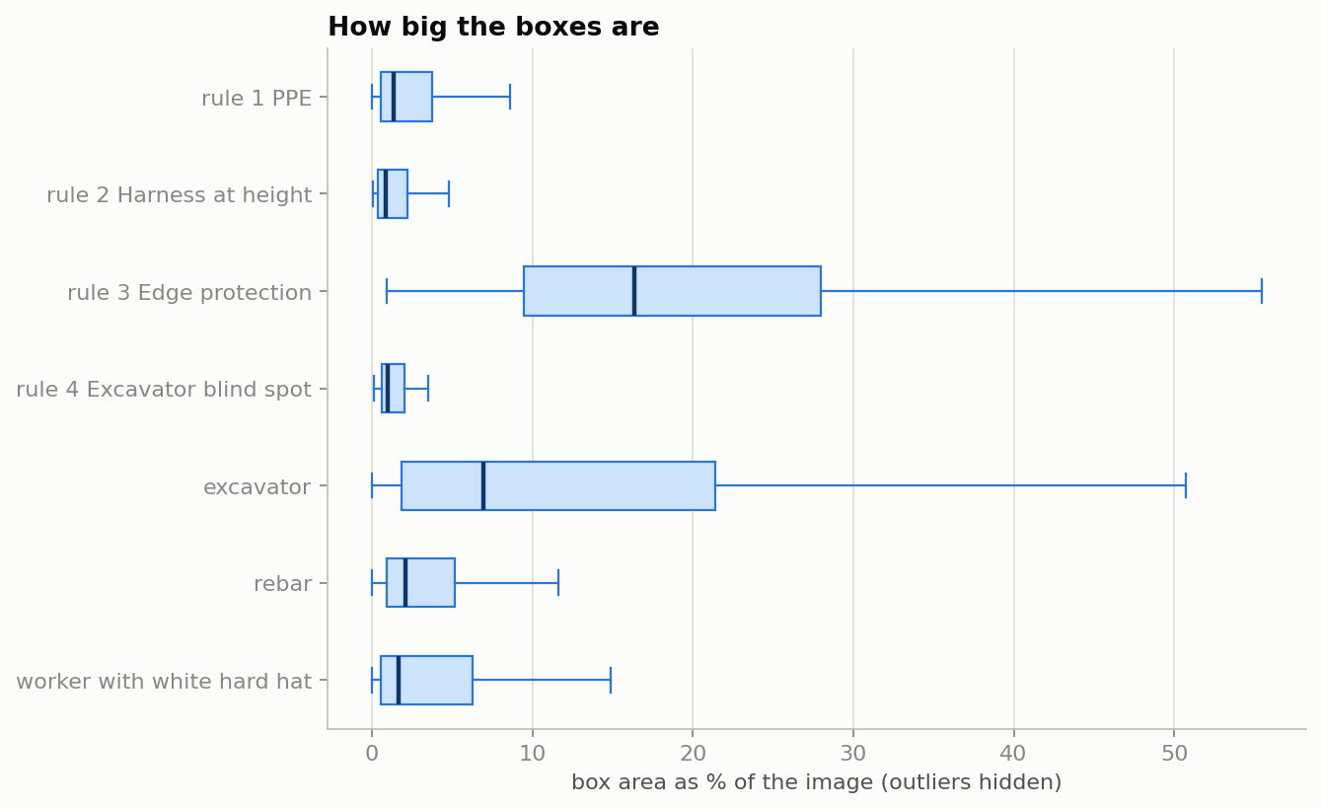
Figure 3. Box size as a % of the photo
Rule | Typical box size (% of photo)
PPE | 1.4%
Harness at height | 0.8%
Edge protection | 16.4%
Excavator blind spot | 1.0%

What it shows: an edge problem is a big area (a whole pit), but a missing helmet or harness is about 1% of the photo. These small details are hard for a model to spot.

7. Captions
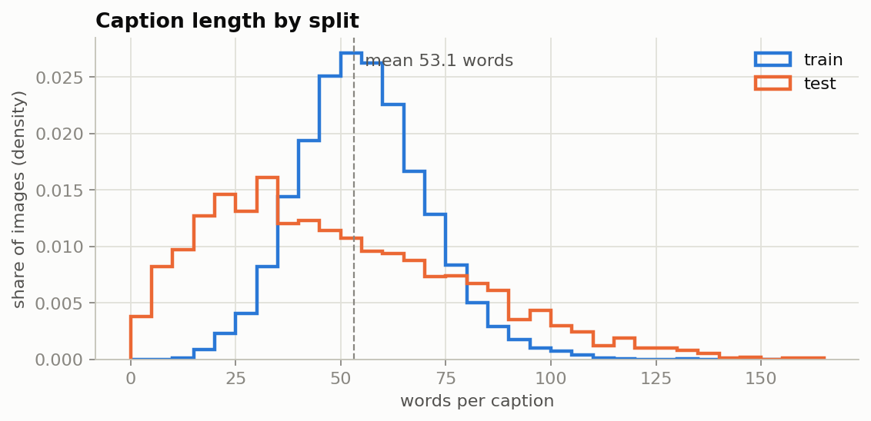
Figure 4. Caption length in words
What it shows: captions are about 53 words long on average (from 2 to 163). Violation reasons are short, about 10 to 17 words, which makes them good training answers.

8. Photo size
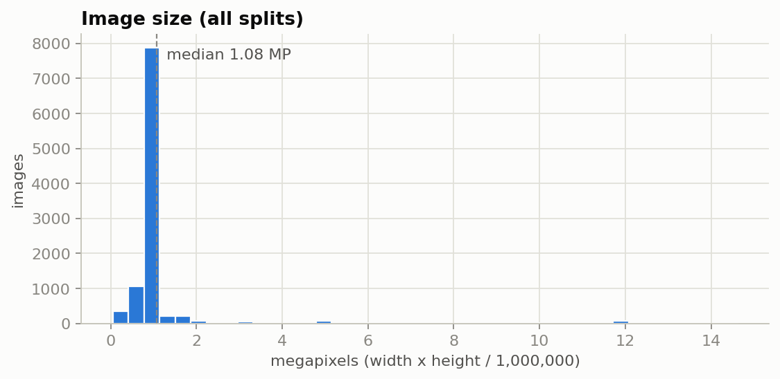
Figure 5. Photo size in megapixels
What it shows: most photos are 1200 x 900 pixels (about 1 megapixel). We resize photos to about 1 megapixel before the model sees them, so very little detail is lost.

9. What this means for us
- Accuracy is misleading. A model that always says "safe" would be 87% right but useless. So we measure precision and recall for each rule.
- It explains the weak baseline. On the 3 rare rules, the untrained model was no better than guessing.
- Fine-tuning plan: give the model more violation examples (balanced training) so it learns the rare rules.
- Extra testing: report results separately for hard cases such as night photos.

