ConstructionSite 10k
Dataset Analysis Report

Project: Development of a Domain-Specific Vision-Language Model for Construction Site Safety Inspection
Student: Mayank Sali, M.Tech, Nirma University
Date: October 2026
Source of numbers: notebooks/01_dataset_analysis.ipynb, run on the full dataset (outputs/eda/)

1. Summary
We analysed all 10,013 images of the ConstructionSite dataset before fine-tuning a vision-language model on it. The main points are:
- The data is clean. No duplicate images, no overlap between train and test, and only a handful of small annotation issues.
- Violations are rare. About 87% of images have no violation at all. Three of the four rules appear in 2% of images or fewer.
- PPE dominates. Rule 1 (PPE) makes up about 75% of all violation labels. The other three rules have only 70 to 172 images each.
- Some violations are tiny in the image. Harness, blind-spot and PPE boxes typically cover only about 1% of the picture.
- Our counts match the paper. Train counts match exactly. Test counts match except PPE, where we find 324 against 323 in the paper.
These points explain the weak zero-shot baseline and shape how we will fine-tune the model (Section 10).

2. Dataset at a glance
Item | Value
Dataset | ConstructionSite (Hugging Face: LouisChen15/ConstructionSite)
Paper | Chen & Zou (2026), Data-Centric Engineering
Images | 10,013 (train 7,009; test 3,004)
Safety rules | 4: PPE, harness at height, edge protection, excavator blind spot
Per-rule labels | Violated or not, plus a written reason and bounding boxes
Other labels | Image caption; boxes for excavator, rebar, worker with white hard hat; illumination, camera distance, view, quality of information
Licence | Non-commercial. Paper states CC BY-NC-SA 4.0; Hugging Face page tags cc-by-nc-4.0

The four rules, word for word from the dataset card:
- Rule 1 (PPE): Use of basic PPE when on foot at construction sites. (hard hats, properly worn clothes covering shoulders and legs, shoes that can cover toes, high-visibility retroreflective vests at night, face shield or safety glasses when cutting, welding, grinding, or drilling).
- Rule 2 (Harness at height): Use of safety harness when working from a height of three meters and the edges are without any edge protection.
- Rule 3 (Edge protection): Adoption of edge protection or edge warning including guardrails, fences, for underground projects three meters in depth with steep retaining wall and for human to stand.
- Rule 4 (Excavator blind spot): Appearance of worker in the blind spots of the operator and within the operation radius of excavators in operation, or excavators with operators inside.

3. Data quality checks
Table 1. Quality checks over all 10,013 images
Check | Count
Duplicate image_id within a split | 0
image_id present in both train and test | 0
Empty captions | 0
Missing illumination / view / quality of info | 0 / 0 / 0
Missing camera distance | 1
Violation with a reason but no box, or a box but no reason | 3
Boxes with zero or negative width/height | 4
Box coordinates outside the 0 to 1 range | 0

The issues found are very small (8 items in total) and do not need any cleaning before training. The 4 broken boxes will simply be skipped if we use boxes later.

4. Safety rule violations
Table 2. Images that violate each rule (our count against the paper)
Rule | Train | % of train | Test | % of test | Matches paper?
1 PPE | 677 | 9.66% | 324 | 10.79% | Train yes; test 324 vs 323
2 Harness at height | 59 | 0.84% | 25 | 0.83% | Yes
3 Edge protection | 109 | 1.56% | 63 | 2.10% | Yes
4 Excavator blind spot | 46 | 0.66% | 24 | 0.80% | Yes
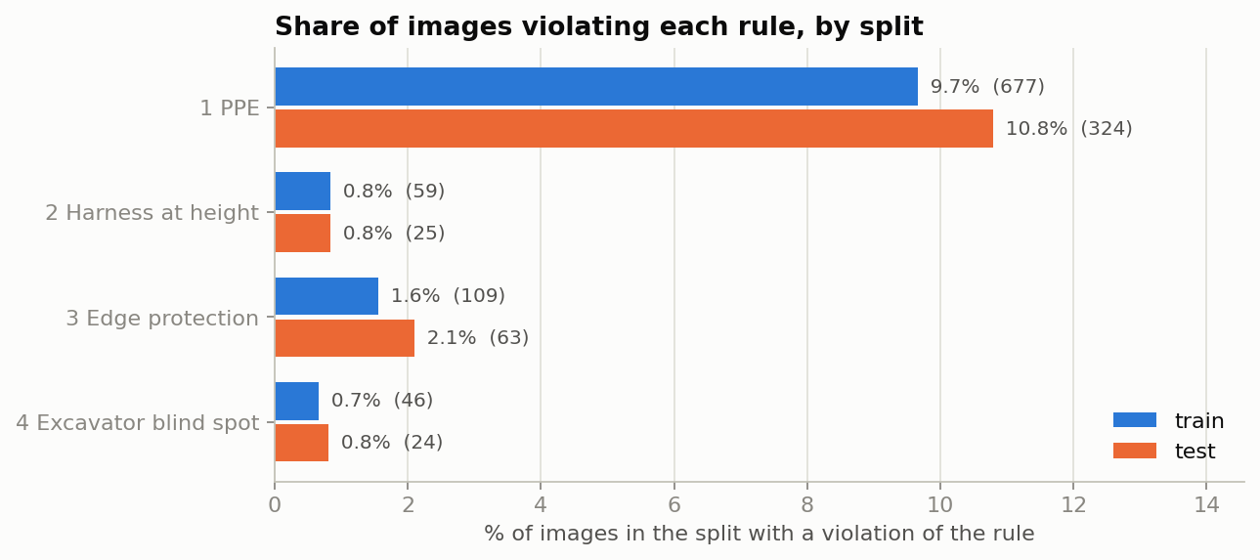
Figure 1. Share of images violating each rule, train and test
What this means. The data is highly unbalanced. If we count every image–rule pair (4 per image), only 3.2% of train pairs and 3.6% of test pairs are violations. A model that always answers "no violation" would look very accurate but would be useless. That is why we report precision, recall and F1 per rule, not accuracy.
Note on the extra PPE image. Our test count for PPE is one higher than the paper (324 against 323). This is likely one borderline annotation that our parser counts as a violation. It changes the PPE test rate by only 0.03 percentage points.

5. Images with more than one violation
Table 3. Number of rules violated per image
Rules violated | Train images | Test images
0 (safe) | 6,143 | 2,592
1 | 841 | 390
2 | 25 | 20
3 | 0 | 2
Any violation | 866 (12.4%) | 412 (13.7%)

Table 4. How often two rules are broken in the same image (train + test)
 | PPE | Harness | Edge | Blind spot
PPE | 1,001 | 11 | 14 | 21
Harness | 11 | 84 | 2 | 0
Edge | 14 | 2 | 172 | 3
Blind spot | 21 | 0 | 3 | 70

The diagonal is the total number of images for each rule. Rules rarely occur together: the largest overlap is PPE with blind spot (21 images). So each rule can be treated as a separate yes/no question, which is how our yes/no prompt and the planned fine-tuning work.

6. Image conditions
Each image is tagged with lighting, camera distance, view and how much useful information it contains.
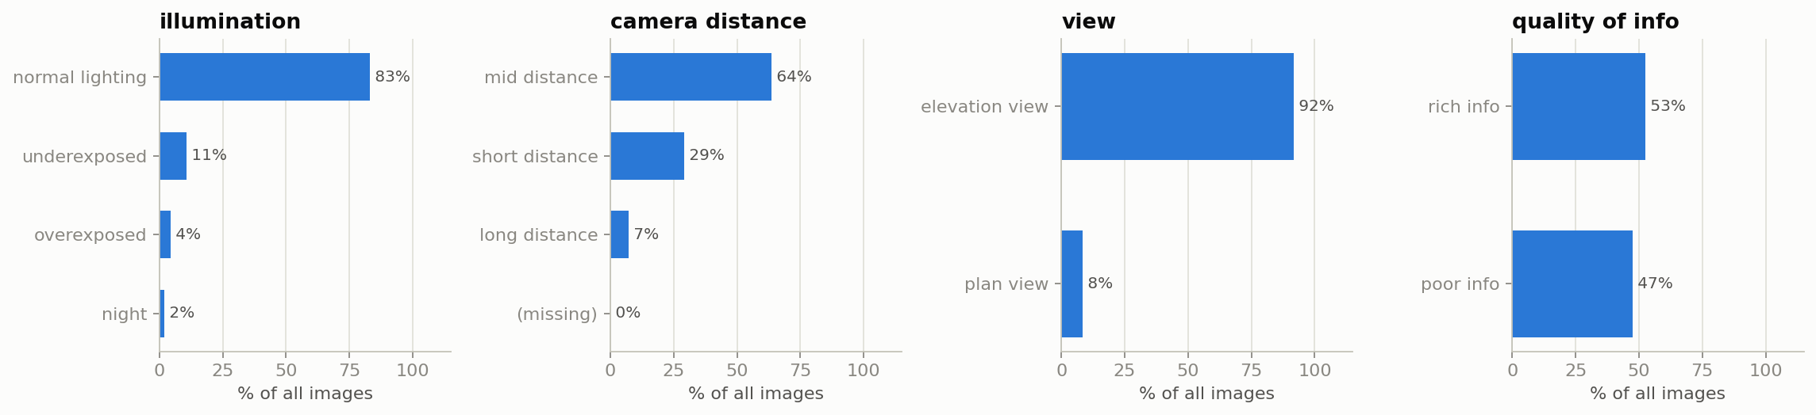
Figure 2. Share of images in each condition
Table 5. Image conditions and the share of images with any violation
Condition | Images | % of all | % with a violation
Normal lighting | 8,311 | 83.0% | 11.6%
Underexposed | 1,073 | 10.7% | 13.4%
Overexposed | 427 | 4.3% | 12.2%
Night | 202 | 2.0% | 56.9%
Mid distance | 6,372 | 63.6% | 13.1%
Short distance | 2,920 | 29.2% | 13.2%
Long distance | 720 | 7.2% | 8.2%
Elevation view | 9,181 | 91.7% | 13.5%
Plan view (from above) | 832 | 8.3% | 4.8%
Rich information | 5,271 | 52.6% | 14.6%
Poor information | 4,742 | 47.4% | 10.7%

Observations. Most images are taken in normal daylight from ground level at mid distance. Night images are few (202) but more than half of them (56.9%) contain a violation, far above the 11–15% seen elsewhere. Plan-view and long-distance images have fewer labelled violations, probably because workers are too small to judge. These groups are worth reporting separately when we evaluate the fine-tuned model.
The split between train and test is not identical. For example, short-distance images are 22% of train but 45% of test, and plan-view images are 10% of train but 4% of test. We use the official split as given, so results stay comparable with the paper.

7. Captions and violation reasons
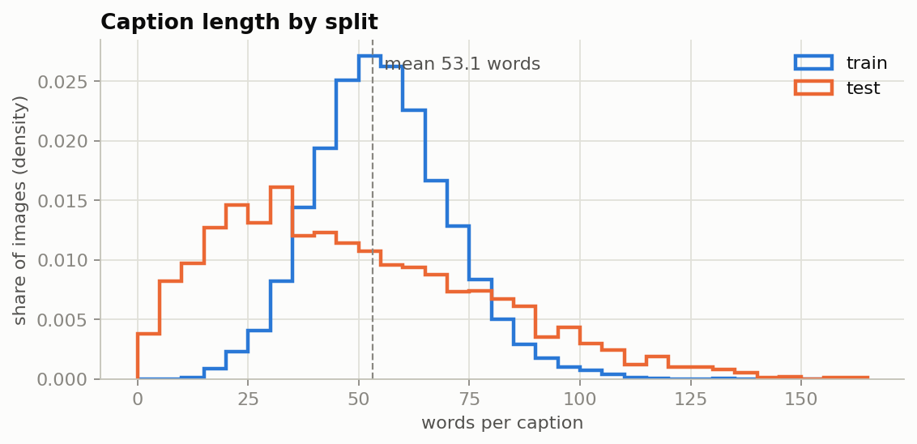
Figure 3. Caption length in words
Every image has a caption. Captions are 53 words long on average (median 53, standard deviation 20.9, range 2 to 163 words; half of all captions are between 40 and 65 words).
Table 6. Written reasons attached to violations
Rule | Reasons | Average length (words)
1 PPE | 1,000 | 12.4
2 Harness at height | 84 | 12.7
3 Edge protection | 172 | 10.1
4 Excavator blind spot | 70 | 17.1

Test captions tend to be shorter than train captions (Figure 3), another small difference between the two splits.
The reasons are short, one-sentence explanations. This makes them suitable as training targets: the model can learn to answer "Yes" and then give a short reason in the same style.

8. Image size
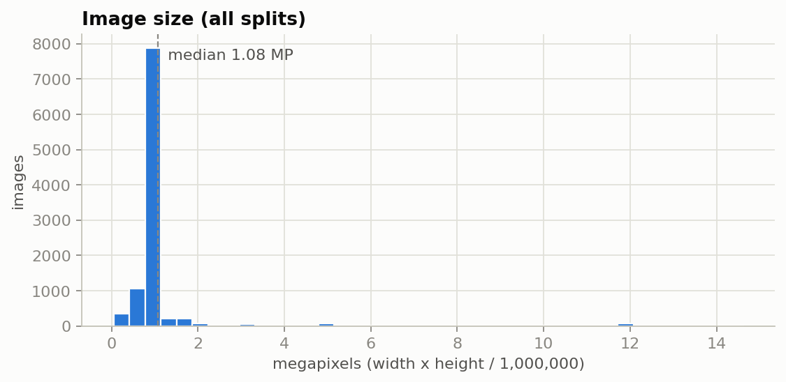
Figure 4. Image size in megapixels
Measure | Value
Width (median, min, max) | 1,200 px (288 to 4,912)
Height (median, min, max) | 900 px (164 to 4,416)
Megapixels (median / mean) | 1.08 / 1.14
Megapixels (10th percentile / max) | 0.69 / 14.63
Aspect ratio (median) | 1.33 (4:3)
Portrait images | 1,054
Most common size | 1200 x 900 (5,376 images)
Next most common | 1200 x 675 (697), 900 x 1200 (571), 1200 x 800 (545)

Most images are about 1 megapixel. Our scripts resize each image to at most about 1.0 megapixel (1280 x 28 x 28 pixels) before the model sees it. For the most common size (1200 x 900, 1.08 megapixels) this means shrinking each side by only about 4%, so almost no detail is lost. Only the few very large images are reduced a lot.

9. Bounding boxes
Table 7. Boxes per label (area as a fraction of the image)
Label | Boxes | Images | Median area | Boxes / image
Rule 1 PPE | 1,662 | 999 | 1.4% | 1.66
Rule 2 Harness | 146 | 84 | 0.8% | 1.74
Rule 3 Edge | 199 | 172 | 16.4% | 1.16
Rule 4 Blind spot | 71 | 70 | 1.0% | 1.01
Excavator | 4,681 | 3,495 | 7.0% | 1.34
Rebar | 2,978 | 1,173 | 2.1% | 2.54
Worker, white hard hat | 1,401 | 994 | 1.7% | 1.41
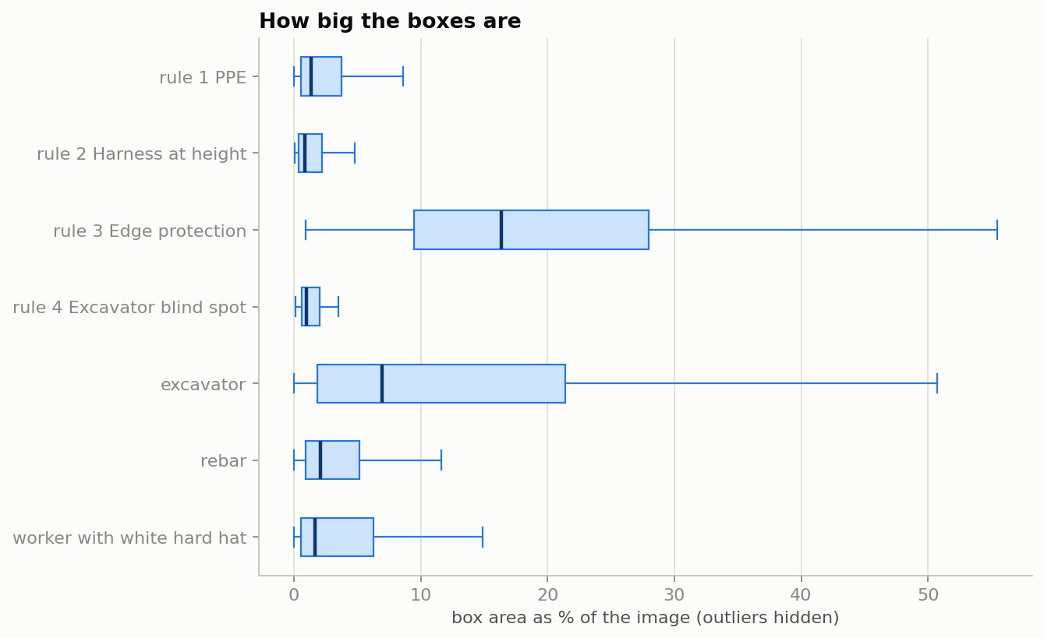
Figure 5. Box size as a share of the image (outliers hidden)
What this means. Edge-protection violations are large regions (a whole excavation), so they are easier to see. PPE, harness and blind-spot violations are about one person, covering roughly 1% of the image. The model has to notice a small detail, such as a missing hard hat or a harness strap, in a large scene. This is one reason why these rules are hard for a small model.
Excavators appear in 35% of all images (3,495), but blind-spot violations are only in 70 images. So most excavator images are negative examples for rule 4, which helps the model learn when a worker near an excavator is safe.

10. What this means for our project

10.1 It explains the baseline results
In the zero-shot baseline (Qwen2-VL-2B, yes/no prompt, full test set), PPE reached 27.2% precision and 46.0% recall. For harness, edge and blind spot, the model said "yes" to most images, so precision was 0.9%, 2.2% and 1.1%. These are almost exactly the violation rates in Table 2 (0.83%, 2.10%, 0.80%). In other words, for the three rare rules the baseline is no better than guessing.

10.2 How we will use this in fine-tuning
- Balanced training. Keep all violation images and repeat the rare ones, and sample only a few non-violation images per violation, so the model is not swamped by "no" answers.
- Validation set. Hold out 10% of the train split (fixed by image id) to choose the decision threshold for each rule, without touching the test set.
- Answer format. Train the model to answer "Yes" or "No" first, then give the annotator's short reason.
- Evaluation. Report precision, recall and F1 per rule on the official test split, plus results for difficult groups such as night and plan-view images.
- Image size. Keep the 1-megapixel limit, as it preserves detail for nearly all images while fitting the GPU.

