INTERNSHIP REPORT

*A report submitted in partial fulfillment of the requirements for the Award of Degree of*

### INTEGRATED M.TECH

**In**

**ARTIFICIAL INTELLIEGENCE**

**By**

**Mayank Samadhiya**

**Reg. No.: 19MIM10077**

**Under Supervision of**

**SmartInterz**

**Duration: 23rd March 2022 to 23rd May 2022**



**DEPARTMENT OF COMPUTER SCIENCE AND ENGINEERING**

**VIT BHOPAL UNIVERSITY**

**2019-2024**

DEPARTMENT OF COMPUTER SCIENCE AND ENGINEERING

**VIT BHOPAL UNIVERSITY**



***CERTIFICATE***

This is to certify that the “**Internship report”** submitted by **Himanshu(Regd. No.: 19MIM10085)** is work done by her and submitted during 2022 – 2023 academic year, in partial fulfillment of the requirements for the award of the degree of **INTEGRATED M.TECH in ARTIFICIAL INTELLIGENCE**, at **SMARTINTERNZ**.

**College Internship Guide Program Chair Dean**

Dr.Vinesh Kumar Dr. S.Periyanayagi Dr.S.Poonkuntran

Senior Assistant Professor (Grade-2) Senior Assistant Professor (Grade-1) Professor

Dean/SCSE

**INTERNSHIP CERTIFICATE**

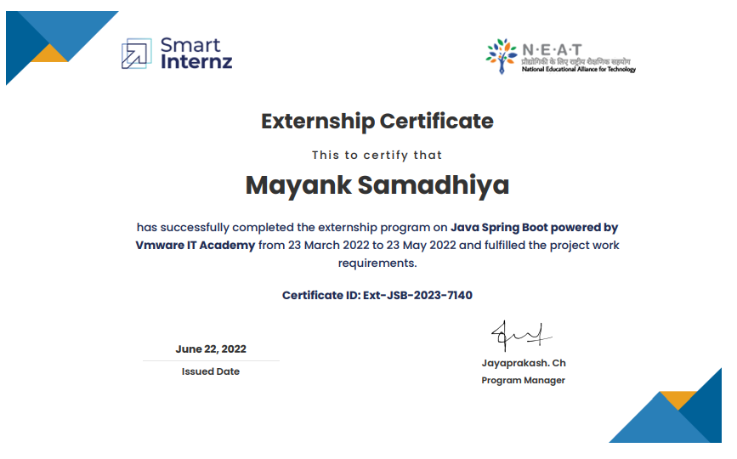

# ACKNOWLEDGEMENT

First, I would like to thank **Jayaprakash. Ch** the Program Manager of **SmartInternz** for giving me the opportunity to do an internship within the organization.

I also would like all the people that worked along with me in **SmartInternz** with their patience and openness. They created an enjoyable working environment. It is indeed with a great sense of pleasure and immense sense of gratitude that I acknowledge the help of these individuals.

I am highly indebted to Dean **Dr.S Poonkuntran**, for the facilities provided to accomplish this internship.

I would like to thank my Program Chair **Dr. S. Periyanayagi** for her constructive criticism throughout my internship.

I would like to thank **Dr. Vinesh Kumar,** for his support and advices to get and complete internship in above said organization.

I am extremely great full to my department staff members and friends who helped me in successful completion of this internship.

Mayank Samadhiya

19MIM10077

**INTERNSHIP REPORT**

**INDEX**

1. **TITLE PAGE** (page -1)

2. **COLLEGE CERTIFICATE PAGE** (page - 2)

3. **INTERNSHIP CERTIFICATE** (page - 3)

4. **ACKNOWLEDGMENT** (page - 4)

5. **INDEX** (page - 5)

6. **ABSTRACT** (page - 6)

7. **LEARNING OBJECTIVES/INTERNSHIP OBJECTIVES** (page - 8)

8. **WEEKLY PROGRESS**  (page - 9)

9. **INTERNSHIP DISCUSSION** (page - 12)

10. **CONCLUSION** (page - 21)

11. **BIBLIOGRAPHY** (page 23)

12. **ANNEXURE – I** (page - 25)

13**. REFRENCES** (page - 26)

**ABSTRACT**

This report describes my internship at SmartBridge SmartInternz. "Java Spring Boot (JSB)" is one of the leading technologies in the field of Cloud Computing, with a lot of potential to be used in many different fields. The main focus of this internship was to find out how JSB can be used in different fields and what kind of problems it might solve.

This internship provided me with the opportunity to learn about the problems JSB has solved so far, and which ones still need solving. I also learned how JSB can be used in different fields, like creating "REST API". And finally, I was able to apply what I learned in a real-world application-based project as part of my internship.

Some of the projects that I worked on were a Nutri-Assistant(Nutrition- Assistant).

# Programmes and opportunities:

The Institute combines pioneering research with top class education. An innovative curriculum allows the student flexibility in selecting courses and projects. Students, even at the undergraduate level, get to participate in ongoing research and technology development - an opportunity unprecedented in India. As a result, a vibrant undergraduate programme co-exists with a strong postgraduate programme.

# Organization Information

Questease Solutions is an initiative by Industry experts with a vision to provide practical oriented training internship programs along with Industry recognized certification supported by expert guidance to crack the job interviews We have trained more than 5000

+ from various colleges across Telangana, Andhra, Orissa, Chhattisgarh etc.

Questease Solutions started its career development Centre in partnership with HCL Learning Ltd in Mid-June 2013 and in pursuance of our continued efforts to enhance the skills of the students, Questease Solutions from time to time gets associated with leading MNC’s to explore the various industry related opportunities for students.

With technology advancing at rapid pace, Industries are forced to adapt to the changes, which in turn impacts the recruitment industry. To cope up with the changes, professionals need to scale up their skills and come out of the academic mind-set to embrace the advancement of the technology, Questease Solutions have structurally designed the Internship keeping in view the changes of the market and accordingly customizing the programs to suit the ever-changing Industry requirements

# Benefits to the company / institution through your report:

The Institute combines pioneering research with top class education. An innovative curriculum allows the student flexibility in selecting courses and projects. Students, even at the undergraduate level, get to participate in ongoing research and technology development - an opportunity unprecedented in India.

**Learning Objectives/Internship Objectives**

* To provide interns with hands-on experience in designing, developing, and implementing Java Spring Boot (JSB) projects.
* To equip interns with the technical knowledge and skills required to work with JSB annotations and libraries.
* To expose interns to the latest JSB technologies that included learning "REST To learn API".
* To provide interns with the opportunity to work with industry experts and professionals in the JSB field.
* Learning about networking Cloud Computing technologies such as Docker and Heroku, is important for developing JSB solutions.
* To foster teamwork, collaboration, and communication skills among interns.
* about various JSB tools like JPA and others.
* To enable interns to apply their theoretical knowledge in a practical setting and gain practical experience in problem-solving and critical thinking.
* To help interns develop their professional network by interacting with peers, mentors, and professionals in the Cloud industry.

**WEEKLY PROGRESS OF INTERNSHIP ACTIVITIES**

* **Week 1**
* HTML Introduction
* HTML Editors, Basics
* HTML Elements, Attributes, Headings, Paragraph
* HTML Styles, Quotations, Comments
* CSS, Types of CSS
* HTML Colors, Lists, Classes
* HTML Id, Images, HTML Links, Iframes
* **Week 2**
* Introduction to JavaScript
* JavaScript Variables
* JS Operations
* JS Conditions
* JS Loops
* JS Selectors
* JS DOM
* **Week 3**
* Introduction to Spring Boot, What is dependency injection?
* Why Spring?, Spring Architecture
* Setting up Spring Boot IDE STS (Spring Tool Suite)
* Web Application, Creating JSP Pages
* Understanding MVC Model, Web App using Spring Boot
* Application Properties file, Accepting Client Data
* Model Object, Model and View, Code Structure
* **Week 4**
* Building Rest Services with Spring Boot
* GET API, POST API
* PUT API, DELETE API
* Sample App using rest API.
* Handling exceptions, Controller Advice, Exception Handler
* Handler Interceptor i.e., preHandle(), postHandle(), afterCompletion()
* File Handling, File Upload, File Download
* **Week 5**
* Scheduling, Java Cron Expression
* Fixed Rate, Fixed Delay
* Spring Boot Crud Operations with H2 Database and Remote MYSQL
* Creating Micro Services
* Web Socket, Sending Emails, SMS through Twilio Service
* Securing Web Application, OAuth2 with JWT
* Creating Docker Image, Authorization Server, Resource Server, JWT Token, Securing Web App
* **Week 6**
* What is Cloud computing?
* Categories of Cloud Services
* Different types of Cloud
* Introduction to Heroku Cloud
* Understanding the services in the cloud, Register for Cloud Account
* Install CF CLI, Deploy the Sample APP
* View the Logs, Connect to a Database Scaling Your APP
* **Week 7 & 8**
* Application Building
* Project Work

**INTERNSHIP DISCUSSION**

**Why Spring?**

Spring makes programming Java quicker, easier, and safer for everybody. Spring’s focus on speed, simplicity, and productivity has made it the world's most popular Java framework.

"We use a lot of the tools that come with the Spring framework and reap the benefits of having a lot of the out-of-the-box solutions, and not having to worry about writing a ton of additional code—so that really saves us some time and energy"

**Microservices**

Microservicesarchitectures are the ‘new normal’. Building small, self-contained, ready-to-run applications can bring great flexibility and added resilience to your code. Spring Boot’s many purpose-built features make it easy to build and run your microservices in production at scale. And

don’t forget, no microservice architecture is complete without [Spring Cloud](https://www.canva.com/link?target=https%3A%2F%2Fspring.io%2Fcloud&design=DAFcANqH67E&accessRole=viewer&linkSource=document) ‒ easing administration and boosting your fault tolerance.

**Cloud**

Developing distributed systems can be challenging. Complexity is moved from the application layer to the network layer and demands greater interaction between services. Making your code ‘cloud-native’ means dealing with 12-factor issues such as external configuration, statelessness, logging, and connecting to backing services. The Spring Cloud suite of projects contains many of the services you need to make your applications run in the cloud.

**Web Apps**

Spring makes building web applications fast and hassle-free. By removing much of the boilerplate code and configuration associated with web development, you get a modern web programming model that streamlines the development of server-side HTML applications, REST APIs, and bidirectional, event-based systems.

1. **NTRODUCTION**

## **Overview**

Most people know good nutrition and physical activity can help maintain a healthy weight. But the benefits of good nutrition go beyond weight. Good nutritions can help to-

* Reduce the risk of some diseases, including heart disease, diabetes, stroke, some

cancers, and osteoporosis,

* Reduce high blood pressure, and lower high cholesterol,
* improve your ability to fight off illness,
* Increase your energy level.

But people are not aware about how to maintain a proper diet and take enough nutrition, so to overcome this issue we came up with a nutri assistant project which helps to maintain users' nutrition level.

## **Purpose**

By using our Nutri-Assistant users can access over 365,000 recipes and 86,000 food products using the spiracular Nutrition, Recipe, and Food API. Recipes can be found using natural language queries such as "gluten-free brownies without sugar" or "low-fat vegan cupcakes". Users can use our assistant to automatically calculate nutritional information for any recipe, analyse recipe costs, visualize ingredient lists, find recipes based on what's in their fridge, find recipes based on special diets, nutritional requirements, or favorite ingredients, classify recipes into types and cuisines, convert ingredient amounts, and even compute an entire meal plan. In short, this project helps users to maintain their overall diet and live a better and healthy life.

# THEORETICAL ANALYSIS

## **Block diagram**

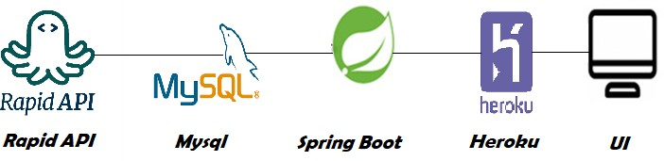

* 1. **Hardware / Software designing**

To complete the project successfully, you need to have:

* Spring boot IDE (Eclipse / STS)
* HTML, CSS (for front-end development)
* Rapid API (for fetching nutrition and recipes details)
* Database on remote MySQL (for storing users’ information)
* Heroku (for deploying the project)

# FLOWCHART

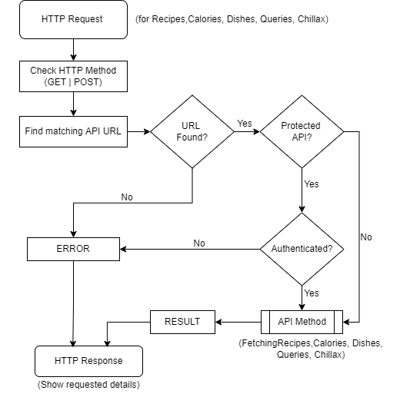

**Nutri Assistant**

# RESULT

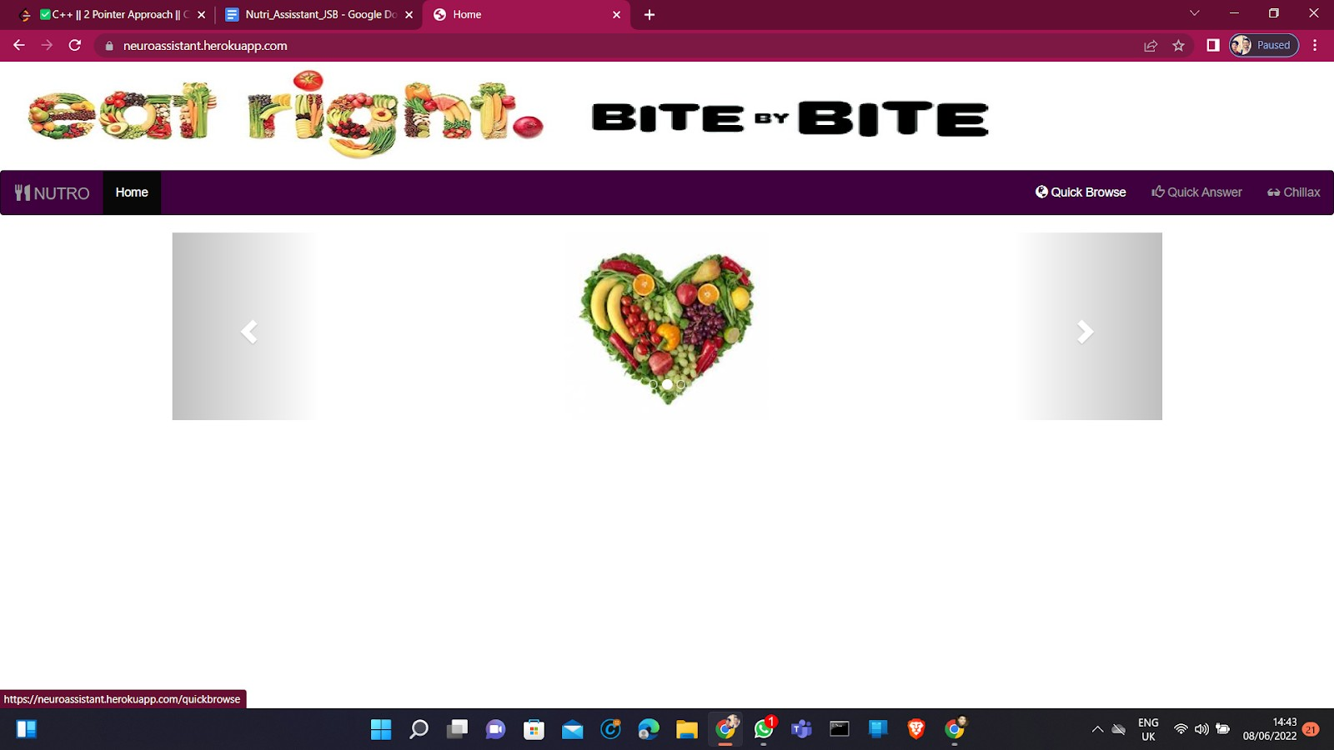 **1. Home Page**

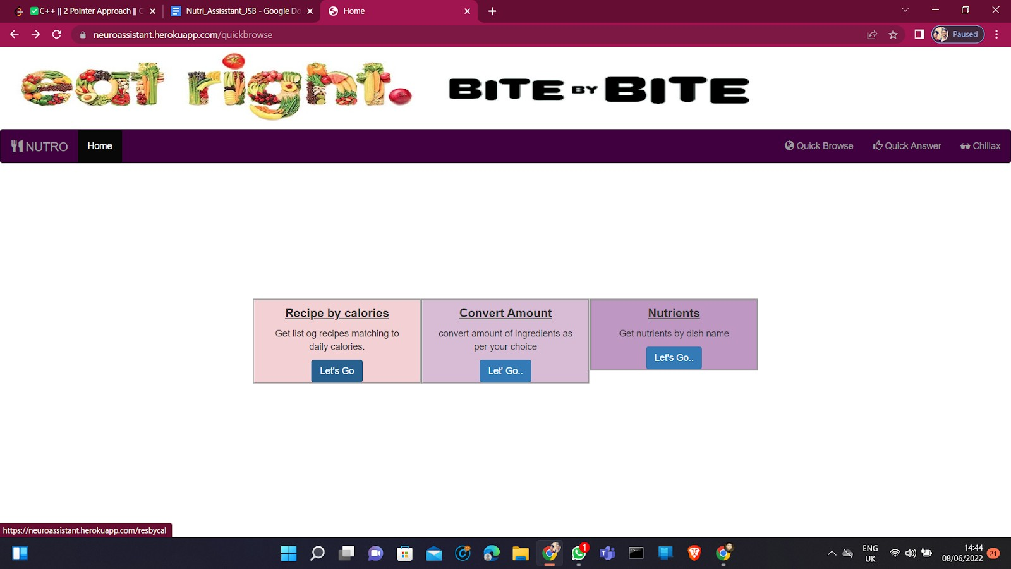**2. After Clicking on Quick Browse Feature**

1. 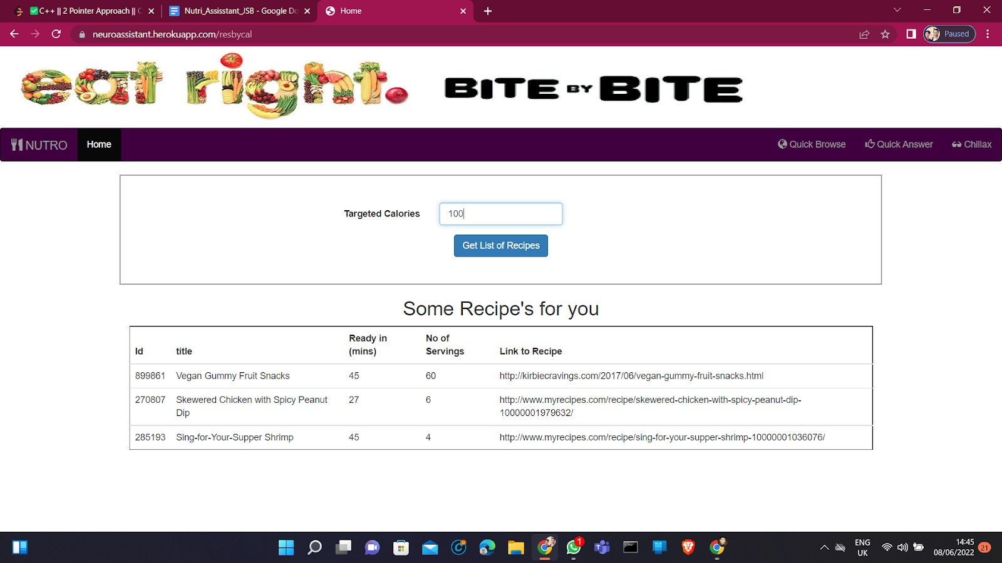**After Clicking on Recipe By Calories**
2. **After Clicking on Nutrients**

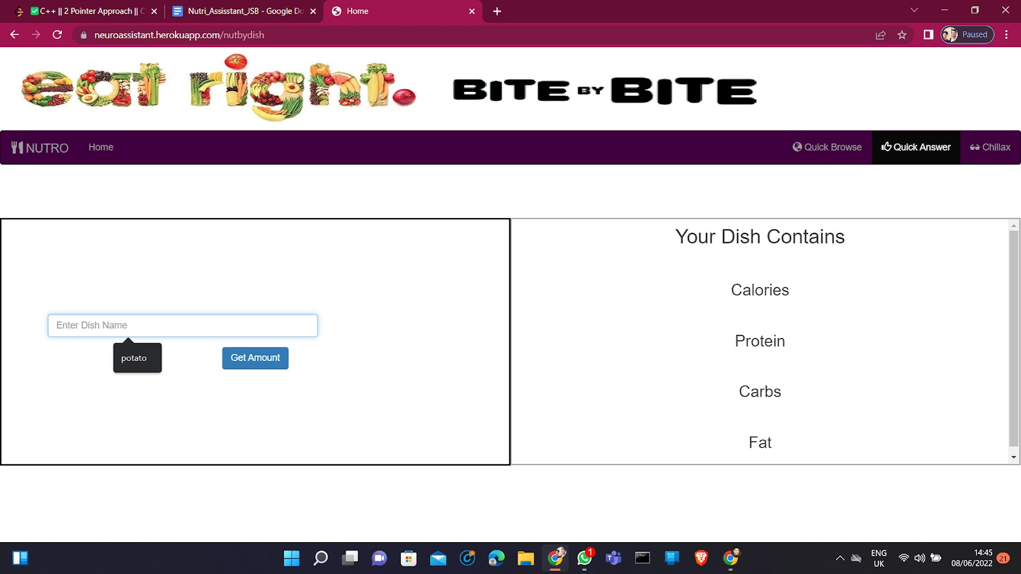

1. **After Entering the Dish name (Potato) we Got following Results**

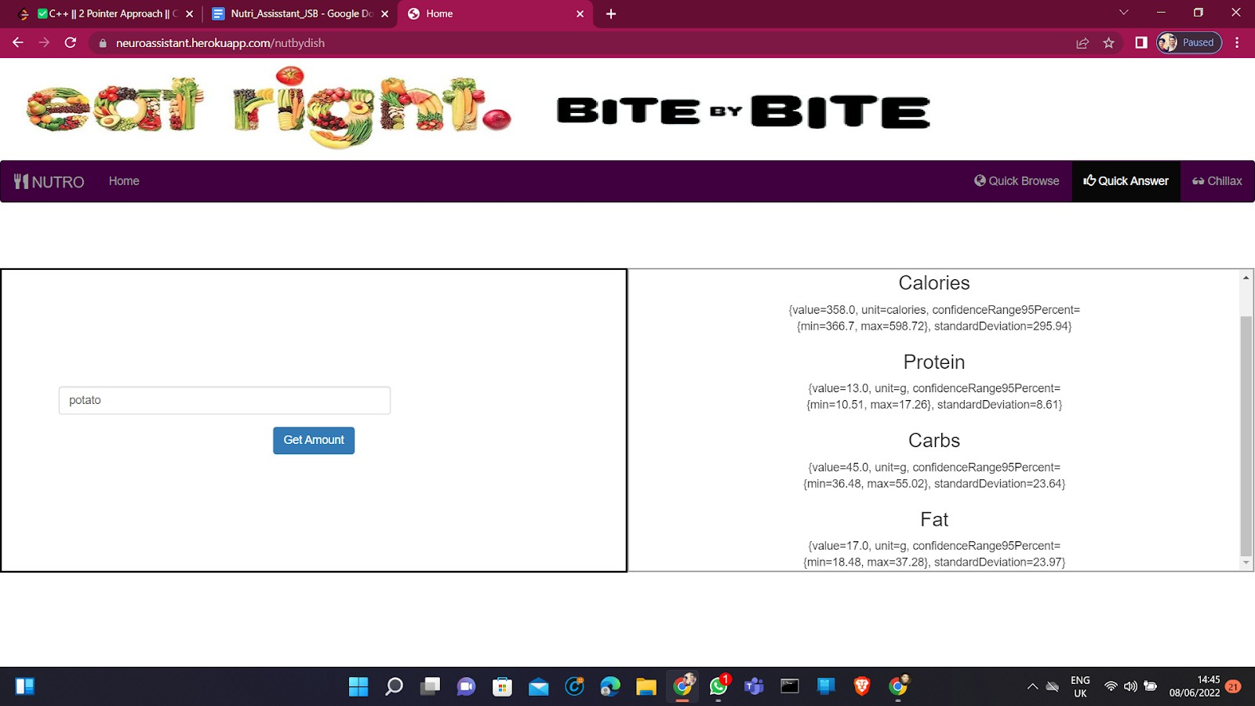

1. **After Clicking on Quick Answer Feature**

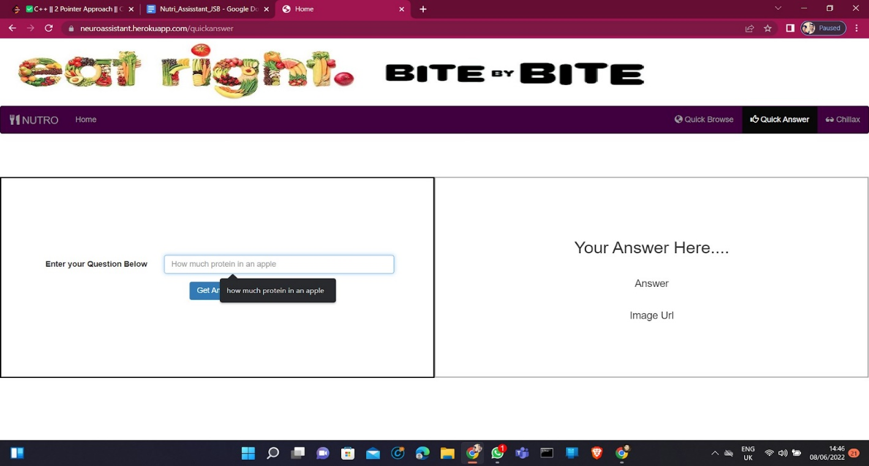

1. **After Entering the question Our Answer Is here**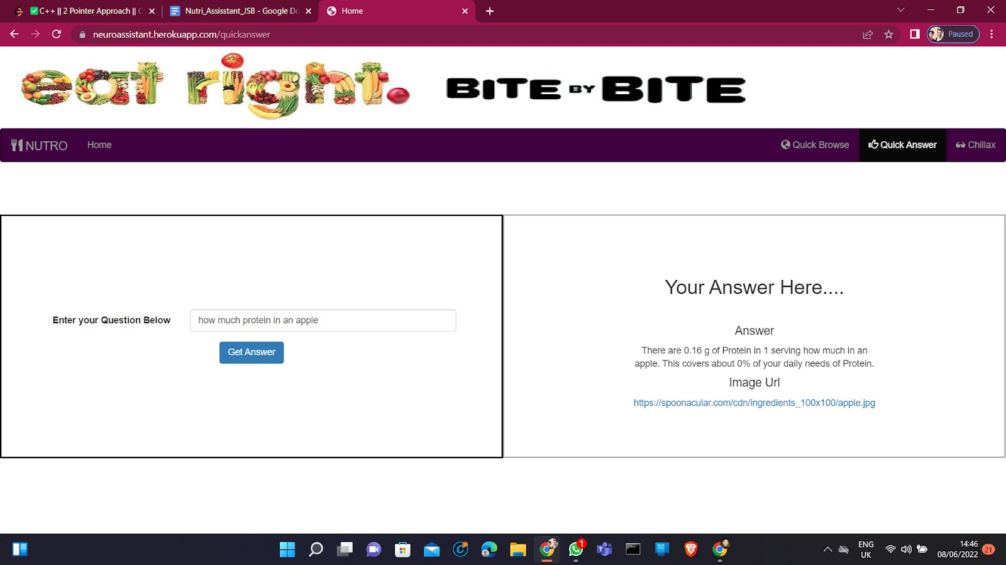

# DVANTAGES & DISADVANTAGES

## **Advantages-**

1. A Better User Experience – With responsive design, it’s a lot easier and cheaper to

ke a Nutrition based web system user friendly across multiple platforms and various screen sizes.

1. Flexible Access – Anyone can use it from anywhere with internet access.
2. Easy Setup – It takes a couple of minutes to set up a new user; provide a URL, username and password and they’re away.
3. Always Up To Date – As everyone is accessing the same version of the web app via a URL, they will always be accessing the most up-to-date version of the software.
4. Storage Increase – With the availability of the cloud, storage space is virtually infinite.

## **Disadvantages-**

1. Internet reliance – Whilst 4G & Wi-Fi internet access is available in many locations, if you happen to lose connection you will not be able to access your web app.
2. Security – Whilst many business people may believe that data is less secure in a cloud environment, we beg to differ. There are ways in which you can reduce risk of a data breach, such as SSL enforcement for a secure HTTPS access to your app.
3. Reduced Speed – It’s likely that a web app will operate at a slightly slower speed than one hosted on a server locally.
4. Browser Support – Unfortunately, we don’t all use the same browser. This means during development you’ll need to ensure your app is supported across a variety of browsers.

# APPLICATIONS:

* **Recipe by calories:** We can get a list of recipes matching daily calories.
* **Convert amount:** We can convert the amount of ingredients as per your choice.
* **Nutrients:** We can get nutrients by dish name.
* **Quick Answer:** We can get the answer for related questions by entering the question. I.e, How much protein is in an apple?
* **Chillax:** This is a fun feature in the app. We can click on the show some joke button to get any joke and show some food trivia will show some interesting facts about foods.

# 7.CONCLUSION

With such a huge database of healthy and nutrient recipes, we are able to provide all kinds of tastes to our customer base, who come from different walks of life, while keeping the health of our customers in mind.

In this digital era, where all kinds of information is on one’s tips, no one wants to

be oblivious to anything. Therefore nowadays, people have grown very health conscious and want to control every aspect of their life. And our Nutri-Assistant app helps them to achieve their goals by telling them everything right from the calories intake to the ingredient base of their meal.

# FUTURE SCOPE

Future of our endeavor is limitless. Our Nutri Assistant app can go really well with a fitness tracker/assisting application. It can track and calculate calories spent and gained in a day/month or over a course of time set by the user. Moreover we can share the culinary data and the eating habits of our user to the fitness app for it to design a better suited routine for our user. We can also share this data with many food delivering apps for them to present our customers with culinary options related to their eating habits and goals.

Many of the fitness/health conscious people have the “tradition” of celebrating a cheat day once a month. Our app can make this day a celebration with some cheat day delicacies.

In the coming age, where almost everything is going digital, from banking to

shopping groceries, that day is not far when everyone is going to depend completely upon these kinds of options (like our project) to track every waking, and sleeping moment of their lives. Our app can assist the people a lot in this transition.

Overall, the sky's the limit. The only constraints stopping us from achieving the untouched heights is our creativity and the courage to take the necessary risks. Enhancements that can be made in the future.

**BIBLIOGRAPHY**

(Click Images To Access Link)

[](https://www.javatpoint.com/)[](https://www.heroku.com/)

[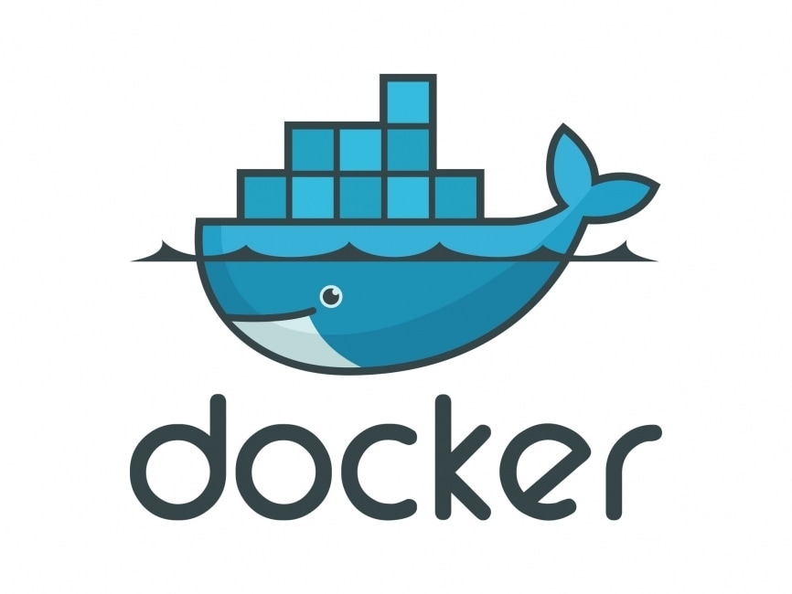](https://www.docker.com/)

[](https://github.com/)

**ANNEXURE – I**

(Click Images To Access Link)

**Source Code:-**

**[](https://github.com/mayanksamadhiya12345/Nutro-Assistant)**

**Demo Video:-**

**[](https://drive.google.com/file/d/1fZfbuYnKaoDXsNpt60gOI2fhAb-pLrV9/view?usp=sharing)**

**REFRENCES**

1. <https://docs.spring.io/spring-boot/docs/current/reference/htmlsingle/>
2. <https://smartinternz.com/guided-project/nutro-assistant>
3. <https://stackoverflow.com/questions/65262871/issue-setting-up-spring-cloud-gateway>
4. <https://github.com/smartinternz02/SBSPS-Challenge-9385-Develop-and-Deploy-an-Application-for-Nutrition-Assistant>
5. <https://rapidapi.com/products/api-hub/>