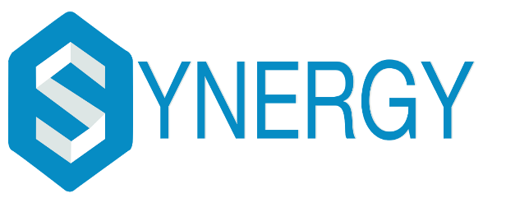

**An International Technical Symposium**

**In association with SENSE-VIT**

**23rd February 2018– 25th February 2018**

**CodeOlympia**

DESCRIPTION

CodeOlympia is a thrilling 12-hours non-stop coding competition held in association with HackerRank where participants get to showcase their coding skills. It’s an event where the participants can participate as an individual or in a team of 2. Participants will be given programming questions of varying levels, and there will be a plethora of coding languages to choose from, in order to solve them and provide the best optimized solution.

DATE: 24th February 2018

CERTIFICATION

The participants will be provided with the participation certificates from HackerRank

Prize-Money worth upto Rs 9000/- can be won by the participants.

The top 5 teams will get exciting goodies, from HackerRank.

REGISTRATION FEE

300/TEAM (Max team of 2)

CONTACT FOR FURTHER DETAILS

Amogh- +91-9003712532

