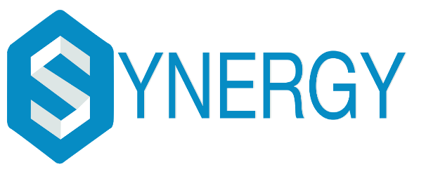

**An International Technical Symposium**

**In association with SENSE-VIT**

**23rd February 2018– 25th February 2018**

**MACHINE LEARNING WORKSHOP**

**DESCRIPTION**

A two day workshop on Artificial Neural Network (ANN) and Fuzzy Logic by field experts from Scientific Computing Solution. The objective of this workshop is to uncover the understandings of ANN, Fuzzy Logic & GA in a clear way with hand worked numerical exercise followed by SCILAB/MATLAB® program to realize various applications of Soft Computing ranging from Image Processing, Data Mining, Pattern Recognition to AI.

Data Science is an interdisciplinary field about processes and systems to extract knowledge or insights from large volumes of data in various forms either structured or unstructured, which will be used in Data Mining and Predictive Analytics, as well as Knowledge Discovery in Databases.

This workshop emphasizes on the broad range of techniques for Machine Learning and Deep Learning using Open Source Python software.

**COURSE STRUCTURE**

**Day- 1:**

**Python Basics**

* Introduction to Python environment, installation procedure, IDE for Python, Navigating Jupyter Notebook
* Understanding Variables and Data Types (Numbers, String, List, Tuples, Dictionary & Numpy arrays)
* Control Structures (For loop & If-else branching & While loops)
* Creating user defined functions in Python

**Data Science using PANDAS Library**

* Series & Data Frame data types in PANDAS
* Loading Data from CSV & TXT files, Understanding Continuous & Categorical Data types & its Significance
* Data Cleaning: Handling Outliers & Missing Values
* Exploratory Data Analysis: Bar plot, Pie Chart, Box plot, Histogram & Scatter Plot, Cross tab Bar plot, Matrix Scatter Plot
* Linear & Non-linear Regression Model for Prediction (Univariate & Multivariate)

**Day-2:**

**Scikit Machine Learning Library Part-1**

* Train/Test Split and K-fold Cross Validation Split & Standard Scalar Transforms
* Logistic Regression Model as a Classifier
* Ensemble Random Forest Classification Model
* Artificial Neural Network (ANN) Model
* Supervised Neural Network Learning Model: Multilayer Perceptron Model as a Classifier

**Scikit Machine Learning Library Part-2**

* Unsupervised Clustering Model: Kmeans Clustering
* K- Nearest Neighbour (KNN) Classifier
* Text Analytics using Python
* Natural Language Processing (NLP) using Python
* Model Validation and Performance Evaluation

**ABOUT THE COMPANY**

Scientific Computing Solutions (SCS-India) is a Chennai based technology consulting and training firm incorporated in the year January 2012. SCS India offers industry consultation services in the field of Data Analytics, Signal Processing, Image Processing, Pattern Recognition, Machine Vision, Soft Computing & Machine Learning, and Data Mining areas. Recently, the project delivered to CSIR-CLRI (Central Leather Research Institute), Chennai, on ‘Artificial Neural Network based Leather Surface Image Analysis Software for Quality Inspection in an Open Source Platform’, was well appreciated by the team of CLRI Scientist.



**CERTIFICATION**

All the participants will be provided with the certificates from Scientific Computing Solutions(SCS).

**RECOMMENDATION**

It is strongly recommended to bring your own LAPTOP during the training on which you can install and run programs if you would like to do the optional, hands-on experiments/exercises after the trainings/ workshops.

**DATES OF THE WORKSHOP**

23rd & 24th February, 2018

**REGISTRATION FEE**

Non-IETE member – Rs.900 / participant

IETE member– Rs.700 /participant

**CONTACT FOR FURTHER DETAILS**

Dhruv- +91-9003754977

Sunderam - +91-8052939174

