**Steps to create MySql Ansible Operator**

1. Create a new project with operator-sdk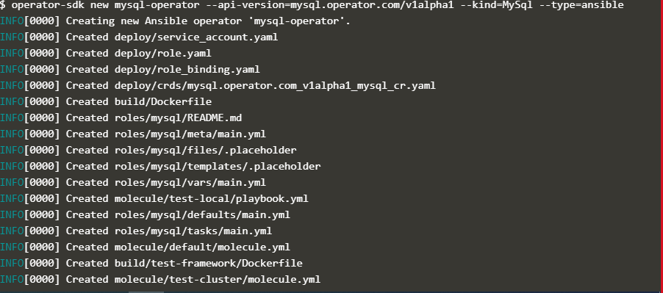
2. Create PV and PVC



1. Create configmap to define mysql variables



1. Create CRD
2. Build Image



1. Push the Image



1. Create all the resources present in deploy folder

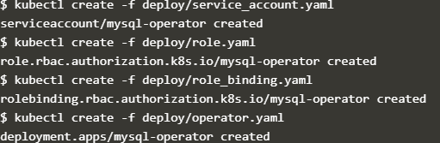

1. Check the operator and CR pod

