author(s) : Mayank Singhal/Sudhakar
For internal use
CI/CD implementation on amos
document number : CCT-FFF-XXXX
version :
status : Draft
source : Atos
document date : 16 October 2018
number of pages : 9

© Copyright 2018, Atos Nederland B.V. All rights reserved. Reproduction in whole or in part is prohibited without the prior written consent of the copyright owner. For any questions or remarks on this document, please contact Atos, +31 6 30327382.
Contents

1 Preamble

2 Steps to deploy services on OpenShift

3 Steps to Configure Pipeline

List of changes
Version | Date | Description | Author(s)
0.1 | 16-10-2018 | Initial version | Mayank Singhal/ Sudhakar

Preamble
This document describes the CI/CD implementation of OpenShift on AWS. It demonstrates configuring Jenkins, Nexus, SonarQube, GOGS. It also describes fetching the code from GOGS then build the application, code quality analysis in sonar, artifact upload to nexus and deployment of image on the different projects.

A Pipeline is a user-defined model of a CD pipeline. A Pipeline's code defines your entire build process, which typically includes stages for fetching the code, building an application, testing it, doing code quality analysis through SonarQube, artifacts uploading to nexus and deploying it. A pipeline can be configured to several stages where the user will be having clear visibility of the entire process by looking at the stages. If any error occurs the user can directly go to that stage and can find the issue.

The picture bellows, gives a simplified view of CI/CD implementation on OpenShift:

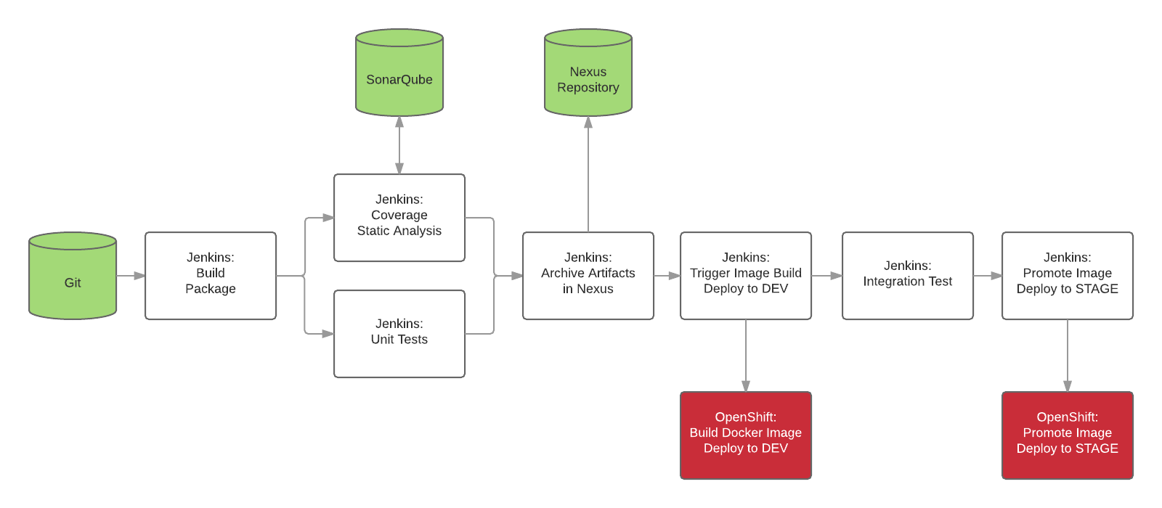

Steps to deploy services on OpenShift
- Deploying Jenkins, Nexus, Sonar and GOGS
- Configuring GOGS, Nexus, Sonar and Jenkins
- Openshift configuration for pipeline

- Deploying Jenkins, Nexus, Sonar and GOGS
Below steps describe how to create Jenkins, Nexus, Sonar and GOGS in the OpenShift for our CI/CD implementation

- First login into the OpenShift web console.

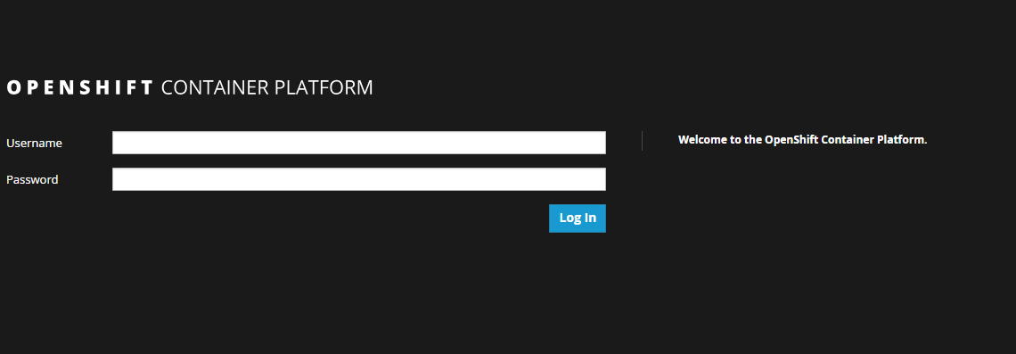

- Create project in OpenShift.

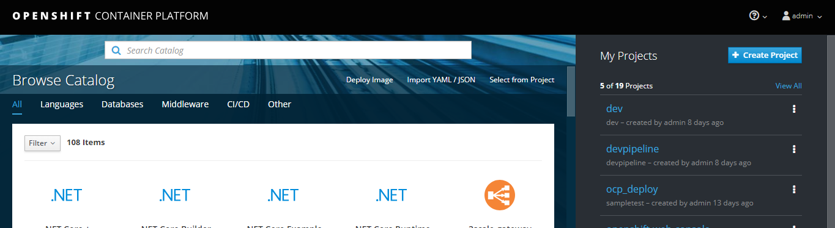

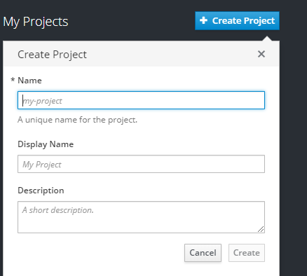

Give a name to the project, Displayname and a short description of its usage. Now the project has been created with nothing in it.

- Go to Add to project and click on Browse Catalog and select Jenkins.

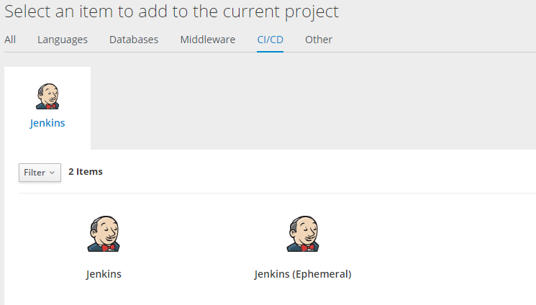

- Deploy GOGS using the below command:
oc process -f http://bit.ly/openshift-gogs-persistent-template --param=HOSTNAME=gogs.apps002.amosdemo.io --param=GOGS_VERSION=0.11.4 | oc create -f –

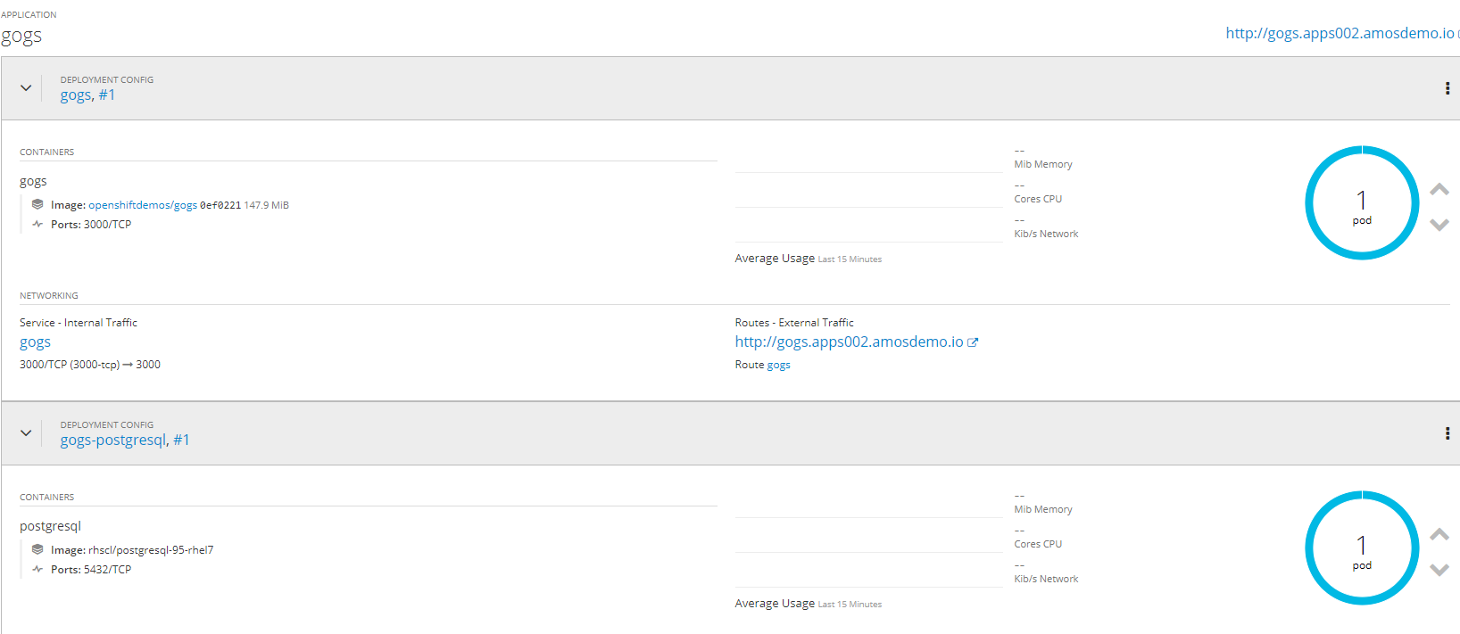

Now, click the gogs url and click on Register to sign up:

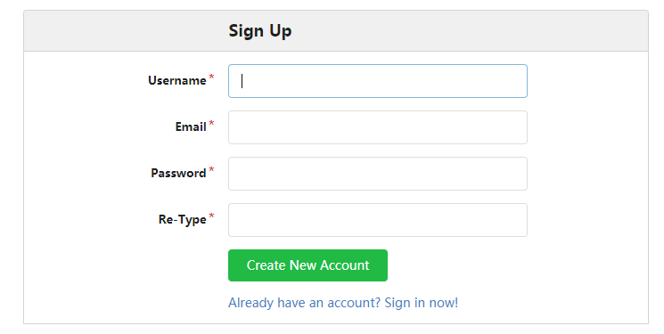

Now Sign in with your credentials and create the repository

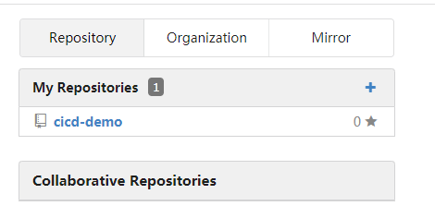

- Deploy NEXUS to store the artifact using the below command:

oc new-app sonatype/nexus3

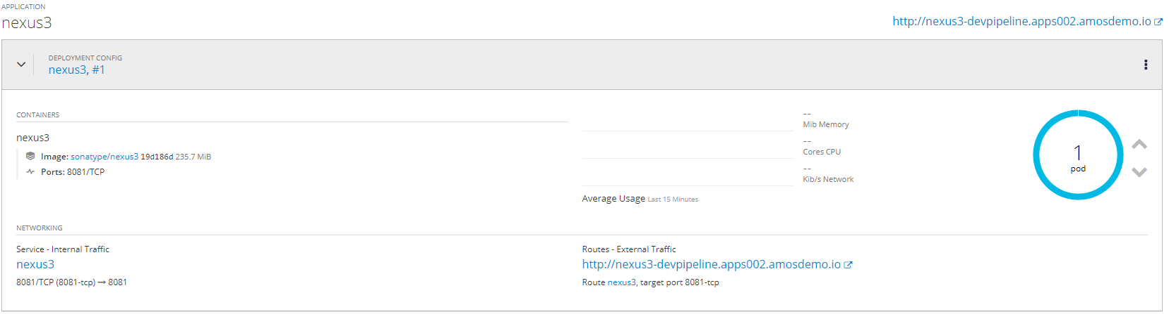

Now Sign in nexus using admin(username) & admin123(password) after logged in click on settings tab and go to Reositories:

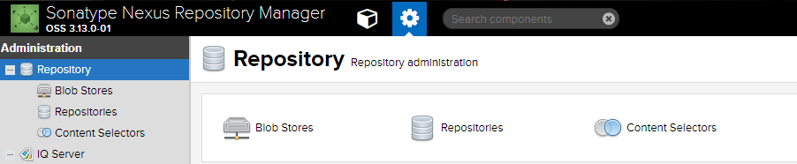

click on create repository and select the folloing to create the rerpository:

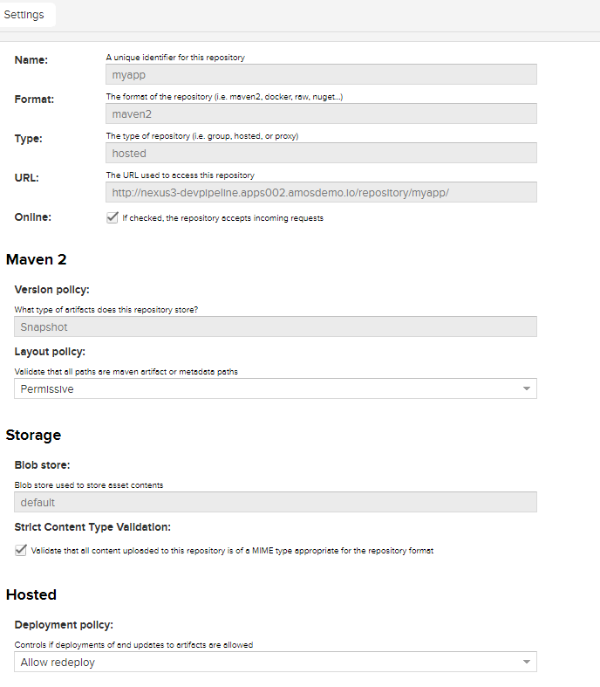

- Deploy SonarQube for code analysis using below command:

oc new-app -f sonarqube-postgresql-template.yaml --param=SONARQUBE_VERSION=6.7

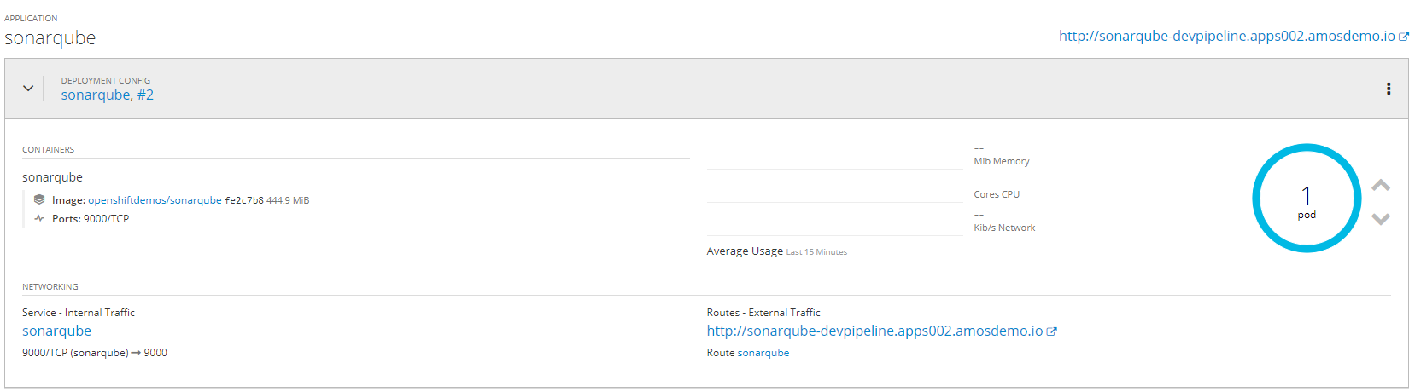

Steps to Configure Pipeline

- Go to Add to project then click on Import YAML/JSON and copy paste the code in the below attached file:

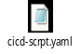

- Now click on save and under Builds go to Pipeline and click on start pipeline, after successful execution of pipeline you will see the below output:

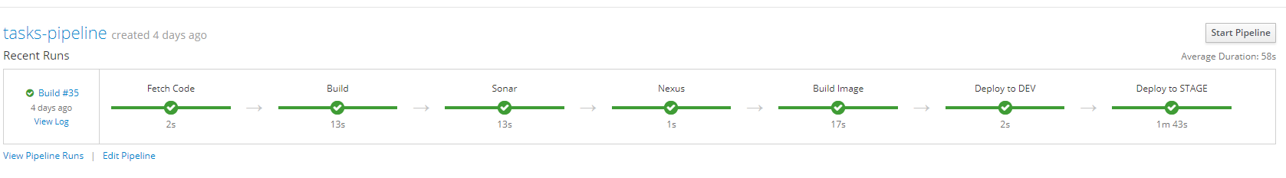

- In the first stage we are fetching the code from GOGS by passing the repository URL.

- In the second stage i.e. Build Stage we are building the code with the help of build tool.

- In the third stage code quality is being done by SonarQube.

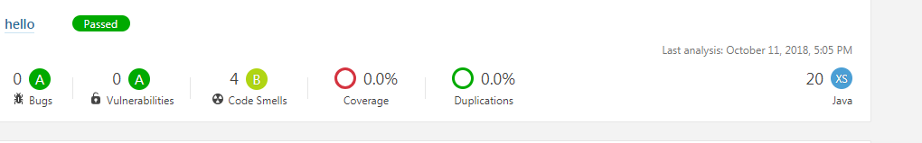

- After the successful analysis of code, the build artifacts are being uploaded to Nexus.

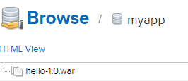

- Now in the Build image stage image will be build, from the artifact and that image can be deployed to dev and stage projects.

