





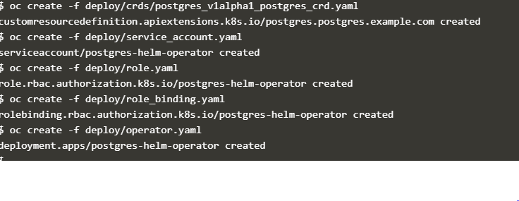

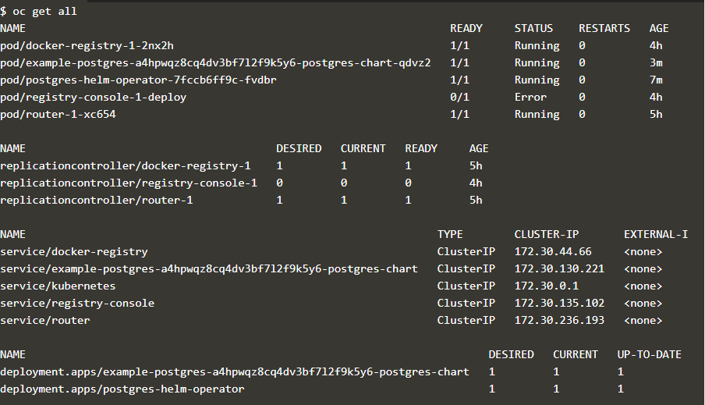



**Issue faced:**

I am getting error while creating the CR pod it was due to service account issue.

To resolve it I have provided admin access to service account by using the below command:

**oc adm policy add-cluster-role-to-user cluster-admin system:serviceaccount:default:postgres-helm-operator -n default --as system:admin**