🚨 CrisisLens
Data Analytics on Disaster-Related Tweets: A Text Classification Case Study
Project Report
Prepared by: Mayank Kumar Sinha
Internship ID: IBMUEDA5524
B.Sc. Data Science
NSHM College of Management & Technology
September 2026

Contents
1. Introduction 3
2. Objective 3
3. Dataset Description 3
4. Analytics Methodology 5
4.1 Data Cleaning & Preparation 5
4.2 Feature Engineering 6
4.3 Predictive Modeling 6
5. Results & Analysis 6
6. Reporting & Deployment 8
7. Conclusion & Future Work 8
8. Tools & Technologies Used 9

1. Introduction
Social media platforms like Twitter/X generate a continuous stream of unstructured, real-time data during emergencies and disasters. Making sense of this data — separating genuine disaster reports from unrelated "noise" — is a practical data analytics problem: words like "fire", "ablaze", or "wreck" are frequently used metaphorically or in unrelated contexts, so raw keyword counts alone are unreliable. This project, CrisisLens, applies a structured data analytics workflow to a labeled tweet dataset: exploring and quantifying patterns in the data, engineering features from unstructured text, and using statistical/predictive models to classify tweets as disaster-related or not — turning raw text data into an actionable, interpretable signal.
The project follows the standard data analytics lifecycle: data collection & inspection, data cleaning, exploratory data analysis (EDA), feature engineering, predictive modeling, performance evaluation, and presentation of insights through a reporting dashboard (an interactive Streamlit application).

2. Objective
- Explore and quantify patterns in a labeled tweet dataset through exploratory data analysis (EDA).
- Clean and structure unstructured tweet text into an analyzable format.
- Engineer quantitative features (TF-IDF) from text data for statistical modeling.
- Apply and compare multiple analytical/predictive models to classify tweets.
- Evaluate model performance using standard analytics metrics and select the best-performing approach.
- Present findings and predictions through an interactive data dashboard (Streamlit).

3. Dataset Description
Dataset Source: Kaggle (kaggle.com/datasets/vstepanenko/disaster-tweets)
The dataset (tweets.csv) contains 11,370 tweets with the following data fields (columns):
- id — unique identifier for each tweet
- keyword — a keyword extracted from the tweet (may be blank)
- location — user-reported location (frequently missing, ~30% null)
- text — the raw tweet text (the primary unstructured data field analyzed in this study)
- target — the label: 1 = real disaster, 0 = not a disaster
Data profiling shows the target classes are imbalanced: approximately 81.4% of tweets are labeled as non-disaster and 18.6% as disaster-related. This imbalance was identified during EDA and explicitly accounted for during modeling.
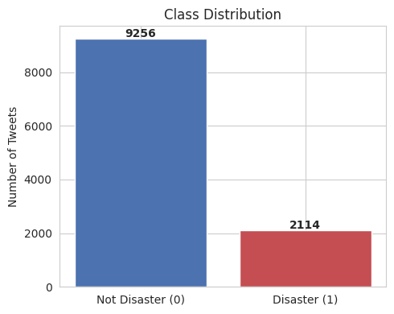
Figure 1: Class distribution of the target variable
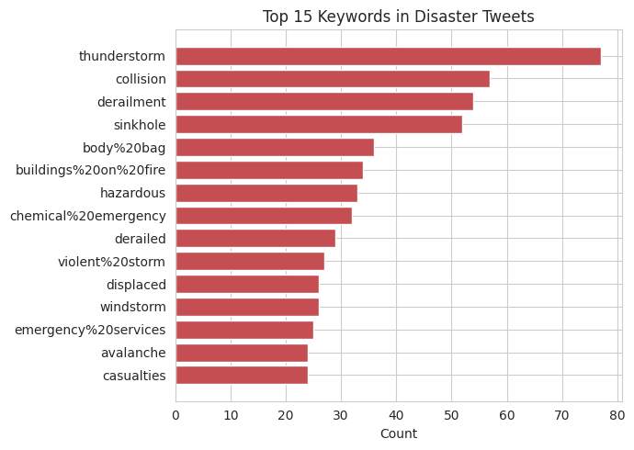
Figure 2: Top 15 keywords appearing in disaster-labeled tweets
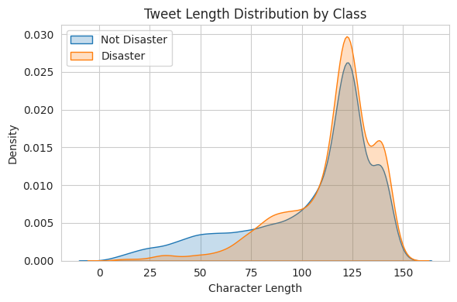
Figure 3: Tweet character-length distribution by class

4. Analytics Methodology

4.1 Data Cleaning & Preparation
Each tweet was cleaned and standardized using the following steps, implemented with Python's re module and NLTK, to convert raw unstructured text into an analysis-ready format:
- Lowercasing all text
- Removing URLs (http/https/www links)
- Removing @mentions
- Removing the '#' symbol while retaining the hashtag word
- Removing punctuation, digits, and special characters
- Removing English stopwords (NLTK stopword list)
- Lemmatizing remaining tokens (NLTK WordNetLemmatizer) and dropping tokens shorter than 3 characters
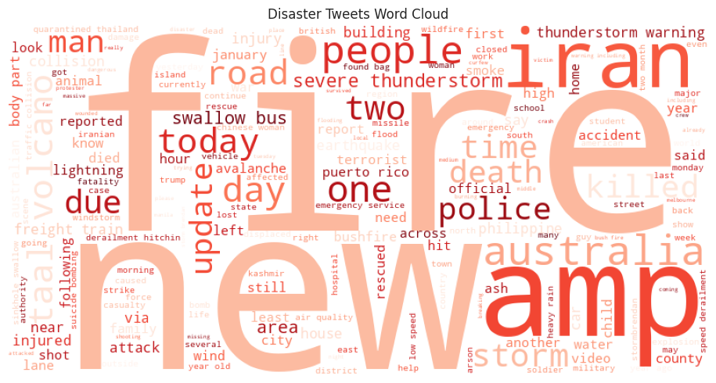
Figure 4: Word cloud of cleaned disaster tweets
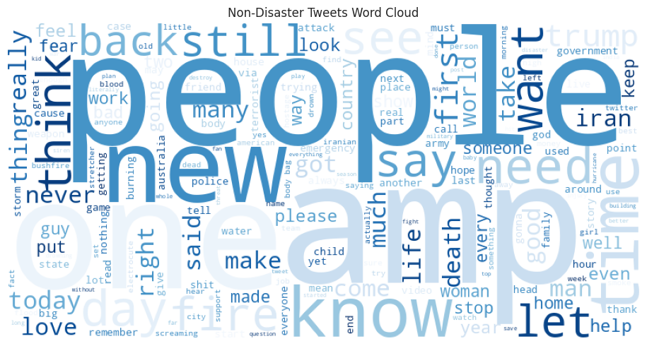
Figure 5: Word cloud of cleaned non-disaster tweets

4.2 Feature Engineering
Cleaned text was converted into quantitative, analyzable features using TF-IDF (Term Frequency–Inverse Document Frequency) vectorization, configured with unigrams and bigrams (ngram_range = (1,2)), a maximum feature set of 8,000 terms, and a minimum document frequency of 2. The data was split into an 80% training set and a 20% test (validation) set using stratified sampling to preserve the class ratio for reliable performance analysis.

4.3 Predictive Modeling
Four analytical models were applied to the engineered features and compared:
- Logistic Regression — with class_weight = 'balanced' to counter class imbalance
- Multinomial Naive Bayes — a standard baseline for text classification
- Linear SVM — with class_weight = 'balanced', wrapped in CalibratedClassifierCV for probability outputs
- XGBoost — gradient-boosted trees with scale_pos_weight tuned to the class ratio

5. Results & Analysis
All four models were evaluated on the held-out 20% test set using standard analytics performance metrics — Accuracy, Precision, Recall, F1-score, and ROC-AUC:
Model | Accuracy | Precision | Recall | F1-Score | ROC-AUC
Logistic Regression (Best) | 0.852 | 0.579 | 0.747 | 0.652 | 0.906
Multinomial Naive Bayes | 0.869 | 0.883 | 0.340 | 0.491 | 0.887
Linear SVM | 0.880 | 0.748 | 0.532 | 0.622 | 0.901
XGBoost | 0.850 | 0.590 | 0.641 | 0.615 | 0.873

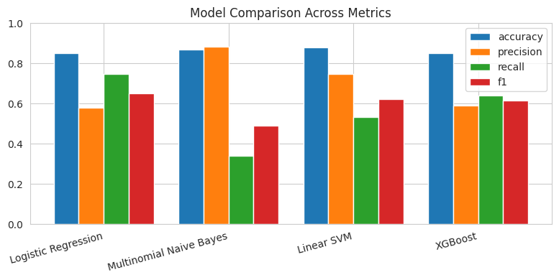
Figure 6: Comparison of Accuracy, Precision, Recall and F1 across models
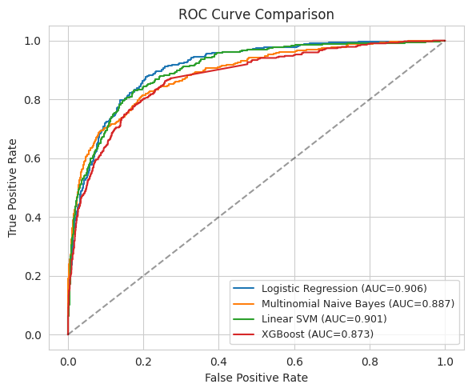
Figure 7: ROC curves for all four models
Logistic Regression was selected as the best-performing model for this analysis. While Linear SVM achieved slightly higher raw accuracy, Logistic Regression achieved the best F1-score (0.652) and ROC-AUC (0.906), and — critically — the highest recall (0.747) among all models. In a disaster-detection setting, failing to flag a real disaster tweet (a false negative) is a far more serious error than a false alarm, making recall a key metric to prioritize in this analysis.
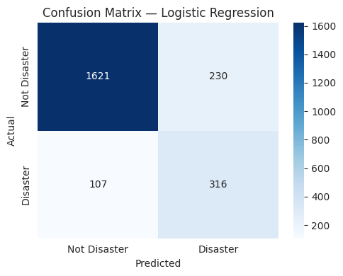
Figure 8: Confusion matrix for the final Logistic Regression model

6. Reporting & Deployment
The final trained model and the fitted TF-IDF vectorizer were serialized using joblib and integrated into an interactive Streamlit data application (app.py), allowing non-technical users to explore the analysis and generate predictions without touching code. The application provides three views:
- Single Tweet Classification — a text box where a user can type or select an example tweet and instantly receive a Disaster / Not Disaster prediction with a confidence score.
- Batch CSV Classification — users can upload a CSV file of tweets and download the file with predictions and probability scores appended for every row, supporting bulk data analysis.
- Insights Dashboard — a gallery of all EDA and evaluation charts (class distribution, keyword frequency, word clouds, model comparison, ROC curve, confusion matrix) generated during the analysis.

7. Conclusion & Future Work
This study demonstrates a complete data analytics workflow applied to unstructured social media text — from raw data exploration to a predictive, deployable reporting tool. A TF-IDF + Logistic Regression pipeline proved to be an effective and interpretable analytical approach, achieving strong recall and ROC-AUC despite the class imbalance uncovered during EDA.
Potential directions for extending this analysis include:
- Using contextual embeddings (e.g. BERT, DistilBERT) to better capture semantic meaning.
- Hyperparameter optimization via GridSearchCV or Optuna.
- Incorporating the keyword and location columns as additional structured features for richer analysis.
- Adding SHAP-based explainability to the dashboard so users can see which words drove each prediction.

8. Tools & Technologies Used
- Language: Python 3
- Data handling & analysis: Pandas, NumPy
- Text preprocessing: NLTK (stopwords, WordNetLemmatizer)
- Feature engineering: Scikit-learn TfidfVectorizer
- Predictive models: Scikit-learn (Logistic Regression, Naive Bayes, SVM), XGBoost
- Data visualization: Matplotlib, Seaborn, WordCloud
- Reporting dashboard: Streamlit
- Environment: Jupyter Notebook

