How Insurers can leverage Data & analytics in Insurance to Reduce Indemnity Spend

# Abstract

From previous.

# Introduction

Previous and Changes

# Claims Value Chain- Rethinking the Future

There is pressure on insurers from all directions for profitability. Insurers have been unable to raise premiums in tandem due to high price competition in the market. This gives little leeway for insurers in handling important operations in traditional ways and instead look for new opportunities. In processes like claims insurers indemnity savings are reduced by issues like-

1. Fraudulent claims-
   1. 107,000 fraudulent insurance claims worth £1.2 billion uncovered by insurers in 2019 up 5% from 2018. That is a new scam uncovered every five minutes – 300 a day. £11,500 average value of fraud claim. (<https://www.abi.org.uk/news/news-articles/2020/09/detected-insurance-fraud/?timeout=s>).
   2. Motor insurance frauds remained the most common, up 6% in number to 58,000 on 2018. Around 75% of fraudulent motor claims contain a personal injury element – this may reflect some fraudulent activity ahead of the introduction of personal injury reforms in April next year
   3. Property frauds showed a significant increase. There were 27,000 dishonest claims detected worth £124million – a rise of 30% in number and 8% in value on 2018.
   4. £1.18bn detected fraud. Over 98,000 detected cases of attempted claims fraud in 2018 - a 6% decrease in volume compared to 2017. motor fraud Fraudulent motor claims were the most common, with over 54,000 cases in 2018, and valued at £628m. liability fraud Volume of fraudulent liability claims is largely unchanged from last year, with just over 19,000 detected, but valued at £416m. An almost 8% increase on the value of claims detected last year. (https://www.abi.org.uk/globalassets/files/publications/public/key-facts/key_facts_2019_spread.pdf)
2. Increasinc claims cost-
   1. According to the Association of British Insurers (ABI), the average comprehensive motor insurance premium paid in the UK during the fourth quarter of 2019 was 3% compared with previous quarter. However, the average premium for 2019 as a whole fell 1% relative to 2018, compared with claims inflation estimated at 5-8%. The 3% gain in UK motor insurance prices in Q4 also followed a 5% decline spread over seven quarters beginning in Q4 2017. At the same time, the average annual comprehensive motor premium paid over 2019 as a whole was £471, down from £477 in 2018.
   2. Claims inflation is driven in part by rising repair costs due to more sophisticated vehicle designs and in-car technology, with repair bills rising 11% in the first half of 2019 alone. But Moody’s believes only gradual price adjustments will be possible in UK motor, given the highly competitive conditions in the market, meaning insurers’ underwriting results are likely to be eroded further.
   3. This lag between price increases and claims inflation will be further exacerbated by the lower-than-expected increase in the Ogden rate that UK courts use to calculate lump sum compensation payments to personal injury victims. Analysts also noted that the revision of the Ogden rate has affected reinsurers with exposure to the UK motor liability sector and has led to market-wide excess of loss repricing, thereby increasing UK motor insurers’ costs. (https://www.reinsurancene.ws/uk-motor-claims-inflation-outpacing-rate-increases-moodys/)
3. Moving towards Sustainable claims resolution-
   1. Moving towards sustainible claims by using green parts in motor to contribute towards environemnt, customer satisfaction and profitability.
4. Regulatory Changes, Inflation Pressure and Broader Market trends-
5. Optimization of processes-
6. Transparency and Customer Visibility - __ Customer regularly complain that they are unhappy due to black box type model in Insurance claims handling. — . Seventy-five percent of policyholders would prefer to speak to only one representative of their insurance company during the claim process. • Those who spoke with three or more representatives were five times as likely to be dissatisfied. • Nearly one in five said their claim experience would keep them from referring their insurance company to their friends. (https://insuranceblog.accenture.com/wp-content/uploads/2013/07/Rethinking_Claims-Achieving_High_Performance_in_the_Insurance_Industry_through_Claims_Transformation.pdf)
7. Intelligent automation-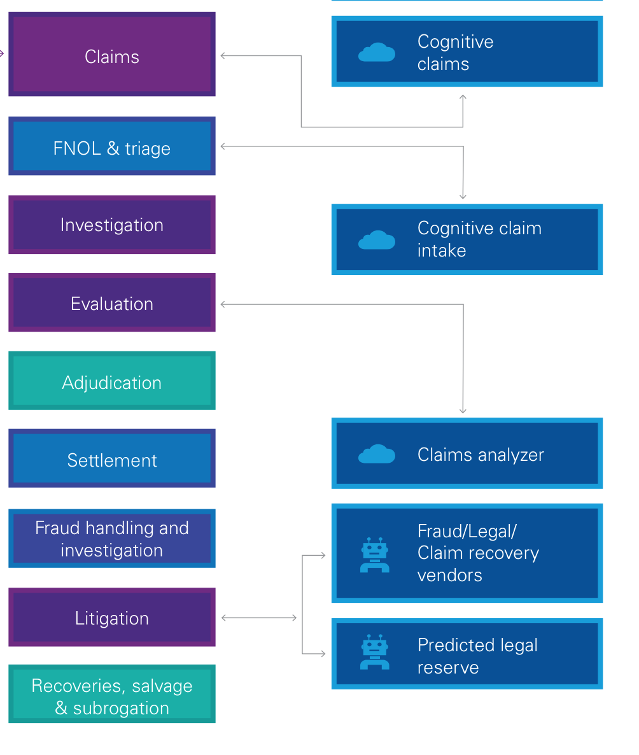

The pillars of such a transformation are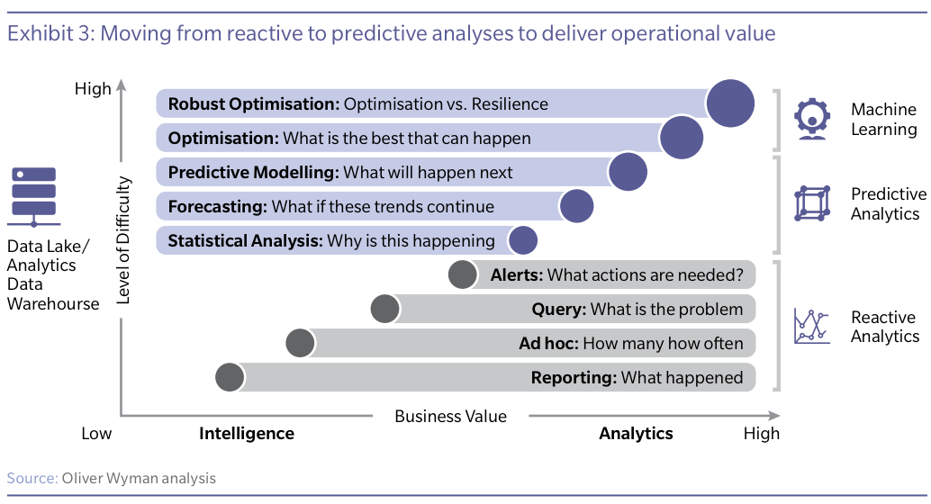

# Data and Analytics

Framework

Moving from reactive to proactive approach.

1. Estimation
2. Prescription
3. Traiging

# Process Transformation

# People Skills

# Technology Disruption