Job Market Reality Check
Analyzing Data Analyst Job Postings to Identify In-Demand Skills, Salary Drivers, and Regional Trends

1. Project Overview
This project analyzes 2,253 real-world Data Analyst job postings (scraped from Glassdoor) to answer a practical, personal question: which tools and skills are actually in demand in today's job market, which ones command higher salaries, and how does demand vary by city? Unlike a generic sales-dashboard project, this analysis is framed as a self-directed market research exercise for someone actively targeting a Data Analyst role — using Python, SQL, Excel, and Power BI end-to-end.

2. Dataset Summary
- Rows: 2,253 job postings scraped from Glassdoor
- Key Fields: Job Title, Company Name, Location (City/State), Salary Estimate, Rating, Industry, Sector, Company Size, Type of Ownership, and full Job Description text
- Engineered Field: Extracted a structured skills list (Python, SQL, Excel, R, Power BI, Tableau, SAS, Statistics, ETL, AWS, JavaScript, etc.) from the unstructured Job Description text using keyword-based text parsing

3. Data Cleaning & Skill Extraction using Python
Data preparation and feature engineering were performed in Python before loading into SQL:
- Data Cleaning: Removed duplicate postings and rows with missing job descriptions.
- Column Standardization: Renamed columns to snake_case for consistency across tools.
- Salary Parsing: Parsed messy salary text (e.g., "$65K–$85K (Glassdoor est.)") into a single average numeric salary field.
- Location Split: Split the Location field into separate city and state columns.
- Skill Extraction: Searched each job description for a predefined list of 20+ tools/skills (python, sql, excel, power bi, tableau, r, sas, aws, etl, statistics, etc.) and stored the matches as a list per job.
- Database Load: Loaded the cleaned DataFrame into a PostgreSQL database (via SQLAlchemy) for structured querying.

4. Data Analysis using SQL (Business Questions)
Structured analysis was performed in PostgreSQL to answer key market-research questions:

4.1 Most In-Demand Skills Overall
Identified which skill combinations appear most frequently across all postings.
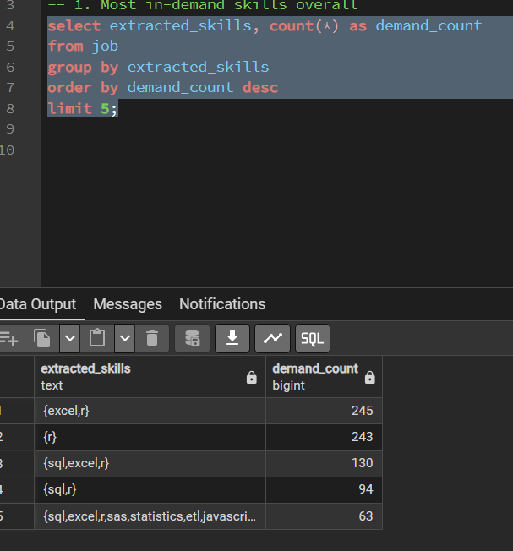
Fig 1. Excel and R are the most frequently paired skills across postings, followed closely by SQL + Excel + R.

4.2 Which Skills Correlate with Higher Salary
Grouped postings by extracted skill sets and compared average salary, filtered to combinations appearing in more than 10 postings.
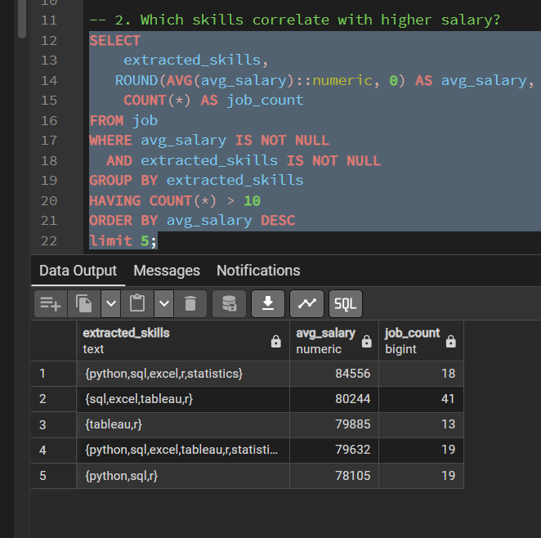
Fig 2. Postings requiring Python + SQL + Excel + Statistics command the highest average salary (~$84,556), ahead of single-tool or two-tool combinations.

4.3 Top Cities by Number of Postings
Ranked cities by total job posting volume to identify the largest Data Analyst job markets.
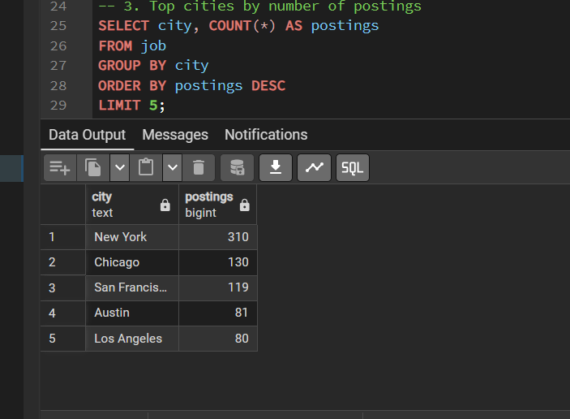
Fig 3. New York leads by a wide margin (310 postings), followed by Chicago and San Francisco.

4.4 Skill Demand by City
Broke down which specific skills are requested most within each city, to spot regional differences in tool demand.
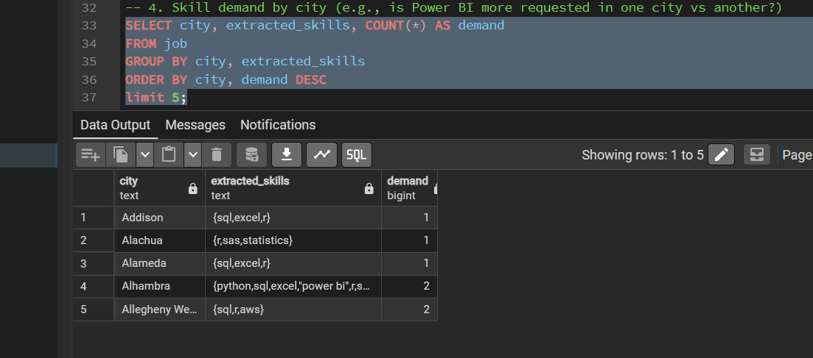
Fig 4. Skill combinations vary meaningfully by city — useful for tailoring a job search or resume by location.

4.5 Ranking Skills Within Each City (Window Function)
Used the RANK() window function, partitioned by city, to identify the single most in-demand skill combination in every city — a more advanced SQL technique than a simple GROUP BY.
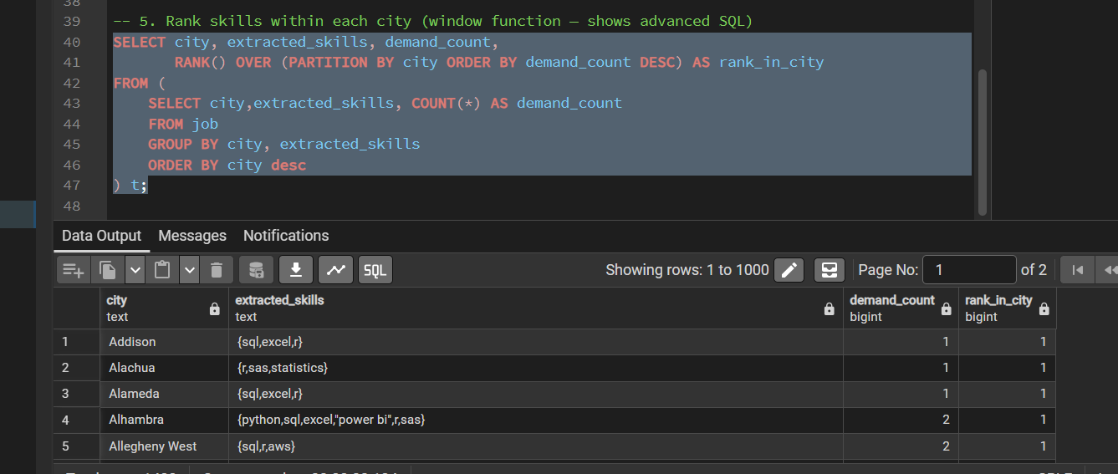
Fig 5. RANK() OVER (PARTITION BY city ORDER BY demand_count DESC) surfaces the #1 skill combination per city.

4.6 Salary Distribution by Seniority Level
Classified postings into Junior, Mid/Unspecified, and Senior based on job title keywords, then compared average salary across levels.
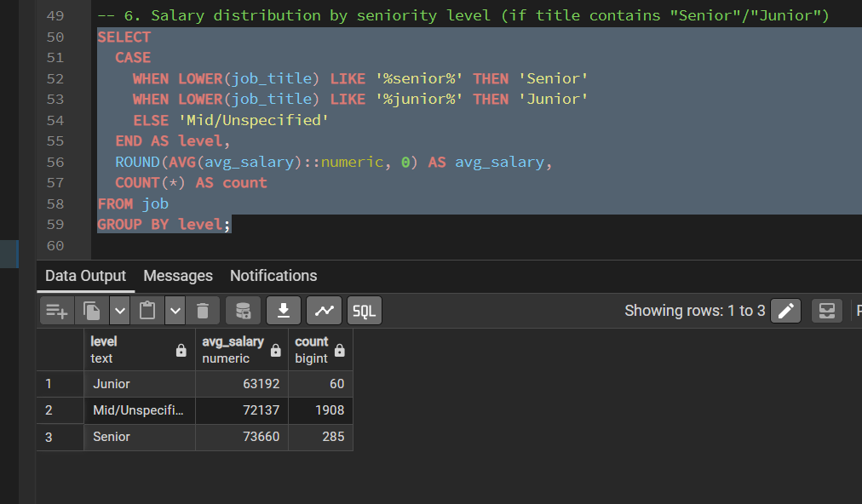
Fig 6. Senior roles average $73,660 vs. $63,192 for Junior roles — Mid/Unspecified dominates by volume (1,908 postings).

5. Data Analysis using Excel
A parallel lightweight analysis was built in Excel using Pivot Tables to cross-tabulate job titles, extracted skills, industry, and company size — demonstrating the ability to produce quick business reporting without a BI tool.
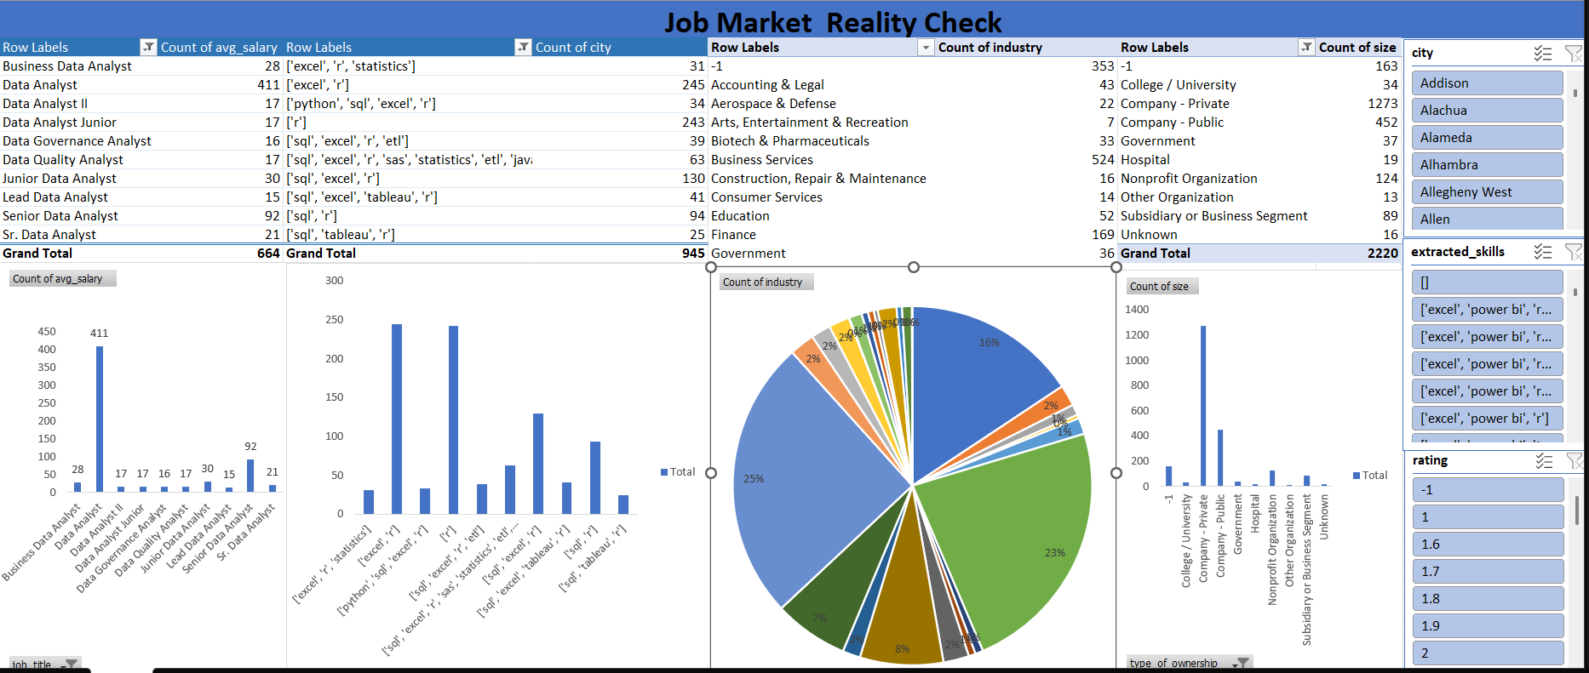
Fig 7. Excel Pivot Tables breaking down postings by job title, skill combination, industry, and company size, with an interactive city/skill/rating filter panel.
- Data Analyst is the single largest job title category (411 postings), followed by Senior Data Analyst (92).
- Company - Private accounts for the largest share of postings by industry/ownership type.
- Skill-combination filters make it easy to slice demand by any city or rating threshold interactively.

6. Dashboard in Power BI
Finally, an interactive Power BI dashboard was built to present the findings visually for a non-technical audience.
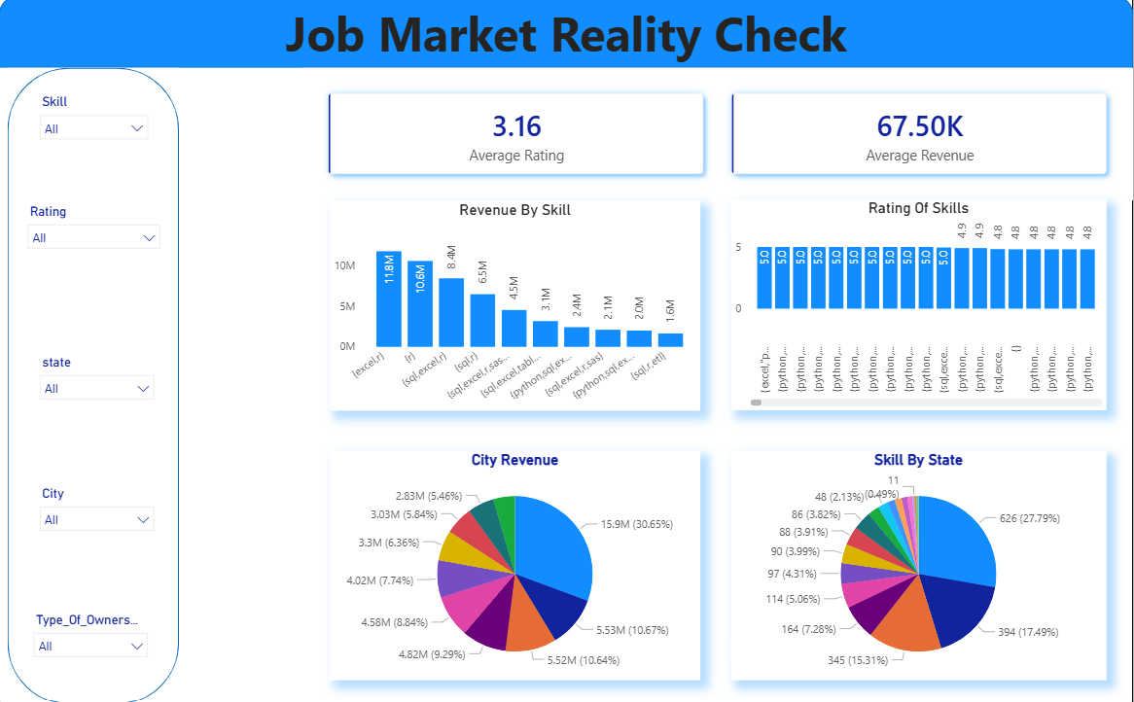
Fig 8. "Job Market Reality Check" dashboard — KPI cards for average rating and average revenue, skill-based revenue breakdown, skill ratings, city-level revenue share, and skill-by-state distribution, all filterable by Skill, Rating, State, and City.
- Excel + R is the single highest-revenue-associated skill pairing (11.8M), well ahead of the next closest combination.
- Postings requiring five or more tools (Python, SQL, Excel, Statistics, ETL, JavaScript) consistently rate 4.8–5.0 in average rating, suggesting more established companies post more complex requirements.
- A small number of cities account for a disproportionate share of total postings/revenue, reinforcing the SQL city-ranking findings.

7. Key Insights
- Excel and R remain the most universally requested tools, appearing far more often than Power BI or Tableau in this dataset — suggesting these fundamentals are still the baseline expectation for most Data Analyst roles.
- Multi-tool combinations (Python + SQL + Excel + Statistics) are associated with meaningfully higher average salaries than single-tool requirements — validating a multi-tool learning strategy.
- Demand is heavily concentrated geographically, with New York alone accounting for roughly 14% of all postings analyzed.
- Seniority has a real but moderate salary impact (~$10K average gap between Junior and Senior titles), smaller than the gap driven by skill set alone.

8. Business / Career Recommendations
- Build the Core Stack First – Prioritize Python, SQL, and Excel as the core toolset, since these appear together most consistently across high-salary postings.
- Add a BI Tool as a Differentiator – Since Power BI/Tableau appear in fewer postings but often alongside higher salary ranges, developing dashboarding skills can be a differentiator.
- Target High-Demand Markets – Given the concentration of postings in a handful of cities, tailor resumes and applications toward the highest-density markets identified (New York, Chicago, San Francisco).
- Reinforce Statistical Foundations – Statistics knowledge appears in the highest-paying skill combinations — worth reinforcing alongside tool proficiency.

