# **README**

(**Team**: LAMBDA)

(Members: Silei Song, Mayank Srivastava, Keenan Stewart)

## About the Project:

* This project is written in C++ language(using g++ compiler) and tested in Linprog.
* All the required points are covered in this project.
  + Implementation of Go-Back-N protocol to transfer messages and files(windows size fixed to 5 as stated).
  + UDP client-server programming.
  + This project handles list, exit, and get.
  + This project also handles “lost, out of sequence, and ack timed out errors.”
* Also, we have implemented makefile to compile and delete executable quickly.

## Instructions to compile:

To compile this project, we have implemented makefile.

* Commands to compile using the makefile
  + “make all”: To compile and create executable in Client and server folder.
  + “make clean”: To delete executable from the Client and server folder.
* Direct
  + Server : “g++ Server_folder/Server.cpp -o Server_folder/Server”
  + Client: “g++ Client_folder/Client.cpp -o Client_folder/Client”

## Instructions to Run program:

To run this code, open and run executable present at the “Client_folder” and “Server_folder.”

Steps:

1. Once the compilation is done, open two terminals (one for the Client and the other for the Server).
2. (Terminal 1) In the “Server_folder” type command “./Server 2734 1000”
   1. Syntax is: “./<executable_file_name> <server_port_no> <Chunk_size_in_bytes>
3. (Terminal 2) In the “Client_folder” type command “./Client 127.0.0.1 2734 1000 10”
   1. Synta is: “./<executable_file_name> <server_ip> <server_port> <Chunk_size> <loss_error_percentage>

## Instruction to execute commands in the program.

The Client will request the Server to list(ls) files or directory where the Server is present. The Client will also request the Server to get any file from the Server and store it in “Client_folder.”

Steps:

* When the client program will start.
  + Choose 1 to perform list, 2 to get (write filename when asked to), and 3 to exit Client successfully.
  + To exit the server, use “CTRL+C” to terminate it successfully.
* Based on the input provided in the command line argument. List, out of sequence, and time out errors are visible.

## Output(Screenshots)

Showing the screenshots of the project, compile and run successfully in the linprog.cs.fsu

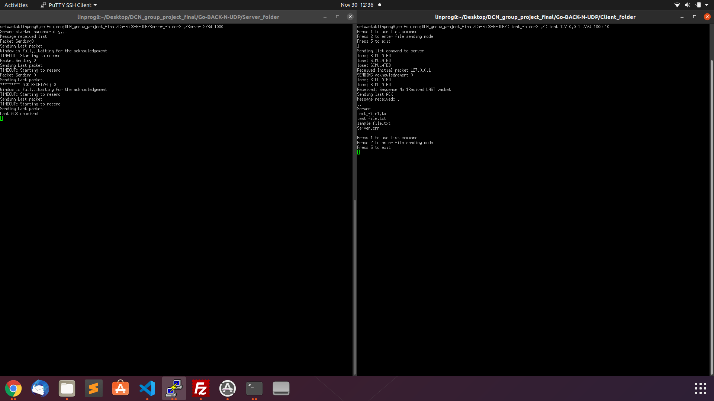

Snap 1: List command executed successfully using GO-BACK-N and UDP

## 

Snap 2: Showing get command, executed successfully using Go-Back-N and UDP

Note: The files used for the testing 15Kb, etc., are deleted since the data present in those files was from “Wikipedia” and can result in an unnecessary plagiarism issue.