- There is a small underline below Services & Solutions, whether user has clicked it or not, it should not be like this-


- Left and right arrows are too close to the content-
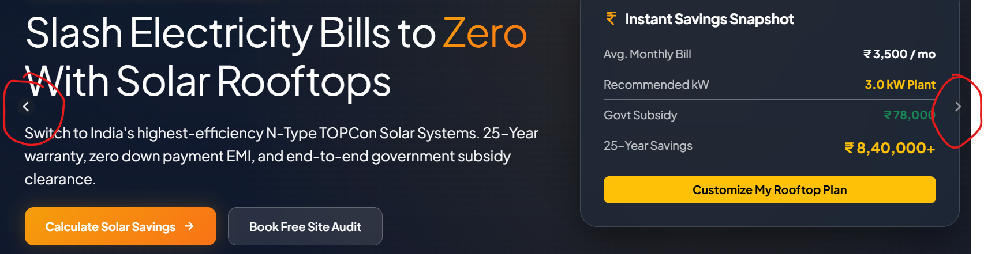

- “Why ADMA Solar”is almost invisible-
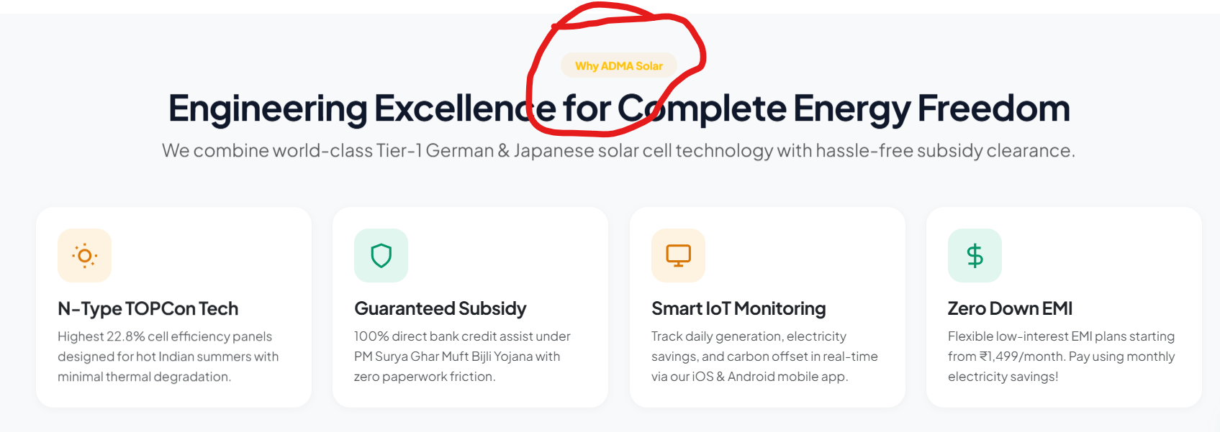

- It should be INR sign, and not dollar sign-
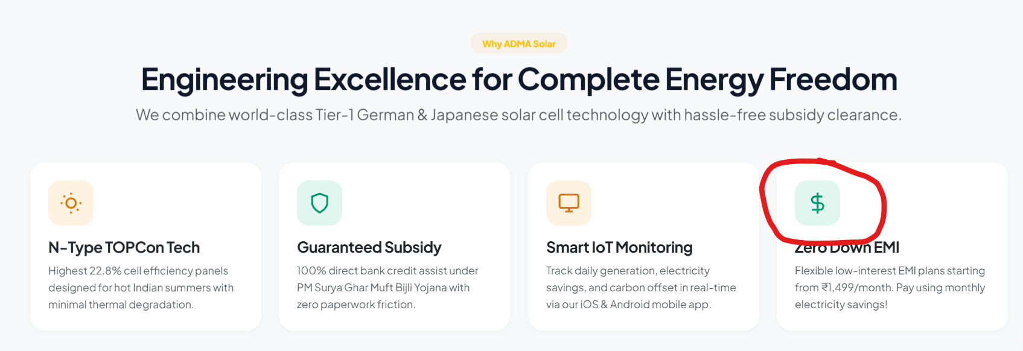

- Remove “our” from “via our iOS & Android mobile app.”-
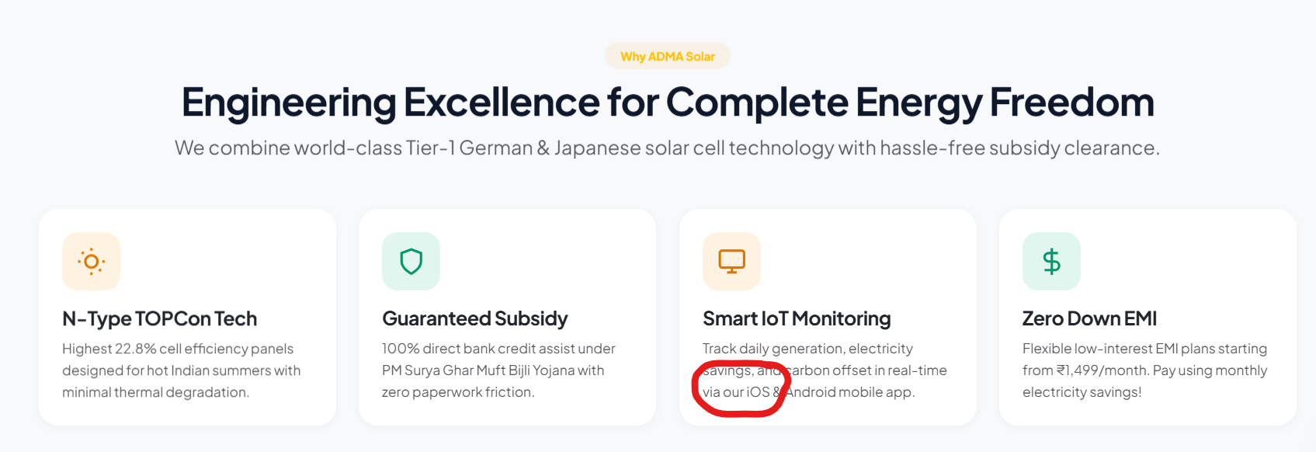

- “Solar Calculator” is almost invisible
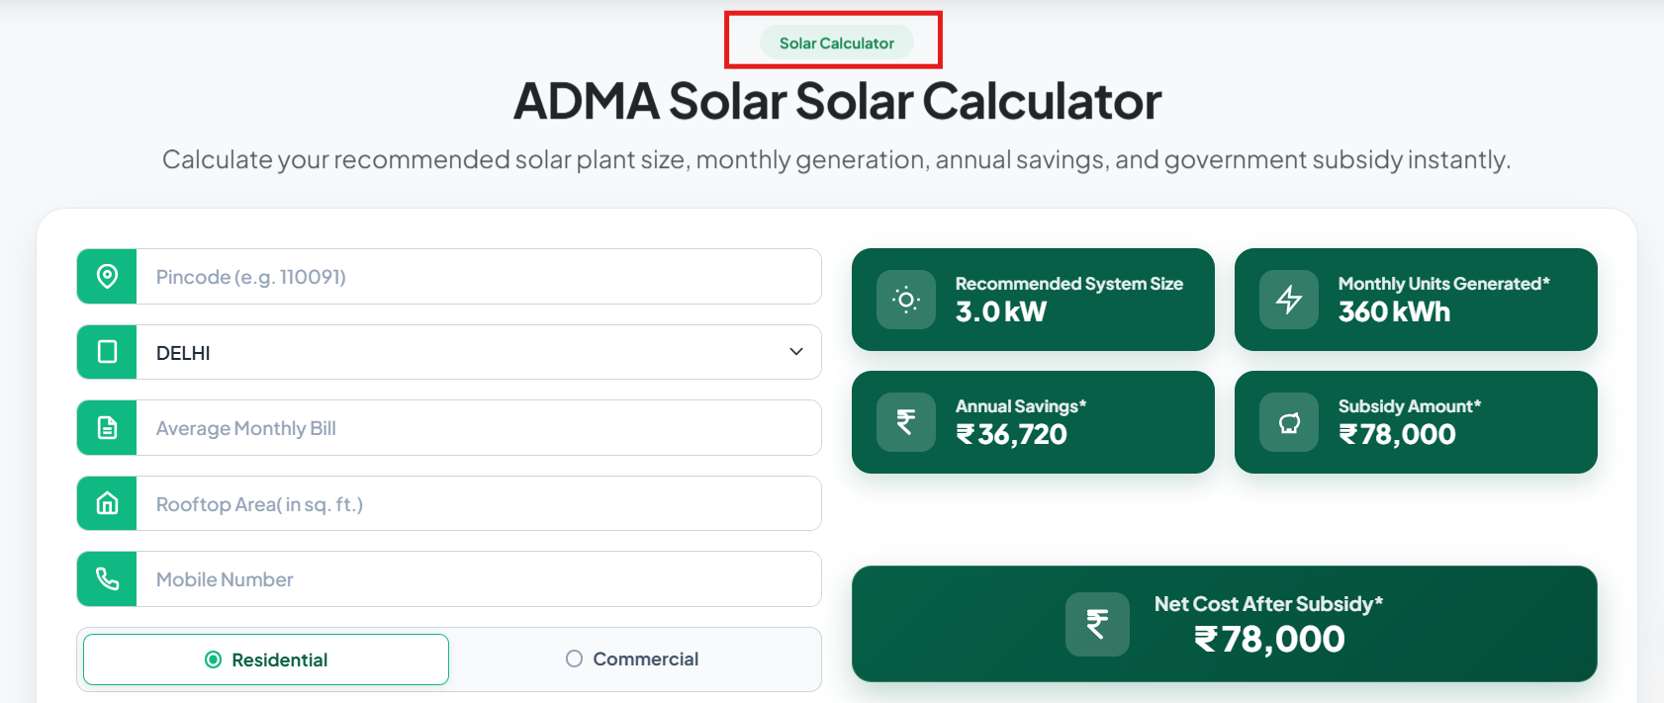

- It should be “ADMA Solar Savings Calculator”
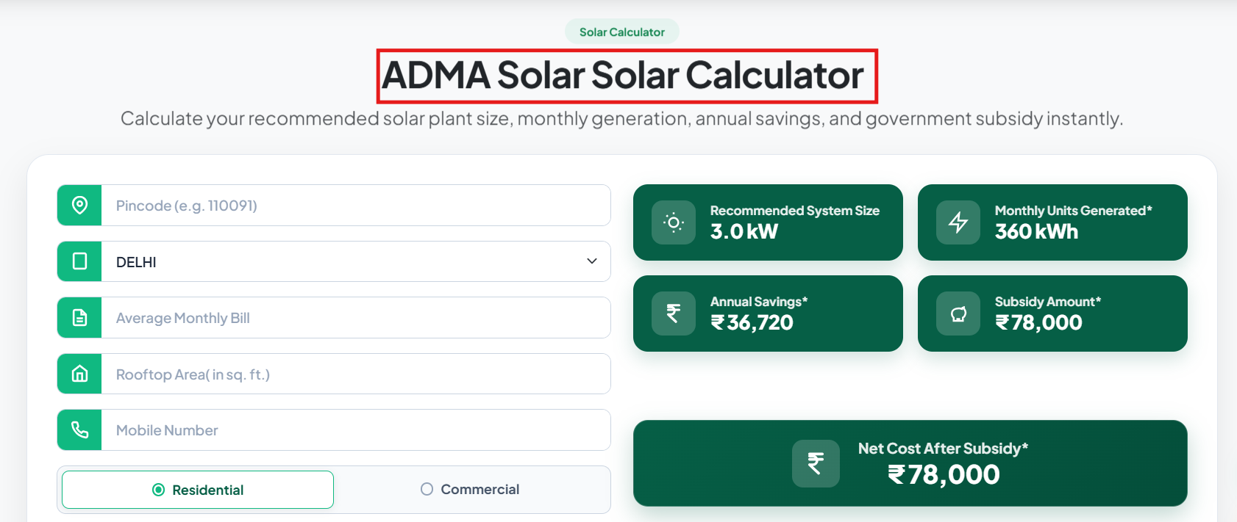

- The “Return to Top” button is moving when I’m trying to click it-
- We need to talk about the configuration excel based calculations-
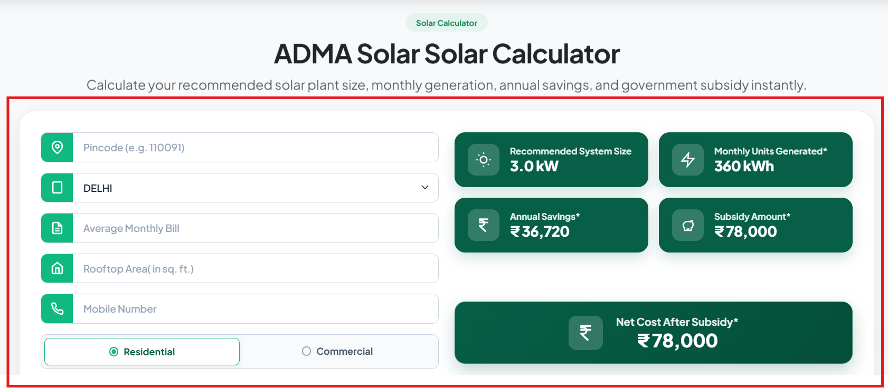

- Not very visible-
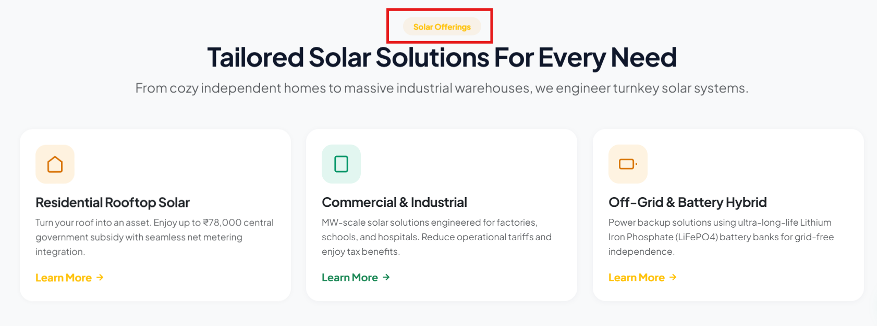

- Icons can be more aligned to the topic, for example icon above residential rooftop solar looks aligned but icons above commercial and off-grid does not align with the topic-
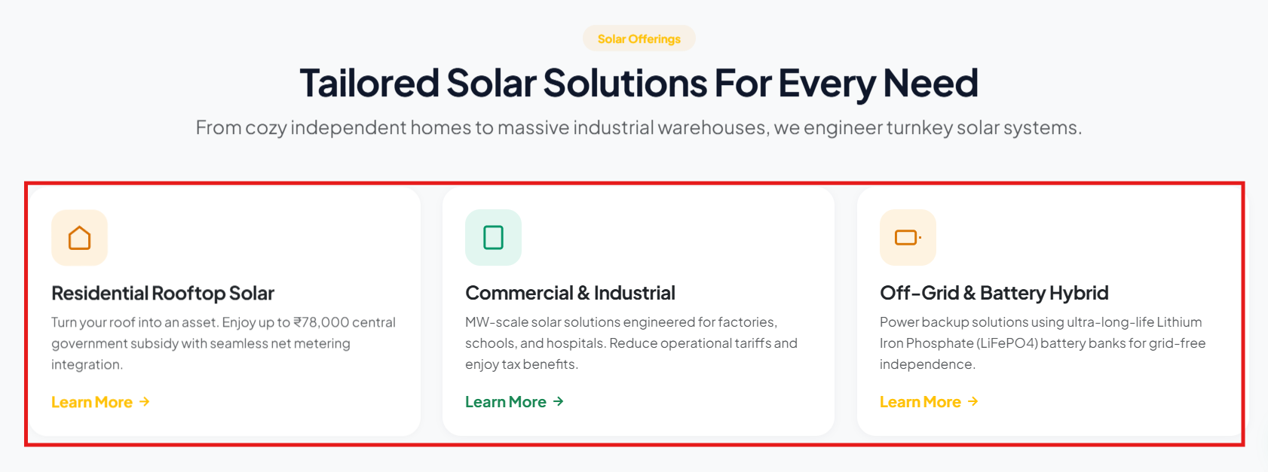

- Point the map to Ghaziabad location, later on we can add more locations-
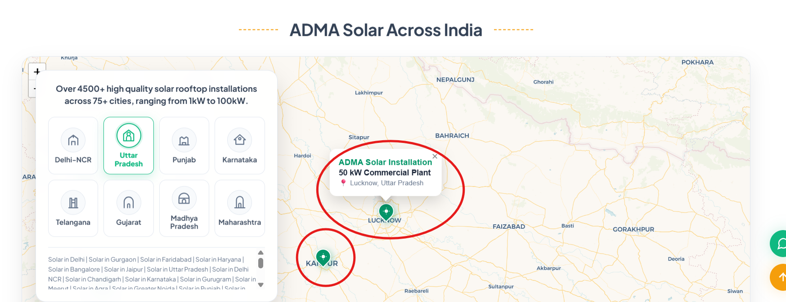

- Not ADMA Solar Panels, we are not the manufacturer of solar panels of any sort yet, remove the ADMA name from the question-
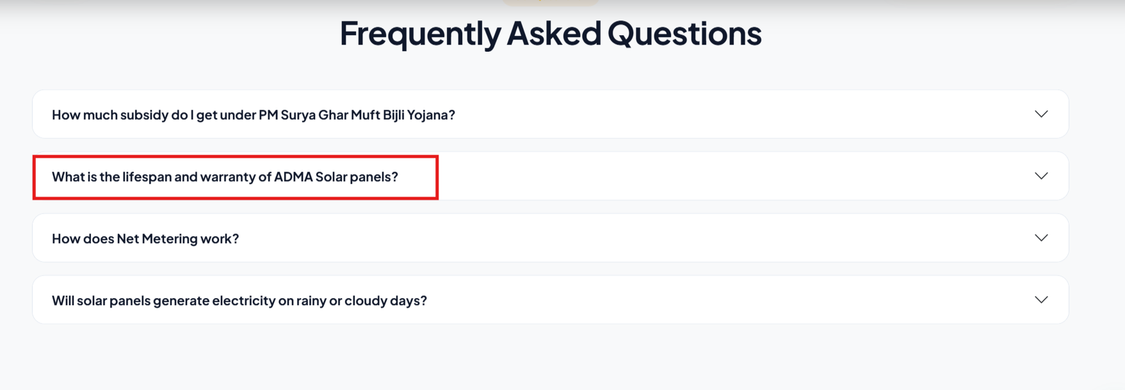

- Change the company name from SoalrNova to ADMA, and instead of Corporate office we can have contact us and can mention phone number (+91 7303397790) and email address-
