**INTRODUCTION**

In a general sense, financial development can be measured through the development of its financial sector which comprises of its market, instruments and institutions and including its regulatory framework. In broader sense, it can also understood as improvements in the information production, allocation of the capital, savings mobilizations and ease of goods and services exchange and also channelizing savings toward the best possible investments. The economy of a country is dependent on the financial development for its growth. So any improvement and upgradation in its financial sectors corresponds directly to the growth of an economy. The role of financial sectors in an economy’s growth is explained by many of previous studies as there is a positive relation between growth and expansion of a financial sector and the economy’s growth rate. Now the expansion of the financial sector can be achieved through developing and implementing policies for the smooth functioning of the financial sector. Moreover, financial development can also be defined as the improvement of the financial sector through the expansion of financial market’s size, stability and efficiency to channelize the savings in an economy towards the more profitable investments. On top of this there are many authors who argued that financial development plays a pivotal role in economic growth such as Schumpeter (1911) stated that “financial development is important for economic growth”. However there are other studies who thinks otherwise such as Robinson (1952) in his article stated that “financial development is a insignificant factor for growth”.

The financial development can also induces a positive effect on the economy by increasing the factors productivity and improving GDP of an economy as it increases the capital accumulation in an country by channelizing savings which later helps in boosting the economy and also provides rise in welfare of the citizens. According to King and Levine (1993), he stated that “ financial system fosters productivity improvement by choosing higher quality entrepreneurs and projects, mobilizing external financing for these entrepreneurs, providing superior vehicles for diversifying the risk of innovative activities and revealing more accurately the potentially large profits associated with the uncertain business of innovation”. Also according to some studies it can be noted that economically underdeveloped countries displays a weak financial sector and developed countries generally have a highly efficient and stable financial sector to foster its growth prospects. However, this study’s objective is to identify the relationship between the financial development and the economic growth for the developing, developed and under-developed countries combined and then providing the suggestions for the improvement in financial sector and laying the path for the future researches.

The rest of the paper is bifurcated in four sections. Where in the next section we will review the existing literature on this area of study briefly and examine their work. Then in second section we are going to provide the descriptive statistics on the variables under study. Then in third section we will conduct the confirmatory analysis of the regression model. Finally, in fourth section we will provide some conclusion of the study and some suggestion for the improvement of financial development and policy measures.

1. **LITERATURE REVIEW**

The role financial development has been given much of importance in many of the researches.

Hafnida Hasan (2018) stated in her article that “The finding indicates that there is long run relationship between financial development and economic growth. Meanwhile, a unidirectional relationship had been found, it come from economic growth to financial development. Therefore, a policy to increase economic growth will push forward in proper to improve financial development in Indonesia”. Also some other studies conform to this result that financial sector assists in many financial activities such as hedging, diversification and trading because for these activities to function properly we need a stable and efficient financial system. Levine (1997) in his article talks about financial sectors as channel between savings and real sectors by allocating credits. Added to this, Das and Guha Khasnobis (2008) pointed out that the channelized credit can also be utilized by financing the working capital requirements and even through investing it in fixed capital where working capital then cause the production to increase and increase in fixed capital leads to rise in productivity in real sector. Similarly there is another study by Biplab Kumar and Inder Skhar Yadav (2017) in which they supported the theory by examining the relation between both financial market and banking sector and growth of an economy. Thus it can be implied that development of financial market and banking sector is essential for the growth of an economy. Because it contributes towards the technological upgradations because a good and financial system helps the firms to get the sufficient funds for the efficient and productive use.

However, there are other studies which shows a different perspective towards the financial sector. As according to some studies it is observed that there is a minor role that is played by the finance in the growth of an economy on the other hand it is financial sector that is being developed through the growth in an economy. Also Wijnberg (1983) argued that “because of financial development, borrowers from informal sector shift to formal sector which in turn reduces the total supply of credit, thereby stifling economic growth of the concerned economy” which stressed on the point that financial sector plays minimal role in a growth of an economy. In addition to above argument, it has observed in some studies that in Asian economic crises of 1997 it was cleared that these financial sectors completely failed to channelizing the funds towards the profitable investments which further creates a room for the doubt that Is financial development really a driver of economic growth?.

Thus it can be observed that there is some cause and effect relationship between financial development and economic growth. But it might be minimal or non-existent we will going to determine it in our paper. However, we know for sure that in any case there will be the need to develop the financial sector of an economy in order to cope up with the demands which were create by the growth of an economy as it move toward becoming a developed nation.

1. **DATA, MODEL, VARIABLES AND DESCRIPTIVE STATISTICS**

The primary aim of this study is to provide the empirical evidence for the relationship between the financial development and the economic growth in developing, under-developed and developed countries. For which we used a basic panel data regression model with fixed effect or the random effect which is subjected to Hausman test. And on the basis of literature we had reviewed in the previous section suggests the use of Liquid liabilities to GDP, Central bank assets to GDP, Bank return on assets, Bank deposits to GDP and Bank credit to bank deposits ratios as the indicator of financial development. Also in order to get the data in normal distribution we transformed the variable into logarithm form. Thus the model takes the form as follows:

(Log of GDP)it = β0i + β1i(LLTG)it + β2i(CBAG)it  + β3i(BRA)it + β4i(BDG)it + β5i(BCBD)it + μit

Where, subscript i and t represents the country and time respectively. The Log of per capita GDP is the dependent variable which shows the per capita GDP in logarithmic terms. Also, the right side of equation depicts the independent variables where LLTG is the liquid liabilities to GDP in logarithm terms it basically denotes the ratio of liquid liabilities to GDP which also known as broad money measure M3. It includes the sum of deposits and currency in the central bank plus all other measures of M1 and M2. CBAG represents the central bank assets to GDP in logarithm terms. CBAG is the ratio of central bank assets to GDP where it denotes the central bank’s claim on domestic real non-financial sector. Now BRA denotes the Bank return on assets in log form where it shows the ratio of bank’s total net income and its total asset which very similar to return on investment for banks. BDG represents the bank deposit to GDP ratio in logarithmic terms. Where it show the size of financial market in a country. Lastly, BCBD or bank credit to bank deposit ratio shows the ratio between bank credits and bank deposits and it also used to assess the liquidity of a bank by making a comparison between its total loans and deposits for the same period of time. Where a higher ratio represents an inability of bank to meets their funds requirement and a lower ratio shows otherwise. In this study we took the indicators of financial development which shows the relative size and absolute size of a financial market. Whereas, liquid liabilities to GDP ratio is the crucial among others as it shows the measure of financial depth and the size of the financial sectors also it is among the broadest of all indicators due to its properties which suggests that it measures more correctly the role of financial sector in channelization of funds. Finally, μ is the error term which follows normal distribution with mean 0 and standard deviation 1 and the subscript i and t here represents the country and time respectively. And we have assumed that there is heterogeneity among the countries thus it is a heterogeneous model. Also here β0i, β1i, β2i, β3i, β4i and β5i are the beta-coefficients of the independent variables with subscript i denoting the country.

This study includes a group of 77 countries for the period of 20 years starting from 1996 to 2017. The data for the above countries have been extracted from the World Bank’s resources where the selection of the countries and time period is strictly in consideration of availability of the data. The countries are selected among the developed, under-developed and developing categories such as India, U.S, Russia, African countries, China, Pakistan, and Bangladesh etc.

The following table shows the descriptive statistics for the variables used in the study.

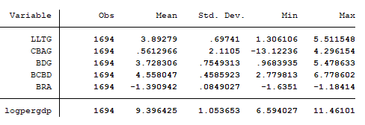

The above table shows that there is not a much standard deviation among the sample. However it is more than enough to distinguish one variable to another. It can be observed that for log of per capita GDP the average value is 9.39 whereas its standard deviation is 1.05 which is considerably low so we can say that its most of the sample value is lying around the mean value as there is less deviation from mean. Now for the variable LLTG and BDG it can be noticed that their average value is lying around 3.89 and 3.72 respectively with the standard deviation of 0.69 and 0.75 respectively. So suggest that average ratio of liquid liabilities to GDP is on an average is equal to 3.89 and bank deposits to GDP is averaged at 3.7 with very low deviation. Similarly, variables CBAG and BCBD have their average at 0.56 and 4.55 respectively with the standard deviation of 2.1 and 0.45 respectively from which it can be inferred that values in CBAG is highly volatile because its standard deviation too high and for the BCBD it is observed that it has the less volatile values owing to low deviation from mean. Lastly for BRA it can be observed that its value is in negative terms it is due to log transformation that we have applied on it so its original values lies between 0 and 1 thus after log transformation it is showing negative values but the main relation is reserved because it is monotonic transformation. Thus it is showing its mean at -1.39 with standard deviation of 0.08 which is considerably low depicting the majority of values lying around the mean. The above observations can also be confirmed from the below graphs of the variables.

 

 

GRAPH : 1,2,3 and 4 depicts the scatterplot of log per capita GDP and LLTG, CBAG, BDG and BRA respectively.

so it can be observed from these five graphs that there is a positive relation between log of per capita GDP and LLTG, BDG and BRA. However, there is negative relation between lo of per capita GDP and BCBD and CBAG.

1. **REGRESSION RESULTS AND ANALYSIS**

The result of fixed effect[1] regression model for the five independent variable namely, Liquid liabilities to GDP, Bank return on assets, Bank deposits to GDP, Central bank assets to GDP and Bank credit to bank deposits ratios and one dependent variable as log of per capita GDP is presented following:

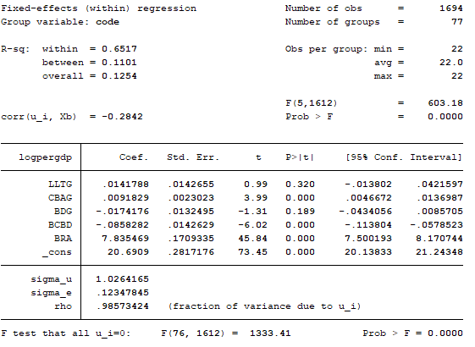

For above regression results we used the data set of 77 countries for 20 years starting from 1996 to 2017. The regression result under fixed effect or within regression model shows that r-squared is equal to 65.17 percent which means that 65.17 percent of the variation in log of per capita GDP is explained by the independent variables namely, Liquid liabilities to GDP, Bank return on assets, Bank deposits to GDP, Central bank assets to GDP, and Bank credit to bank deposits ratios. However, from above regression results it also can be noted that two variables i.e. LLTG and BDG is showing a statistically insignificant coefficients. That is, they are insignificant under 5 percent level of significance. Moreover, CBAG and BRA is depicting a positive association with the per capita GDP but BCBD is showing a negative association. Which implies that a one unit change in Central bank assets to GDP will leads to a 0.009 unit increase in per capita GDP similarly a one unit change in Bank return on assets leads to 7.83 unit increase in per capita GDP. Whereas a one unit change in Bank credit to bank deposits ratios will leads to decrease in per capita GDP by 0.085 units. Also the total number of observations is 1694 and the correlation between error term and regressors is -0.28 which lower than 0.5 (rule of thumb) which signify that there less significant relation between the error term and regressors. Thus it can be seen that the independent variables are explaining the variations in the per capita GDP.

In the next section we are going to test for the serial autocorrelation, contemporaneous autocorrelation (or cross-sectional dependency) and heteroscedasticity and correct for it if there is found any problem in the specified model.

1. **HYPOTHESIS TESTING AND MODEL CORRECTION**

After, testing for the heteroscedasticity[2] in the model, we got the chi-square statistics 16854.10 with p-value less than 0.000 or we can say that p-value is lesser than significance level which means we have to reject the null hypothesis that sigma-square is equal for all i that is, there is no heteroscedasticity. It implies that variance of error terms is changing proportionately with any of the variable. However, it will not make the biasedness in the result but it can make it less reliable by making it less precise. Besides it can cause the p-values to be lower than usual thus making the variance of a coefficient increase. So we will have to rectify the heteroscedasticity.

Now to check for serial autocorrelation in the model, we use the Wooldridge test[3] for serial autocorrelation in panel data. And after observing the result of the test it can be inferred that there is a presence of autocorrelation in the model. Because we are getting the F-statistics with one degree of freedom equal to 866.011 and its p-value is 0.000 so at 5% significance level we have to reject the null hypothesis that there is no autocorrelation in the model. Thus there is a presence of autocorrelation in our model. In the presence of autocorrelation the disturbance term or the error term shows the serial correlation due to which the values of standard error of the coefficient is affected and then predictions will be inefficient. Thus we will get the biased parameters as we can’t get correct estimate values.

Lastly we are going to check for the cross-sectional independency or contemporaneous autocorrelation[4]. For which we are going to use Pesaran’s test for cross-sectional dependency, so after running the test we are getting the Pesaran’s test statistics equal to 24.303 and the p-value equal to 0.000 which is too low so at 5% significance level, null hypothesis that there is no cross-sectional dependence is rejected. Which means there is a presence of contemporaneous autocorrelation in the model. But, some authors have stated that pesaran’s test for cross-sectional dependency is not sufficient to claim that there is a presence of cross-section dependency in the model thus we have check for the Friedman’s test for cross-sectional dependency. So after running the test we get Friedman test statistic equal to 186.450 and p-value equal to 0000 which is again too low. Thus the null hypothesis that there is no cross-section dependency is rejected. Hence, according to this model also we are getting the same result that there is a presence of contemporaneous autocorrelation in the model. This problem might be caused by the spill over effects or may be due to unobserved common factors. This problem leads to biasedness and inconsistency in the regression.

Our model is diagnosed with serial autocorrelation, contemporaneous autocorrelation (or cross-sectional dependency) and heteroscedasticity. Amongst all, this cross-section dependency can leads to major biasedness in the model. So in order to rectify for all of the problems is to use robust standard errors given by the Driscoll-kraay. This test requires t dimension to be large and here we are also using the large interval of time thus it will give the standard error that are robust to contemporaneous autocorrelation and serial correlation and we will get the robustness to heteroscedasticity with it. So after running the new regression with Driscoll-kraav robust standard errors we will get the following results:

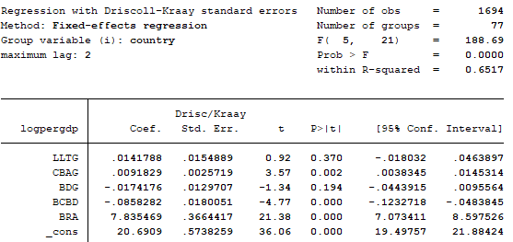

So it can be observed from the above table that our new regression has the same r-square as we have previously at 65.17% i.e. 65 percent of the variations in the log of per capita GDP is explained by the independent variables. However, it can be seen now too that our two variables that is LLTG and BDG is still statistically insignificant at 5% level of significance. Moreover, it can be noticed that standard errors have increased now but all the other value coefficients is same as the previous. Finally, now we have corrected the model for serial autocorrelation, cross section dependency and heteroscedasticity too.

1. **CONCLUSION**

This study has been aimed to determine the relationship between the economic growth - which captured by the per capita GDP - and financial development which is captured by the variables namely, Liquid liabilities to GDP, Bank return on assets, Bank deposits to GDP, Central bank assets to GDP and Bank credit to bank deposits ratios. For this study we had to use the data for 77 countries for the time period beginning from 1996 to 2017. In this study, we later checked for any problems in the model and meanwhile we checked for the cross section dependency in the model using the new tests as compared to other authors who in his studies used the older techniques to determine the cross section dependencies in the model which are in sufficient to determine it. Later, after correcting the model for any problem in the model our regression depicted that there is exist the causality between the dependent and independent variables. However, among all other variable bank return to asset ratio has the most influence on the economic growth. But two variables namely, liquid liabilities to GDP and bank deposit to GDP has very little influence on the economic growth because they found out to be statistically insignificant but they have an influence on the economic growth. Besides, Central bank assets to GDP and Bank credit to bank deposits ratios have the depicted influence on the economic growth rate though Bank credit to bank deposit ratios have negative influence on the economic growth.

Thus the most important conclusion of the study is that there is a relationship between the financial development and the economic growth as implied by the analysis. So the policy makers should now have to focus more on the development of the financial sector and policy makers should have to focus more on the formulation of policies that provide a favourable environment for the financial markets to grow. And also according to other studies it has been implicated that policy maker should also give more emphasis on the growth related monetary and fiscal policies in the short run and in the long run should give more focus on the growth of financial market.

**REFERENCES**

1. Levine, Ross. "Stock Markets, Banks, and Economic Growth."

The American Economic Review 88.3 (1998): 537-58. JSTOR. Web. 01 Oct. 2015.

1. Khan, Mohsin S., and A. Senhadji Semlali. "Financial Development and Economic Growth: An Overview." IMF Working Papers 00.209 (2000): 1. Web.
2. Robinson, J. (1952), “The generalization of the general theory”, The Rate of Interest and Other Essays, Macmillan, London.
3. King, R.G. and Levine, R. (1993a), “Finance and growth: schumpeter might be right”, The Quarterly Journal of Economics, Vol. 108 No. 3, pp. 717-737.
4. BK guru and IS Yadav – Journal of Economics,Finance and Aministrative (2019) “[Financial development and economic growth: panel evidence from BRICS](https://www.emerald.com/insight/content/doi/10.1108/JEFAS-12-2017-0125/full/html)”
5. Guha-Khasnobis, B. and Mavrotas, G. (2008), Financial Development, Institutions, Growth and Poverty Reduction, Palgrave Macmillan, New York, NY.
6. Wijnberg, S.V. (1983), “Interest rate management in LDCs”, Journal of Monetary Economics, Vol. 12 No. 3, pp. 433-452.
7. World Bank - https://databank.worldbank.org/source/world-development-indicators

**APPENDIX**

1. The below diagram is the result of heteroscedasticity test obtained by Wooldridge test

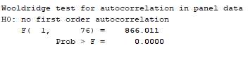

1. The below diagram is the result of Pesaran’s test for cross sectional independence. 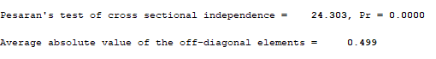
2. The below diagram is the result obtained after checking for cross sectional independence by Friedman’s test. 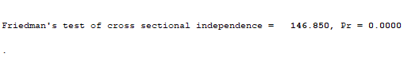
3. The below diagram shows the Hausman test for selection between fixed effect and random effect model.

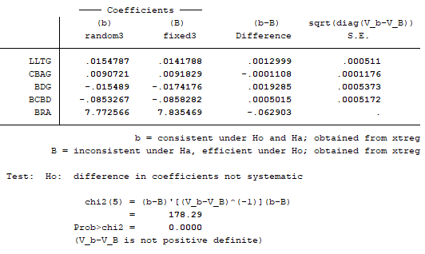

1. After using Hausman test, with null hypothesis being there is no correlation between error term and regressors it can be observed that p-value of chi-square is less than 0.05, thus we rejected the null hypothesis. Hence, our model is fixed effect model. Moreover we have also choose fixed effect model due to the factor that the country level data is heterogeneous data thus fixed effect model is suitable. (see Appendix)
2. See appendix for the heteroscedasticity test results.
3. See appendix for the Wooldridge test results
4. See appendix for the Pesaran test and Friedman test