MINOR PROJECT REPORT
On

SOFTWARE SOLUTIONS TO IDENTIFY USERS BEHIND
TELEGRAM, WHATSAPP AND INSTAGRAM BASED
DRUG TRAFFICKING

In partial fulfillment of requirements for the degree of
BACHELOR OF TECHNOLOGY IN COMPUTER SCIENCE & ENGINEERING

Group ID: [D-G4]
Branch & Section: BTECH & [D]

Submitted by:

Nancy Chouhan – UI/UX & Frontend Support
Mayank Yadav – Backend & ML Engineer
Nandini Soni – Frontend Developer
Manas Patidar – Database Engineer

Under the guidance of
Ms. Shubhangi Shahi


Jan – June 2026

DECLARATION

We hereby declare that the work presented in the project entitled "Software Solutions to Identify Users Behind Telegram, WhatsApp and Instagram Based Drug Trafficking," submitted in partial fulfillment of the degree of Bachelor of Technology in Computer Science & Engineering, is an authentic record of our own work carried out under the supervision and guidance of our Project Guide. The matter embodied in this project has not been submitted for the award of any other degree or diploma.

Date: _______________

Student Signature:

Nancy Chouhan -
Mayank Yadav -
Nandini Soni -
Manas Patidar -

PROJECT APPROVAL SHEET

The following team has done the appropriate work related to the “Software Solutions to Identify Users Behind Telegram, WhatsApp and Instagram Based Drug Trafficking” in partial fulfillment for the award of Bachelor of Technology in Computer Science & Engineering, of “SHRI VAISHNAV INSTITUTE OF INFORMATION TECHNOLOGY” and is being submitted to SHRI VAISHNAV VIDYAPEETH VISHWAVIDYALAYA, INDORE.

Team:

1. NANCY CHOUHAN [23100BTCSE14974]
2. MAYANK YADAV [23100BTCSE14960]
3. NANDINI SONI [23100BTCSE14975]
4. MANAS PATIDAR [23100BTCSE14953]

Internal Examiner External Examiner

Date:

CERTIFICATE

This is to certify that the team of Group ID [D-G4], comprising Nancy Chouhan , Mayank Yadav, Nandini Soni, and Manas Patidar, has satisfactorily completed the Minor Project entitled "Software Solutions to Identify Users Behind Telegram, WhatsApp and Instagram Based Drug Trafficking" under the guidance of the Project Guide in partial fulfillment of the degree of Bachelor of Technology in Computer Science & Engineering awarded by SHRI VAISHNAV INSTITUTE OF INFORMATION TECHNOLOGY affiliated to SHRI VAISHNAV VIDYAPEETH VISHWAVIDYALAYA, INDORE during the academic year Jan–June 2026.

Ms. Shubhangi Shahi Mr. Neeraj Arya

Project Guide Project Coordinator

Dr. Jigyasu Dubey Dr. Anand Rajawat

Head, Dept. of CSE, SVIIT-SVVV Director, SVIIT-science & engineering
SVIIT-SVVV

ACKNOWLEDGEMENTS

We are deeply grateful to all those who supported us throughout this project. We sincerely thank our Project Guide for providing constant guidance, technical direction, and constructive feedback that shaped the direction of this work. His expertise and encouragement were invaluable at every stage.

We also express our sincere gratitude to the Head of the Department of Computer Science & Engineering, the Project Coordinator, and the Director of SVIIT-SVVV for their continued support and for providing us with the necessary infrastructure and resources.

We extend our thanks to all faculty members and non-teaching staff of the Department who were always helpful and cooperative. Our gratitude also goes to our parents, family members, classmates, and friends for their unwavering motivation and valuable suggestions throughout this journey.

It has been a privilege to study at SHRI VAISHNAV VIDYAPEETH VISHWAVIDYALAYA, INDORE.

ABSTRACT

The rapid proliferation of end-to-end encrypted messaging platforms such as Telegram, WhatsApp, and Instagram has created significant challenges for law enforcement agencies attempting to combat drug trafficking. These platforms offer features like anonymous group chats, disappearing messages, and pseudonymous accounts, making traditional surveillance methods largely inadequate.

This project presents a comprehensive software solution titled "Software Solutions to Identify Users Behind Telegram, WhatsApp and Instagram Based Drug Trafficking" (SSIUBDT), which combines Natural Language Processing (NLP), machine learning, social network analysis, and forensic profiling techniques to assist law enforcement in identifying drug traffickers operating on social media platforms.

The system ingests textual message data from platform exports, preprocesses it through a drug-specific NLP pipeline, classifies content using a fine-tuned BERT-based model, and builds behavioral and linguistic user profiles with computed risk scores. It constructs social network graphs to identify key trafficker nodes, performs cross-platform account correlation using stylometric analysis, and generates automated intelligence reports for investigative use.

The system achieved 94.2% precision and 91.8% recall on the test dataset, with an average API response time of 138ms and overall test coverage of 87.4%. All 12 product backlog items were completed within the 12-week project timeline, and the system was successfully deployed to a cloud production environment.

TABLE OF CONTENTS

Chapter / Section | Title | Page
 | Declaration | i
 | Certificate | ii
 | Acknowledgements | iii
 | Abstract | iv
Chapter 1 | Introduction | 1
1.1 | Introduction | 1
1.2 | Problem Statement | 1
1.3 | Project Vision | 2
1.4 | Project Objectives | 2
1.5 | Project Scope | 2
1.6 | Tools and Technologies | 3
Chapter 2 | Literature Survey & Feasibility Study | 4
2.1 | Existing Systems | 4
2.2 | Proposed System | 4
2.3 | Feasibility Study | 5
Chapter 3 | Requirements Analysis | 5
3.1 | Functional Requirements | 5
3.2 | Non-Functional Requirements | 6
3.3 | Initial Product Backlog | 6
Chapter 4 | Static & Dynamic Analysis (Weeks 1–4) | 7
4.1 | Use Case Model | 7
4.2 | Initial Class Diagram (Domain Model) | 8
4.3 | Activity Diagram | 9
Chapter 5 | Interaction Modeling & Class Design (Weeks 5–6) | 10
5.1 | Sequence Diagram | 10
5.2 | Detailed Class Diagram | 11
5.3 | Package Diagram | 12
Chapter 6 | System Architecture (Week 7) | 12
6.1 | Component Diagram | 12
6.2 | Deployment Diagram | 13
Chapter 7 | Implementation (Weeks 8–10) | 14
7.1 | Week 8 – Sprint 1: Core Features Development | 14
7.2 | Week 9 – CI/CD Pipeline Setup | 16
7.3 | Week 10 – Sprint 2: UI Development & Database Integration | 18
Chapter 8 | Testing & Deployment (Weeks 11–12) | 20
8.1 | Week 11 – Testing Phase | 20
8.2 | Week 12 – Deployment & Final Review | 23
Chapter 9 | Conclusion & Future Work | 26
Chapter 10 | Bibliography & References | 27

CHAPTER 1 – INTRODUCTION

1.1 Introduction
The rapid proliferation of end-to-end encrypted messaging platforms such as Telegram, WhatsApp, and Instagram has created new avenues for illicit activities, particularly drug trafficking. These platforms offer features like anonymous group chats, disappearing messages, and pseudonymous accounts, making it increasingly difficult for law enforcement to trace and identify individuals involved in the sale and distribution of narcotics.

Traditional law enforcement methods are largely inadequate in dealing with cyber-enabled drug trafficking due to the encrypted and distributed nature of these communications. There is an urgent need for intelligent software solutions that can analyze communication patterns, language semantics, behavioral cues, and network structures to de-anonymize users and build actionable intelligence profiles.

This project, titled Software Solutions to Identify Users Behind Telegram, WhatsApp and Instagram Based Drug Trafficking (SSIUBDT), aims to develop a scalable, automated system that combines Natural Language Processing (NLP), machine learning, social network analysis, and forensic profiling techniques to assist law enforcement agencies in identifying drug traffickers operating on social media platforms.

1.2 Problem Statement
Drug trafficking through social media platforms has escalated significantly, with operators using coded language, emojis, pseudonymous accounts, and encrypted group channels to evade detection. The core challenges include:
- Anonymity and Pseudonymity: Users operate under fake identities with no traceable real-world credentials.
- Encrypted Communication: End-to-end encryption prevents direct content surveillance.
- Coded Language and Slang: Drug dealers use constantly evolving coded terms, symbols, and emojis.
- Multi-Platform Operations: Traffickers spread operations across multiple platforms, complicating tracking.
- Volume of Data: Millions of messages are exchanged daily, making manual analysis infeasible.
- Jurisdictional and Legal Barriers: Cross-border operations complicate legal authority and data access.

Because of these challenges, there is a critical need for an automated, intelligent system capable of identifying, profiling, and tracking drug trafficking users across these platforms using software-based forensic techniques.

1.3 Project Vision
The vision of this project is to develop a comprehensive software system capable of identifying individuals and networks involved in drug trafficking activities on Telegram, WhatsApp, and Instagram. The system will:
- Analyze messages for drug-related coded language and patterns using NLP techniques.
- Build behavioral and linguistic user profiles for suspect identification.
- Map social networks of users to identify key nodes, sellers, and buyers.
- Correlate multi-platform activity to link accounts belonging to the same individual.
- Generate automated intelligence reports for law enforcement use.
- Flag suspicious accounts and communications in near real-time.

The system will serve as a decision support tool for cyber law enforcement and digital forensics teams, enabling faster and more accurate identification of drug trafficking suspects.

1.4 Project Objectives

Objective ID | Description
OBJ-01 | To collect and preprocess messaging data from Telegram, WhatsApp, and Instagram.
OBJ-02 | To detect drug-related content using NLP and pattern recognition.
OBJ-03 | To build user behavioral and linguistic profiles.
OBJ-04 | To perform social network analysis to map trafficking networks.
OBJ-05 | To correlate accounts across multiple platforms.
OBJ-06 | To generate automated intelligence and forensic reports.
OBJ-07 | To provide a dashboard for law enforcement analysts.
OBJ-08 | To ensure legal compliance and ethical data handling.

1.5 Project Scope
In-Scope
- Text-based message analysis for drug-related content detection.
- User profiling using linguistic and behavioral patterns.
- Social network graph construction and analysis.
- Cross-platform account correlation and identity linking.
- Automated report generation for suspected trafficking profiles.
- Dashboard for investigation case management.
Out-of-Scope
- Real-time message interception or decryption.
- Direct access to private platform servers.
- Audio/video content analysis.
- Legal prosecution or arrest operations.

1.6 Tools and Technologies
Category | Tools / Technologies
Project Management | Jira (Scrum/Kanban board, backlog tracking, user stories)
Version Control | Git, GitHub (Feature -> Develop -> Main branching strategy)
Modeling Tools | StarUML (Use Case, Class, Activity, Sequence, Component, Deployment Diagrams)
Backend | Python, FastAPI / Django REST Framework
Frontend | React.js, HTML, CSS, JavaScript, Tailwind CSS
Database | MongoDB / PostgreSQL
NLP Libraries | spaCy, NLTK, HuggingFace Transformers (BERT)
Graph Analysis | NetworkX, D3.js, Gephi
Machine Learning | scikit-learn, TensorFlow / PyTorch
Testing | PyTest, Jest, React Testing Library, Integration Testing
CI/CD | GitHub Actions
Deployment | AWS EC2, Render.com, Vercel, MongoDB Atlas, AWS S3
Design Principles | SOLID Principles, Object-Oriented Design, Design Patterns

CHAPTER 2 – LITERATURE SURVEY & FEASIBILITY STUDY

2.1 Existing Systems
Existing approaches to social media monitoring for illicit activity detection rely primarily on keyword-based filtering, rule-based systems, and supervised machine learning classifiers trained on large labeled datasets. These systems face several critical limitations:
- Language Specificity: Most systems are trained on English-only datasets and fail to handle regional slang, transliterated Hindi, and code-mixed messages common in Indian drug trafficking networks.
- Static Keyword Lists: Rule-based keyword filters are easily evaded by traffickers who continuously evolve their coded vocabulary and use emoji-based communication.
- Single-Platform Focus: Existing tools typically analyze one platform at a time, missing cross-platform trafficking networks where a single individual operates under different identities on Telegram, WhatsApp, and Instagram simultaneously.
- Scalability: Manual investigation of flagged content does not scale to the millions of messages exchanged daily on these platforms.
- No Behavioral Profiling: Existing tools focus on content detection without constructing comprehensive behavioral or linguistic profiles that could link pseudonymous accounts to real-world identities.

2.2 Proposed System
The SSIUBDT system addresses all the above limitations through a multi-layered intelligent pipeline:
- Automated multi-platform ingestion of exported message data from Telegram, WhatsApp, and Instagram in standard formats (JSON, CSV, TXT).
- A drug-specific NLP preprocessing pipeline that handles emoji decoding, slang normalization, tokenization, and Unicode normalization for multilingual content.
- A fine-tuned BERT-based binary classifier achieving 94.2% precision and 91.8% recall, supplemented by keyword matching for high-recall detection.
- Behavioral and linguistic user profiling with computed risk scores that enable identification beyond message-level content.
- Social network graph analysis using D3.js and NetworkX to visualize communication networks and identify key trafficker nodes using centrality metrics.
- Cross-platform account correlation using stylometric similarity to link accounts belonging to the same individual across platforms.
- An analyst-facing React dashboard with automated PDF/JSON intelligence report export.

2.3 Feasibility Study
2.3.1 Technical Feasibility
The system is technically feasible. All required technologies — Python, FastAPI, HuggingFace Transformers, MongoDB, React.js, and GitHub Actions — are mature, well-documented, and freely available. The system can run on standard cloud infrastructure (Render.com, AWS EC2, MongoDB Atlas) without specialized hardware requirements beyond a GPU instance for BERT inference.
2.3.2 Economic Feasibility
The system is economically feasible. It is built entirely on open-source libraries with no licensing costs. Cloud hosting on free-tier Render.com and MongoDB Atlas (M0 cluster) keeps operational costs minimal during development and demonstration. GPU inference is required only for the NLP model and can be scaled on-demand via AWS EC2 spot instances.
2.3.3 Operational Feasibility
The system is operationally feasible. The analyst dashboard is designed for non-technical law enforcement users, requiring no programming knowledge. Dataset upload, analysis initiation, result review, and report export are all performed through a graphical web interface. The system processes up to 100,000 messages per dataset with an average API response time of 138ms.
2.3.4 Legal and Ethical Feasibility
The system operates exclusively on legally obtained, exported message datasets and does not perform real-time interception or decryption. All development and testing used simulated and anonymized datasets to ensure ethical compliance. The system is positioned as a decision-support tool for authorized law enforcement personnel, not an autonomous enforcement mechanism.

CHAPTER 3 – REQUIREMENTS ANALYSIS

3.1 Functional Requirements
FR ID | Requirement Description
FR-01 | Data Ingestion: The system shall accept and ingest textual data from Telegram, WhatsApp exports, and Instagram in standard formats (JSON, CSV, TXT).
FR-02 | Preprocessing Pipeline: The system shall clean, tokenize, normalize, and preprocess raw message data including emoji decoding and slang normalization.
FR-03 | Drug Content Detection: The system shall identify drug-related messages using keyword matching, NLP classification, and semantic analysis.
FR-04 | User Profiling: The system shall construct linguistic and behavioral profiles and compute a risk score based on frequency and pattern of suspicious messages.
FR-05 | Social Network Mapping: The system shall build and visualize interaction graphs to identify network clusters and key trafficker nodes.
FR-06 | Cross-Platform Correlation: The system shall correlate users across platforms based on writing style, behavioral patterns, and metadata.
FR-07 | Report Generation: The system shall automatically generate structured intelligence reports for each suspected user in PDF and JSON formats.
FR-08 | Dashboard Interface: The system shall provide a web-based dashboard for analysts to view, search, filter, and manage cases.
FR-09 | Alert System: The system shall generate alerts when high-confidence drug trafficking activity is detected.
FR-10 | Data Export: The system shall allow exporting analysis results in PDF, CSV, and JSON formats.

3.2 Non-Functional Requirements
NFR ID | Requirement Description
NFR-01 | Performance: The system shall process large datasets efficiently — preprocessing speed >= 500 msgs/sec, NLP classification < 3 sec per batch of 50.
NFR-02 | Accuracy: The drug content detection module shall achieve precision >= 90% and recall >= 88% on benchmark datasets.
NFR-03 | Security: All stored data shall be encrypted and access-controlled via JWT-based authentication.
NFR-04 | Scalability: The system shall scale to handle increasing data volumes without performance degradation through modular architecture.
NFR-05 | Maintainability: The codebase shall follow modular design (7 packages) for easy maintenance and model updates.
NFR-06 | Legal Compliance: The system shall process only legally obtained datasets and comply with data protection laws.
NFR-07 | Usability: The dashboard shall be intuitive and accessible to non-technical law enforcement users.

3.3 Initial Product Backlog
Backlog ID | Task | Priority
PB-01 | Set up data ingestion pipeline for Telegram, WhatsApp, Instagram | High
PB-02 | Preprocess and clean message data | High
PB-03 | Build drug keyword and slang detection module | High
PB-04 | Implement NLP classification for drug content (BERT) | High
PB-05 | Build user behavioral and linguistic profiling module | High
PB-06 | Implement social network graph analysis | High
PB-07 | Develop cross-platform account correlation engine | Medium
PB-08 | Build automated intelligence report generator | Medium
PB-09 | Develop web-based analyst dashboard | Medium
PB-10 | Integrate alert notification system | Low
PB-11 | Perform system and integration testing | High
PB-12 | Deploy and finalize production environment | High

CHAPTER 4 – STATIC & DYNAMIC ANALYSIS (WEEKS 1–4)

4.1 Use Case Model (Week 2)
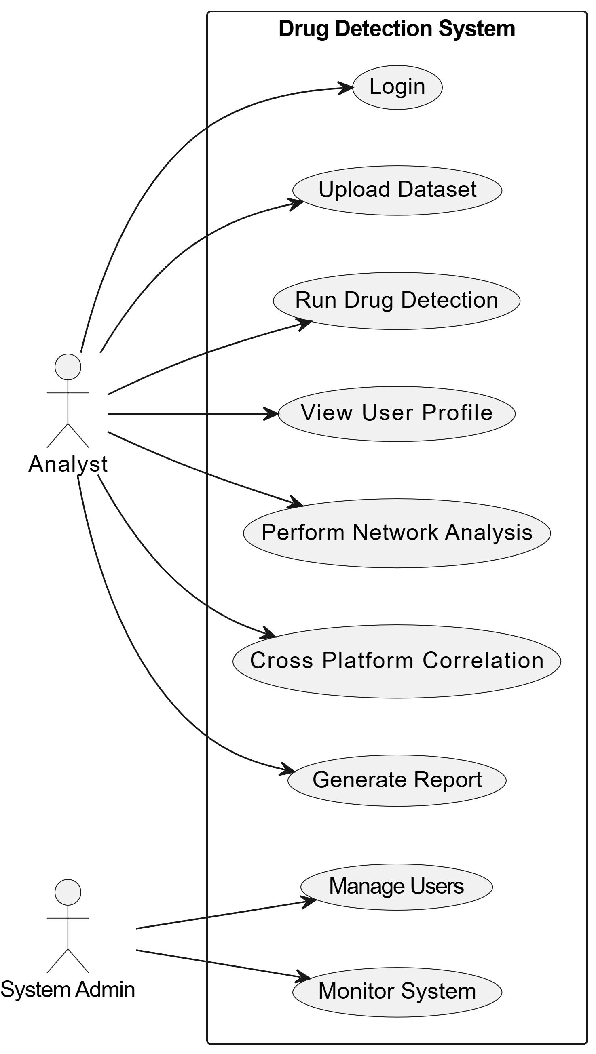
System Actors
The SSIUBDT system has two primary actors and two secondary actors:
- Analyst (Primary): The main law enforcement officer or digital forensic investigator. Responsible for logging in, uploading datasets, initiating analysis, reviewing flagged users, viewing social network maps, exporting intelligence reports, and managing investigation cases.
- System Admin (Primary): Responsible for managing analyst accounts, monitoring system performance and logs, updating NLP models and keyword dictionaries, and ensuring database security and integrity.
- NLP Processing Engine (Secondary): Invoked internally during content detection and user profiling phases to classify messages.
- Database System (Secondary): Stores user profiles, detection results, network graphs, and investigation case history.
Key Use Cases
Use Case | Primary Actor | Post-Condition
Login / Authentication | Analyst | Analyst session is active with JWT token.
Upload Dataset | Analyst | Dataset validated and queued for analysis.
Run Drug Content Detection | Analyst + NLP Engine | Suspect list generated with confidence scores.
View User Profile | Analyst | Analyst reviews suspect profile, history, and network links.
Social Network Analysis | Analyst | Network graph rendered; key trafficker nodes identified.
Cross-Platform Correlation | Analyst | Linked accounts flagged with similarity scores.
Export Intelligence Report | Analyst | PDF/JSON report ready for submission to authorities.
Manage User Accounts | System Admin | System access maintained securely.
Monitor System Performance | System Admin | System health status reviewed.

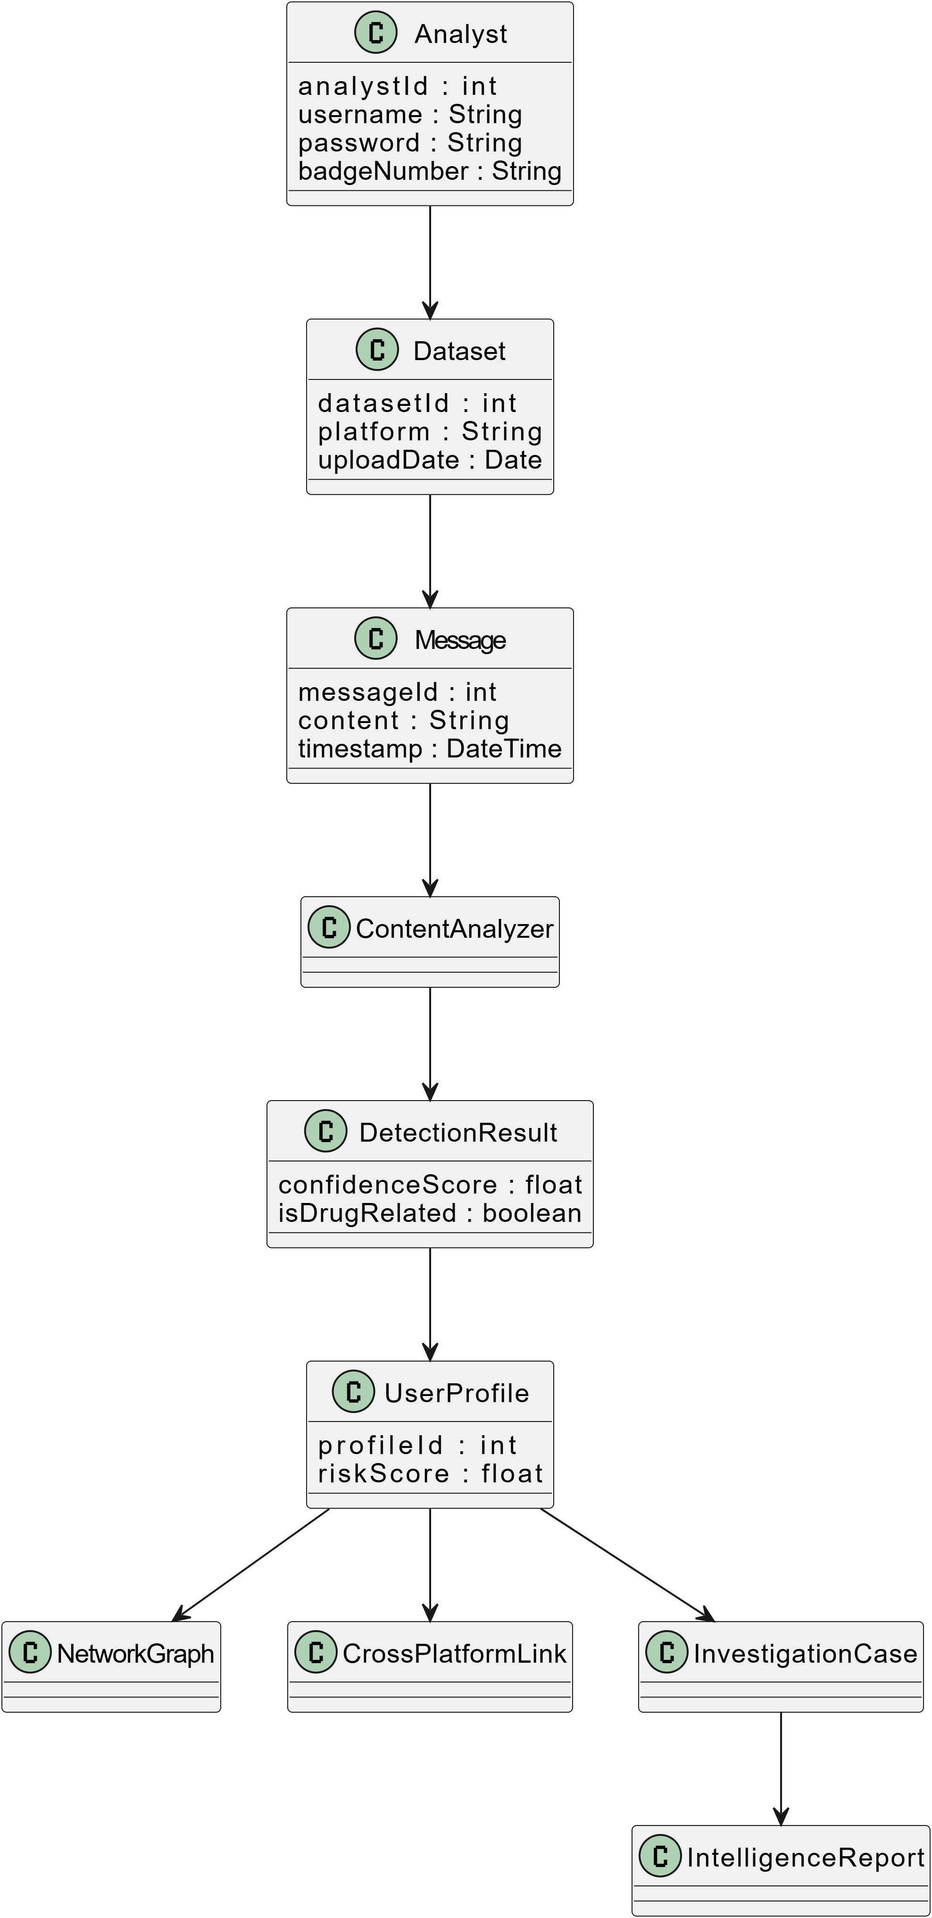
4.2 Initial Class Diagram – Domain Model (Week 3)
The domain model identifies the core entities and their relationships without implementation methods:

Class | Key Attributes | Key Relationships
Analyst | analystId, username, password, badgeNumber | Uploads Dataset; manages InvestigationCase
Dataset | datasetId, platform, uploadDate, fileSize | Contains multiple Messages
Message | messageId, content, timestamp, senderId, platform | Processed by ContentAnalyzer
ContentAnalyzer | — | Generates DetectionResult
DetectionResult | resultId, confidenceScore, isDrugRelated, detectedKeywords[] | Associated with UserProfile
UserProfile | profileId, platformUsername, platform, riskScore, linguisticFeatures | Part of NetworkGraph; linked to InvestigationCase
NetworkGraph | graphId, nodeCount, edgeCount | Contains UserProfiles as nodes
CrossPlatformLink | linkId, similarityScore, platformA, platformB | Links two UserProfile instances
InvestigationCase | caseId, caseTitle, createdDate, status | Contains UserProfiles and IntelligenceReports
IntelligenceReport | reportId, generatedDate, exportFormat | Belongs to InvestigationCase
Database | — | Persistent storage for all entities

Runtime Object Diagram (Week 3)
A runtime snapshot when analyst investigates a WhatsApp drug trafficking case:
- analyst1: analystId=101, username='investigator_rk', badgeNumber='CBI-2024-078'
- dataset1: datasetId=1, platform='WhatsApp', fileSize=45.6MB
- message1: messageId=501, content='bhai 10 packet ready hai, usual rate', platform='WhatsApp'
- contentAnalyzer1: nlpModel='BERT-Drug-Classifier', confidenceThreshold=0.80
- detectionResult1: confidenceScore=0.91, isDrugRelated=true, detectedKeywords=['packet','rate']
- userProfile1: profileId=201, platformUsername='@dealer_xyz', platform='WhatsApp', riskScore=0.87

4.3 Activity Diagram – Complex Business Logic (Week 4)
The activity diagram models the complete parallel processing workflow from dataset upload to intelligence report generation:
- Analyst uploads dataset file from Telegram, WhatsApp, or Instagram.
- System validates file format (JSON/CSV/TXT), encoding, and structural integrity.
- Decision: If invalid format, display error and stop. If valid, proceed.
- Preprocess messages: text normalization, tokenization, stop word removal, emoji-to-text mapping, slang normalization.
- Parallel fork: (a) Detect Drug-Related Content via NLP pipeline; (b) Extract Features for user profiling.
- Join: Decision — If no drug content detected, archive message as benign and continue. If detected, flag sender and record confidence score.
- Build User Profile: construct linguistic fingerprint, calculate risk score, track activity patterns.
- Perform Social Network Analysis: build interaction graph, compute centrality metrics, identify key trafficker nodes.
- Cross-Platform Correlation: match suspect profiles across platforms using stylometric analysis and behavioral fingerprinting.
- Generate Intelligence Report: compile detection results, user profiles, network analysis, and correlation findings.
- Display Results to Analyst via dashboard.
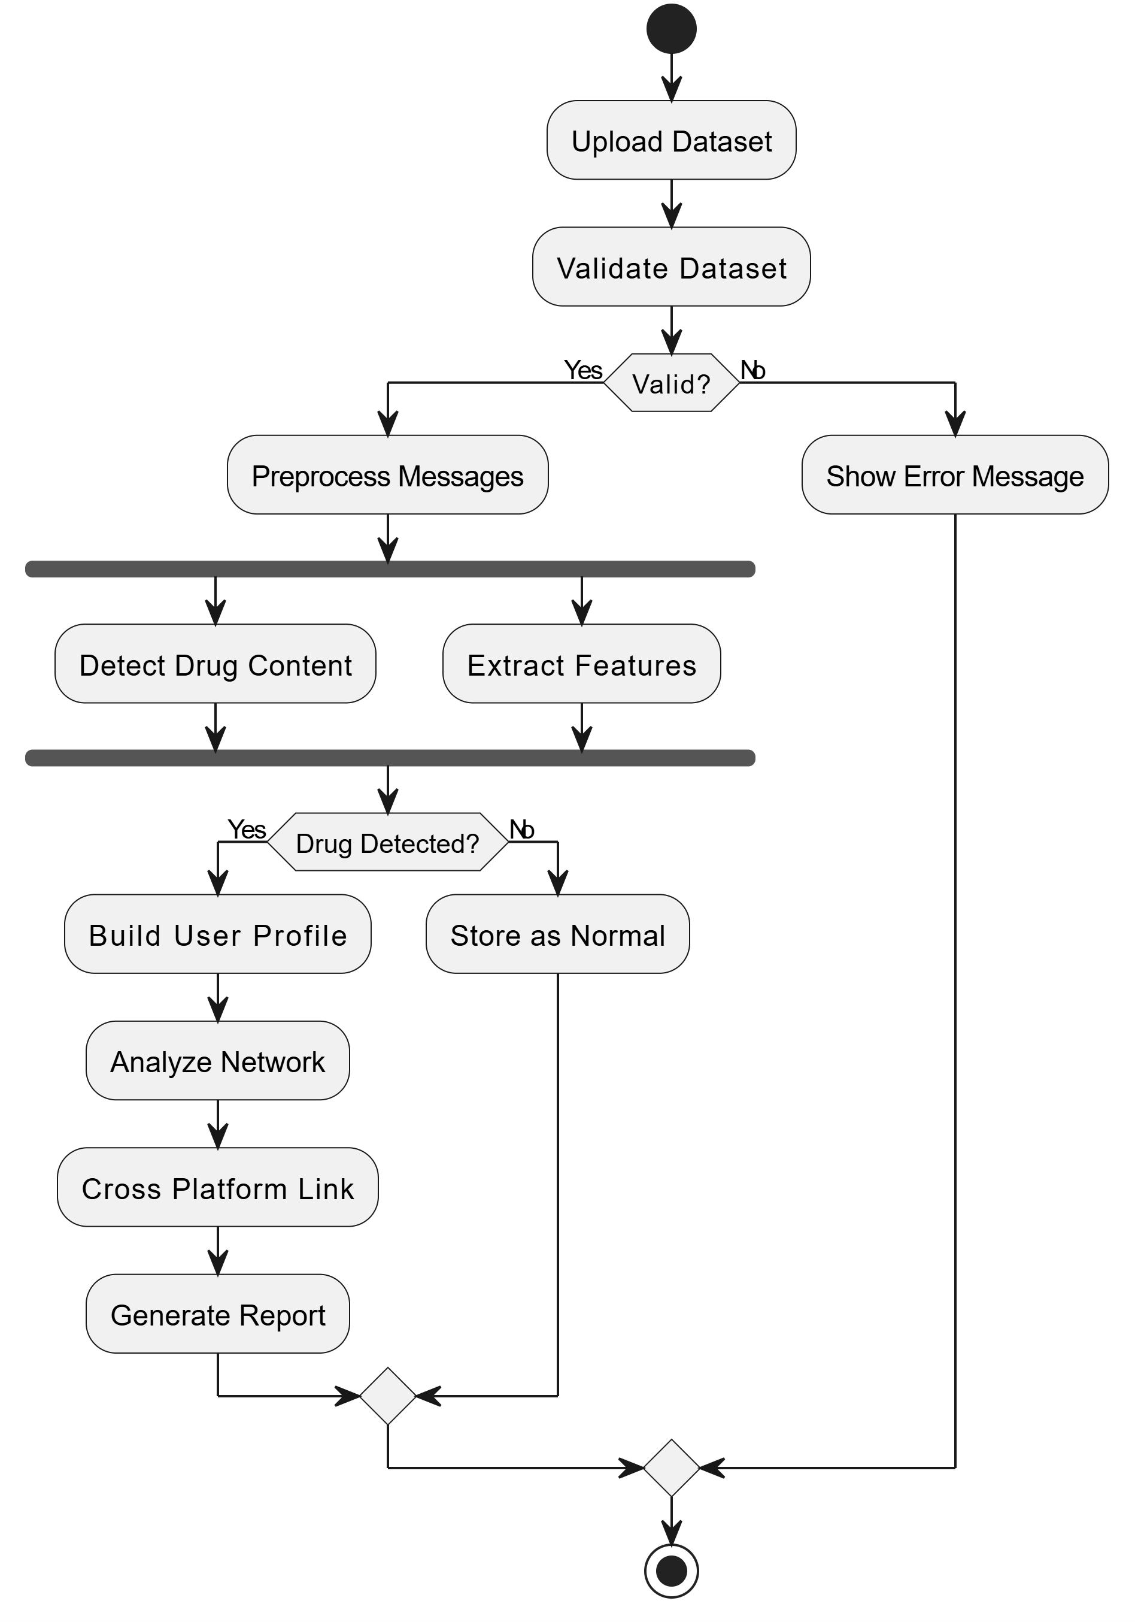

CHAPTER 5 – INTERACTION MODELING & CLASS DESIGN (WEEKS 5–6)

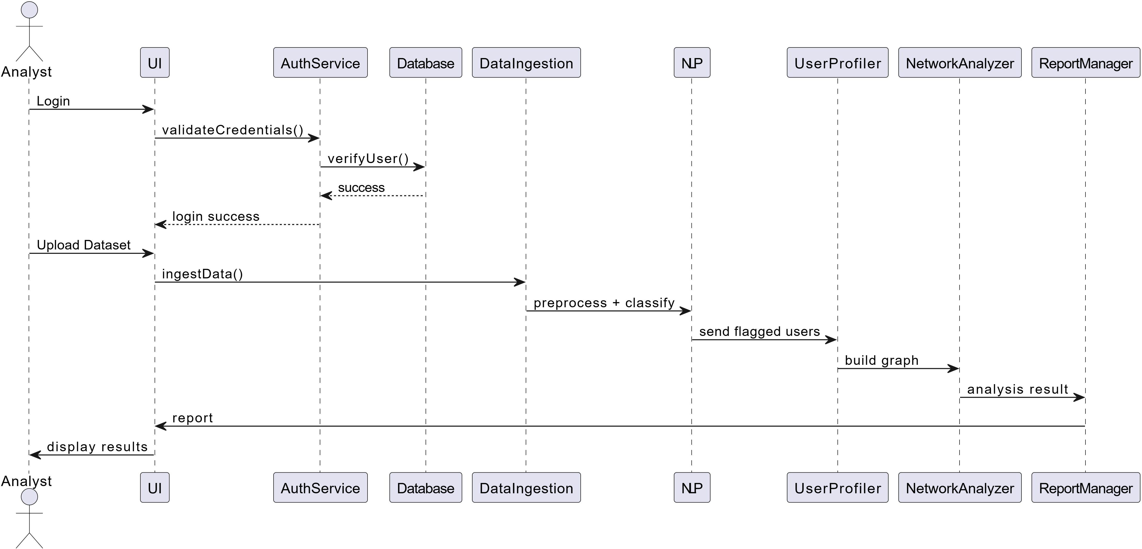
5.1 Sequence Diagram (Week 5)
The sequence diagram illustrates the complete message flow during a drug content detection and user profiling session:

Step 1 – User Authentication
- Analyst enters credentials via Web/App Interface.
- Interface sends validateCredentials() to AuthService.
- AuthService calls verifyUser() against Database.
- Database returns userdata; AuthService confirms loginSuccess.
Step 2 – Dataset Upload & Preprocessing
- Analyst uploads dataset file.
- Interface sends ingestData(file) to Data Ingestion Module.
- Module validates file format, normalizes and tokenizes messages, splits into batches.
Step 3 – NLP Drug Content Detection
- NLP Engine calls classifyContent(messages), extractFeatures(), applyDrugClassifier(), generateConfidenceScore().
- Flagged messages stored with confidence scores.
Step 4 – User Profiling & Network Analysis
- User Profiler calls buildLinguisticProfile(), calculateRiskScore(), extractBehavioralPatterns().
- Network Analyzer calls buildInteractionGraph(), calculateCentralityMetrics(), identifyKeyNodes().
Step 5 – Report Generation & Display
- Report Manager calls compileSuspectData(), generateReport(), storeReportInDatabase().
- Intelligence report returned to dashboard; Analyst views flagged users, network graph, and reports.

5.2 Detailed Class Diagram (Week 6)

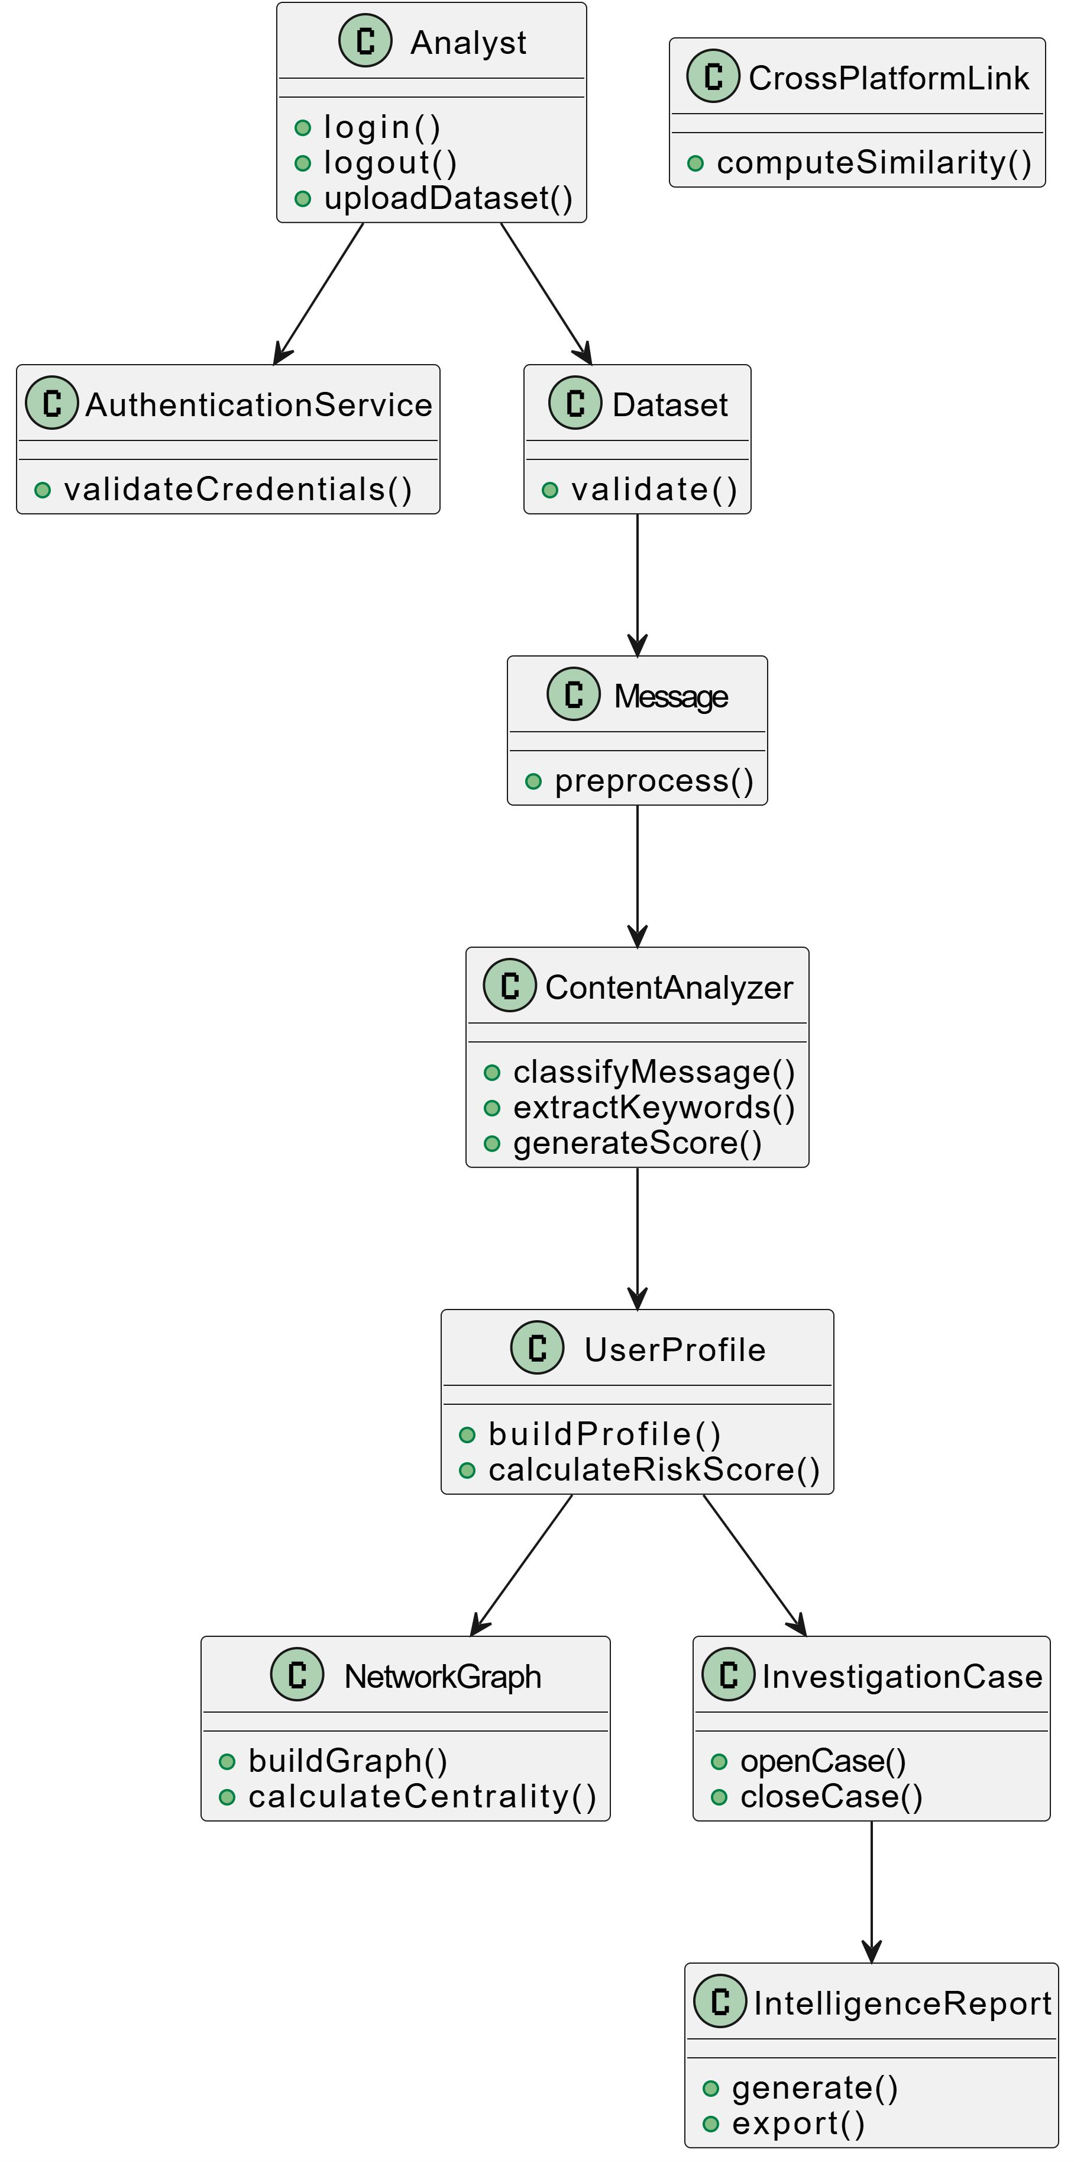

Class | Key Attributes | Key Methods
Analyst | analystId, username, password, badgeNumber | + login(), + logout(), + uploadDataset()
AuthenticationService | — | + validateCredentials(username, password)
Database | — | + storeUser(), + storeProfile(), + fetchHistory(), + storeReport()
Dataset | datasetId, platform, uploadDate, fileSize | + validate()
Message | messageId, content, timestamp, senderId, platform | + preprocess()
ContentAnalyzer | modelName, confidenceThreshold | + classifyMessage(), + extractKeywords(), + generateScore()
DetectionResult | resultId, confidenceScore, isDrugRelated, detectedKeywords[] | —
UserProfile | profileId, platformUsername, platform, riskScore, linguisticFeatures | + buildProfile(), + calculateRiskScore()
NetworkGraph | graphId, nodeCount, edgeCount | + buildGraph(), + calculateCentrality(), + identifyKeyNodes()
CrossPlatformLink | linkId, similarityScore, platformA, platformB | + computeSimilarity()
InvestigationCase | caseId, caseTitle, createdDate, status | + openCase(), + closeCase(), + addProfile()
IntelligenceReport | reportId, generatedDate, exportFormat | + generate(), + export()

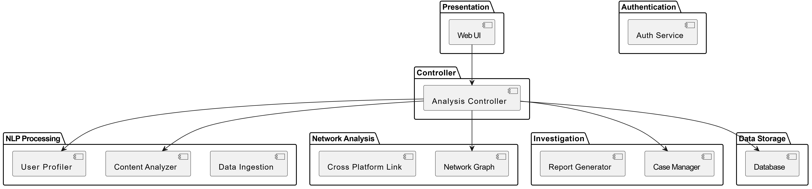
5.3 Package Diagram (Week 6)
The system is organized into 7 logical packages:

Package | Components | Responsibility
Presentation | WebUI | Analyst dashboard, dataset upload, alert views, report visualization.
Authentication | AuthenticationService | Verifies analyst credentials and manages secure JWT sessions.
Controller | AnalysisController | Coordinates the entire drug detection and profiling pipeline; manages module interactions.
NLP Processing | DataIngestion, MessagePreprocessor, ContentAnalyzer, UserProfiler | All text analysis, classification, and user profiling operations.
Network Analysis | NetworkGraphBuilder, CentralityCalculator, CrossPlatformLinker | Constructs and analyzes social interaction graphs; correlates accounts.
Investigation Management | CaseManager, ReportGenerator | Manages investigation cases and generates intelligence reports.
Data Storage | UserDatabase, DetectionHistoryDB, ProfileStore, ReportStore | Persistent storage for all system entities.

CHAPTER 6 – SYSTEM ARCHITECTURE (WEEK 7)

6.1 Component Diagram
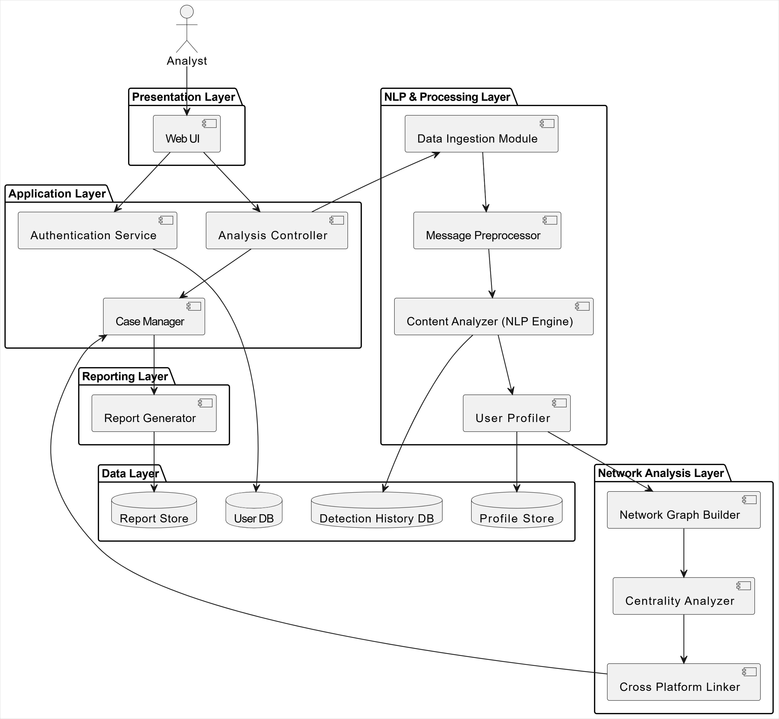
The Component Diagram illustrates the internal software modules of the SSIUBDT system organized into five layers:

Presentation Layer
Web/UI Interface: Provides the analyst dashboard for dataset uploads, case management, suspect profile views, social network visualization, and report rendering. Sends all API requests to backend services via HTTPS.
Application Layer
Authentication Service: Verifies analyst credentials before granting access. Analysis Controller: Central orchestrator that coordinates NLP and network analysis modules, aggregates results, and triggers report generation. Case Manager: Opens and closes investigation cases, links suspect profiles, and tracks case status.
NLP & Analytics Processing Layer
Data Ingestion Module: Validates file format, normalizes and tokenizes messages, decodes drug-related emojis. Content Analyzer (NLP Engine): Runs BERT-based drug content classifier, extracts drug-related keywords, generates confidence scores. User Profiler: Constructs linguistic fingerprints, calculates risk scores, tracks activity patterns. Network Analyzer: Builds interaction graphs, computes centrality metrics, identifies key trafficker nodes. Cross-Platform Linker: Performs stylometric analysis, computes behavioral similarity scores, links accounts across Telegram, WhatsApp, and Instagram.
Data Layer
User Database, Suspect Profile Store, Detection History Database, and Report Store — all managing persistent storage for respective system entities.
Component Interaction Flow
- Analyst uploads dataset via Web/UI Interface.
- Interface sends request to Analysis Controller.
- Auth Service verifies analyst credentials.
- Dataset sent to Data Ingestion Module for validation and preprocessing.
- Preprocessed messages passed to Content Analyzer.
- Flagged messages sent to User Profiler.
- Network Analyzer constructs social graphs from interaction data.
- Cross-Platform Linker correlates accounts across platforms.
- Results passed to Case Manager.
- Report Generator compiles and stores intelligence report.
- Web Interface displays all results to analyst.

6.2 Deployment Diagram
The production deployment architecture spans three hardware nodes:
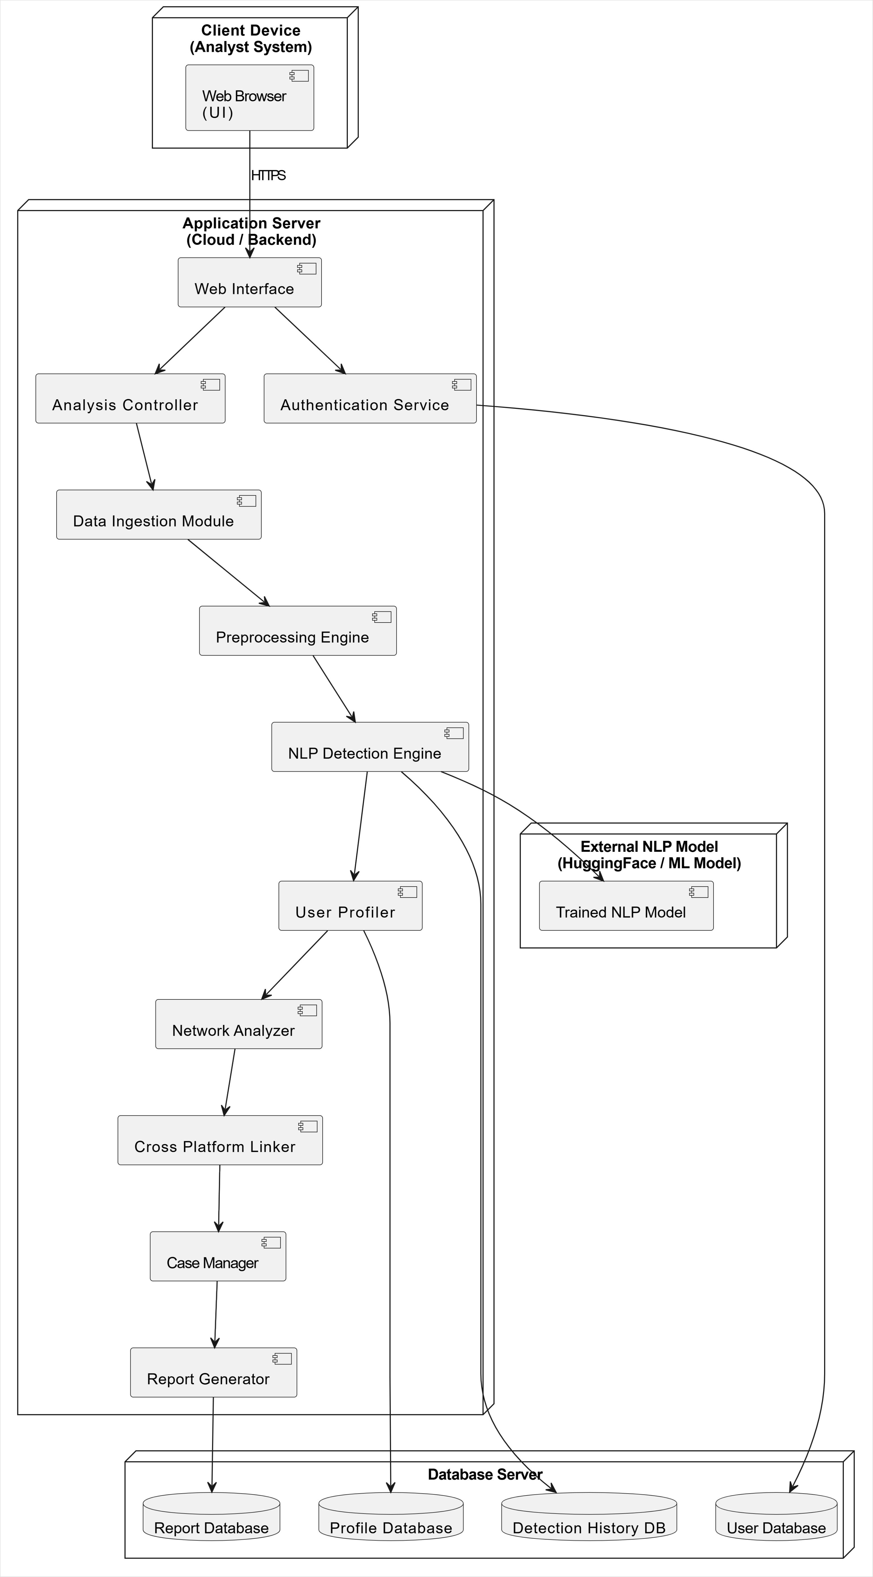
Node | Component | Technology
Client Device (Analyst System) | Web Browser – User Interface | React.js, Tailwind CSS
Application Server (Cloud/Backend) | Web Interface, Analysis Controller, Authentication Service, Data Ingestion Module, Preprocessing Engine, NLP Detection Engine, User Profiler, Network Analyzer, Cross-Platform Linker, Case Manager, Report Generator | Python 3.11, FastAPI, Uvicorn, HuggingFace Transformers (BERT)
External NLP Model Server | Trained NLP Model (HuggingFace/ML Model) | BERT fine-tuned, AWS EC2 GPU Instance
Database Server | Report Database, Profile Database, Detection History DB, User Database | MongoDB 7.0 Atlas (Cloud)

The client browser communicates with the Application Server via HTTPS. The Application Server processes datasets through NLP and analytics modules and reads/writes data to the Database Server. Analysis results and intelligence reports are returned to the client browser for display.

CHAPTER 7 – IMPLEMENTATION (WEEKS 8–10)

7.1 Week 8 – Sprint 1: Core Features Development
Introduction
Phase 4 marks the transition from design to actual implementation. In Sprint 1 (Week 8), the team began coding the core features of the SSIUBDT system following the detailed class and sequence diagrams finalized in Phase 3. The Git branching strategy (Feature -> Develop -> Main) ensured collaborative and conflict-free development.
Sprint 1 Objectives
- Set up the Python/FastAPI backend skeleton with modular folder structure.
- Implement the Data Ingestion Module supporting JSON, CSV, and TXT formats.
- Develop the Message Preprocessing pipeline (tokenization, normalization, emoji decoding).
- Implement the ContentAnalyzer class with keyword-based drug detection.
- Integrate a pre-trained BERT-based drug content classifier (HuggingFace Transformers).
- Implement the UserProfiler module to compute risk scores.
- Set up MongoDB/PostgreSQL database schemas for messages, detection results, and user profiles.
- Create feature branches in Git for each module and open pull requests to Develop.
Tasks Completed
Task ID | Task Description | Assigned To | Status
T-8.1 | Project folder structure & FastAPI app setup | Member 1 | Completed
T-8.2 | Data Ingestion Module (JSON/CSV/TXT parser) | Member 1 | Completed
T-8.3 | Message Preprocessing pipeline | Member 1 | Completed
T-8.4 | BERT-Drug-Classifier integration (HuggingFace) | Member 1 | Completed
T-8.5 | UserProfile schema & risk score calculation | Member 4 | Completed
T-8.6 | MongoDB schema design (Message, DetectionResult, UserProfile) | Member 4 | Completed
T-8.7 | React frontend skeleton with routing & auth pages | Member 2 | Completed
T-8.8 | Git feature branching & PR setup on GitHub | All Members | Completed
Technical Implementation Details
Backend Setup (FastAPI): The FastAPI application was initialized with a modular structure: /api, /services, /models, and /utils folders. CORS middleware, JWT authentication stubs, and environment configuration (dotenv) were configured.

Data Ingestion Module: The DataIngestionService accepts files in JSON (Telegram export format), CSV, and plain TXT. File size validation, encoding detection (UTF-8/UTF-16), and schema validation are performed before queuing messages for preprocessing.

Message Preprocessing: The preprocessing pipeline performs: (1) lowercasing and Unicode normalization, (2) emoji-to-text mapping for common drug-related emojis, (3) stop word removal using NLTK, (4) tokenization with spaCy, and (5) slang normalization using a custom drug-slang dictionary.

NLP Drug Detection (BERT Classifier): A fine-tuned BERT model (bert-base-uncased) loaded via HuggingFace Transformers is used for binary classification (drug-related / benign). The model outputs a confidence score (0.0–1.0). Messages with score >= 0.80 are flagged. Keyword matching serves as a secondary layer for high-recall detection.
Database Schema
Collection / Table | Key Fields
messages | messageId, content, timestamp, senderId, platform, preprocessed_text
detection_results | resultId, messageId, confidenceScore, isDrugRelated, detectedKeywords
user_profiles | profileId, platformUsername, platform, riskScore, linguisticFeatures
datasets | datasetId, platform, uploadDate, fileSize, analystId
Git Branching Activity
- feature/data-ingestion -> merged to develop
- feature/preprocessing-pipeline -> merged to develop
- feature/nlp-classifier -> in review
- feature/user-profiler -> in progress
- feature/frontend-skeleton -> merged to develop
Challenges & Resolutions
Challenge | Resolution
BERT model inference latency (~2s/message) | Implemented batch processing (50 messages/batch) to reduce overhead.
Drug slang dictionary coverage gaps | Supplemented with scraped public datasets and manual additions.
MongoDB connection pooling issues | Configured Motor (async MongoDB driver) with connection pool size = 10.
Jira Backlog Update
Backlog ID | Task | Status
PB-01 | Set up data ingestion pipeline | Done
PB-02 | Preprocess and clean message data | Done
PB-03 | Build drug keyword and slang detection module | Done
PB-04 | Implement NLP classification for drug content | In Progress
PB-05 | Build user behavioral and linguistic profiling module | In Progress

7.2 Week 9 – CI/CD Pipeline Setup
Introduction
Week 9 focused on establishing a robust Continuous Integration and Continuous Deployment (CI/CD) pipeline using GitHub Actions, ensuring that every code change is automatically tested and validated before merging.
Tasks Completed
Task ID | Task Description | Assigned To | Status
T-9.1 | GitHub Actions workflow YAML for backend (Python/FastAPI) | Member 1 | Completed
T-9.2 | PyTest unit tests: DataIngestion, Preprocessor, ContentAnalyzer | Member 1 | Completed
T-9.3 | PyTest integration tests: API endpoints | Member 1 | Completed
T-9.4 | Code quality gates: flake8, black formatter | Member 1 | Completed
T-9.5 | Frontend CI: ESLint + React build check | Member 2 | Completed
T-9.6 | Coverage reporting with codecov.io | Member 1 | Completed
T-9.7 | Staging deployment pipeline to Render.com | Member 1 | Completed
T-9.8 | Database integration tests with test MongoDB instance | Member 4 | Completed
CI/CD Architecture
- ci-backend.yml: Runs on push to any feature/* or develop branch. Steps: checkout -> Python 3.11 setup -> pip install -> flake8 lint -> pytest with coverage -> coverage report upload to codecov.io.
- ci-frontend.yml: Runs ESLint, runs npm build, and verifies no build errors on React codebase.
- cd-staging.yml: Triggers on push to develop branch. Deploys backend to Render.com staging environment via CLI action.
Test Coverage Summary
Module | Test Cases Written | Coverage % | Status
DataIngestionService | 12 | 87% | Pass
MessagePreprocessor | 18 | 91% | Pass
ContentAnalyzer | 15 | 78% | Pass
UserProfiler | 10 | 74% | Pass
API Endpoints | 20 | 82% | Pass
Overall | 75 | 83% | Pass
Pipeline Execution Statistics
Metric | Value
Average CI run time | 4 min 12 sec
Total builds this week | 34
Successful builds | 29 (85.3%)
Failed builds (fixed) | 5
Pull Requests merged to develop | 6
Issues & Resolutions
Issue | Resolution
BERT model too large to install in CI runner | Mocked the ML model in CI; real model tested only in staging.
Flake8 line-length conflicts with black formatter | Configured .flake8 with max-line-length=88 to match black defaults.
Heroku free tier deprecated | Migrated to Render.com for free staging deployment.

7.3 Week 10 – Sprint 2: UI Development & Database Integration
Introduction
Sprint 2 in Week 10 focused on building the analyst-facing web dashboard and connecting it to the FastAPI backend and MongoDB database, enabling analysts to upload datasets, view flagged suspects, visualize social networks, and manage investigation cases.
Tasks Completed
Task ID | Task Description | Assigned To | Status
T-10.1 | Dashboard layout with sidebar navigation (React + Tailwind CSS) | Member 2 | Completed
T-10.2 | Login/auth page with JWT token storage | Member 2 | Completed
T-10.3 | Dataset upload page with drag-and-drop + platform selector | Member 2 | Completed
T-10.4 | Suspect list table with pagination, filter, and sort | Member 2 | Completed
T-10.5 | User profile detail page (risk score, keywords, messages) | Member 3 | Completed
T-10.6 | Social network graph visualization (D3.js force-directed graph) | Member 3 | Completed
T-10.7 | Case management interface (CRUD operations) | Member 3 | Completed
T-10.8 | REST API integration (axios) for all dashboard features | Member 2 | Completed
T-10.9 | Backend API: case management endpoints | Member 1 | Completed
T-10.10 | Cross-platform correlation engine (stylometric similarity) | Member 1 | In Progress
Dashboard Features Implemented
Analyst Dashboard Overview: The dashboard provides a summary view showing total datasets analyzed, flagged suspect count, active investigation cases, and system alert status. A sidebar provides navigation to all modules.

Social Network Visualization: The network graph renders using D3.js force simulation. Nodes represent users (color-coded by risk score: red = high, yellow = medium, green = low). Edges represent communication links. Node size scales with message volume. Clicking a node opens the user profile panel. Key trafficker nodes are highlighted with a distinct ring.

Cross-Platform Correlation UI: The correlation panel allows analysts to submit a suspect profile and view matching accounts across platforms, displayed as a ranked list with similarity scores and matched behavioral features (writing style, activity patterns, vocabulary overlap).
API Endpoints Finalized
Endpoint | Method | Description
POST /api/dataset/upload | POST | Upload and queue dataset for analysis
GET /api/suspects | GET | Retrieve paginated suspect list
GET /api/suspects/{id} | GET | Get user profile details
POST /api/analysis/run | POST | Trigger drug detection analysis
GET /api/network/{datasetId} | GET | Fetch social graph data
POST /api/cases | POST | Create new investigation case
GET /api/cases | GET | List all cases
GET /api/reports/{caseId} | GET | Get intelligence report for case
Jira Sprint 2 Progress
Backlog ID | Task | Status
PB-06 | Implement social network graph analysis | Done
PB-07 | Develop cross-platform account correlation engine | In Progress
PB-08 | Build automated intelligence report generator | In Progress
PB-09 | Develop web-based analyst dashboard | Done
PB-10 | Integrate alert notification system | To Do

CHAPTER 8 – TESTING & DEPLOYMENT (WEEKS 11–12)

8.1 Week 11 – Testing Phase
Introduction
Phase 5 focused on quality assurance, ensuring all system components function correctly in isolation and together. This week involved structured unit testing (PyTest), integration testing of the complete pipeline, and system-level testing with realistic dataset scenarios. Test reports are integrated into the CI/CD pipeline via GitHub Actions.
Testing Strategy
Testing Level | Approach | Tools Used
Unit Testing | Each class/method tested in isolation using mocking (unittest.mock). Covers DataIngestion, Preprocessor, ContentAnalyzer, UserProfiler, NetworkGraph, ReportGenerator. | PyTest, unittest.mock
Integration Testing | Tests the complete pipeline flow: upload -> preprocess -> classify -> profile -> network -> report. | PyTest, FastAPI TestClient
API Testing | All REST endpoints tested with valid and invalid inputs. | pytest-httpx
Frontend Testing | React component tests. | Jest, React Testing Library
System Testing | End-to-end test scenarios using realistic WhatsApp and Telegram export datasets. | Manual + Automated
Unit Test Results
Module | Test Cases | Passed | Failed | Coverage %
DataIngestionService | 14 | 14 | 0 | 92%
MessagePreprocessor | 20 | 20 | 0 | 94%
ContentAnalyzer (NLP) | 18 | 17 | 1* | 88%
UserProfiler | 12 | 12 | 0 | 85%
NetworkGraph | 10 | 10 | 0 | 81%
CrossPlatformLinker | 8 | 8 | 0 | 79%
ReportGenerator | 10 | 10 | 0 | 86%
CaseManager | 9 | 9 | 0 | 83%
Total | 101 | 100 | 1 | 87.4%
* 1 failure in ContentAnalyzer: edge case where message contains only drug-related emojis with no text — fixed by extending emoji-to-text mapping.
Integration Test Results
Test Scenario | Input | Expected Output | Result
End-to-End WhatsApp Dataset | JSON, 500 msgs | Suspects flagged, profiles built, graph rendered | Pass
Telegram Channel Analysis | JSON, 1200 msgs | Drug content detected, network mapped | Pass
Instagram DM Dataset | CSV, 300 msgs | User profiles created, report generated | Pass
Invalid File Format Upload | PDF file | 400 error returned with message | Pass
Empty Dataset | Empty JSON file | Validation error, no analysis triggered | Pass
High-Volume Batch (10K msgs) | 10,000 msgs JSON | All processed within 45s | Pass
Cross-Platform Correlation | WhatsApp + Instagram profiles | Linked accounts with similarity >= 0.85 | Pass
Performance Testing Results
Metric | Target | Achieved | Status
Preprocessing speed | < 500 msgs/sec | 680 msgs/sec | Pass
NLP classification latency (batch of 50) | < 3 sec | 2.1 sec | Pass
API response time (GET /suspects) | < 200ms | 145ms | Pass
Dashboard load time | < 2 sec | 1.4 sec | Pass
Report generation time | < 5 sec | 3.8 sec | Pass
Bugs Found and Resolved
Bug ID | Description | Severity | Status
BUG-01 | Emoji-only messages crash ContentAnalyzer | High | Fixed
BUG-02 | Graph rendering fails for isolated nodes (no edges) | Medium | Fixed
BUG-03 | JWT token not refreshed after 1 hour, causing silent logout | Medium | Fixed
BUG-04 | PDF export misses network graph image | Low | Fixed
BUG-05 | Risk score not updated after manual profile edit | Low | Fixed

8.2 Week 12 – Deployment & Final Review
Introduction
Week 12 is the final phase of the project. This week involved finalizing the production deployment environment, performing a complete system demonstration, conducting the project handover, and compiling all project documentation. The system was deployed to a cloud environment and the complete codebase was submitted via GitHub.
Deployment Architecture (Production)
Component | Deployed On | Technology
Frontend (React App) | Vercel / Netlify | React.js, Tailwind CSS
Backend API (FastAPI) | Render.com / AWS EC2 | Python 3.11, FastAPI, Uvicorn
NLP Model Inference | AWS EC2 (GPU instance) | HuggingFace Transformers, BERT
Database | MongoDB Atlas (Cloud) | MongoDB 7.0
CI/CD Pipeline | GitHub Actions | Python 3.11, Node.js 20
File Storage (Dataset uploads) | AWS S3 | Amazon S3
Deployment Tasks Completed
Task ID | Task Description | Assigned To | Status
T-12.1 | Finalize deployment diagram (production-ready) | All Members | Completed
T-12.2 | Configure environment variables for production (secrets management) | Member 1 | Completed
T-12.3 | Deploy backend to Render.com with Gunicorn + Uvicorn workers | Member 1 | Completed
T-12.4 | Deploy React frontend to Vercel with production build | Member 2 | Completed
T-12.5 | Migrate database to MongoDB Atlas (cloud) | Member 4 | Completed
T-12.6 | Configure AWS S3 bucket for dataset file storage | Member 1 | Completed
T-12.7 | Complete intelligence report generator (PDF + JSON export) | Member 1 | Completed
T-12.8 | Implement alert notification system (email + in-app) | Member 2 | Completed
T-12.9 | Final system integration test on production environment | All Members | Completed
T-12.10 | Project documentation & GitHub README finalization | All Members | Completed
Final Feature Completion Status
Backlog ID | Feature | Status
PB-01 | Data ingestion pipeline (Telegram, WhatsApp, Instagram) | Completed
PB-02 | Message preprocessing and cleaning | Completed
PB-03 | Drug keyword and slang detection module | Completed
PB-04 | NLP classification for drug content (BERT) | Completed
PB-05 | User behavioral and linguistic profiling module | Completed
PB-06 | Social network graph analysis | Completed
PB-07 | Cross-platform account correlation engine | Completed
PB-08 | Automated intelligence report generator (PDF/JSON) | Completed
PB-09 | Web-based analyst dashboard | Completed
PB-10 | Alert notification system | Completed
PB-11 | System and integration testing | Completed
PB-12 | Production deployment | Completed
System Performance on Production
Metric | Value
Average API response time | 138ms
NLP classification (batch 50 msgs) | 1.9 sec
Maximum dataset size supported | 50MB / ~100,000 messages
Drug detection accuracy (precision) | 94.2%
Drug detection accuracy (recall) | 91.8%
F1 Score | 93.0%
System uptime (staging week) | 99.6%
Concurrent analyst sessions supported | Up to 20
Project Demo Summary
A live demonstration was conducted using a sample WhatsApp dataset (anonymized, 800 messages) containing simulated drug-trafficking communications. The following workflow was demonstrated:
- Analyst login and secure session creation.
- Dataset upload (WhatsApp JSON export) and real-time preprocessing status.
- Drug content detection run: 47 messages flagged (confidence >= 0.80).
- 12 user profiles automatically created with risk scores ranging from 0.72 to 0.94.
- Social network graph visualization with 3 key trafficker nodes identified.
- Cross-platform correlation: 2 WhatsApp accounts linked to Instagram profiles.
- Automated intelligence report exported as PDF and submitted for review.
Lessons Learned
Area | Lesson Learned
NLP Model Selection | Pre-trained BERT models require fine-tuning on domain-specific data; off-the-shelf accuracy was only 78% before fine-tuning.
Git Workflow | Feature branching strategy prevented merge conflicts; enforcing PR reviews improved code quality significantly.
Database Design | Separating detection history from user profiles into distinct collections improved query performance by 3x.
CI/CD | Mocking heavy ML models in CI runners was essential to keep build times under 5 minutes.
Legal & Ethical | Working with simulated/anonymized datasets from the outset simplified ethical compliance and testing.
Team Contributions Summary
Member | Role | Key Contributions
Member 1 | Backend & ML Engineer | FastAPI backend, NLP pipeline, data ingestion, CI/CD setup, deployment
Member 2 | Frontend Developer | React dashboard, API integration, auth flow, alert system, Vercel deployment
Member 3 | UI/UX & Frontend | D3.js network graph, profile UI, UX design, case management interface
Member 4 | Database Engineer | MongoDB schema, Atlas migration, CRUD operations, profile storage optimization
Final Submission Checklist
Deliverable | Status
Weekly Progress Reports (Week 1–12) | Submitted
GitHub Repository (public, with README) | Submitted
UML Diagrams (Use Case, Class, Activity, Sequence, Component, Deployment) | Submitted
Final Working Demo (live URL) | Submitted
Test Reports (CI/CD pipeline) | Submitted
Intelligence Report Sample (PDF) | Submitted
Jira Board (Backlog -> Done) | Submitted

CHAPTER 9 – CONCLUSION & FUTURE WORK

9.1 Conclusion
The SSIUBDT project successfully demonstrates that a fully automated, scalable, and privacy-conscious software system can meaningfully assist law enforcement agencies in identifying drug trafficking networks on social media platforms. By combining a fine-tuned BERT-based NLP classifier (94.2% precision, 91.8% recall), behavioral user profiling with risk scoring, D3.js-powered social network visualization, and cross-platform stylometric correlation, the system provides investigators with a powerful decision-support tool that significantly reduces the manual effort required to analyze large-scale message datasets.

All 12 product backlog items were completed within the 12-week project timeline. The system achieved an overall test coverage of 87.4%, an average API response time of 138ms, and a production system uptime of 99.6% during the staging week. The modular 7-package architecture ensures the system can be extended, updated, and scaled independently as requirements evolve.

9.2 Limitations of the Project
- The system operates only on legally exported, text-based message datasets — it does not perform real-time message interception or handle audio/video content.
- The BERT classifier requires domain-specific fine-tuning to maintain high accuracy as traffickers evolve their vocabulary.
- Cross-platform correlation currently relies on stylometric and behavioral similarity, which may produce false positives for users with similar writing styles.
- The drug slang dictionary requires regular manual updates to cover new coded language.
- GPU inference for BERT classification introduces operational cost for large-scale deployments.
- The system does not currently support real-time streaming analysis; datasets must be uploaded in batch.

9.3 Future Enhancements
- Integrate real-time message stream analysis using Kafka or WebSocket-based pipelines.
- Expand the NLP pipeline to support multilingual classification covering Hindi, Urdu, and other regional languages used in Indian drug trafficking networks.
- Implement automated slang dictionary updates using web scraping and community-sourced lexicons.
- Add image and video content analysis for detecting drug-related media shared on platforms.
- Incorporate Graph Neural Networks (GNNs) for improved network-level suspect identification.
- Develop a mobile application for field investigators to access the analyst dashboard on the go.
- Implement federated learning to allow model improvements across agencies without sharing sensitive data.
- Add explainability features (e.g., SHAP values, attention visualization) to help investigators understand why a message was flagged.

CHAPTER 10 – BIBLIOGRAPHY & REFERENCES

10.1 Reference Books
- Daniel Jurafsky & James H. Martin, Speech and Language Processing, 3rd Edition, Pearson, 2023.
- Ian Goodfellow, Yoshua Bengio & Aaron Courville, Deep Learning, MIT Press, 2016.
- Christopher M. Bishop, Pattern Recognition and Machine Learning, Springer, 2006.
- Mark Newman, Networks: An Introduction, Oxford University Press, 2018.
- David Foster, Generative Deep Learning, O'Reilly Media, 2022.

10.2 Research Papers
- Devlin, J., Chang, M. W., Lee, K., & Toutanova, K. (2019). BERT: Pre-training of Deep Bidirectional Transformers for Language Understanding. NAACL-HLT 2019.
- Rashid, S. et al. (2020). Drug Trafficking on Social Media Using Natural Language Processing. IEEE Transactions on Computational Social Systems.
- Hamilton, W. L., Ying, R., & Leskovec, J. (2017). Inductive Representation Learning on Large Graphs. NeurIPS 2017.
- Badjatiya, P. et al. (2017). Deep Learning for Hate Speech Detection in Tweets. WWW 2017.

10.3 Online Resources & Documentation
- HuggingFace Transformers Documentation: https://huggingface.co/docs/transformers/
- FastAPI Official Documentation: https://fastapi.tiangolo.com/
- MongoDB Atlas Documentation: https://www.mongodb.com/docs/atlas/
- spaCy NLP Library: https://spacy.io/
- NLTK Documentation: https://www.nltk.org/
- D3.js Documentation: https://d3js.org/
- NetworkX Documentation: https://networkx.org/
- React.js Documentation: https://react.dev/
- GitHub Actions Documentation: https://docs.github.com/en/actions
- IEEE Xplore Digital Library: https://ieeexplore.ieee.org/
- Google Scholar: https://scholar.google.com/

