Rate My Course User Guide

Group 3

Title: User Guide

Project: Rate My Course

Document type: Technical Working paper

Version: 1.0

Date: 4/23/17

Author: Jackie Shan, Maya Novarini, Pedro Preciado

Inspected: N/A

Approved: N/A

Confidentiality: Public

Table of Contents

1. List of illustrations - page 3.
2. Introduction - page 5.
3. Concept of Operations - page 6.
4. Procedures -page 7.

List of Illustrations

Rate My Course Homepage - Illustration 1

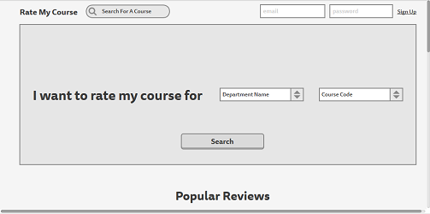

Rate My Course Rate page - Illustration 2

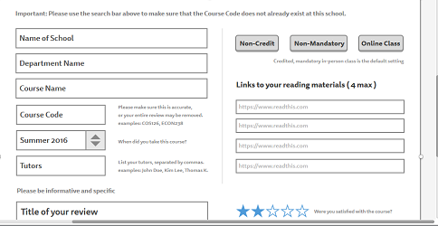

Rate My Course Review page - Illustration 3

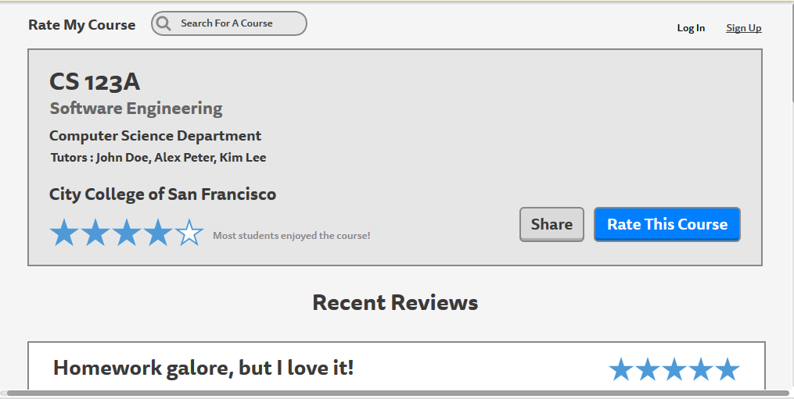

Rate My Course Sign Up page - Illustration 4

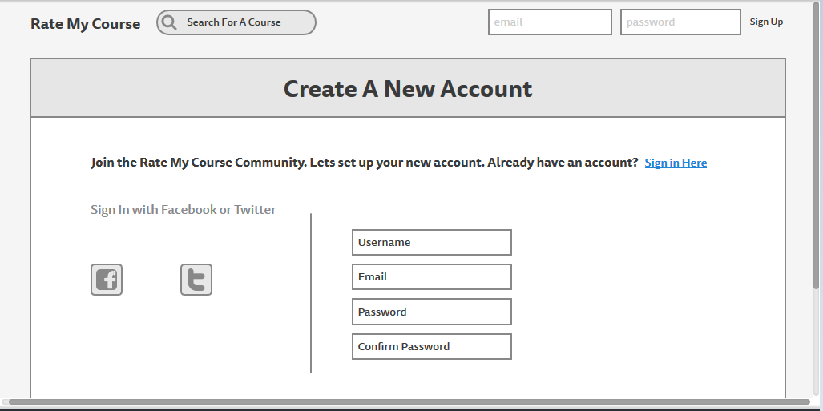

Introduction

Rate My Course is a website that allows users to view the feedback on courses taken by previous students. User that leave a review on a particular course can rate the course from a scale of 1-5 and also write a comment of of what they like or dislike about the course. This information can be used by other user to influence their own decision on whether they wish to take the same course of not.

The purpose of this Document is to demonstrate how to use Rate My Course’s review system and also how to navigate the various pages of Rate My Course.

Concept of Operations

When users first enter Rate My Course, they’re brought to the Rate My Course Homepage. The Homepage can be viewed as a hub to easily access various other Rate My Course pages. On the homepage there is a search option that allows reviewers to search up courses from particular department that they can write a review about. The homepage also includes a list of recent and popular reviews posted by users. See Illustration 1.

Users of Rate My Course are encouraged to either sign in to their account or sign up as a member. The sign up page allows users to be a member of Rate My Course, which grants them the ability to write reviews and also interact with them.

The Course page displays a list of reviews provided by users. Users can use various filters to sort the list of reviews presented to them or use the search tool for specificity. Members of Rate my Course can also leave rate the review if they found it helpful or not.

The Rate page allows user to write a review on the course. Certain guidelines are in place that the user is required to follow in order for the review to be posted.

Procedures