**Effect of Artificial Intelligence (AI) health program on weight - “Diet and Exercise Advice for Slimming” (DEXASLIM) study**

Maya Oleynikova

*Introduction*

In a rapidly-changing landscape of AI-powered interventions to improve human health, we attempt to quantify the potential impact of one such weight loss program.

*Methods*

The DEXASLIM study enrolled 54 adults (18 years or older) who expressed an interest in a weight loss program and randomized to either a waitlist control condition or an experimental intervention. The intervention was a DEXASLIM program intended to help the patient lose weight through a personalized, tailored lifestyle application with a natural language processing interface. Patients’ weights were recorded at Week 0 and Week 6. Additionally, patients were asked to keep a food diary and record exercise activity each day during the duration of the trial. After Week 6, the waitlist control group was given full access to the DEXASLIM program. Entries with missing data were excluded. For each participant, the change in weight was determined by calculating the difference between the Week 0 weight measurement and Week 6 weight measurement.

In assessing the results, a descriptive analysis was performed to ascertain the distribution of the data. This was achieved using a double histogram, plotting separately the change in weight in both the control and intervention groups. To assess potential confounding of change in weight due to sex, a double boxplot was used to analyze the spread of data between males and females. Analytic investigation performed using a two-sample t-test to examine a potential difference in weight change between the intervention and control group. A mean and standard deviation (SD) would be calculated for each group. A paired t-test approach was used to determine if statistically significant weight loss occurred in the absence of the DEXASLIM intervention. Upon performing both tests, if the p-value is less than alpha (α = 0.05) and 95% confidence interval does not cross 0, then a statistically significant change would be surmised.

*Results*

Our descriptive analysis indicates that the weight differences in both the DEXASLIM and waitlist control groups followed an approximately normal distribution, with minimal confounding observed from participant sex (Table 1, Figure 1). Evidence of the DEXASLIM intervention is therefore not influenced by sex. This conclusion allows us to assume equal variances and proceed with parametric statistical testing.

Results from the two-sample t-test revealed a statistically significant difference in average weight change between the DEXASLIM and waitlist control groups, with a mean difference of -1.88 kg (95% CI: 0.53 to 3.23, p < 0.05). This reveals that the DEXASLIM intervention is effective for weight loss, with the program participants observing a more significant weight loss than the controls (Figure 2).

Results from the paired t-test showed a significant difference in weight change from week 0 to week 6 of the trial in the control waitlist group, with a mean difference of 3.27 kg (95% CI: 2.25 to 4.29, p < 0.05). This shows that the waitlist control group had, on average, an increase in weight over the course of the study period; no significant weight loss was therefore observed in this group.

*Conclusion*

Through this analysis, we found that the DEXASLIM intervention results in statistically significant weight loss over a 6 week study period compared to a waitlist control group. This shows that AI-powered programs for healthy lifestyles could be beneficial for reducing metabolic disease through reduction in weight and encouraging healthy habits. More research is needed to determine the magnitude of this intervention. Additionally, we found that the control waitlist group experienced significant weight gain over the course of the study; this shows that weight is subject to change over time regardless of intervention. Future studies should ensure to properly establish a control group to be able to adjust for these changes in the final analysis.

Some recommendations for the future would be to expand the DEXASLIM intervention to a larger group and observe the changes on a larger scale; this would increase the power of the results. Given the limitations of using weight as a measured outcome, it would likewise be recommended to expand the outcomes and incorporate surveys, blood tests, and other measures of health to properly measure the impact of this intervention.

A key limitation of this analysis was the small sample size (n=54) which affects the power of the analysis. Additionally, the short duration of only 6 weeks of intervention time would likely limit the observed effect, since it often takes much longer for weight loss programs to be effective. Lastly, the sampling strategy was biased in that the study only recruited adults that expressed interest in losing weight, which is not representative of the population as a whole.

**Appendix 1: Tables & figures**

Table 1: Demographics of study participants by intervention status (n=52)

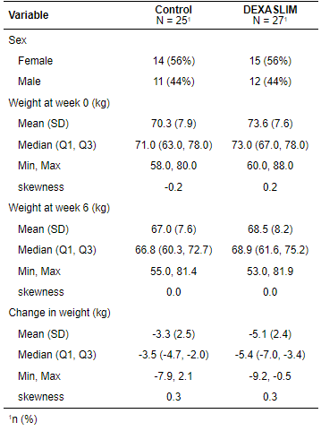

Figure 1: Boxplots of intervention change in weight by sex (n=27)

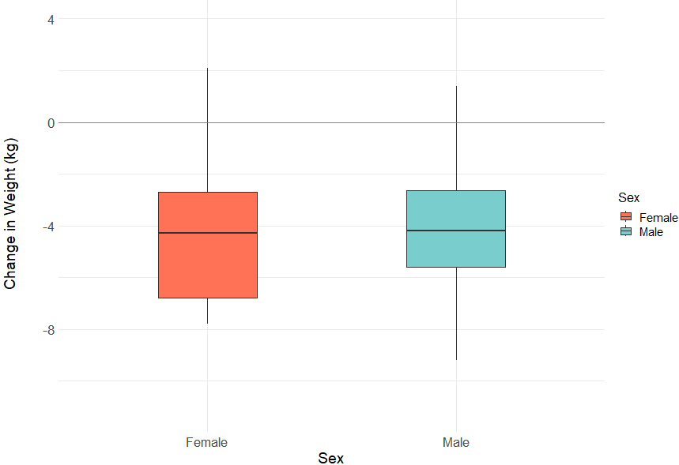

Figure 2: Bar chart of change in weight in DEXASLIM and control groups (n=52)

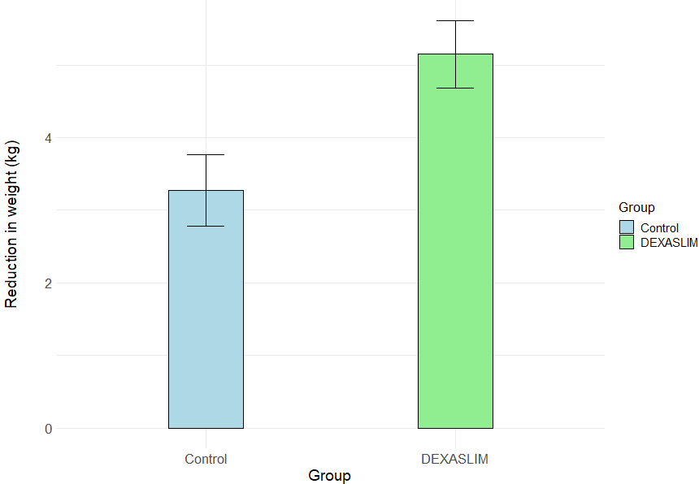

**Appendix 2: R code**

*Note: the full R script for this analysis can also be found on the GitHub:*

# Author: Maya Oleynikova

# Project: UW BIOST 511 (AUT 2024) Final Project - DEXASLIM

# Purpose: Perform descriptive and analytic analyses on DEXASLIM dataset for final report

# Date: 12/6/2024

# Set up ------------------------------------------------------

library(tableone)

library(e1071)

library(tidyverse)

library(gtsummary)

library(systemfonts)

library(flextable)

# Data ------------------------------------------------------

# Loading in DEXASLIM data, removing rows with missing data

data <- read.csv("C:/Users/mayaol/biost511/final_project/dexaslim.csv")

data <- na.omit(data)

# Creating weightdiff variable (change from Week 0 to Week 6)

data$weightdiff <- data$week6weight - data$preweight

# Creating factor variables for sex and group

data$sex.f <- ifelse(data$sex == 1, "Male", "Female")

data$group.f <- ifelse(data$group == 1, "DEXASLIM", "Control")

# Analysis ------------------------------------------------------

# Table 1: Demographics of study participants by intervention status (n=52)

data %>% select(sex.f, preweight, week6weight, group.f, weightdiff) %>%

tbl_summary(by=group.f,

missing = "ifany",

type = all_continuous() ~ "continuous2",

statistic = all_continuous() ~ c("{mean} ({sd})",

"{median} ({p25}, {p75})",

"{min}, {max}",

"{skewness}"),

digits = list(all_continuous() ~ 1),

label = list(sex.f ~ "Sex",

preweight ~ "Weight at week 0 (kg)",

week6weight ~ "Weight at week 6 (kg)",

weightdiff ~ "Change in weight (kg)")

) %>%

modify_header(label = "**Variable**") %>%

as_flex_table()

# Figure 1: Boxplots of intervention change in weight by sex (n=27)

ggplot(data, aes(x = factor(sex.f), y = weightdiff)) +

geom_boxplot(aes(fill = factor(sex.f)),

outlier.shape = 16,

outlier.size = 3,

width = 0.4) +

labs(title = "Boxplot of Weight Difference by Sex",

x = "Sex",

y = "Change in Weight (kg)",

fill = "Sex") +

theme_minimal() +

scale_fill_manual(values = c("coral1", "darkslategray3")) +

theme(axis.text.x = element_text(size = 16),

axis.text.y = element_text(size = 16),

axis.title = element_text(size = 18),

plot.title = element_text(size = 16, hjust = 0.5),

axis.title.y = element_text(size = 18, margin = margin(r = 30)),

legend.title = element_text(size = 16),

legend.text = element_text(size = 14))+

scale_y_continuous(expand = c(0.05, 0), limits = c(min(data$weightdiff) - 2, max(data$weightdiff) + 2)) +

geom_hline(yintercept = 0, color = "antiquewhite4", size = 0.5)

# Figure 2: Bar chart of change in weight in DEXASLIM and control groups (n=52)

# First, adjusting data by changing the sign on weightdiff for readability

data$weightdiff_change <- data$weightdiff * (-1)

ggplot(data, aes(x = factor(group.f), y = weightdiff_change, fill = factor(group.f))) +

stat_summary(fun = "mean", geom = "bar", width = 0.3, color = "black") +

stat_summary(fun.data = "mean_se", geom = "errorbar", width = 0.15) +

labs(title = "Bar chart of change in weight in DEXASLIM and control groups",

x = "Group",

y = "Reduction in weight (kg)",

fill = "Group") +

scale_fill_manual(values = c("lightblue", "lightgreen")) +

theme_minimal() +

theme(axis.text.x = element_text(size = 16),

axis.text.y = element_text(size = 16),

axis.title = element_text(size = 18),

axis.title.y = element_text(size = 18, margin = margin(r = 30)),

plot.title = element_text(size = 16, hjust = 0.5),

legend.title = element_text(size = 16),

legend.text = element_text(size = 14))

# Hypothesis test ------------------------------------------------------

# Parametric hypothesis tests

# 1. To assess for a potential difference in weight change between the DEXASLIM

# and control groups

# Two-sample t-test calculation

t.test(weightdiff ~ group.f, alternative = "two.sided",

var.equal = TRUE, conf.level = 0.95, data=data)

# 2. To assess for a potential difference in weight change in the control group

# Paired t-test calculation

t.test(data$preweight[data$group.f == "Control"],

data$week6weight[data$group.f == "Control"],

alternative = "two.sided", paired = TRUE, conf.level = 0.95)

# -----------------------------------------------------------------------------

# Not included in report - used to check assumption of Normal distribution only

# Create an overlayed histogram of weightdiff by group

ggplot(data, aes(x = weightdiff, fill = factor(group.f), color = factor(group.f))) +

geom_histogram(binwidth = 0.4, position = "identity", alpha = 0.5,

aes(y = ..density..)) + # Use density instead of counts

labs(title = "Overlayed Histogram of Weight Difference by Group",

x = "Change in Weight (kg)",

y = "Density",

fill = "Group", color = "Group") +

scale_fill_manual(values = c("lightblue", "lightgreen")) +

scale_color_manual(values = c("blue", "green")) +

theme_minimal() +

theme(axis.text.x = element_text(size = 12),

axis.text.y = element_text(size = 12),

axis.title = element_text(size = 14),

plot.title = element_text(size = 16, hjust = 0.5)) +

xlim(-15, 10) +

ylim(0, 1)