Take Home Test 2
Maya Dara Sofia Pasiliao
CSC 342/343 – Computer Organization
April 24, 2020

Start time:
End time:
I will neither give nor receive unauthorized assistance on this TEST. I will use only one computing device to perform this TEST, I will not use cell while performing this TEST.
Maya Dara Sofia Pasiliao
Table of Contents
Objective 3
Recursive GCD Using x86 Intel on Microsoft’s Visual Studio 3
Recursive GCD Using MIPS on MARS Simulator 4
Recursive GCD Using 64-bit Intel Processor on Linux 5

Objective
The objective of this test is to understand how different processors handle recursive function calls by running and debugging a recursive function call on three different platforms: x86 Intel on Microsoft’s Visual Studio, MIPS on MARS Simulator, and on a 64-bit Intel processor running Linux. Each frame on the stack will also be explained and shown.

Recursive GCD Using x86 Intel on Microsoft’s Visual Studio
The following screenshot shows the initial disassembly window for the gcd c file.
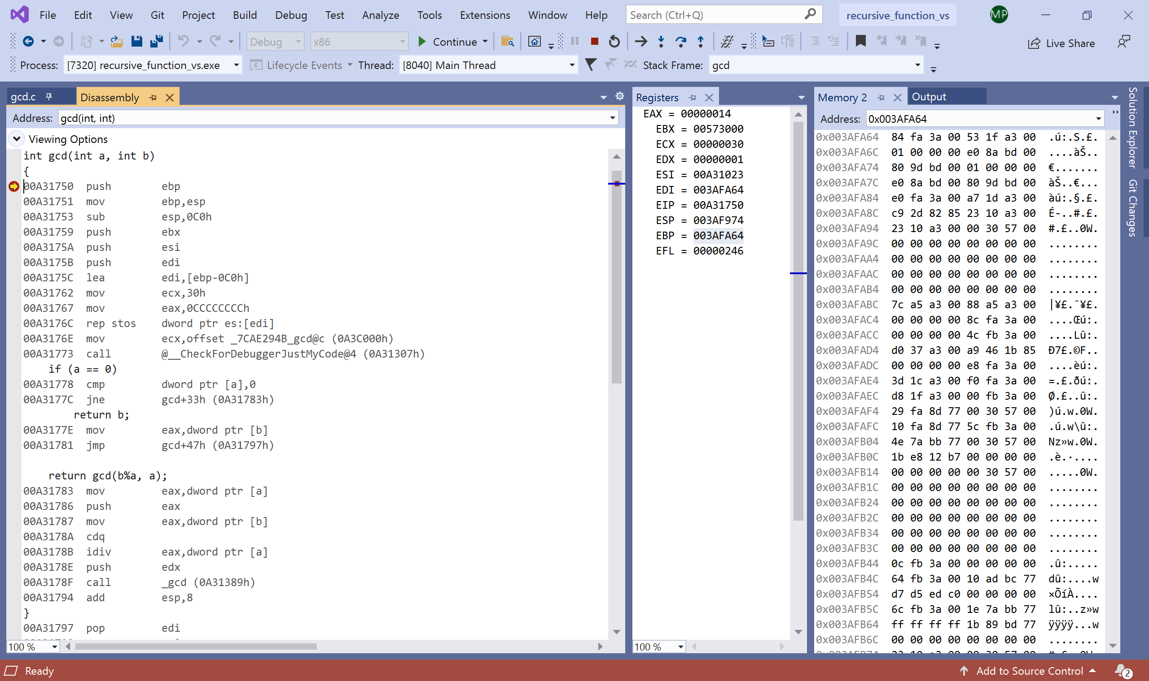
The following screenshot shows the disassembly window at the beginning of the first gcd function call. The initialized values can be seen in the memory window at address 0x003AF978, where 30 in hexadecimal is equal to 48 in decimal and 14 in hexadecimal is equal to 20 in decimal.
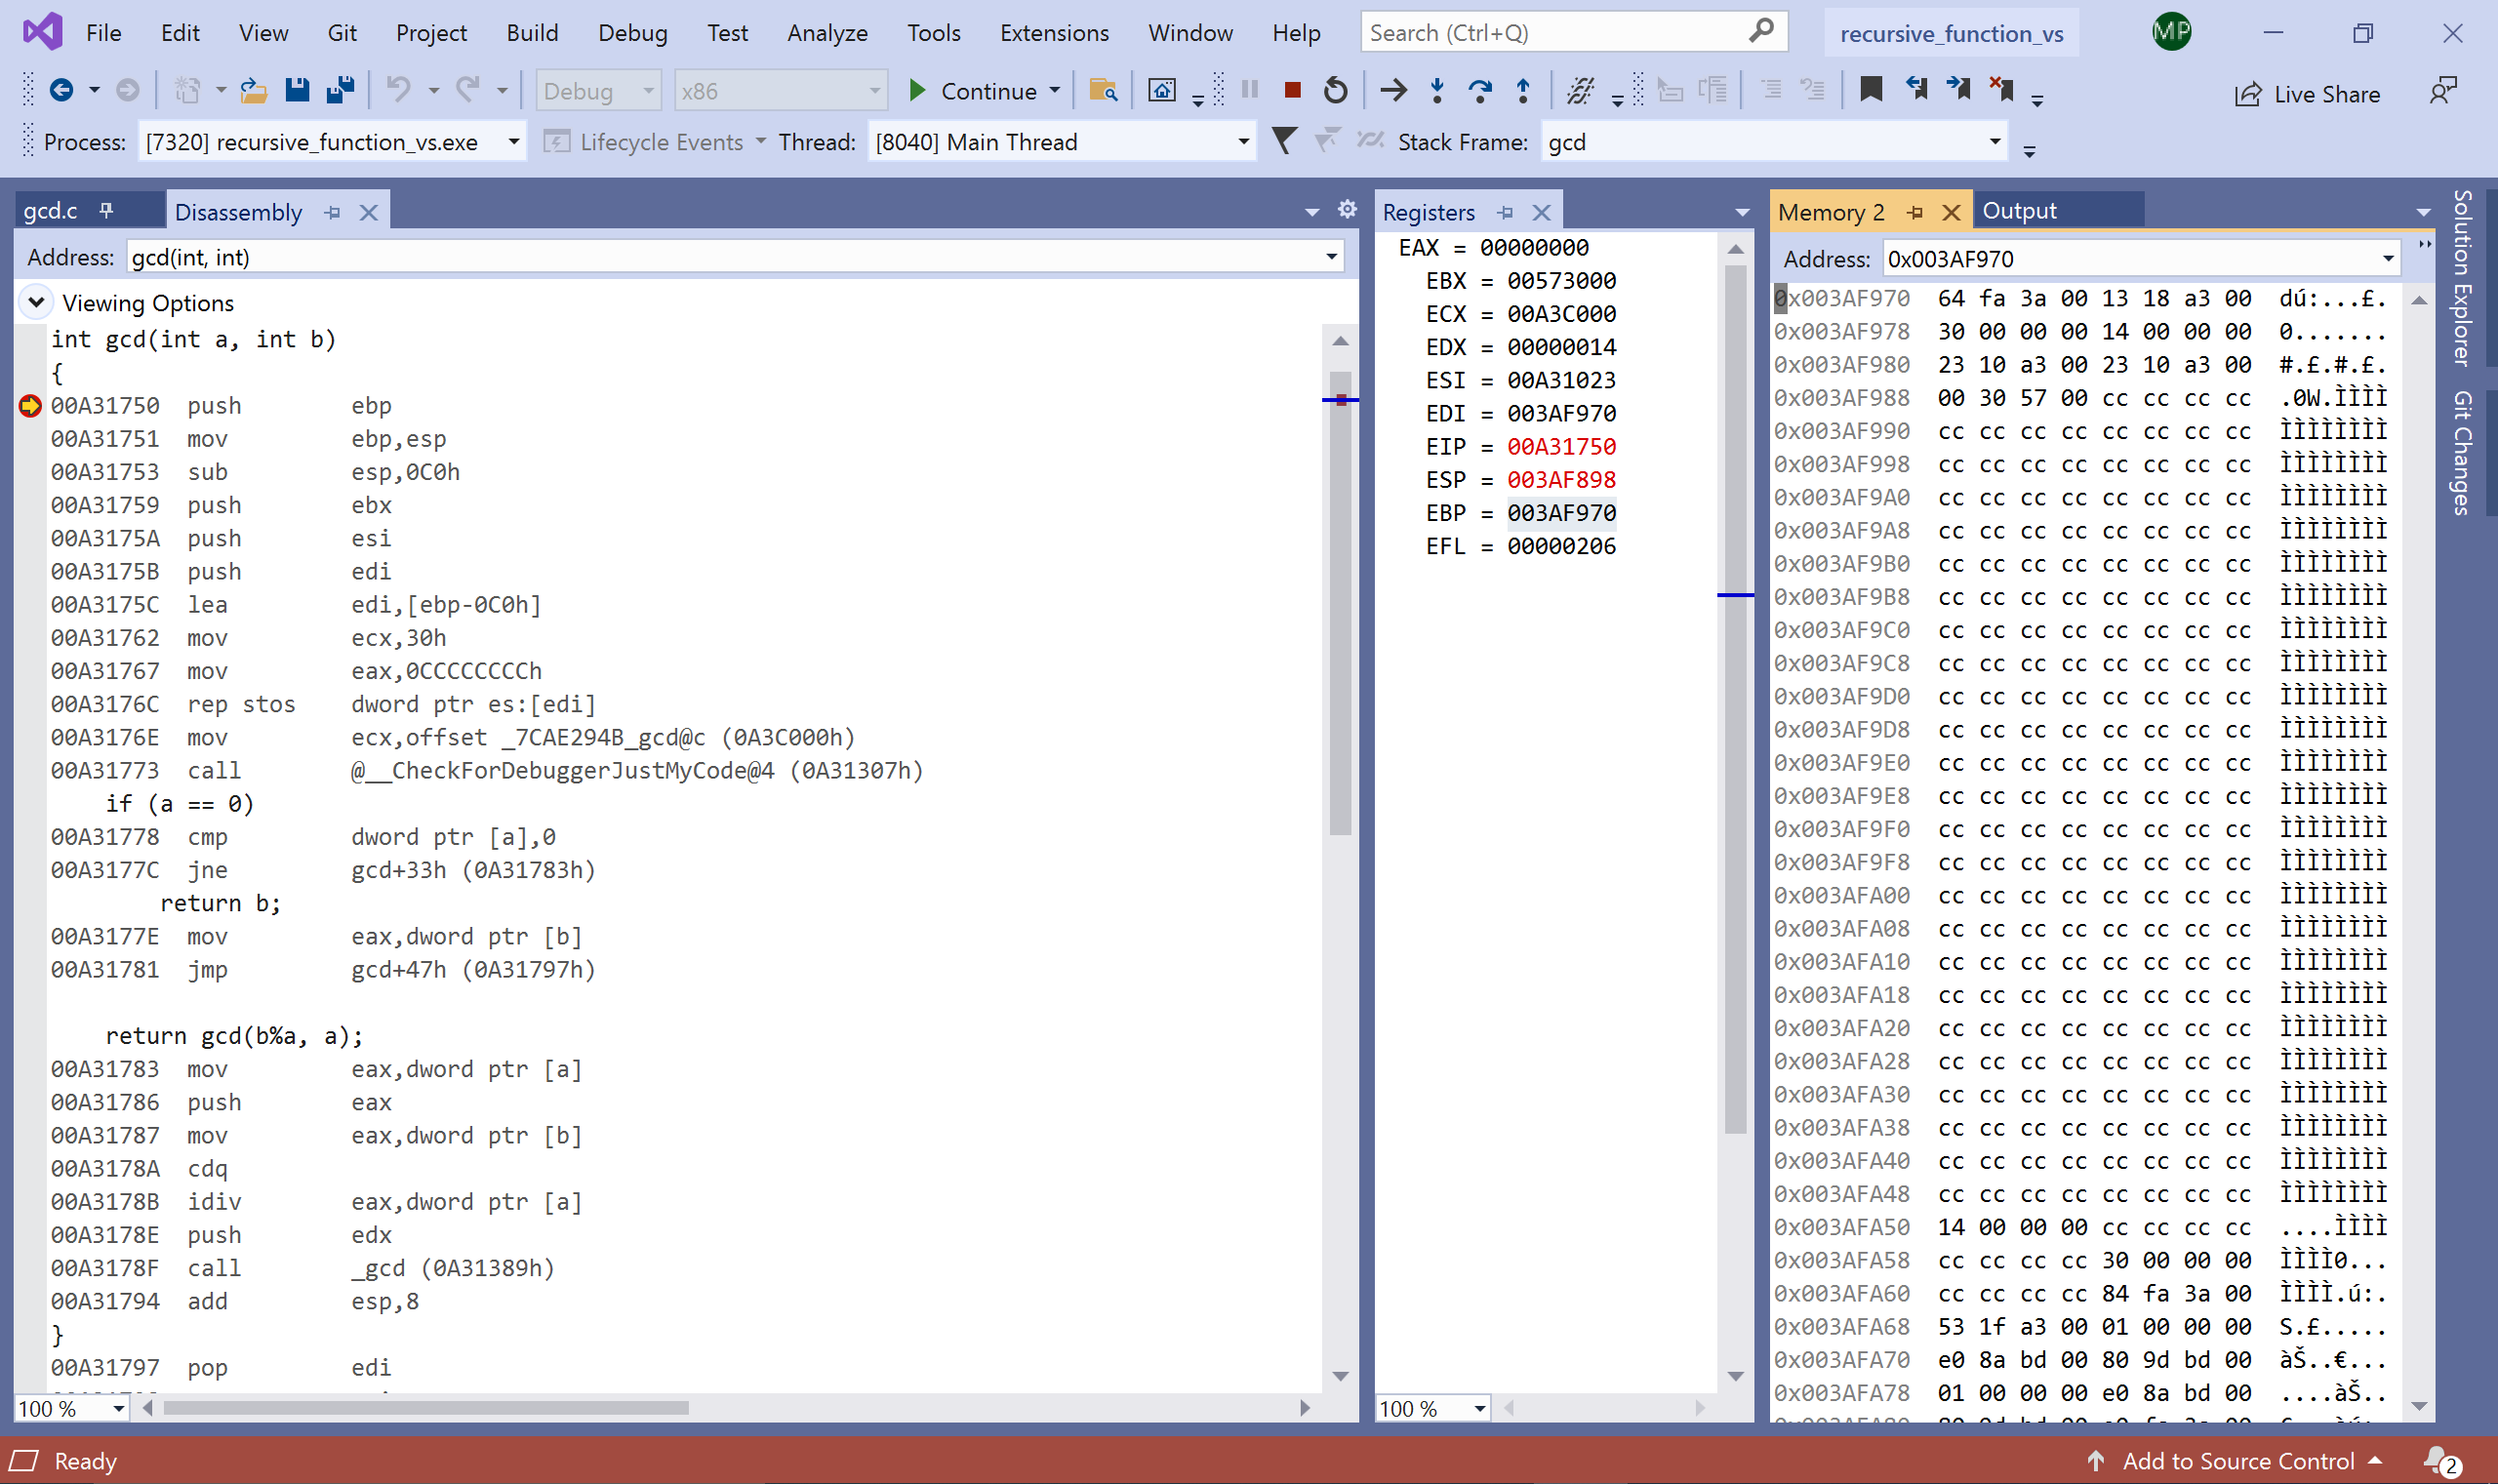
The following screenshot shows the disassembly window of the last line of the first gcd function call about to be executed.
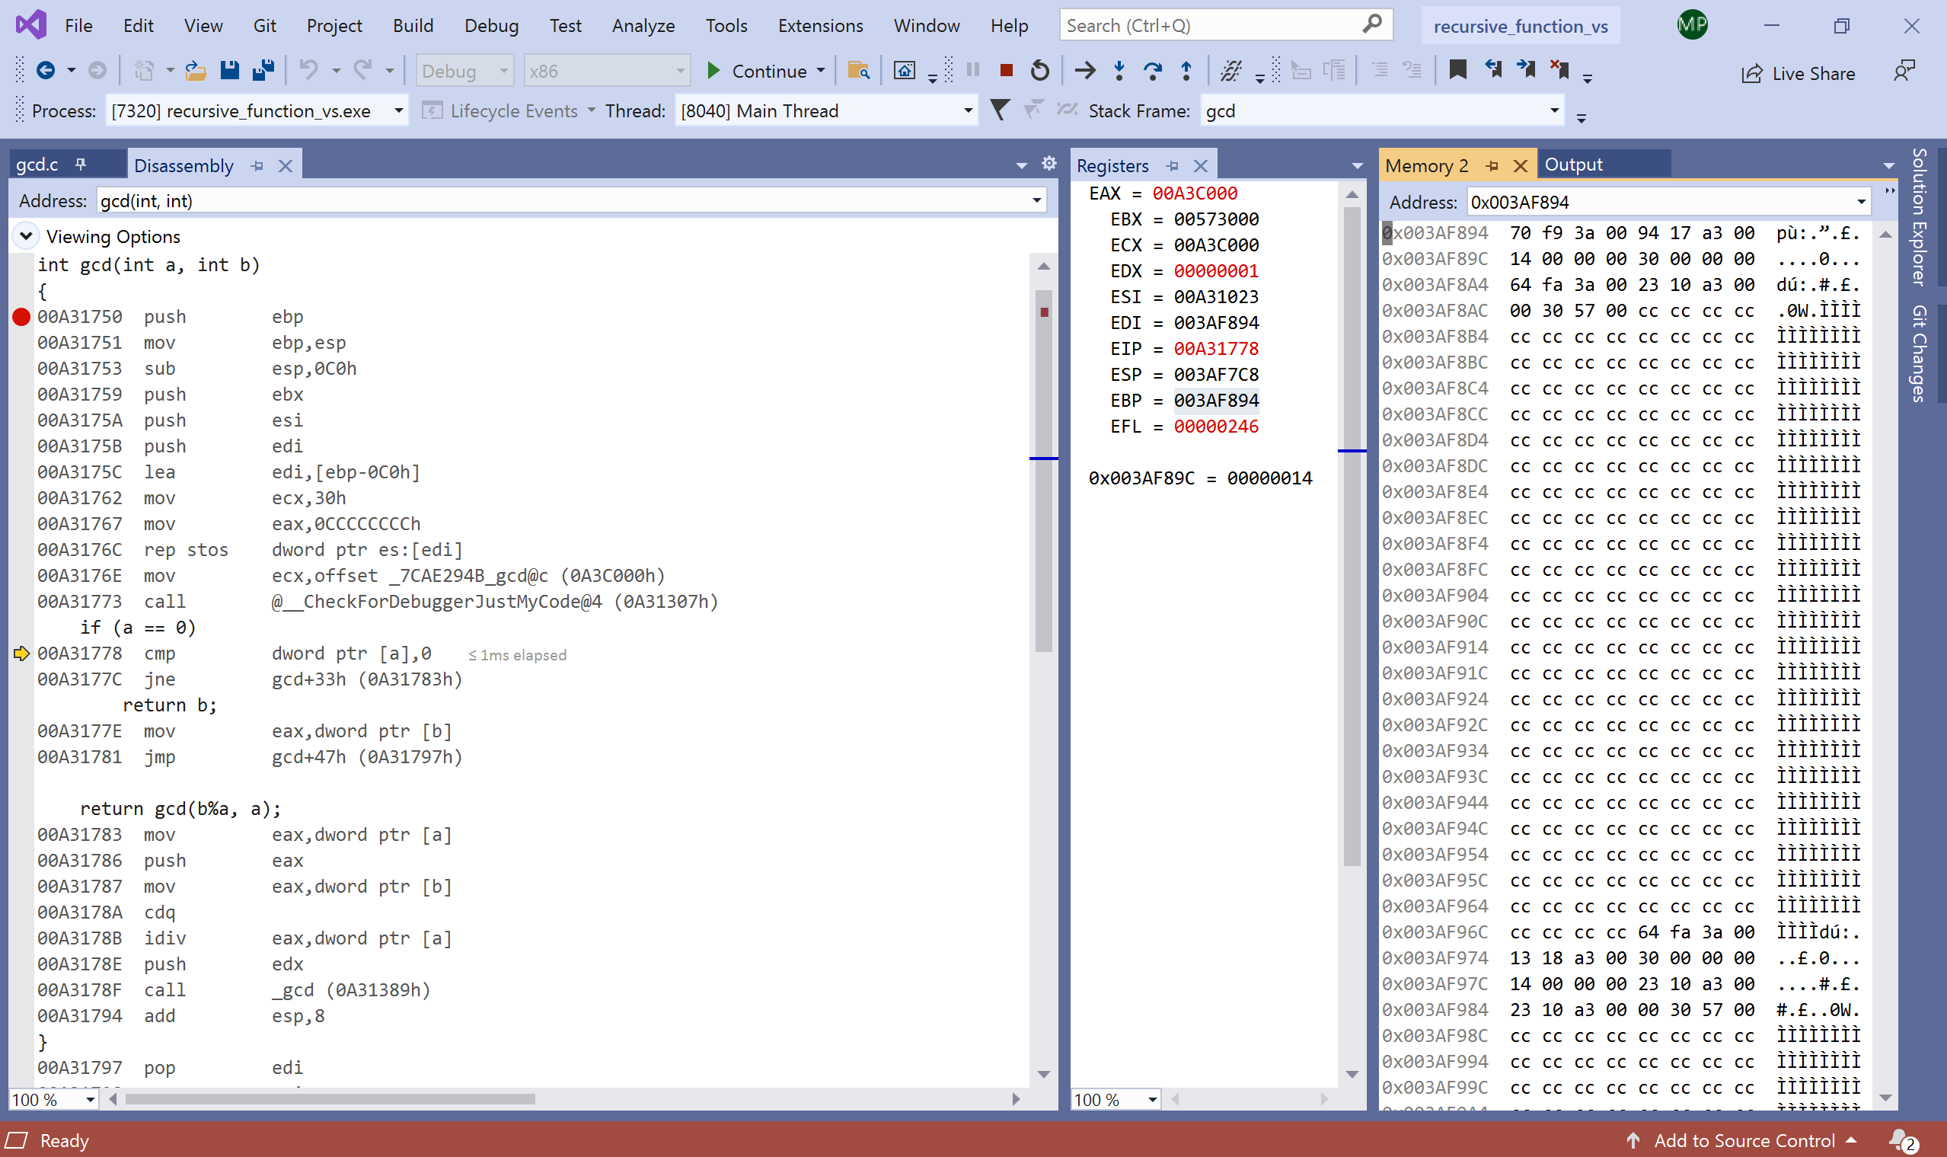
The following screenshot shows the disassembly window at the beginning of the next function call where values of a and b are 4 and 8 respectively.
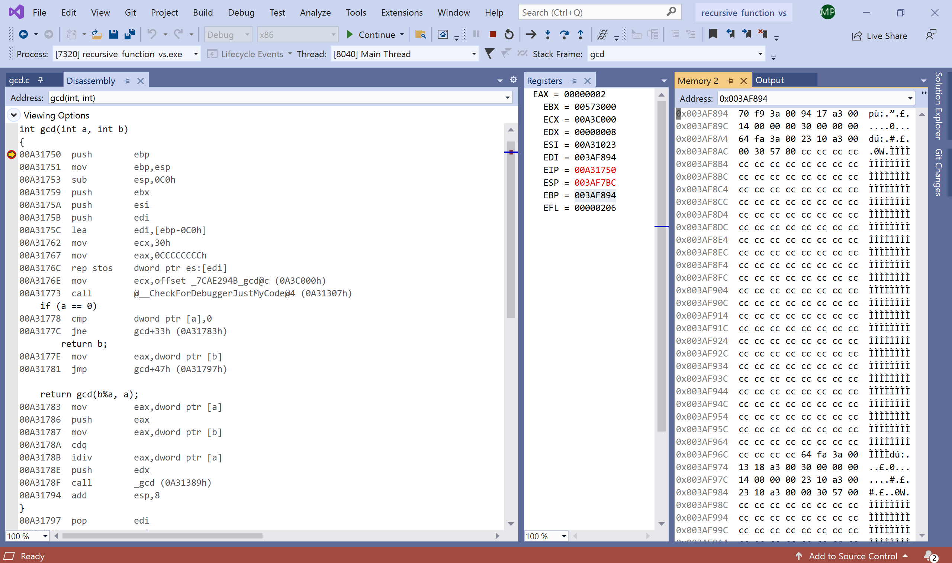
The following screenshot shows the disassembly window at the end of the function call to gcd with values 4 and 8 just before the next function call is executed.
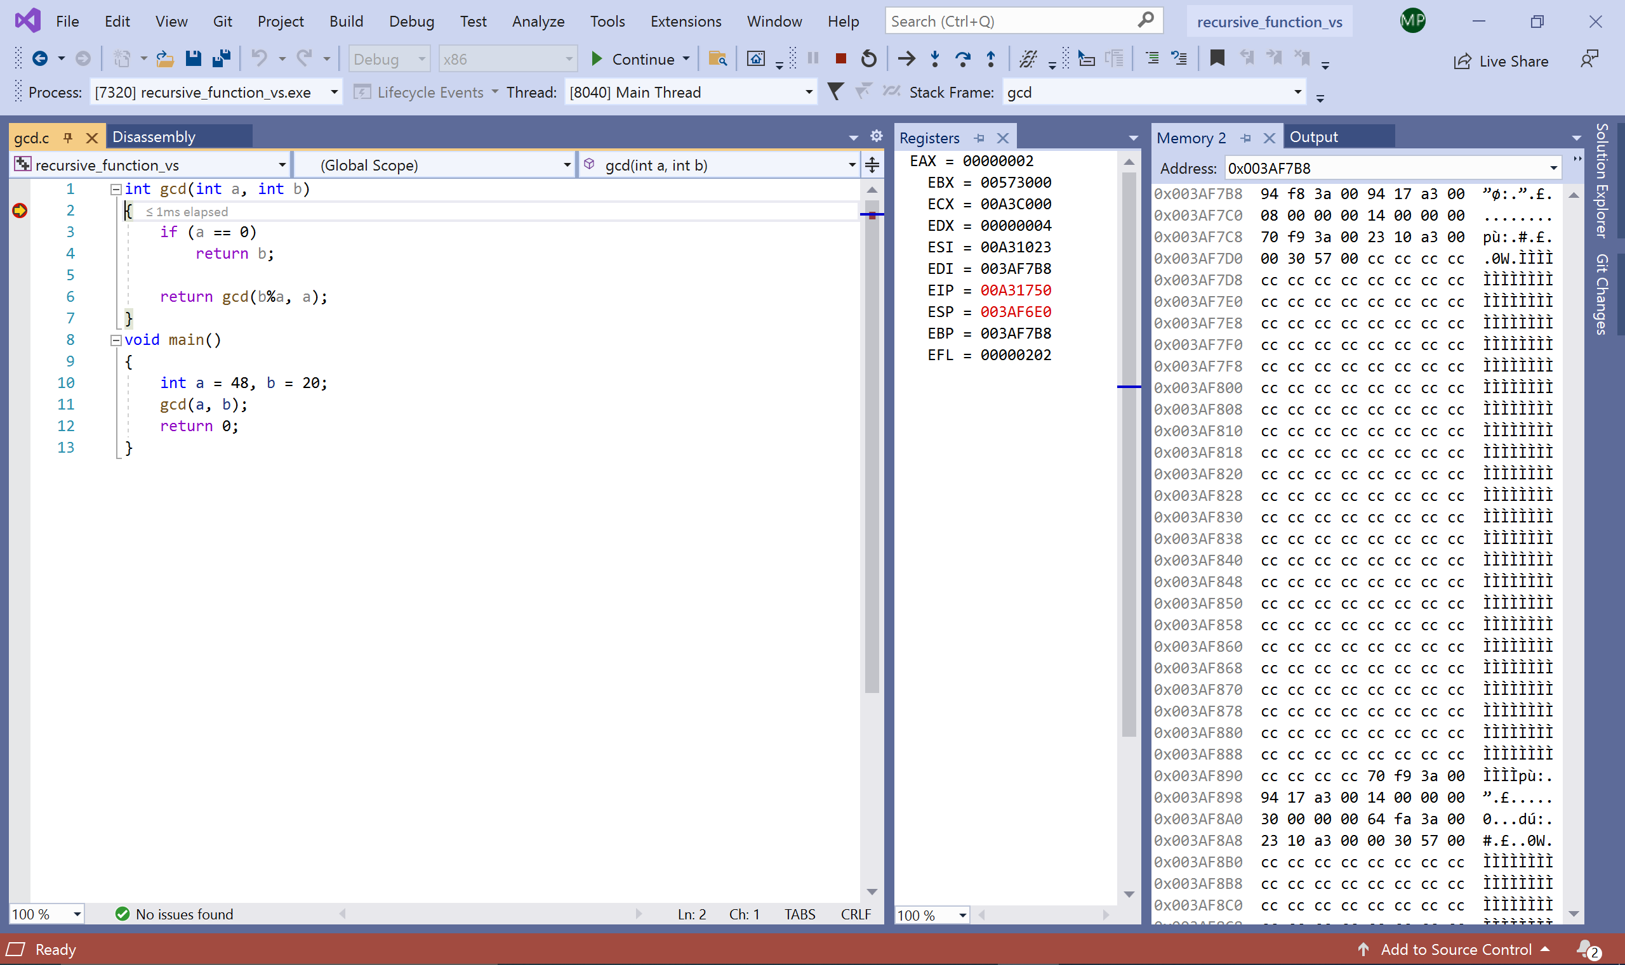

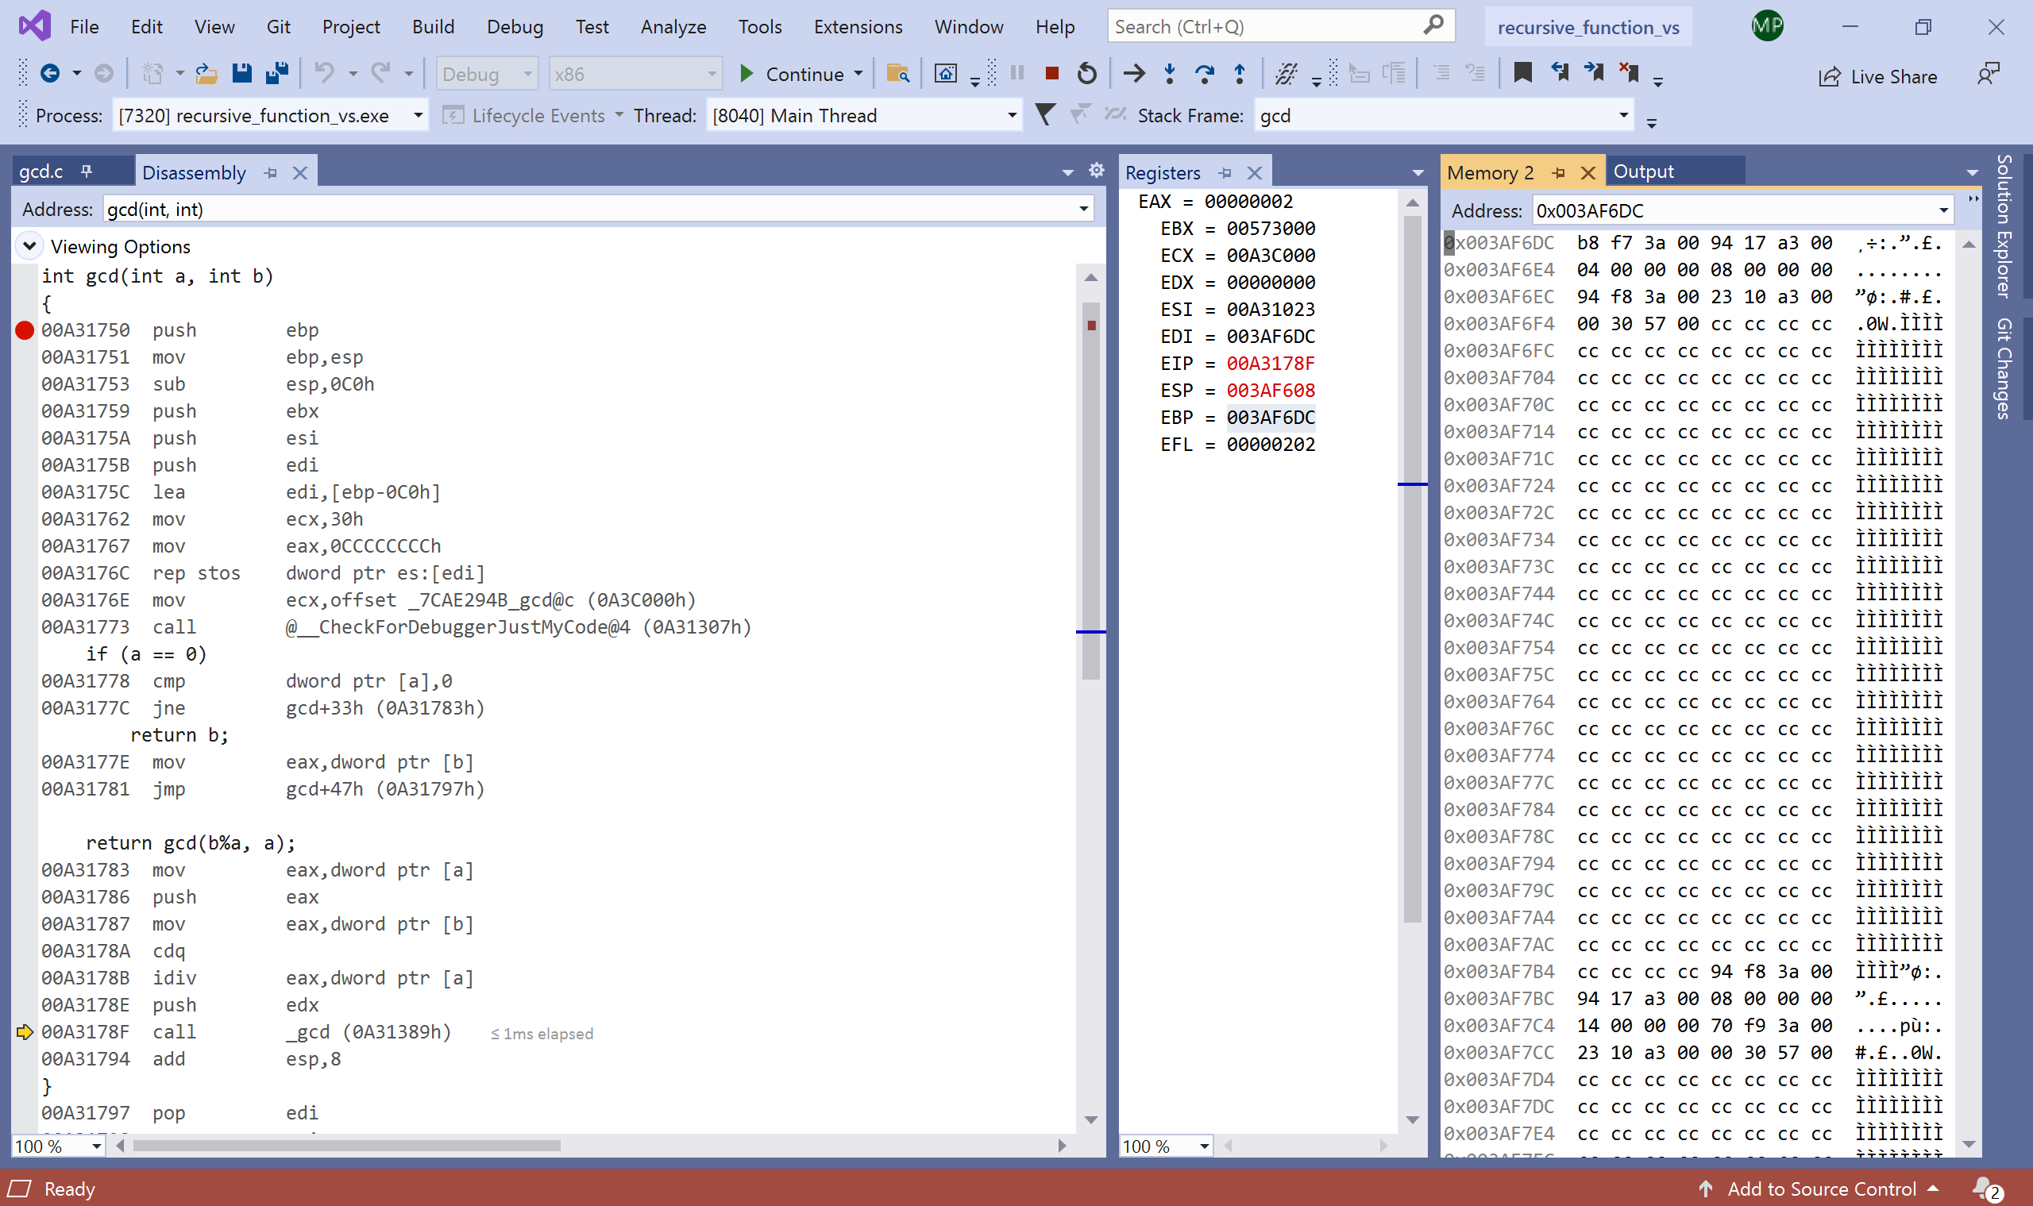

Recursive GCD Using MIPS on MARS Simulator
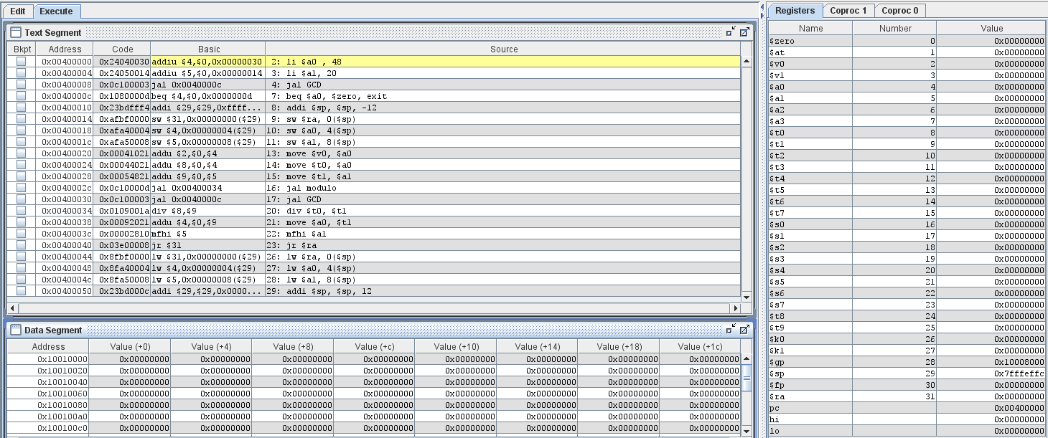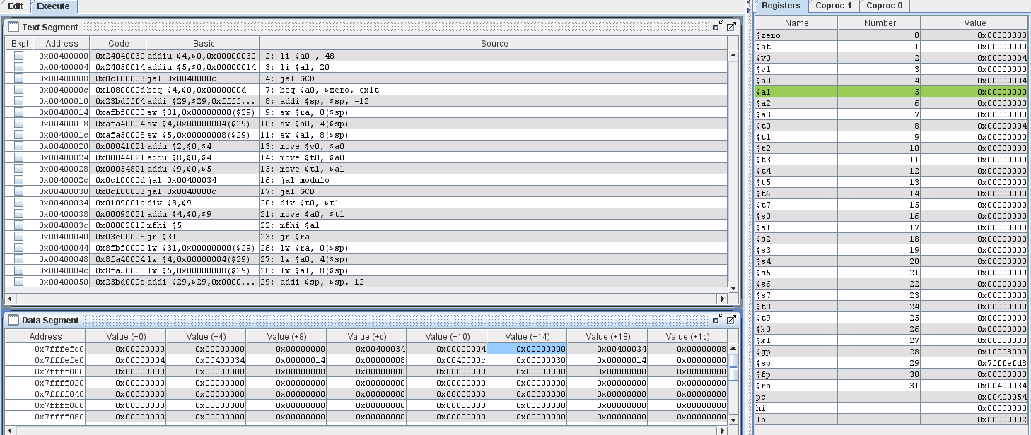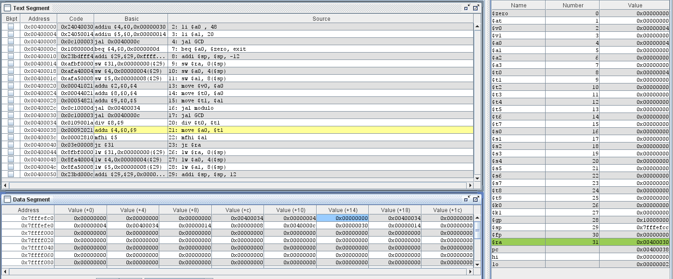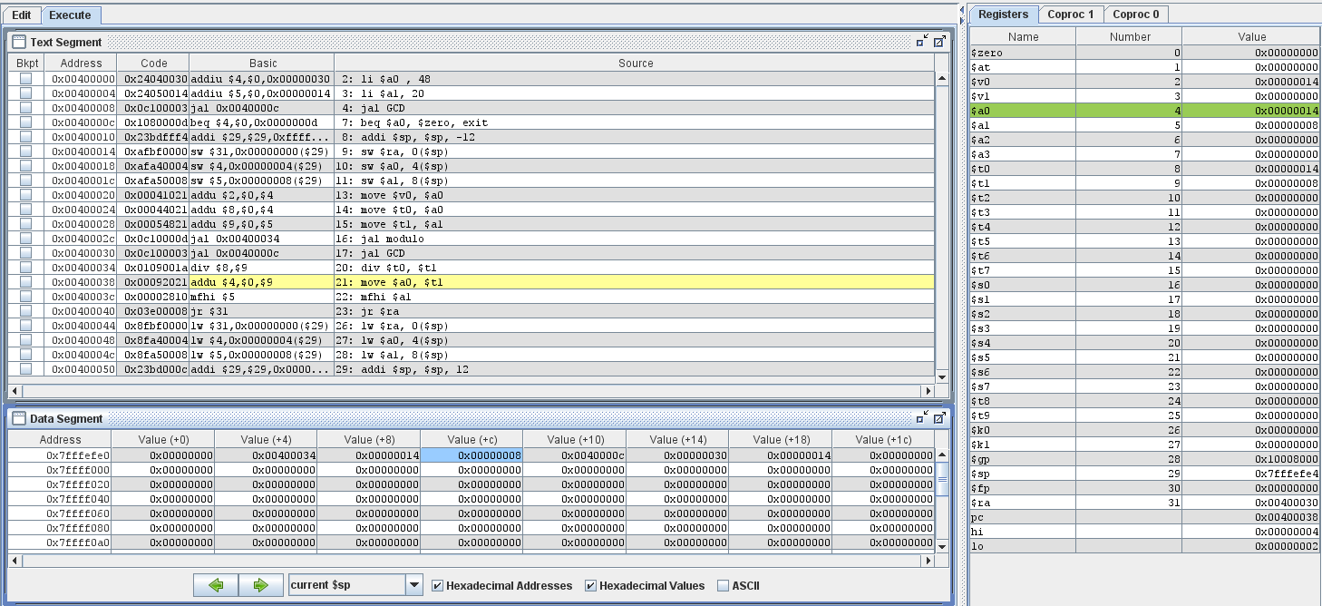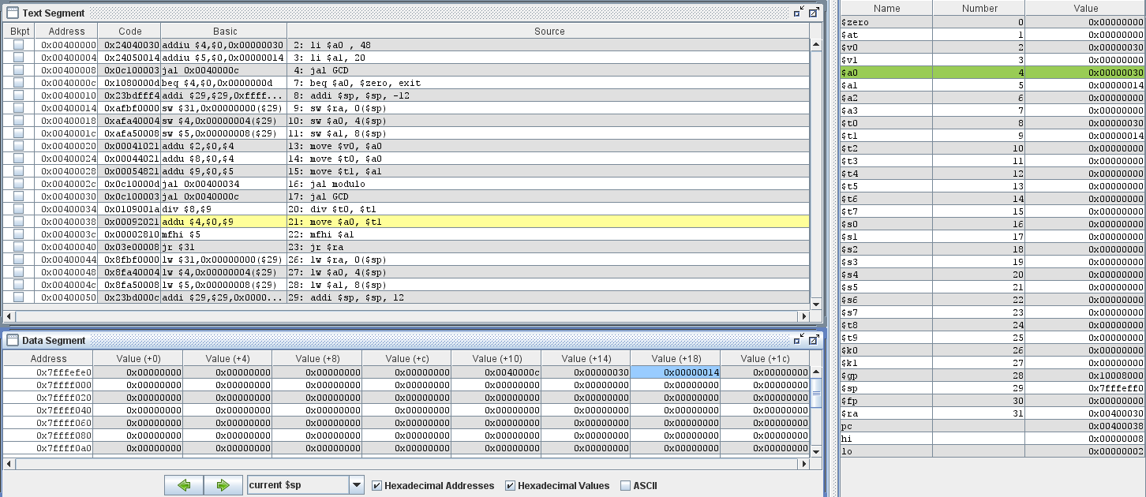

Recursive GCD Using 64-bit Intel Processor on Linux
The break point was set at main. This screenshot shows the disassembly dump for the declaration of variables a and b. The movl commands can be seen allocating space for these variables.
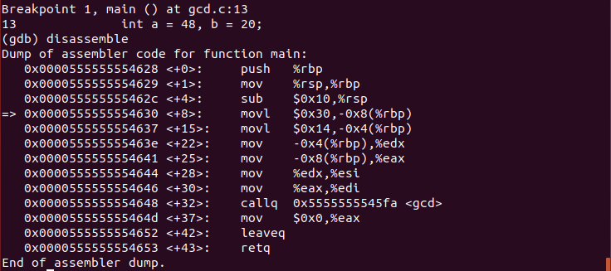
The following screenshot shows the disassembly dump for the initial function call to gcd with values 48 and 20.
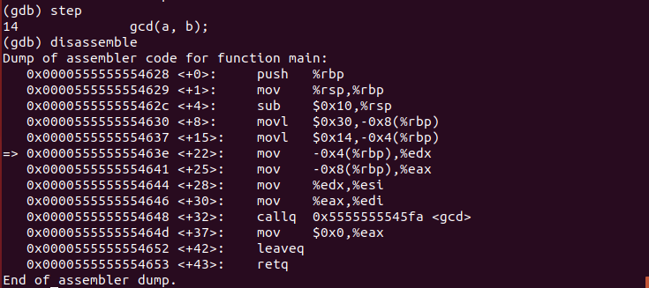
The following screenshot shows the disassembly dump for the first execution of the gcd function when it is called using the callq command. It is initially checking if a equals 0, but since it is not it will call gdb again.
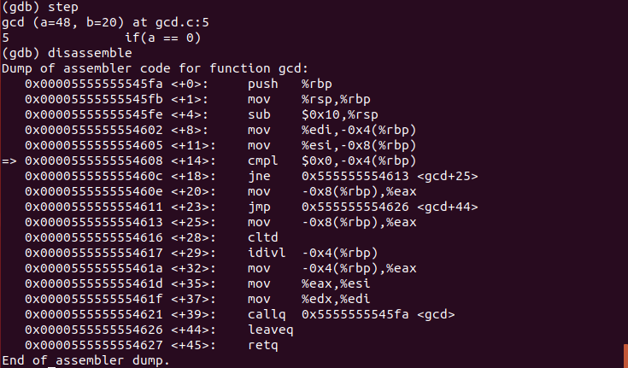
The following screenshot shows the disassembly dump for the next function call.
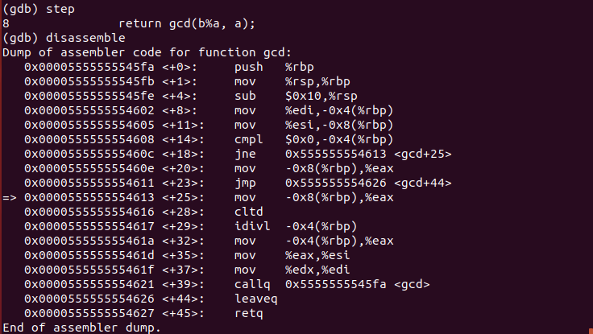
The following screenshot shows the disassembly dump for a function call to gcd, but this time with values 4 and 8.
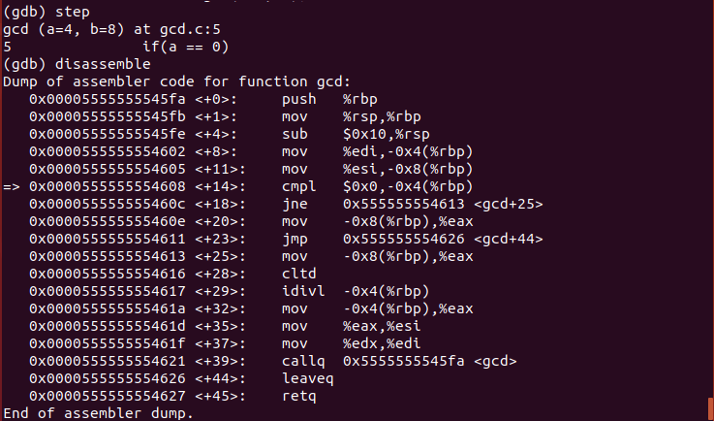
The following screenshot shows the disassembly dump for the last line of the function call to gcd with values 4 and 8.
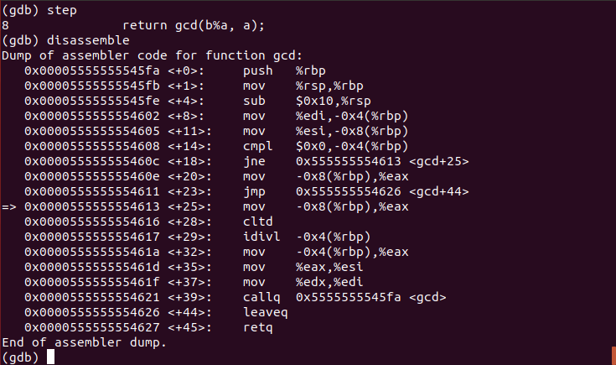
The following screenshot shows the disassembly dump for the function call to gcd with values 0 and 4.

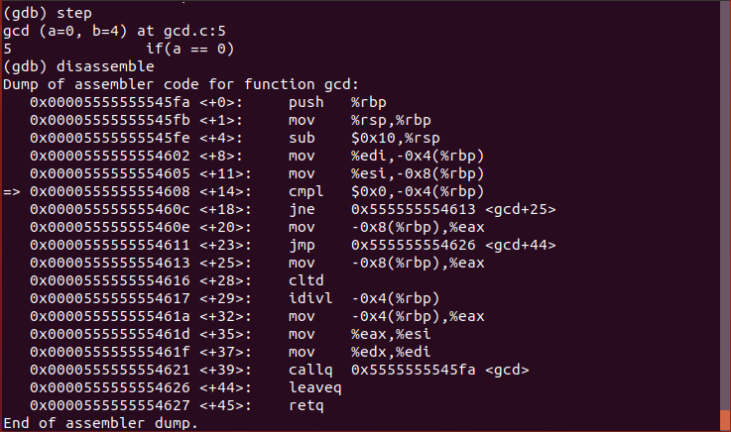
The following screenshot shows the disassembly dump for the first return of the recursion because a was found to be equal to 0.
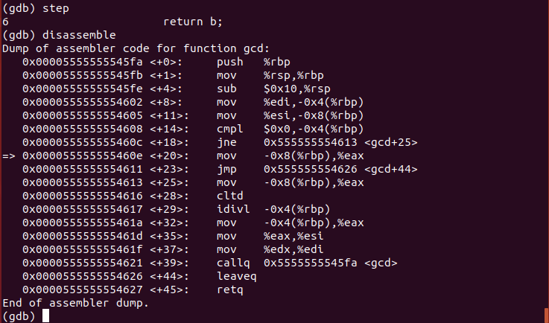
The following screenshot shows the disassembly dump for the last line of main.
